Emails blasts with your members, clients and listservs:
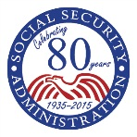 Social Security Administration
SocialSecurity.gov
Start Planning Today with my Social Security  Perhaps Someday you want to go skydiving, enter a hot dog eating contest, or ride a mechanical bull. You also may want to retire Someday.  Your retirement may seem far off, but the fact is there’s no better time than now to lay the foundation for a bright future. Social Security is just one piece of the puzzle. Saving is another. And, if you become disabled and unable to work, you may be eligible for disability benefits.  Open your free my Social Security account today and access your personal, online account information.  - It takes just minutes.  - Verify your earnings history (benefits are based on your earnings).  - See your benefit estimates and more.  - It’s quick and easy.  - Advanced security features protect your privacy.  Social Security benefits are not intended to be your only income source when you retire. On average, Social Security will replace about 40 percent of your annual pre-retirement earnings. You will need other savings, investments, pensions, or retirement accounts to live comfortably. Use your online Social Security Statement, available in your personal account, as a tool for planning your Someday.  Don’t wait for Someday to arrive— open a my Social Security account now at SocialSecurity.gov/myaccount/. |  |  | Create a my Social Security Account »
 |  |  | QUICK LINKS
 |  |  | my Social Security
 |  |  | Disability Benefits
 |  |  | Social Security Updates
 |  |  | If You Receive Benefits…
 |  |  | If You Do Not Receive Benefits…
 |  |  | Follow the Social Security Administration at the above social media sites.
GET STARTED
Social Security Administration
Office of External Affairs, Annex Building,
6401 Security Blvd., Baltimore, MD 21235
oea.net.post@ssa.gov

Employee Sign-Ups
Please encourage your employees to sign up for their account or invite Social Security representatives to come out and sign up your employees at a sign-up event or employee benefits fair.
Share our email blast with your employees
Social Security Administration
Socialsecurity.gov
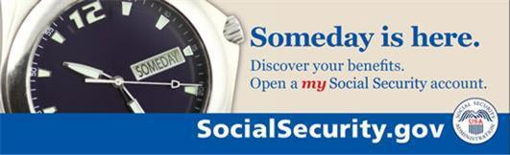
Helping You Discover Your Benefits  Are you saving enough for your retirement? Someday, each of us would like to relax and enjoy the fruits of our labor. In general, Americans are not saving enough for that “Someday” when they will retire. Most don’t have pensions and must depend on Social Security for most of their income.  Social Security offers a my Social Security account to help people prepare for and manage for their “Someday.”  With a my Social Security account you can:  - Get your online Social Security Statement;  - Verify your lifetime earnings;  - See estimates of your future benefits;  - Manage your benefits, and so much more.  Ten-thousand people reach retirement age daily and many are unprepared. Social Security encourages you to plan now by opening a personal my Social Security account at socialsecurity.gov/myaccount.  Opening a my Social Security account online is quick, safe, free, and easy. Please encourage colleagues, family members & others to open his or her own personal my Social Security account at socialsecurity.gov/myaccount. |  |  | Create a my Social Security Account »
 |  |  | QUICK LINKS
 |  |  | my Social Security
 |  |  | Getting Benefits While Working
 |  |  | Disability Benefits
 |  |  | Social Security Updates
 |  |  | Follow the Social Security Administration at the above social media sites.
GET STARTED

