Electronic Consent Based Social Security Number Verification (eCBSV)
SCREEN PACKAGE

Table of Contents
1. eCBSV Registration Screens 5
a. Optional Screens to Test Open ID Connect (OIDC) Registration 5
i. Validate to Perform Dynamic Client Registration 5
ii. Validation successful 6
iii. Invalid Issuer URL Validation - Failure message 7
iv. Validate to Perform Dynamic Client Registration using Authorization Header Credentials 8
v. Validation successful 9
vi. Validation failure 10
b. Entity Registration for Direct Customers 11
i. Provide Information 11
ii. Review and Submit 13
iii. Entity Registration Success 14
iv. Sample Entity Registration Email 14
c. Financial Institution Registration for Indirect Customers 15
i. Enter Information & EIN Consent 15
ii. Permitted Entity Certification 16
iii. Sign Permitted Entity Certification 18
iv. Financial Institution Success 21
2. eCBSV Customer Connection Screens 22
a. Login Screen 22
b. Redirected to Entity Login Screen 23
c. Unenrolled Home Screen 24
d. Contacts 25
i. First-Time User 25
ii. Add Contact and Assign Role(s) 26
iii. Contact Main Screen 28
e. Permitted Entity Certification 29
i. Main Screen 29
ii. Sign Certification 31
iii. Main Screen After Signature 36
f. User Agreement 37
i. User Agreement Main 37
ii. User Reads & Initials User Agreement Section(s) 39
iii. Sign Agreement 41
iv. Main Screen After Signature 46
g. Tier Subscription 47
i. Select Tier Selection 47
ii. Tier Subscription Review & Pay 49
iii. Pay.Gov Redirect 50
iv. Pay.gov Pay Screen 1 (for payments of $24,999 or lower) 51
v. Pay.gov Pay Screen 2 (Checking or Savings Account (ACH)) 52
vi. Pay.gov Pay Screen 3 (Credit or Debit Card) 53
vii. Pay.gov Pay Screen 4 (Review and Submit Payment) 54
h. Start Exchanging 55
i. Payment Confirmation 55
ii. Print/Download Page Contents 56
i. Payment Receipt 57
i. Receipt 57
ii. Print/Download Receipt 58
iii. Sample Enrollment Email 59
j. Enrolled User Home Screen 60
k. Entity Information 61
l. Tier Subscription Renewal 62
i. Tier Subscription Selection 62
ii. Tier Subscription Review & Pay 64
iii. Pay.gov Redirect 65
m. Documents 66
n. ETE Registration 67
i. Registration 67
ii. ETE Registration Success 68

eCBSV Registration Screens

Optional Screens to Test Open ID Connect (OIDC) Registration

Validate to Perform Dynamic Client Registration

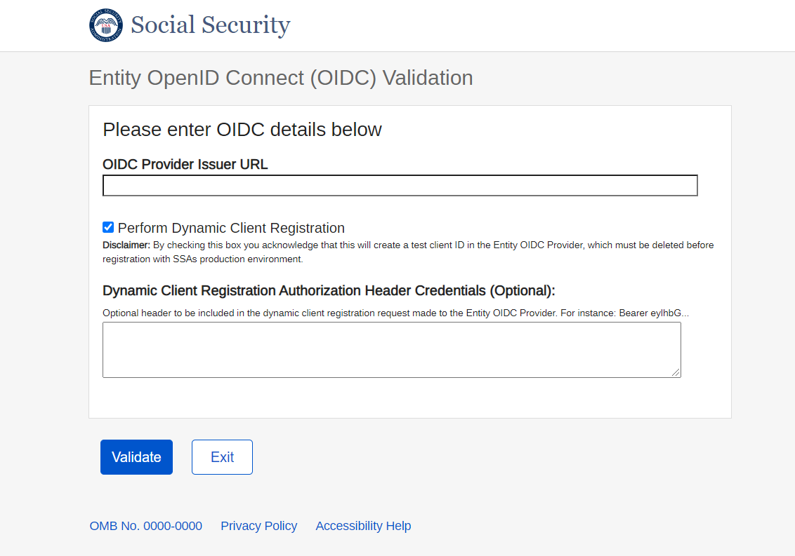

    - Validation successful

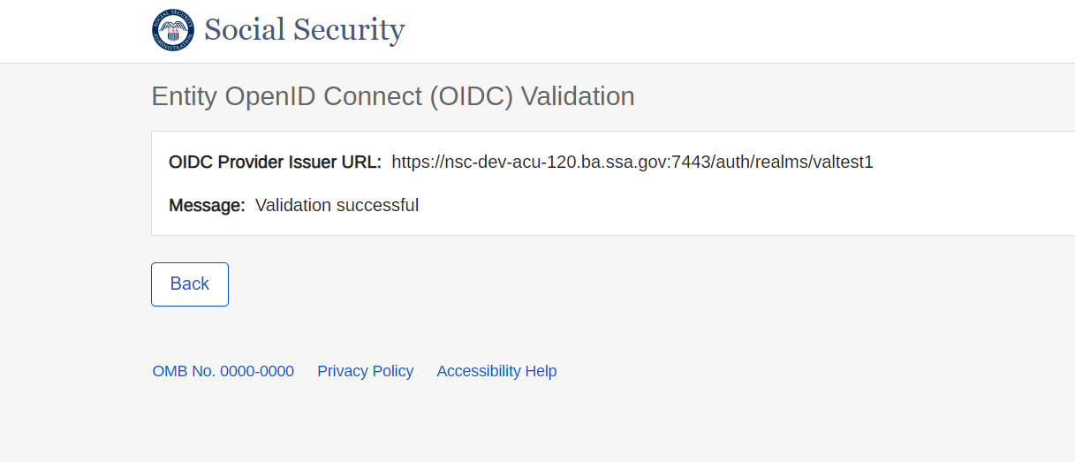

    - Invalid Issuer URL Validation - Failure message

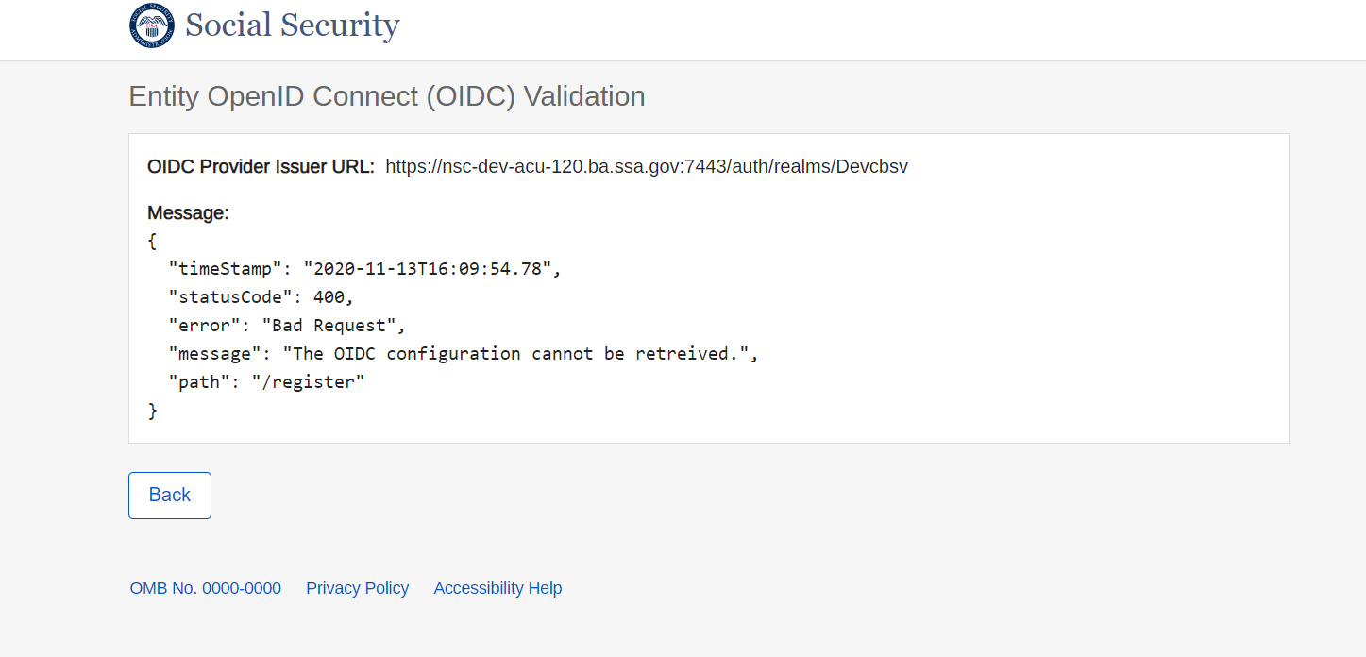

    - Validate to Perform Dynamic Client Registration using Authorization Header Credentials

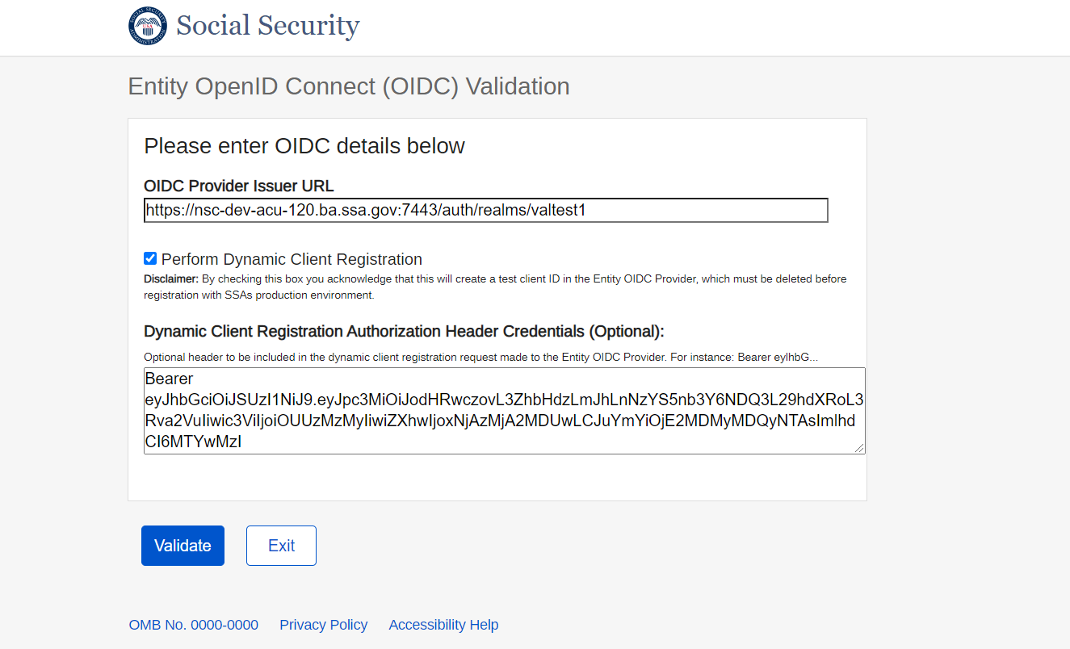

    - Validation successful

    - Validation failure

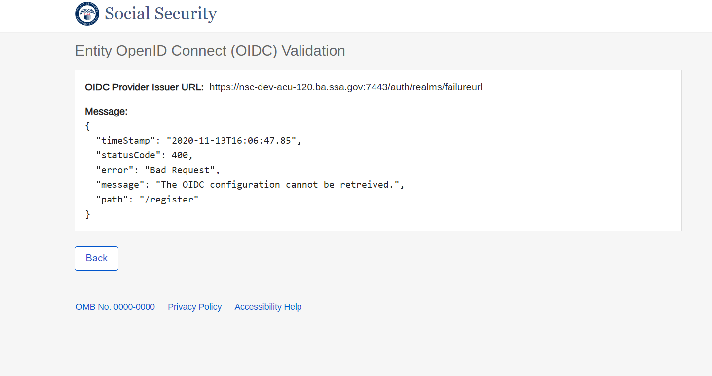

Entity Registration for Direct Customers

Provide Information
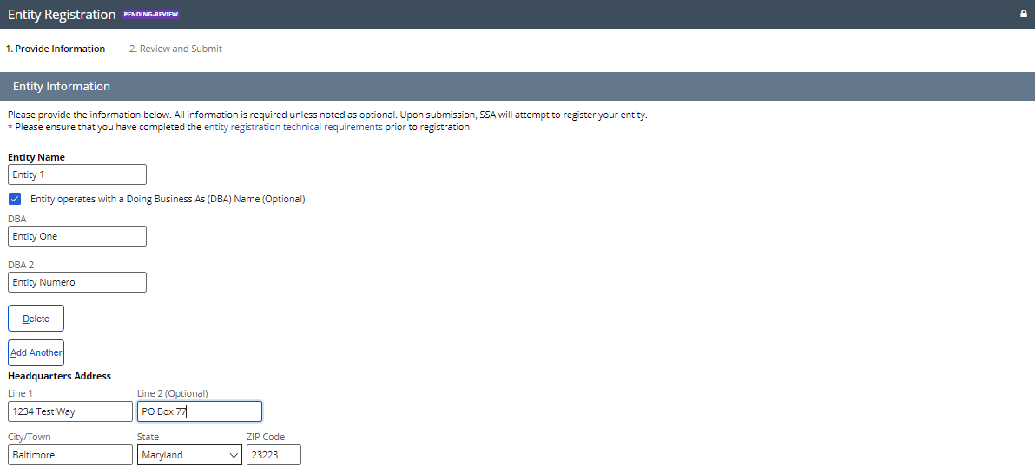
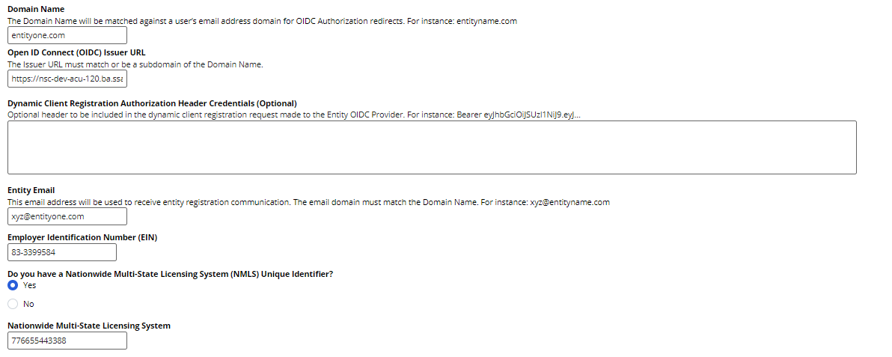
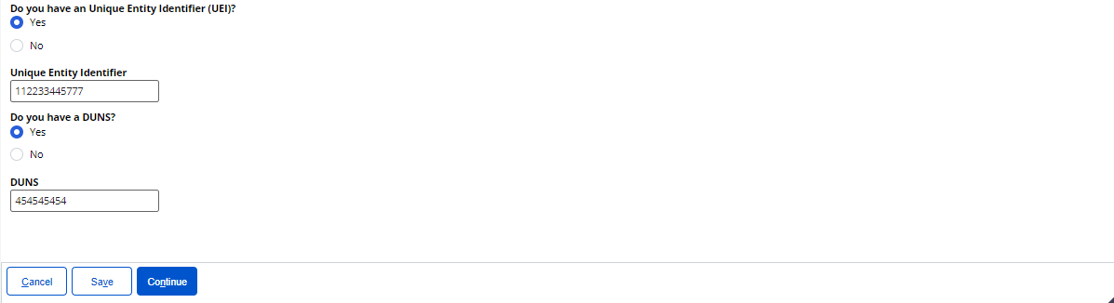

Review and Submit
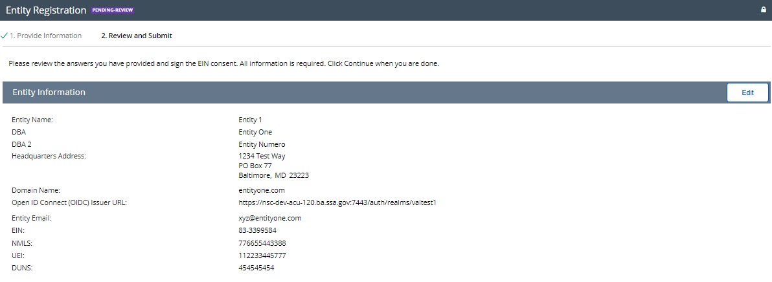
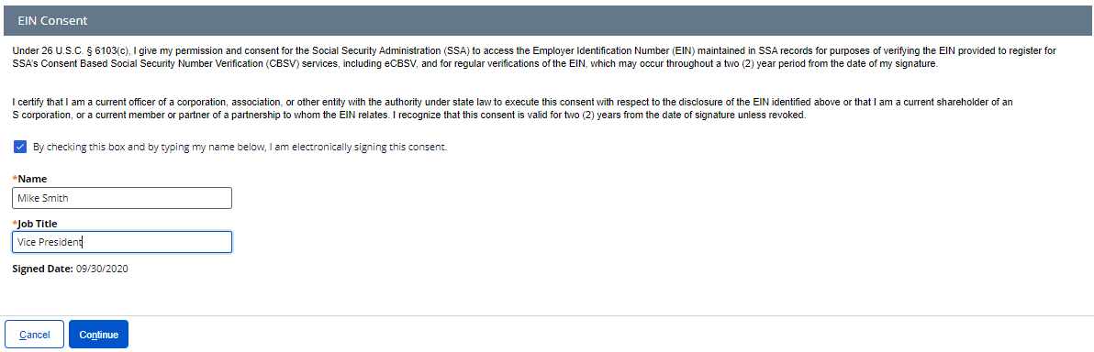

Entity Registration Success
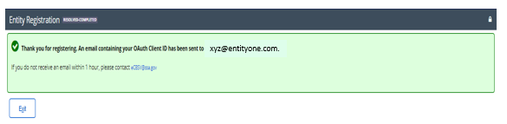

Sample Entity Registration Email
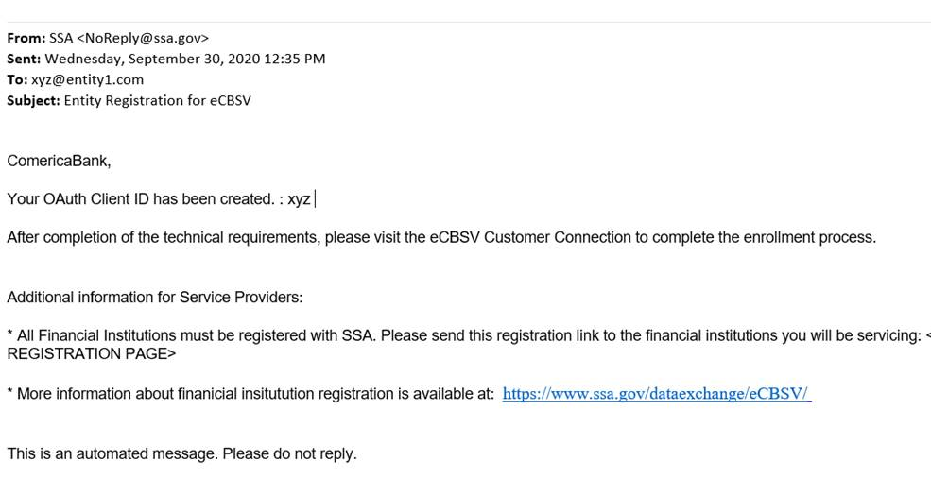
Entity 1,

Financial Institution Registration for Indirect Customers

Enter Information & EIN Consent
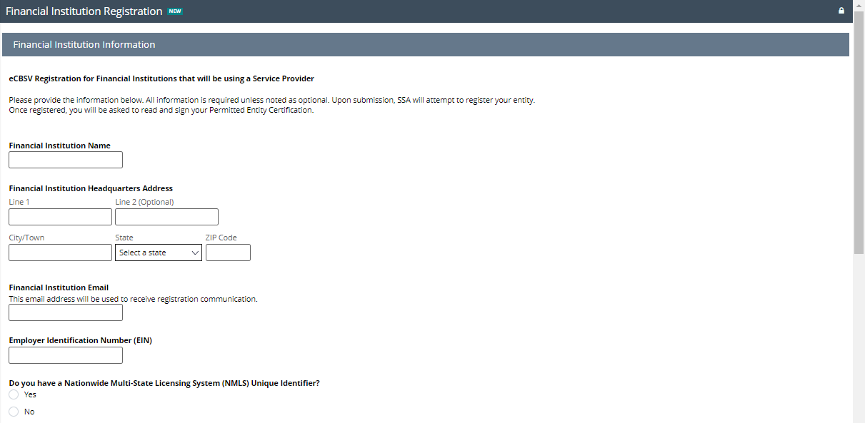
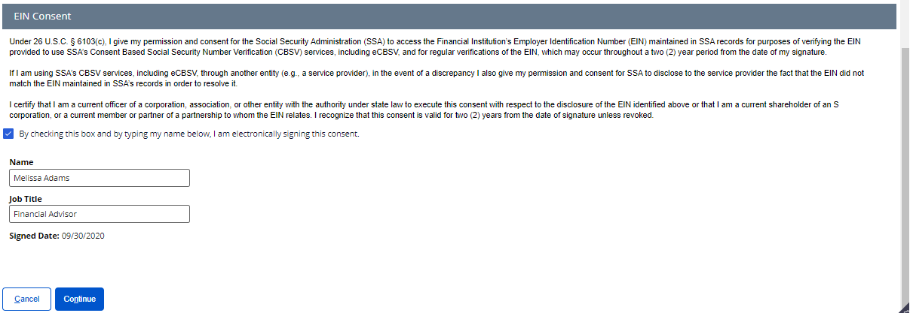

Permitted Entity Certification
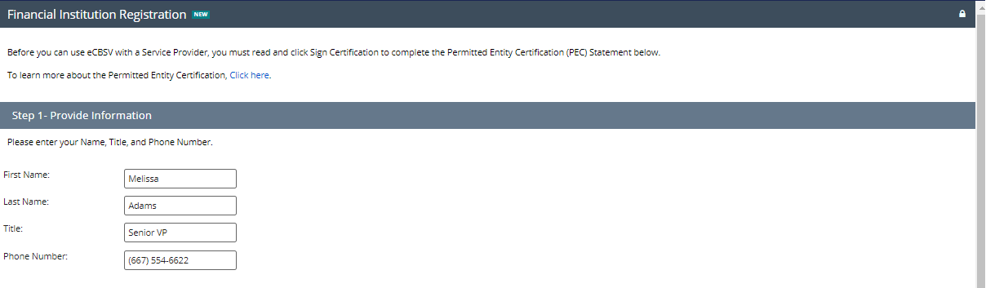
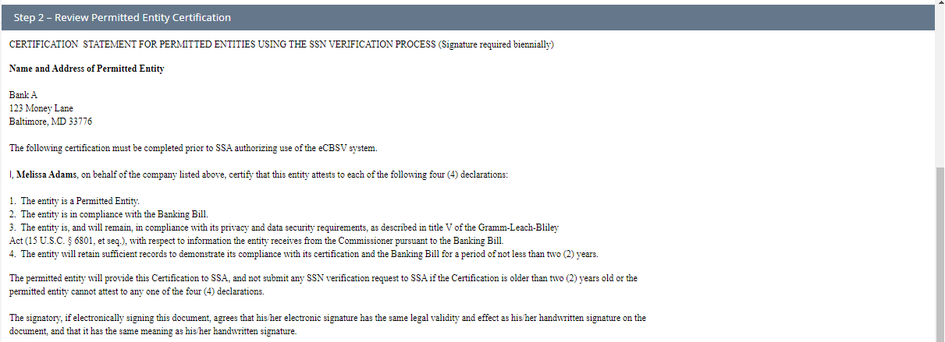
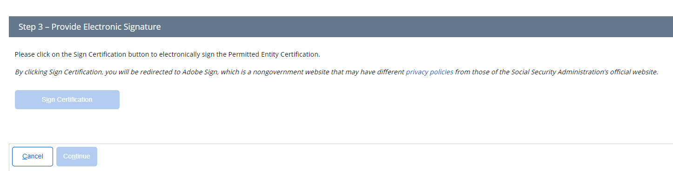

Sign Permitted Entity Certification
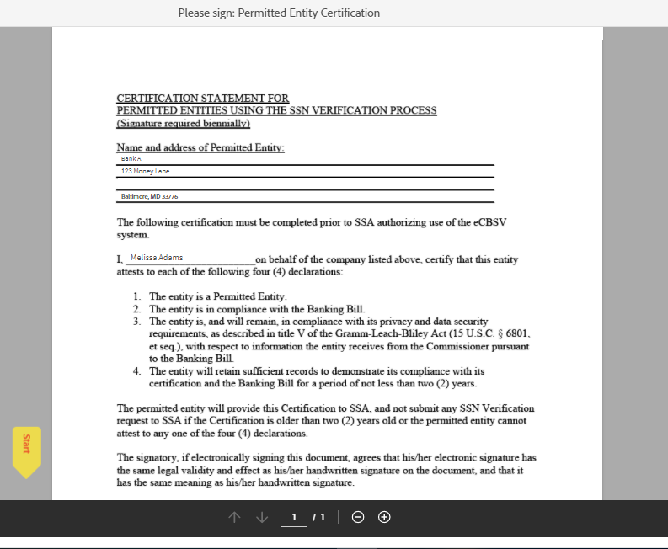
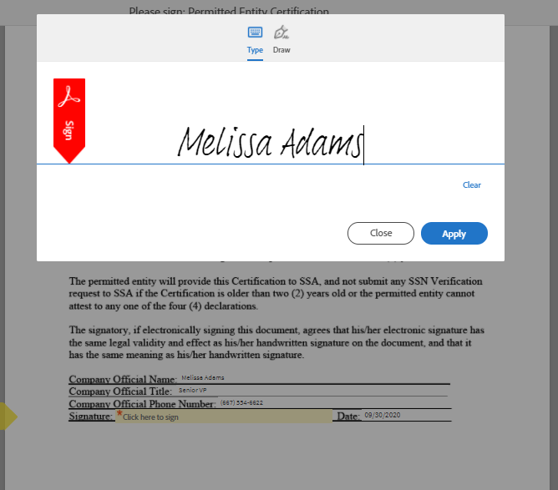
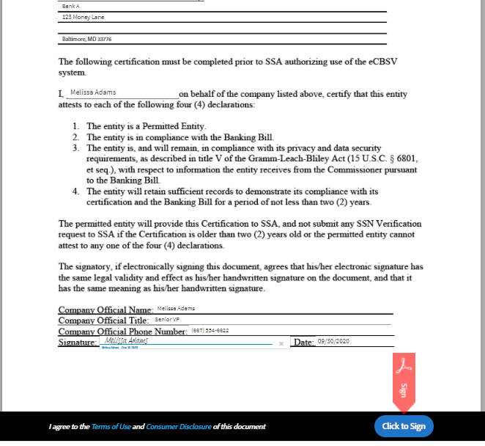
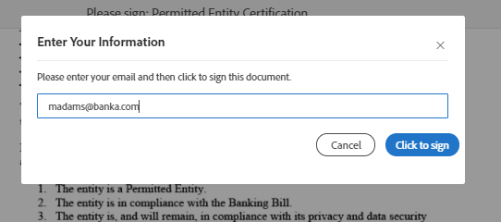

Financial Institution Success
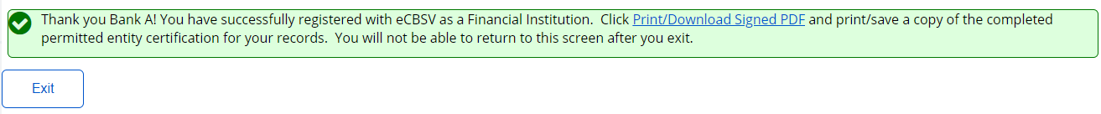

eCBSV Customer Connection Screens

Login Screen
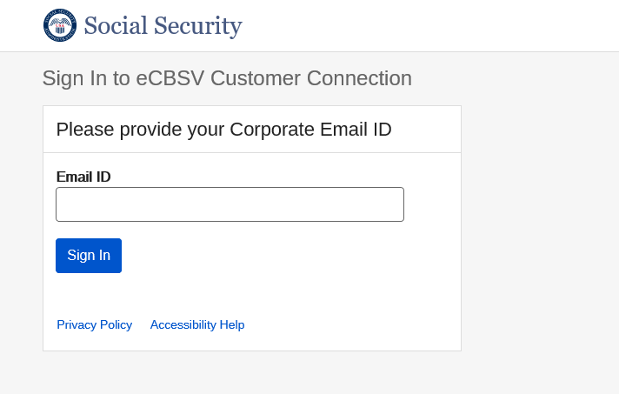

Redirected to Entity Login Screen
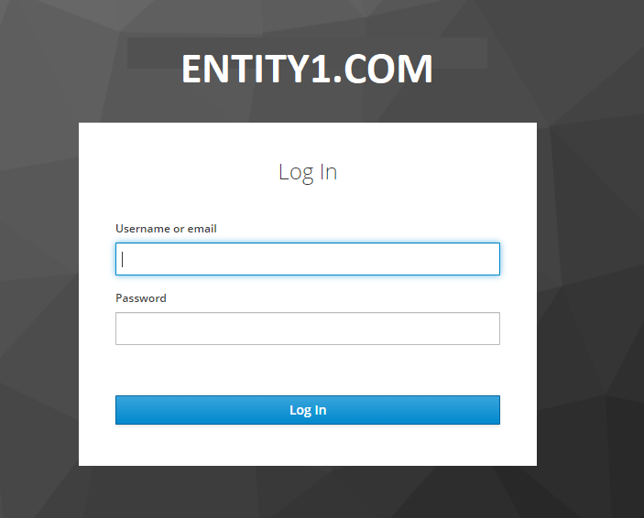

Unenrolled Home Screen
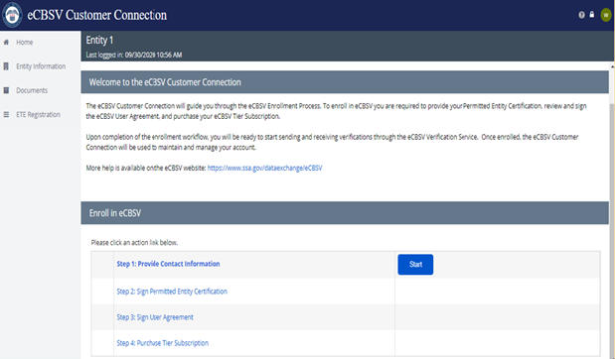

  - Contacts

    - First-Time User
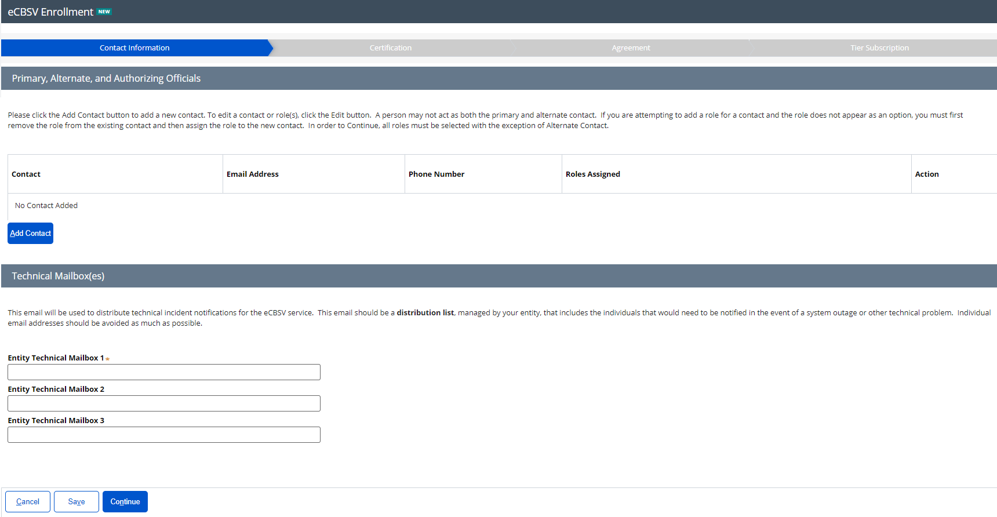

Add Contact and Assign Role(s)
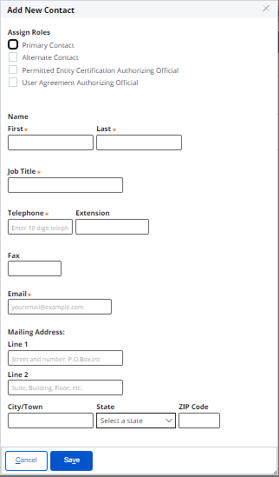
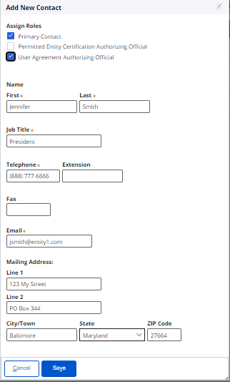

Contact Main Screen
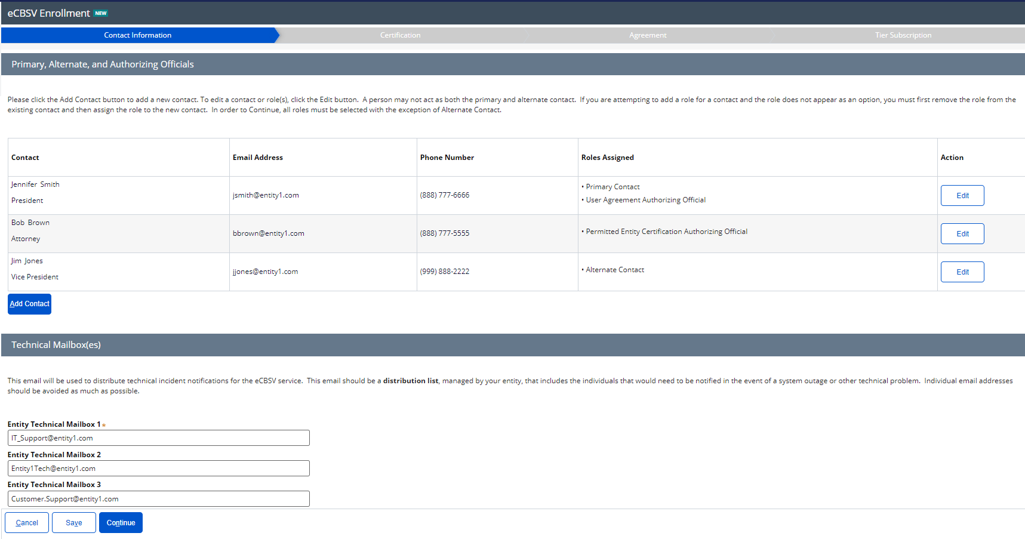

Permitted Entity Certification

Main Screen
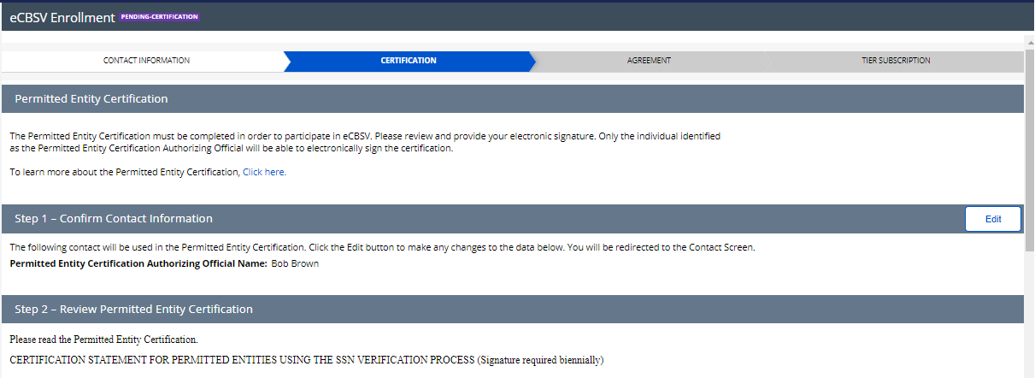
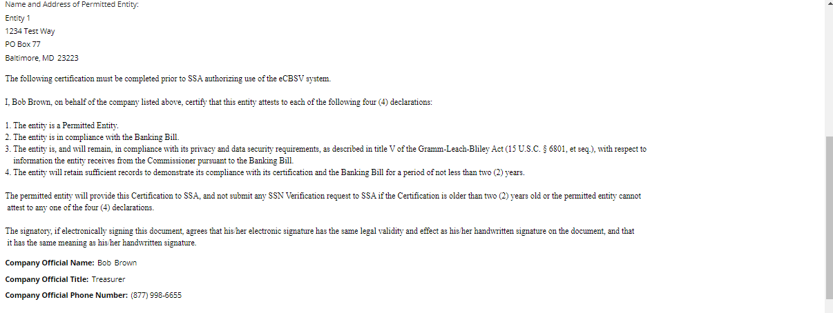

    - Sign Certification
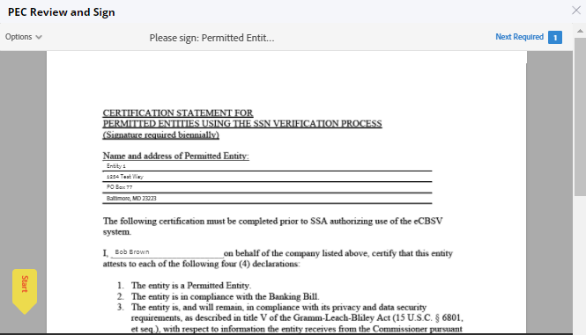
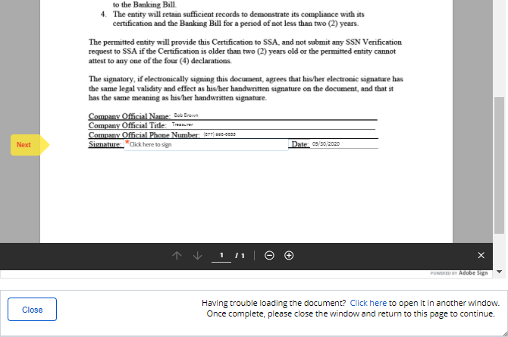
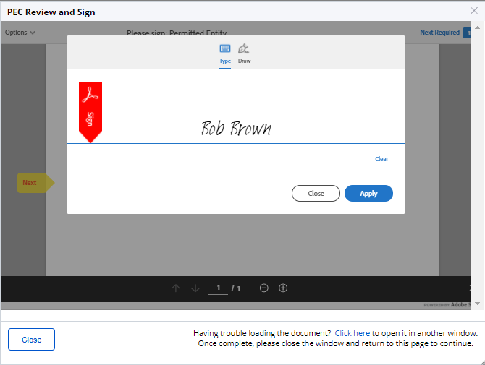
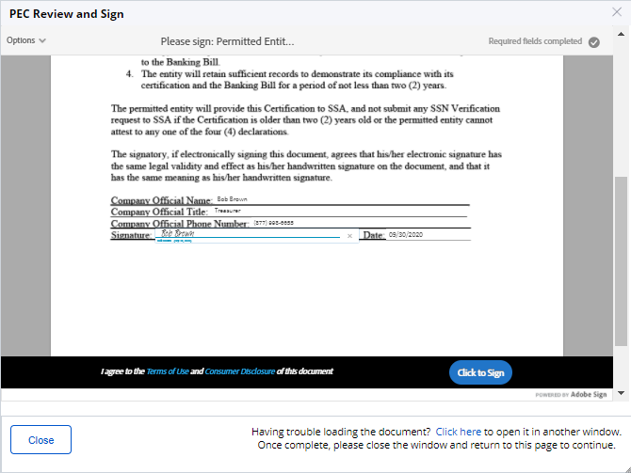
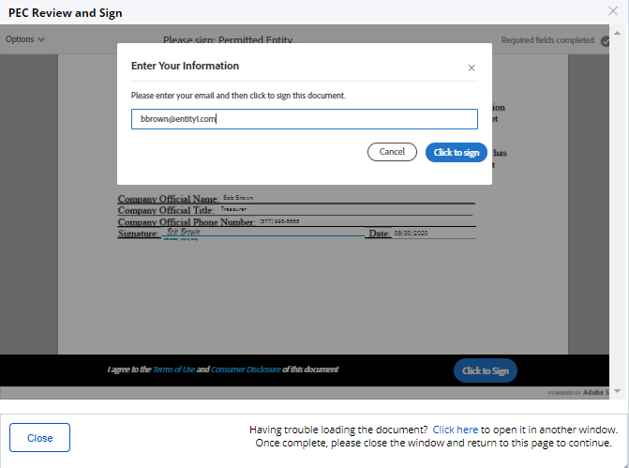

    - Main Screen After Signature
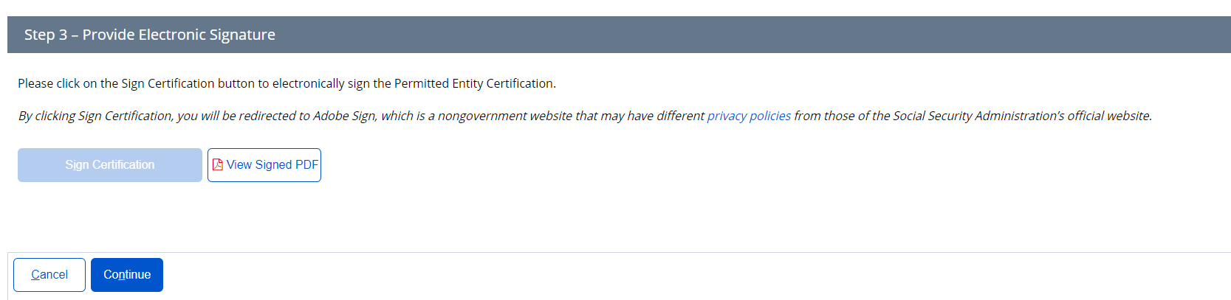

  - User Agreement

    - User Agreement Main
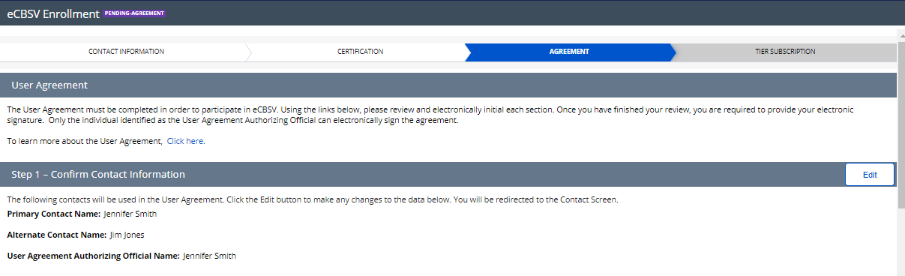
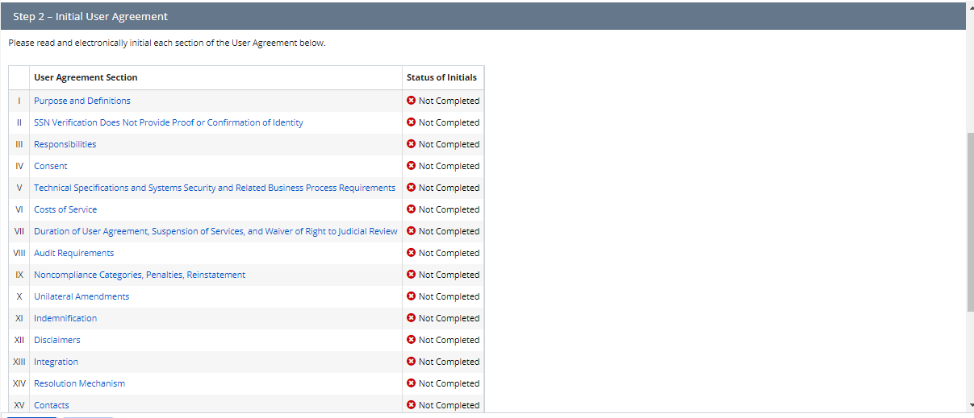
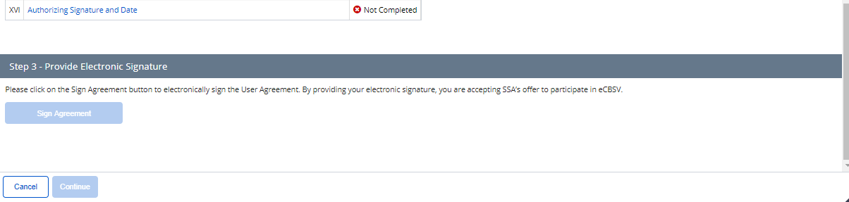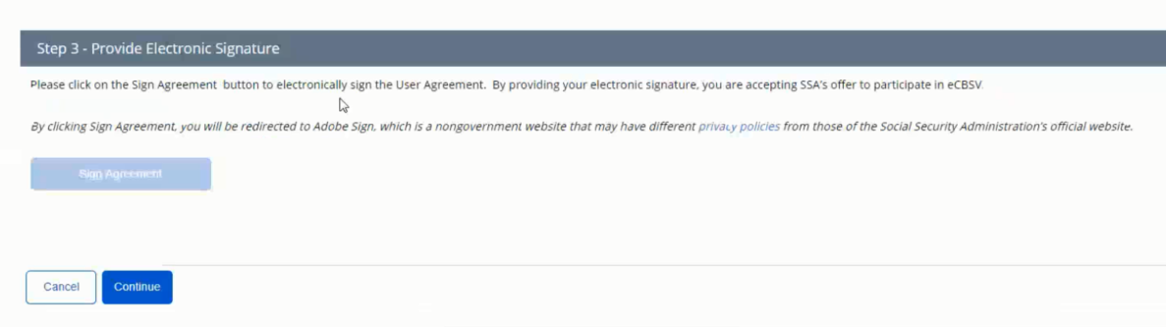

User Reads & Initials User Agreement Section(s)
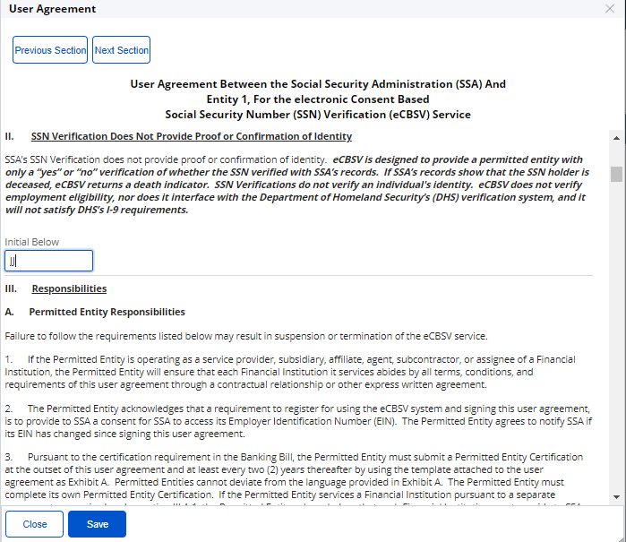
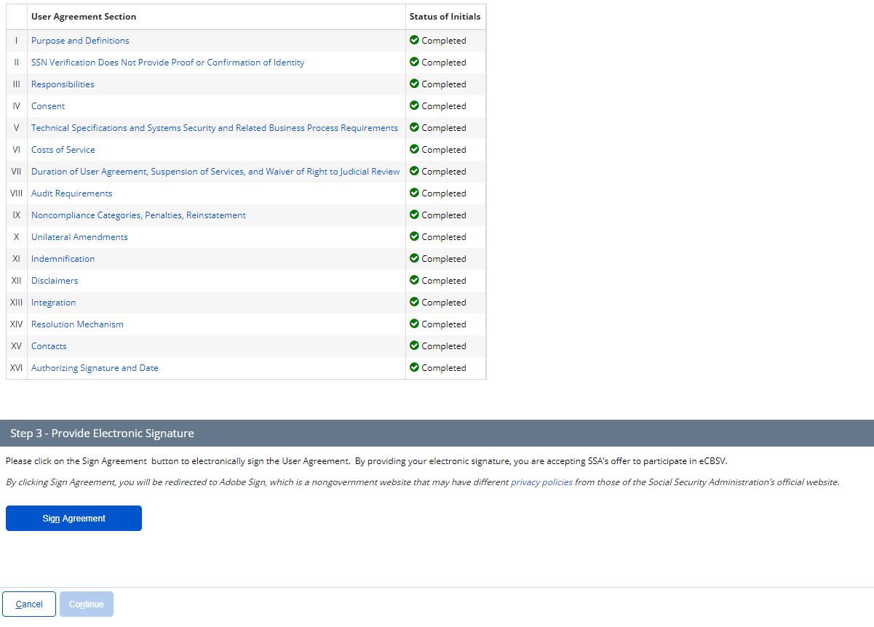
    - Sign Agreement
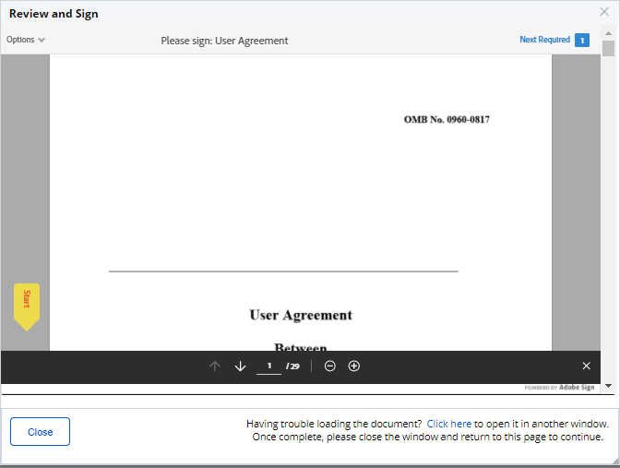
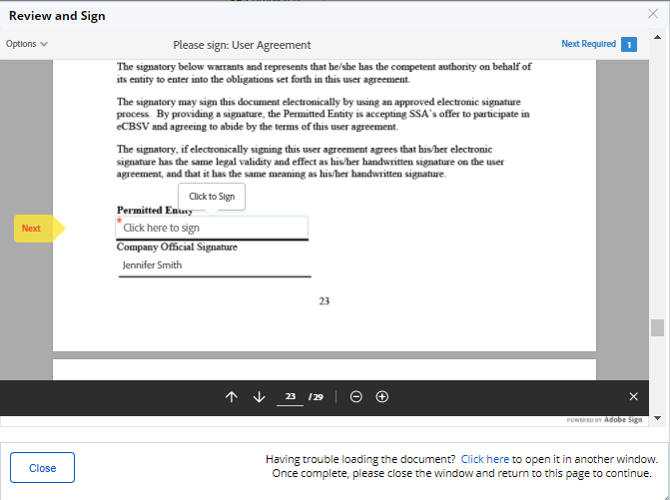
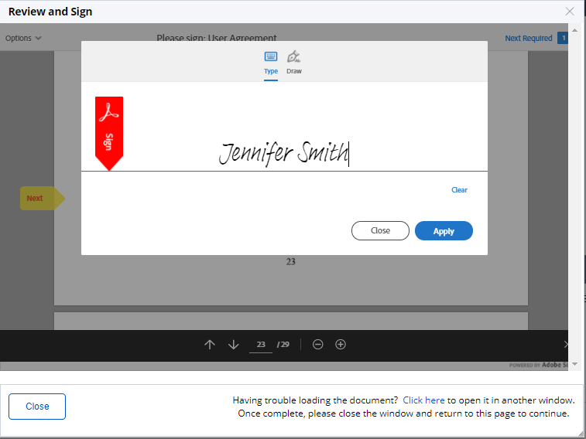
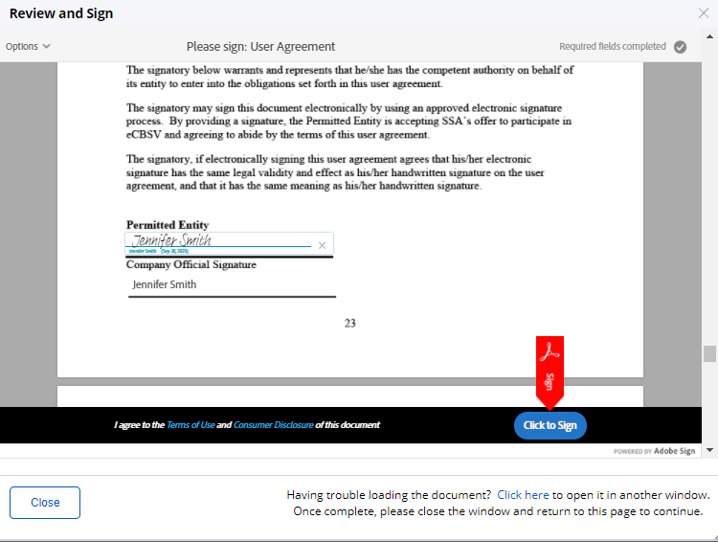
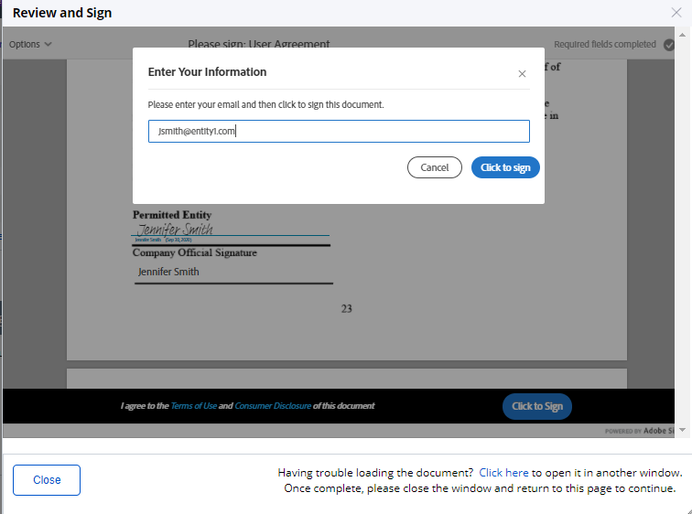

    - Main Screen After Signature
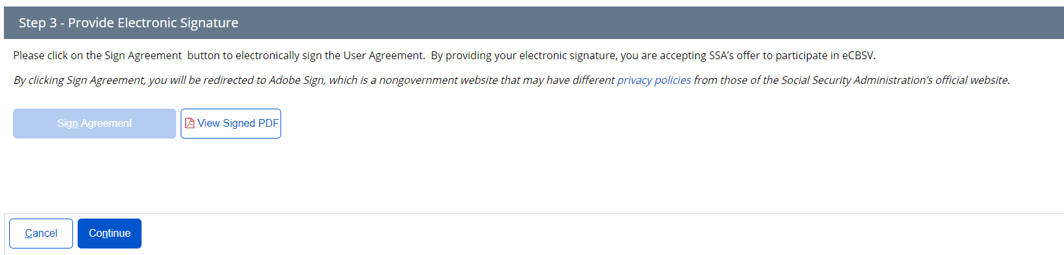

  - Tier Subscription

    - Select Tier Selection
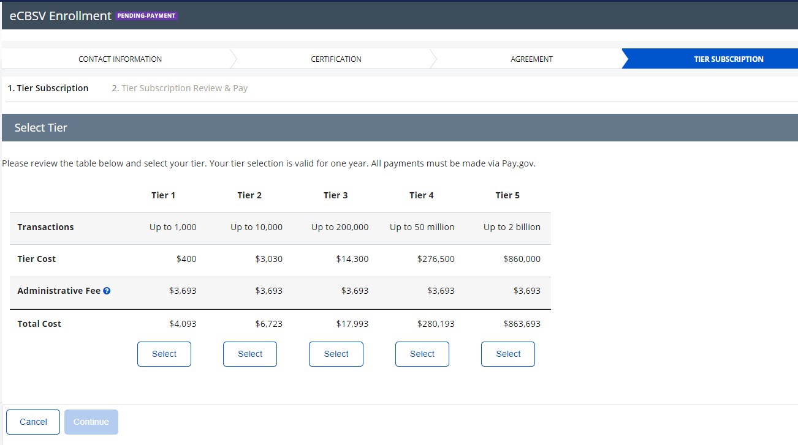
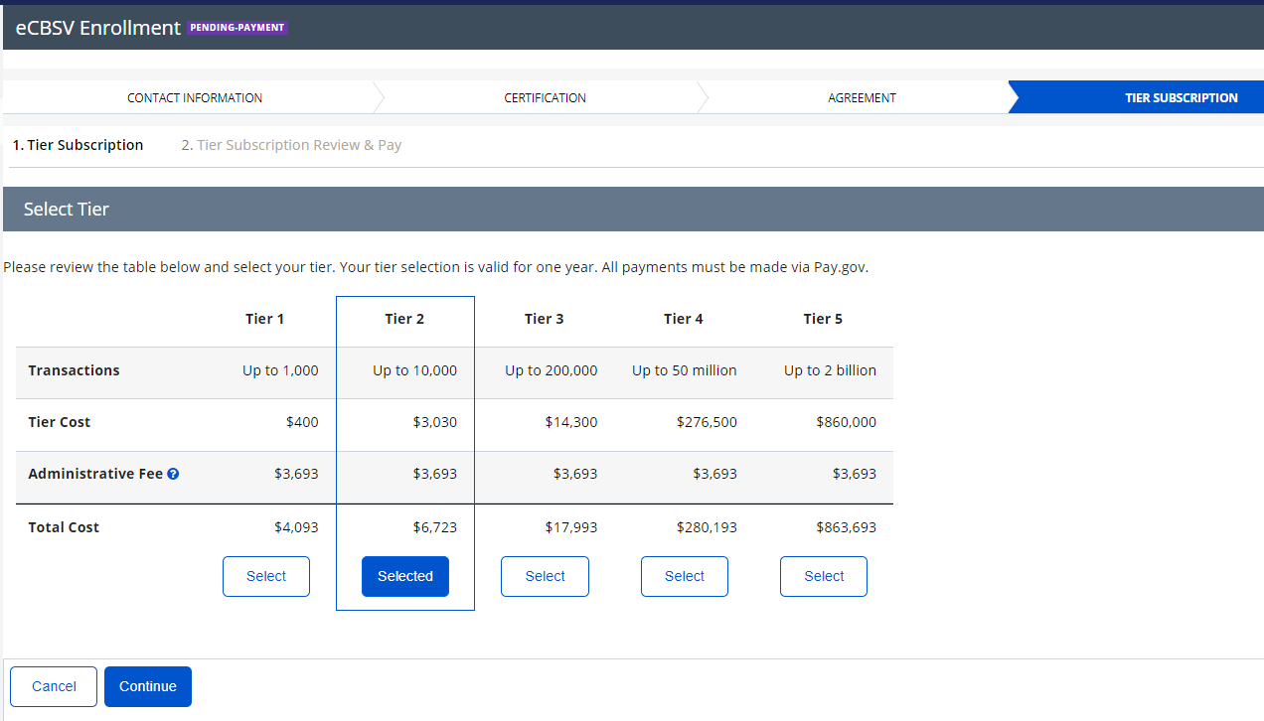

    - Tier Subscription Review & Pay
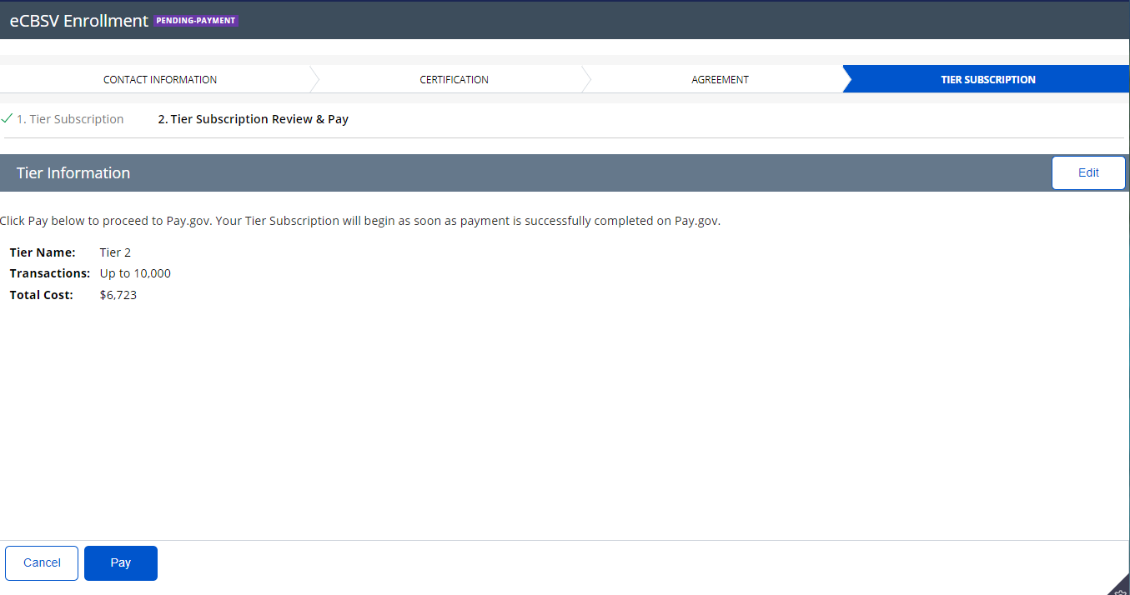

    - Pay.Gov Redirect
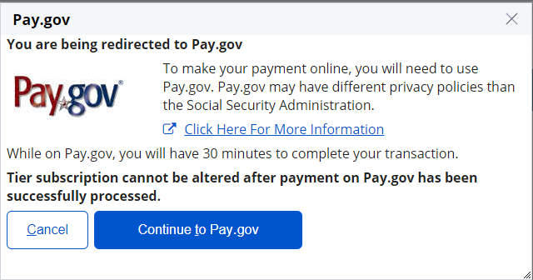

    - Pay.gov Pay Screen 1 (for payments of $24,999 or lower)

Note: Customers with payments of $25,000 and greater will not see this screen as they will be required to pay by ACH.

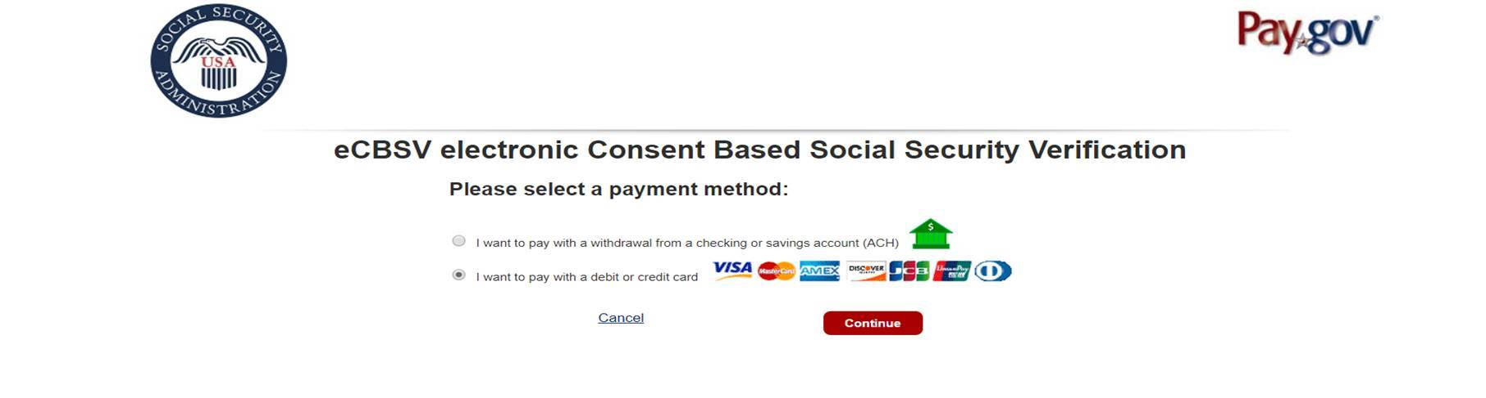

    - Pay.gov Pay Screen 2 (Checking or Savings Account (ACH))
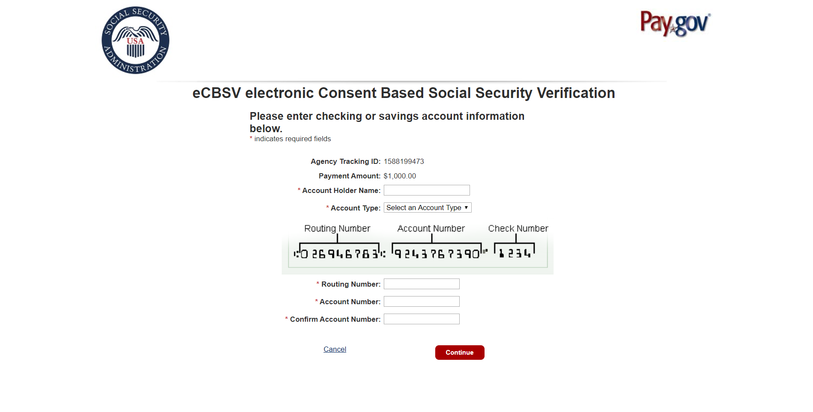

    - Pay.gov Pay Screen 3 (Credit or Debit Card)
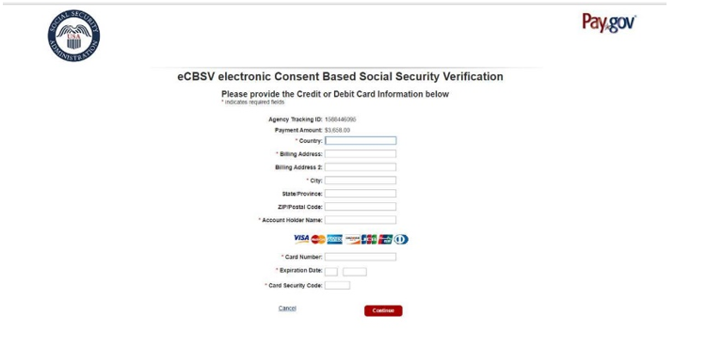

    - Pay.gov Pay Screen 4 (Review and Submit Payment)
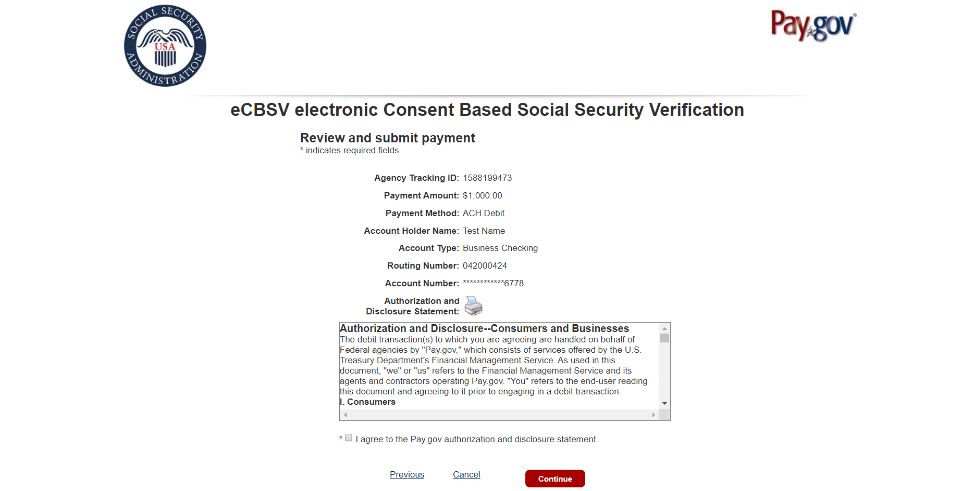

  - Start Exchanging

    - Payment Confirmation
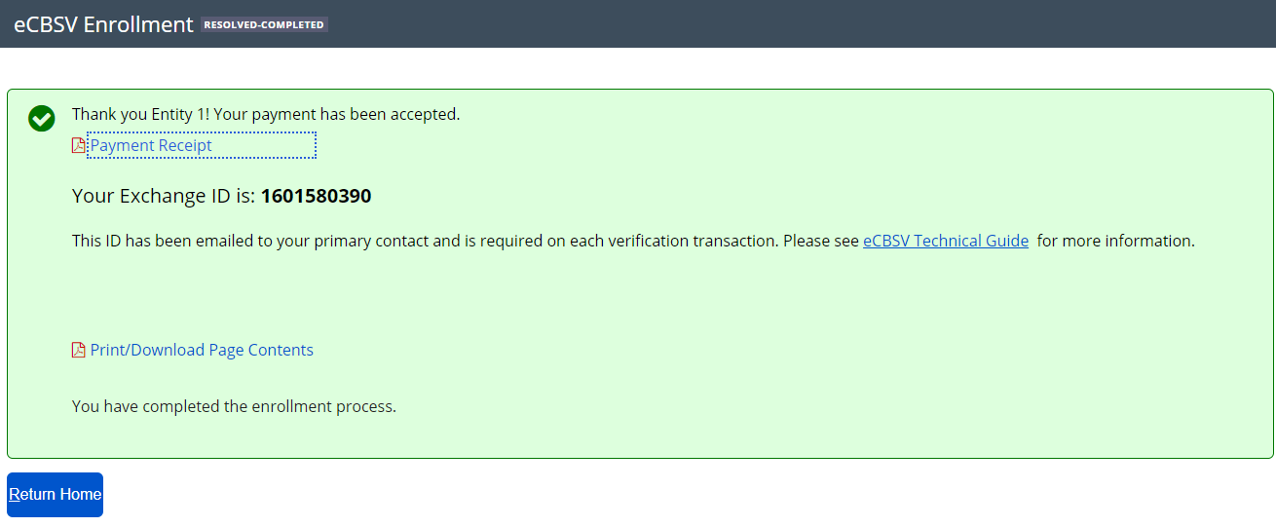

    - Print/Download Page Contents
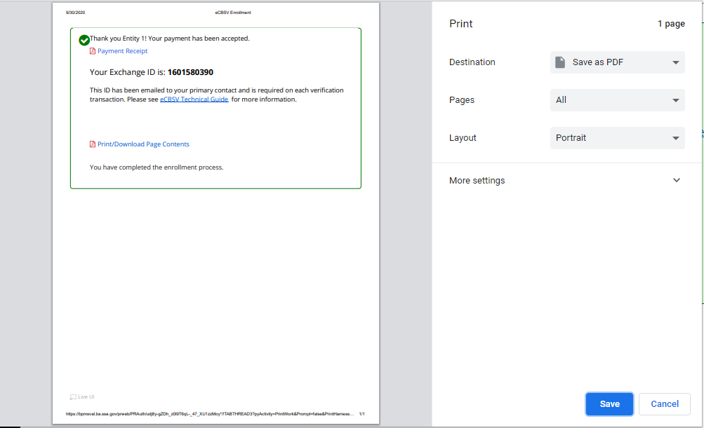

  - Payment Receipt

    - Receipt
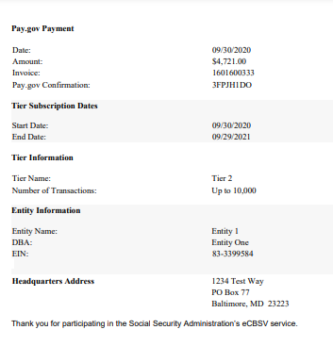

Print/Download Receipt
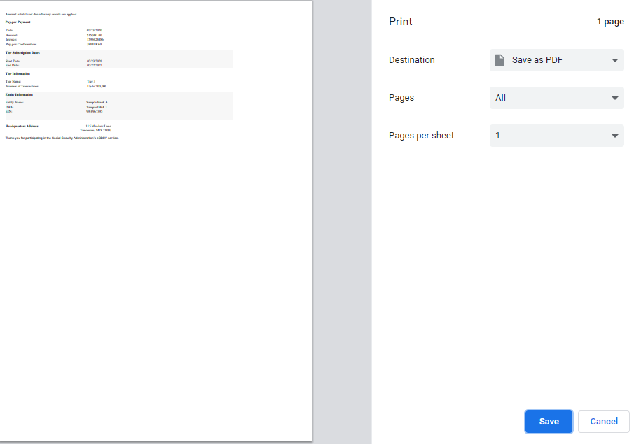

    - Sample Enrollment Email
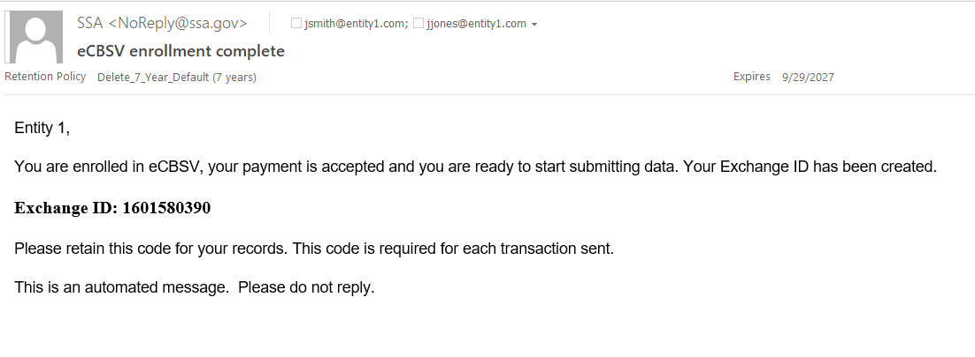

Enrolled User Home Screen
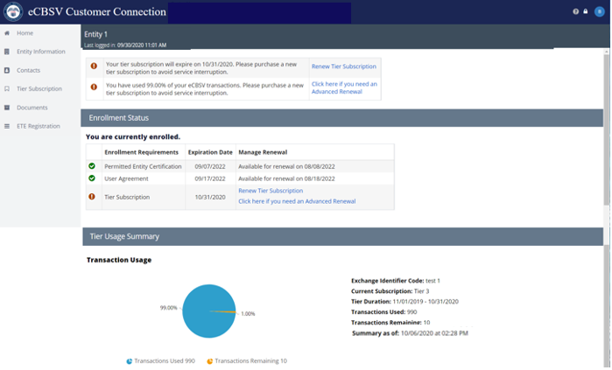

Entity Information
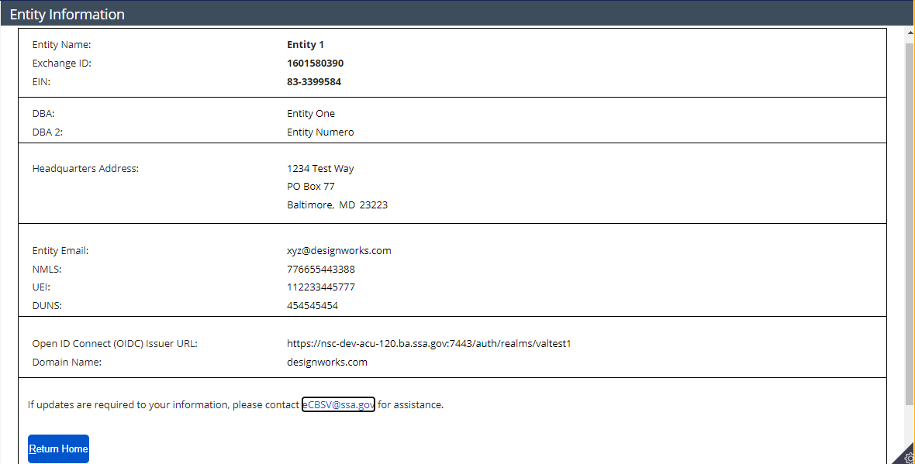

Tier Subscription Renewal

Tier Subscription Selection
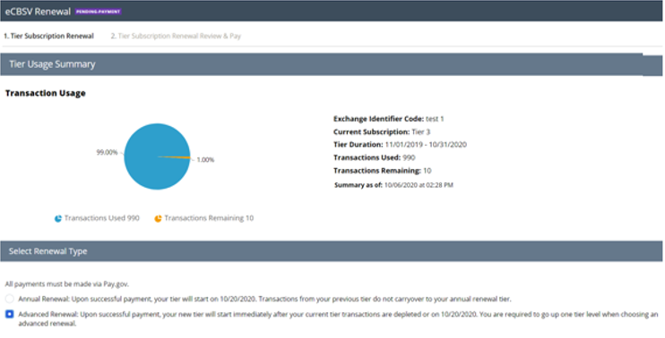
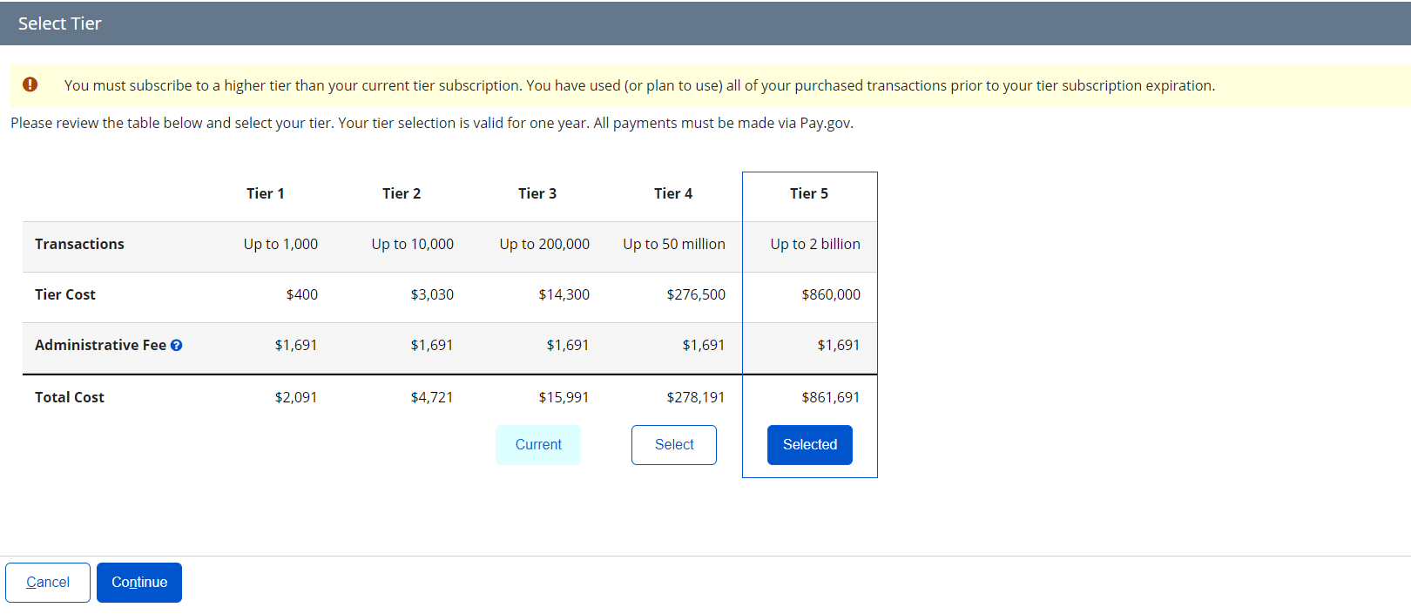

Tier Subscription Review & Pay
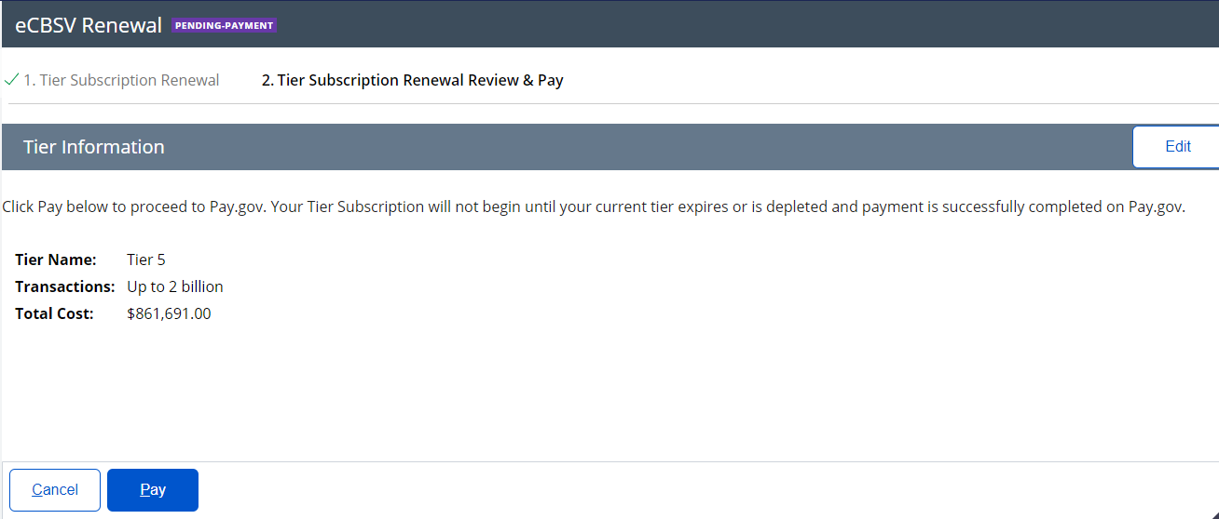

Pay.gov Redirect

Documents
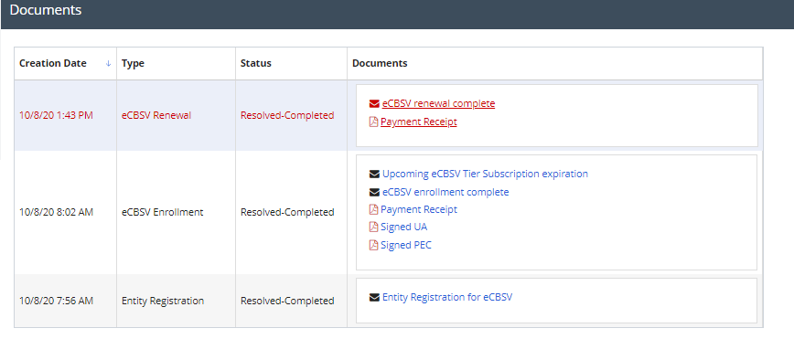


ETE Registration

Registration
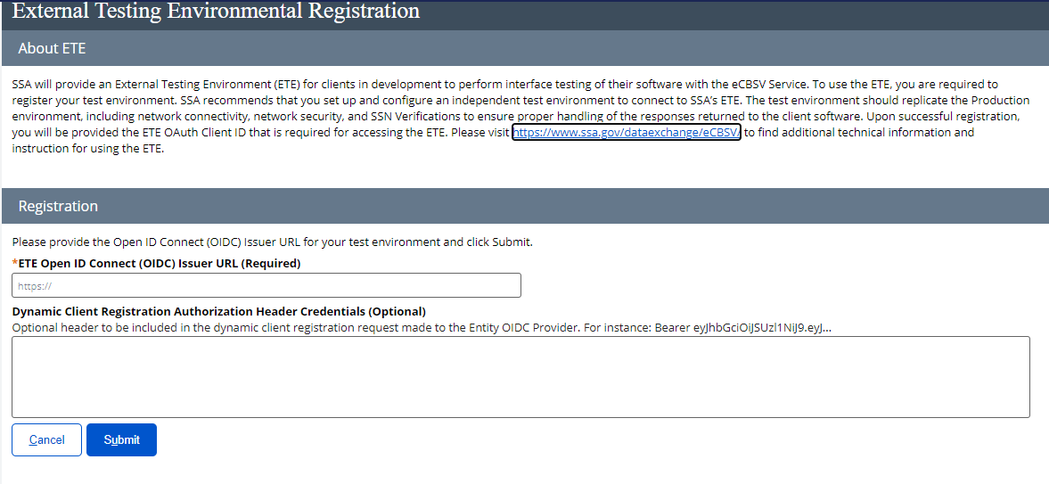

ETE Registration Success
