Table of Contents

1. How do I access AccuWage Online (AWON)? 2
2. If I already have access to upload employer wage files, do I need to request additional access? 3
3. I am having technical problems accessing my Business Services Online (BSO) account and AccuWage Online, is there someone I can call? 3
4. I am a developer and do not have an account, what are my options? 4
5. I requested additional access to view wage report submission error details and to verify Social Security Numbers (SSNVS), and am still waiting for the notice containing an activation code to be mailed to my employer. Do I need to wait to use AccuWage Online? 4
6. Does checking my file with AccuWage Online count toward my filing date requirements or considered a submission for the Internal Revenue Service (IRS)? 4
7. What types of files can I check with AccuWage Online and are there any technical restrictions? 4
8. It is taking AccuWage Online a long time to test my file. Is there anything I can do to improve the processing speed? 4
9. How do I zip my file? 5
10. Can I test multiple files concurrently using AccuWage Online? 7
11. Can I open multiple browsers to run more than one session of AccuWage Online simultaneously? 7
12. I have tested numerous files in AccuWage Online. Where are the results of my tests? 7
13. AccuWage Online found “Alert and Informational” issues; do I need to fix these? 8
14. AccuWage Online identified 500 issues (Error, Alert or Informational) and stopped testing my file. How can I test the rest of my file for other issues? 8
15. AccuWage Online identified issues (Critical, Error, and Alert or Informational) in my file, how do I view the specific issues? 8
16. I need to submit a wage file for a prior tax year; can I still use AccuWage Online? 8
17. Can I still download the AccuWage Downloadable through SSA? 8
18. Can I still use a previously downloaded version of AccuWage? 9

How do I access AccuWage Online (AWON)?

- Log on to your Business Services Online (BSO) account.

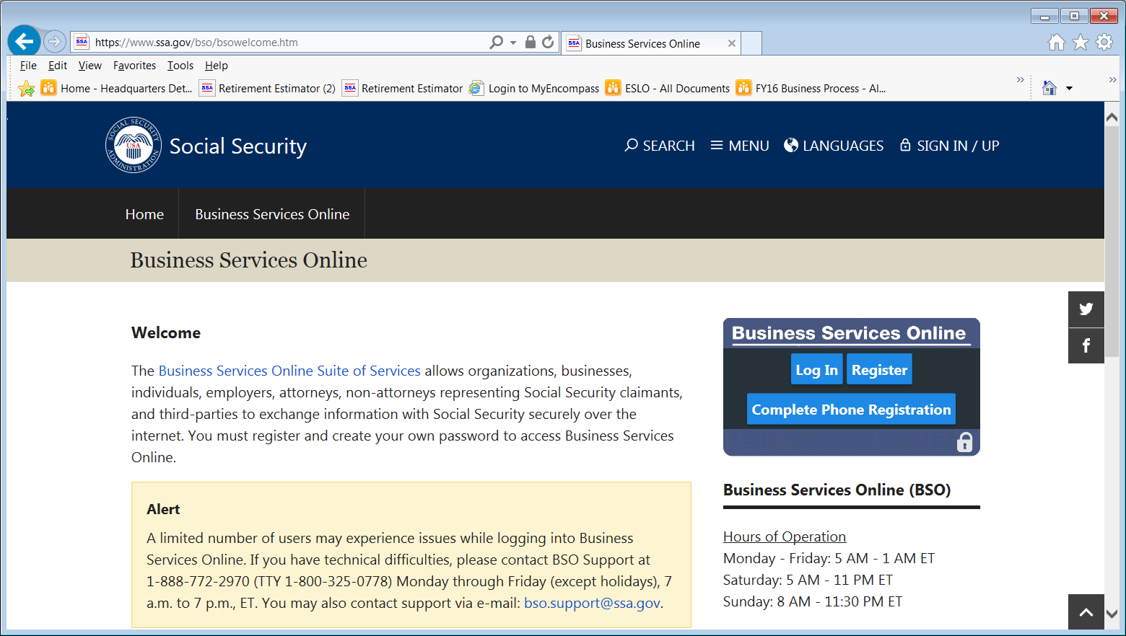
Business Services Online Log In

- Select the ‘Report Wages To Social Security’ Link

Report Wages to Social Security

- AccuWage Online is the fourth tab on the Employer Wage Reporting (EWR) Home Page. Select the fourth tab and then, select the AccuWage Online link to access the AccuWage Online Home page.

AccuWage Online Tab
AccuWage Online Link

If I already have access to upload employer wage files, do I need to request additional access?

No, AccuWage Online is available to everyone who has a Business Services Online (BSO) account and has requested the “Report Wages to Social Security” service role. Click here for more information about Business Services Online (BSO)

I am having technical problems accessing my Business Services Online (BSO) account and AccuWage Online, is there someone I can call?

Please review the information and links on the Business Services Online and AccuWage Online information pages. If you continue to experience technical difficulties, call 1-888-772-2970 for assistance or contact support via email at bso.support@ssa.gov . For general wage reporting assistance, call 1-800-772-6270 or contact support via email at employerinfo@ssa.gov . Support is available Monday through Friday (except holidays) 7 a.m. to 7 p.m. Eastern Time.

I am a developer and do not have an account, what are my options?

You can create a Business Services Online (BSO) account and use AccuWage Online even if you do not intend to submit wages. Click here for more information about AccuWage.

I requested additional access to view wage report submission error details and to verify Social Security Numbers (SSNVS), and am still waiting for the notice containing an activation code to be mailed to my employer. Do I need to wait to use AccuWage Online?

No, AccuWage Online does not require you to wait for the activation code and can be accessed immediately.

Does checking my file with AccuWage Online count toward my filing date requirements or considered a submission for the Internal Revenue Service (IRS)?

No, the use of AccuWage Online is not considered a wage submission in any way. It is only a tool to help screen for common format errors to avoid submission rejections and data accuracy problems. You will still need to submit your file to SSA by accessing the “Report Wages to Social Security” option within Business Services Online (BSO).

What types of files can I check with AccuWage Online and are there any technical restrictions?

AccuWage Online tests wage files for format accuracy. Files must be submitted in “text format” and adhere to the Electronic Filing W-2 (EFW2) and Electronic Filing W-2 Correction (EFW2C) guidelines. Additionally, we strongly encourage you to zip your file for efficiency when using AccuWage Online. For technical specifications, please visit the Specifications for Filing Forms W2 and W2C (EFW2/ EFW2C) page

It is taking AccuWage Online a long time to test my file. Is there anything I can do to improve the processing speed?

Yes, your testing experience will take considerably less time if you zip your file. SSA strongly recommends that all wage report submitters zip their files before testing them through AccuWage Online.

How do I zip my file?

- Right click on the text file you wish to zip, place the pointer over WinZip and click Add to Zip file….

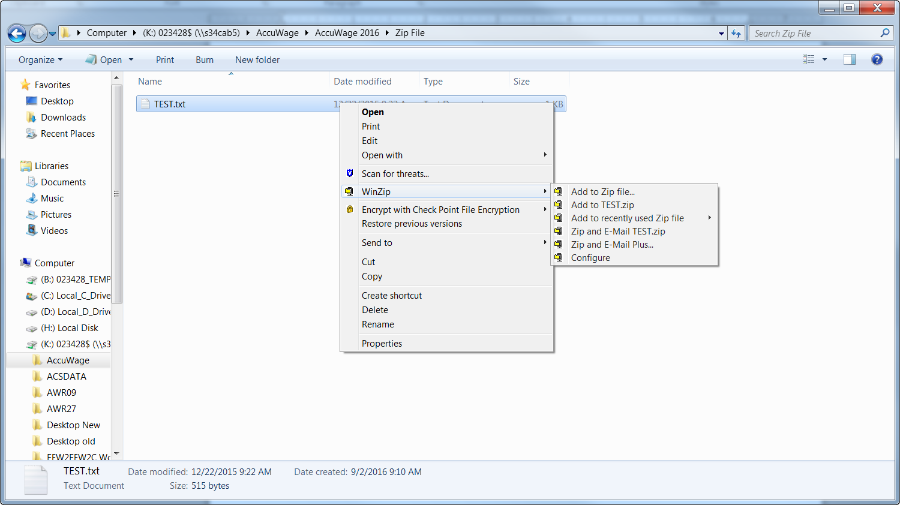
Add to Zip file…
WinZip

- Click the Add button on the pop up box

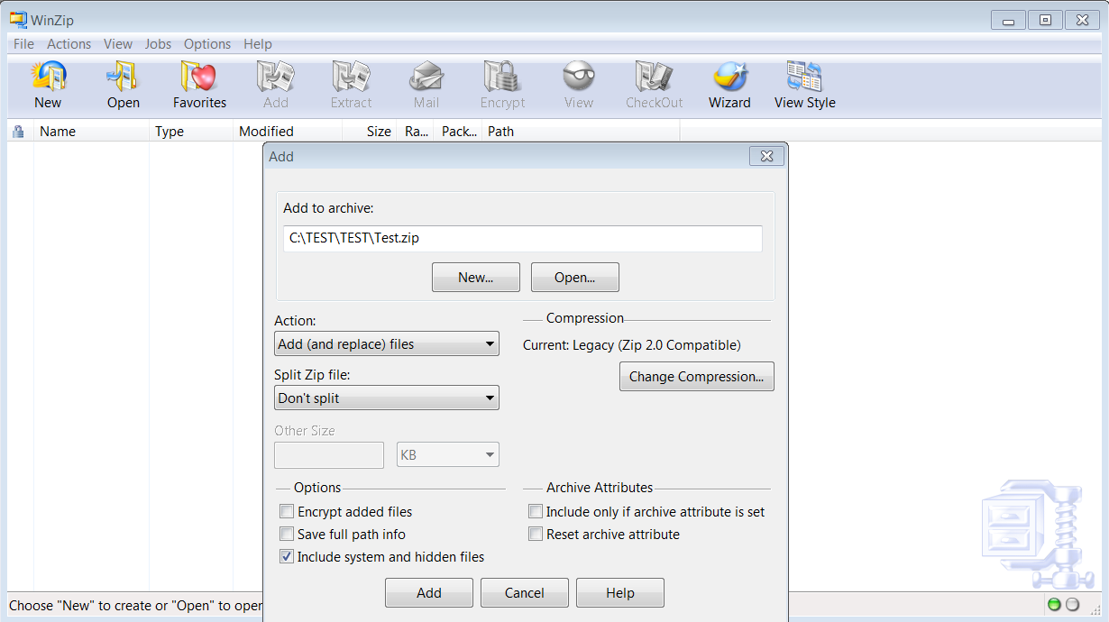
Add Button

- Click OK in the Add Complete pop Up box

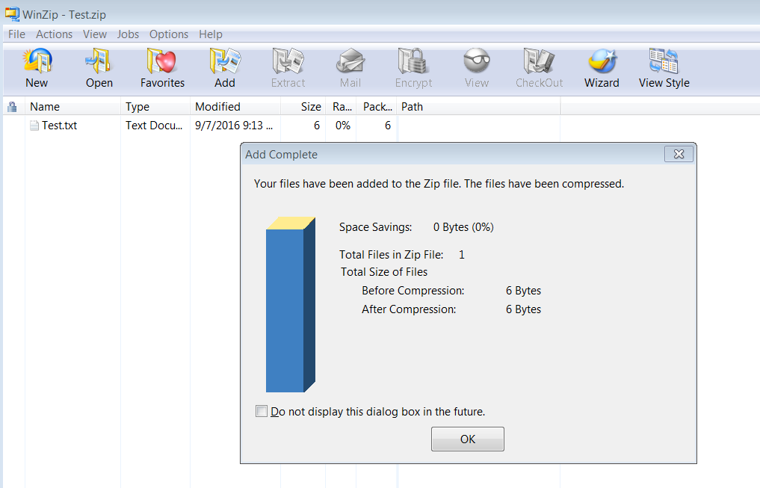
OK Button

- Exit the WinZip box by selecting the X in the top right hand corner.

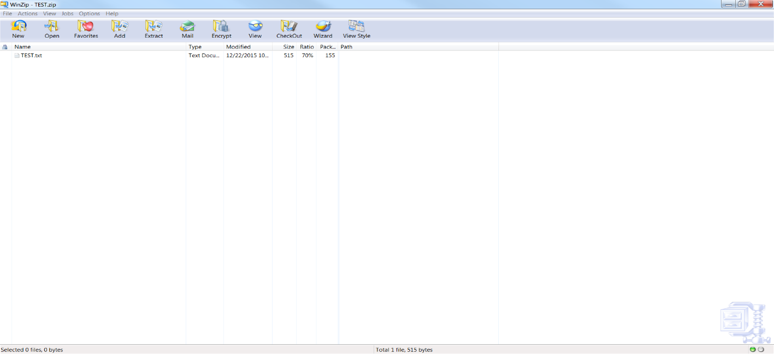
Exit out of WinZip

- The new zip file will appear next to your original text file.

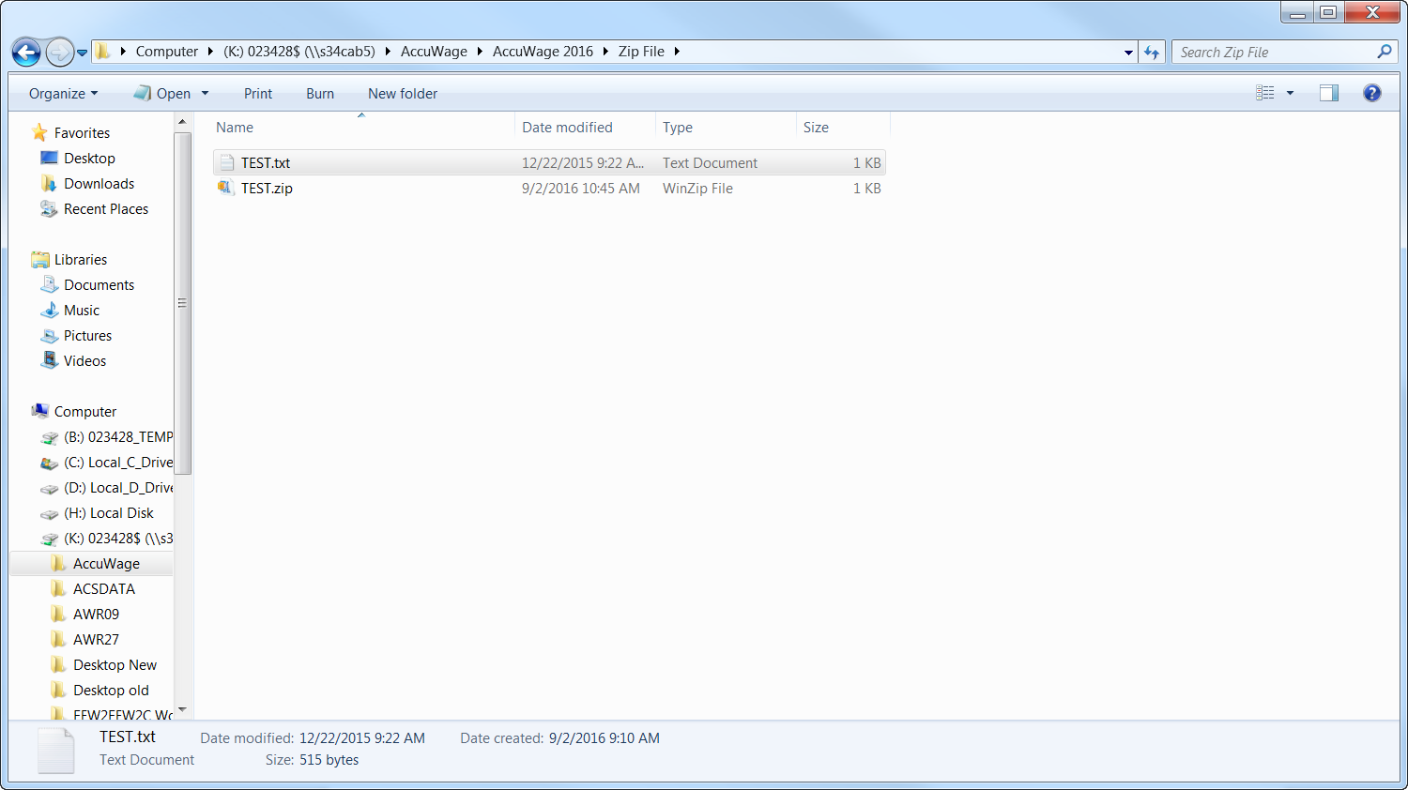
Zipped File

Can I test multiple files concurrently using AccuWage Online?

No, AccuWage Online tests one file at a time. You cannot submit another file until validation of the previously submitted file is complete.

Can I open multiple browsers to run more than one session of AccuWage Online simultaneously?

SSA does not recommend running multiple sessions of AccuWage Online concurrently. AccuWage Online restricts you to one upload at a time, regardless of the number of browsers/sessions running. Running multiple browsers/ sessions of AccuWage Online could potentially obstruct testing results.

I have tested numerous files in AccuWage Online. Where are the results of my tests?

The test results displayed are of the most recently tested file. Results of previously tested files are not saved or accessible once another file is tested or the user exits the browser, application or BSO

AccuWage Online found “Alert and Informational” issues; do I need to fix these?

All issues should be reviewed and corrected. “Alert and Informational” issues will not prevent the file from being able to be submitted to SSA, however, your submission could be returned because of other errors.

AccuWage Online identified 500 issues (Error, Alert or Informational) and stopped testing my file. How can I test the rest of my file for other issues?

AccuWage Online stops testing a file when 500 issues (Error, Alert or Informational) have been identified. The ‘Test Results’ page will display an error message stating the maximum number of issues were encountered. Review and correct the issues summarized on the Test Results page, and then re-run the file.

AccuWage Online identified issues (Critical, Error, and Alert or Informational) in my file, how do I view the specific issues?

AccuWage Online offers two methods to view the four types of issues (Critical, Error, Alert, and Informational), the ‘Test Results’ page and the ‘Test Report’ page.

The ‘Test Results’ page is an interactive web view that has two main sections containing information. The ‘Records’ section provides (or top section) the option to filter records by issue type and displays information for filtered records in a grid showing the records with the issues. Click on a row you would like more information about, and the ‘Issue(s) for Selected Record #’ section (or bottom section) will display detailed information about each error found in that row.

The ‘Test Report’ page can be saved to your computer, printed, or viewed from the screen and lists all the errors and alerts in an expanded view based on each row of data in the file that contained an issue.

I need to submit a wage file for a prior tax year; can I still use AccuWage Online?

Yes, you can use AccuWage Online to test ANY year of your wage file.

Can I still download the AccuWage Downloadable through SSA?
No, effective 9/23/17, the AccuWage Downloadable is no longer available due to the download compatibility issues many users experience. SSA recommends using the AccuWage Online application to test your wage files for compatibility withEFW2/EFW2C specifications before submitting to SSA. Click here to get started using the AccuWage Online application.

Can I still use a previously downloaded version of AccuWage?
SSA no longer supports the downloadable versions. If you use a previous version, it will not have current tax year edits. We advise you to use AccuWage Online.

