This the Social Security Administration Logo


Electronic Wage Reporting System

**AccuWage Online 2017**

**Help Guide**

*For Official Use Only*

09/23/2017

**Table of Contents**

1. Introduction 4

2. Acceptable File Extensions 4

3. Zipped Files 4

4. Sessions 6

5. Wage Report Criteria 6

6. AccuWage User Profile 6

7. Using AccuWage Online with Assistive Devices 6

8. Browser Recommendations 6

9. Starting the Application 7

10. AccuWage Online Home Page 8

11. Test Results Page 9

12. Starting the Test 10

13. File Upload 12

14. Validation in Progress 13

15. Completed Tests 14

16. Keyboard Shortcuts 16

17. Return to EWR Home Acknowledgement 17

18. View/Print HTML Test Report 17

18.1 Print the HTML Test Report 19

18.2 Saving the HTML Test Report 20

19. Correcting Issues 20

19.1 Suggested Steps for Correcting Issues Caused by Missing or Incorrect Data 20

19.2 Suggested Steps for Correcting Critical Issues 20

20. Exiting AccuWage Online 20

21. System Error 21

22. Troubleshooting 21

23. Glossary of Terms 22

List of Figures

Figure 1:Error Your Unzipped file is too large. 5

Figure 2: Error Your Session has timed out . 5

Figure 3: Electronic Wage Reporting (EWR) Home Page 7

Figure 4: AccuWage Online Home Page 8

Figure 5: Test Results Screen 9

Figure 6: Issue Level Descriptions 10

Figure 7: File Dialog box – Choosing the Wage Report to Test 11

Figure 8: File Upload is in Process 12

Figure 9: Validation in Progress 13

Figure 10: Completed Test- no issues found 14

Figure 11: Completed Test- Critical 14

Figure 12: Completed Test - Error, Alert or Informational 15

Figure 13: Completed Test - Maximum Number of Issues 16

Figure 14: Return to EWR Home Acknowledgement 17

Figure 15: Test Report 18

Figure 16: Test Report screen – print options 19

Figure 17: Test Failed due to an unexpected system error 21

# Introduction

AccuWage Online enables Annual Wage Report (AWR) submitters to test the accuracy of their wage reports prior to sending them to the Social Security Administration (SSA) for processing. AccuWage Online checks both W-2 and W-2C wage reports to ensure they comply with Publication 42-007: Specifications for Filing Forms W-2 Electronically (EFW2) or Publication 42-014: Specifications for Filing Forms W-2C Electronically (EFW2C). AccuWage Online generates a Test Report listing all issues found in the wage report. Wage reports cannot be edited using AccuWage Online. The submitter can create a new EFW2/EFW2C file or correct the existing EFW2/EFW2C file that generated the issues. The wage report can be repeatedly retested until all issues are corrected.

**IMPORTANT:** AccuWage Online identifies many, but not all, wage report issues. For example, AccuWage Online does not verify names and Social Security Numbers (SSNs). The likelihood of submission rejection, though not eliminated, is greatly reduced when using this application.

# Acceptable File Extensions

Wage files must be plain text **(.txt)** or plain text zipped (**.zip**) format.

AccuWage Online does **NOT** accept the following file extensions:

* .pdf,
* .bin,
* .lib,
* .exe,
* .dll,
* .jar.

If your file is in one of the formats that listed above please convert it to plain text before attempting to test it through the application. Remember to zip your file for optimal performance.

# Zipped Files

* 1. SSA strongly recommends that all wage report submitters zip their files before running them through AccuWage Online to reduce the risk of session timeout and incomplete testing. Your testing experience will take considerably less time if you zip your file. For instructions on how to zip your file, please see the [FAQ.](https://www.ssa.gov/employer/accuwage/faqAccuWageOnline.docx)
  2. If you upload a large unzipped file (more than 100MB or 100000 KB), you will receive following alert.

If you select Yes – upload and testing continues

If you select No – returns User to the AWON home page

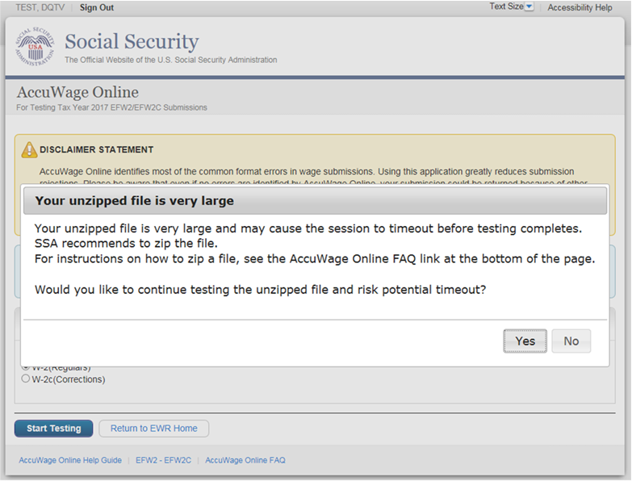

###### Figure 1:Error Your Unzipped file is too large.

If you select Yes – upload and testing continues and you will get following error if your file is large and causes time out 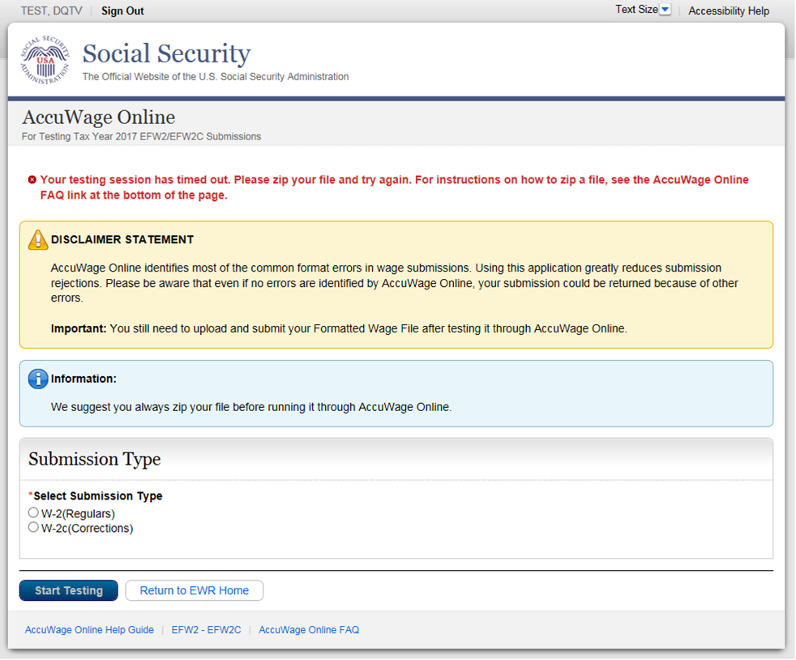

###### Figure 2: Error Your Session has timed out .

# Sessions

AccuWage Online can only test one file per session. A session occurs each time a file is tested through AccuWage Online. If AccuWage Online is already open in a browser window, opening another window with AccuWage Online will not start a new session. If the file validation is in progress on the first window, if you try to upload another file through a second window simultaneously, AccuWage Online will display an error message and disable the ‘Start Testing’ button on the second window. In order to test the second file, please wait until the first file processing is complete. We do not recommend having more than one window open on your browser with AccuWage Online at a time.

# Wage Report Criteria

Wage reports must be in the EFW2/EFW2C format. If you need assistance with this, please see <https://www.ssa.gov/employer/EFW2&EFW2C.htm>

# AccuWage User Profile

In order to use AccuWage Online to test your wage reports, you must have a valid Business Services Online (BSO) username and password with the employer services profile. For instructions on registering for a BSO username and password, please see the [FAQ](https://www.ssa.gov/employer/accuwage/faqAccuWageOnline.docx).

# Using AccuWage Online with Assistive Devices

Section 508 of the Rehabilitation Act requires Federal agencies to make their electronic and information technology accessible to people with disabilities.

SSA recommends that people using assistive devices and keyboard–only users navigate the AccuWage Online application using the keyboard shortcuts rather than command buttons.

# Browser Recommendations

SSA recommends the following browsers for optimal testing experience:

* Internet Explorer 10 or above
* Chrome
* Firefox

# Starting the Application

AccuWage Online can be accessed by logging on at Business Services Online (BSO) [**https://www.ssa.gov/employer/**](https://www.ssa.gov/employer/)and going to the Employer Wage Reporting (EWR) home page. You will need to log in with your BSO username and password. Once you are on the Employer Wage Reporting home page, AccuWage Online is the fourth tab as shown below. Select the AccuWage Online link to go to the AccuWage Online Homepage.

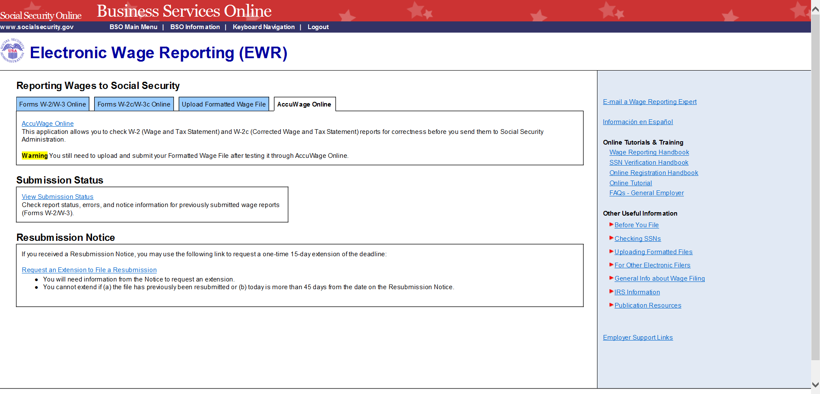

AccuWage Online

AccuWage Online Link

###### Figure 3: Electronic Wage Reporting (EWR) Home Page

# AccuWage Online Home Page

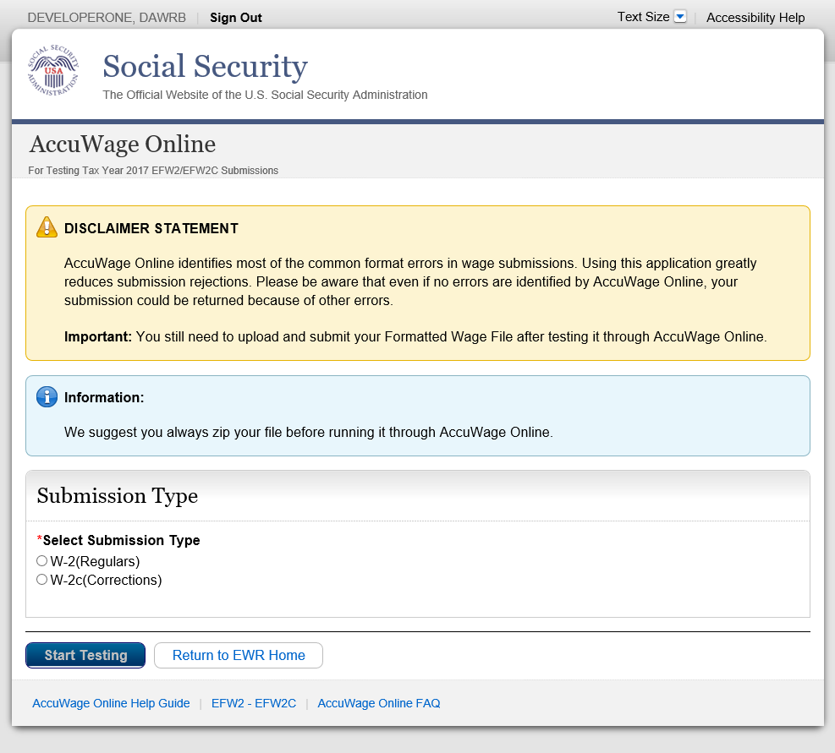

Return to EWR Home

Start Testing

Select Submission Type

###### Figure 4: AccuWage Online Home Page

AccuWage Online Help Guide

AccuWage Online FAQ

EFW2-EFW2C Specifications

**Select Submission Type:** Select the Submission Type (W-2 or W-2c) of the report you wish to test, then click the ‘Start Testing’ button in the bottom left hand corner of the application. The ‘Start Testing’ button will be disabled until the selection of Submission Type has been made.

**Return to EWR Home**: This button will take the user to an acknowledgement pop up which reminds the user they are leaving their AccuWage Online session and returning to the EWR Home page.

**AccuWage Online Help Guide**: This link will open the Microsoft Word version of the AccuWage Online Help Guide.

**EFW2-EFW2C Specifications:** This link will take the user to the EFW2-EFW2C Specifications guides.

# Test Results Page

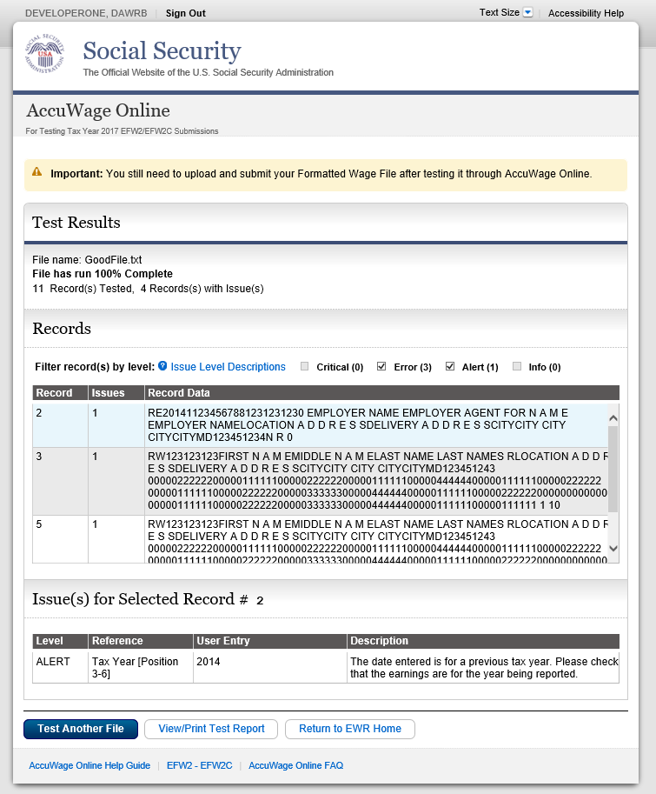

View/Print Test Report

Test Another File

Filters record(s) by level

File Status

Issue Level Descriptions

Issue(s) for Selected Record

Records

###### Figure 5: Test Results Screen

**File Status**: When the Test Results page appears, the message displaying the status of the file will also display. Most times, it will display as “File has run 100% Complete” to show that the entire file was tested. If a critical issue is found, it will display as “Testing failed due to Critical Error on Record #” to show that the file stopped processing due to a critical issue and the entire file was not tested.

**Records:** The top portion of the Test Results page will display how many records have been tested and how many of those records have issues. It contains the following columns:

* Records - displays number of record that have an issue(s)
* Issues - displays the numbers of issues in that record
* Record Data - displays the data in the record

**Issue(s) for Selected Record:** The bottom portion of the Test Results page will display the detailed information for the record selected. It contains the following columns:

* Level - displays which type of issue is present
* Reference - displays the field name
* User Entry - display the field data found on the record
* Description - displays the detailed message for the issues found

**Test Another File:** This button will return the user to the AccuWage Online Home page to test another file.

**View/Print Test Report:** The user is able to click this button and the Test Report will be displayed. The report will list all issues per record.

**Issue Level Descriptions:** This link will display a pop up that will list each issue level with its description.

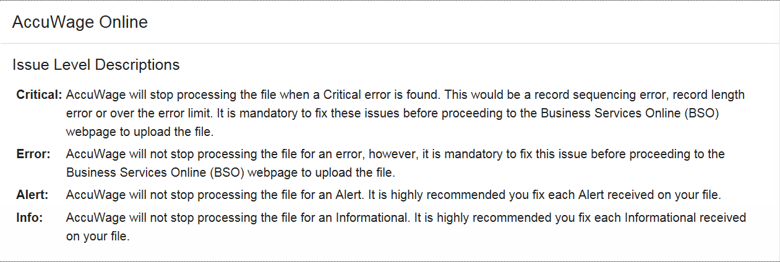

###### Figure 6: Issue Level Descriptions

**Filter record(s) by level:** There are four different issue levels a wage report may contain. After a wage report is tested, if any issues were found, the issues found will be checked along with the count of each issue level. The default filter displays all four issue levels, however, simply unchecking particular categories will remove it from the Issues for Selected Record section. It does not remove the issue from the file. The filter shows all issues for the entire wage report, not by record. For record-level information, select the particular record under the ‘Record Data’ column for which you would like to see more detail.

# Starting the Test

1. Select either W-2 (Regulars) or W-2C (Corrections) depending on which type of wage report is being tested.
2. Clickthe ‘Start Testing’ button in the lower left hand corner of the Home page.
3. The ‘Choose File to Upload’ dialog box will appear.
4. Select the location where the wage report is stored.
5. Locate the folder/directory where the wage report is stored.
6. Double click the wage report when it appears.
7. Click the ‘Open’ button or double-click the file name to open the wage report.

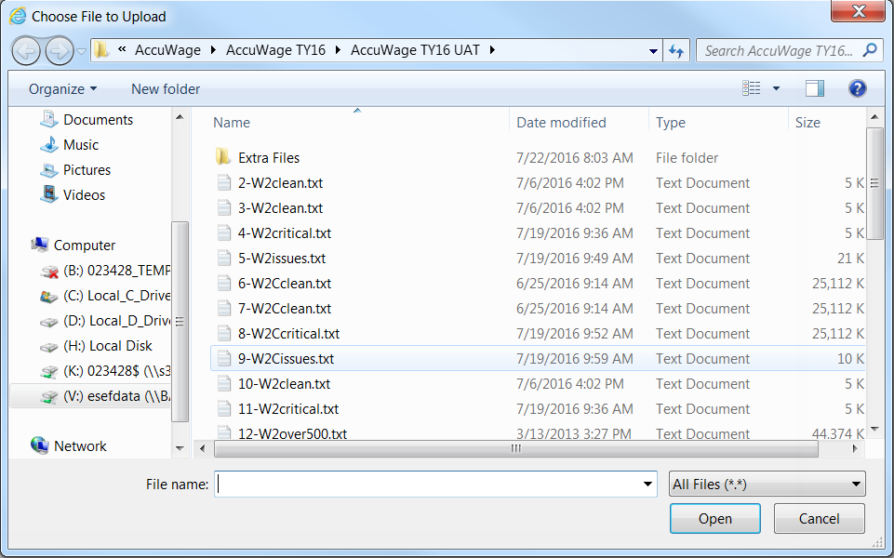

###### Figure 7: File Dialog box – Choosing the Wage Report to Test

# File Upload

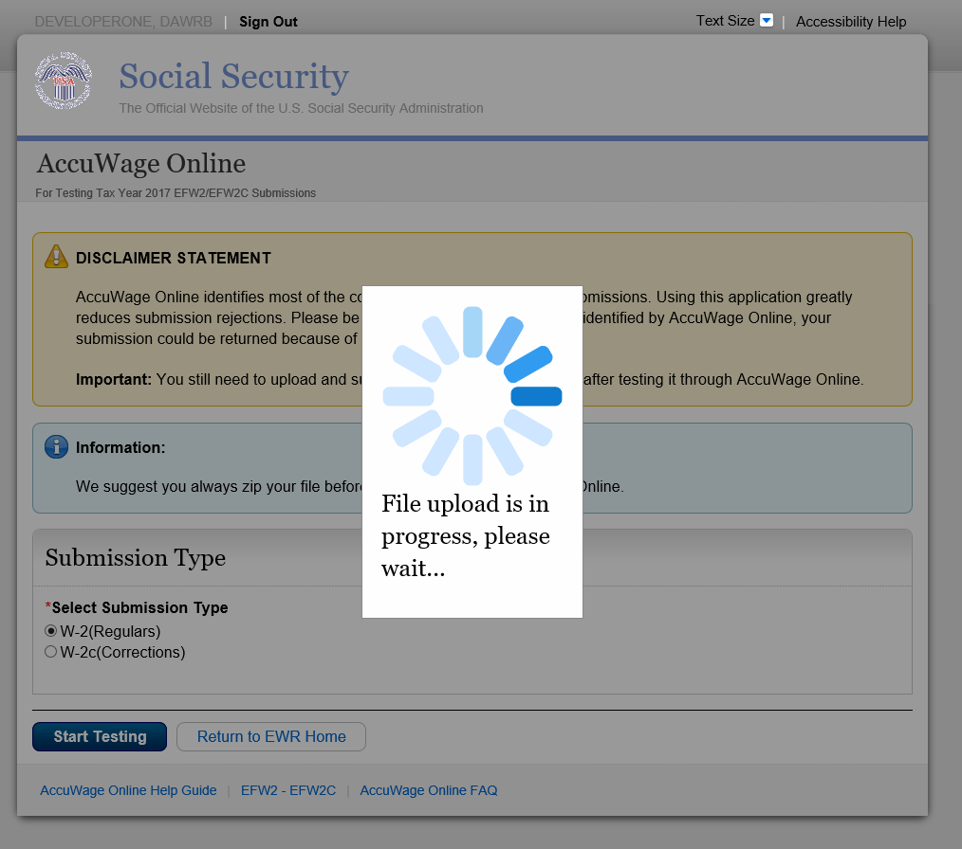

###### Figure 8: File Upload is in Process

After the wage report has been selected in the ‘Choose File to Upload’ dialog box, the wage report will be uploaded to AccuWage Online for testing.

# Validation in Progress

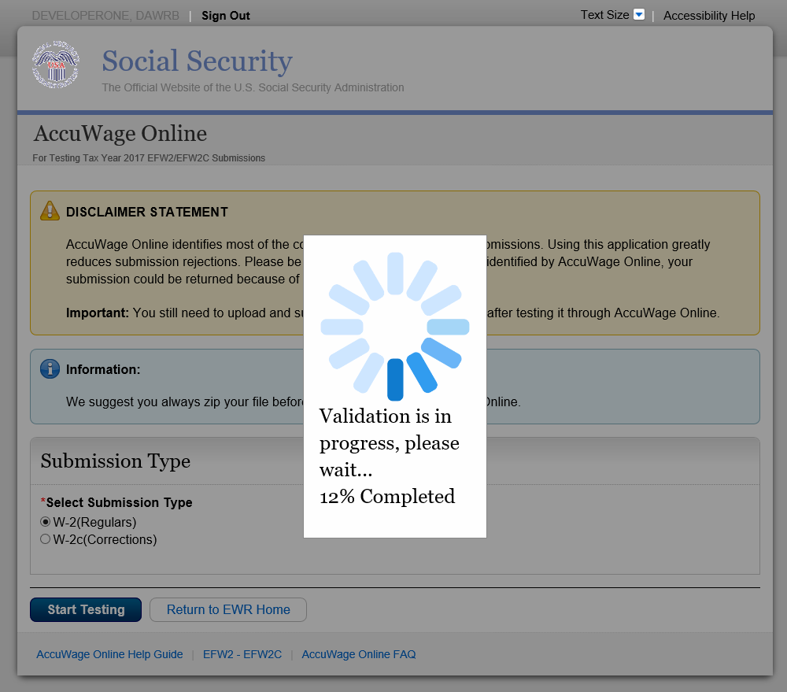

###### Figure 9: Validation in Progress

After the wage report has been uploaded to AccuWage Online, the application will begin validating the wage report. The percent validated will display as shown above.

# Completed Tests

15.1 If the submitted wage report is 100% correct, the Test Report page will display stating there were no issues found.

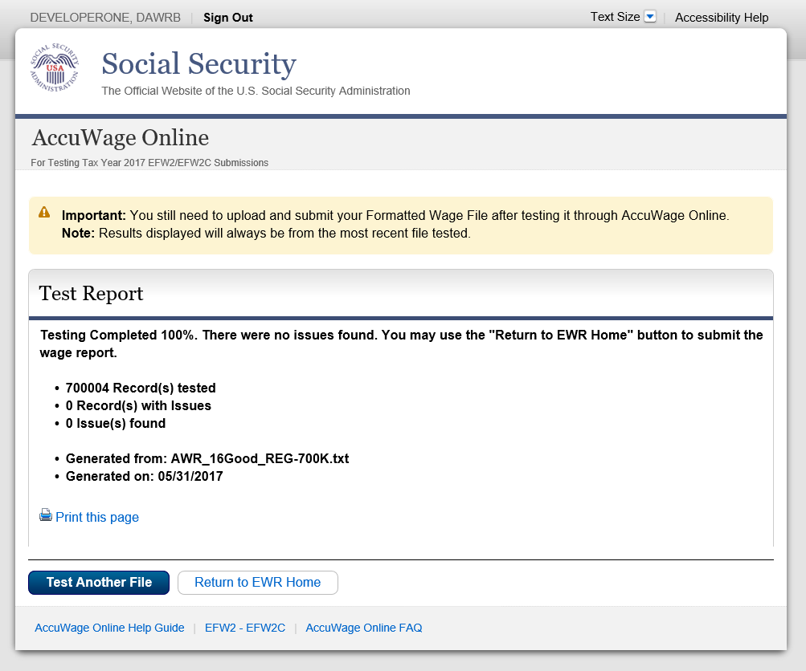

###### Figure 10: Completed Test- no issues found

15.2 If the submitted wage report contains a critical issue, the Test Results page will display stating testing stopped due to a critical error.

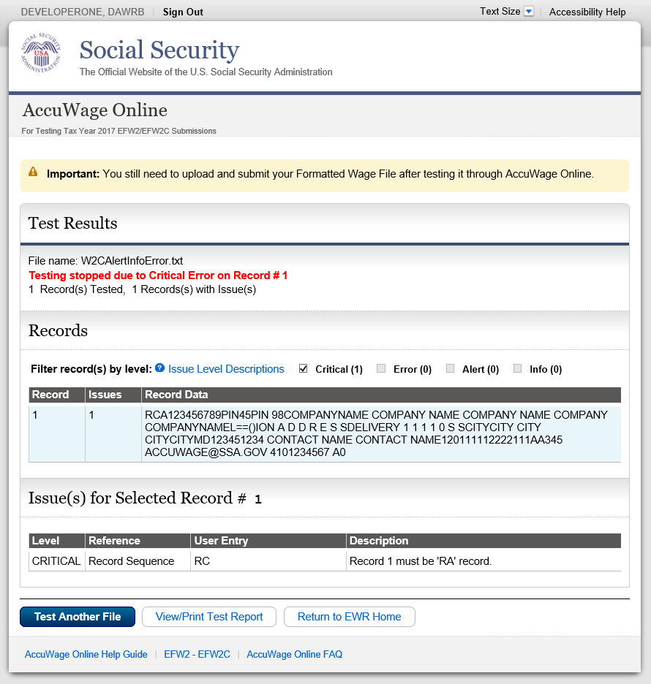

###### Figure 11: Completed Test- Critical

15.3 If the submitted wage report contains any other issue levels (Error, Alert or Informational), the Test Results page will display stating testing was 100% complete.

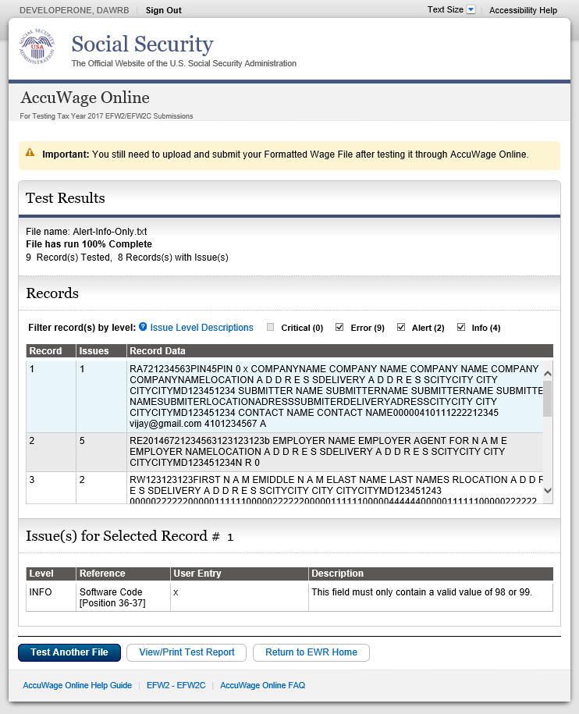

###### Figure 12: Completed Test - Error, Alert or Informational

15.4 If the submitted report contains over 500 total issues (Error, Alert or Informational), the Test Results page will display stating the maximum number of issues were encountered. AccuWage Online stops testing the wage report when 500 issues have been found. Please fix the issues and re-run the wage report.



###### Figure 13: Completed Test - Maximum Number of Issues

# Keyboard Shortcuts

Below is a list of the keyboard shortcuts per browser:

|  |  |  |  |
| --- | --- | --- | --- |
| **Control** | **Internet Explorer** | **FireFox** | **Chrome** |
| W-2 (Regulars) Radio Button | ALT + W | ALT + SHIFT + W | ALT +  W |
| W-2C (Corrections) Radio Button | ALT + C | ALT + SHIFT + C | ALT + C |
| Start Testing | ALT + N | ALT + SHIFT + N | ALT + N |
| Test Another File | ALT + L | ALT + SHIFT + L | ALT + L |
| View Tested Results | ALT + R | ALT + SHIFT + R | ALT + R |
| View/Print Test Report | ALT + P | ALT + SHIFT + P | ALT + P |
| Return to EWR | ALT + U | ALT + SHIFT + U | ALT + U |
| OK | ALT + O | ALT + SHIFT + O | ALT + O |
| Cancel | ALT + C | ALT + SHIFT + C | ALT + C |

# Return to EWR Home Acknowledgement

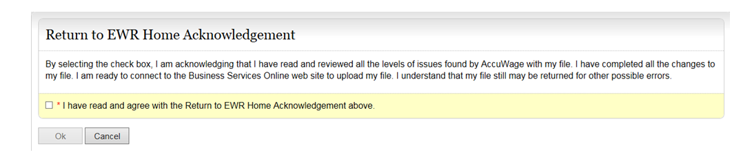

###### Figure 14: Return to EWR Home Acknowledgement

The user must check the “I Agree” box before the “OK” button is enabled. This message acknowledges that the user has reviewed all the levels of issues found by AccuWage Online and they have completed all changes to their wage report. The user is ready to connect to the Business Services Online website to upload their wage report.

# View/Print HTML Test Report

The Test Report can be viewed, printed or saved. The Test Report includes:

* File Status message
* Number of records tested
* Number of records with issues
* Total number of issues found
* Name and path of wage report file being tested
* Date test was performed
* Record number
* Issue number
* Level
* Name of field containing errors (Reference)
* Data in field containing errors (User Entry)
* Complete error description

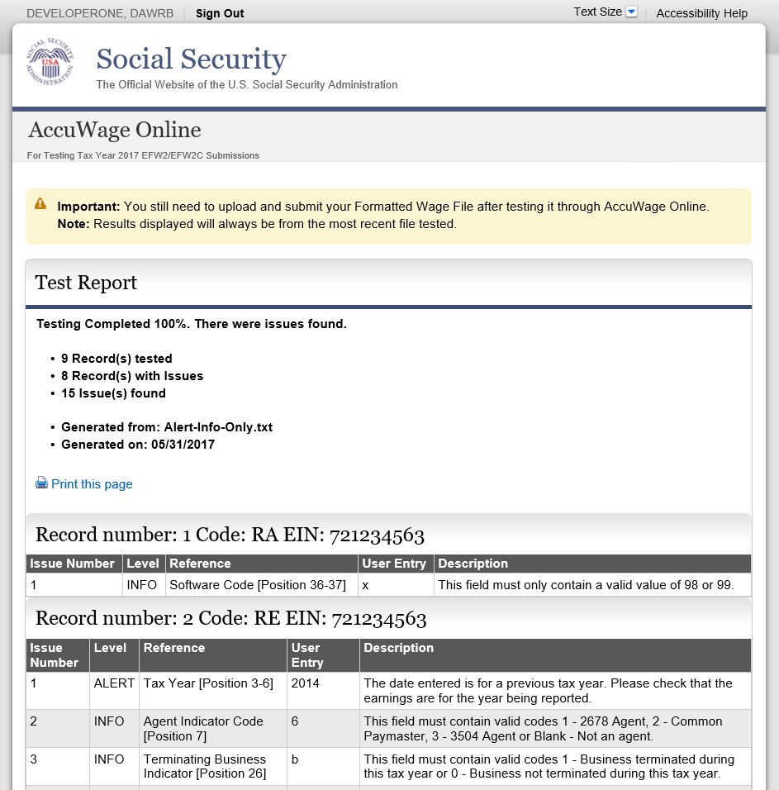

###### Figure 15: Test Report

## 18.1 Print the HTML Test Report



Print

###### Figure 16: Test Report screen – print options

There are two ways to print the Test Report:

1. Select the Print link. A window will appear asking what pages you want to print.
2. Use the print feature in your browser.

## 18.2 Saving the HTML Test Report

To save the Test Report:

1. Go to Tools located under the browser menu, select File then Save As from the drop down menu.
2. Enter the file name and select the file destination.
3. Click “Save” and you should have saved the Test Report to the desired location.

# Correcting Issues

AccuWage Online only tests wage reports and cannot be used to update or modify the original wage report. You must make corrections to the original report.

## 19.1 Suggested Steps for Correcting Issues Caused by Missing or Incorrect Data

1. View issue messages in the Issue(s) for Selected Record Detail list or View/Print HTML Test Report.
2. Determine which fields need to be changed.
3. Access the original file to correct the original data.
4. Test again with AccuWage software using the amended file.

## 19.2 Suggested Steps for Correcting Critical Issues

Critical issues immediately terminate testing and must be corrected before continuing. They are shown in the File Status display located at the top of the Test Results page. Critical issues can be corrected by following the steps described in the Suggested Steps for Correcting Issues Caused by Missing or Incorrect Data section above.

# Exiting AccuWage Online

There are two options for exiting AccuWage Online listed below. After you have closed AccuWage Online all data is erased. AccuWage Online does not store any data.

* Click the ‘Return To EWR’ button located at the bottom of the webpage. This will return you to the Employer Wage Reporting webpage.
* Click the ‘Sign Out’ button located at the top right hand side of the webpage. This will end the entire Employer Wage Reporting Session.

# System Error

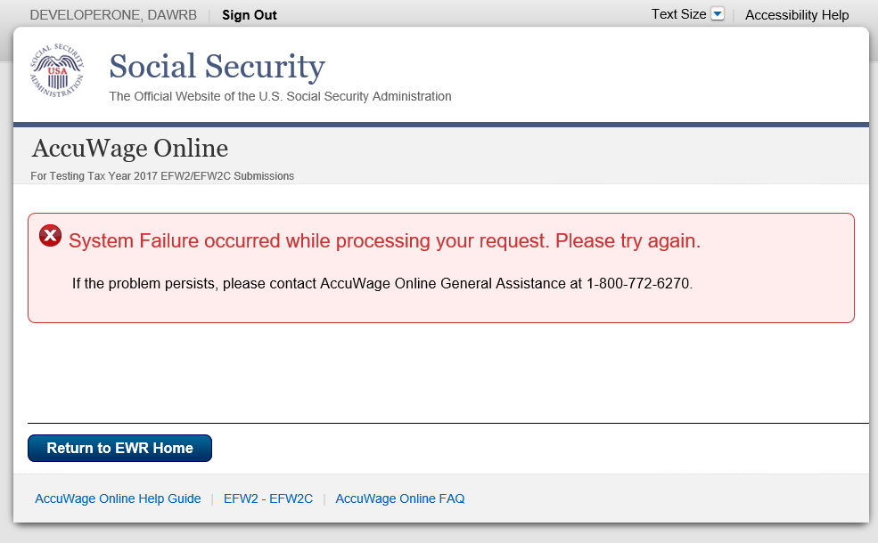

###### Figure 17: Test Failed due to an unexpected system error

This message will appear if there is an unexpected system error.

# Troubleshooting

For issues related to file uploads, browsers, files extensions, etc., please refer to the [FAQ](https://www.ssa.gov/employer/accuwage/faqAccuWageOnline.docx). If you still cannot resolve your issue, please contact the [AccuWage Help Mailbox](mailto:accuwage.help@ssa.gov)

# Glossary of Terms

**AccuWage Online**

The name of the application used to test EFW2 and EFW2C wage reports.

**Agent**

An organization authorized to submit wage and tax reports for one or more employers.

**Alert**

An issue type received on the Test Results screen that will not stop processing. It is highly recommended that each Alert is reviewed and corrected, if appropriate, before proceeding to the Business Services Online (BSO) webpage to upload the file.

**AWR**

Annual Wage Reporting. The process by which employers report the earnings and taxes of their employees.

##### BSO

Business Services Online. An online service for employers to submit wage data directly to SSA using a PC with an Internet connection.

**Character**

A letter, number or punctuation symbol.

**Critical**

An issue type received on the Test Results screen caused by an incorrectly formatted record sequence, record length or over the error limit that causes AccuWage to immediately stop testing a wage report. You must correct this issue type before continuing to use AccuWage.

**Error**

An issue type received on the Test Results screen that will not stop processing of the wage file, however, it is mandatory to fix this issue before proceeding to the Business Services Online (BSO) webpage to upload the file.

**EFW2**

A publication distributed by SSA containing specifications for the Electronic Filing of W-2 information.

**EFW2C**

A publication distributed by SSA containing specifications for the Electronic Filing of W-2c Information.

**HTML**

Hypertext Markup Language for publishing hypertext on the World Wide Web.

**Informational**

An issue type received on the Test Results screen that will not stop processing of the wage file. It is highly recommended that each informational issue is reviewed and corrected, if appropriate, before proceeding to the Business Services Online (BSO) webpage to upload the file.

**Internet**

An international network of public or private networks that can be used by employers or submitters to download the AccuWage application.

**SSA**

The Social Security Administration.

**SSN**

Social Security Number. A nine-digit number assigned by SSA.

**Submitter**

A person, organization or reporting agent submitting wage reports to SSA.

**Wage Report**

Annual W-2 or W2-C wage and tax reports submitted to SSA for processing.