Tax Year 2023

Special Wage Payment (SWP)

Tutorial

Follow the instructions below to submit a special wage payments file to the Social Security Administration (SSA). For information on preparing Special Wage Payment data files for electronic filing, go to Publication 957.

- Select the Upload Formatted Wage File tab on the EWR homepage to access the Wage File Upload (WFU) application. Select the Submit a Special Wage Payment File link. The system displays the “Submit Your Special Wage Payments File” page.
See “Accessing EWR Suite of Services Tutorial” for how to access the EWR homepage.
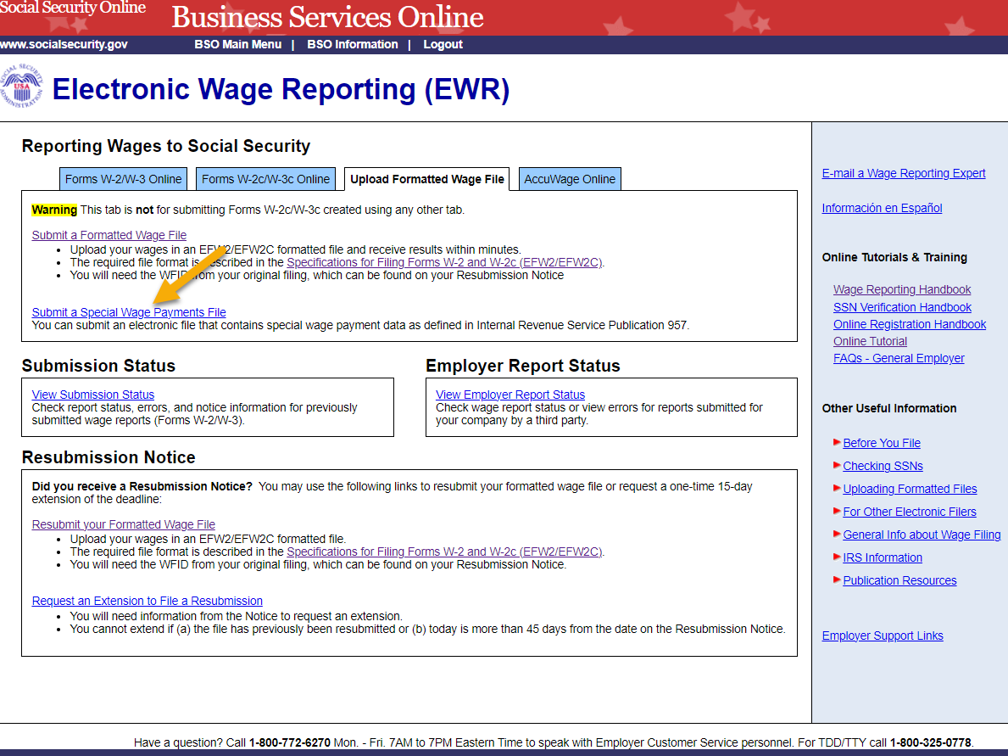
- On the “Submit Your Special Wage Payments File” page:
  - Select the Reporting Back Pay and Special Wage Payments link to view the Internal Revenue Service (IRS) Publication 957, “Reporting Back Pay and Special Wage Payments to the Social Security Administration”.
  - To submit a your file, use the Choose File button to select a wage file from your computer’s file system, then select the Submit button to upload your file. During file transmission, an “in progress” window is displayed. When the file upload is completed, the system displays the “Confirmation – Your File Was Received” page. A pop-up window advising you to save and/or print the page will also appear.
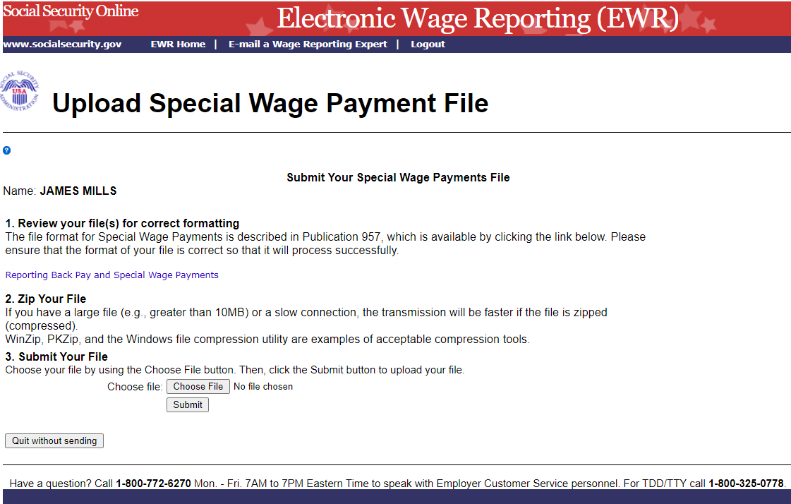
- On the Special Wage Payments File Submission Confirmation page, select the Submit Another File button to submit another file; select the EWR Home button or the EWR Home link at the top of the page to return to the EWR homepage.
