BSO Tutorial

Registration Services

Contains the following lessons:

- Register User
- Register User
- Complete Phone Registration

- Login
- Login
- Forgot Password

- Logout

- Contact SSA

- Manage Account
- View / Edit Account Info
- Change Password
- Disable Account

- Manage Services
- View / Edit Services
- Remove Access to Services
- Request New Services
- Request Services Suite for Employers
- Request Services Suite for Attorneys
- Request Internet Representative Payee Suite
- View Pending Services
- Re-Request Activation Codes
- Enter Activation Code(s)

- Manage Employer Information
- Add Employer Information
- Update Employer Information
- Remove Employer Information

LESSON 1: REGISTER USER

Follow the instructions below to register for Business Online Services. After completing the steps, you will receive a User ID and set a password so that you can log in to Business Services Online (BSO) and request online services.

STEP 1: Point your browser to the Business Services Online (BSO) Welcome page: www.socialsecurity.gov/bso/bsowelcome.htm.

STEP 2: Select the Register button on the Business Services Online Welcome page. The system displays the Log In to Online Services page.

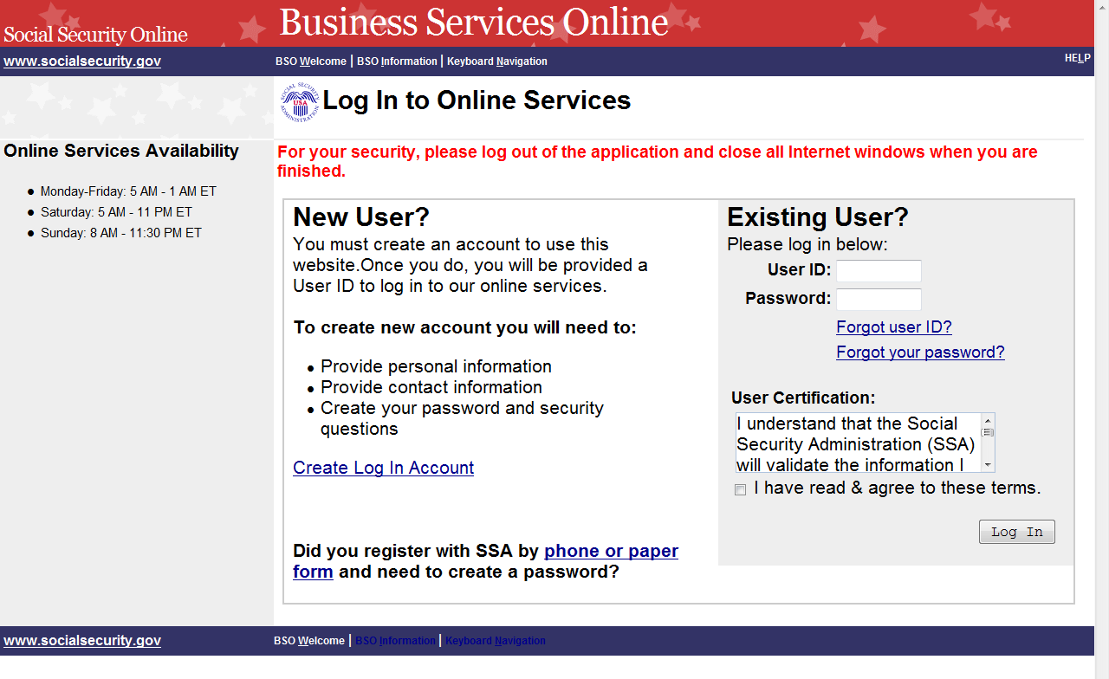

STEP 3: In the New User? column on the Log In to Online Services page, select the Create Log In Account link. The system displays the Create a Login Account, Step 1: Provide Information page. (To return to the Business Services Online Welcome page, select the BSO Welcome link in the page footer.)

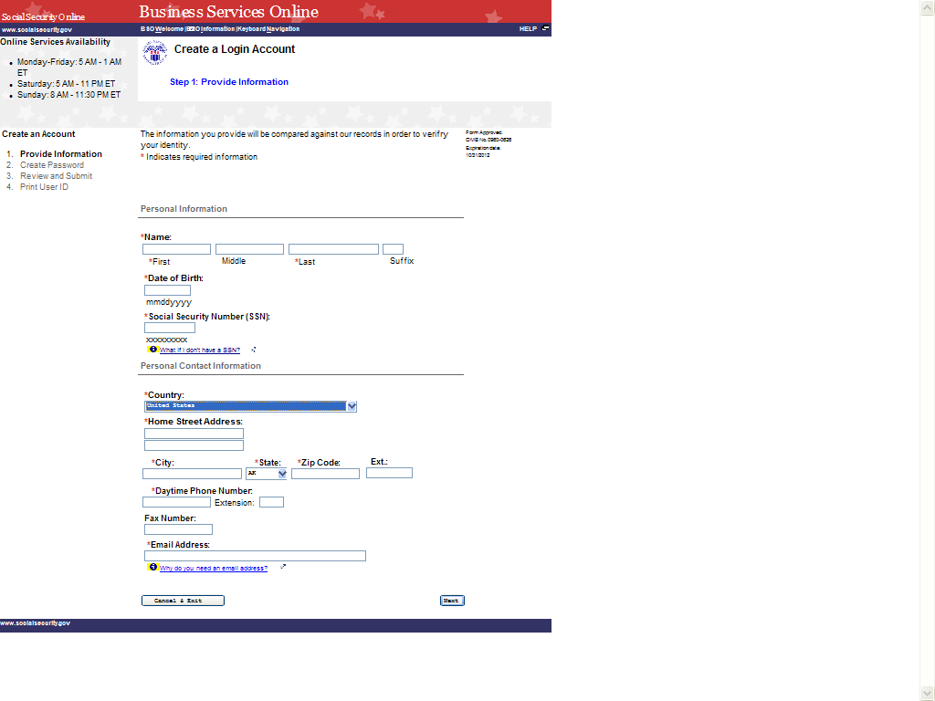

STEP 4: Enter information in the Create a Login Account, Step 1: Provide Information page.

TIPS
  - Fields that are required are marked with a red asterisk (*).

  - Links to informational pages are indicated with a blue information () link. Clicking on the link will display an informational page in a separate window.
  - Do not use punctuation in any field. This includes dashes or slashes in date of birth, social security number, zip code, and phone or fax numbers.

  - Date of birth must be entered in the format mmddyyyy. For example, if your date of birth is January 1, 1990, you would enter 01011990.

  - If you do not have an SSN and work outside the United States for a business or organization that has an Employer Identification Number (EIN), you may leave the SSN field blank.

  - If you live outside of the United States, when you select your country, text areas for you to enter Province and Postal Code information will appear.

  - The Social Security Administration will use your email address to send you any important information affecting Business Service Online users.

STEP 5: Select the Next button to continue registering. The system displays the Create a Login Account, Step 2: Create Your Password page. (Select the Back button to return to Create a Log In Account, Step 1: Provide Information. To return to the Business Services Online Welcome page without registering, select the Cancel & Exit button.)

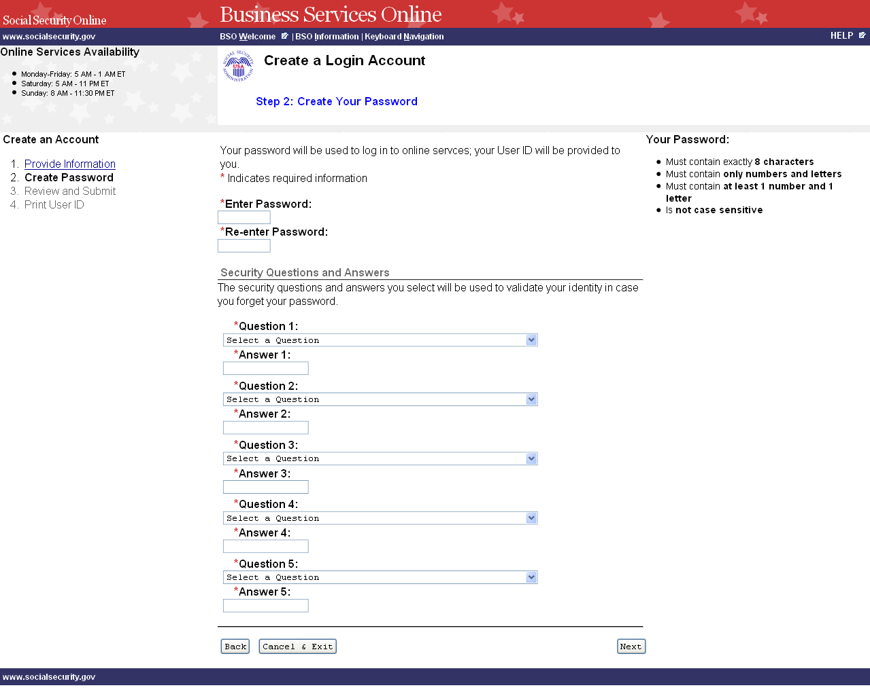

STEP 6: Enter a password to use when you log in to Business Services Online. Re-enter the password for confirmation. Your password:

  - Must contain exactly 8 characters
  - Must contain only numbers and letters (no special characters)
  - Must contain at least 1 number and 1 letter
  - Is not case sensitive

STEP 7: Select 5 questions and enter your answers. You will be asked to enter the same answers if you need to change your password later.

  - You may not select the same question more than once.
  - Answers to questions are not case sensitive; they cannot contain any special characters.

STEP 8: Select the Next button to continue. The system displays the Create a Login Account, Step 3: Review and Submit page. (Select the Back button to return to the Create a Log In Account, Step 1: Provide Information. To return to the Business Services Online Welcome page without registering, select the Cancel & Exit button.)

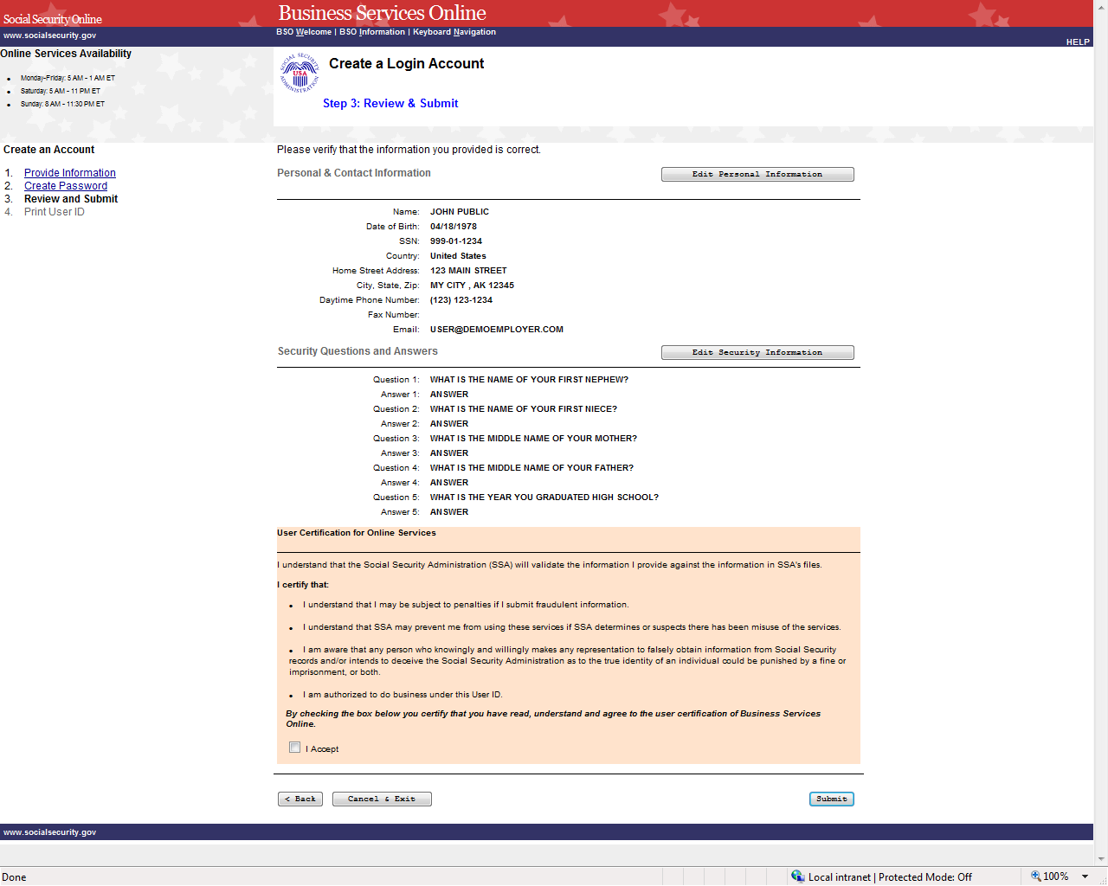

STEP 9: The information you entered on the previous two pages is displayed for your review. To make corrections, select the Edit Personal Information button to return to the Create a Log In Account, Step 1: Provide Information page. Or select the Edit Security Questions button or the Back button at the bottom of the page to return to the Create a Login Account, Step 2: Create your Password page.

STEP 10: After making any corrections, read the conditions stated in the User Certification for Online Services section of the page. You must agree to these conditions by checking the “I Accept” checkbox to proceed. Select the Submit button to process the registration. The system displays the Create a Login Account, Step 4: Print your User ID. (Select the Back button at the bottom of the page to return to Create a Login Account, Step 2: Create Your Password page. To return to the Business Services Online Welcome page without registering, select the Cancel & Exit button.)

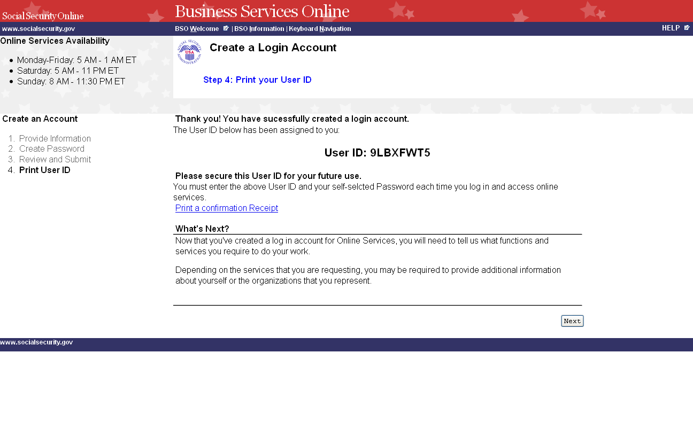

STEP 11: You may click on the Print a Confirmation Receipt link to print your User ID for your records. You will need your User ID and password to log in to Business Services Online to request services and perform other functions. Refer to other lessons in this Tutorial for guidance.

LESSON 2: COMPLETE PHONE REGISTRATION

If you started your registration for online services by speaking with an Employer Customer Service representative or completing a form, follow the instructions below to complete your registration.

STEP 1: Point your browser to the Business Services Online Welcome page: www.socialsecurity.gov/bso/bsowelcome.htm.

STEP 2: Select the Complete Phone Registration button on the Business Services Online Welcome page. The system displays the Log In to Online Services page.

STEP 3: In the New User? column of the Log In to Online Services page, select the link portion of Need to complete a phone/form registration? The system displays the Complete Phone Registration Attestation page. (To return to the Business Services Online Welcome page, select the BSO Welcome link in the page footer.)

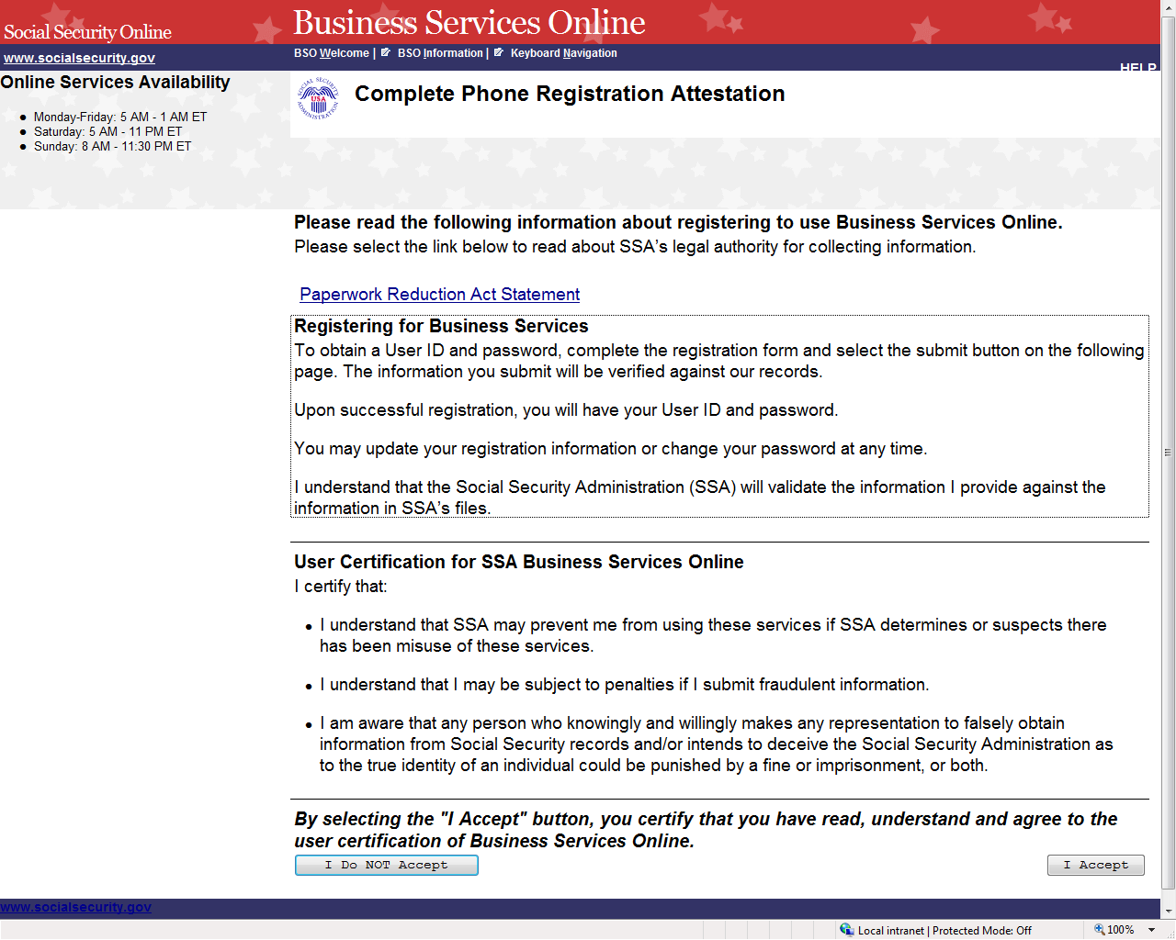
STEP 4: Read the conditions stated in the User Certification for SSA Business Services Online section of the page. You must agree to these conditions by selecting the I Accept button to proceed. The system displays the Complete Phone Registration page. (Selecting the I Do NOT Accept button will display the Business Services Online Welcome page.)

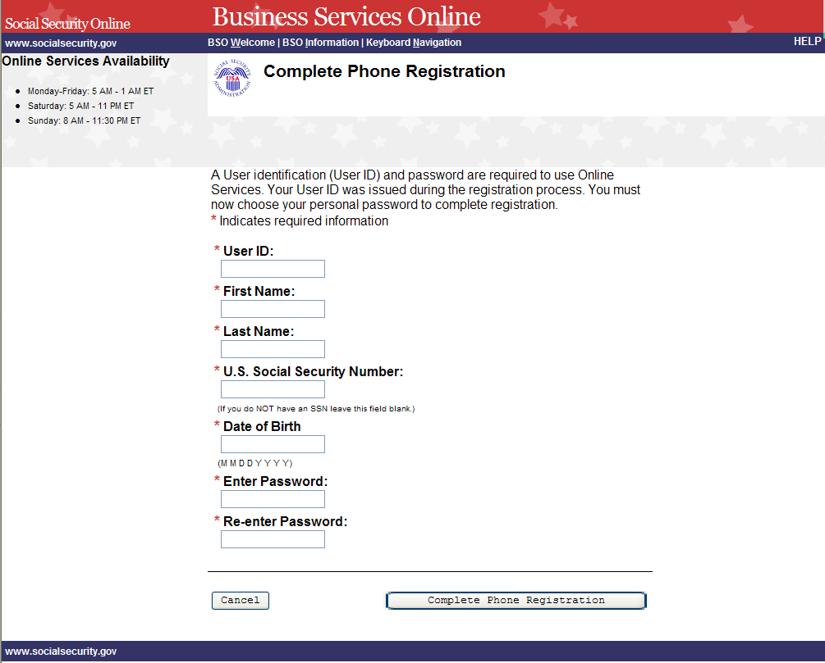

STEP 5: Enter the registration information.

TIPS
  - Fields that are required are marked with a red asterisk (*).

  - Enter your user id that was given to you when you registered over the phone or in person.

  - Do not use punctuation in any field. This includes dashes or slashes in date of birth and social security number.

  - If you do not have a U. S. Social Security Number, leave the SSN field blank.

  - Date of birth must be entered in the format mmddyyyy. For example, if your date of birth is January 1, 1990, you would enter 01011990.

  - Your password must contain any combination of eight letters and numbers (e.g. 9580859A or frog2828). Special characters are not allowed and passwords are not case sensitive. Do not share your password with anyone.

  - When you tab off or click out of a field, the system will check the format of what was entered and display a message if it needs to be corrected.

STEP 6: Select the Complete Phone Registration button to complete the registration process. The Log In to Online Services page will be displayed. (To return to the Business Services Online Welcome page without completing the registration process, select the Cancel button.)

LESSON 3: LOGIN

Follow the instructions below to log in to Business Services Online with your User ID and password.

STEP 1: Point your browser to the Business Services Online Welcome page: www.socialsecurity.gov/bso/bsowelcome.htm.

STEP 2: Select the Log In button on the Business Services Online Welcome page. The system displays the Log In to Online Services page.

STEP 3: Under the Existing User? column, enter your User ID and password. Read the terms stated under the User Certification heading. You must agree to these conditions by checking the “I have read & agree to these terms.” checkbox to proceed. Select the Log In button. The system displays the Business Services Online Main Menu page.

- If you have forgotten your User ID, please call 1-800-772-6270 Monday through Friday, 7:00 a.m. to 7:00 p.m. Eastern Time to speak with Employer Customer Service personnel. For TDD/TTY, call 1-800-325-0778.

- If you have forgotten your password, select the Forgot your password? link beneath the Password field. Refer to the Forgot Password lesson in this Tutorial for further guidance.

(To return to the Business Services Online Welcome page, select the BSO Welcome link on the page footer.)

NOTE

The menu selection on your BSO Main Menu is unique to you and presents only the applications and services to which you have access.

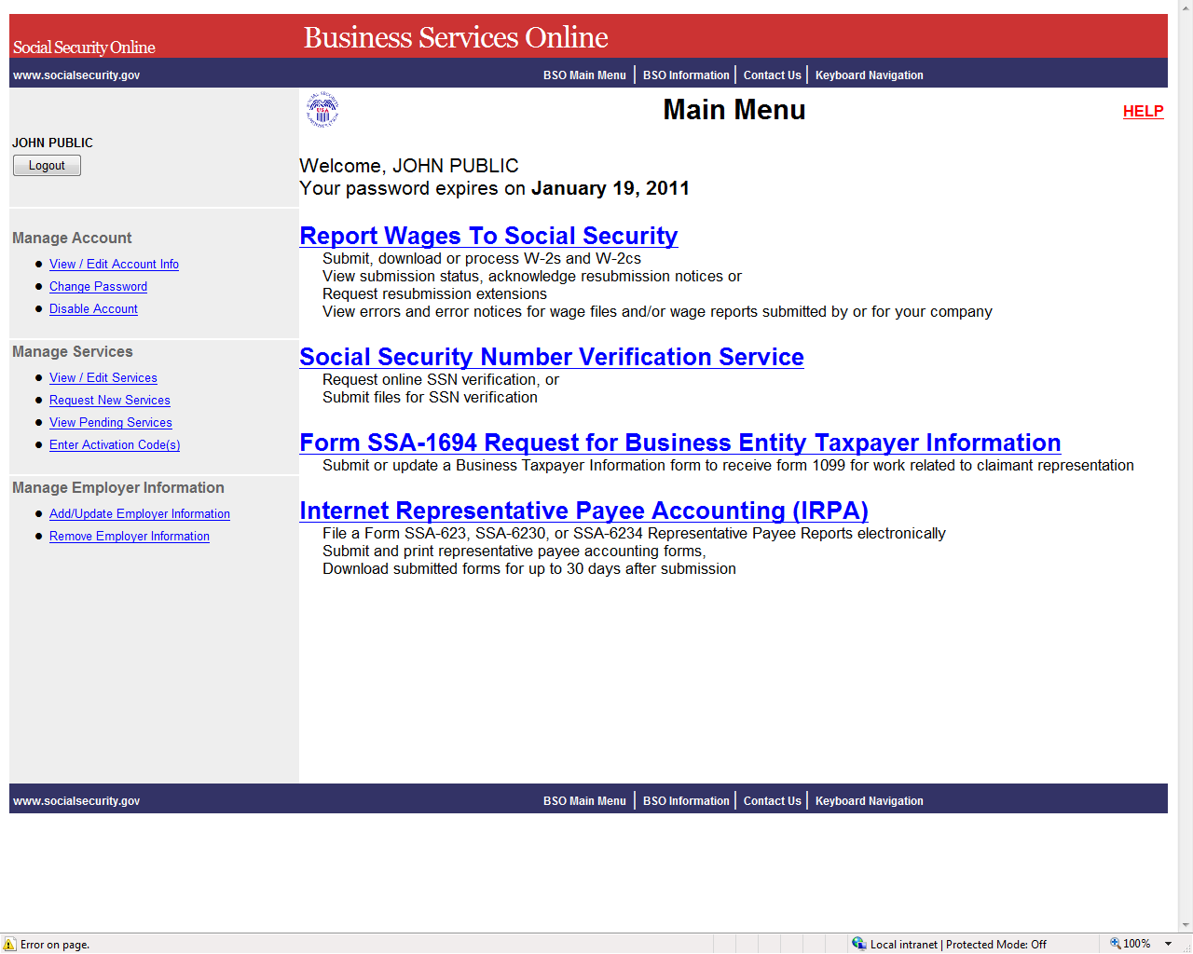

LESSON 4: FORGOT PASSWORD

Follow the instructions below if you have forgotten your password and wish to get a new one.

STEP 1: Point your browser to the Business Services Online Welcome page: www.socialsecurity.gov/bso/bsowelcome.htm.

STEP 2: Select the Log In button on the Business Services Online Welcome page. The system displays the Log In to Online Services page.

STEP 3: Under the Existing User? column, enter your User ID. Select the Forgot your password? link under the Password field. The system displays the Forgot Password page. (To return to the Business Services Online Welcome page, select the BSO Welcome link on the page footer.)
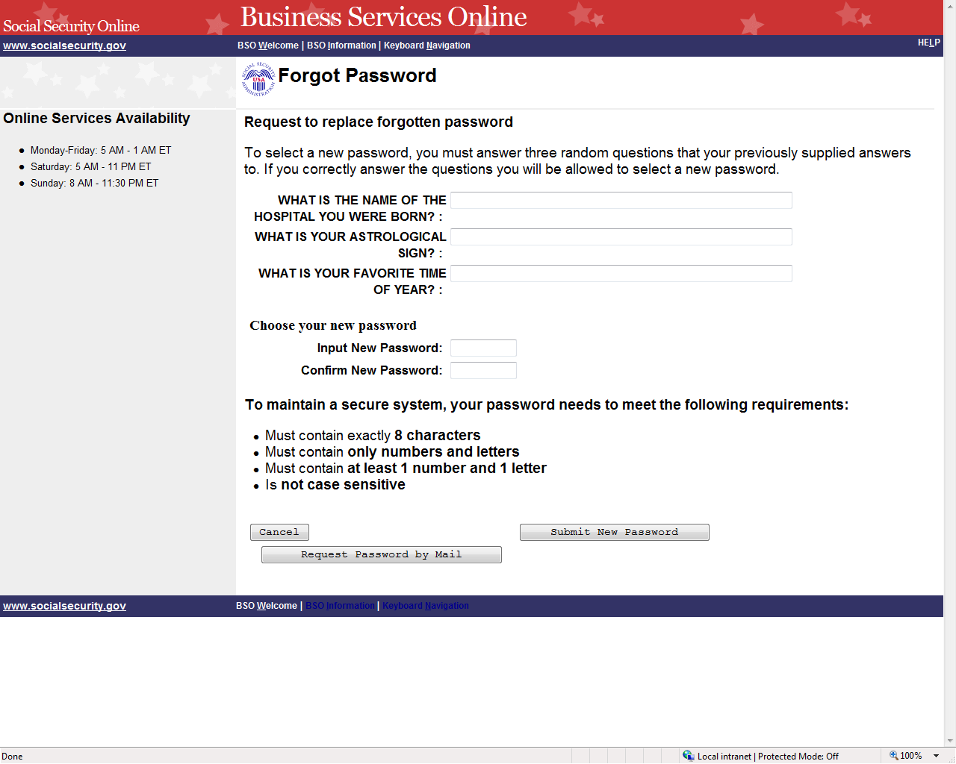
STEP 4: The Forgot Password page presents you with the choice of entering and submitting a new password online, or requesting a temporary password by mail.

- If you would like to change your password online immediately, continue to Step 5.

- If you would rather receive a temporary password by mail, you do not have to enter anything on the Forgot Password page. Just select the Request Password by Mail button, and proceed to Step 7.

(To return to the Business Services Online Welcome page, select the Cancel button.)

STEP 5: Enter the answers to three security questions randomly selected from the five you chose and answered during registration. Next, enter a new password and confirm that password by entering it a second time. Select the Submit New Password button. The system displays the Forgot Password Update Successful page. (To return to the Business Services Online Welcome page without submitting the new password, select the Cancel button.)

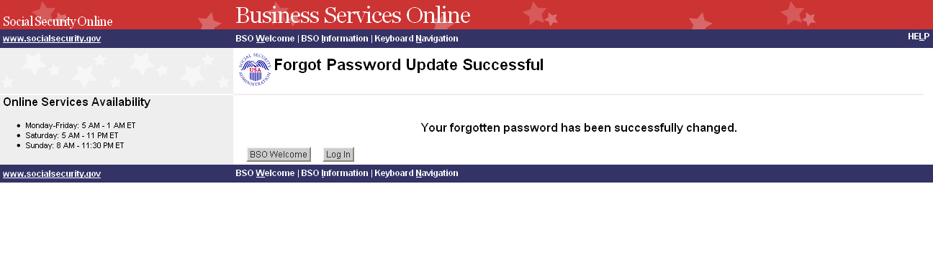
STEP 6: Select the Log In button to log in using the new password. Select the BSO Welcome button to return to the Business Services Online Welcome page.

STEP 7: If you selected the Request Password by Mail button on the Forgot Password page, the system displays the Request Password by Mail page.

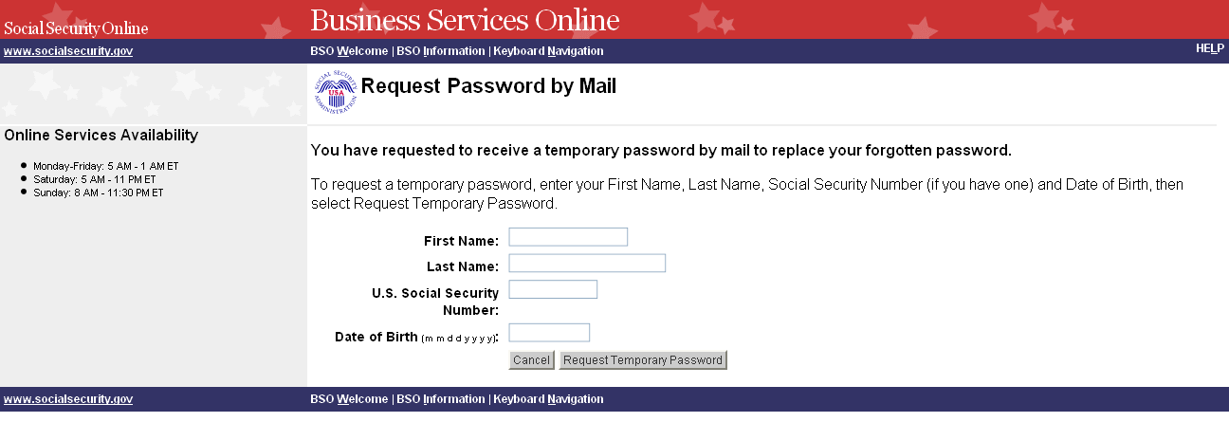

STEP 8: Enter your First Name, Last Name, U.S. Social Security Number, and Date of Birth. Select the Request Temporary Password button to send the request. The system displays the Password By Mail Success page. (To return to the Business Services Online Welcome page without sending the request, select the Cancel button.)

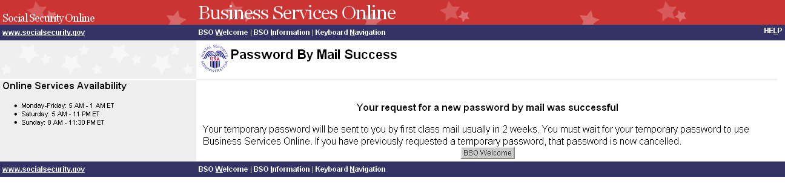

NOTE
Until you receive your new password in the mail, you will not be able to log in to BSO.

LESSON 5: LOGOUT

Follow the instructions below to log out of Business Services Online (BSO).

STEP 1: Select any Log Out button where displayed.

The system displays the Log Out of BSO page.

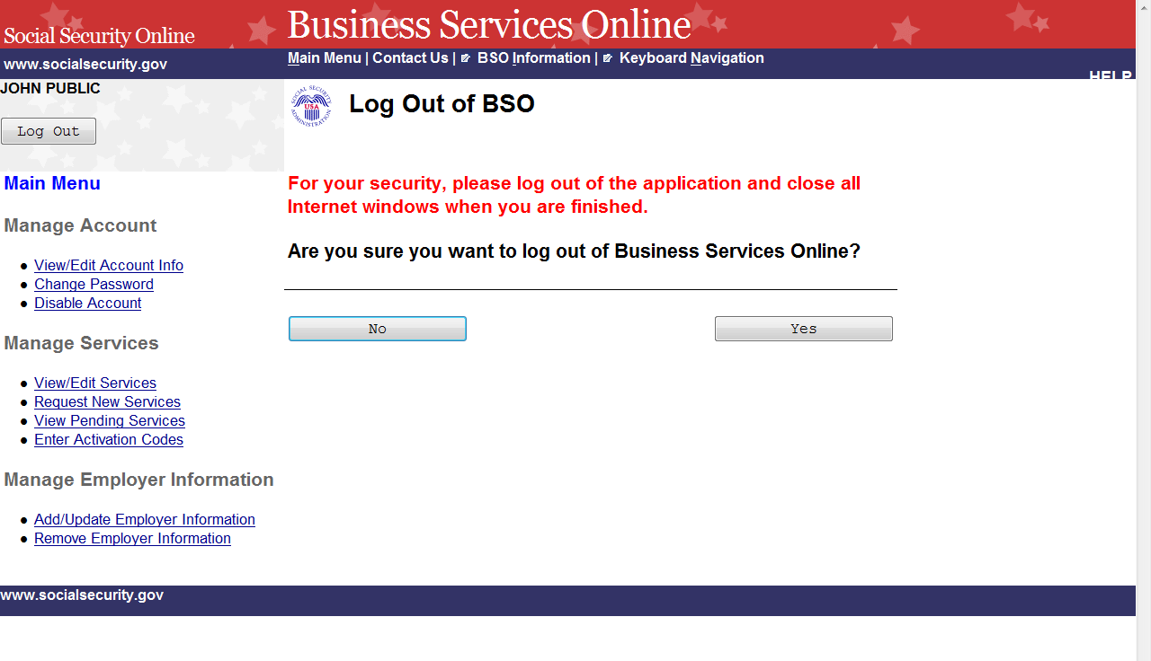

STEP 2: Select the Yes button to end the current session. The system displays the Customer Satisfaction Survey or the Business Services Online Welcome page. (To continue your session and return to the BSO Main Menu, select the No button.)

LESSON 6: CONTACT SOCIAL SECURITY AMMINISTRATION (SSA)

Follow the instructions below to submit a question or statement to the SSA.

STEP 1: Point your browser to the Business Services Online Welcome page: www.socialsecurity.gov/bso/bsowelcome.htm.

STEP 2: Select the Log In button on the Business Services Online Welcome page. The system displays the Log In to Online Services page.

STEP 3: Under the Existing User? column, enter your User ID and password. Read the terms stated under the User Certification heading. You must agree to these conditions by checking the “I have read & agree to these terms.” checkbox to proceed. Select the Log In button. The system displays the Business Services Online Main Menu page. (To return to the Business Services Online Welcome page, select the BSO Welcome link on the page footer.)

NOTE

The menu selection on your BSO Main Menu is unique to you and presents only the applications and services to which you have access.

STEP 4: Select the Contact Us link in the page header or footer. The system displays the E-mail a Wage Reporting Expert pop-up window from Electronic Wage Reporting (EWR).

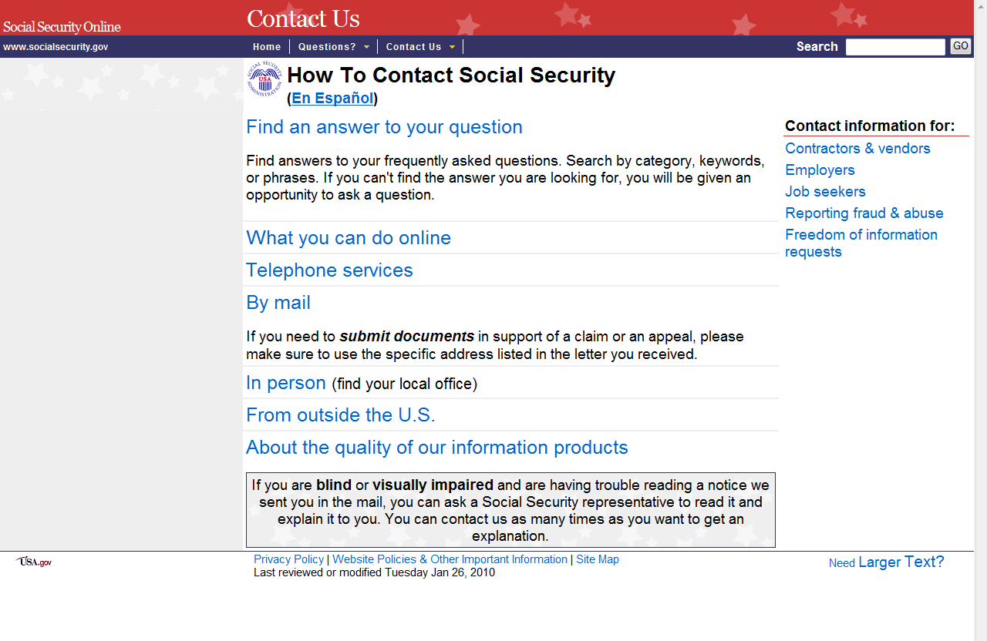

STEP 5: Registration Information from the user account is displayed in the Name, E-mail, and Phone Number fields. Verify that the information is correct. The E-mail and Phone Number can be changed for contact purposes only. (Select the Close Browser Window button to close the pop-up window without sending a message.)
TIPS:
  - Fields that are required are marked with a red asterisk (*).

  - For Representative Payee Accounting questions, please call 1-800-772-1213 or go to www.socialsecurity.gov/payee.

  - Call 1-800-772-6270 Mon. - Fri. 7AM to 7PM Eastern Time to speak with Employer Customer Service personnel if you do not wish to send an e-mail.

STEP 6: Select the desired organization in the Recipient drop-down box. Type your message in the Message field.

STEP 7: Select the Send Your Message button to send the message. (Select the Close Browser Window button to close the pop-up window.)

LESSON 7: EDIT ACCOUNT INFORMATION

Follow the instructions below to update your account information.

STEP 1: Point your browser to the Business Services Online Welcome page: www.socialsecurity.gov/bso/bsowelcome.htm.

STEP 2: Select the Log In button on the Business Services Online Welcome page. The system displays the Log In to Online Services page.

STEP 3: Under the Existing User? column, enter your User ID and password. Read the terms stated under the User Certification heading. You must agree to these conditions by checking the “I have read & agree to these terms.” checkbox to proceed. Select the Log In button. The system displays the Business Services Online Main Menu page. (To return to the Business Services Online Welcome page, select the BSO Welcome link on the page footer.)

NOTE

The menu selection on your BSO Main Menu is unique to you and presents only the applications and services to which you have access.

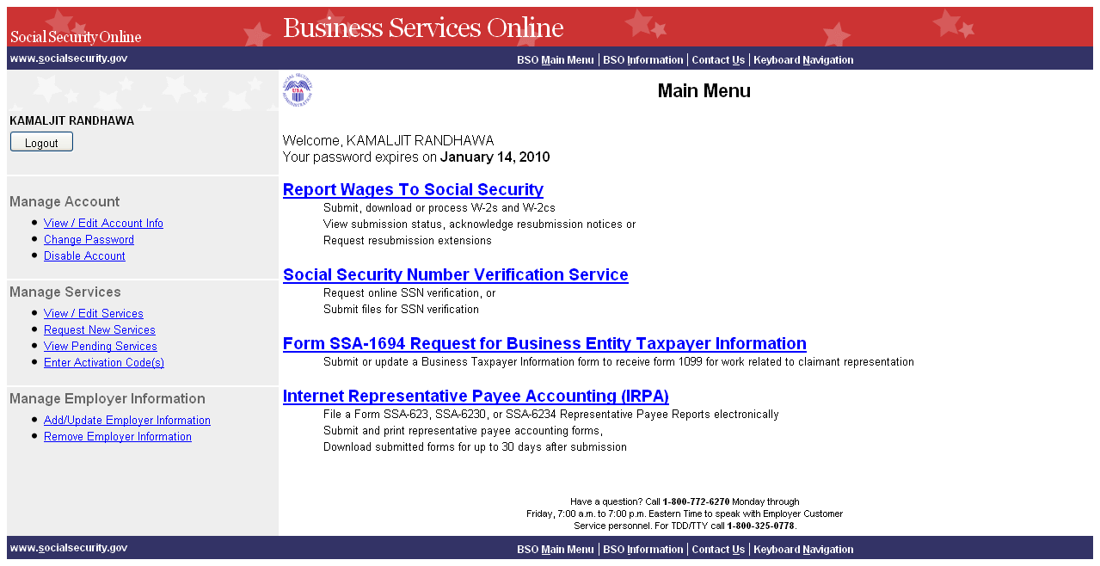

STEP 4: Under the Manage Account section of the left navigation panel, select the View/Edit Account Info link. The system displays the View/Edit Account Information page. (To return to the Business Services Online Main Menu, select the BSO Main Menu link in the second line of the page header.)

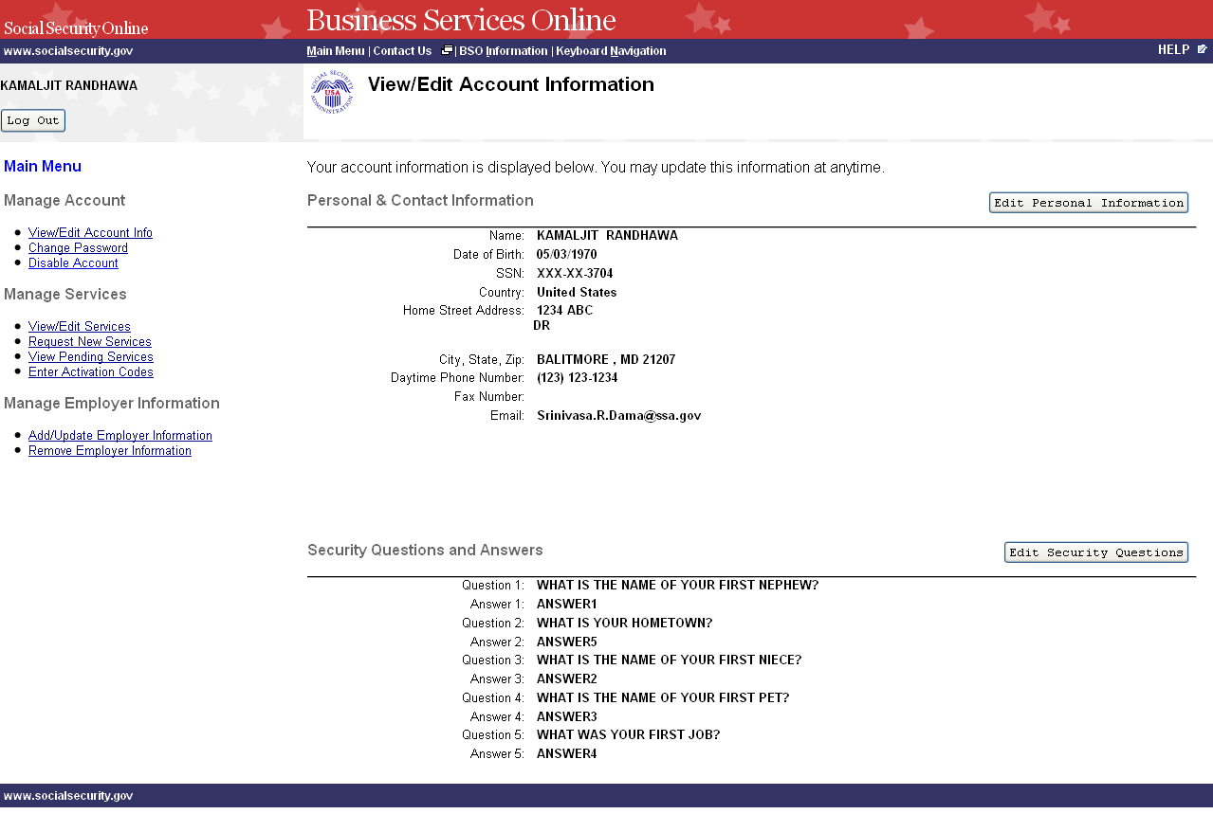

STEP 5: Select the Edit Personal Information button to edit personal and contact information. The system displays the Edit Personal & Contact Information page. (To return to the Business Services Online Main Menu, select the BSO Main Menu link in the second line of the page header.)

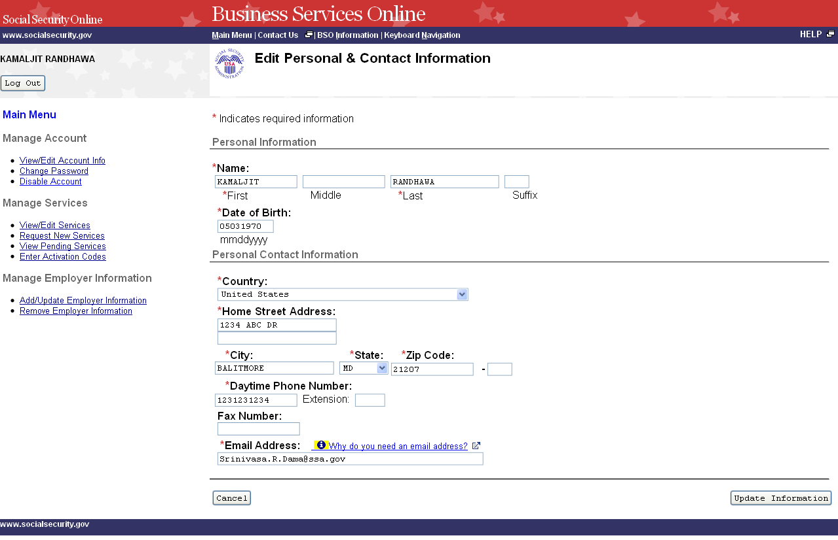

STEP 6: Edit the information you wish to change. Select the Update Information button to update the account information. The system displays the Edit Personal & Contact Information – Confirmation page. (Select the Cancel button to cancel the update and return to the View/Edit Account Information page. To return to the Business Services Online Main Menu, select the BSO Main Menu link in the second line of the page header.)

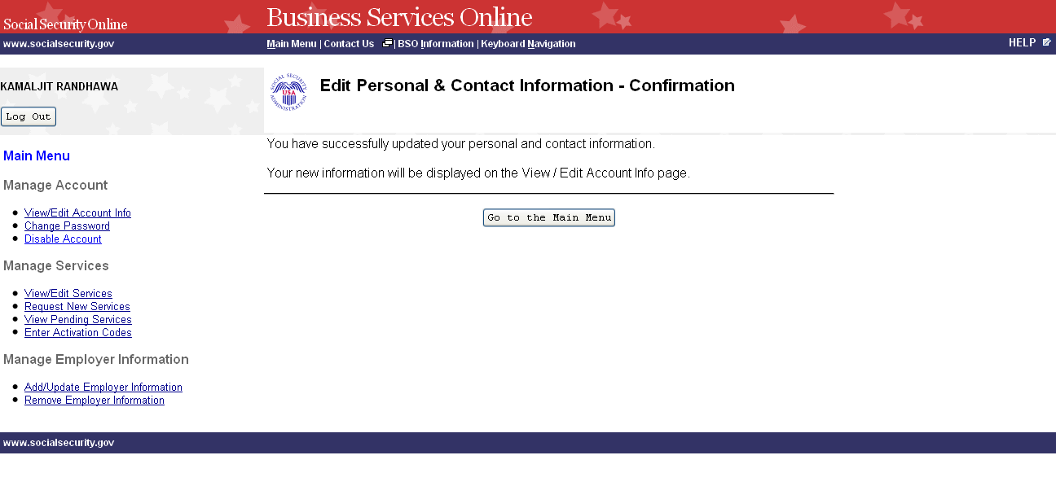
STEP 7: To edit other account information, select the View/Edit Account Info link under the Manage Account section of the left navigation panel. The system displays the View/Edit Account Information page. (Select the Go to the Main Menu button to return to the Business Services Online Main Menu.)

STEP 8: Select the Edit Security Questions button to edit the five questions and answers used to verify your identity if you forget your password. The system displays the Edit Security Questions page. (To return to the Business Services Online Main Menu, select the BSO Main Menu link in the second line of the page header.)

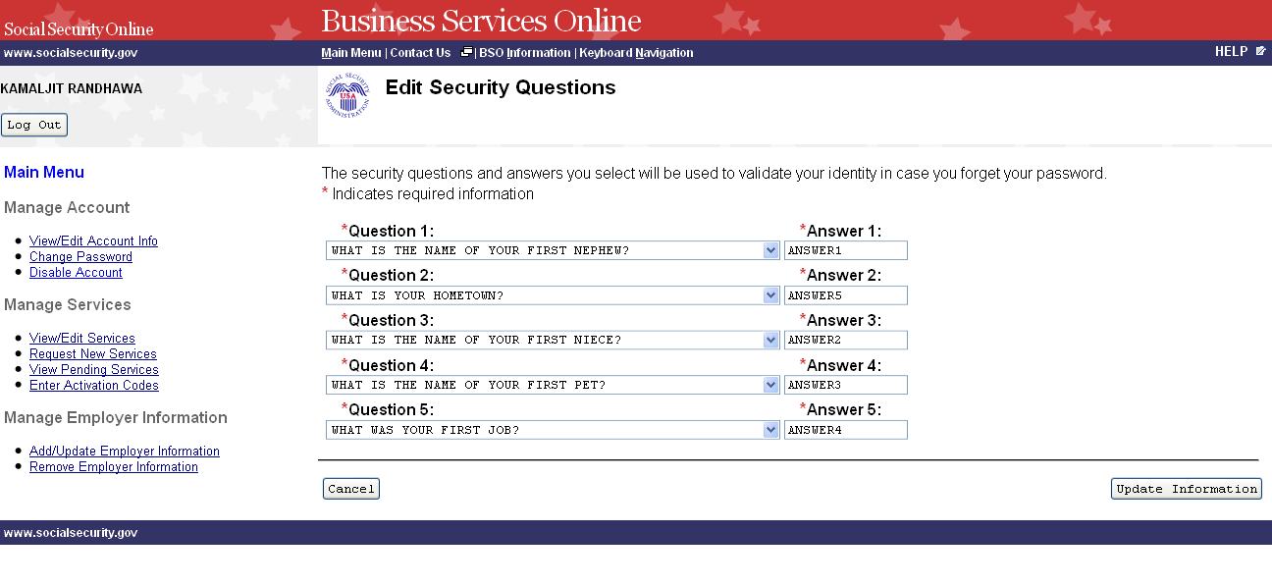
STEP 9: Edit the information you wish to change. Select the Update Information button to update the account information. The system displays the Edit Security Questions – Confirmation page. (Select the Cancel button to cancel the update and return to the View/Edit Account Information page. To return to the Business Services Online Main Menu, select the BSO Main Menu link in the second line of the page header.)

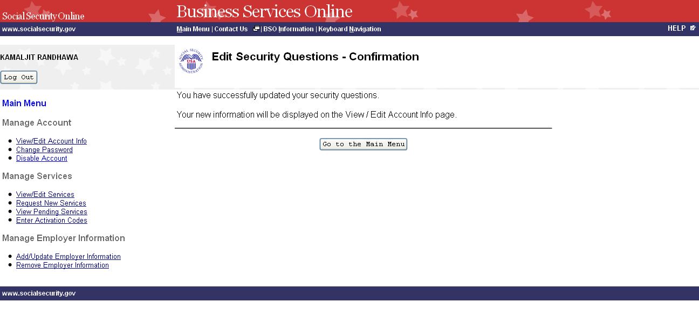
STEP 10: Select the Go to the Main Menu button to return to the Business Services Online Main Menu.

LESSON 8: CHANGE YOUR PASSWORD

You can change your password at any time. For security purposes, you are required to change your password at least once every 90 days in order to maintain an active User Identification Number (User ID). Follow the instructions below to change your password.

STEP 1: Point your browser to the Business Services Online Welcome page: www.socialsecurity.gov/bso/bsowelcome.htm.

STEP 2: Select the Log In button on the Business Services Online Welcome page. The system displays the Log In to Online Services page.

NOTE
When your password is more than 90 days old, the following message will display at the top of the page:
It has been more than 90 days since your password has been changed. You must change your password to continue with Online services.

The system will then automatically display the Change Password page. (Go to Step 5.)

STEP 3: Under the Existing User? column, enter your User ID and password. Read the terms stated under the User Certification heading. You must agree to these conditions by checking the “I have read & agree to these terms.” checkbox to proceed. Select the Log In button. The system displays the Business Services Online Main Menu page. (To return to the Business Services Online Welcome page, select the BSO Welcome link in the page footer.)

NOTE
The menu selection on your BSO Main Menu is unique to you and presents only the applications and services to which you have access.

STEP 4: Select the Change Password link from the left navigation panel. The system displays the Change Password page.

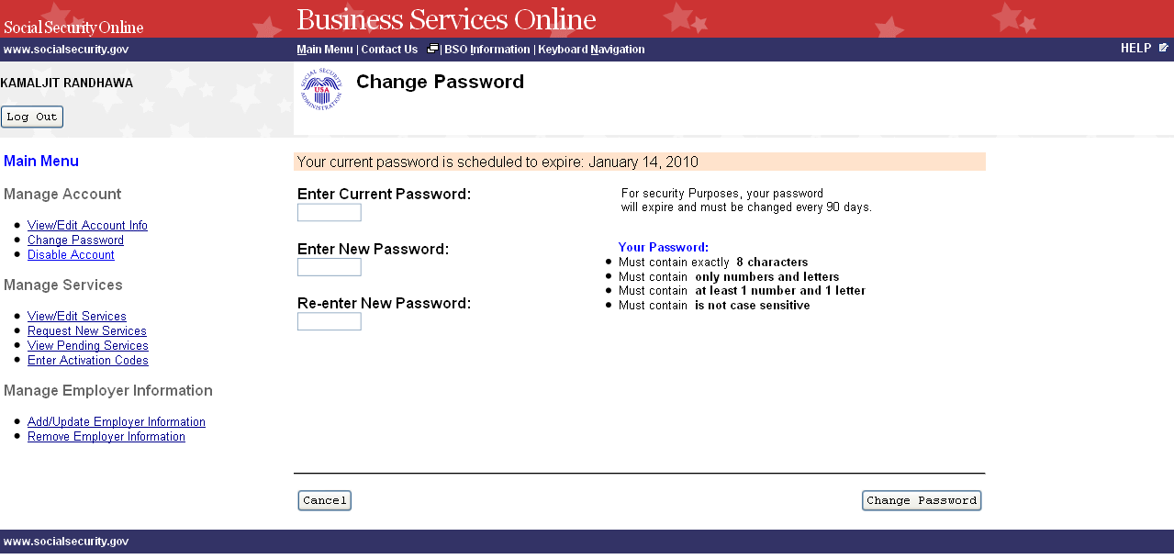

STEP 5: Enter your current password and new password. Enter your new password again for verification purposes. Your new password:

  - Must contain exactly 8 characters
  - Must contain only numbers and letters (no special characters)
  - Must contain at least 1 number and 1 character
  - Is not case sensitive

STEP 6: Select the Change Password button. The system displays the Password Change Successful page. (To return to the Business Services Online Main Menu without changing your password, select the Cancel button.)

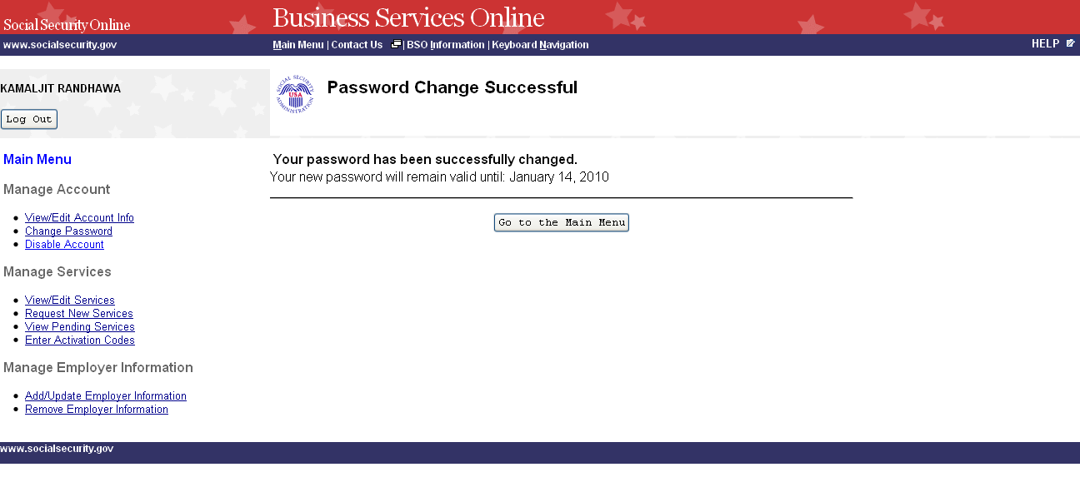
STEP 7: Select the Go to the Main Menu button to return to the Business Services Online Main Menu.

LESSON 9: DISABLE YOUR ACCOUNT

Follow the instructions below to disable your account. When you disable your account, you will no longer be able to use your User ID to access online services.

STEP 1: Point your browser to the Business Services Online Welcome page: www.socialsecurity.gov/bso/bsowelcome.htm.

STEP 2: Select the Log In button on the Business Services Online Welcome page. The system displays the Log In to Online Services page.

STEP 3: Under the Existing User? column, enter your User ID and password. Read the terms stated under the User Certification heading. You must agree to these conditions by checking the “I have read & agree to these terms.” checkbox to proceed. Select the Log In button. The system displays the Business Services Online Main Menu page. (To return to the Business Services Online Welcome page, select the BSO Welcome link on the page footer.)

NOTE

The menu selection on your BSO Main Menu is unique to you and presents only the applications and services to which you have access.

STEP 4: Under the Manage Account section of the left navigation panel, select the Disable Account link. The system displays the Disable Account page.

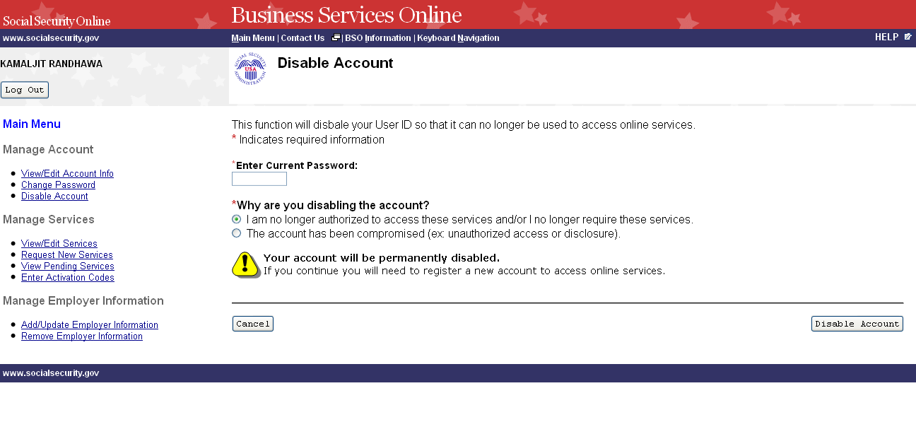
STEP 5: Enter your password in the Enter Current Password field and select the radio button beside the reason for disabling your User ID. Select the Disable Account button. The system displays the Disable Account – Confirmation page. (To return to the Business Services Online Main Menu without disabling your user id, select the Cancel button.)

NOTE
If you select the Disable Account button, your account will be permanently disabled. You will need to register a new account to access online services.
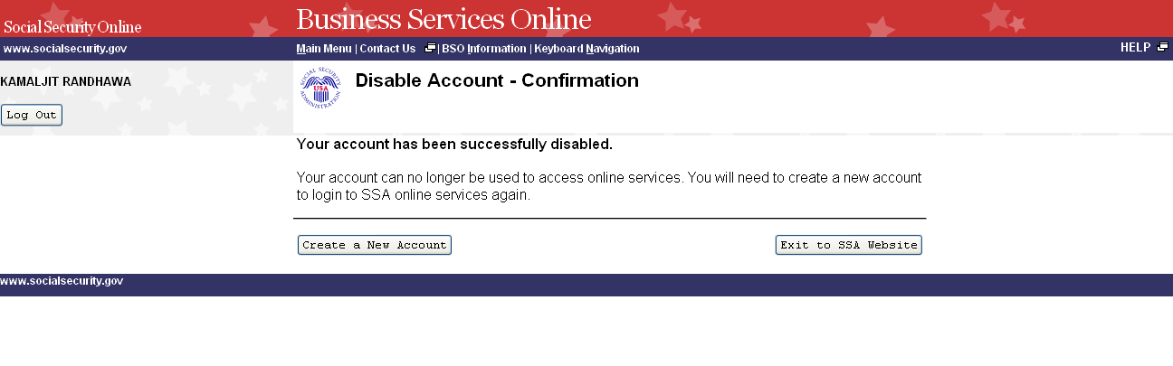
STEP 6: Select the Exit to SSA Website button to go to the Social Security Online page. To register a new account to access online services, select the Create a New Account button.

LESSON 10: REMOVE ACCESS TO BSO SERVICES

Follow the instructions below to remove access to one or more BSO services. Use this option if you no longer need to use a service(s) in BSO.

STEP 1: Point your browser to the Business Services Online Welcome page: www.socialsecurity.gov/bso/bsowelcome.htm.

STEP 2: Select the Log In button on the Business Services Online Welcome page. The system displays the Log In to Online Services page.

STEP 3: Under the Existing User? column, enter your User ID and password. Read the terms stated under the User Certification heading. You must agree to these conditions by checking the “I have read & agree to these terms.” checkbox to proceed. Select the Log In button. The system displays the Business Services Online Main Menu page. (To return to the Business Services Online Welcome page, select the BSO Welcome link in the page footer.)

NOTE

The menu selection on your BSO Main Menu is unique to you and presents only the applications and services to which you have access.

STEP 4: Under the Manage Services section of the left navigation panel, select the View/Edit Services link. The system displays the Remove Access to BSO Services page. This page lists the services to which you currently have access. (To return to the Business Services Online Main Menu, select the BSO Main Menu link in the second line of the page header.)

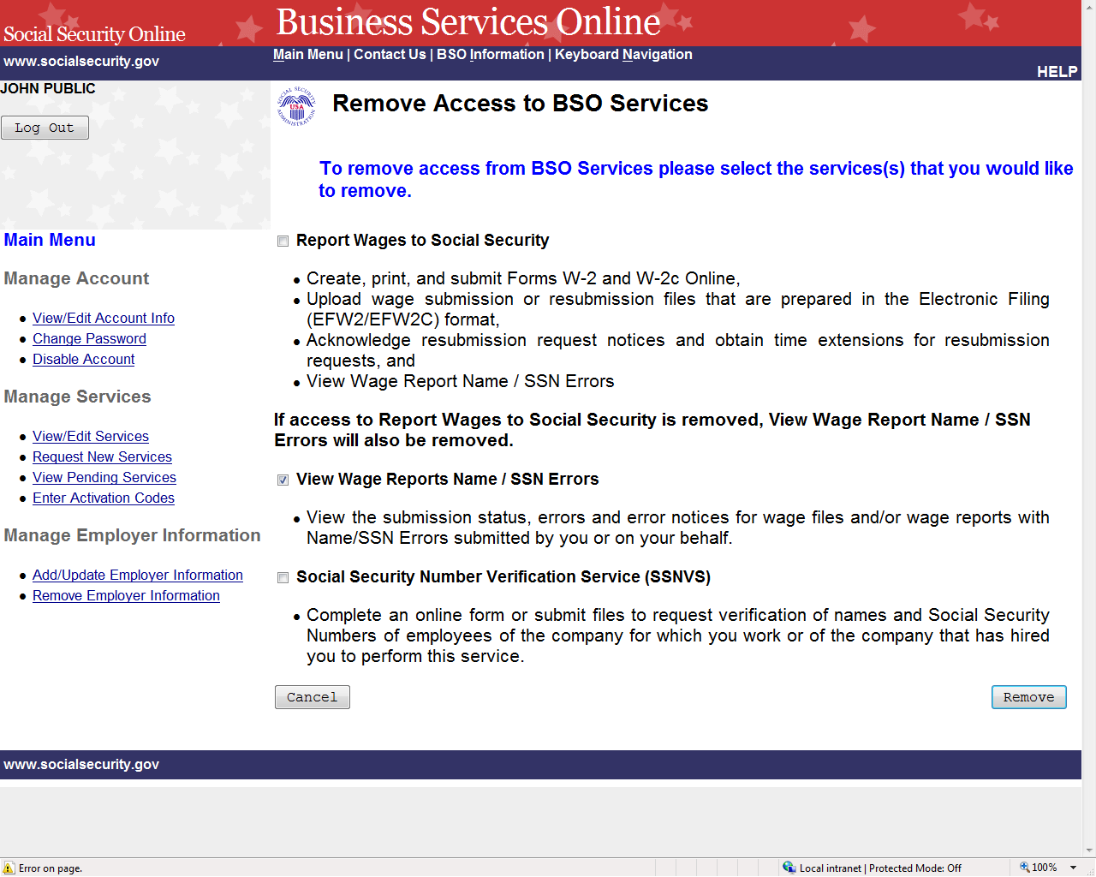

STEP 5: Select the checkbox(es) of the service(s) you wish to remove and select the Remove button. The system displays the Remove Access to BSO Services Successful page. (Select the Cancel button to return to the Business Services Online Main Menu without removing any services. To return to the Business Services Online Main Menu, select the BSO Main Menu link in the second line of the page header.)
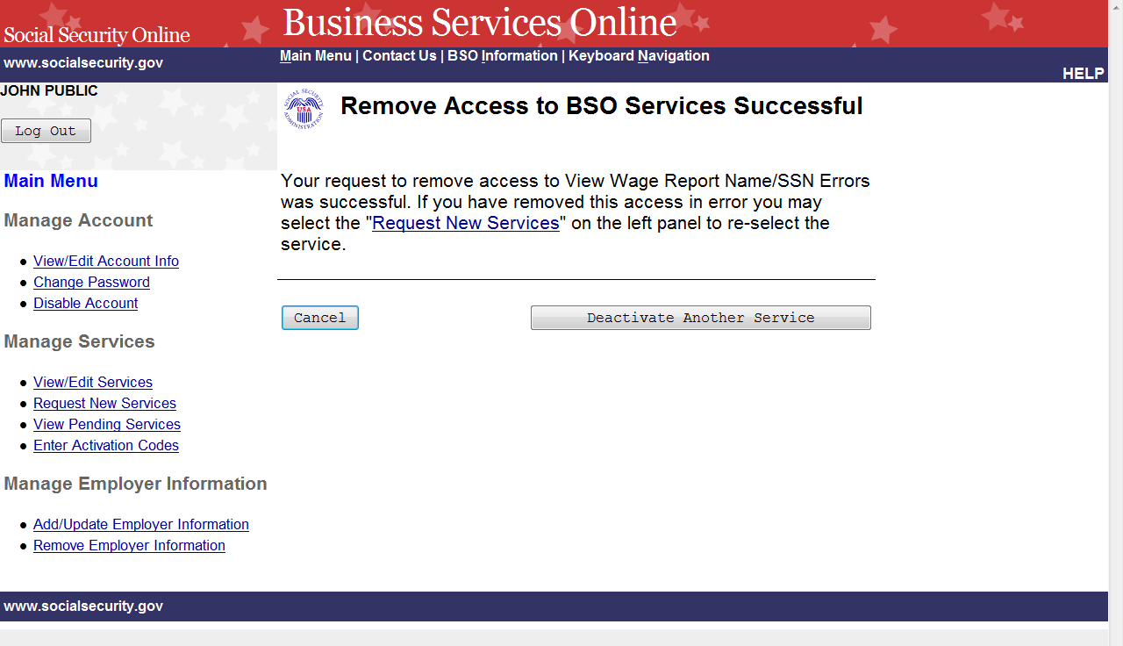

STEP 6: Select the Deactivate Another Service button to return to the Remove Access to BSO Services page. Select the Cancel button to return to the Business Services Online Main Menu.

LESSON 11: REQUEST SERVICES SUITE FOR EMPLOYERS

Follow the instructions below to log in to request access to the SSA Services Suite for Employers. Note that the request for this suite can be combined with requests for other services. For guidance in accessing a different service(s), refer to another lesson(s) in this Tutorial that specifically addresses the service(s).

STEP 1: Point your browser to the Business Services Online Welcome page: www.socialsecurity.gov/bso/bsowelcome.htm.

STEP 2: Select the Login button on the Business Services Online Welcome page. The system displays the Log In to Online Services page.

STEP 3: Under the Existing User? column, enter your User ID and password. Read the terms stated under the User Certification heading. You must agree to these conditions by checking the “I have read & agree to these terms.” checkbox to proceed. Select the Log In button. The system displays the Business Services Online Main Menu page. (To return to the Business Services Online Welcome page, select the BSO Welcome link in the page footer.)

NOTE
The menu selection on your BSO Main Menu is unique to you and presents only the applications and services to which you have access.

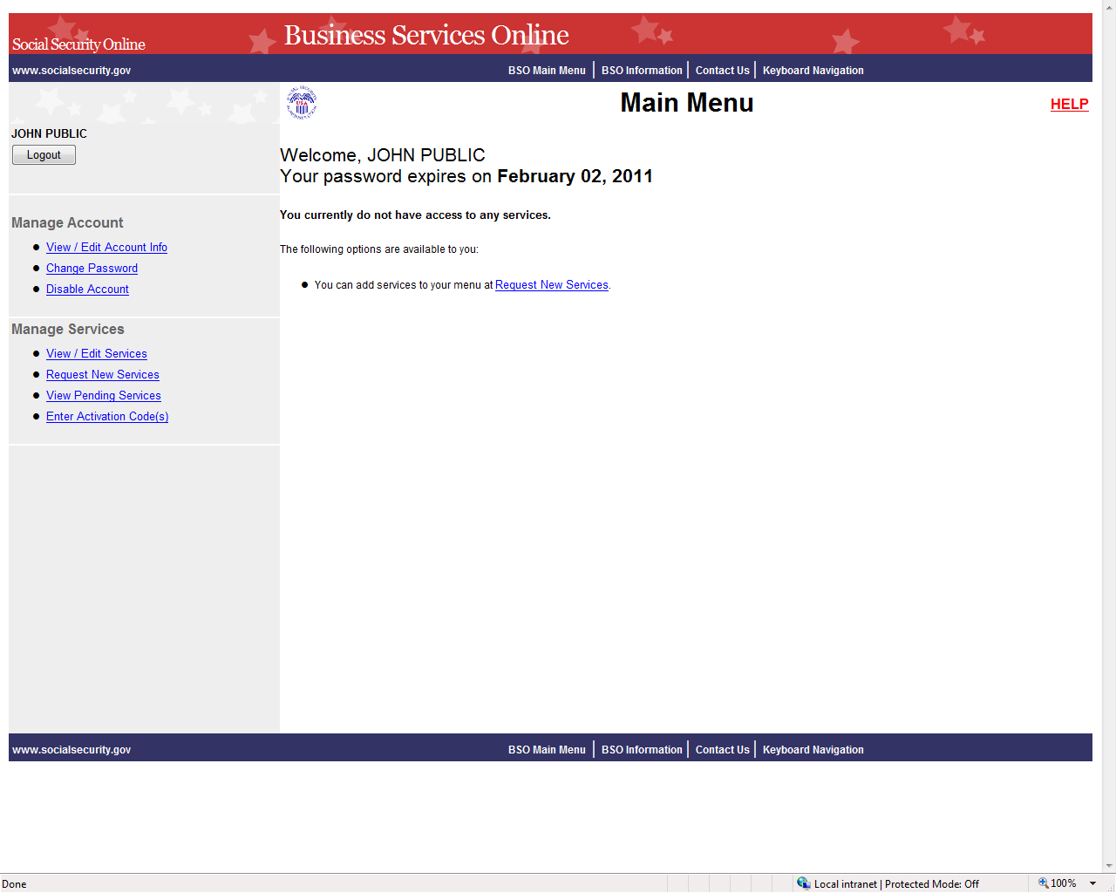

STEP 4: Select the Request New Services link in the Main Menu or the left navigation panel. The system displays the Request Access to Services page. (To return to the Business Services Online Welcome page, select the Logout button.)

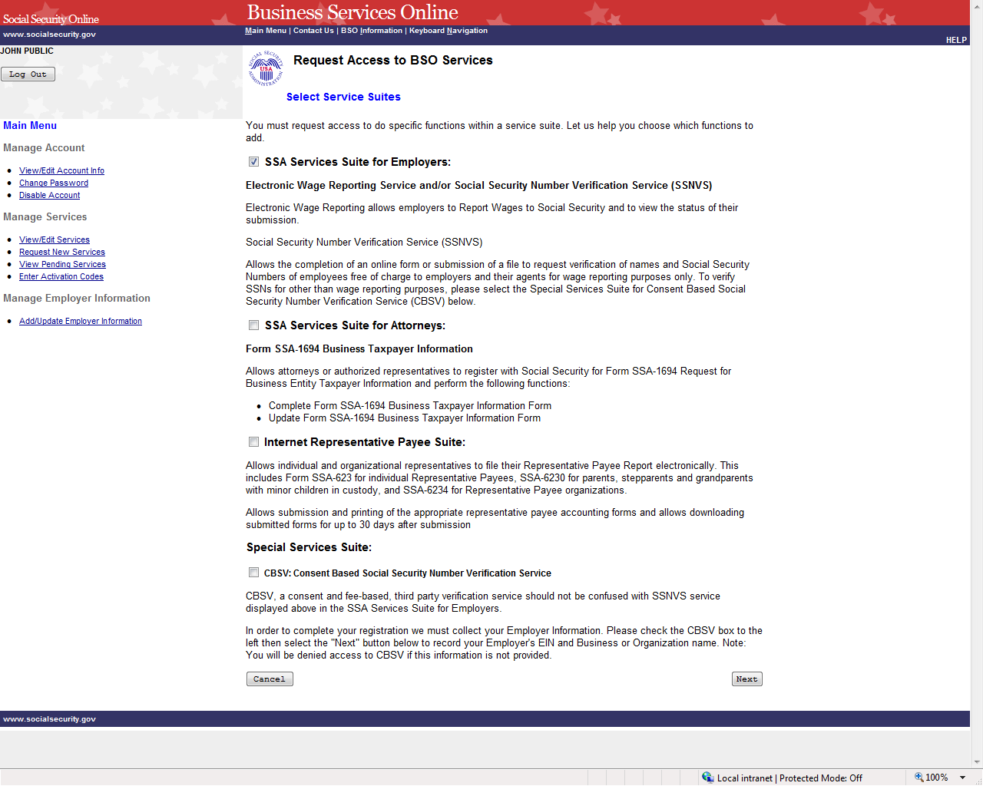

STEP 5: Continue with this lesson if you wish to request access to the Suite for Employers. If a different or additional suite(s) of services is needed, refer to another lesson that specifically addresses requesting that suite.

Check the checkbox saying “SSA Services Suite for Employers:” and select the Next button.
- If Employer information has not been entered, the Request Access to BSO Services page is re-displayed with the message “Employer Information is required for the selected suite(s). Please select this link Add Your Employer Information to continue.”
- If Employer information has already been entered, the system displays the Adding Services Wizard pages for the suite(s) of services you selected.
(To return to the Business Services Online Main Menu page, select the Cancel button.)

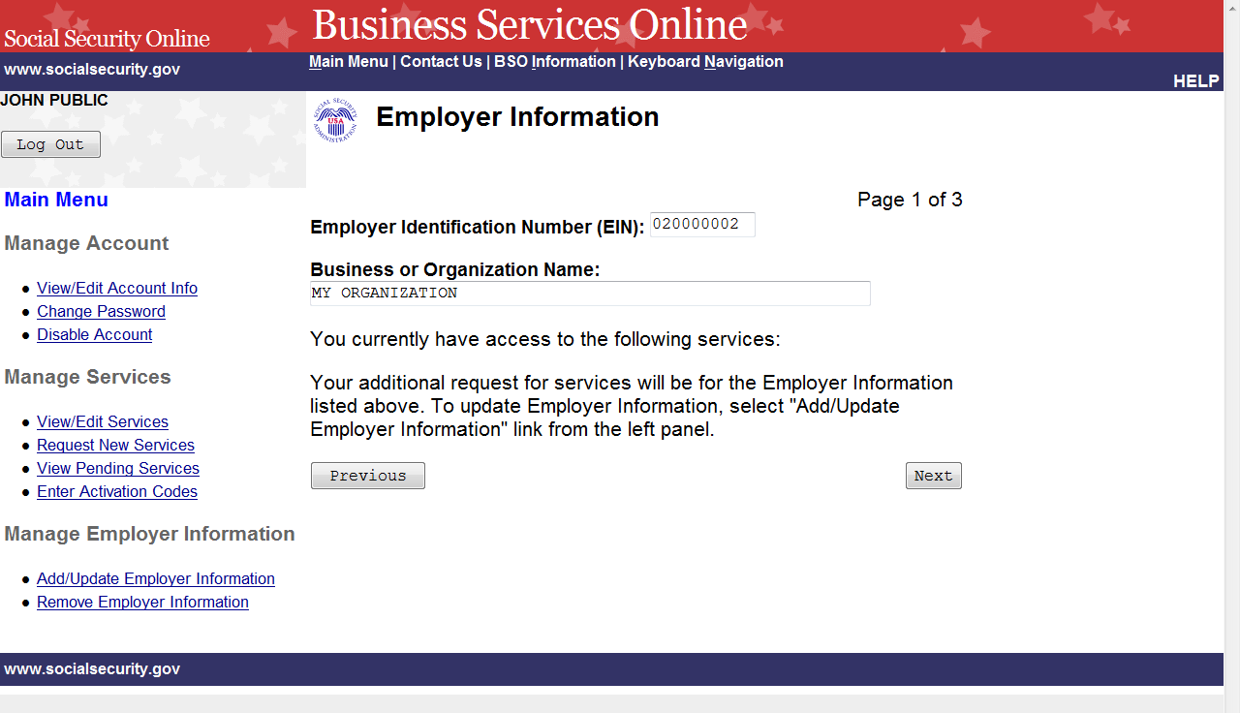

STEP 6: The Employer Identification Number (EIN) and Business or Organization name associated to your User ID will be displayed. The services listed are only the ones to which you have access. Select the Next button to continue. The system displays the Report Wages to Social Security page of the adding services wizard. (Select the Previous button at the bottom of the page to return to the Request Access to BSO Services page. To return to the Business Services Online Main Menu, select Main Menu on the second line of the page header.)
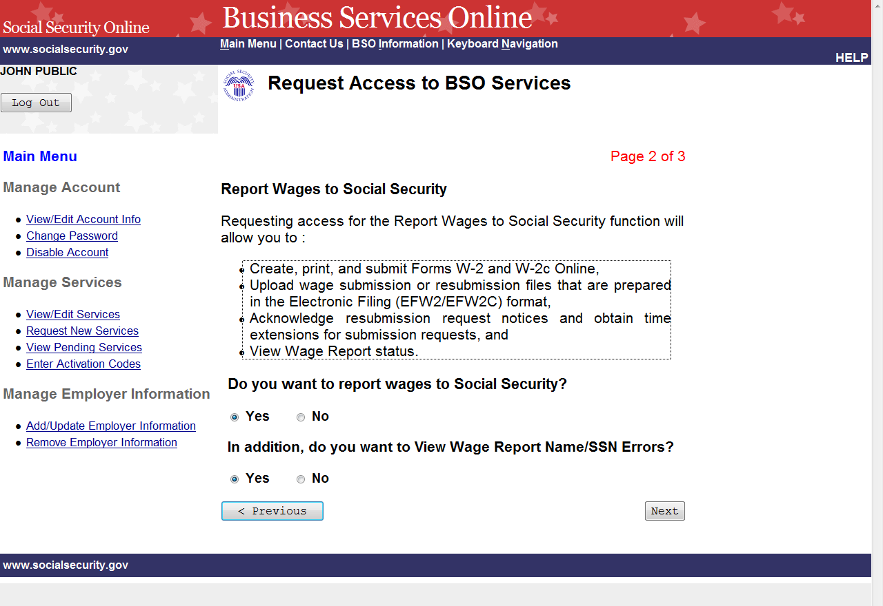

STEP 7: Request access to Report Wages to Social Security by selecting the “Yes” radio button. If Report Wages is selected, the View Wage Report Name/SSN Errors may also be selected. Select the Next button to continue. The system displays the Social Security Number Verification Service (SSNVS) page of the adding services wizard. (To return to the Employer Information page of the adding services wizard, select the Previous button at the bottom of the page. To return to the Business Services Online Main Menu without adding services, select Main Menu on the second line of the page header. )

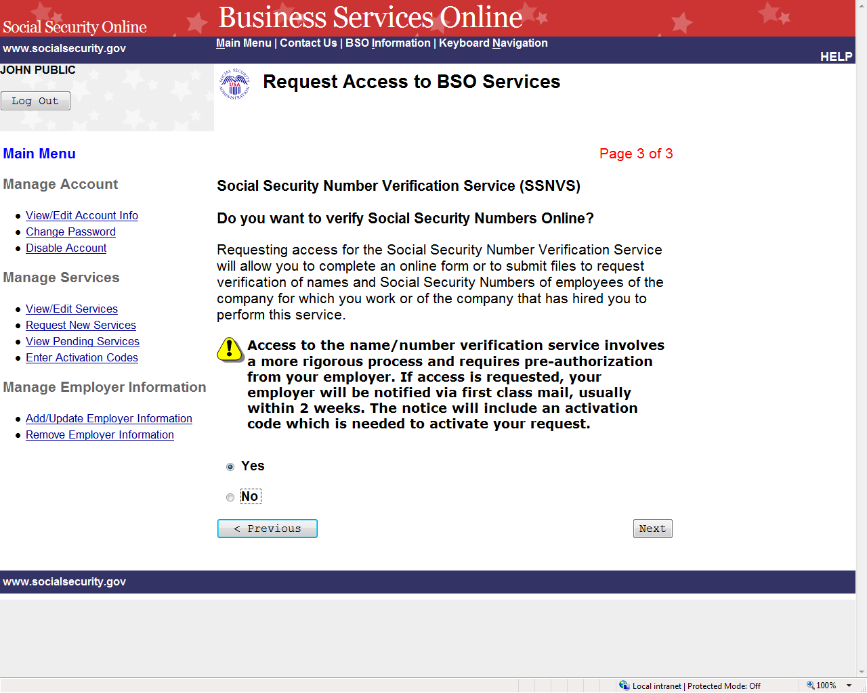

STEP 8: Request access to Social Security Number Verification Service (SSNVS) by selecting the “Yes” radio button and the Next button. The system displays the Request Summary page. (To return to the Report Wages to Social Security page of the adding services wizard, select the Previous button at the bottom of the page. To return to the Business Services Online Main Menu without adding services, select Main Menu on the second line of the page header.)

NOTE
The functions listed on your Request Summary page is unique to you and presents only the services which you have requested access.

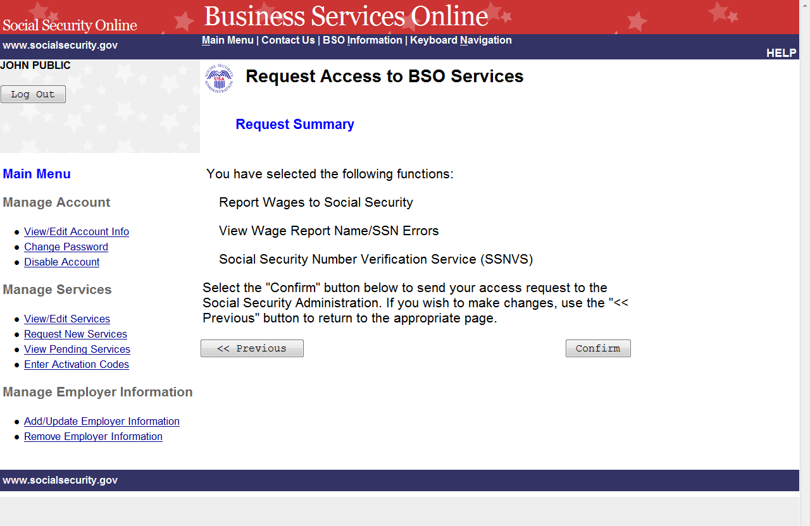

STEP 9: Review the list of functions and select the Confirm button to submit your access request. The system will display the Request Access to BSO Services Confirmation page. (To return to the Social Security Number Verification Service (SSNVS) page of the adding services wizard, select the Previous button at the bottom of the page. To return to the Business Services Online Main Menu without adding services, select Main Menu on the second line of the page header.)

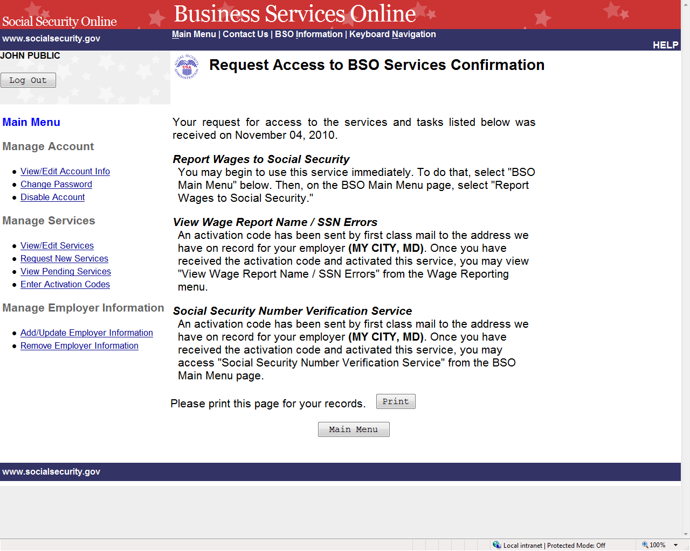

STEP 10: The confirmation page shows what services were selected, which are active immediately and which require activation codes. Please print this page for your records. Activation codes will be mailed to the address we have on record for your employer (please note the city and state shown) and are usually received within two weeks. To return to the Business Services Online Main Menu, select the Main Menu button.

NOTE
If the activation codes do not arrive at the address shown for your employer within two weeks, you may re-request them. Refer to the Re-Request Activation Codes lesson in this Tutorial for guidance.

LESSON 12: REQUEST SERVICES SUITE FOR ATTORNEYS

Follow the instructions below to request access to the SSA Services Suite for Attorneys. Note that the request to this suite can be combined with requests to other services. For guidance in accessing a different suite(s), refer to another lesson(s) in this Tutorial that specifically addresses the service(s).

STEP 1: Point your browser to the Business Services Online Welcome page: www.socialsecurity.gov/bso/bsowelcome.htm.

STEP 2: Select the Login button on the Business Services Online Welcome page. The system displays the Log In to Online Services page.

STEP 3: Under the Existing User? column, enter your User ID and password. Read the terms stated under the User Certification heading. You must agree to these conditions by checking the “I have read & agree to these terms.” checkbox to proceed. Select the Log In button. The system displays the Business Services Online Main Menu page. (To return to the Business Services Online Welcome page, select the BSO Welcome link in the page footer.)

NOTE
The menu selection on your BSO Main Menu is unique to you and presents only the applications and services to which you have access.

STEP 4: Under the Manage Services section in the left navigation panel, select the Request New Services link. The system displays the Request Access to BSO Services page. (To return to the Business Services Online Welcome page, select the Logout button.)

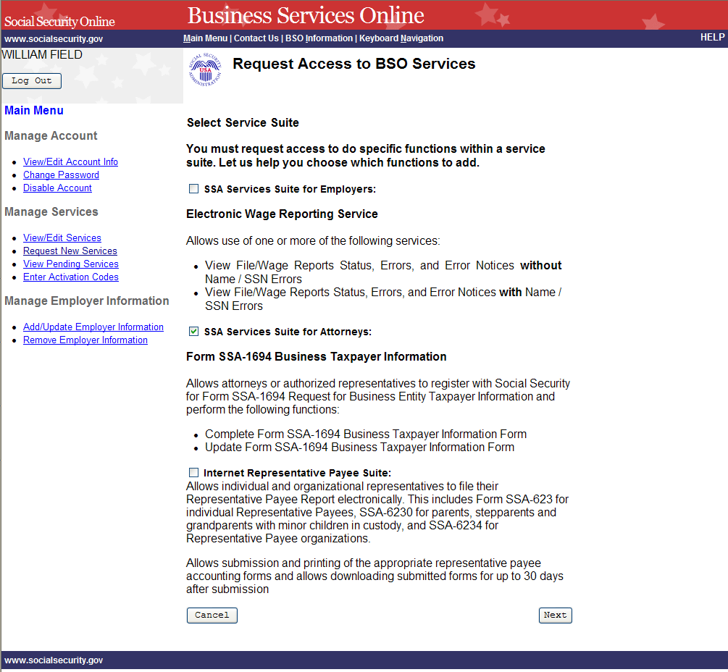

STEP 5: Continue with this lesson if you wish to request access to the SSA Services Suite for Attorneys. If a different or additional suite(s) of services is needed, refer to another lesson that specifically addresses requesting that suite.

Check the checkbox saying “SSA Services Suite for Attorneys:” and select the Next button.
- If Employer information has not been entered, the Request Access to BSO Services page is re-displayed with the message “Employer Information is required for the selected suite(s). Please select this link Add Your Employer Information to continue.”
- If Employer information has already been entered, the system displays the Adding Services Wizard pages for the suite(s) of services you selected.
(To return to the Business Services Online Main Menu page, select the Cancel button.)

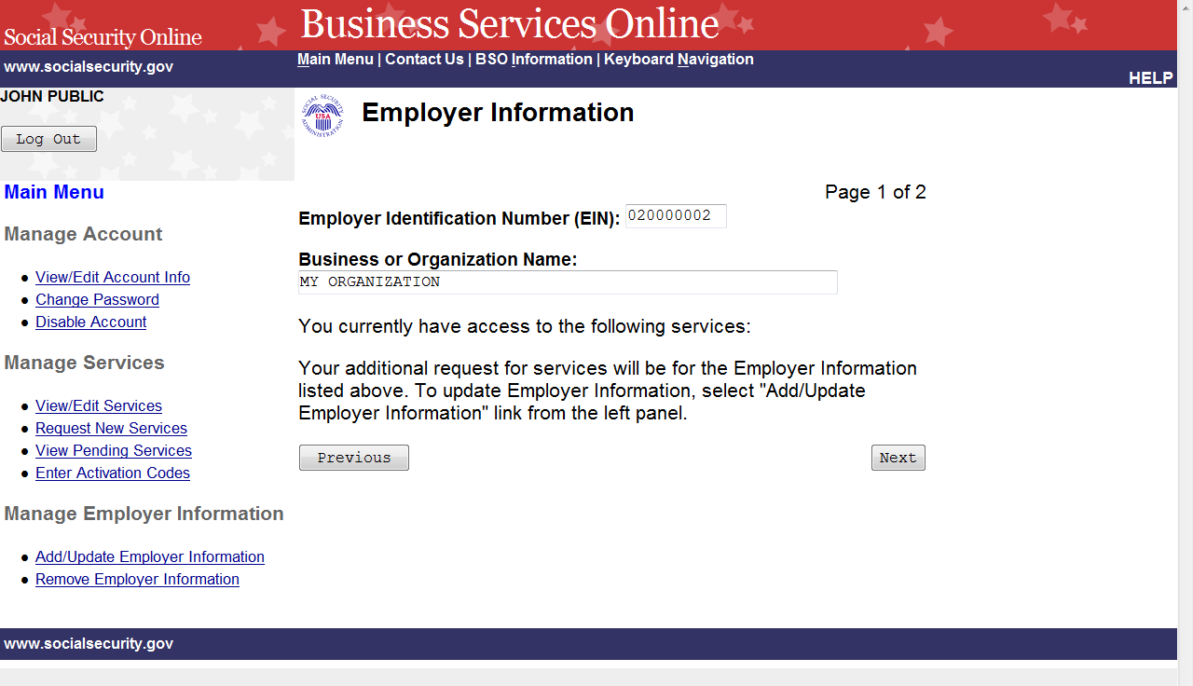

STEP 6: Review the employer information displayed.
- If the employer information displayed is incorrect, you may update your employer information by selecting the Add/Update Employer Information link on the left navigation panel.
- If the employer information displayed is correct, select the Next button. The system displays the Complete Form SSA-1694 Business Taxpayer Information Form page of the adding services wizard.

(Select the Previous button at the bottom of the page to return to the Request Access to BSO Services page. To return to the Business Services Online Main Menu, select Main Menu on the second line of the page header.)

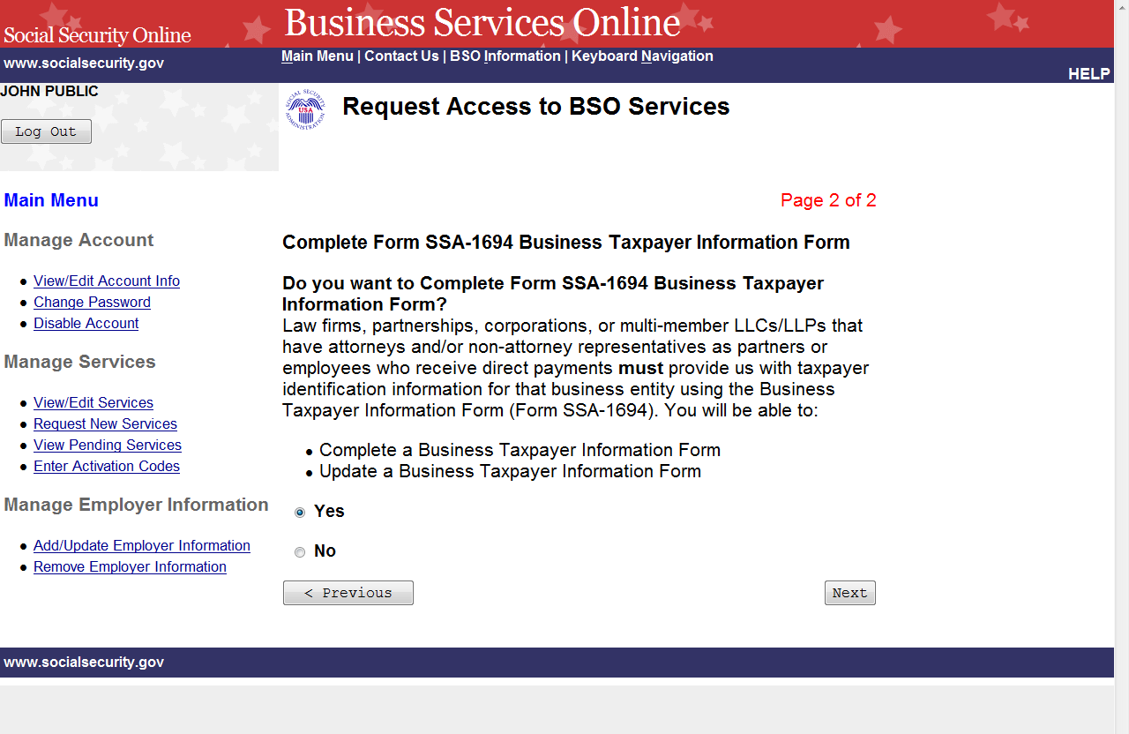

STEP 7: Request access to Complete Form SSA-1694 Business Taxpayer Information Form by selecting the “Yes” radio button and the Next button. The system displays the Request Summary page. (To return to the Employer Information page of the adding services wizard, select the Previous button at the bottom of the page. To return to the Business Services Online Main Menu without adding services, select Main Menu on the second line of the page header.)

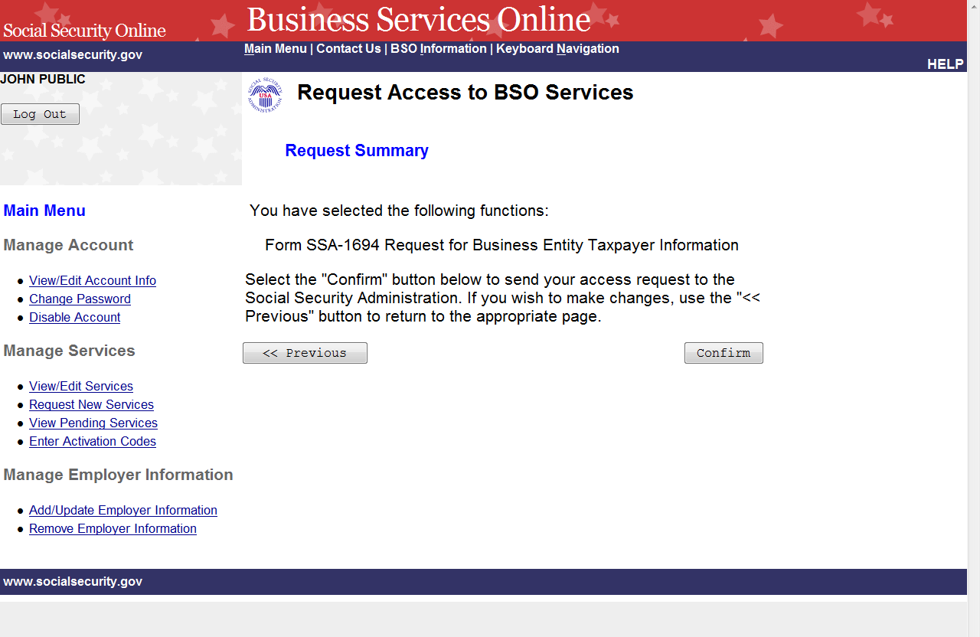

STEP 8: Review the list of services and select the Confirm button to submit your access request. The system will display the Request Access to BSO Services Confirmation page. (To return to the Complete Form SSA-1694 Business Taxpayer Information Form page of the adding services wizard, select the Previous button at the bottom of the page. To return to the Business Services Online Main Menu without adding services, select Main Menu on the second line of the page header.)
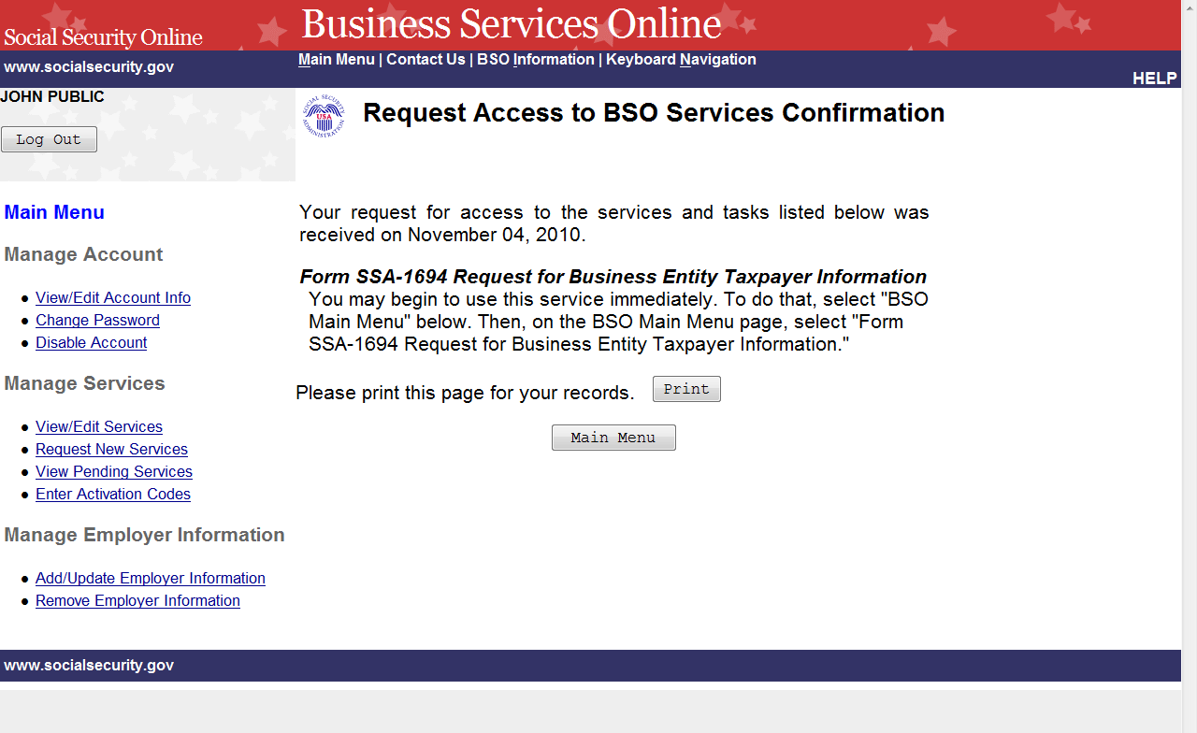
STEP 9: The confirmation screen shows the selected service. A print button may be selected to print the confirmation. To return to the Main Menu, select the Main Menu button.

LESSON 13: REQUEST INTERNET REPRESENTATIVE PAYEE SUITE

Follow the instructions below to request services in the Internet Representative Payee Suite. Note that the request to this suite can be combined with requests to other services. For guidance in accessing a different suite(s), refer to another lesson(s) in this Tutorial that specifically addresses that service(s).

STEP 1: Point your browser to the Business Services Online Welcome page: www.socialsecurity.gov/bso/bsowelcome.htm.

STEP 2: Select the Login button on the Business Services Online Welcome page. The system displays the Log In to Online Services page.

STEP 3: Under the Existing User? column, enter your User ID and password. Read the terms stated under the User Certification heading. You must agree to these conditions by checking the “I have read & agree to these terms.” checkbox to proceed. Select the Log In button. The system displays the Business Services Online Main Menu page. (To return to the Business Services Online Welcome page, select the BSO Welcome link on the page footer.)

NOTE
The menu selection on your BSO Main Menu is unique to you and presents only the applications and services to which you have access.

STEP 4: Under the Manage Services section in the left navigation panel, select the Request New Services link. The system displays the Request Access to BSO Services page. (To return to the Business Services Online Welcome page, select the Logout button.)

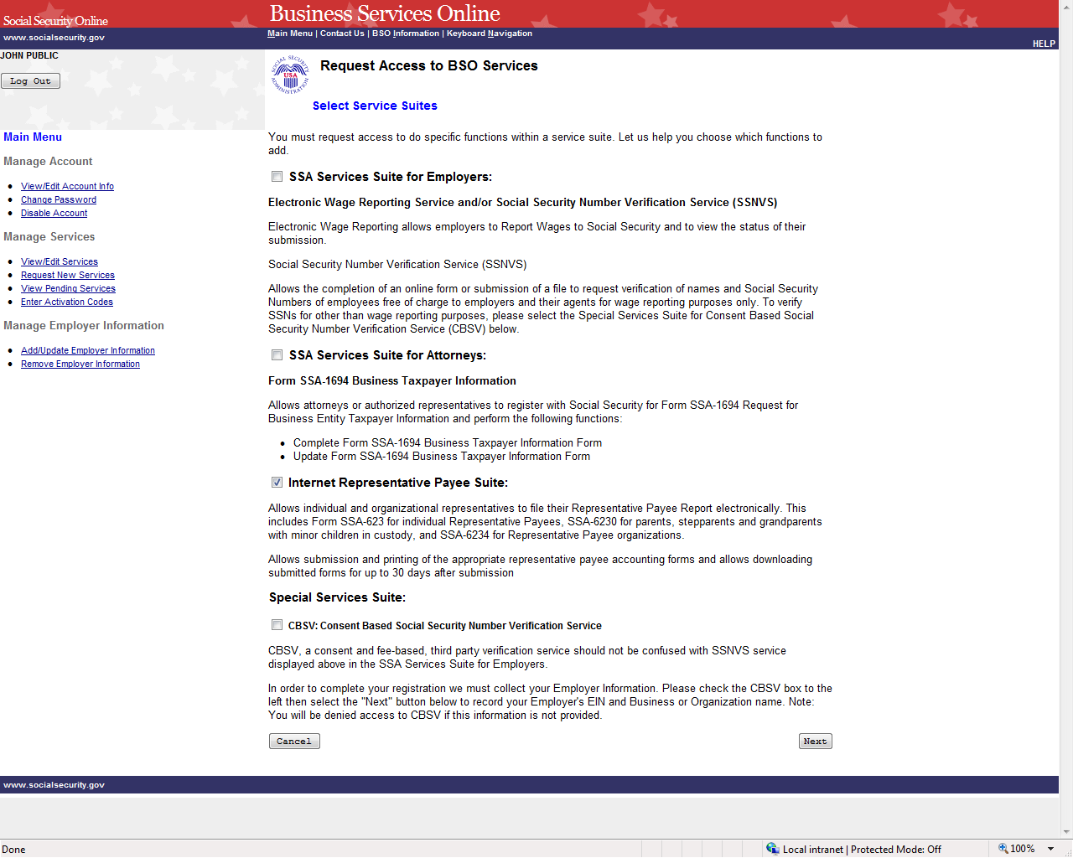

STEP 5: Continue with this lesson if you wish to request access to the Internet Representative Payee Suite. If a different or additional suite(s) of services is needed, refer to another lesson that specifically addresses requesting that suite.

Check the checkbox saying “Internet Representative Payee Suite:” and select the Next button. The system displays the Internet Representative Payee page of the adding services wizard. (To return to the Business Services Online Main Menu page, select the Cancel button.)

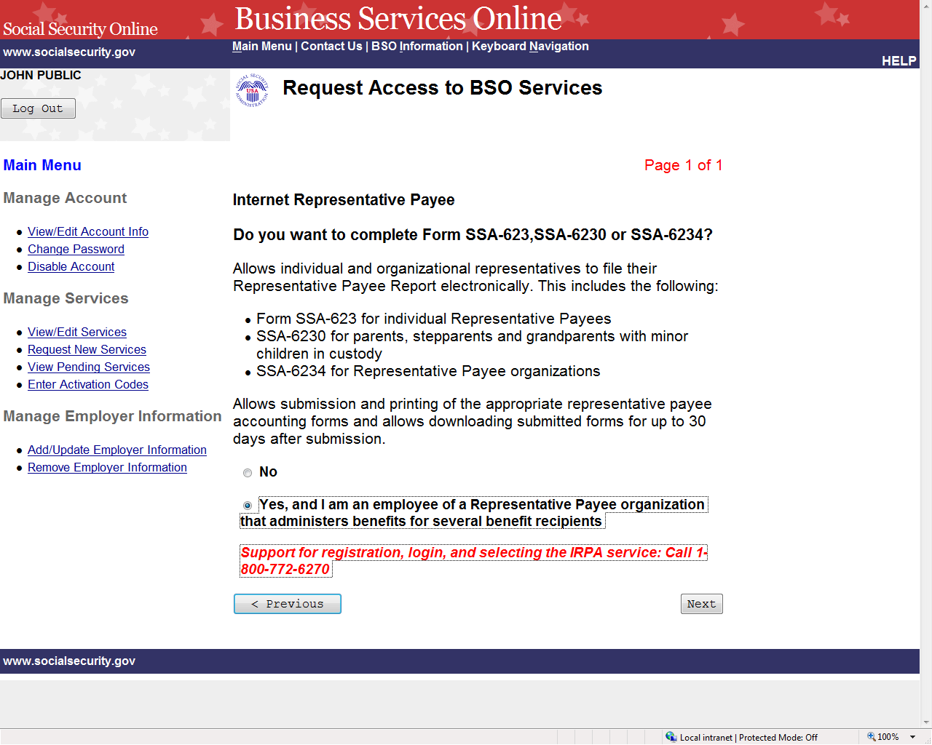

STEP 6: Request access to complete the forms to file the Representative Payee Report electronically by selecting the “Yes” radio button and the Next button. The system displays the Request Summary page. (To return to the Select Access to BSO Services page, select the Previous button at the bottom of the page. To return to the Business Services Online Main Menu without adding services, select Main Menu on the second line of the page header.)
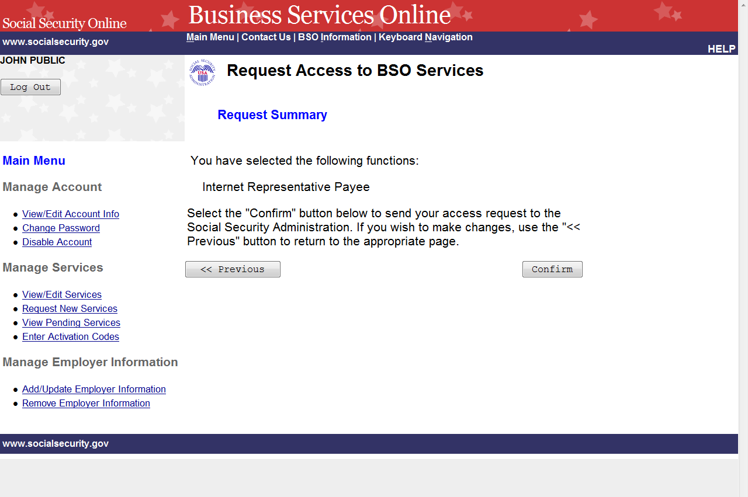

STEP 7: Select the Confirm button to submit your access request. The system will display the Request Access to BSO Services Confirmation page. (To return to the Internet Representative Payee page of the adding services wizard, select the Previous button at the bottom of the page. To return to the Business Services Online Main Menu without adding services, select Main Menu on the second line of the page header.)
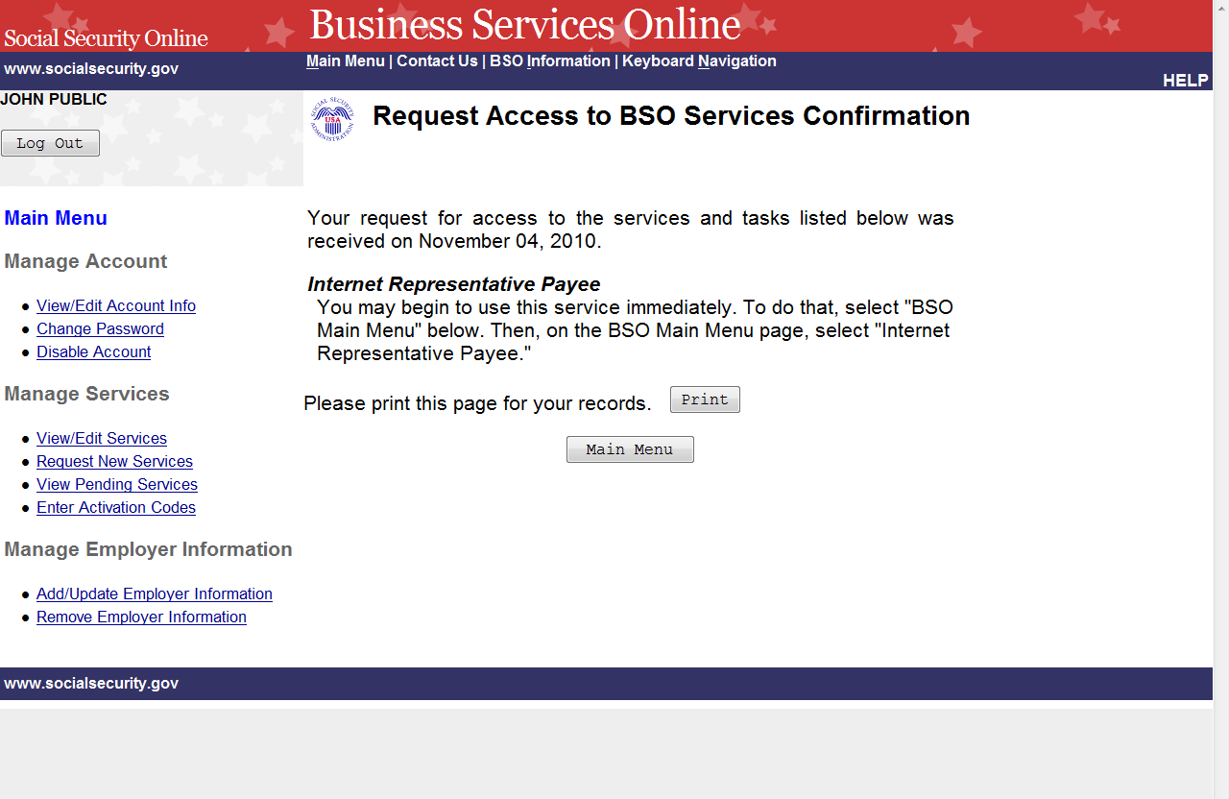
STEP 8: The confirmation screen informs you that you may begin to use this service immediately. To return to the Main Menu, select the Main Menu button.

LESSON 14: RE-REQUEST ACTIVATION CODES

Follow the instructions below to re-request activation codes for BSO services. Use this option if you have not received your activation codes from Social Security or if you have misplaced them. You may re-request activation codes if it has been at least 10 days since you requested access to BSO services. If you re-request any activation codes, previously issued codes will no longer be valid.

STEP 1: Point your browser to the Business Services Online Welcome page: www.socialsecurity.gov/bso/bsowelcome.htm.

STEP 2: Select the Log In button on the Business Services Online Welcome page. The system displays the Log In to Online Services page.

STEP 3: Under the Existing User? column, enter your User ID and password. Read the terms stated under the User Certification heading. You must agree to these conditions by checking the “I have read & agree to these terms.” checkbox to proceed. Select the Log In button. The system displays the Business Services Online Main Menu page. (To return to the Business Services Online Welcome page, select the BSO Welcome link in the page footer.)

NOTE

The menu selection on your BSO Main Menu is unique to you and presents only the applications and services to which you have access.

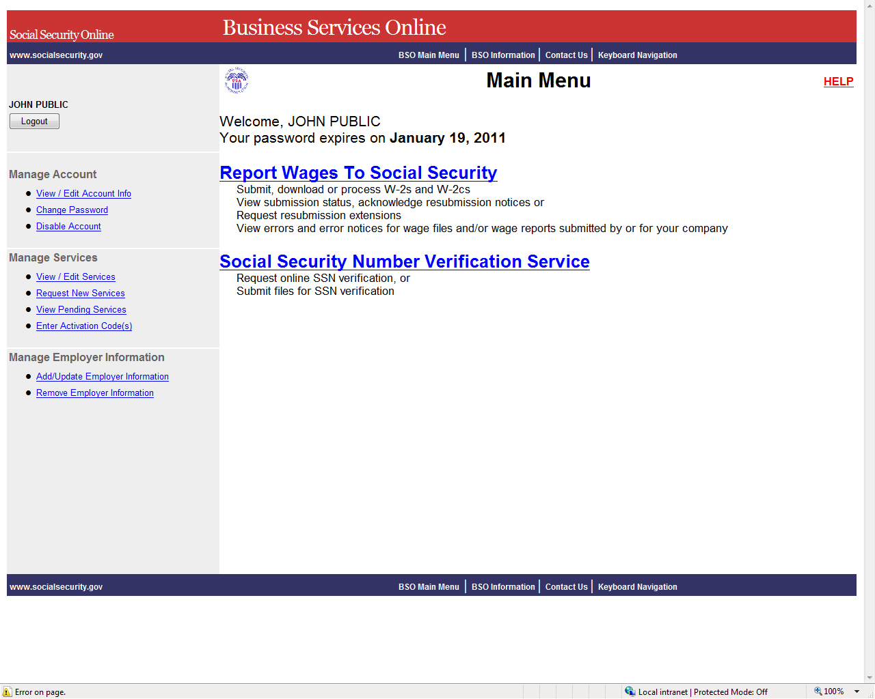

STEP 4: Under the Manage Services section of the left navigation panel, select the View Pending Services link. The system displays the Re-Request Activation Codes page. This page lists the services for which you are awaiting activation codes.

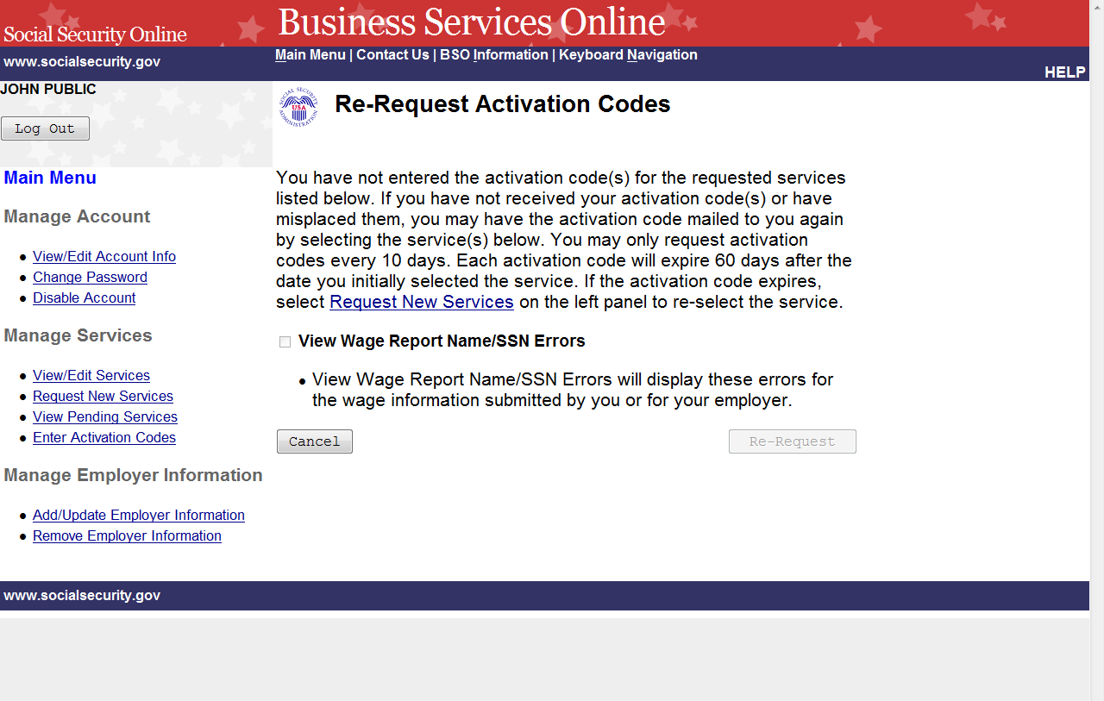

STEP 5: The actions you can take at this time will depend on when you last requested access to a service.
  - If it has not been at least 10 days since you requested the access to the service(s), you will not be able to re-request your activation code(s) at this time.
  - If it has been more than 60 days since you requested the access to the service(s), you will need to re-request access to the service(s) by selecting the Request Access to BSO Services link in the first paragraph of the current page.
  - If it has been between 10 and 60 days since you requested the access to the service(s), you may select the checkbox(es) of the service(s) and select the Re-Request button. The system displays the View Pending Services – Confirmation of Activation Code Notice Re-Request page.

(Select the Cancel button to return to the Business Services Online Main Menu without re-requesting any activation codes. To return to the Business Services Online Main Menu, select the BSO Main Menu link in the second line of the page header.)

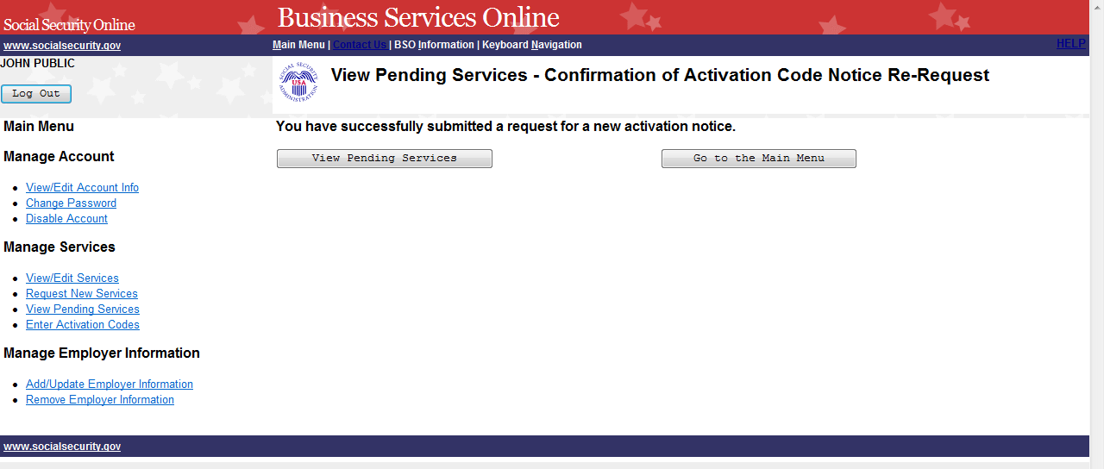

STEP 6: Select the View Pending Services button to return to the Re-Request Activation Codes page. To return to the Business Services Online Main Menu, select the Go to the Main Menu button.

LESSON 15: ENTER ACTIVATION CODE(S)

Follow the instructions below to enter the activation codes received by you directly or from your employer. Certain services that you requested require you to enter an activation code before you can use the online service.

STEP 1: Point your browser to the Business Services Online Welcome page: www.socialsecurity.gov/bso/bsowelcome.htm.

STEP 2: Select the Login button on the Business Services Online Welcome page. The system displays the Log In to Online Services page.

STEP 3: Under the Existing User? column, enter your User ID and password. Read the terms stated under the User Certification heading. You must agree to these conditions by checking the “I have read & agree to these terms.” checkbox to proceed. Select the Log In button. The system displays the Business Services Online Main Menu page. (To return to the Business Services Online Welcome page, select the BSO Welcome link in the page footer.)

NOTE
The menu selection on your BSO Main Menu is unique to you and presents only the applications and services to which you have access.

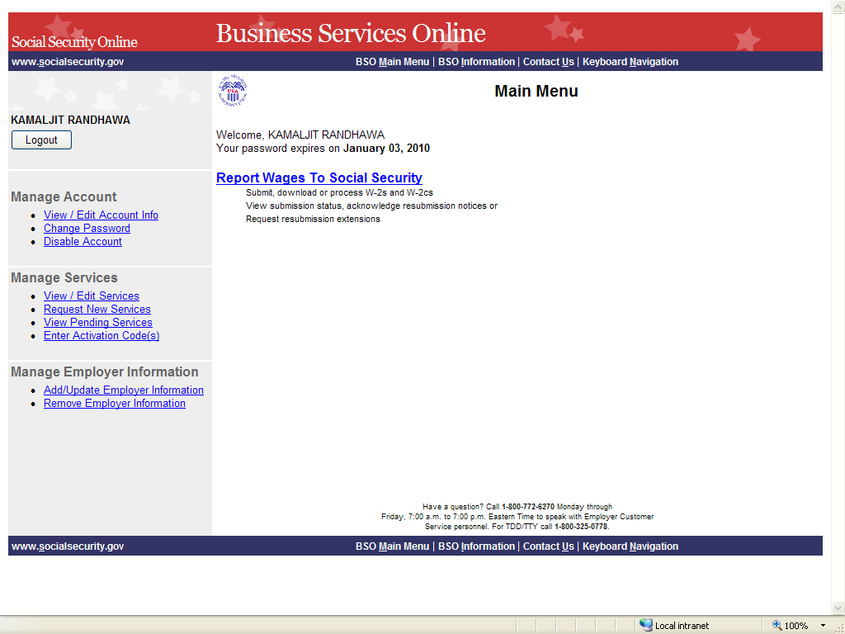

STEP 4: Select the Enter Activation Code(s) link on the left navigation panel. The system displays the Enter Activation Code(s) page. (Select the Cancel button to return to the Business Services Online Main Menu page without activating a service.)

NOTE
If you have more than one activation code to enter, repeat Steps 4 and 5.

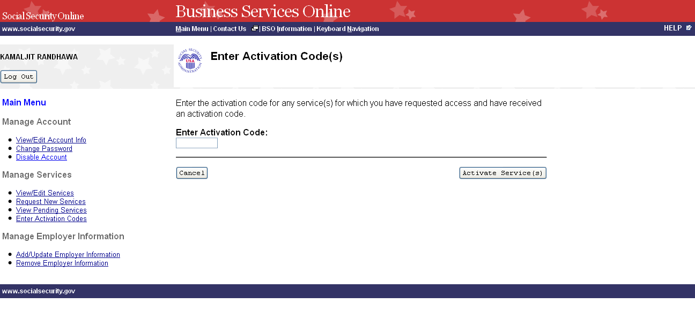
STEP 5: Enter the activation code in the Enter Activation Code field and select the Activate Service(s) button. The system displays the Enter Activation Code(s) – Confirmation page. (Select the Cancel button to return to the Business Services Online Main Menu page without activating a service.)

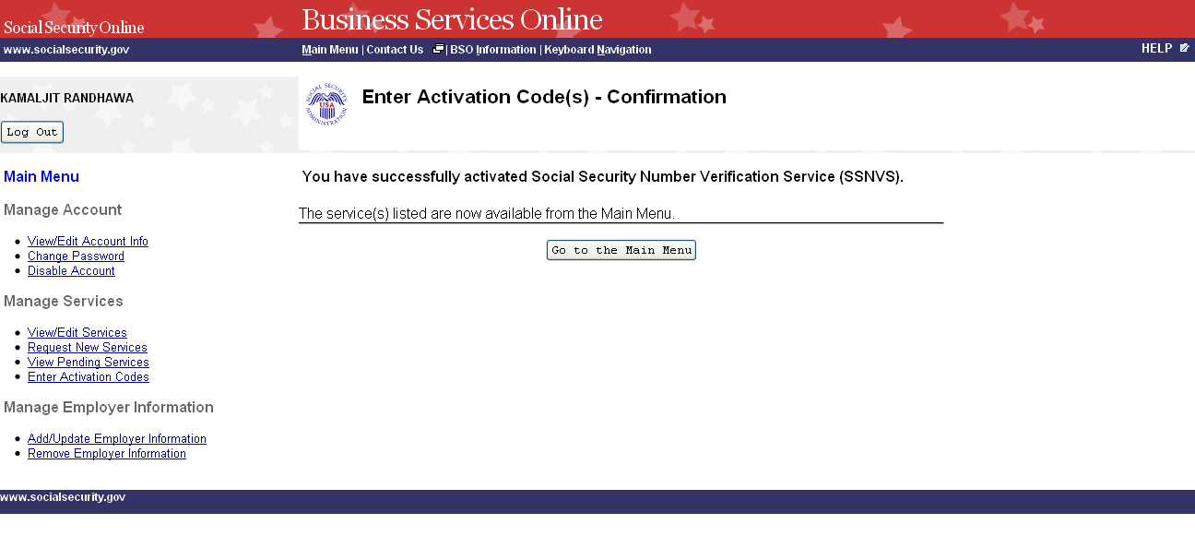
STEP 6: Select the Go to the Main Menu button to return to the Business Services Online Main Menu page. The activated service will be listed.

LESSON 16: ADD EMPLOYER INFORMATION

Follow the instructions below to add employer information. Employer information is required in order to request certain business services.

STEP 1: Point your browser to the Business Services Online Welcome page: www.socialsecurity.gov/bso/bsowelcome.htm.

STEP 2: Select the Log In button on the Business Services Online Welcome page. The system displays the Log In to Online Services page.

STEP 3: Under the Existing User? column, enter your User ID and password. Read the terms stated under the User Certification heading. You must agree to these conditions by checking the “I have read & agree to these terms.” checkbox to proceed. Select the Log In button. The system displays the Business Services Online Main Menu page. (To return to the Business Services Online Welcome page, select BSO Welcome link in the page footer.)

NOTE
The menu selection on your BSO Main Menu is unique to you and presents only the applications and services to which you have access.

STEP 4: Select the Add/Update Employer Information link from the left navigation panel. The system displays the Employer Information Attestation page. (Select the Logout button to return to the Business Services Online Welcome page.)

NOTE

Certain services require Employer information to have been added before you request the service. If you have not previously added Employer information, the Request Access to BSO Services page is re-displayed with the message “Employer Information is required for the selected suite(s). Please select this link Add Your Employer Information to continue.” When you select the link, the system displays the Employer Information Attestation page.

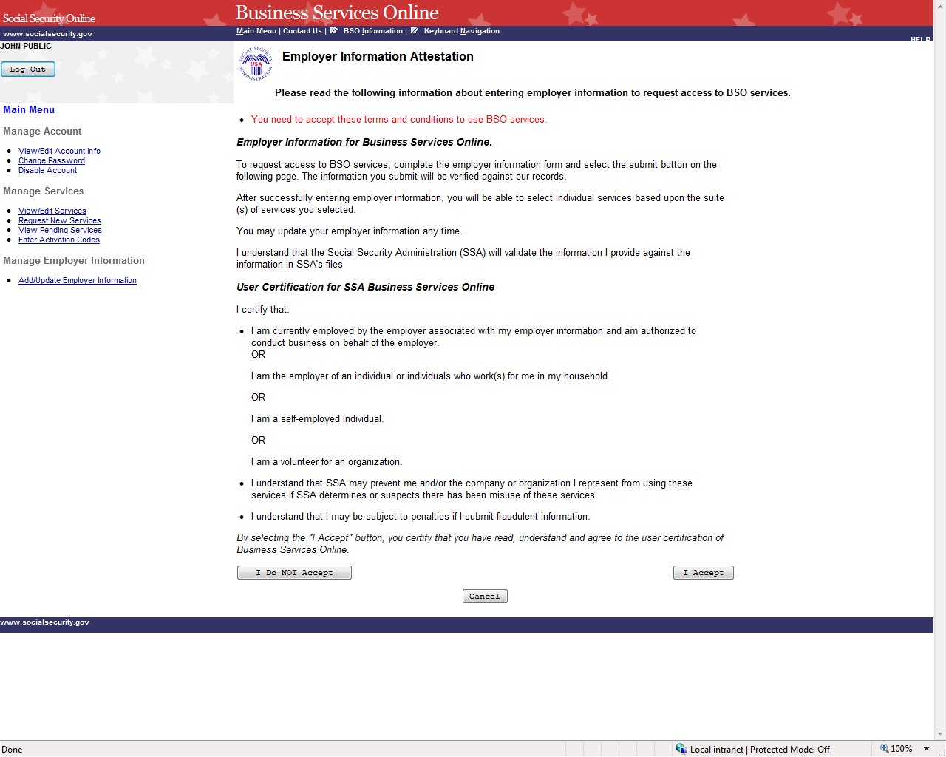

STEP 5: Read the statements located under the User Certification for Business Services Online heading. You must agree to these terms by selecting the I Accept button to proceed. The system displays the Add Employer Information page.

(Selecting the I Do NOT Accept button will display again the Employer Information Attestation page with the message in red “You need to accept these terms and conditions to use BSO services.”)

(Select the Cancel button to return to the Business Services Online Main Menu page. To return to the BSO Welcome page, select the Log Out button.)
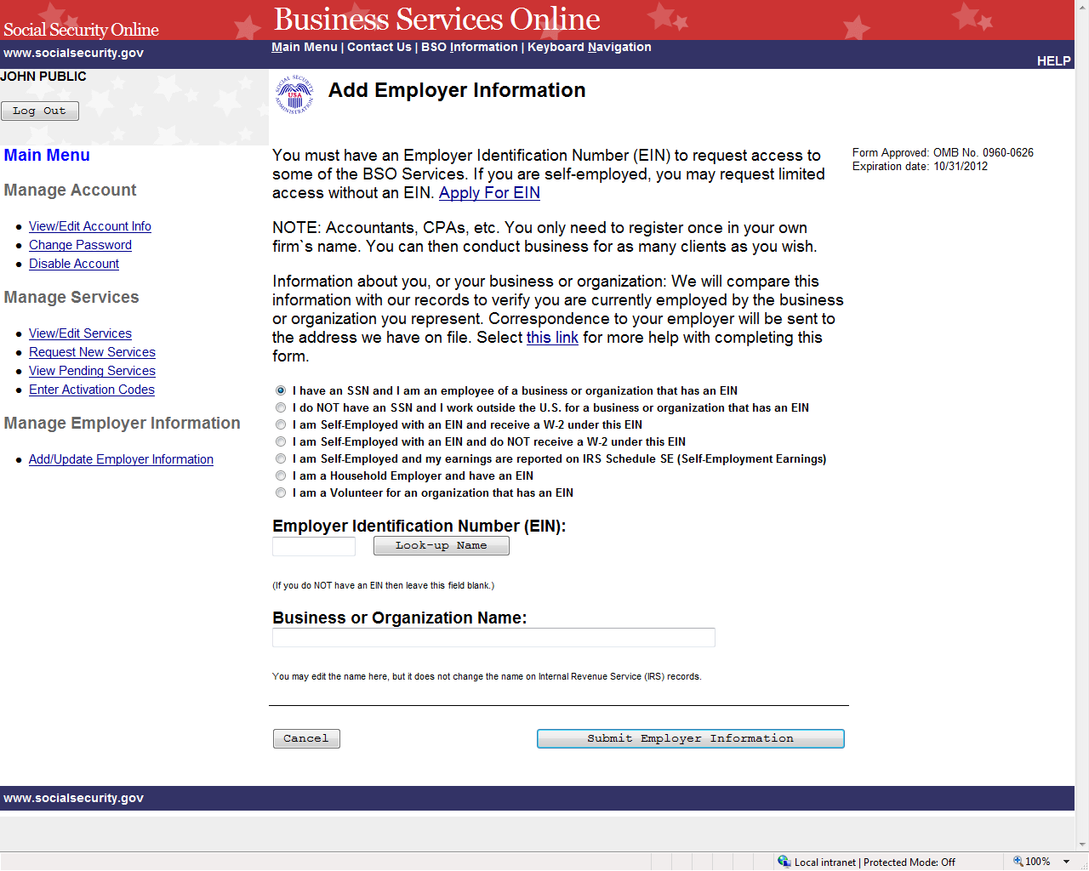

STEP 6: Select the radio button beside the description that best describes you and enter the Employer Identification Number (EIN) and Business or Organization Name.

TIPS
  - Do not enter dashes in the EIN.

  - If you do not have an EIN, leave the EIN field blank.

STEP 7: The look-up button may be used to retrieve the name of the business or organization that the IRS has provided to SSA to help you verify that the entered EIN is yours. You may edit the name, but it does not change the name on Internal Revenue Service (IRS) records. Select the Submit Employer Information button to process the employer information. The system displays the Add Your Employer Information Successful page. (Select the Cancel button to return to the Business Services Online Main Menu page. To return to the BSO Welcome page, select the Log Out button.)

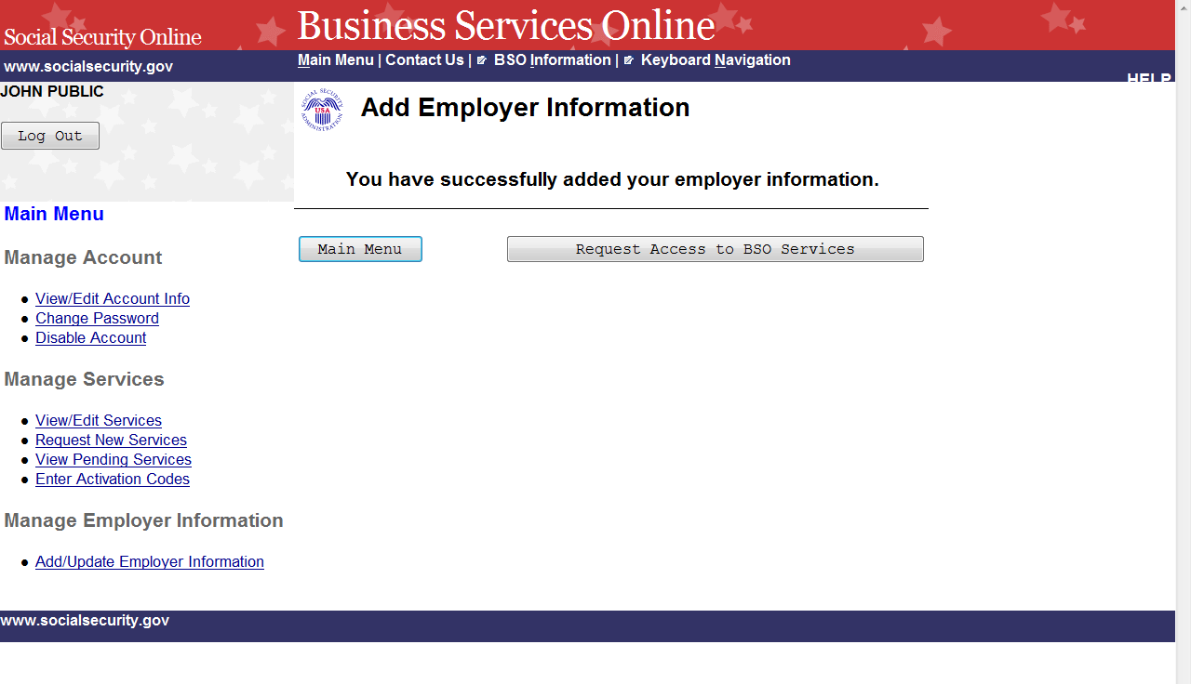
STEP 8: Select the Request Access to BSO Services button to select services you need to access. The system displays the Request Access to BSO Services page. (Select the Main Menu button to return to the Business Services Online Main Menu page. To return to the BSO Welcome page, select the Logout link.)

LESSON 17: UPDATE EMPLOYER INFORMATION

Follow the instructions below to update employer information. To change your Employer Identification Number (EIN) you must first "Remove Your Employer Information" which will deactivate all active services with this employer and then re-request services by selecting the Request New Services link under the Manage Services section on the left navigation panel.

STEP 1: Point your browser to the Business Services Online Welcome page: www.socialsecurity.gov/bso/bsowelcome.htm.

STEP 2: Select the Log In button on the Business Services Online Welcome page. The system displays the Log In to Online Services page.

STEP 3: Under the Existing User? column, enter your User ID and password. Read the terms stated under the User Certification heading. You must agree to these conditions by checking the “I have read & agree to these terms.” checkbox to proceed. Select the Log In button. The system displays the Business Services Online Main Menu page. (To return to the Business Services Online Welcome page, select BSO Welcome link in the page footer.)

NOTE
The menu selection on your BSO Main Menu is unique to you and presents only the applications and services to which you have access.

STEP 4: Select the Add/Update Employer Information link from the left navigation panel. The system displays the Update Your Employer Information page. (Select the Logout button to return to the Business Services Online Welcome page.)

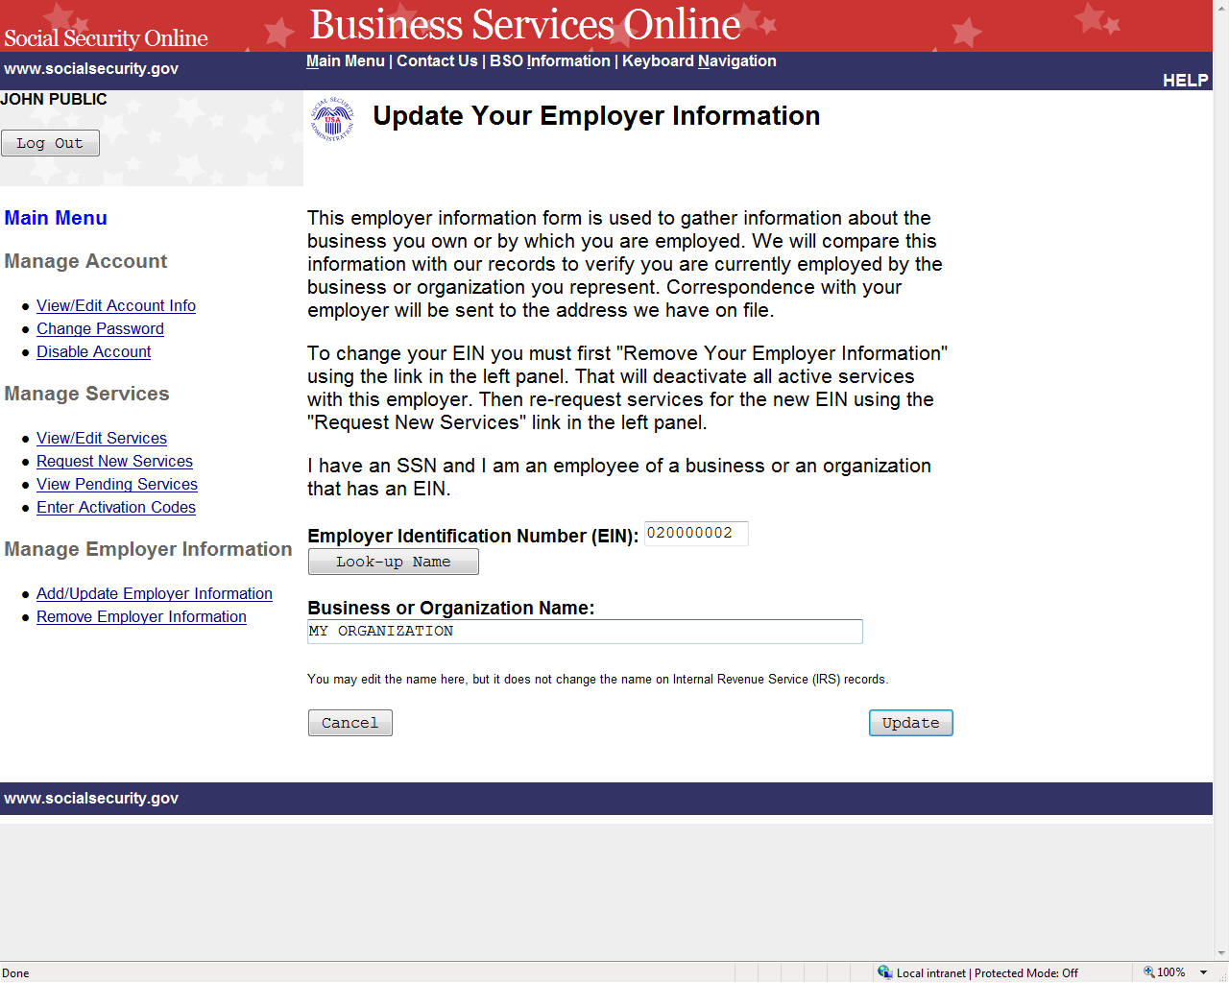

STEP 5: Change any information and select the Update to submit the changes. The system displays the Update Your Employer Information Successful page. (Select the Cancel button to return to the Business Services Online Main Menu page without submitting any changes).

NOTE
Changing the EIN will deactivate all active services with this employer. To request services for this different employer, select the Request New Services link under the Manage Services section on the left navigation panel.

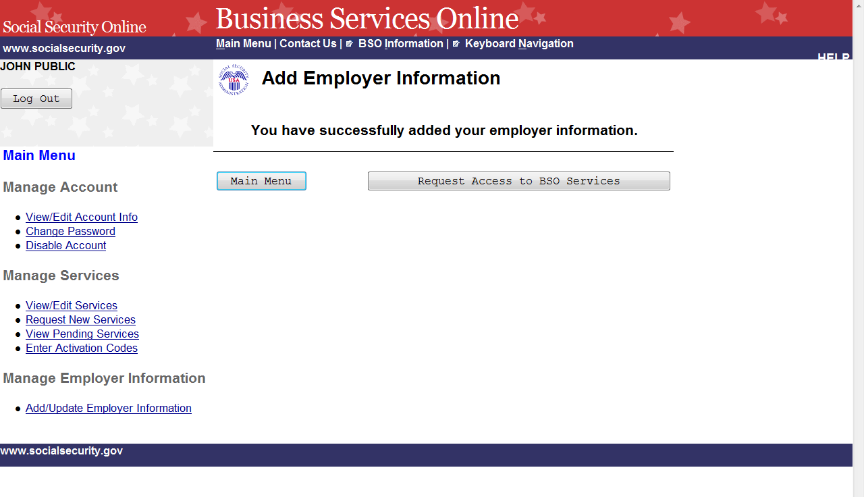

STEP 6: Select the Main Menu button to return to the Business Services Online Main Menu.

LESSON 18: REMOVE EMPLOYER INFORMATION

Follow the instructions below to remove employer information. Removing this employer information will cause the services for this employer to be deactivated.

STEP 1: Point your browser to the Business Services Online Welcome page: www.socialsecurity.gov/bso/bsowelcome.htm.

STEP 2: Select the Log In button on the Business Services Online Welcome page. The system displays the Log In to Online Services page.

STEP 3: Under the Existing User? column, enter your User ID and password. Read the terms stated under the User Certification heading. You must agree to these conditions by checking the “I have read & agree to these terms.” checkbox to proceed. Select the Log In button. The system displays the Business Services Online Main Menu page. (To return to the Business Services Online Welcome page, select BSO Welcome link in the page footer.)

NOTE
The menu selection on your BSO Main Menu is unique to you and presents only the applications and services to which you have access.

STEP 4: Under the Manage Employer Information section of the left navigation panel, select the Remove Employer Information link. The system displays the Remove Your Employer Information page. (Select the Logout button to return to the Business Services Online Welcome page.)

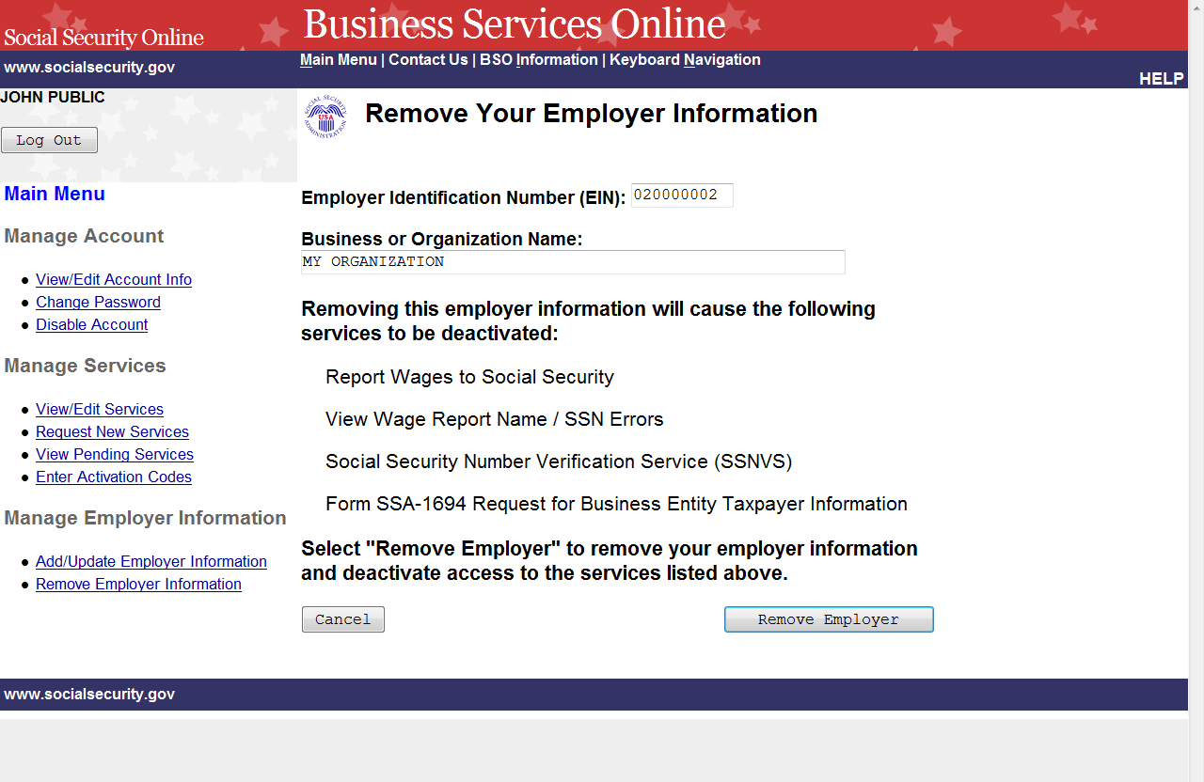
STEP 5: Select the Remove Employer button to submit the changes. The system displays the Remove Your Employer Information Successful page. (Select the Cancel button to return to the Business Services Online Main Menu page without removing the employer.)
NOTE
Removing this employer information will cause the listed services to be deactivated.

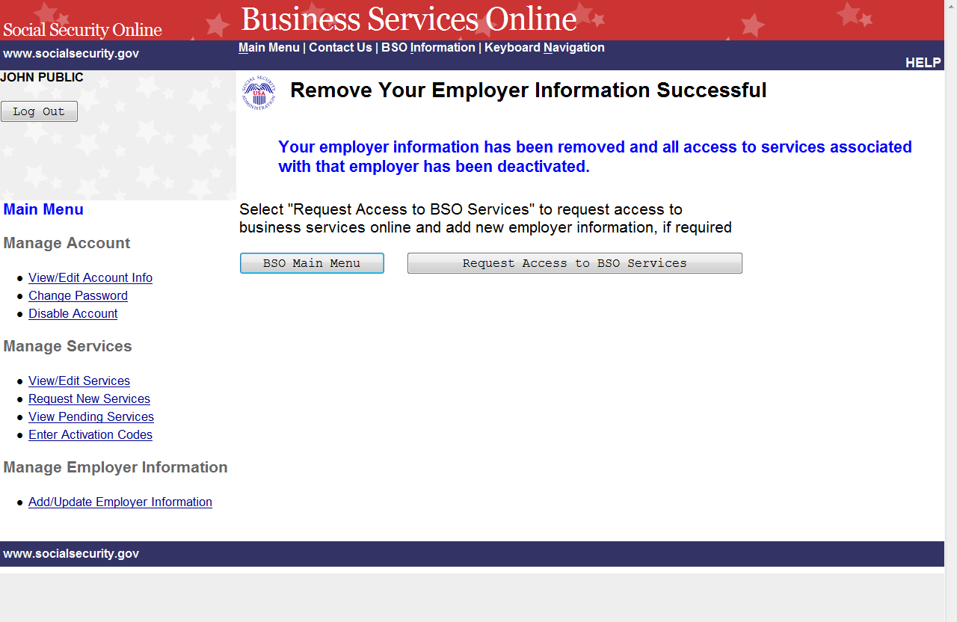

STEP 6: Select the Request Access to BSO Services button to request new services for a different employer. To return to the Business Services Online Main Menu, select the BSO Main Menu button.

