Tax Year 2020 W-2 Online Tutorial

Step-By-Step Instructions for Create/Resume Forms W-2 Online
- Select “MENU” on the Social Security home page, then select Business Services to go to the “Business Services” page. On the “Business Services” page, select Log in or Use Business Services Online button to go to the “Business Services Online” page.
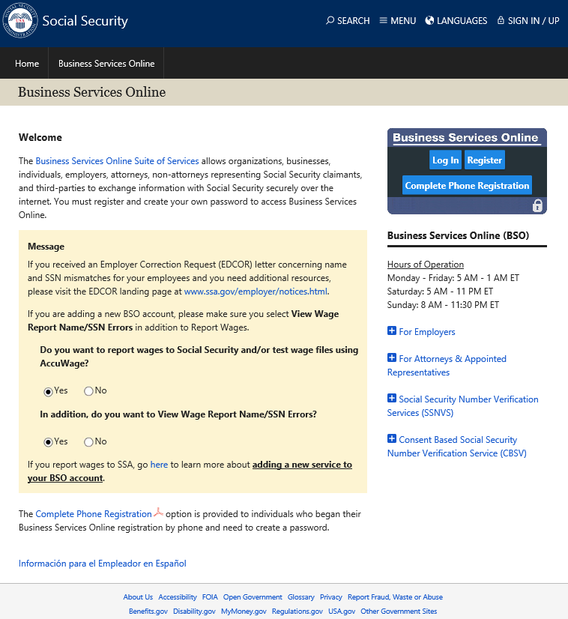
- Select the Log In button on the “Business Services Online” page. The system displays the “Log In to Online Services” page.
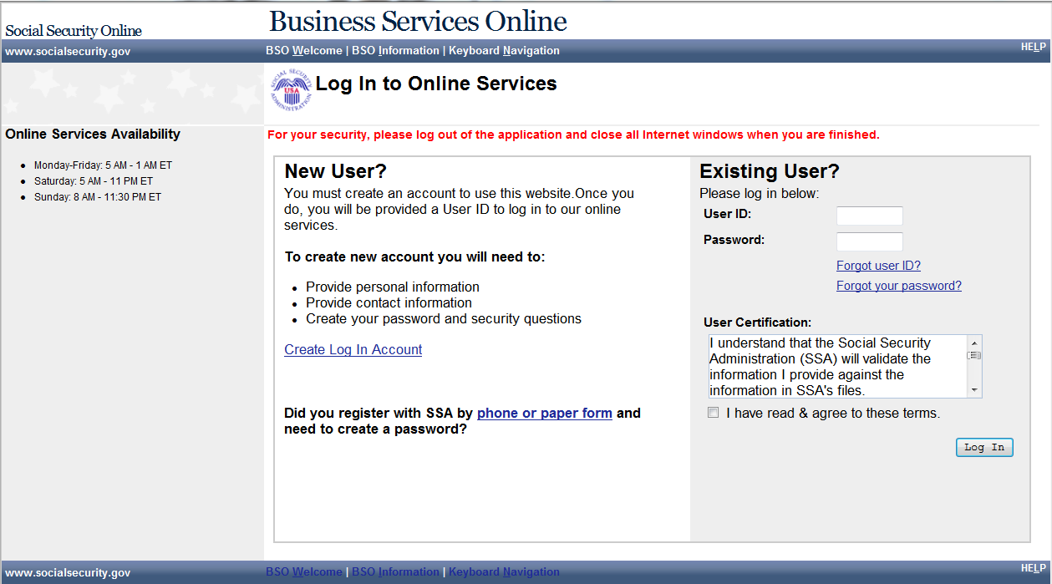
- Enter your User ID and Password.
- Select the I have read & agree to these terms check box on the “Log In to Online Services” page.
  - Select the Log In button to display the BSO “Main Menu” page.
  - To return to the “Business Services Online” page, select the BSO Welcome link at the top or bottom of the page.

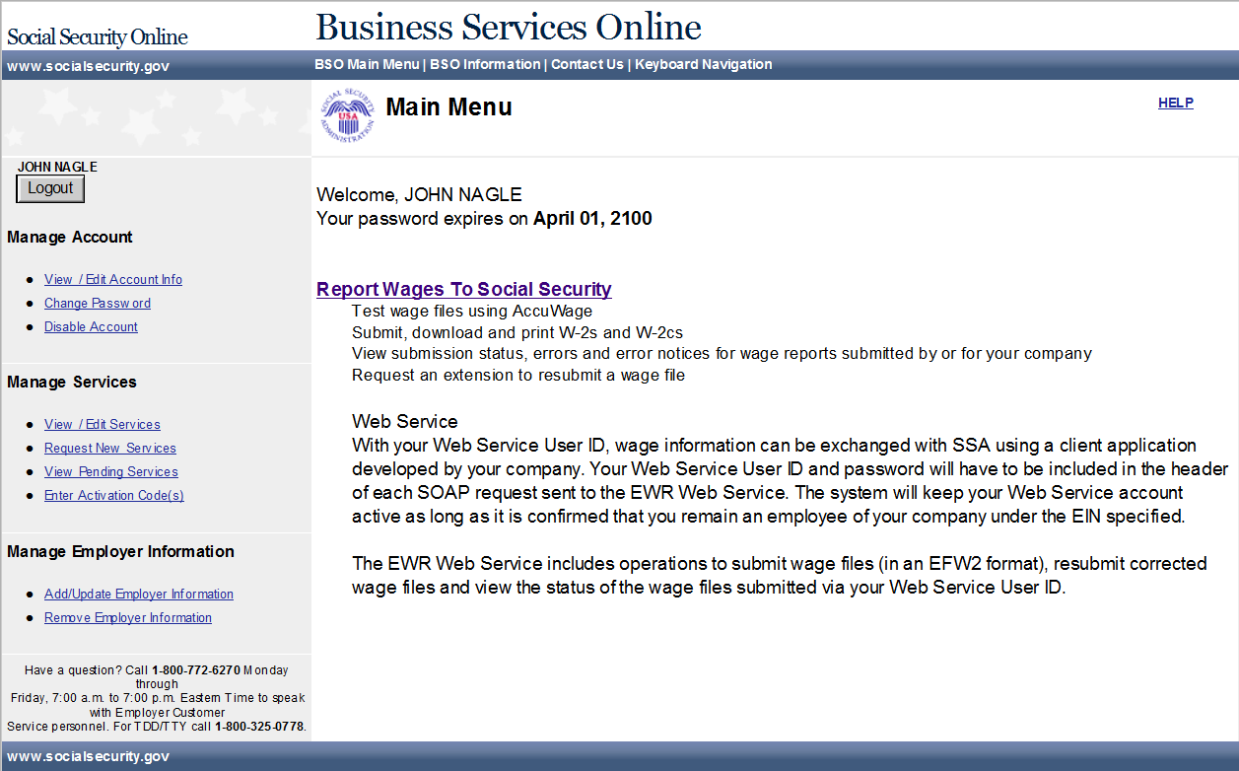
- Select the Report Wages To Social Security link on the BSO “Main Menu” page. The system displays the “Wage Reporting Attestation” page.
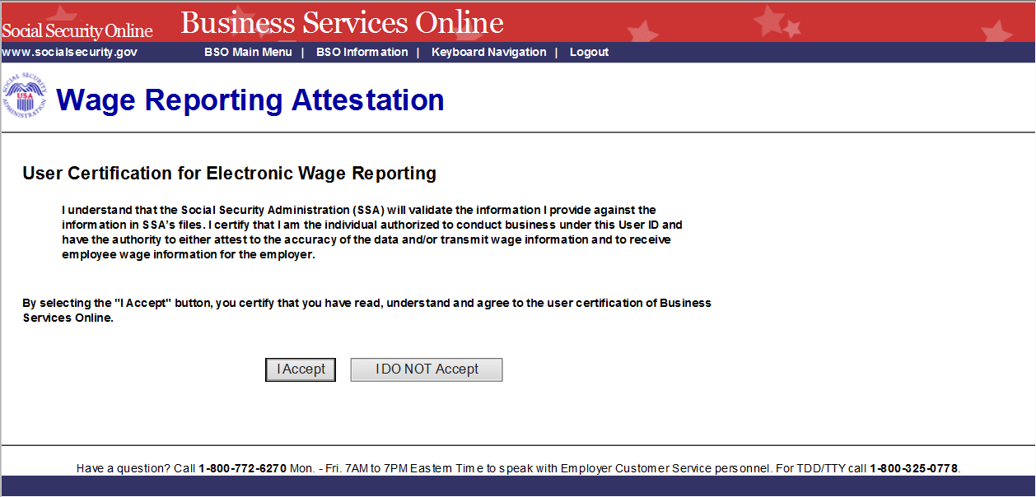
- Select the I Accept button on the “Wage Reporting Attestation” page to go to the “EWR home” page. To return to the BSO “Main Menu” page, select the I DO NOT Accept button.
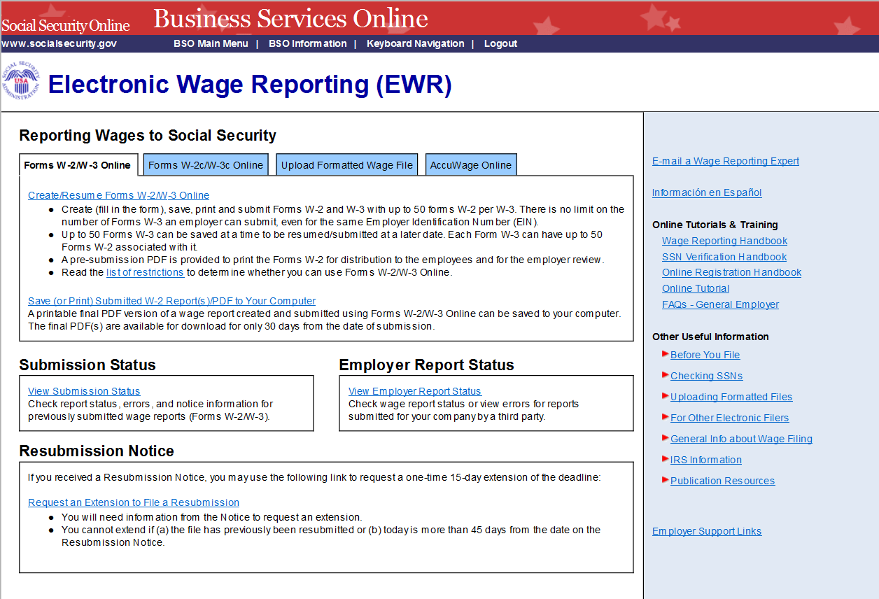
- On the EWR home page:
  - Forms W-2/W-3 Online tab is default.
  - Select the Create/Resume Forms W-2/W-3 Online link. If there are no unsubmitted reports, the system displays the “Before You Create Your Form(s) W-2/W-3” page. If there are unsubmitted Forms W-2/W-3, the system displays the Forms W-2/W-3 Online “Unsubmitted Reports” page.
Note: You may have a maximum of fifty unsubmitted reports at one time. When you have reached the fifty “saved” report limit, you must first submit at least one of the unsubmitted reports in order to be able to start a new report. If there are forty-nine or fewer reports, you may continue without submitting the existing reports.

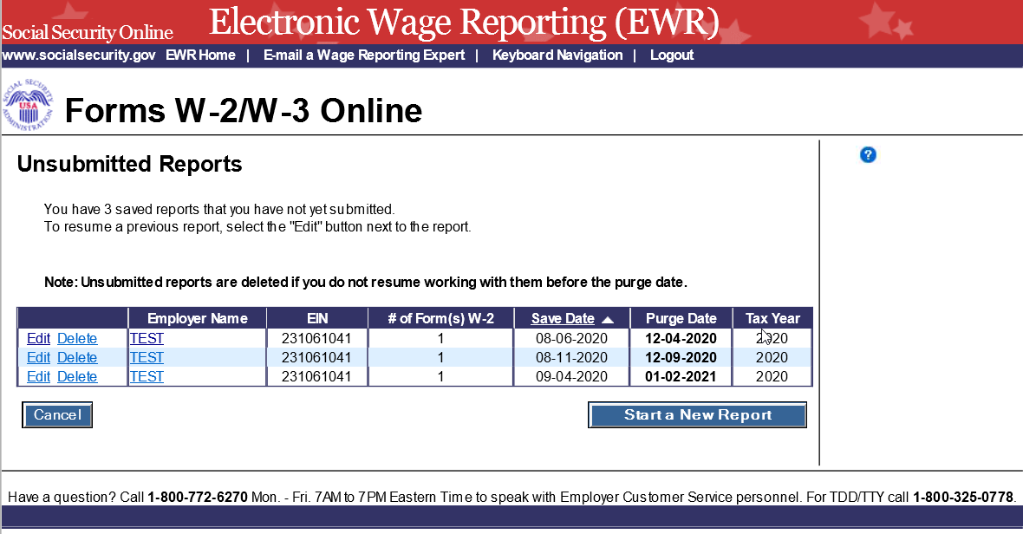
- On the Unsubmitted Reports page:
  - Select the Start a New Report button. The system displays the “Before You Create Your Form(s) W-2/W-3” page.
  - Select the Edit link or the Employer Name link to go to the “W-2 List for this Submission” page.
  - Select the Delete link to delete an unsubmitted report. The “Are you sure you want to delete the unsubmitted report?” page will be displayed.
  - Select the Cancel button to return to the EWR home page.

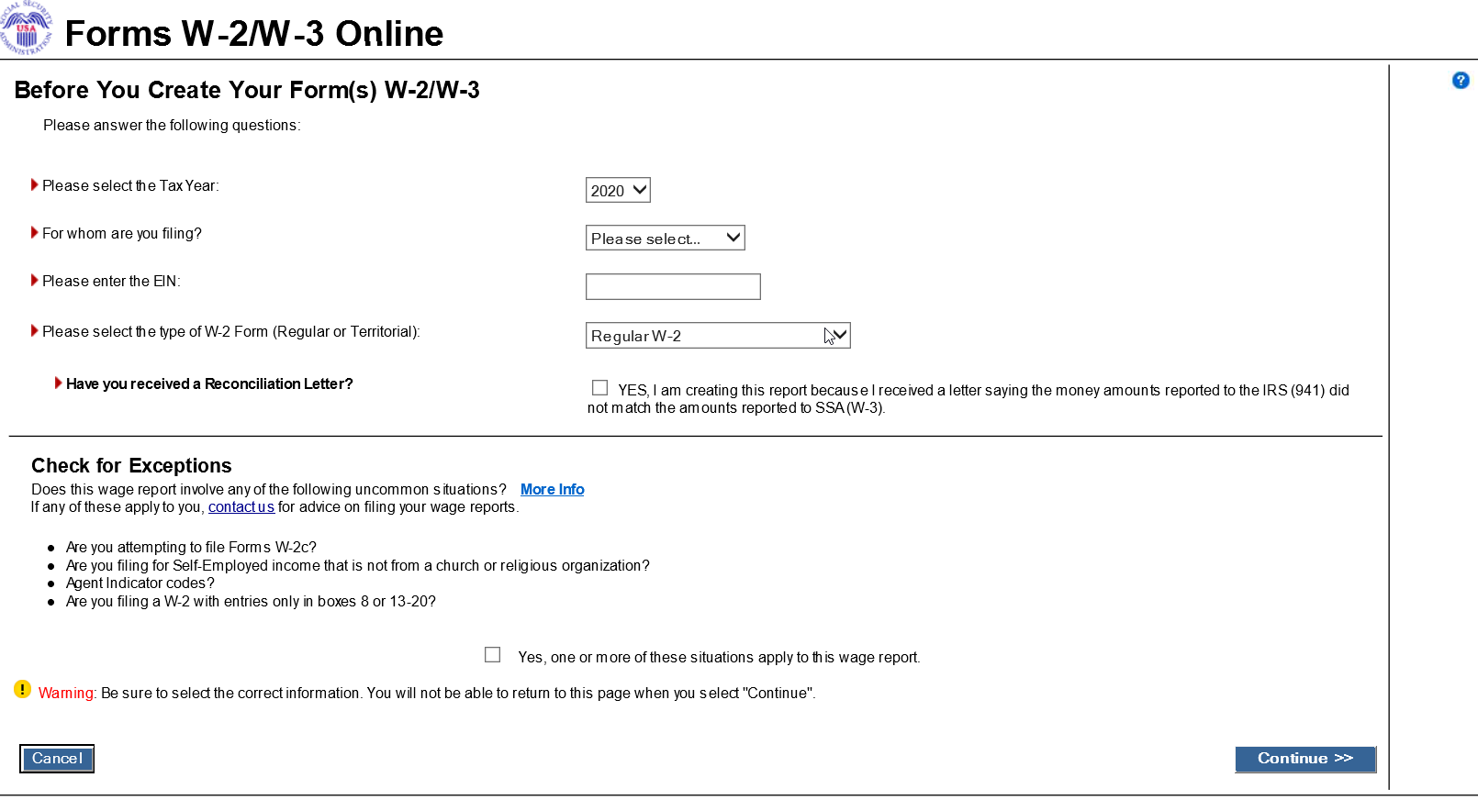
- On the Before You Create Your Form(s) W-2/W-3 page:
  - Provide correct information related to Tax Year, company name, EIN and the type of W-2 Form you are creating. If you received a Reconciliation Letter, select the check box.
  - If none of the situations listed in the Check for Exceptions section apply, select the Continue button to go to the “Employer Information for this Wage Report” page.
  - If any of the situations listed in the Check for Exception section apply, select the check box and the Continue button to go to the “W-2 Online Restrictions” page.
  - Select the Cancel button to return to the EWR home page.
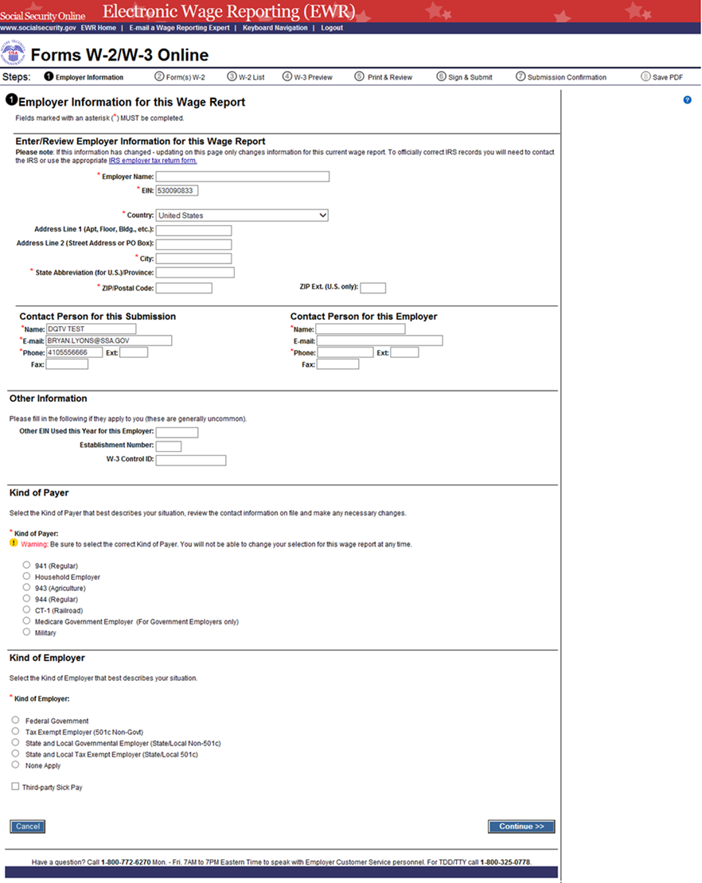
- On the Employer Information for this Wage Report page:
  - Enter or review Employer Information, Contact Person information, Other Information and select the Kind of Payer and the Kind of Employer, then select the Continue button to go to the “Enter W-2 Information” page.
  - If W-2 reports from last year exist, the system will display these reports.
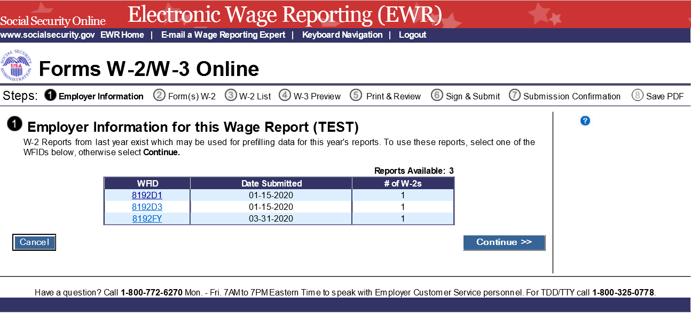
  - The user can choose to use these reports for Data Assist purpose by selecting one of the WFIDs to go to the “W-2(s) Available for WFID XXXXXX” page or choose to create a new W-2 by selecting Continue button to go to the “Enter W-2 Information” page.
  - Select the Cancel button to return to the EWR home page.
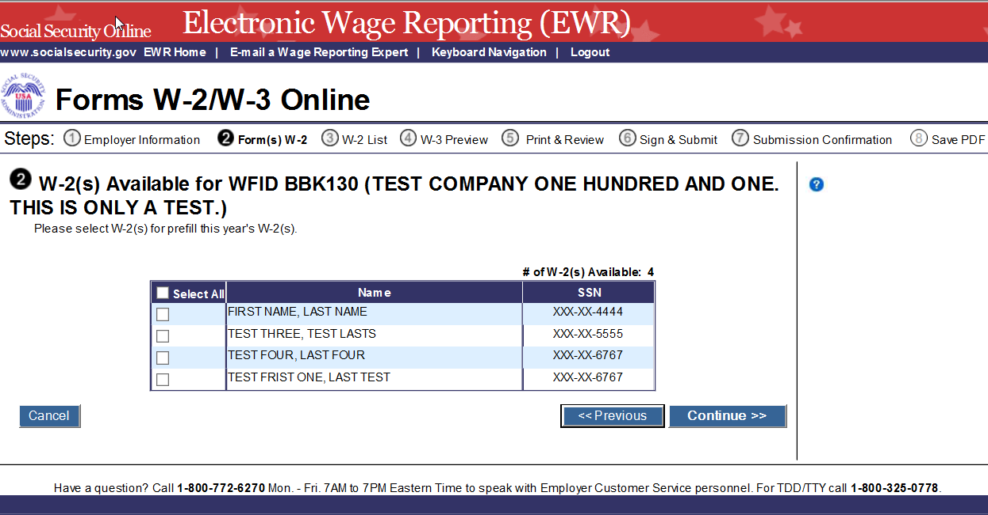
- On the W-2(s) Available for WFID XXXXXX page:
  - Select W-2(s) for prefill this year’s W-2(s), and then select the Continue button to go to the “W-2 List for this Submission” page.
  - Select the Previous button to return to the “Employer Information for this Wage Report” (with W-2 reports) page.
  - Select the Cancel button to return to the EWR home page.
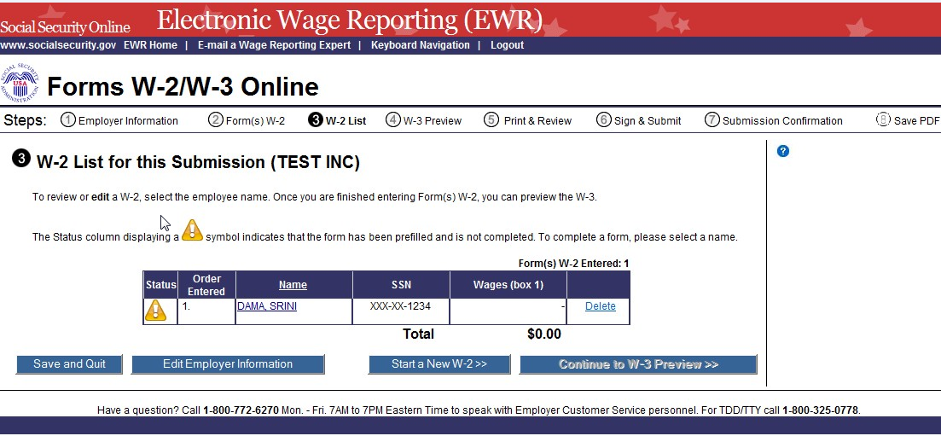
- On the W-2 List for this Submission page:
  - The Status column displaying a symbol indicates that the form has been prefilled and not completed. To complete a form, please select a name to go to the “Enter W-2 Information” page.
  - When all prefilled forms are completed, will be replaced by .

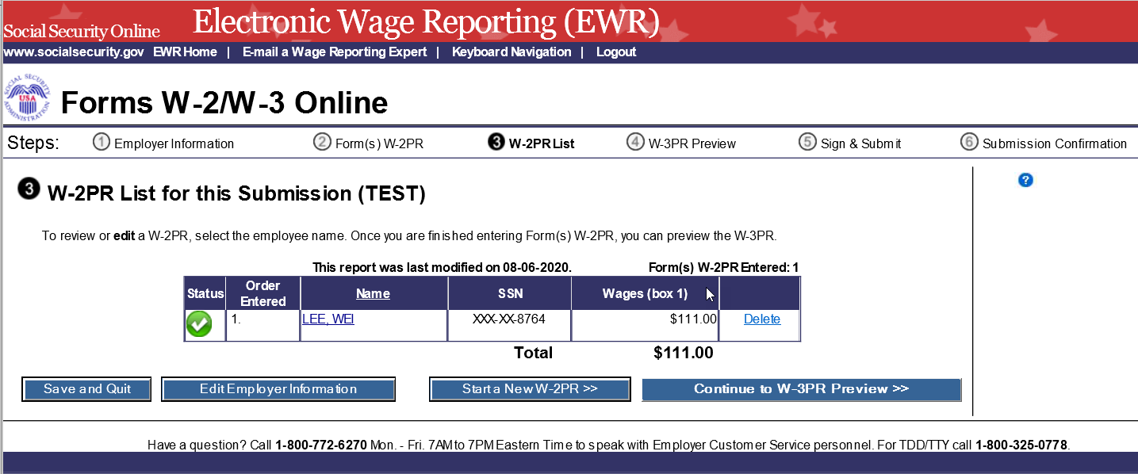
- Select a name to view and edit the W-2 data.
- Select the Delete link to delete the W-2. When you select the delete link, “Are you sure you want to delete this W-2” page will be displayed for your assistance.
- Select the Save and Quit button to exit W-2 Online without submitting your wage report to the Social Security Administration (SSA). When you select this button, “Are you sure you want to save and exit W-2 Online without submitting your annual wage report to SSA” page will be displayed for your assistance.
- Select the Edit Employer Information button to go to the “Employer Information for this Wage Report” page.
- Select the Start a New W-2 button to go to the “Enter W-2 Information” page.
- Select the Continue to W-3 Preview button to go to the “W-3 Preview for this Submission” page. If one of the prefilled forms has not been completed, the Continue to W-3 Preview button will not be active.
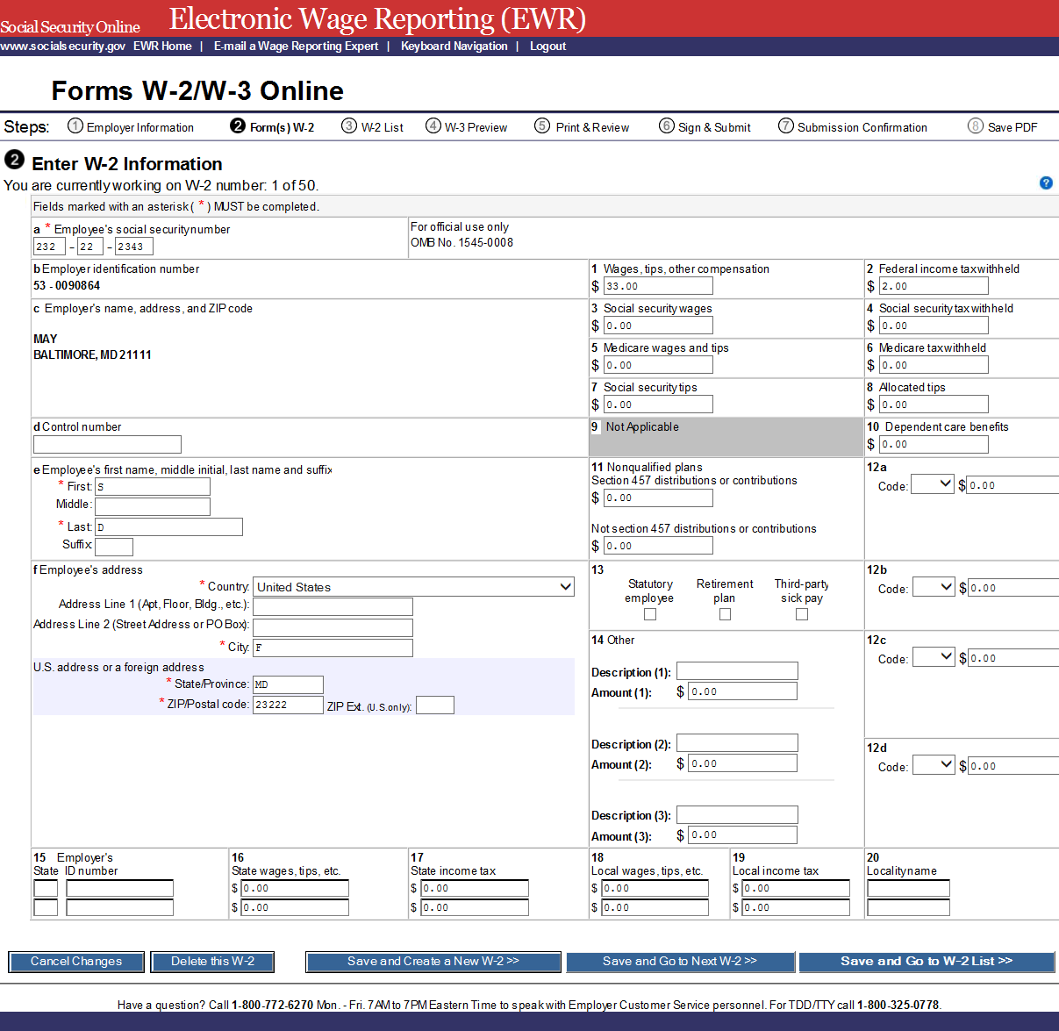
- On the Enter W-2 Information page:
  - Select the Save and Create a New W-2 button to save this W-2 information and create a new W-2. The system may display some alerts. If an alert is displayed, you may proceed by making corrections to the W-2 or by selecting the override checkbox.
  - Select the Save and Go to Next W-2 button to save this W-2 information and edit next W-2 on the W-2 List for this Submission page. The system may display some alerts. If an alert is displayed, you may proceed by making corrections to the W-2 or by selecting the override checkbox.
  - Select the Save and Go to W-2 List button when you finish creating or editing W-2s to go to the “W-2 List for this Submission” page.
Note: You can enter a maximum of fifty W-2s. The number of the current W-2 is displayed at the top of the “Enter W-2 Information” page. When entering your fiftieth W-2, the system will no longer display the Save and Create a New W-2 button.
  - Select the Cancel Changes button to discard changes made to this W-2 and go to the “W-2 List for this Submission” page.
  - Select the Delete this W-2 button: If the form has been saved previously, the system will display the “Are you sure you want to delete this W-2” page; If the form has not been saved previously, the system will display the “W-2 List for this Submission” page.

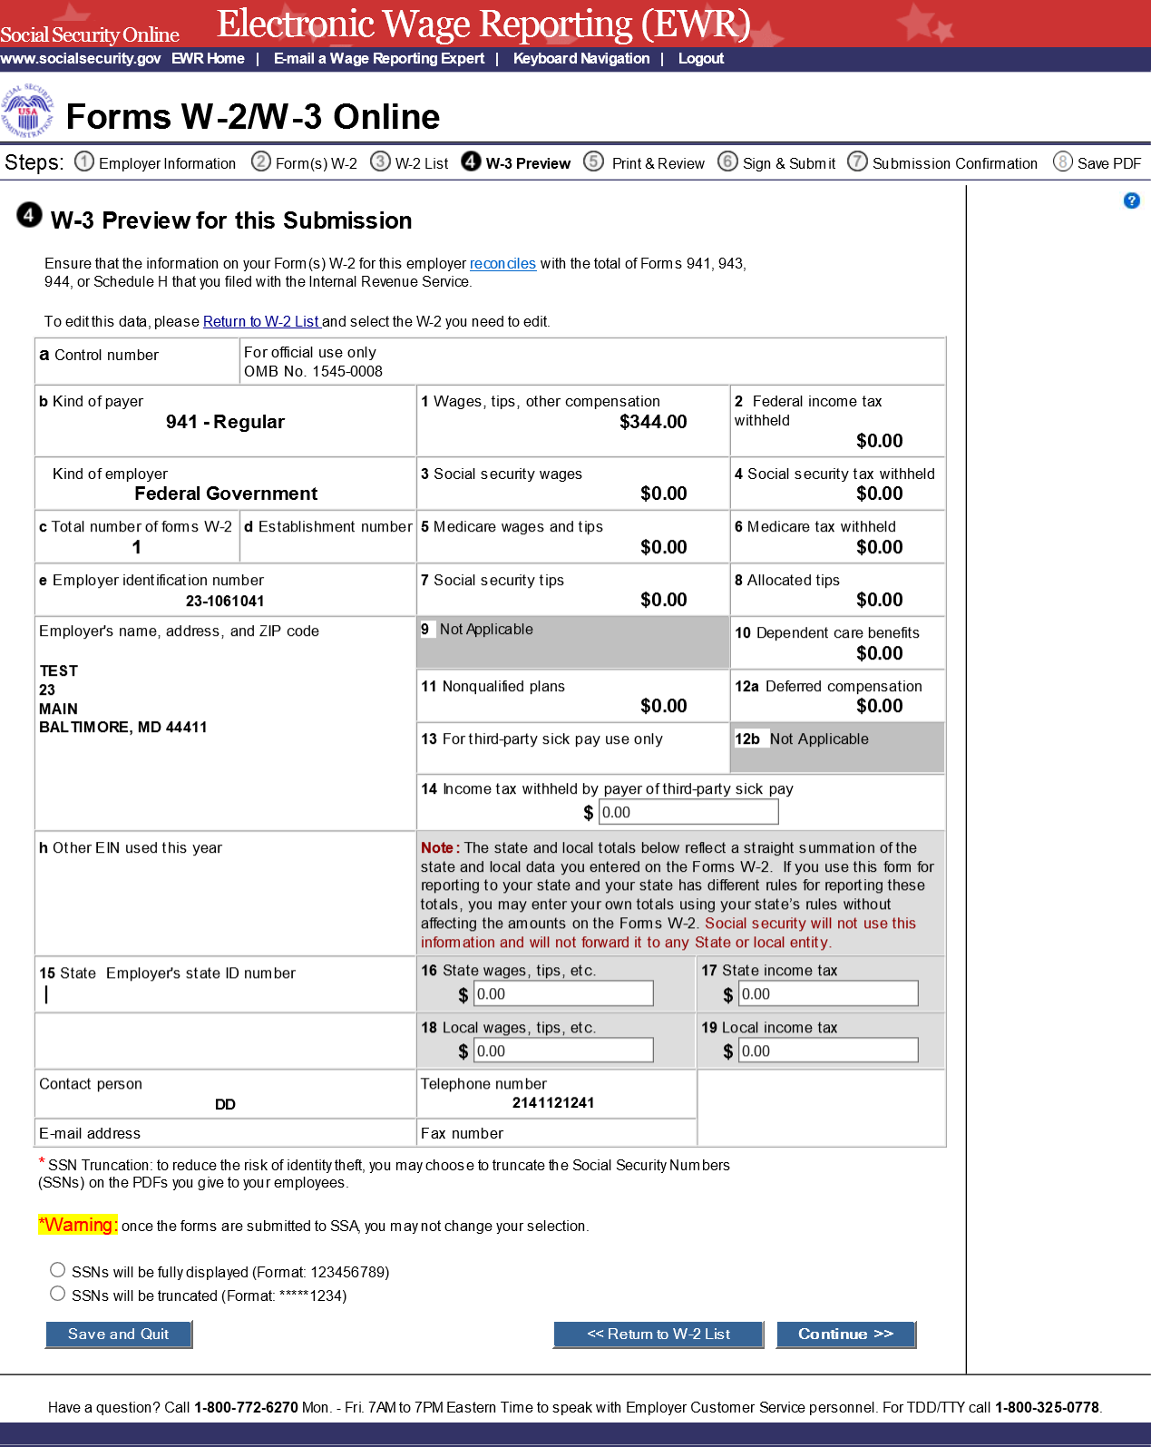
- On the W-3 Preview for this Submission page:
  - The totals displayed in Boxes 16, 17, 18, and 19 are straight summations of state tax information entered on the Forms W-2. If you intend to use this form for reporting to your state and your state has different rules for reporting those totals, you may enter your own totals and select the I Agree check box to continue. This information will not be used by Social Security, nor will it be forwarded to any state or local entity.
  - SSN Truncation: to reduce the risk of identity theft, you may choose to truncate the Social Security Numbers (SSNs) on the PDFs you give to your employees by selecting the check box labeled “SSNs will be truncated (Format *****1234); if you choose not to truncate the SSNs, please select the check box labeled “SSNs will be fully displayed (Formate 123456789). Once the forms are submitted to SSA, you may not change your selection.
  - Select the Continue button to go to the “Print Unsubmitted Form(s) W-2/W-3 for Review” page.
  - Select the Return to W-2 List button to return to the “W-2 List for this Submission” page.
  - Select the Save and Quit button to exit W-2 Online without submitting your wage report to SSA. When you select this button, “Are you sure you want to save and exit W-2 Online without submitting your annual wage report to SSA” page will be displayed for your assistance.
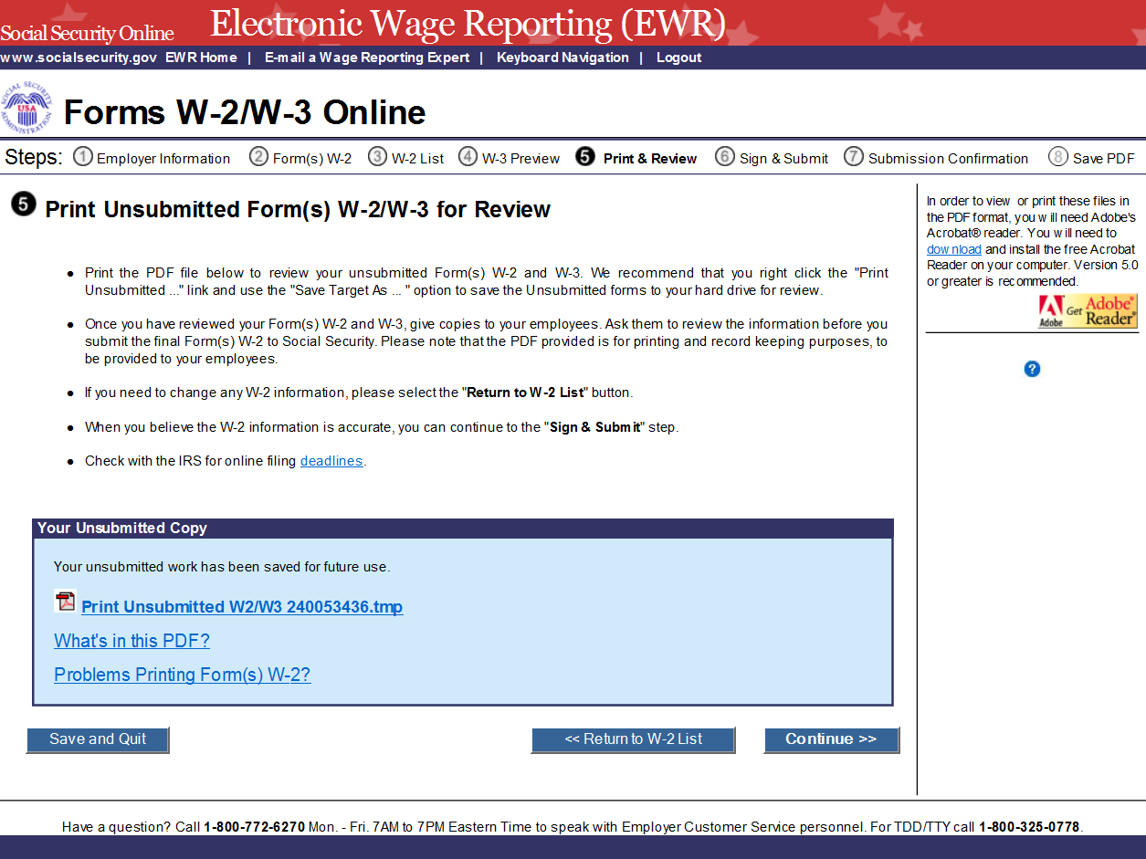
- On the Print Unsubmitted Form(s) W-2/W-3 for Review page:
  - Select the Continue button to go to the “Sign and Submit” page.
  - Select the Return to W-2 List button to return to the “W-2 List for this Submission” page.
  - Select the Save and Quit button to exit W-2 Online without submitting your wage report to SSA. When you select this button, “Are you sure you want to save and exit W-2 Online without submitting your annual wage report to SSA” page will be displayed for your assistance.
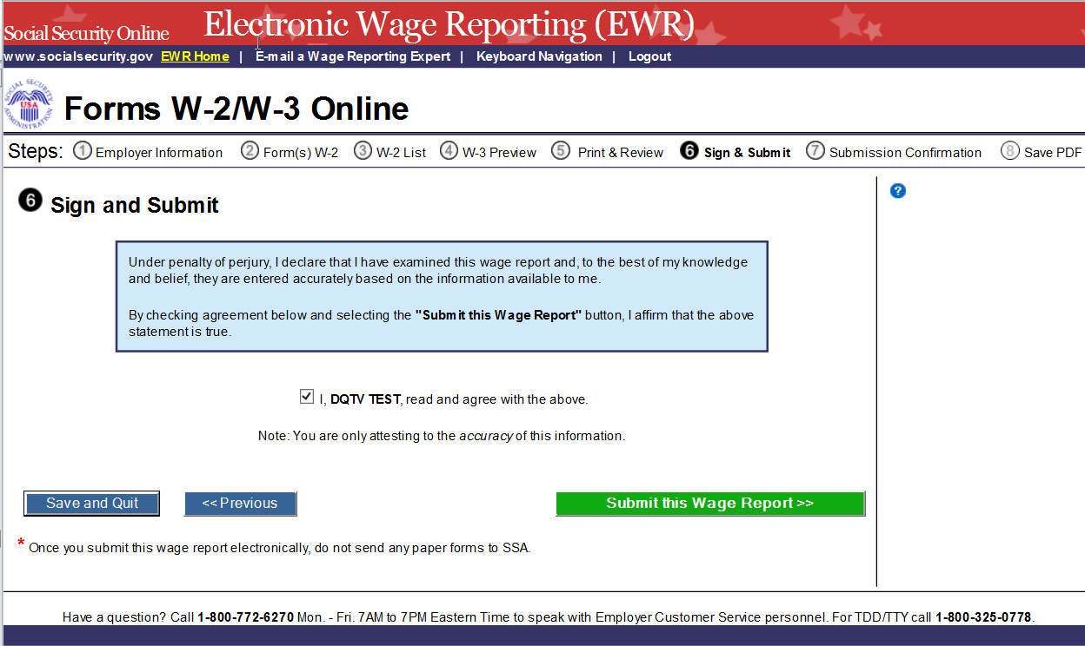
- On the Sign and Submit page:
  - Select the check box to attest to the accuracy of the report and select the Submit this Wage Report button to submit your wage report correction. The system will display the “Confirmation Receipt - Your W-2/W-3 File Was Received” page with a pop-up window.
  - Select the Save and Quit button to exit W-2 Online without submitting your wage report correction to SSA. When you select this button, “Are you sure you want to save and exit W-2 Online without submitting your annual wage report to SSA” page will be displayed for your assistance.
  - Select the Previous button to return to the “Print Unsubmitted Form(s) W-2 for Review” page.

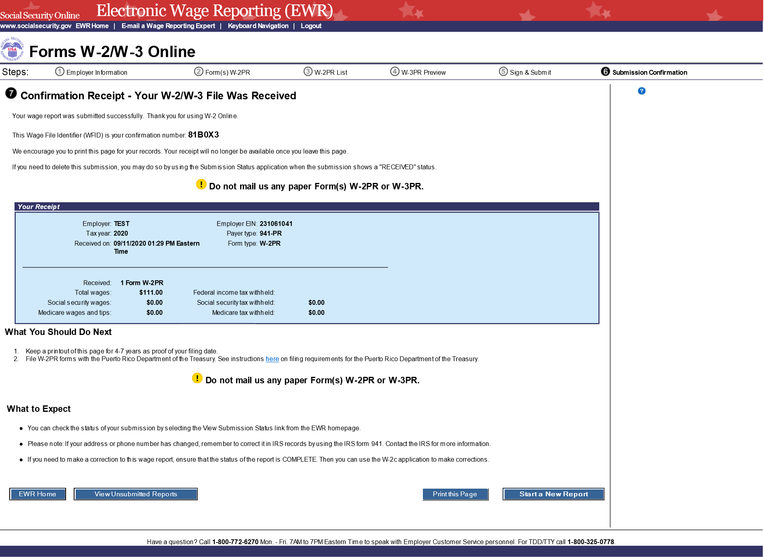
- On the pop-up window:
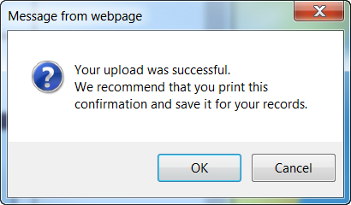
- Select the OK button to print the “Confirmation Receipt - Your W-2/W-3 File Was Received” page.
- Select the Cancel button to close the pop-up window.
- On the Confirmation Receipt – Your W-2/W-3 File Was Received page:
  - Select the Print this Page button to print the confirmation page.
  - Select the Go to Save Official PDF button to go to the “Save PDF” page.
Note: Your wage file will be available for you to review under your BSO account until the date displayed on your “Save PDF” page.

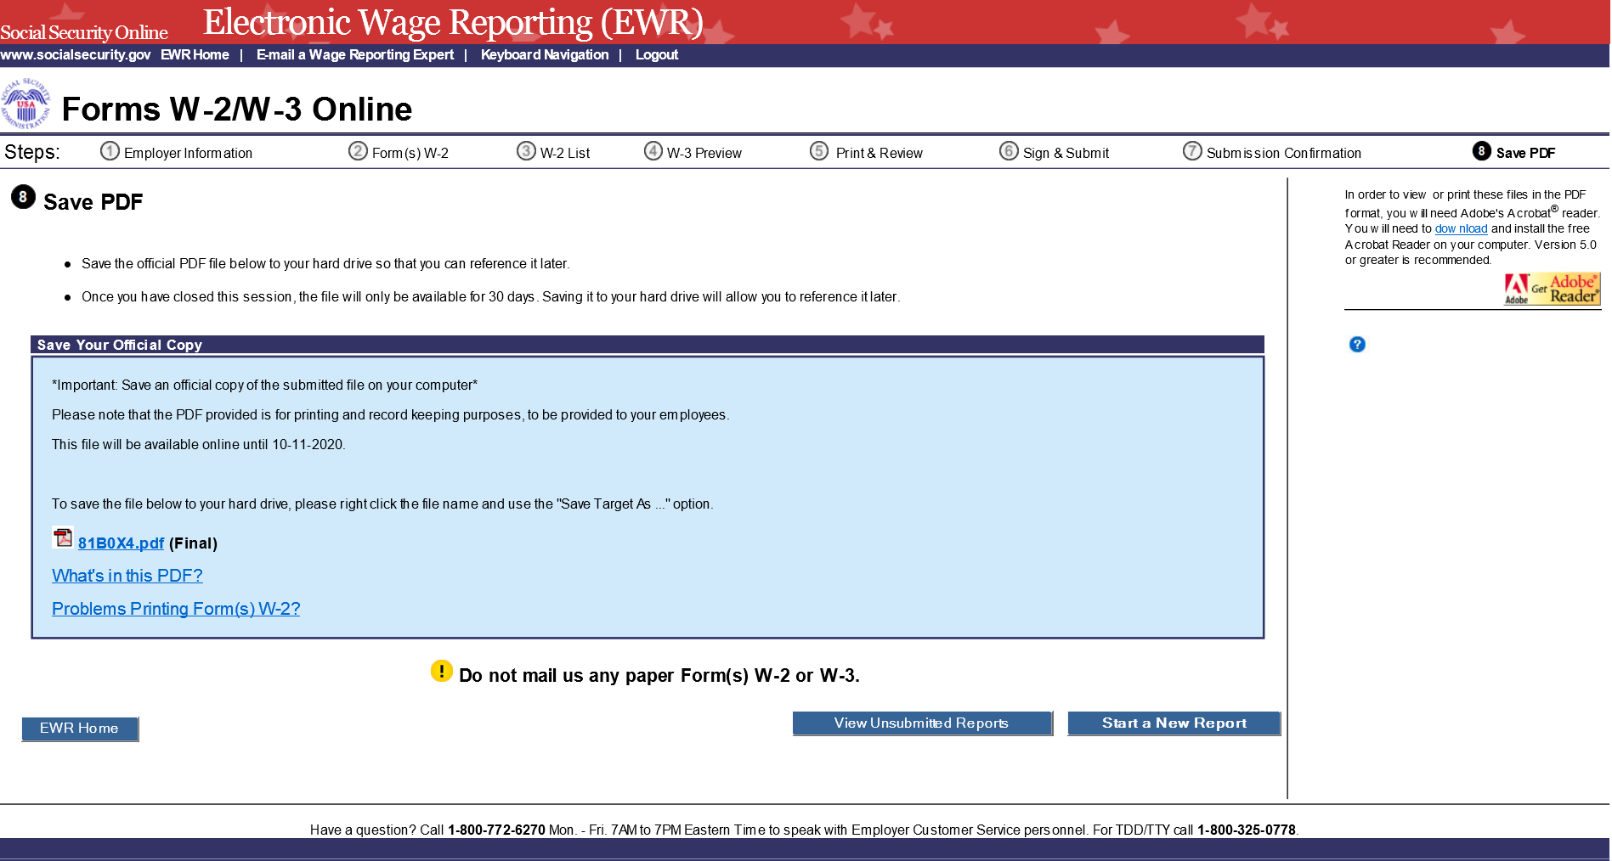
- On the Save PDF page:
  - Right click the file name (<filename.pdf>) to view or save the submitted report.
  - Select the Start a New Report button to return to the “Before You Create Your Form(s) W-2/W-3” page.
  - Select the View Unsubmitted Reports button to go to the “Unsubmitted Reports” page.
  - Select the EWR Home button to go to the EWR home page.

Step-By-Step Instructions for Download Submitted Reports
- Select the Save (or Print) Submitted W-2 Report(s)/PDF to Your Computer link under the Forms W-2/W-3 Online tab on EWR home page. The system displays the “Download Submitted Reports” page.
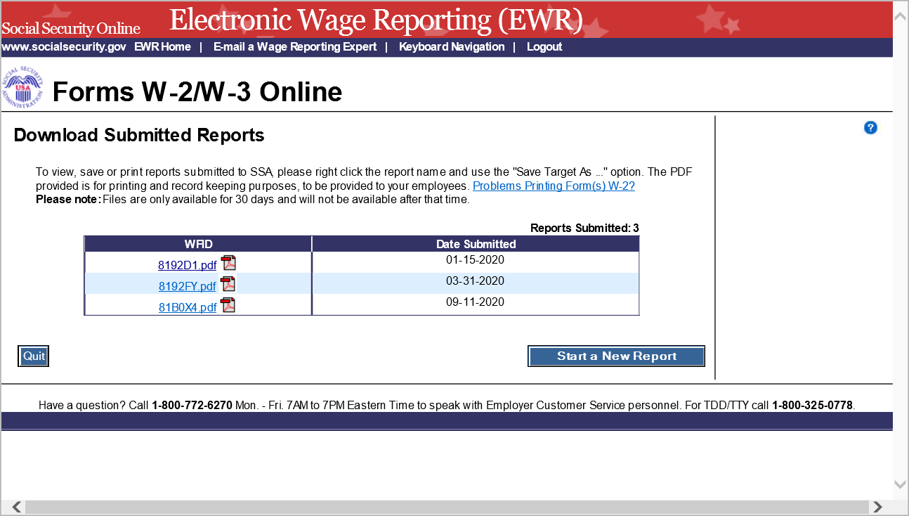
- Right-click the WFID link on the “Download Submitted Reports” page to display a menu including the following options:
- Select Save Target As to download the file onto your computer.
- Select Open in New Window to view the file.
Note: Adobe Acrobat Reader is required to view your downloaded wage file. If you do not have Adobe Acrobat Reader on your computer, you can download it at adobe website.
Note: If a submission has been deleted through the Submission Status application by the user, a message will be displayed to let the user know that the report is not downloadable.
- Select the Quit button to return to the EWR home page.
- Select the Start a New Report button to proceed to the “Before You Create Your Form(s) W-2/W-3” page.

Appendix: Other Pages
- Are You Sure You Want to Delete This W-2 Page: If a user selects the Delete This W-2 button on the “Enter W-2 Information” page, the system shall display the “Are you sure you want to delete this W-2” page.
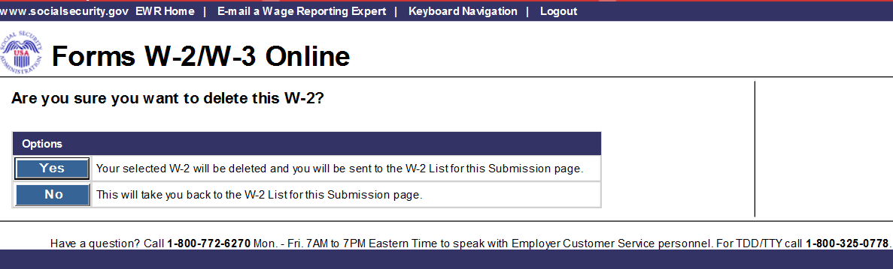

- W-2 Online Restrictions Page: Users can access “W-2 Online Restrictions” page by selecting the Continue button on the “Before You Create Your Form(s) W-2/W-3” page when the check box “Yes, one or more of these situations apply to this wage report” is selected.
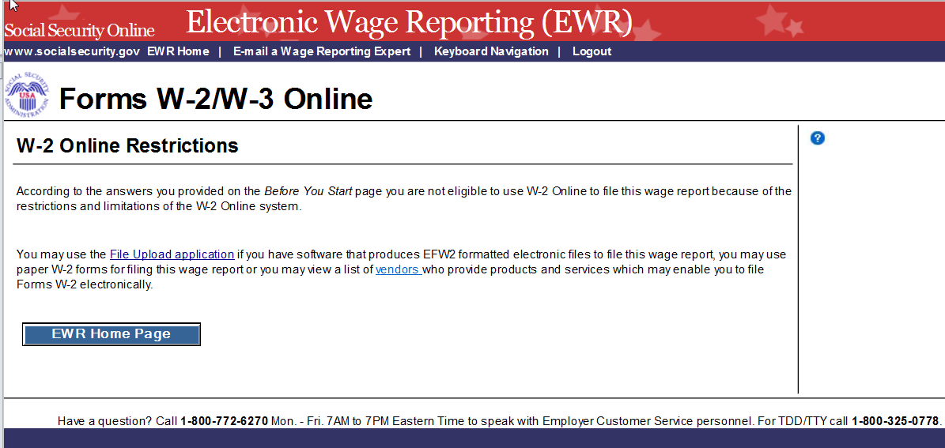

- Are You Sure You Want to Save and Exit W-2 Online Without Submitting Your Annual Wage Report to SSA? page: If a user selects the Save and Quit button on the “W-2 List for this Submission (ABC Limited)” page, “W-3 Preview for this Submission” page, the “Print Unsubmitted Form(s) W-2/W-3 for Review” page or on the “Sign and Submit” page, the system shall display the “Are you sure you want to save and exit W-2 Online without submitting your annual wage report to SSA” page.

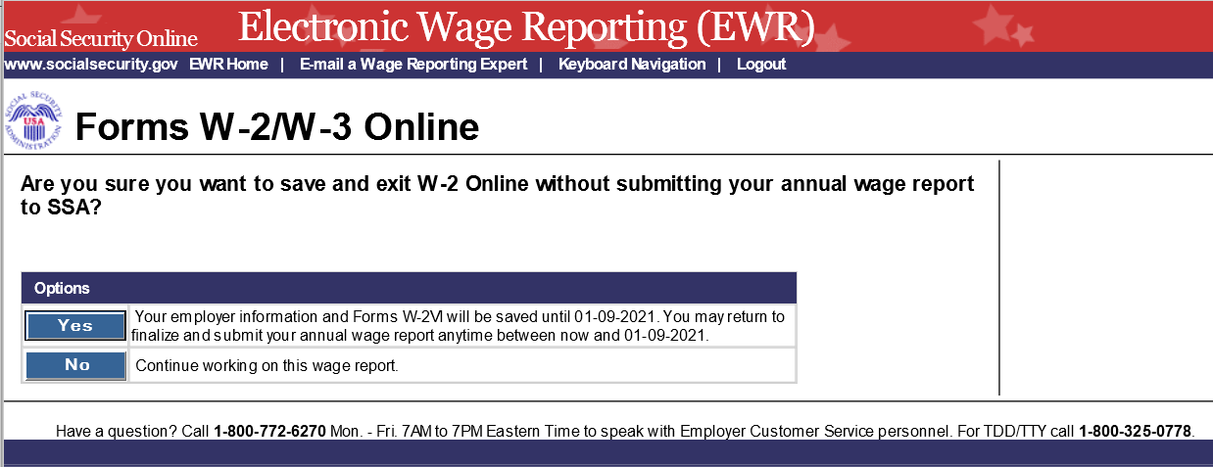
- Are You Sure You Want to Delete the Unsubmitted Report Page: If a user selects Delete button on the “Unsubmitted Reports” page, the system shall display the “Are you sure you want to delete the Unsubmitted Report” page.
