Tax Year 2025
W-2/W-3 Online Tutorial

December Pilot Release

Table of Contents

1.0 Access Forms W-2/W-3 Online Pilot Program 4
2.0 Forms W-2/W-3 Path 11
2.1 Create New Reports 11
2.1.1 Forms W-2/W-3 Online Landing Page 11
2.1.2 For Whom Are You Filing Page 12
2.1.3 Enter Employer Information Page 17
2.1.4 W-2 List Page (without W-2 Forms) 21
2.1.5 Enter W-2 Information Page 22
2.1.6 W-2 List Page (with W-2 Forms) 25
2.1.7 Preview W-3 Page 26
2.1.8 SSN Masking Page 28
2.1.9 Review Unsubmitted Forms Page 28
2.1.10 Sign and Submit Page 29
2.1.11 Confirmation of Submission Page 29
2.2 Unsubmitted Reports 31
2.2.1 Resume Unsubmitted Reports 32
2.2.2 Delete Unsubmitted Reports 32
2.3 Submitted Reports 32
3.0 Forms W-2c/W-3c Path 33
3.1 Create New Correction Reports 33
3.1.1 Corrections W-2c/W-3c Landing Page 33
3.1.2 For Whom Are You Filing Page 34
3.1.3 Enter Employer Information Page 39
3.1.4 W-2c List Page (without W-2c Forms) 42
3.1.5 Enter W-2c Information Page 43
3.1.6 W-2c List Page (with W-2c Forms) 56
3.1.7 Preview W-3c Page 56
3.1.8 SSN Masking Page 57
3.1.9 Review Unsubmitted Forms Page 57
3.1.10 Sign and Submit Page 58
3.1.11 Confirmation of Submission Page 59
3.2 Unsubmitted Correction Reports 61
3.2.1 Resume Unsubmitted Reports 61
3.2.2 Delete Unsubmitted Reports 61
3.3 Submitted Correction Reports 61
4.0 Other Features 62
4.1 Header 62
4.2 Exit Wage Report 63
4.3 W-2/W-2c Preview (PDF) 63
4.4 Delete W-2/W-2c Forms 64
4.5 Import W-2 Form(s) 64
4.6 W-3/W-3c Preview (PDF) 67
4.7 Review (Review Unsubmitted Report) 68
4.8 Final (PDF) 69
4.9 Receipt 71
4.10 Errors 72
4.11 Loading Data 73
4.12 Feedback 74

Access Forms W-2/W-3 Online Pilot Program
The Forms W-2/W-3 Online Pilot Program is one of the Electronic Wage Reporting (EWR) applications. You must be a pilot participant to access the pilot program.
Step 1: On the United States Social Security Administration (SSA) homepage (https://www.ssa.gov/), in the “Services for” section at the bottom of the page, select the Employers & businesses link. The system displays the Employer W-2 Filing Instructions & Information page.
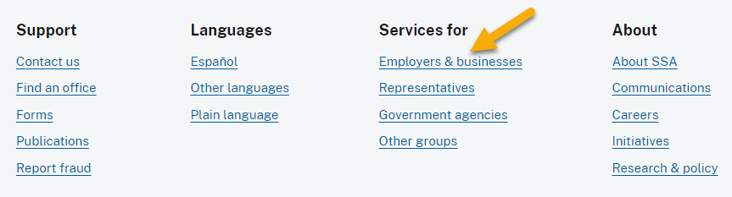
Step 2: On the Employer W-2 Filing Instructions & Information page, select the Business Services Online button. The system displays the Business Services Online page.

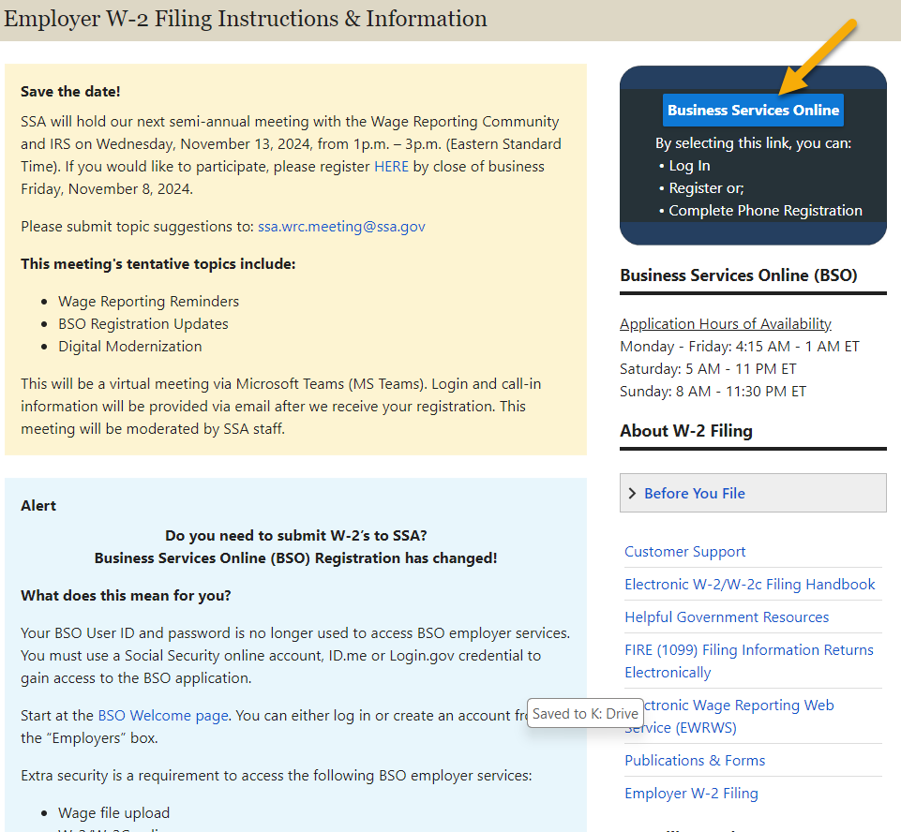

Step 3: On the Business Services Online (BSO) page:
- Select the Log in link in the “Employers” section. The system displays the Create an Account or Sign In page.
- Select the Create account link in the “Employers” section if you need to create an account.
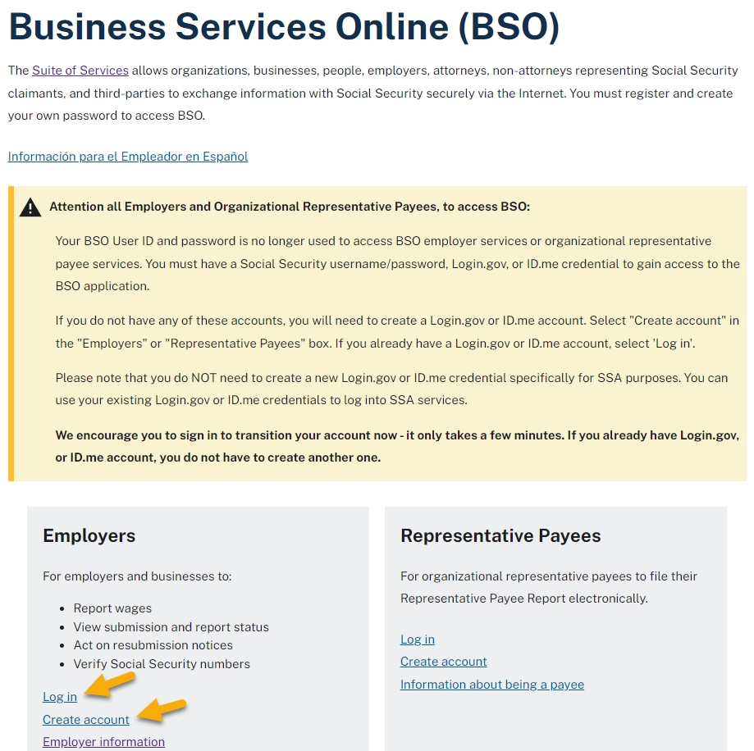
Step 4: On the Create an Account or Sign In page, choose one of the three options to sign in. Each option will require you to enter a one-time code, then navigate to the Social Security Terms of Service page.
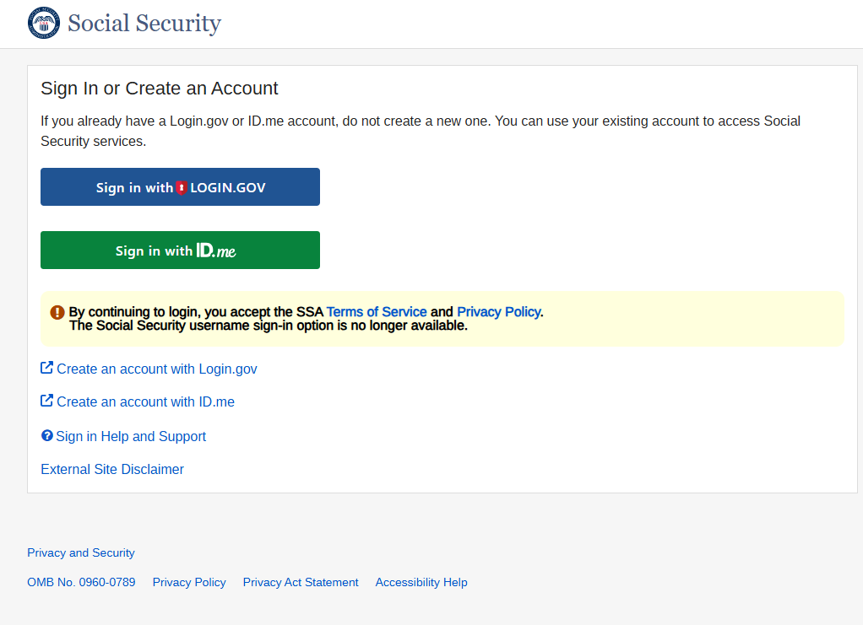
Step 5: On the Social Security Terms of Service page, select the I agree to the Terms of Service check box, then select the Next button. The system displays the Social Security Privacy Act Statement page.

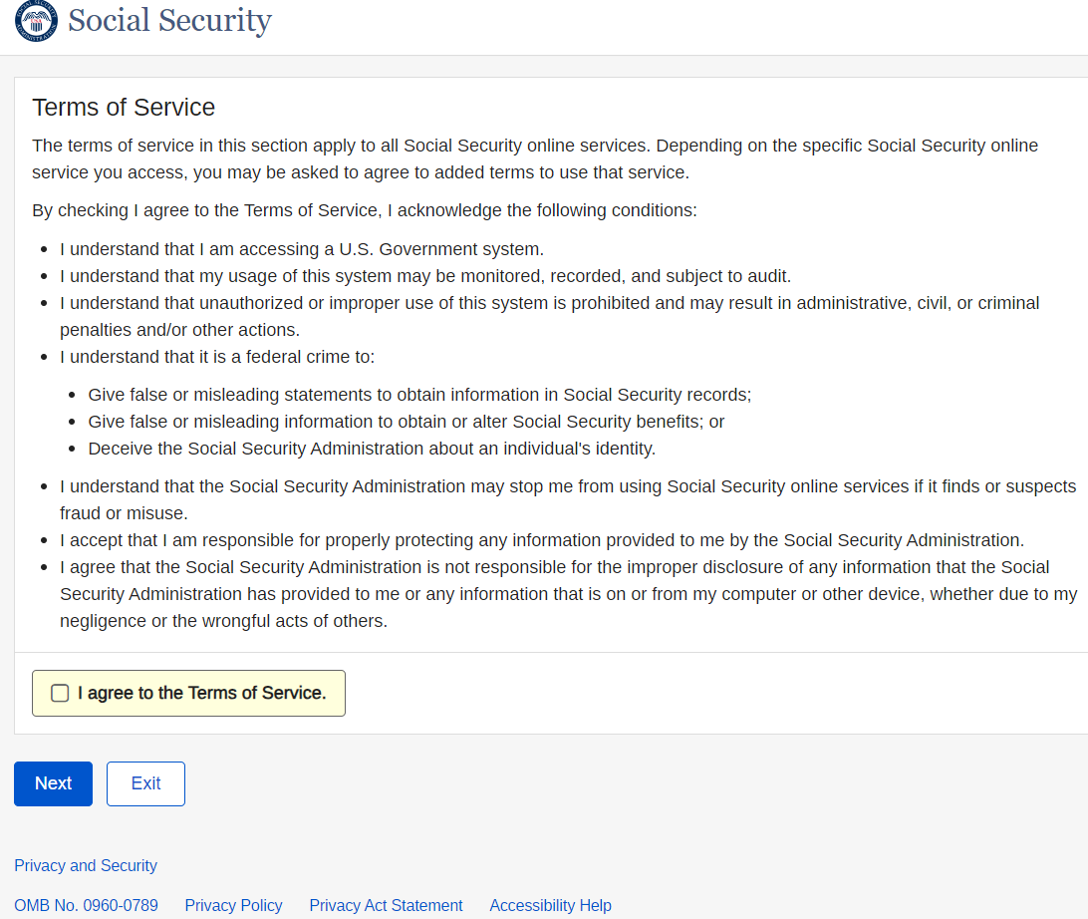

Step 6: On the Social Security Privacy Act Statement page, select the Next button. The system displays the BSO User ID page.
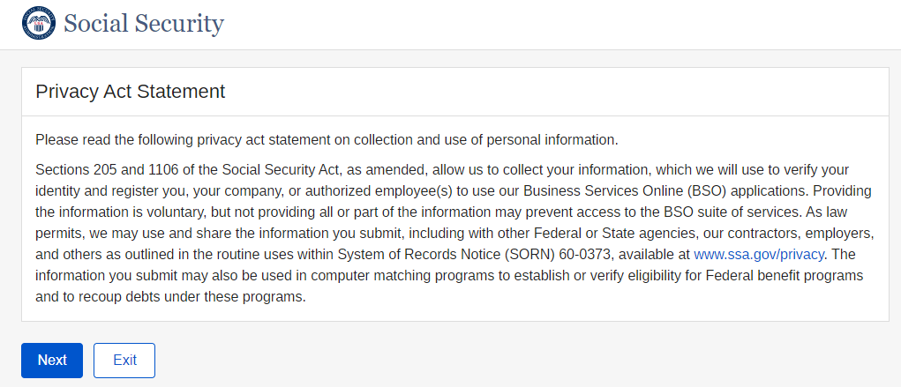
Step 7: On the BSO User ID page, select a set of User ID/EIN, then select the Next button. The system displays the BSO Main Menu page.
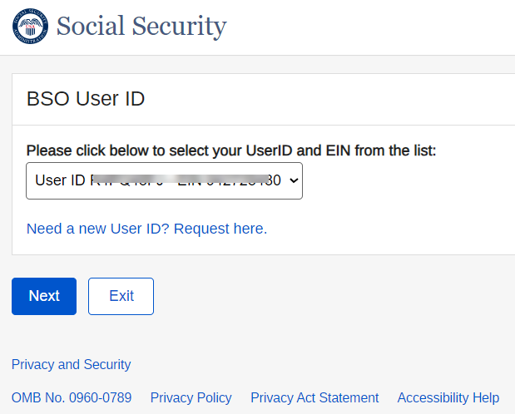
Step 8: On the BSO Main Menu page, select the Report Wages To Social Security link. The system displays the Wage Reporting Attestation page.
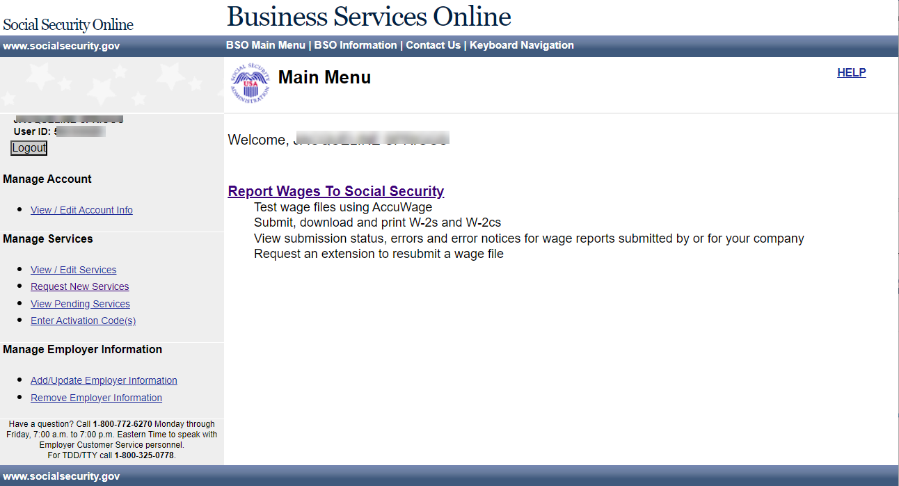
Step 9: On the Wage Reporting Attestation page, select the I Accept button. The system displays the Report Wages to Social Security page (EWR homepage).
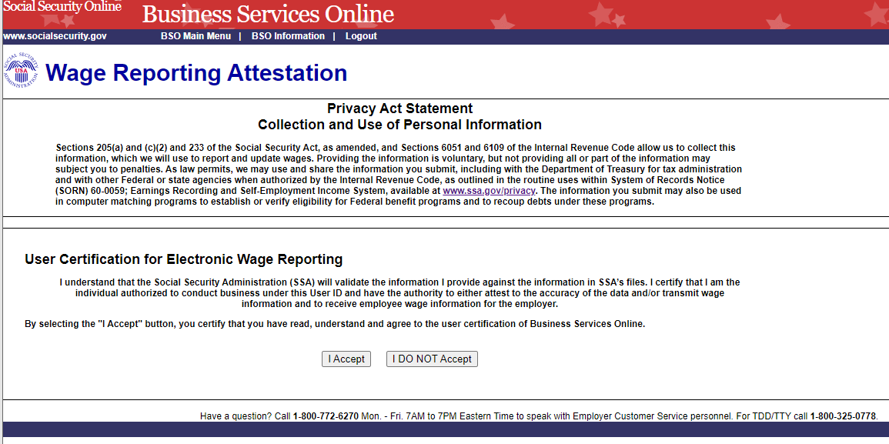
Step 10: On the EWR homepage, select the Pilot program Participants – Forms W-2/W-3 Online link. The system displays the Forms W-2/W-3 Online pilot program landing page. Only pilot participants can access this link.
Follow the same steps to access Corrections W-2c/W-3c landing page.
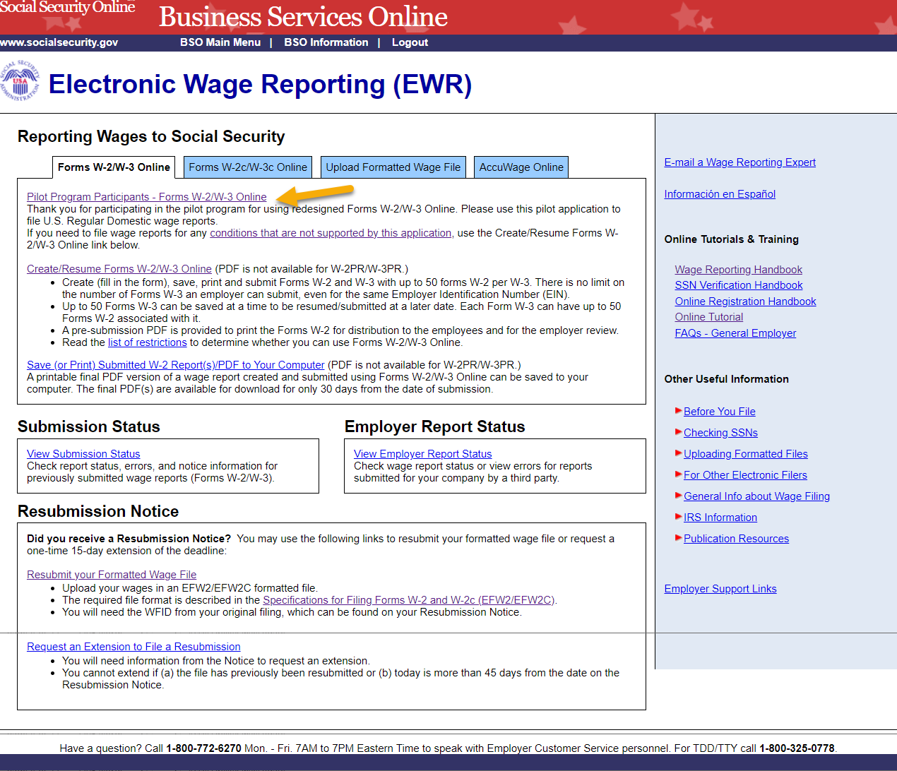
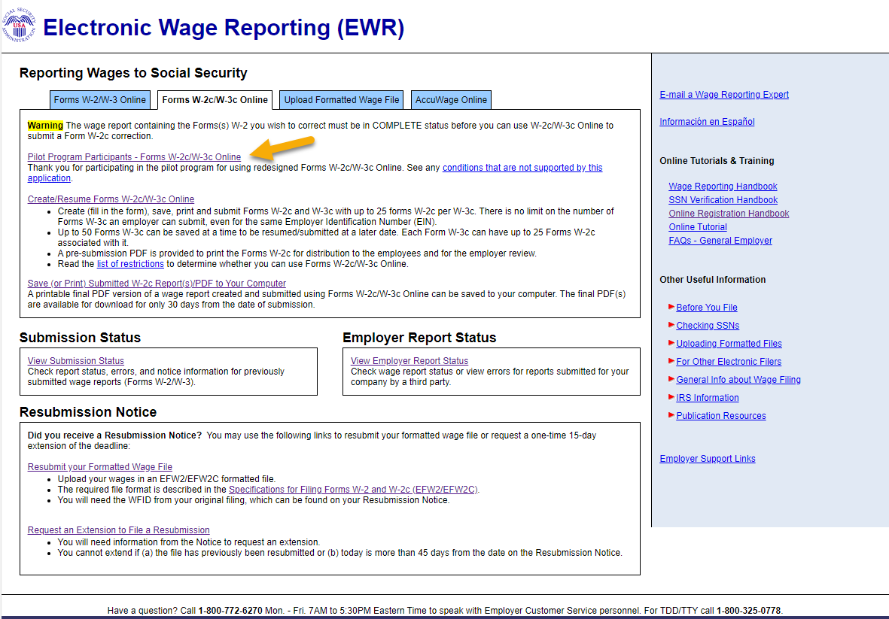

Forms W-2/W-3 Path
This path allows you to:
- Create and submit up to 50 regular domestic Forms W-2 per W-3 Report to SSA. (Use legacy W-2/W-3 Online application on the EWR home page to file a different type of W-2/W-3.)
- Print and/or save a PDF copy of W-2/W-3 Forms for your employees.
- Continue existing Unsubmitted Reports previously started in this application.
- View the final PDF of submitted reports from the last 30 days.

Create New Reports

2.1.1 Forms W-2/W-3 Online Landing Page
On the Forms W-2/W-3 Online Pilot program landing page, select the Create a New Report button. The system displays the For Whom Are You Filing page.
From any page within the pilot program, you can go back to the EWR Home page by selecting the EWR Home link in the top left corner of the page.
Reports created but not submitted will be displayed in the “Unsubmitted Reports” section. Unsubmitted Reports are available for 120 days. See the Unsubmitted Reports section within this tutorial for additional information.
Reports created and submitted will be displayed in the “Submitted Reports” section. Submitted reports are available for 30 days. See the Submitted Reports section within this tutorial for additional information.
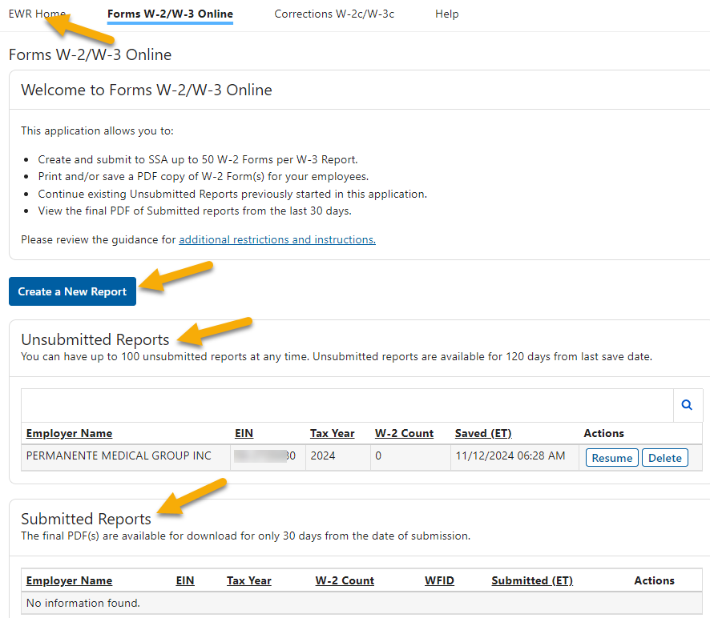

2.1.2 For Whom Are You Filing Page
On the For Whom Are You Filing page: you can file reports for “My Company”, “Previously Filed Employer” and “New Employer”.
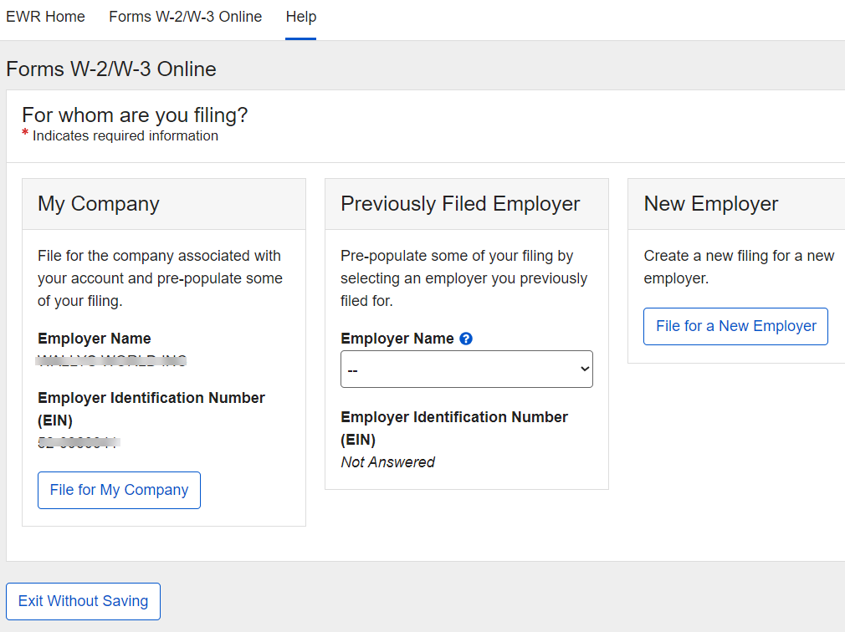

File for My Company:
To file reports for your own company, select the File for My Company button. The system displays the “Wage Report Setup” section below the employer selection section on the same page.
- Employer Name and EIN are prepopulated from the user’s registration account.
- Establishment Number is optional.
- Tax Year is default to the current tax year.
- Kind of Payer is default to 941 (Regular).

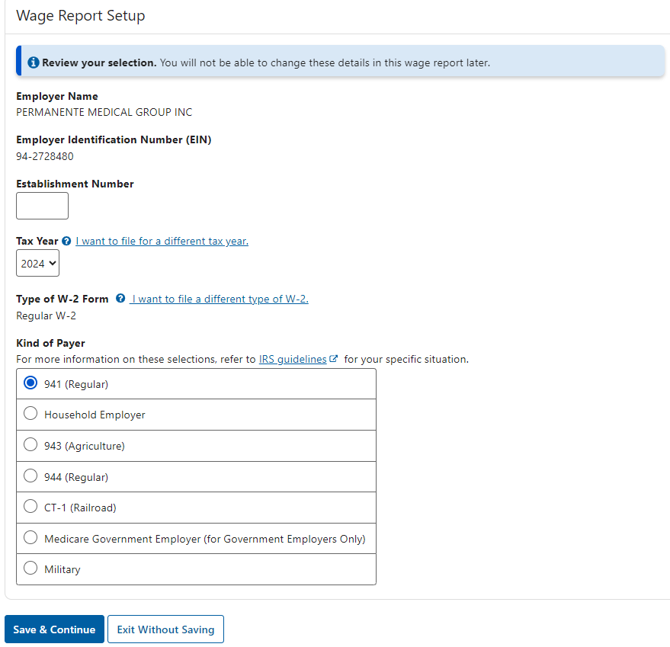

File for Previously Filed Employer:
To file reports for an employer you previously filed for, select that employer’s name/EIN from the Employer Name dropdown list. EIN for the selected employer will be displayed below the Employer Name field and the File for Selected Employer button will be displayed.
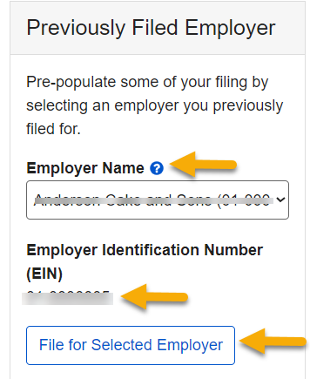
Select the File for Selected Employer button. The system displays the “Wage Report Setup” section below the employer selection section on the same page.
- Employer Name and EIN are prepopulated from the previously filed report. These can not be changed.
- Establishment Number is prepopulated from the previously filed report. This can be changed.
- Tax Year is defaulted to the current tax year.
- Kind of Payer is prepopulated from the previously filed report. This can be changed.
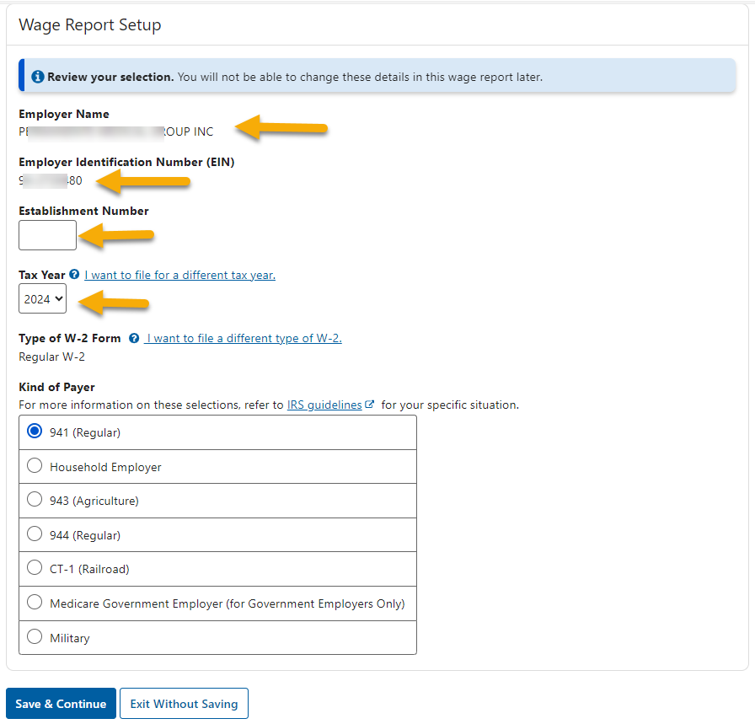

File for New Employer:
To file reports for a company you have not previously filed for, select the File for a New Employer button. The system displays the “Wage Report Setup” section below the employer selection section on the same page.
- Employer Name and EIN are required fields.
- Establishment Number is optional.
- Tax Year is defaulted to the current tax year.
- Kind of Payer is defaulted to 941 (Regular).
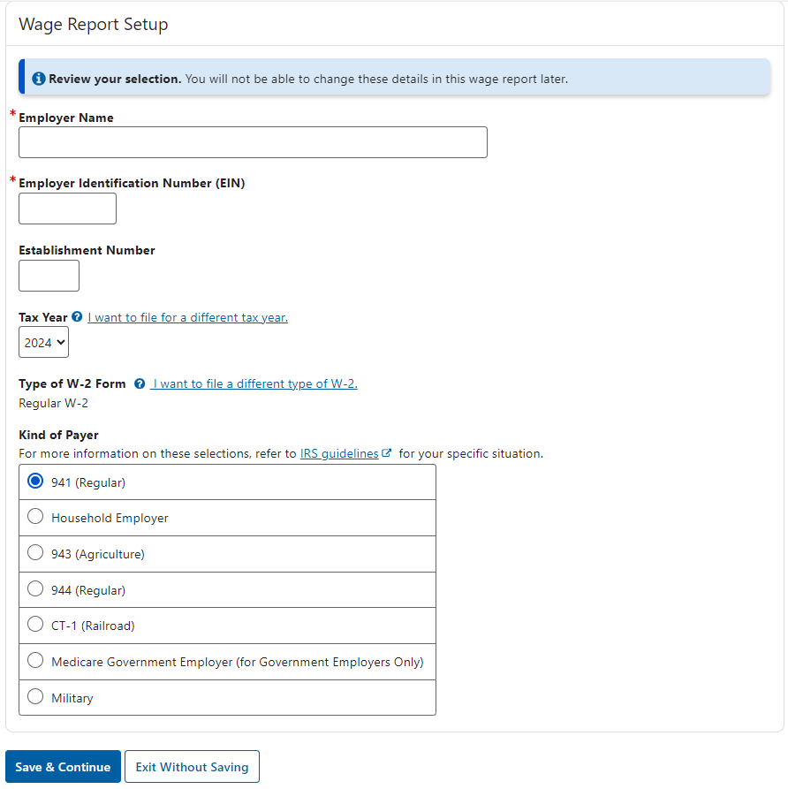
Note:
- You will not be able to change the information entered in the” Wage Report Setup” section once you navigate away from the page. If you need to change it, create a new report and delete the one you no longer need.
- No matter whom you are filing for, select the Save & Continue button. The system displays the Enter Employer Information page.

2.1.3 Enter Employer Information Page
The Enter Employer Information page includes the following four sections:
- Employer Address
- Other Information
- Contact Details: Contact Person for this Submission and Contact Person for this Employer
- Select Kind of Employer

- If you selected to file reports for your own company, the Employer Address and the Contact Person for this Submission fields will be prepopulated.
- If you selected to file reports for a previously filed employer, all fields will be prepopulated.
- If you selected to file reports for a new company, only the Contact Person for this Submission field will be prepopulated.
Select the Save & Continue button. The system displays the W-2 List page.
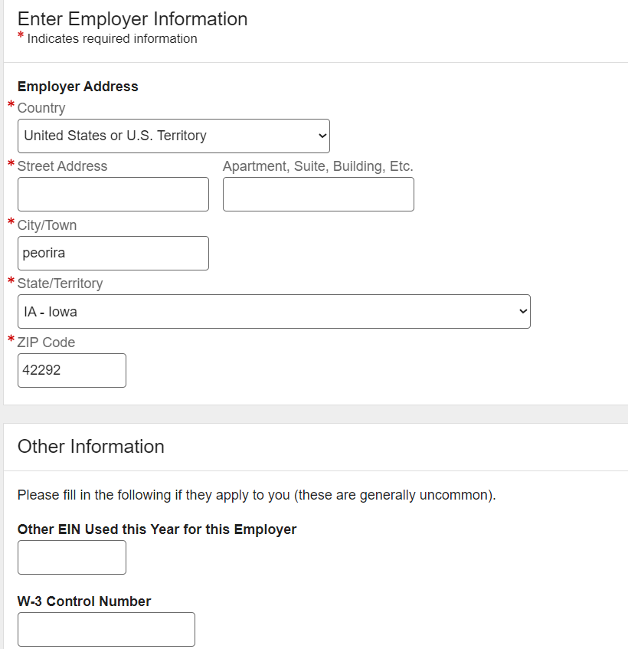
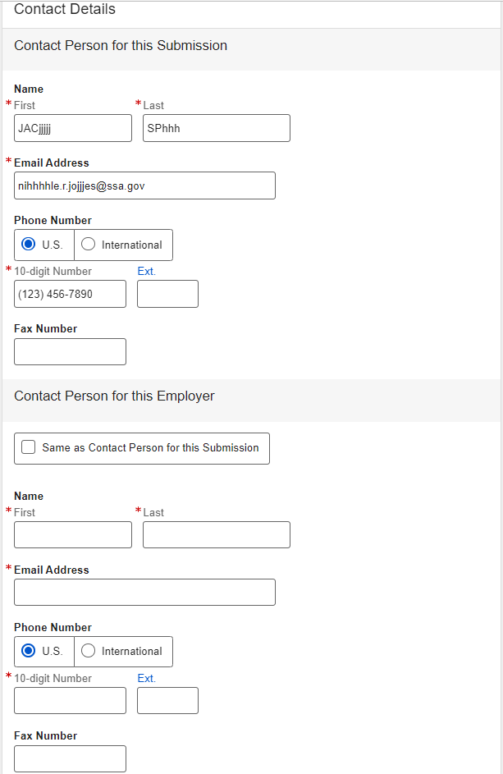
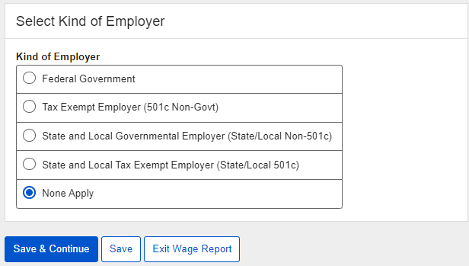

2.1.4 W-2 List Page (without W-2 Forms)
If no W-2 Forms were added to this report previously, the W-2 List page displays an empty table. Select the Add New W-2 button. The system displays the Enter W-2 Information page.
If you filed for the same employer previously, you can use the Import W-2 Form(s) function. See the Import W-2 Form(s) section within this tutorial for additional information.
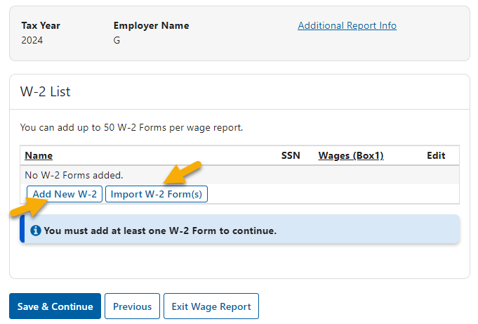

Enter W-2 Information Page
The Enter W-2 Information page includes employee information, federal information and state/local information.
- The W-2 Form must be free of errors to be saved.
- Enter all money fields that are relevant to this W-2. At least one money field must be entered in boxes 1 through 12.
- You can have four box 12 sets, three box 14 sets and two state/local sets. If you have more box 12, box 14 or state/local sets, you will need to create another W-2 for the same employee.
- Select either the “Box 12 Code Descriptions” link or the dropdown arrow to see the description of each Box 12 code.
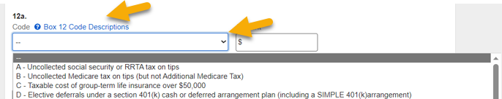
- SSA will not send state/local data to IRS.

When you finish working on this page, you can choose to:
- Save this W-2 and return to the W-2 List page,
- Save this W-2 and add another W-2 to the same report, or
- Delete this W-2 and return to W-2 List page.

You can navigate between the Enter W-2 Information page and the W-2 List page to add W-2 Forms, edit W-2 Forms, preview W-2 Forms, or delete W-2 Forms. After entering all W-2 Forms for this report and you are ready to submit this report to SSA, you will need to return to the W-2 List page.
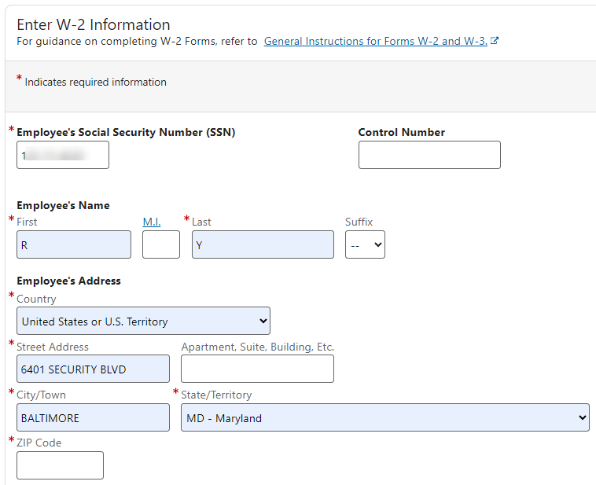

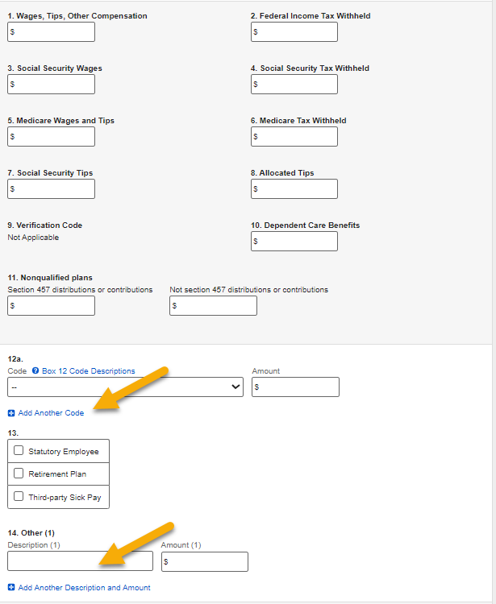
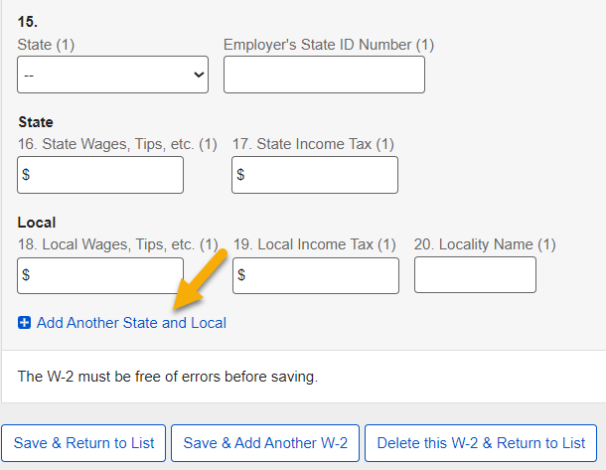

W-2 List Page (with W-2 Forms)
The W-2 List page can display up to 50 W-2 Forms, which is the maximum number of W-2 Forms allowed in each report. Once the limit is reached, the Add New W-2 button will not be displayed. If you have more than 50 W-2 Forms to report for an employer, you can create another wage report for the same employer.
To preview the W-2 Form in PDF, select one or more W-2 Forms, then select the Preview button. The system displays the W-2 Preview page. See the W-2 Preview section within this tutorial for additional information.
To delete W-2 Forms, select one or more W-2 Forms, then select the Delete button. The system displays the Delete W-2 page. See the Delete W-2 section within this tutorial for additional information.
Select the Save & Continue button. The system displays the Preview W-3 page.

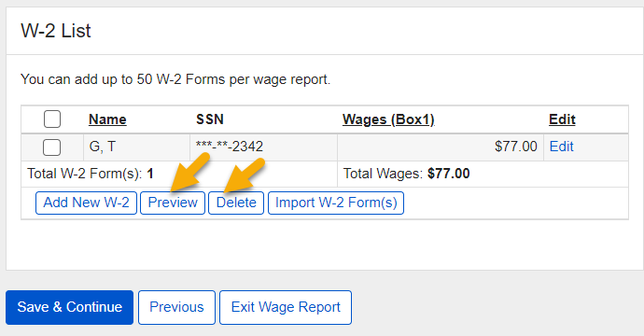

2.1.7 Preview W-3 Page
On the Preview W-3 page:
- If third-party sick pay is relevant to this report, select the check box and/or enter the money amount.
- Confirm that you want to use the system calculated sums for the state and local fields from the W-2 Forms. If you want to override the sums, the system will display fields for you to do so. See the Override State/Local Data section within this tutorial for additional information.
- To preview the W-3 in PDF, select the Preview W-3 button. The system displays the W-3 Preview page. See the W-3 Preview section within this tutorial for additional information.
- The Preview W-3 button will not be displayed until a selection is made in the “state and local wage reporting” section.
- Select the Save & Continue button. The system displays the SSN Masking page.

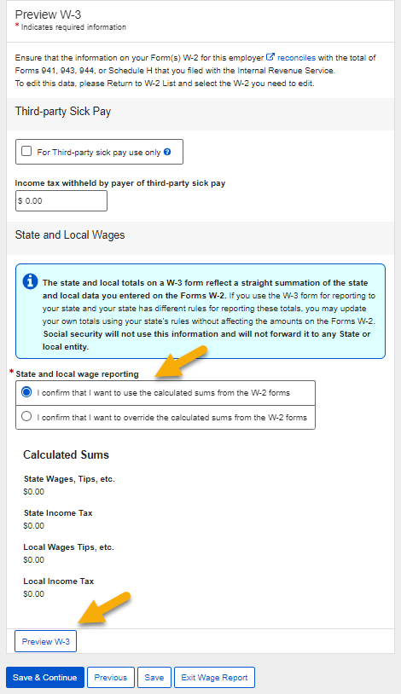

2.1.8 SSN Masking Page
On the SSN Masking page, select one of the Masking Options. Once the report is submitted to SSA, you will not be able to change the SSN masking option.
Select the Save & Continue button. The system displays the Review Unsubmitted Forms page.
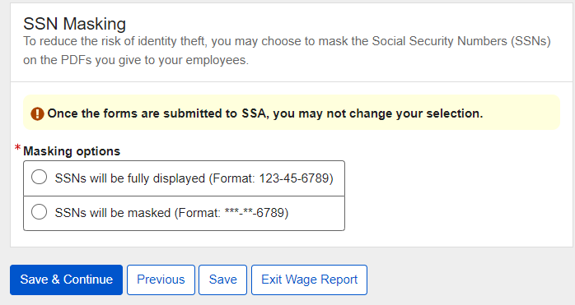

2.1.9 Review Unsubmitted Forms Page
On the Review Unsubmitted Forms page:
- Select the Generate PDF for Review button. The Review page will be displayed. See Review within this tutorial for additional information.
- Select the Save & Continue button. The system displays the Sign and Submit page.
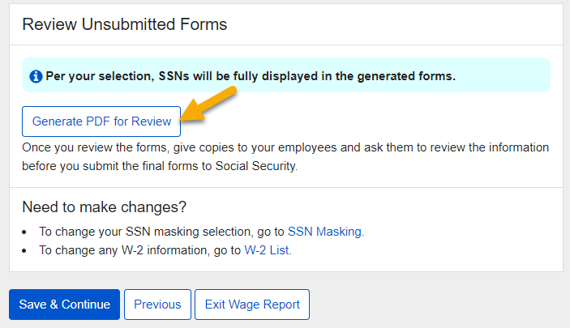

2.1.10 Sign and Submit Page
On the Sign and Submit page, select the check box to affirm the statement, then select the Submit this Wage Report button. The system displays the Confirmation of Submission page.
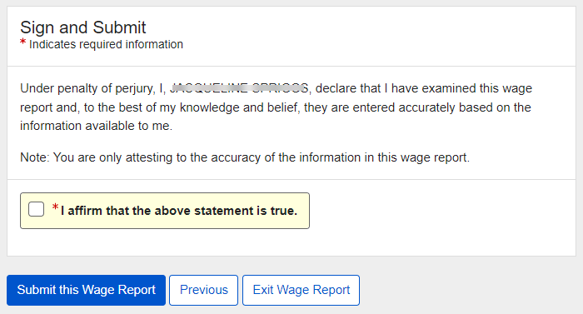

Confirmation of Submission Page
SSA encourages you to print or save a copy of this page as a receipt and proof of filing date. Take a note of the Wage File Identifier (WFID) because this will be needed in all communications with SSA regarding this wage report. It will also be needed to check this report’s status through the Submission Status application and the Employer Report Status application within the EWR suite of services.
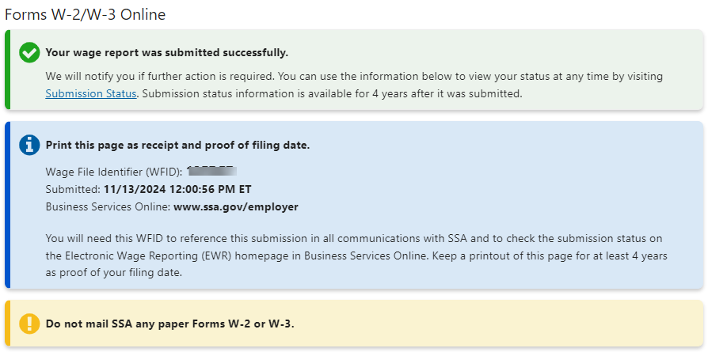
To see a copy of the submitted report in PDF, select the Generate PDF button. The system displays the Final page. See Final within this tutorial for additional information.
To see the submission receipt, select the Print or Save WFID and Receipt button. The system displays the Receipt page. See Receipt within this tutorial for additional information.
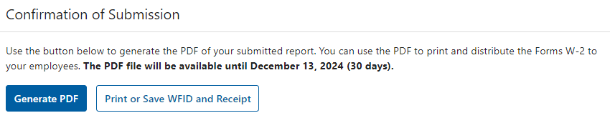
Select the Return to Forms W-2/W-3 Online button if you want to start from the beginning of the Forms W-2/W-3 Online application. The system displays the Forms W-2 Online landing page. See the Forms W-2/W-3 Online Landing Page in the “Create New Reports” section within this tutorial for additional information.
Select the Start a New Report button if you want to file a new report. The system displays the For whom are you filing page. See the For Whom Are You Filing Page section within this tutorial for additional information.
Select the Return to EWR Home button if you want to exit the Forms W-2/W-3 Online application but stay within the EWR suite of services. The system displays the Reporting Wages to Social Security page (EWR homepage). See Step 10 in the “Access Forms W-2/W-3 Online Pilot Program” section within this tutorial for additional information.
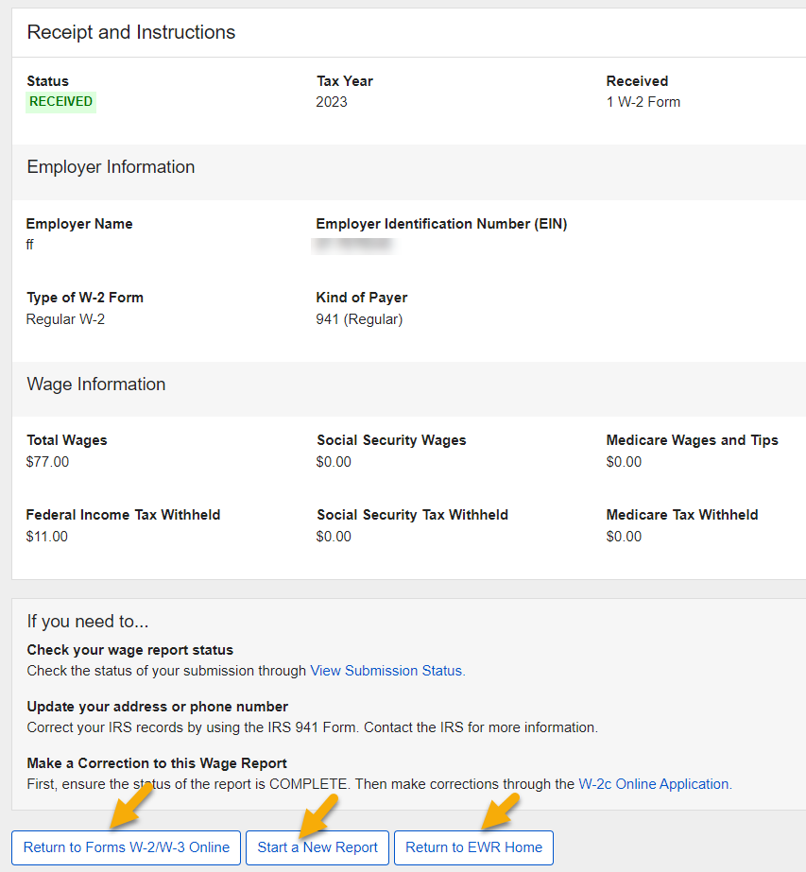

Unsubmitted Reports
On the Forms W-2/W-3 Online Landing page, your unsubmitted reports will be displayed in the “Unsubmitted Reports” section.
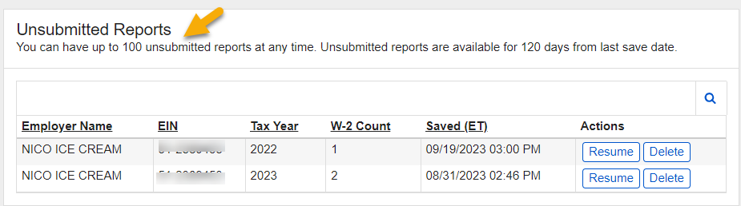

2.2.1 Resume Unsubmitted Reports
To resume working on an unsubmitted report, select the Resume button. The system displays the Enter Employer Information page. See the Enter Employer Information Page in the “Create New Report” section for additional information.

2.2.2 Delete Unsubmitted Reports
To delete an unsubmitted report, select the Delete button. The system displays the Delete Unsubmitted Report page. Follow the instructions on the page to complete your action. Once a report is deleted, it can’t be recovered.
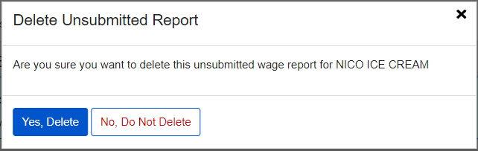

Submitted Reports
On the Forms W-2/W-3 Online Landing page, your reports submitted within the last 30 days will be displayed in the “Submitted Reports” section.
To view a submitted report in PDF, select the View PDF button. The system displays the Final page. See the Final section within this tutorial for additional information.
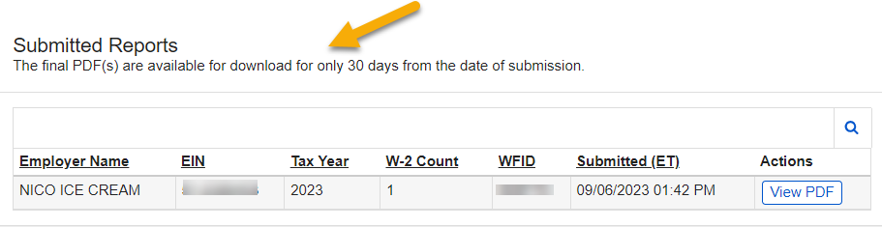

Forms W-2c/W-3c Path
This path allows you to:
- Create and submit up to 25 Forms W-2c per W-3c Report to SSA.
- Print and/or save a PDF copy of W-2c/W-3c Forms for your employees.
- Continue existing Unsubmitted Reports previously started in this application.
- View the final PDF of submitted reports from the last 30 days.

Create New Correction Reports

3.1.1 Corrections W-2c/W-3c Landing Page
On the Corrections W-2c/W-3c Online Pilot program landing page, select the Create a New Correction button. The system displays the For Whom Are You Filing page.
From any page within the pilot program, you can go back to the EWR Home page by selecting the EWR Home link in the top left corner of the page.
Reports created but not submitted will be displayed in the “Unsubmitted Correction Reports” section. Unsubmitted Reports are available for 120 days. See the Unsubmitted Correction Reports section within this tutorial for additional information.
Reports created and submitted will be displayed in the “Submitted Correction Reports” section. Submitted reports are available for 30 days. See the Submitted Correction Reports section within this tutorial for additional information.

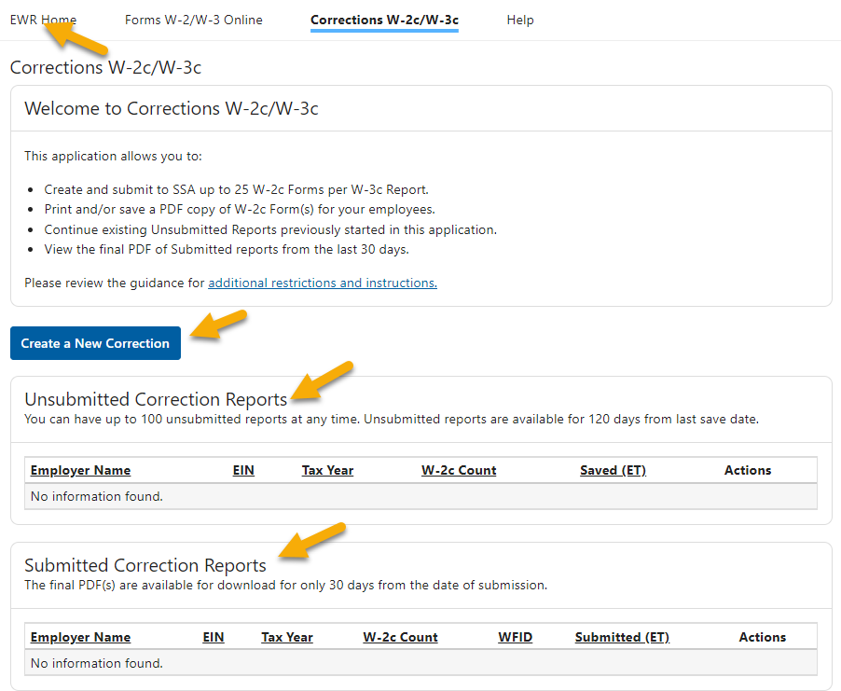

3.1.2 For Whom Are You Filing Page
On the For Whom Are You Filing page: you can file reports for “My Company”, “Previously Filed Employer” and “New Employer”.

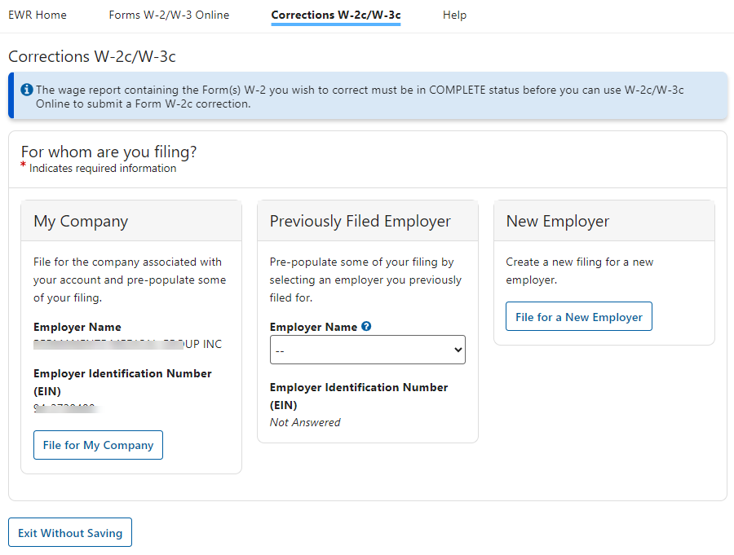

File for My Company:
To file reports for your own company, select the File for My Company button. The system displays the “Wage Report Setup” section below the employer selection section on the same page.
- Employer Name and EIN are prepopulated from the user’s registration account.
- Establishment Number is optional.
- Tax Year is default to the current tax year.
- Kind of Payer is default to 941 (Regular).

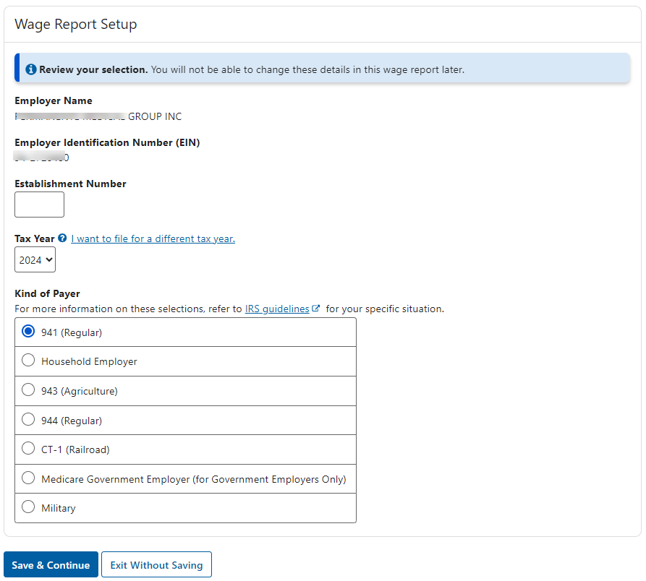

File for Previously Filed Employer:
To file reports for an employer you previously filed for, select that employer’s name/EIN from the Employer Name dropdown list. EIN for the selected employer will be displayed below the Employer Name field and the File for Selected Employer button will be displayed.
Select the File for Selected Employer button. The system displays the “Wage Report Setup” section below the employer selection section on the same page.
- Employer Name and EIN are prepopulated from the previously filed report. These can not be changed.
- Establishment Number is prepopulated from the previously filed report. This can be changed.
- Tax Year is defaulted to the current tax year.
- Kind of Payer is prepopulated from the previously filed report. This can be changed.
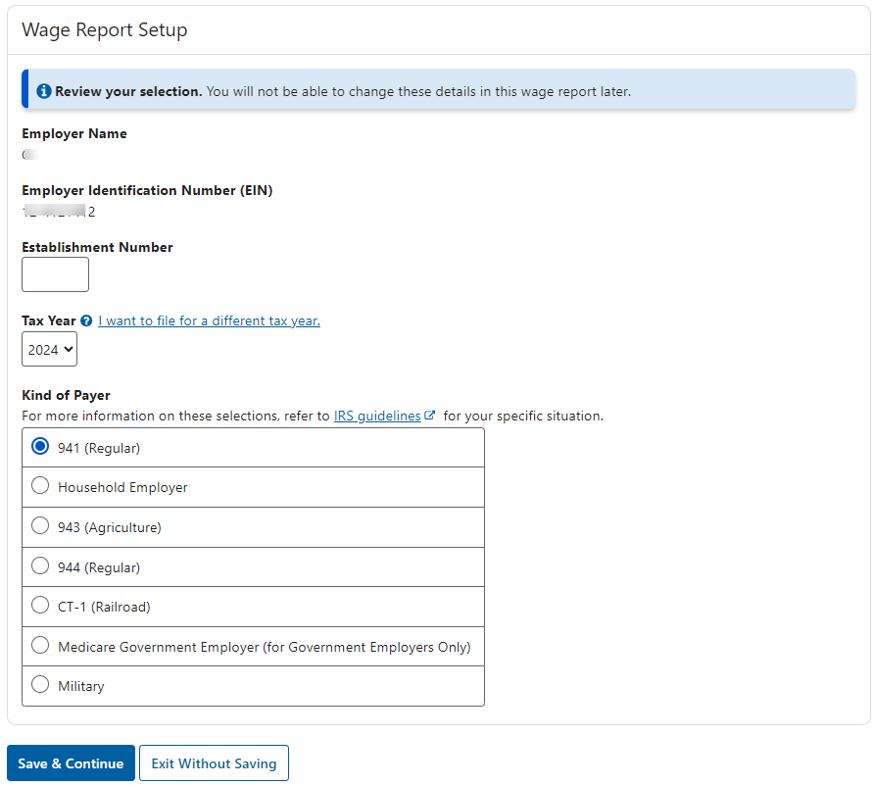

File for New Employer:
To file reports for a company you have not previously filed for, select the File for a New Employer button. The system displays the “Wage Report Setup” section below the employer selection section on the same page.
- Employer Name and EIN are required fields.
- Establishment Number is optional.
- Tax Year is defaulted to the current tax year.
- Kind of Payer is defaulted to 941 (Regular).
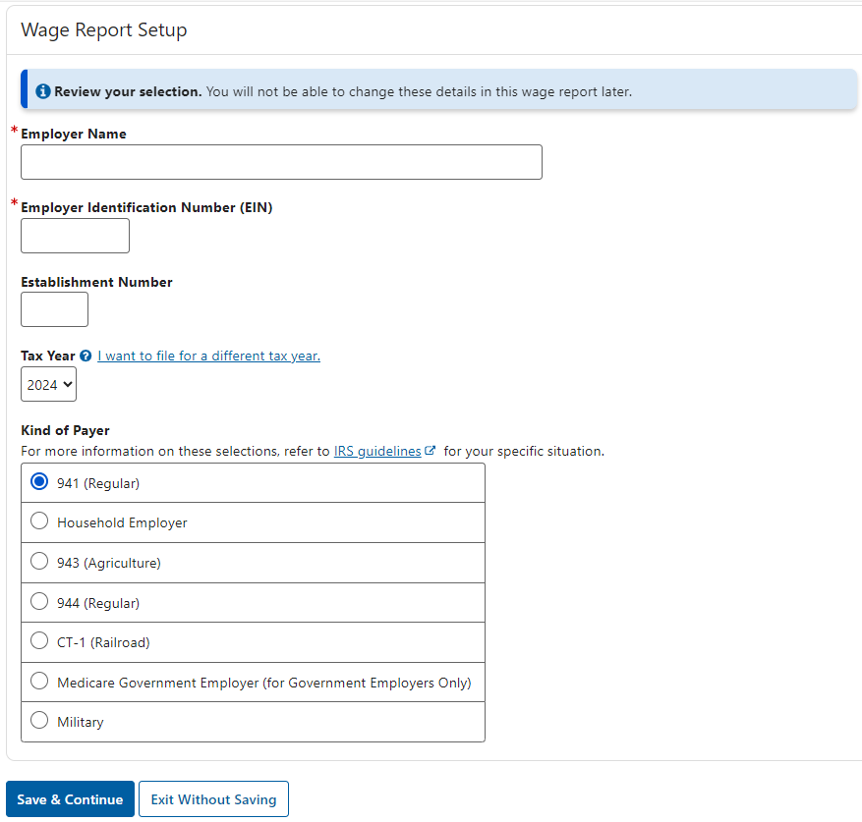

Note:
- You will not be able to change the information entered in the” Wage Report Setup” section once you navigate away from the page. If you need to change it, create a new report and delete the one you no longer need.
- No matter whom you are filing for, select the Save & Continue button. The system displays the Enter Employer Information page.

3.1.3 Enter Employer Information Page
The Enter Employer Information page includes the following four sections:
- Employer Address
- Other Information
- Contact Details: Contact Person for this Submission and Contact Person for this Employer
- Select Kind of Employer

- If you selected to file reports for your own company, the Employer Address and the Contact Person for this Submission fields will be prepopulated.
- If you selected to file reports for a previously filed employer, all fields will be prepopulated.
- If you selected to file reports for a new company, only the Contact Person for this Submission field will be prepopulated.
Select the Save & Continue button. The system displays the W-2 List page.

3.1.4 W-2c List Page (without W-2c Forms)
If no W-2c Forms were added to this report previously, the W-2c List page displays an empty table. Select the Add New W-2c button. The system displays the Enter W-2 Information page.
If you filed for the same employer previously, you can use the Import W-2 Form(s) function. See the Import W-2 Form(s) section within this tutorial for additional information.

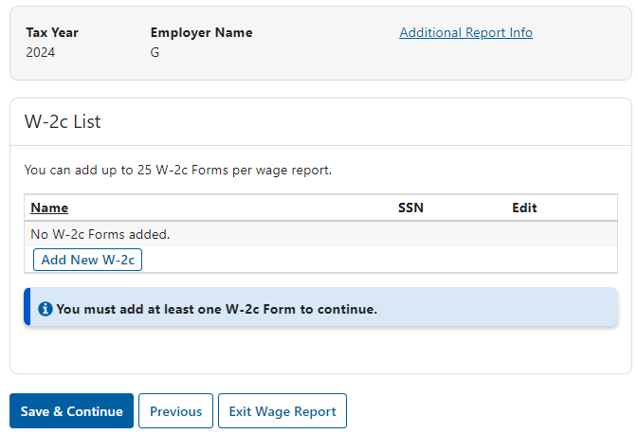

Enter W-2c Information Page
To submit a correction, you must fix at least one of the following: Employee’s Name, or a money amount (Boxes 1-13).
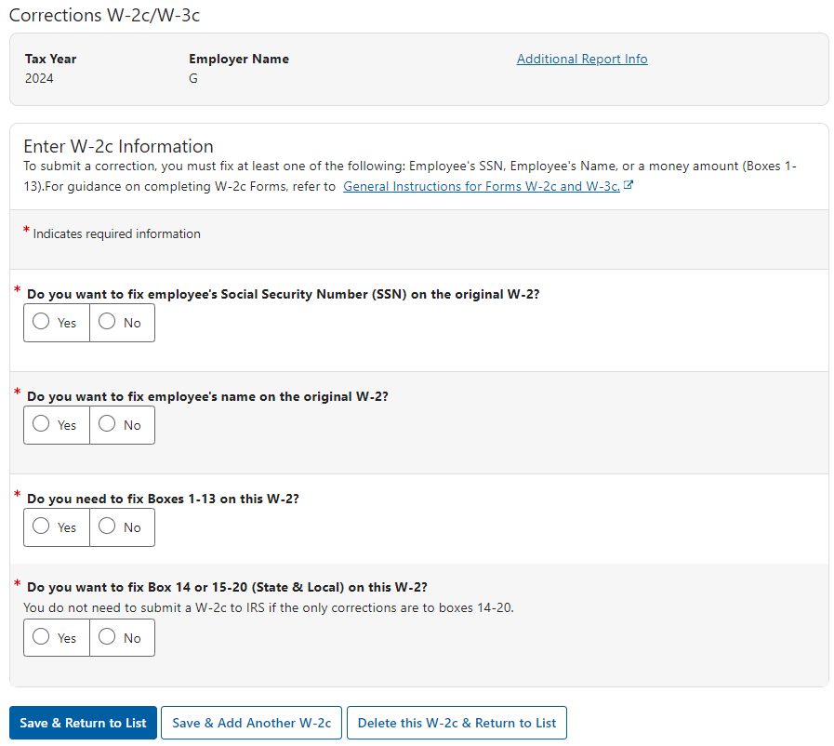

3.1.5.1 Fix/Not Fix Employee’s Social Security Number (SSN)
Select Yes to fix employee’s Social Security Number. The system displays Previously Reported Social Security Number (SSN) and Correct Social Security Number (SSN) fields.
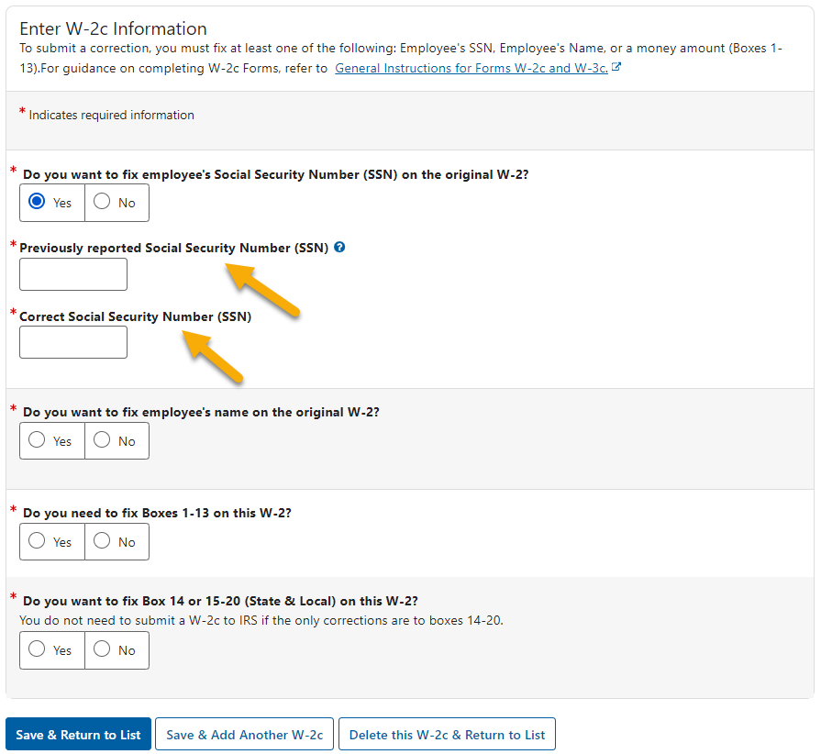

Select No, the system will display a single Employee’s Social Security Number (SSN) field.

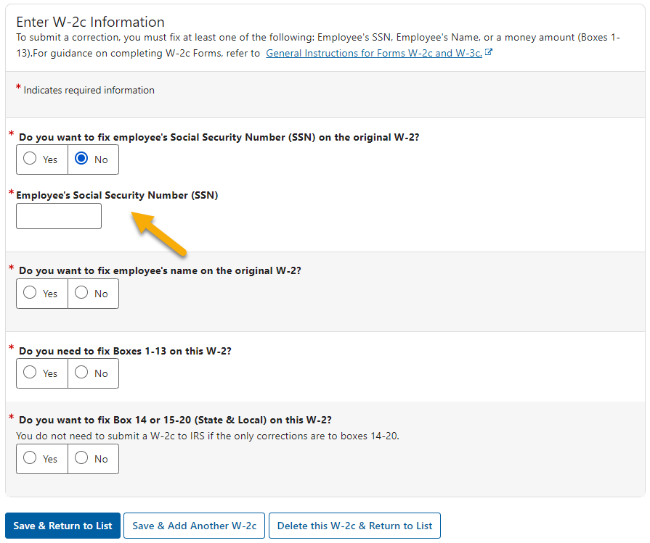

3.1.5.2 Fix/Not Fix Employee’s Name
Select Yes to fix employee’s name on the original W-2. The system displays Previously Reported Employee’s Name, Employee’s Correct Name and Employee’s Address fields.

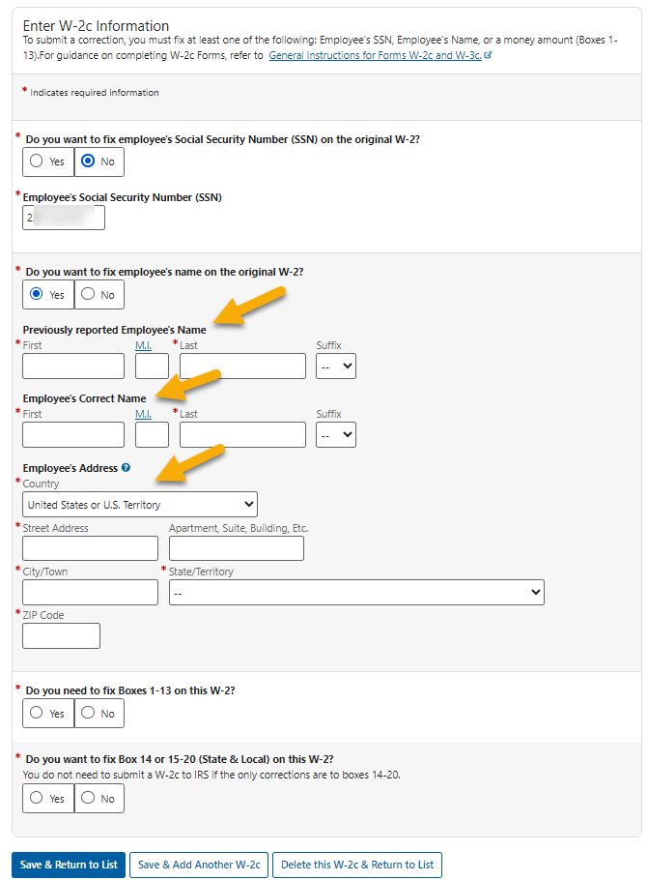
Select No, the system will only display the Employee’s Name and Employee’s Address fields.
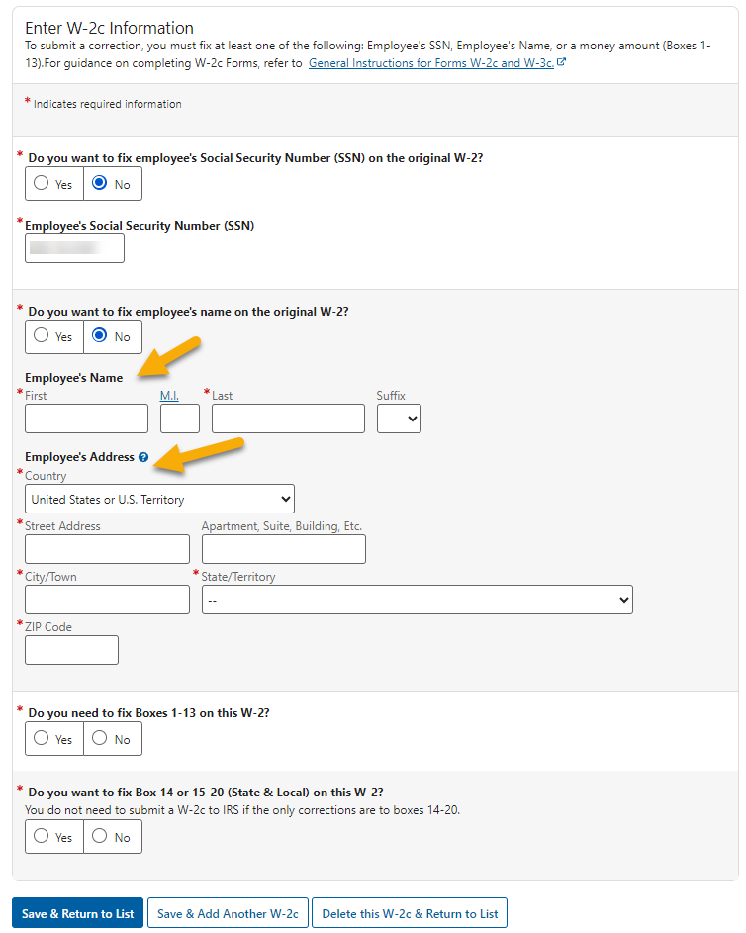

3.1.5.3 Fix/Not Fix Boxes 1-13
Select Yes to fix one or more Boxes 1-13. The system displays Boxes 1-13 section.
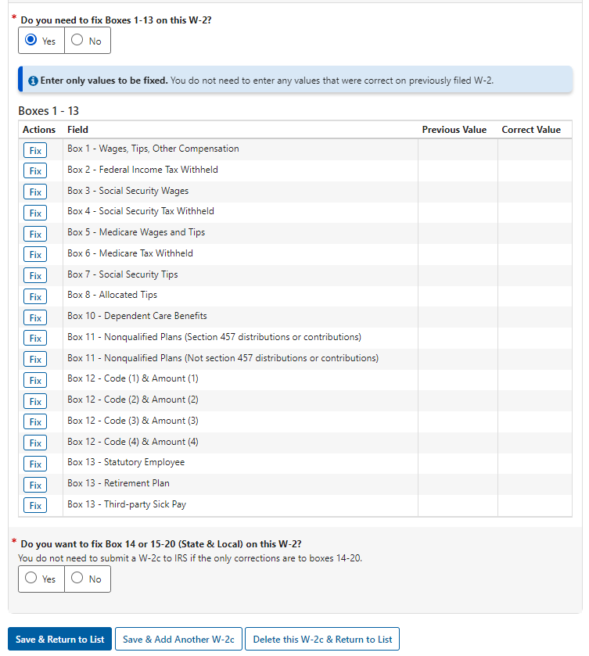
Select No, no additional fields will be displayed.

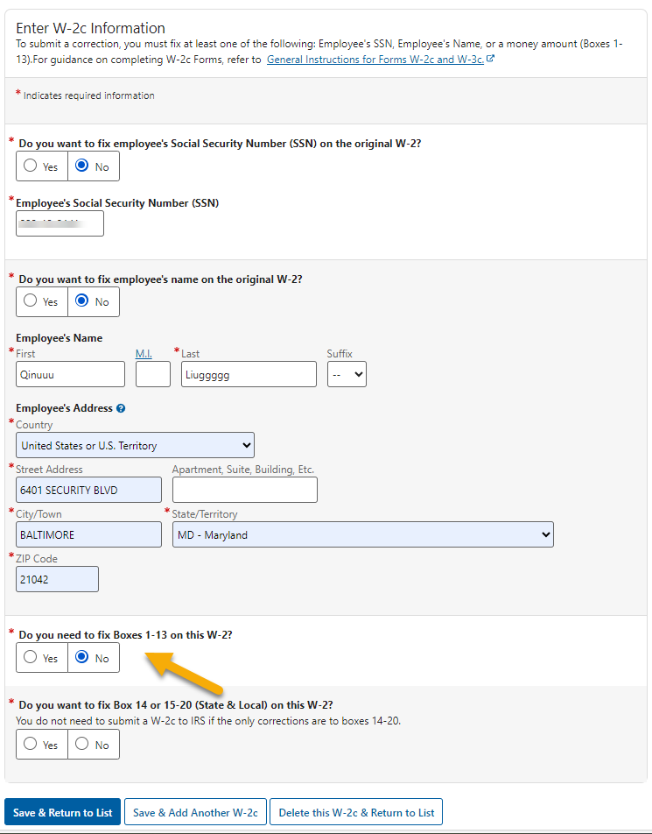

3.1.5.3.1 Fix Boxes 1-13
- Select the Fix button in front of the Box you want to fix. The system displays the box you selected with two fields: Previously Reported Value and Correct value.
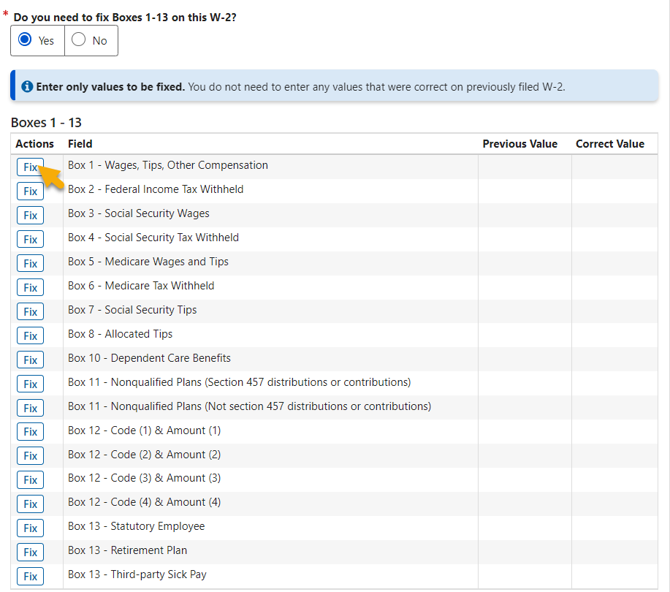
- Enter both values, then select the Update & Save Changes button. The system returns to the Enter W-2c Information page.
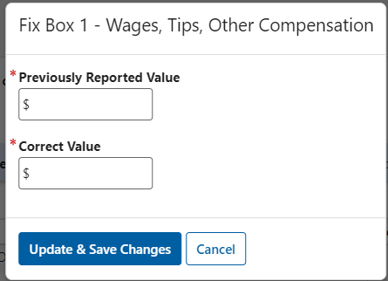
- In the Boxes 1-13 table, the values you entered display in the Previous Value column and Correct Value column. A Clear button also appears behind the Fix button.
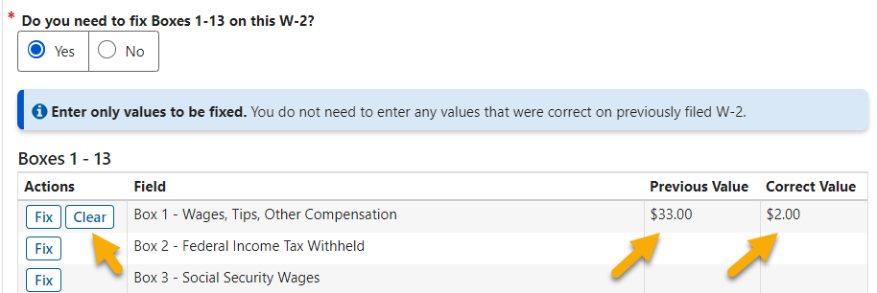
- Select the Clear button to clear the values you just entered. The Clear button also disappears.
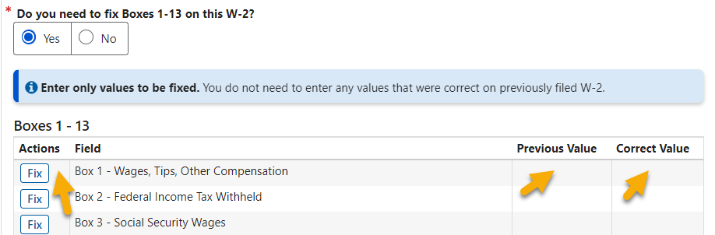

3.1.5.3.2 Fix Box 12
When you select to fix Box 12, a Code dropdown list displays in addition to the Previously Reported Value field and the Correct Value field.
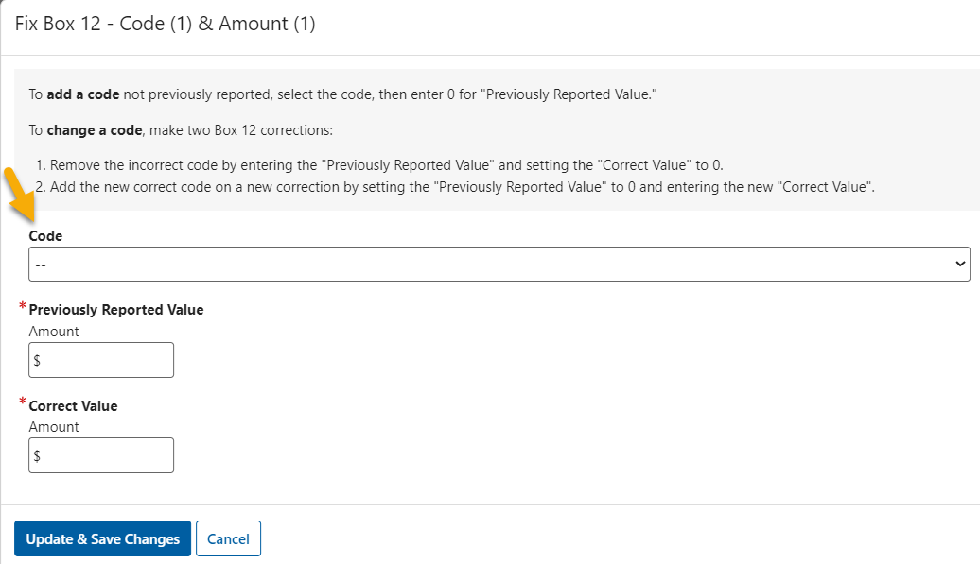
Select the down arrow in the Code field. The system displays a list of codes with definitions.
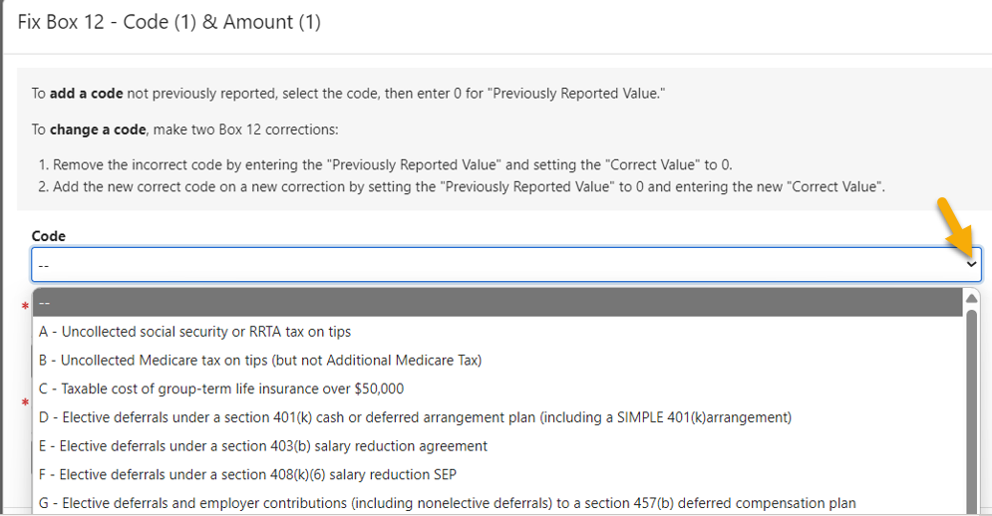Select the Code you want to fix, enter the Previously Reported Value and Correct Value, then select the Update & Save Changes. The system displays the Enter W-2c Information page.
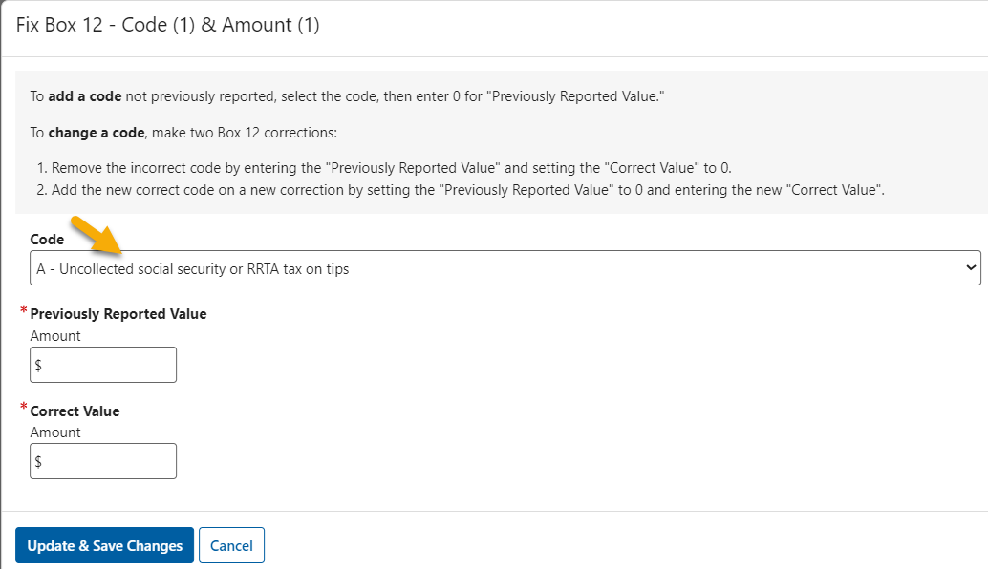
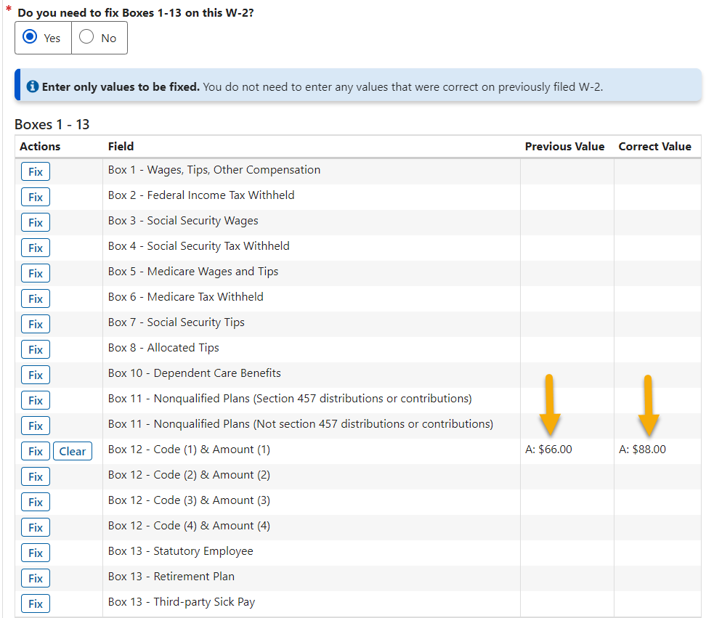

3.1.5.4 Fix/Not Fix Box 14 or 15-20
Select Yes to fix one or more Box 14 or Boxes 15-20. The system displays Optional Box 14 and Optional Boxes 15-20 sections.
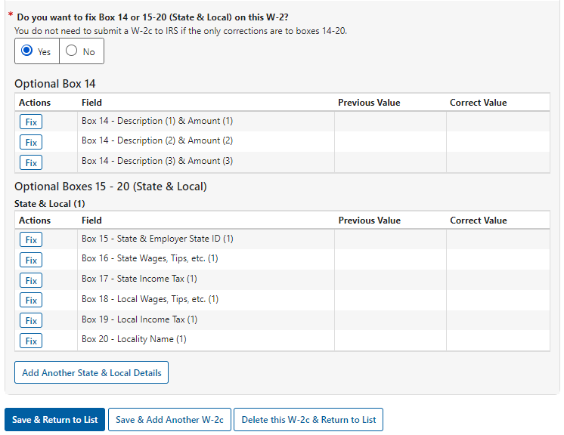

Select No, no additional fields will be displayed.
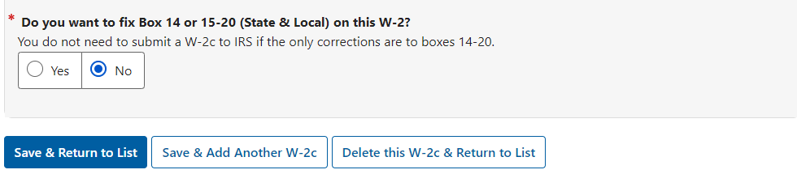

SSA will not send state/local data to IRS. When you finish working on this page, you can choose to:
- Save this W-2c and return to the W-2c List page,
- Save this W-2c and add another W-2c to the same report, or
- Delete this W-2c and return to the W-2c List page.

You can navigate between the Enter W-2c Information page and the W-2c List page to add W-2c Forms, edit W-2c Forms, preview W-2c Forms, or delete W-2c Forms. After entering all W-2c Forms for this report and you are ready to submit this report to SSA, you will need to return to the W-2c List page.

W-2c List Page (with W-2c Forms)
The W-2c List page can display up to 25 W-2c Forms, which is the maximum number of W-2c Forms allowed in each report. Once the limit is reached, the Add New W-2c button will not be displayed. If you have more than 25 W-2c Forms to report for an employer, you can create another wage report for the same employer.
To preview the W-2c Form in PDF, select one or more W-2c Forms, then select the Preview button. The system displays the W-2c Preview page. See the W-2/W-2c Preview section within this tutorial for additional information.
To delete W-2c Forms, select one or more W-2c Forms, then select the Delete button. The system displays the Delete W-2c page. See the Delete W-2/W-2c section within this tutorial for additional information.
Select the Save & Continue button. The system displays the Preview W-3c page.
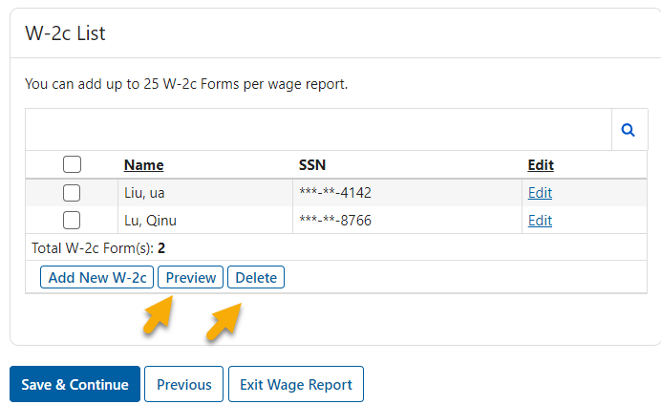

3.1.7 Preview W-3c Page
On the Preview W-3c page, you can
- Fix third-party sick pay;
- Fix total State and Local Wages; and
- Preview W-3c.
To preview the W-3c in PDF, select the Preview W-3c button. The system displays the W-3c Preview page. See the W-3/W-3c Preview section within this tutorial for additional information.
Select the Save & Continue button. The system displays the SSN Masking page.

3.1.8 SSN Masking Page
On the SSN Masking page, select one of the Masking Options. Once the report is submitted to SSA, you will not be able to change the SSN masking option.
Select the Save & Continue button. The system displays the Review Unsubmitted Forms page.
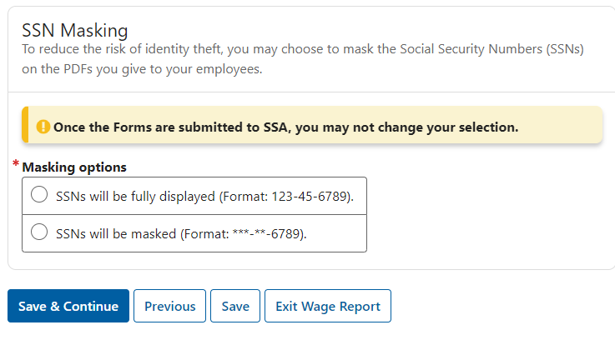

3.1.9 Review Unsubmitted Forms Page
On the Review Unsubmitted Forms page:
- Select the Generate PDF for Review button. The Review page will be displayed. See Review within this tutorial for additional information.
- Select the Save & Continue button. The system displays the Sign and Submit page.

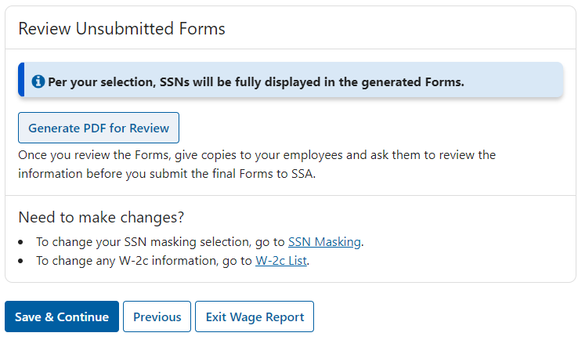

3.1.10 Sign and Submit Page
On the Sign and Submit page, select the check box to affirm the statement, then select the Submit this Wage Report button. The system displays the Confirmation of Submission page.
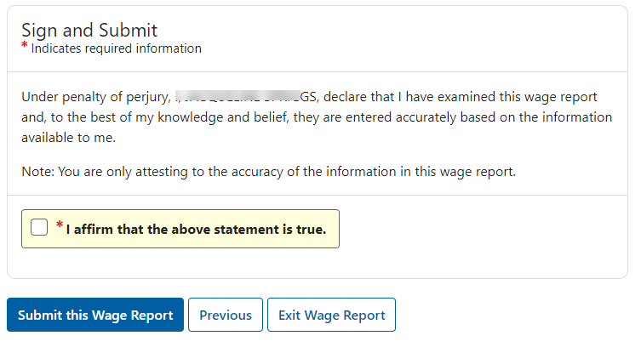

Confirmation of Submission Page
SSA encourages you to print or save a copy of this page as a receipt and proof of filing date. Take a note of the Wage File Identifier (WFID) because this will be needed in all communications with SSA regarding this wage report. It will also be needed to check this report’s status through the Submission Status application and the Employer Report Status application within the EWR suite of services.
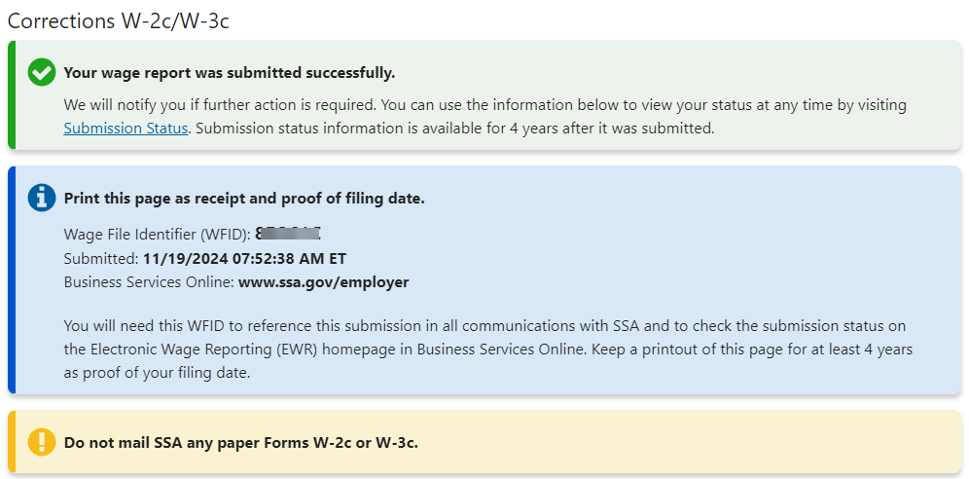
To see a copy of the submitted report in PDF, select the Generate PDF button. The system displays the Final page. See Final within this tutorial for additional information.
To see the submission receipt, select the Print or Save WFID and Receipt button. The system displays the Receipt page. See Receipt within this tutorial for additional information.
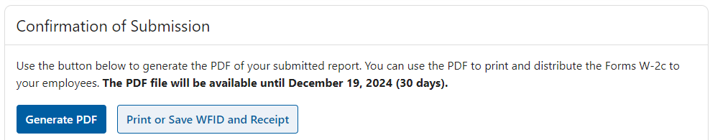
Select the Return to Forms W-2c/W-3c Online button if you want to start from the beginning of the Forms W-2c/W-3c Online application. The system displays the Forms W-2 Online landing page. See the Forms W-2c/W-3c Online Landing Page in the “Forms W-2c/W-3c Path” section within this tutorial for additional information.
Select the Start a New Report button if you want to file a new report. The system displays the For whom are you filing page. See the For Whom Are You Filing Page section in the “Forms W-2c/W-3c Path” within this tutorial for additional information.
Select the Return to EWR Home button if you want to exit the W-2 Online application but stay within the EWR suite of services. The system displays the Reporting Wages to Social Security page (EWR homepage).
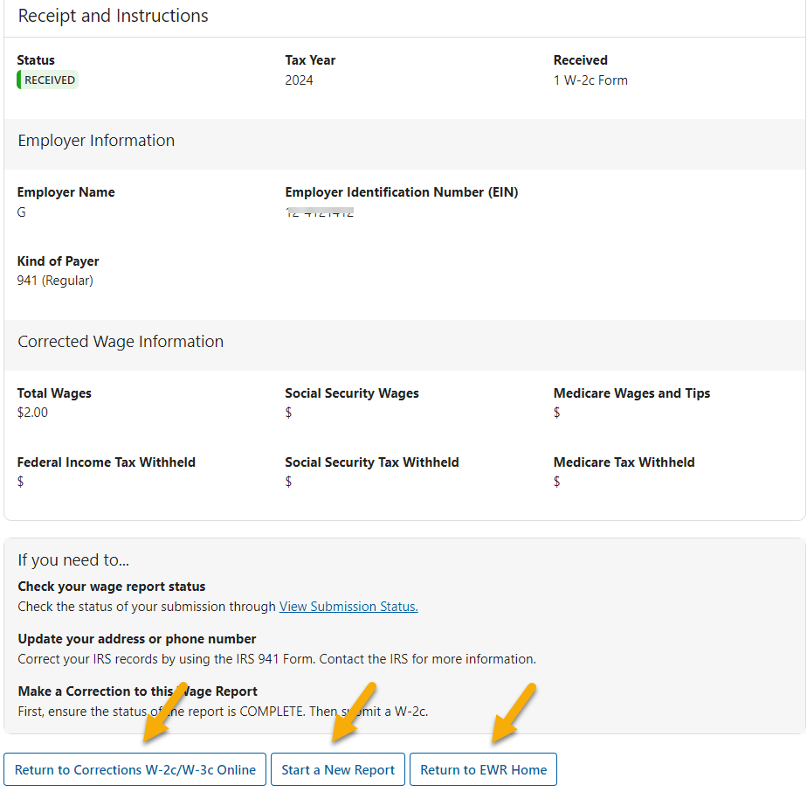

Unsubmitted Correction Reports
On the Corrections W-2c/W-3c landing page, your unsubmitted reports will be displayed in the “Unsubmitted Correction Reports” section.
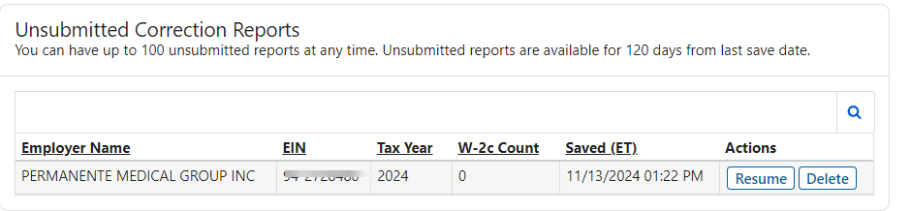

3.2.1 Resume Unsubmitted Reports
To resume working on an unsubmitted report, select the Resume button. The system displays the Enter Employer Information page. See the Enter Employer Information Page in the “Forms W-2c/W-3c Path” section for additional information.

3.2.2 Delete Unsubmitted Reports
To delete an unsubmitted report, select the Delete button. The system displays the Delete Unsubmitted Report page. Follow the instructions on the page to complete your action. Once a report is deleted, it can’t be recovered.
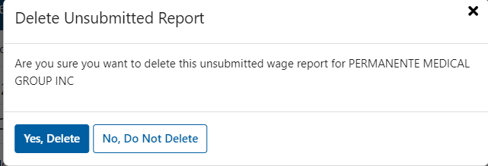

Submitted Correction Reports
On the Corrections W-2c/W-3c landing page, your reports submitted within the last 30 days will be displayed in the “Submitted Correction Reports” section.
To view a submitted report in PDF, select the View PDF button. The system displays the Final page. See the Final section within this tutorial for additional information.

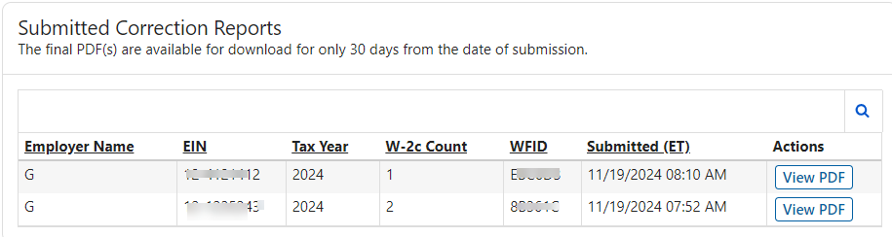

Other Features

4.1 Header
Information entered on the For Whom Are You Filing page will be displayed in the header section on the following pages:
- Enter Employer Information
- W-2 List
- W-2c List
- Enter W-2 Information
- Enter W-2c Information
- Preview W-3
- Preview W-3c

Select the Additional Report Info link, W-2/W-3 path displays EIN, Type of W-2 Form, and Kind of Payer information; W-2c/W-3c path displays EIN and Kind of Payer information.
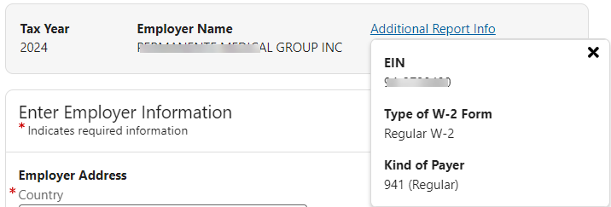
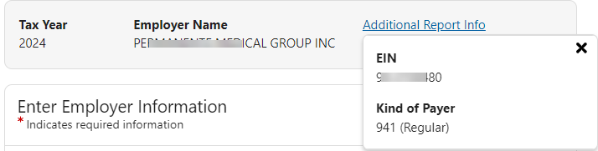

4.2 Exit Wage Report
If an Exit Wage Report action is initiated, you can choose to Exit Wage Report or Cancel & Stay on Page.
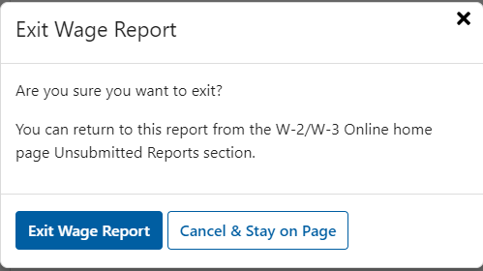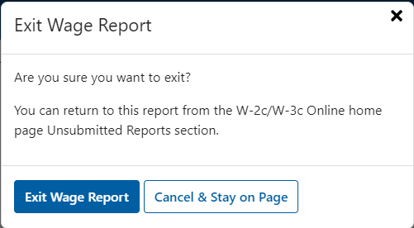

4.3 W-2/W-2c Preview (PDF)
When you are on the W-2 List page, select the W-2 Forms you want to preview, then select the Preview button. The system displays the W-2 Preview page.
You can preview each W-2 Form by selecting the Next W-2 and Previous W-2 buttons. To dismiss the page, select the Close button or the X mark in the top right corner of the page, or click anywhere outside the W-2 Preview page. Follow the same steps to preview W-2c Form.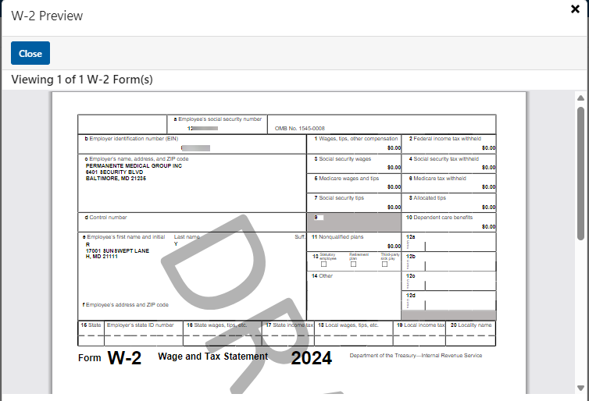
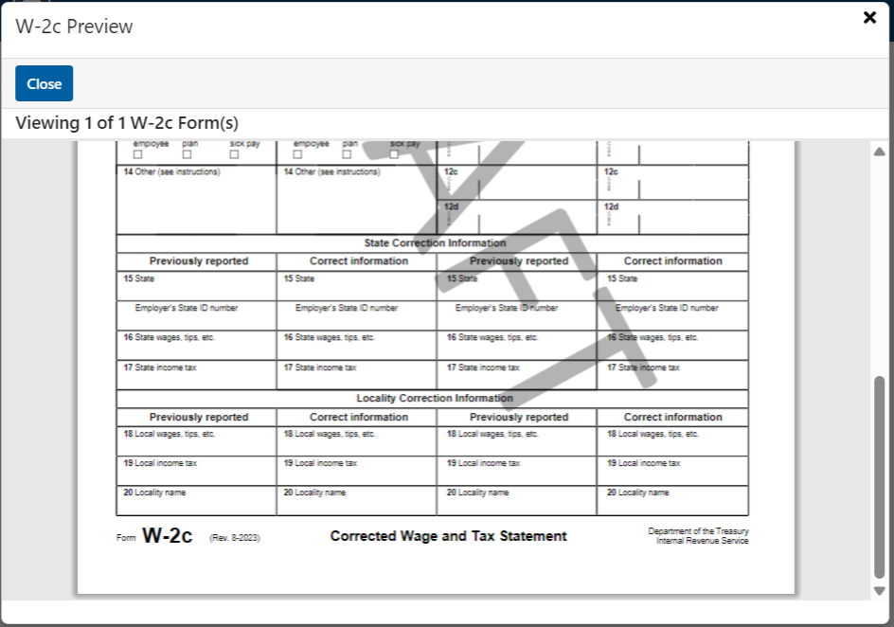

4.4 Delete W-2/W-2c Forms
When you are on the W-2 List page, select the W-2 Forms you want to delete, then select the Delete button. The system displays the Delete W-2 page. If you are sure you want to delete the selected W-2 Form(s), select the Delete button; if not, select the Cancel button or click anywhere outside the Delete W-2 page.
Follow the same steps to delete selected W-2c Forms.
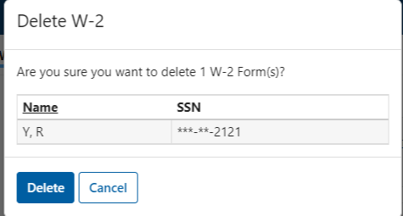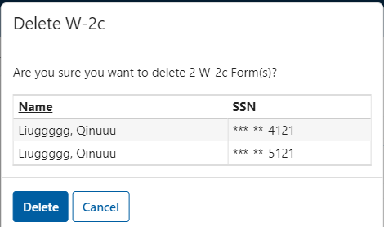

4.5 Import W-2 Form(s)
When you are on the W-2 List page, select the Import W-2 Form(s) button. The system displays the Import W-2 Form(s) page. If you did not file for the same employer previously, the system will display an empty table.
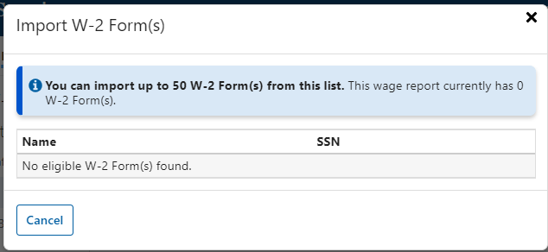
If you filed for the same employer previously. The system displays a table with all the eligible W-2 Forms.
On the Import W-2 Form(s) page:
- The total W-2 Form(s) this wage report currently has is displayed in the message.
- The total number of W-2 Forms available for selection is displayed at the top of the table.
- You can import up to 50 W-2 Forms from the list.
- The total number of W-2 Forms selected is displayed at the bottom of the table.
- Select the Import Selected W-2 Forms button. The system displays the W-2 List page and all W-2 Forms selected will be imported to the W-2 List page.

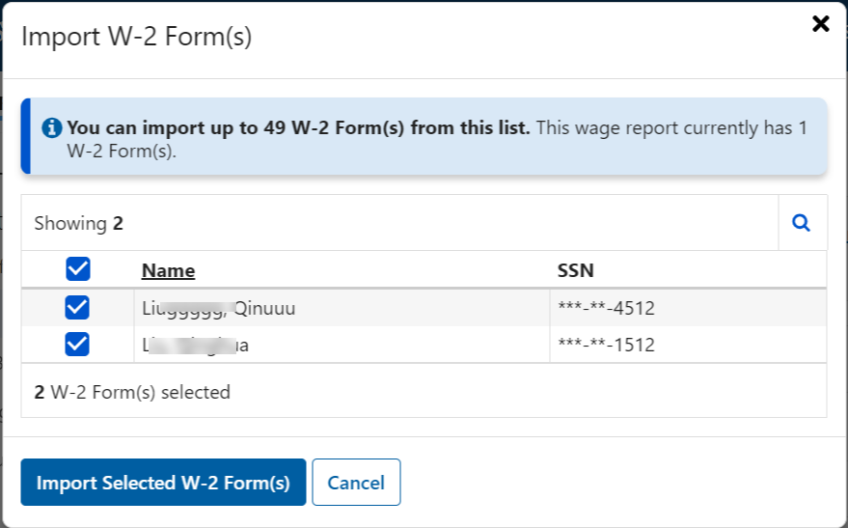
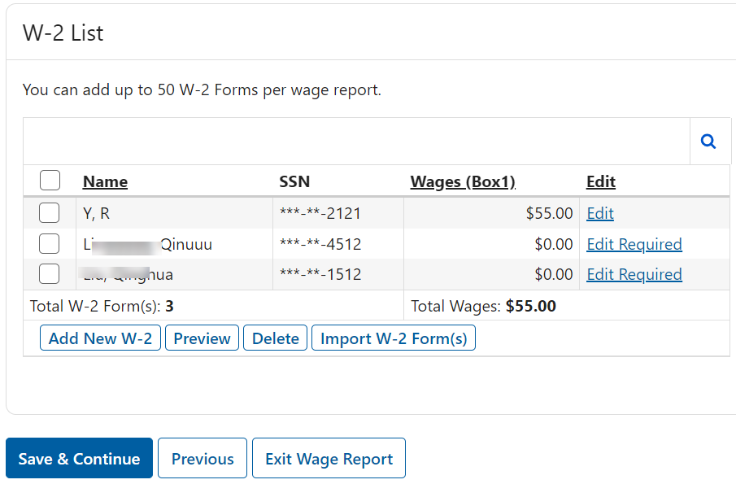
4.6 Override State/Local Data
If the I confirm that I want to override the calculated sums from the W-2 forms radio button on the Preview W-3 page is selected, an “Override with Values” section will be displayed on the right side of the “Calculated Sums” section. Enter new values to replace the system calculated sums. Although SSA will not send the state/local data to IRS, state/local data will be saved on the unsubmitted/submitted wage reports in PDF for your record.
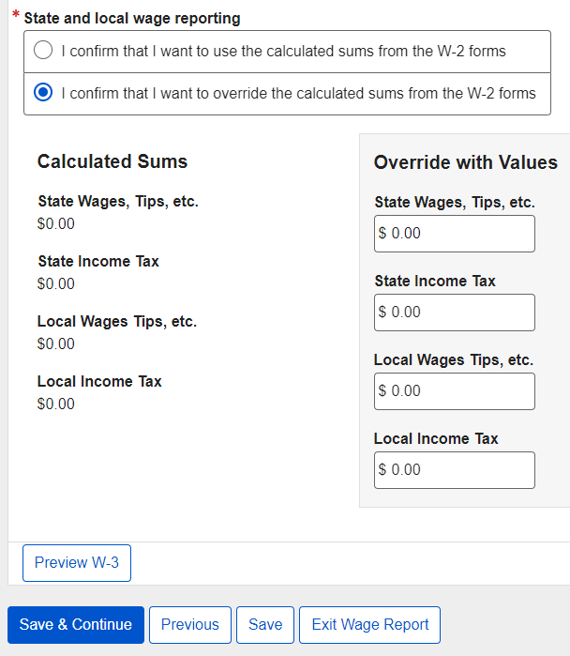

4.6 W-3/W-3c Preview (PDF)
When you are on the Preview W-3 page, select the Preview W-3 button. The system displays the W-3 Preview page.
To dismiss the page, select the Close button or the X mark in the top right corner of the page, or click anywhere outside the W-3 Preview page.
Follow the same steps to access W-3c Preview page.
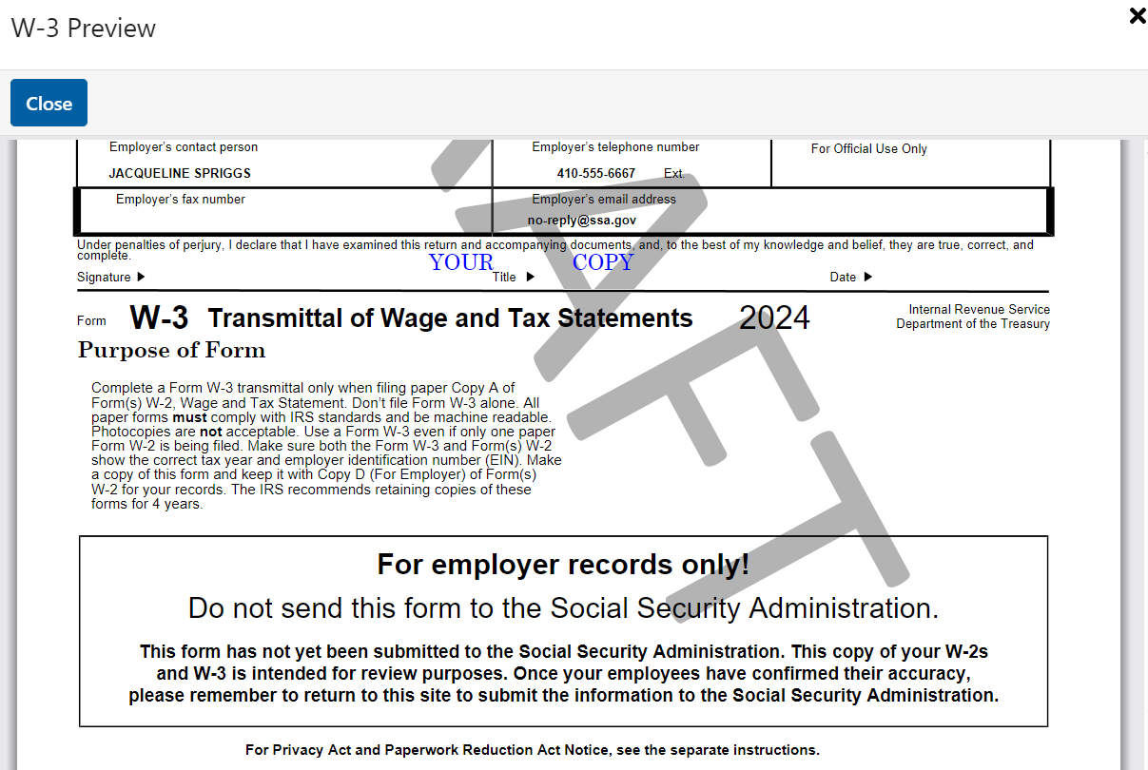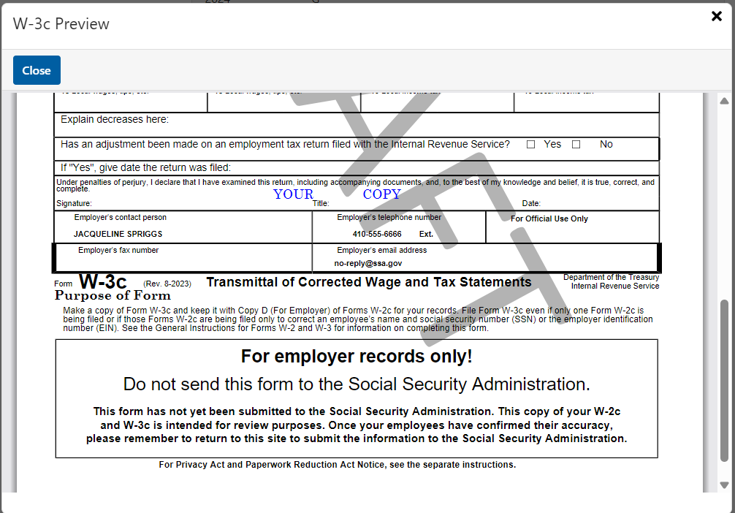

4.7 Review (Review Unsubmitted Report)
On the Review Unsubmitted Forms page, select the Generate PDF for Review button. The system displays the Review page.
On the Review page, select the Download button. The system will download a copy of your unsubmitted report in PDF. To dismiss the page, select the Close button or the X mark in the top right corner of the page, or click anywhere outside the Review page.
To dismiss the page, select the Close button or the X mark in the top right corner of the page, or click anywhere outside the Preview page.
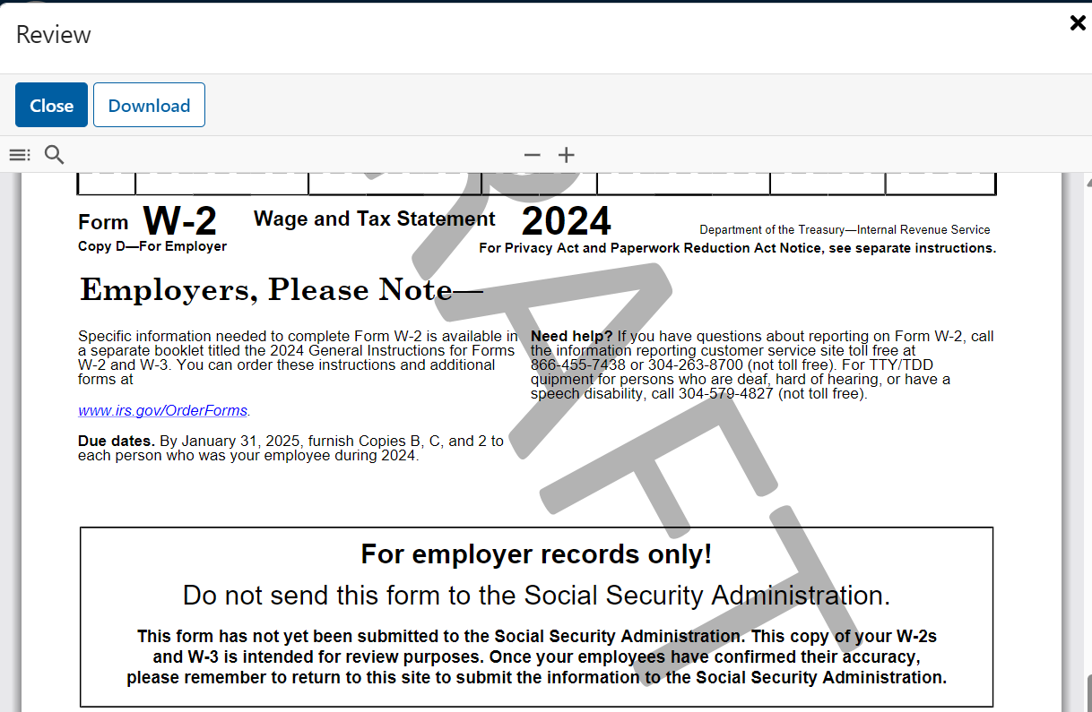

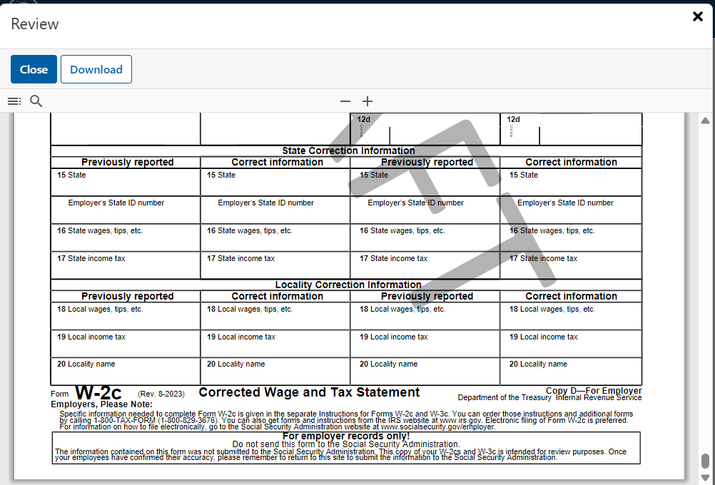

4.8 Final (PDF)
On the Final page, select the Download button. The system will download a copy of your submitted report in PDF. To dismiss the page, select the Close button or the X mark in the top right corner of the page, or click anywhere outside the Final page.
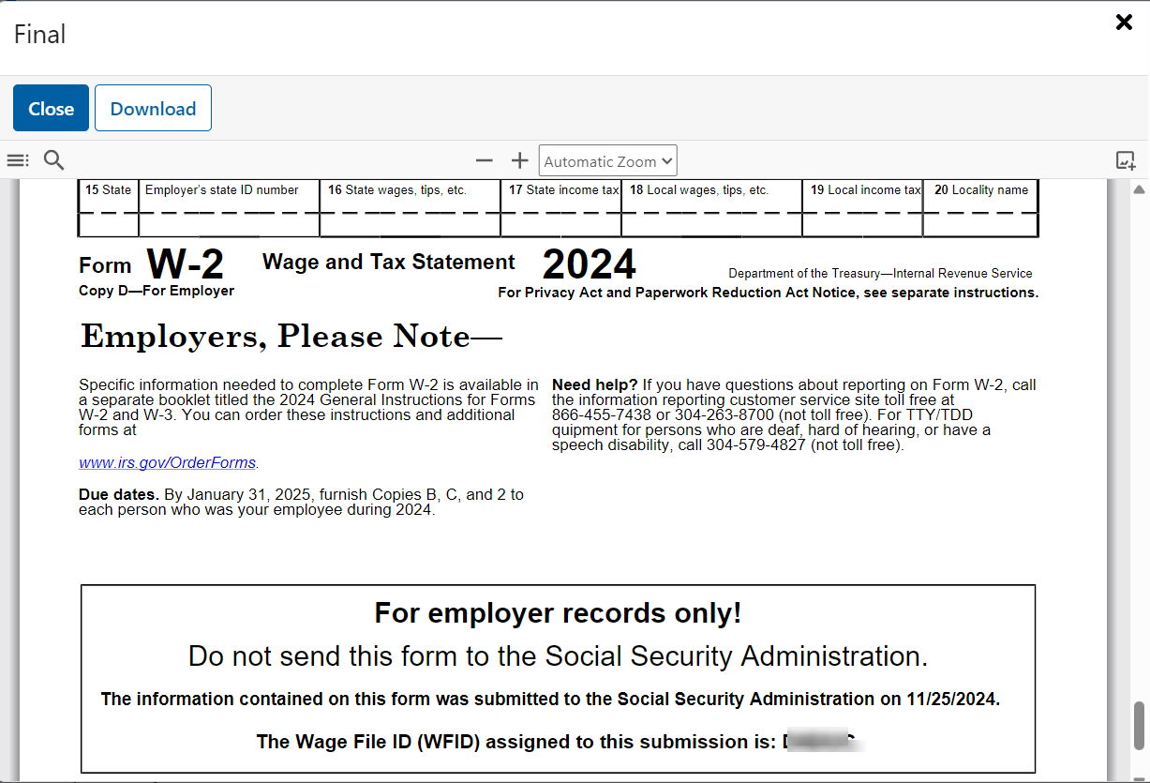
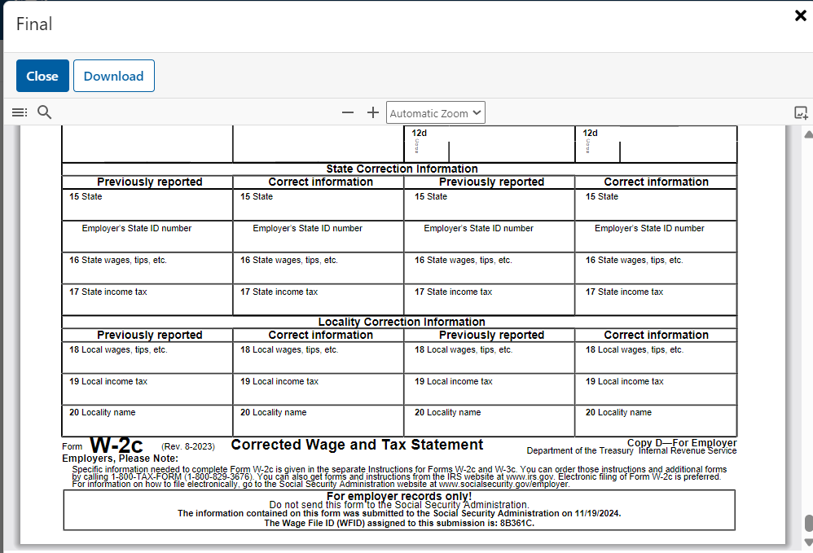

4.9 Receipt
Select the Print or Save WFID and Receipt button on the Confirmation of Submission page. The system displays the Receipt page.
To print the Receipt, select the Print button.
To dismiss the page, select the Close button or the X mark in the top right corner of the page, or click anywhere outside the Receipt page. 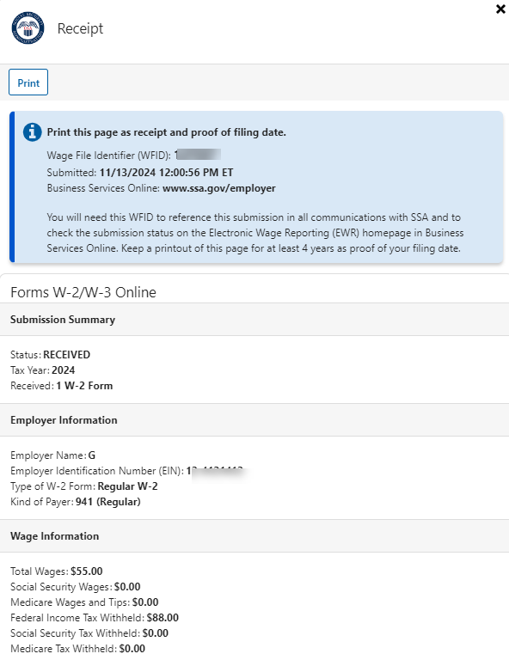
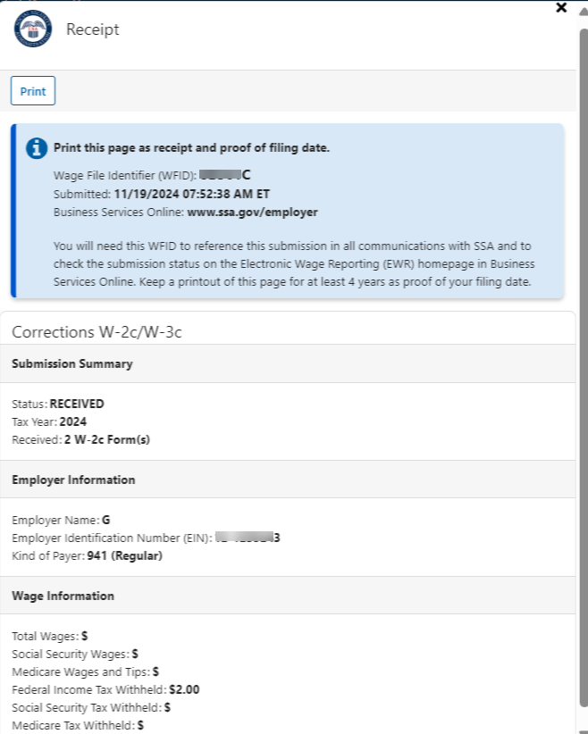

4.10 Errors
When data entered breaks the system built-in rules, error messages will be displayed in red at the top of the page and above the specific fields. Follow the error messages to make corrections. Forms W-2/W-3 must be free of errors before submitting to SSA.

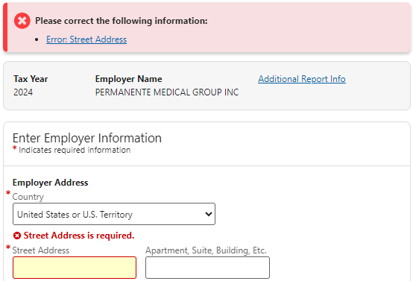

4.11 Loading Data
When the system loads a large amount of data or the network is busy, a Loading Data page might display. The page will be disappeared once the data loading is completed.
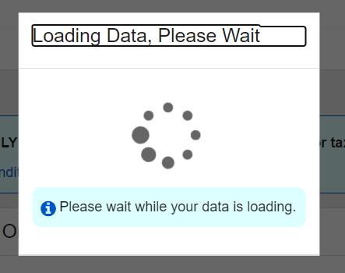

4.12 Feedback
User feedback is very important to the performance of W-2/W-3 Online. The survey link is available on every page throughout the application. You can take the survey more than once. However, you may want to wait to complete the survey until after you submit the wage report.


