User Guide for Access Electronic Requests

Office of Disability Determinations
October 2011
Electronic Records Express Website
Document Exchange Services

Access Electronic Requests
This function is a part of the Electronic Outbound Request (eOR) feature in which Consultative Examination (CE) and Medical Evidence request letters are sent by electronic means via the Electronic Records Express website from the DDS to the provider (hospital, doctor, copy service, etc.). Through this link you can: view outstanding electronic requests, download request letters and other supporting documentation, and conveniently submit responses without having to enter any barcode index information.
You will receive an email notification when a request is sent to your ERE account from the DDS. The email will include a link that will direct you to enter your ERE User ID and password. After logging in, you are taken to the individual request associated with the email you received.
You may also access your eOR by choosing the Access Electronic Requests link under the Document Exchange Services heading on the Electronic Records Express Home page. Here you can view all of the electronic requests sent to you from the DDS.
Please note that you are responsible for information submitted on the ERE website when using your ERE User ID and password. You should never share your ERE User ID or password with others.
Electronic Records Express Home—Access Electronic Requests
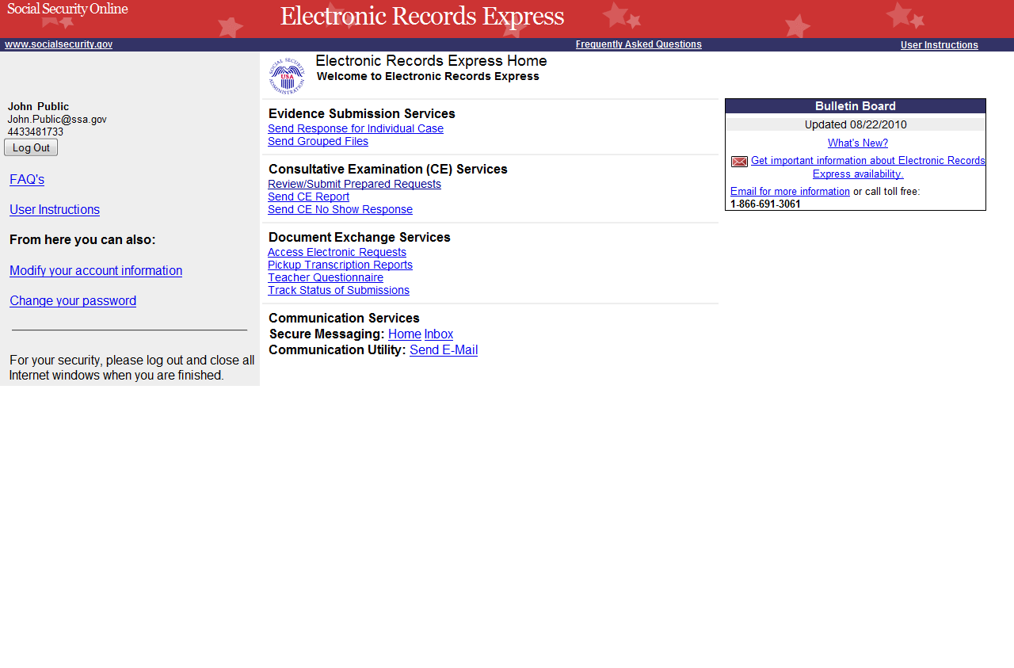

Step 1—Access Electronic Requests
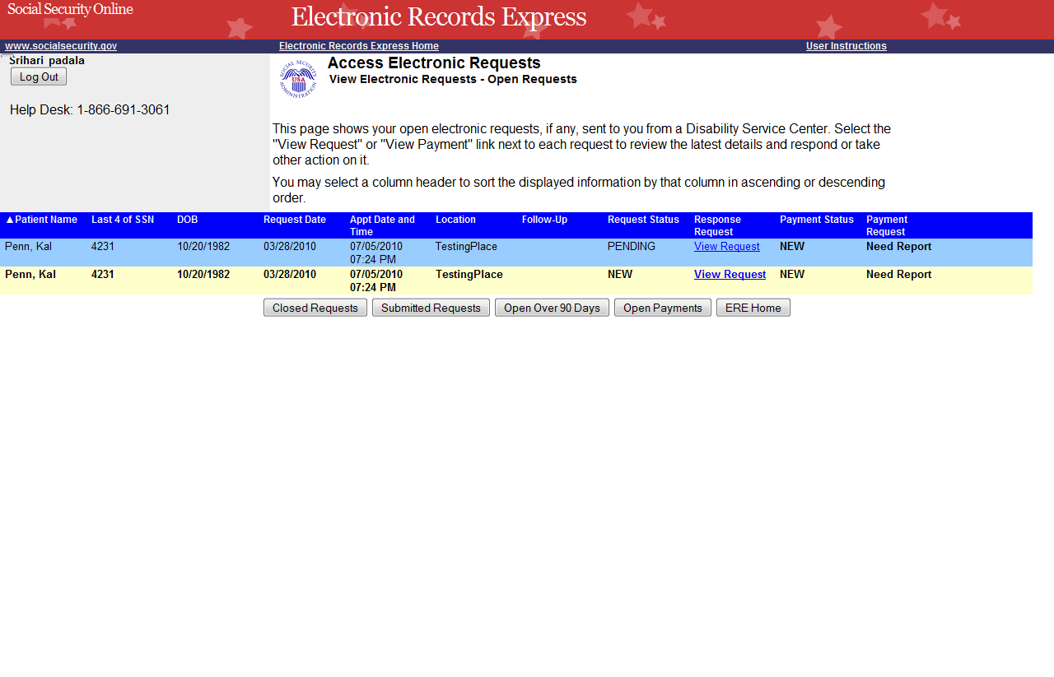
Select “View Request” to view an individual request
Select the column heading to sort the displayed information
Select “Closed Requests,” “Submitted Requests,” or “Open Over 90 Days” to see these types of requests
Note: This page of the Electronic Records Express website does not differentiate between Medical Evidence and CE requests.

Step 1—Access Electronic Requests
- This page allows you to view and sort the status of all requests received from the DDS.
- You may select a column header to sort the displayed information by that column in ascending or descending order. Sorted columns display a small arrow adjacent to the column header. The column headers are:
- Name
- Last 4 of SSN
- DOB
- Request Date
- Appt Date and Time
- Location
- Follow-up
- Request Status
- Response Request
- Payment Status
- Payment Request

- Select View Request in the Response Request column to view an individual request and proceed to Step 2.
You may also:
- Select the Closed Requests button to display requests cancelled by the DDS.
- Select the Submitted Requests button to display requests that you submitted.
- Select the Open Over 90 Days button to display requests sent by the DDS over 90 days ago.
- Select the ERE Home button to go to the Electronic Records Express Home page.
Request Status Definitions

- New— A new request that has not been opened.
- Pending—A request that has been opened/viewed.
- Prepared—A CE Admin staff has prepared a report for this request.
- Responded—Response submitted by provider through ERE Website.
- Accepted—The DDS received the request response.
- Cancelled—The DDS cancelled the request.
- Updated--- Updated initial request.
- Updated Pending--- Updated Initial request and awaiting documents.

Note: The Electronic Request will be removed from the list based on the retention days received with the request if less than 120 days. Otherwise, Electronic Requests will be removed from the list 120 days from the Request Date.
Step 2—View Electronic Request Details—CE
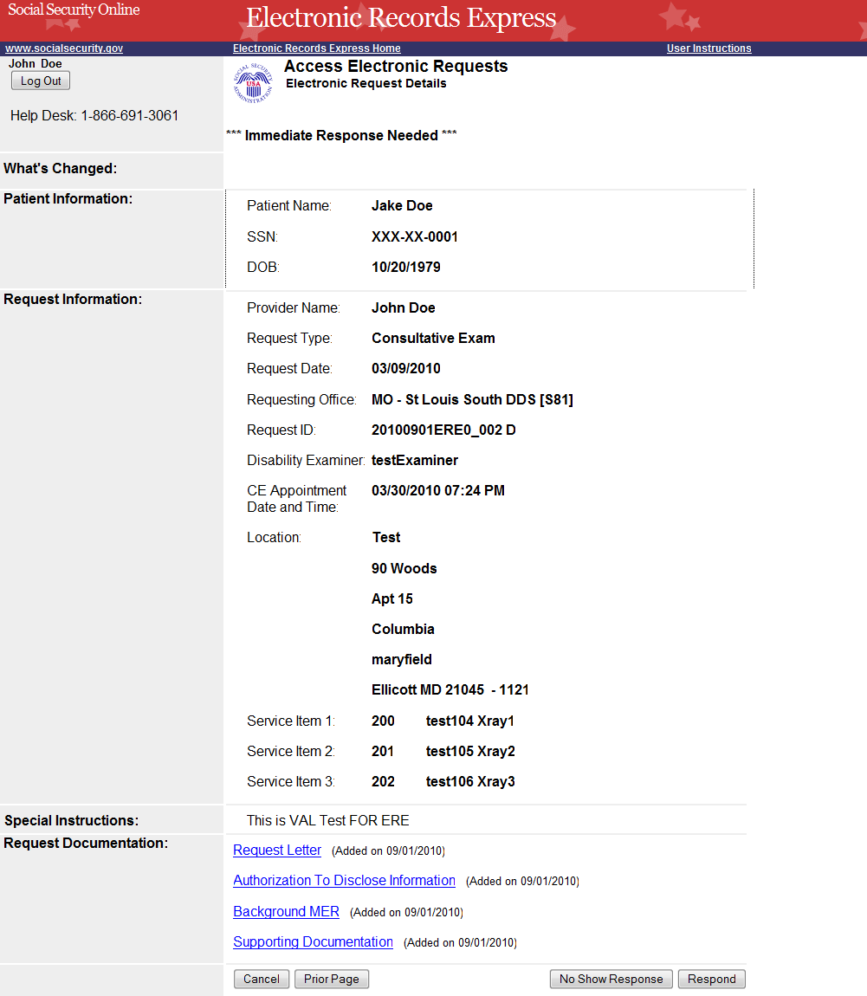
Select an underlined heading to view Request Documentation
Select Respond to respond to the request
Note: The Patient and Request information is automatically populated to this screen. You cannot edit this information.

If you are responding to a CE request, see the following instructions (instructions for responding to an Evidence Request are on page 8).

Step 2—View individual electronic request—CE
- To view the request documentation, select an underlined document heading in the Request Documentation section.
- To respond to the electronic request, select Respond.
Step 3—Send CE Report
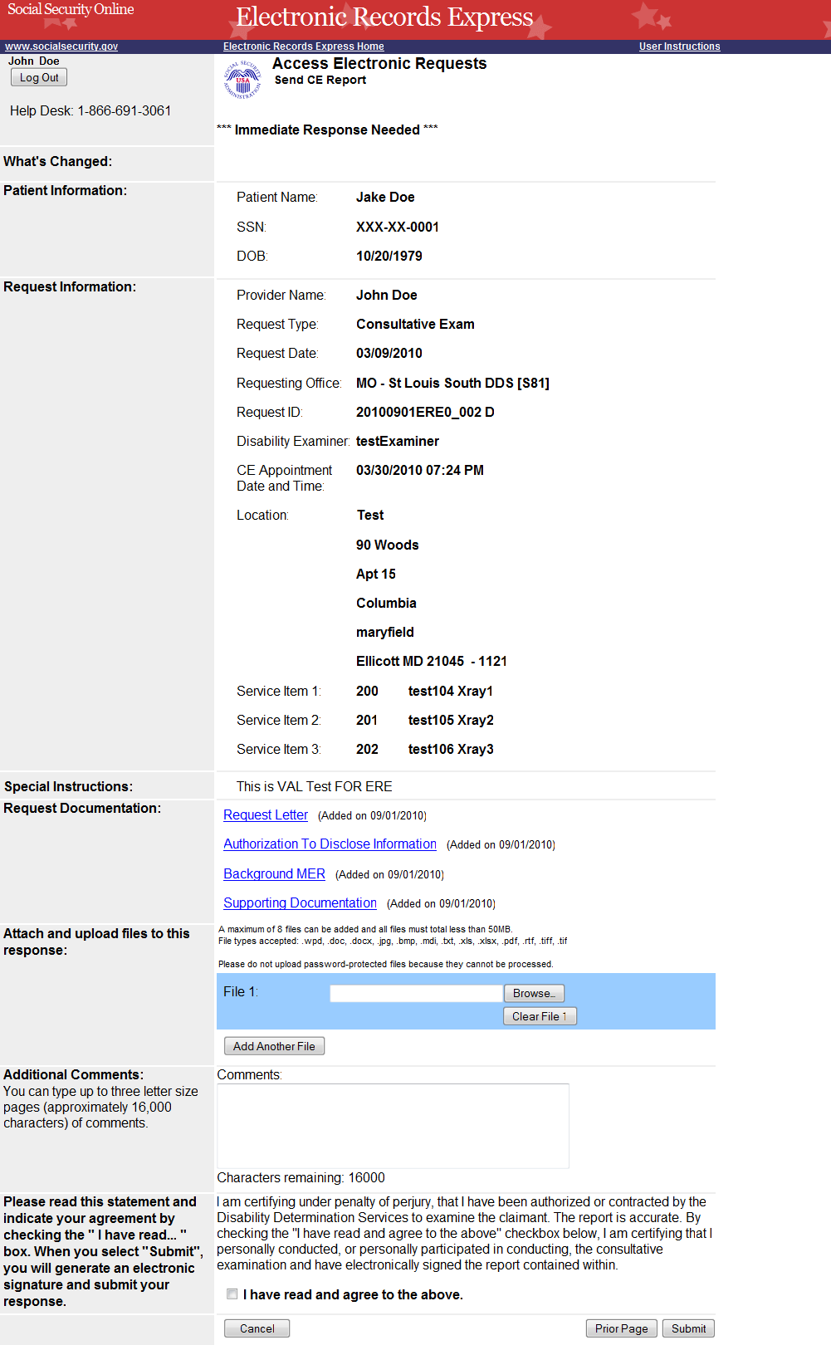

Step 3—Send CE Report
- Review the Patient Information, Request Information, and Request Documentation.
- Select the Browse button to select a file to send. (Do not send files that are password protected.) The Choose file window appears.
- Locate the file you wish to send and highlight the file name. The document’s file name moves into the File name box at the bottom of the Choose file window.
- Select the Open button. The Choose file window closes, and the file name displays in the box to the left of the Browse… button. If you have chosen the incorrect file, select the Clear File 1 button to clear the File 1 field.
- Select the Add Another File button to send additional files. Only files for the SSN in the Patient and Request Information may be sent with this transaction.
Note: A maximum of eight (8) files may be sent for one individual by selecting the Add Another File button and repeating the previous steps.
SSA’s Electronic Records Express website will accept the following file formats: .wpd, .doc, .docx, .jpg, .bmp, .mdi, .txt, .rtf, .xls, .xlsx, .pdf, .tiff, .tif.
Do not upload documents containing macros (i.e., a set of instructions or scripts that automates tasks). They may cause system problems, which will require you to re-submit your documents without macros.
- Type Comments, if needed. For example, you may need to provide an explanation of why you are not submitting a CE and any additional details. Type-in and/or cut-and-paste your text (up to 16,000 characters, approximately three letter size pages) directly into the box provided. The count of remaining characters shows beneath the box.
- The next step is your “Electronic Signature”. This allows you to certify that the claimant has been examined, a report has been prepared, and the report is accurate. Read the certification statement located at the bottom of the screen and indicate your understanding by checking the box beside, “I have read and agree to the above.” By checking the box, you affirm your intent to sign the report. This process eliminates the need for you to physically sign and send the paper report to the DDS.
- Select the Submit button to provide the electronic signature and forward the information to the DDS office that sent the request.
The website will create a text file and add it to the files and information you have submitted. This text file will contain the following information:
- Index information you entered from the request letter
- The signature attestation statement to which you agreed
- Your name as it is registered with Electronic Records Express—serving as your electronic signature.
Important Note
It is against SSA policy for a user to delegate the uploading of their Consultative Examination reports, via the Access Electronic Request website function, to staff members. Users interested in delegating this responsibility should consider using the Send CE Report(s) with Scanned Signature website function or CE Administrative Staff Upload (Review/Submit CE Reports, Pickup Provider’s Transcription Reports and Prepare CE Report for Provider).
Step 4—Tracking Information
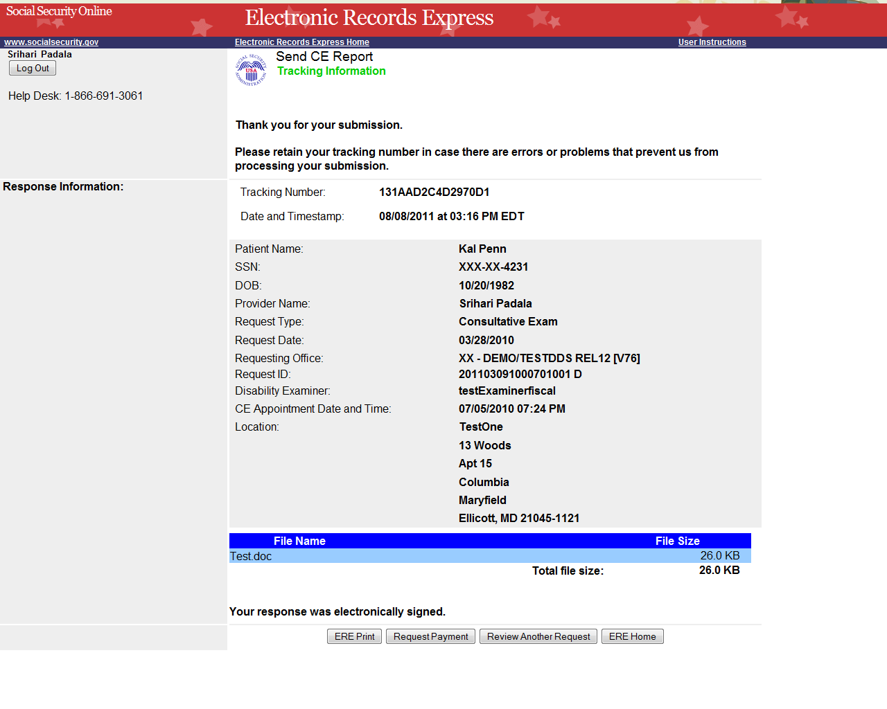
Tracking Number

Step 4—Tracking Information
- After your submission uploads, Electronic Records Express provides a Tracking Information page. The Tracking Information page provides a tracking number for you to keep and use if you want to check on the status of your submission.
- If you do not receive the Tracking Information page, you should resubmit the materials.
- If you continue to have transmitting problems, contact the Electronic Records Express Website Help Desk at EETechSupport@ssa.gov or 1-866-691-3061.
- To respond to another request, select the Review Another Response button.
NOTE: We strongly recommended that you print or take a screenshot of the Tracking Information page for your documentation. To do this, simply select ERE Print, located at the bottom of the page. This print link works the same as if you selected File and Print from your browser’s menu. You cannot bookmark and save a Tracking Information page, and you will not be able to retrieve it later once you exit the webpage.

Instructions for responding to an Evidence Request:

Step 2—View individual electronic request – Evidence Request
- To view a Request Documentation file, select the underlined document heading in the Request Documentation section.
- To respond to the electronic request, select Respond.
- Select the Browse button to pick a file to send. (Do not send files that are password protected.) The Choose file window appears.
- Locate the file you wish to send and highlight the file name. The document’s file name moves into the File name box at the bottom of the Choose file window.
- Select the Open button. The Choose file window closes and the file name displays in the box to the left of the Browse… button. If you have chosen the incorrect file, select the Clear File 1 button to clear the File 1 field.
- Select the Add Another File button to send additional files. A maximum of eight files may be added for this transaction.
- Type Comments, if needed. The Comment field is where you can provide additional information. Type-in and/or cut-and-paste your text (up to 16,000 characters, approximately three letter size pages) directly into the box provided. The count of remaining characters shows beneath the box.
- Select the Submit button to submit the evidence
- Continue to Step 3—Tracking Information.
Step 3—Tracking Information
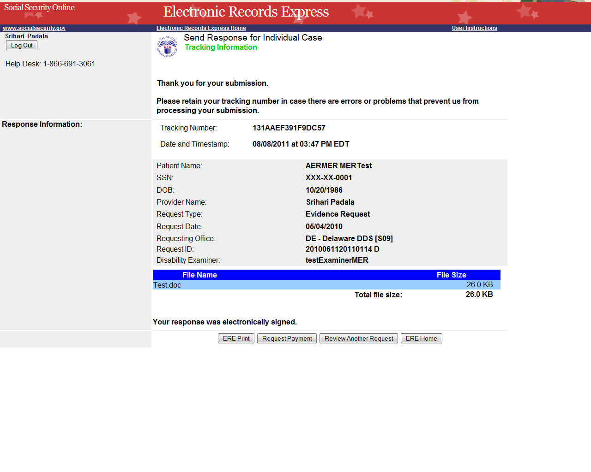
Select ERE Print to print the Tracking Information page

Step 3—Tracking Information
- After your submission uploads, Electronic Records Express provides a Tracking Information page. The Tracking Information page displays a tracking number for you to keep and use if you want to check on the status of your submission. This page also displays the File Name of the specific files and indicates if you submitted comments.
- If you do not receive the Tracking Information page, you should resubmit the materials.
- If you continue to have transmitting problems, contact the Electronic Records Express Website Help Desk at EETechSupport@ssa.gov or 1-866-691-3061.
- To respond to another request, select the Review Another Request button.

NOTE: We strongly recommended that you print or take a screenshot of the Tracking Information page for your documentation. To do this, simply select ERE Print located at the bottom of the page. This print link works the same as if you selected File and Print from your browser’s menu.
You cannot bookmark and save a Tracking Information page, and you will not be able to retrieve it at a later time from the SSA or DDS office once you exit the webpage.
If the file you selected to transmit is 0 byte, or too large (over 50mb), a rejection page will be displayed. Choose Try Again to take you back to the previous page to adjust the file and submit again.

Access Keys
This application contains access keys to improve navigation and provide information. You will find a list of these keys in the table below:
Button | Access Key
Add Another File | 2 – 8 (number corresponds to the file to be added)
Cancel | n
Closed Requests | c
ERE Home | h
ERE Print | p
Log Out | l
No Show Response | s
Open Over 90 Days | 9
Open Payments | p
Prior Page | p
Request Payment | y
Respond | r
Review Another Request | r
Submit | s
Submitted Requests | s
Other keyboard commands, hotkeys or access keys will vary based upon browser and the version of the browser that you are using. A list of these commands can be found in the Help section of your browser. The Help feature can be located on the Menu bar of your browser or by using the F1 function key on the keyboard. Any assistive devices that you may be using will also have a list of these shortcut keys in their Help section.
Note: To use these keys select the “Alt” button on your keyboard and the access key simultaneously.

How to Get Important Information about Electronic Records Express Website Availability
You may subscribe to receive ERE website availability notifications through the GovDelivery services on the Social Security Administration’s Electronic Records Express internet website: Social Security Online: Electronic Records Express. Please see the following website for GovDelivery FAQs: https://service.govdelivery.com/service/help.html#general1

To subscribe to the ERE website availability notification, follow these instructions:
- Click Get important information about Electronic Records Express website availability.
- Type your email address and select Go
- Confirm your email address
- Select “Send updates immediately by e-mail.”
- Choose an optional password
- Select Save
- Select Next
- Subscribe to additional topics by checking the boxes or unsubscribe by un-checking the boxes
- Select Save
- Subscribe to topics from other agencies by checking the boxes or unsubscribe by
un-checking the boxes
- Select Save
**Once you have subscribed, you will receive a Subscription Acknowledgement e-mail with instructions on how to update your user profile**

