User Guide for Access Provider’s Electronic Requests

Office of Disability Determinations
October 2011

Electronic Records Express

Document Exchange Services

Access Provider’s Electronic Request
This function is a part of the Electronic Outbound Request (eOR) feature. The DDS can electronically send Consultative Examination (CE) requests through the Electronic Records Express website to the CE Provider’s administrative staff. This function allows the CE administrative staff to view outstanding electronic requests, download request letters and other supporting documentation, and conveniently submit responses to the CE Provider without having to enter any barcode index information.
Begin by logging into the Electronic Records Express with your username and password. Under the Document Exchange Services heading, select Access Provider’s Electronic Requests. This takes you to the page that allows you to access CE requests sent to the CE Provider from the DDS.
Please note that you are responsible for information submitted on the ERE website when using your ERE User ID and password. You should never share your ERE User ID or password with others.
Electronic Records Express Home—Access Provider’s Electronic Requests
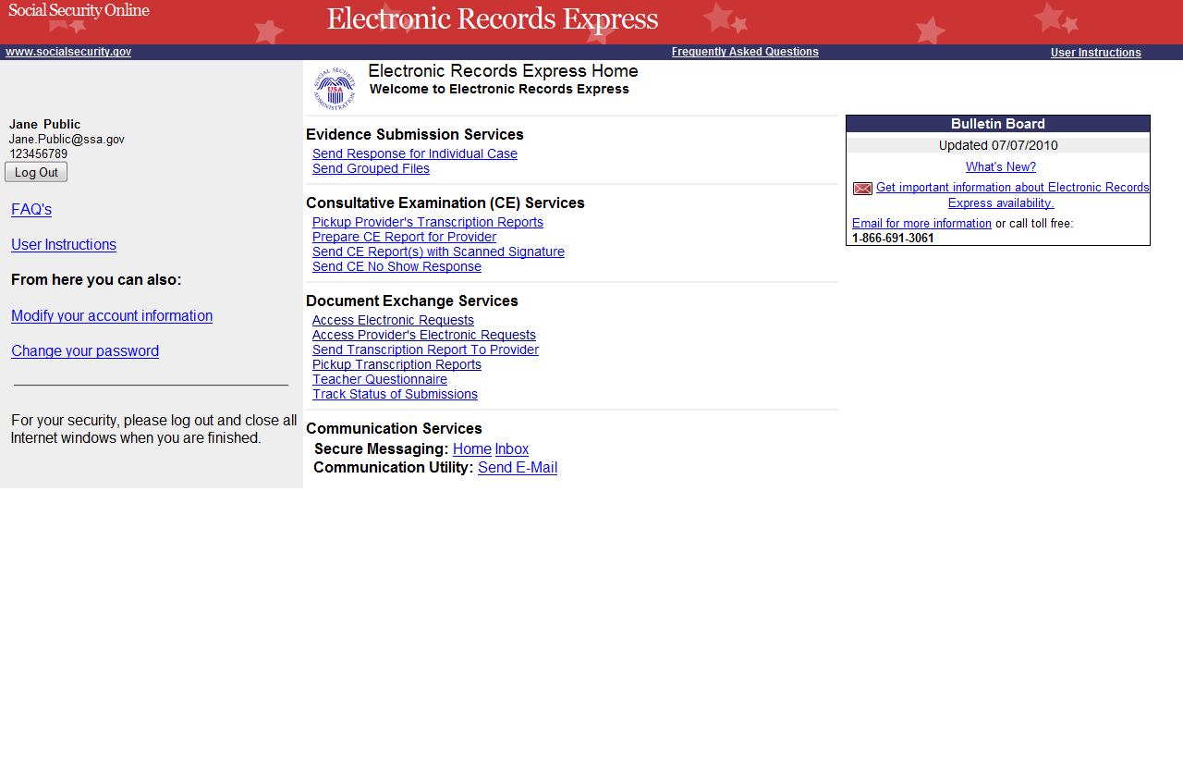
Step 1—Select Provider
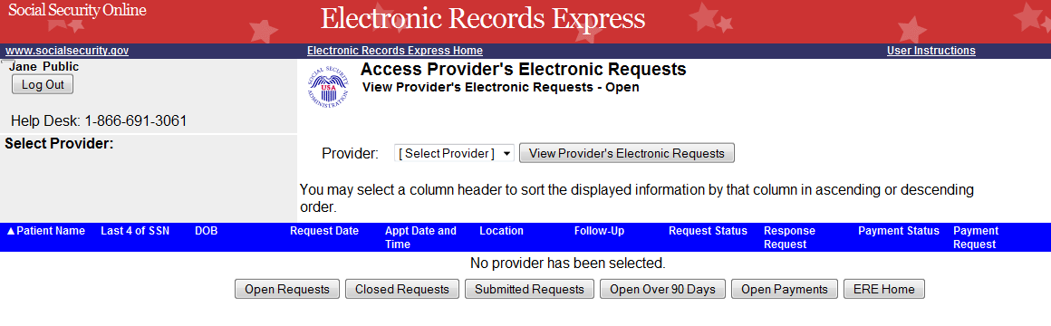
Select a Provider from the dropdown box
Select “View Provider’s Electronic Requests”

Step 1—Select Provider
- Select a Provider from the dropdown box. Only CE Providers associated with your username will display in the drop down list.
- Select the View Provider’s Electronic Requests button.
- If you do not wish to continue with the transaction and you want to return to the homepage, select the ERE Home button.
Step 2—Access Provider’s Electronic Request—Open Requests
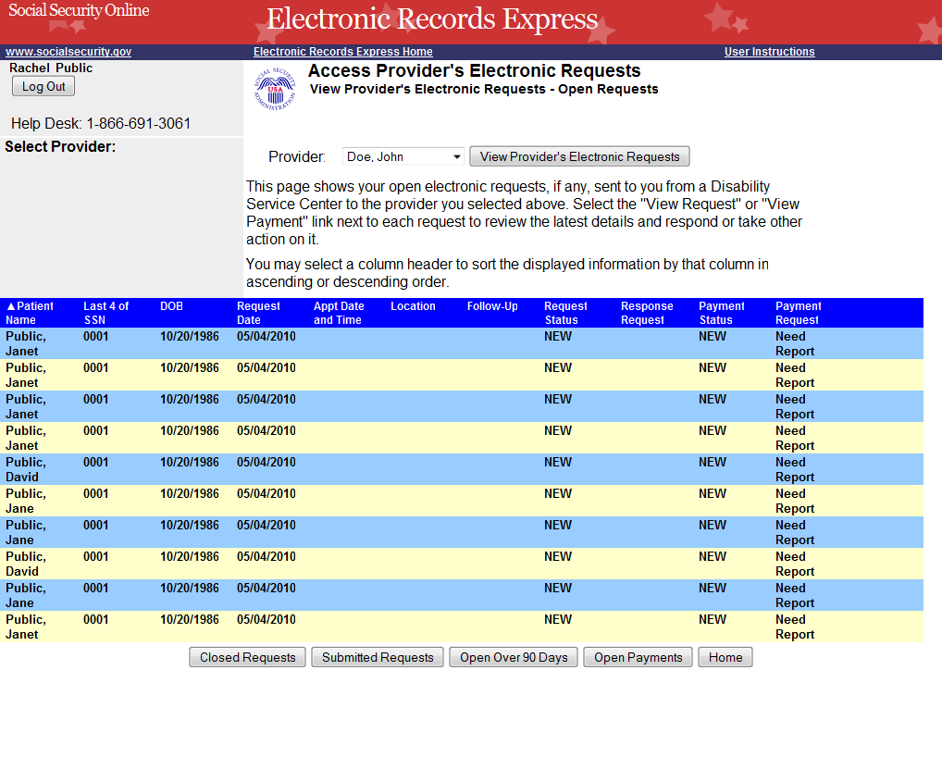
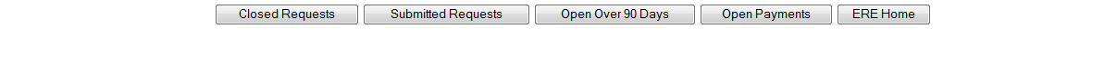

Step 2—View Provider’s Electronic Request—Open Requests
- This page allows you to view and sort all requests received from the DDS.
- You may select a column header to sort the displayed information by that column in ascending or descending order. Sorted columns display a small arrow adjacent to the column header. The column headers are:
- Name
- Last 4 of SSN
- DOB
- Request Date
- Appt Date and Time
- Location
- Follow-up
- Request Status
- Response Request
- Payment Status
- Payment Request
- Select View Request link in the Response Request column to view an individual request.
You may also:
- Select the Closed Requests button to display requests accepted by the CE provider or cancelled by the DDS.
- Select the Submitted Requests button to display requests that you submitted.
- Select the Open Over 90 Days button to display requests sent by the DDS over 90 days ago.
- Select the ERE Home button to go to the Electronic Records Express Home page.
Status Meanings

- New— A new request that has not been opened.
- Pending—A request that has been opened/viewed.
- Prepared—A CE Admin staff has prepared a report for this request.
- Responded—Response submitted by provider through ERE Website.
- Accepted—The DDS received the request response.
- Cancelled—The DDS cancelled the request.
- Updated- Updated initial request
- Updated Pending-Updated initial request and awaiting documents.

Note: The Electronic Request will be removed from the list based on the retention days received with the request if less than 120 days. Otherwise, Electronic Requests are removed from the list 120 days from the Request Date.
Access Provider’s Electronic Requests – Submitted Requests
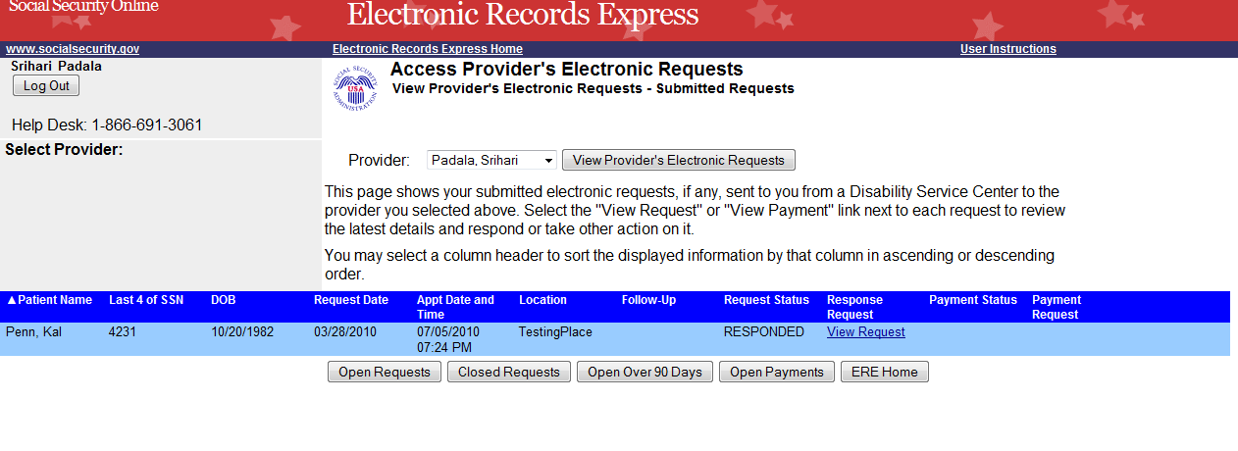
Step 3—Assess Provider’s Electronic Request—Electronic Request Details
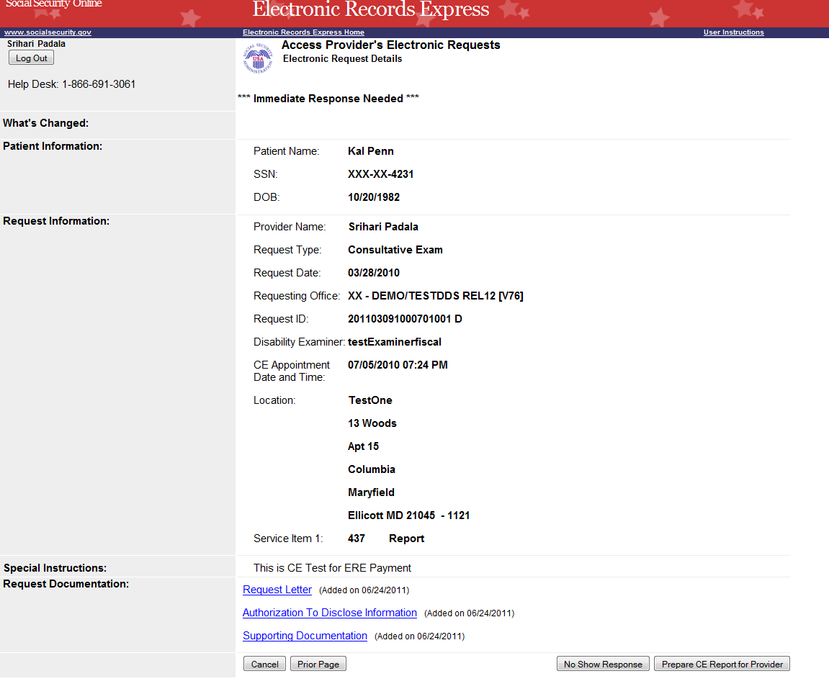
Click on an underlined heading to view Request Documentation
Click the “Prepare CE Report for Provider” button to respond to the DDS electronic request
Note: The Patient and Request information is automatically populated to this screen.

Step 3—Access Provider’s Electronic Request—Electronic Request Details
- To view the request documentation, click on the underlined document heading in the Request Documentation section.
- To prepare the CE response for the CE Provider, select Prepare CE Report for Provider and continue to Step 4—Send CE Report.
Step 4—Prepare CE Report for Provider
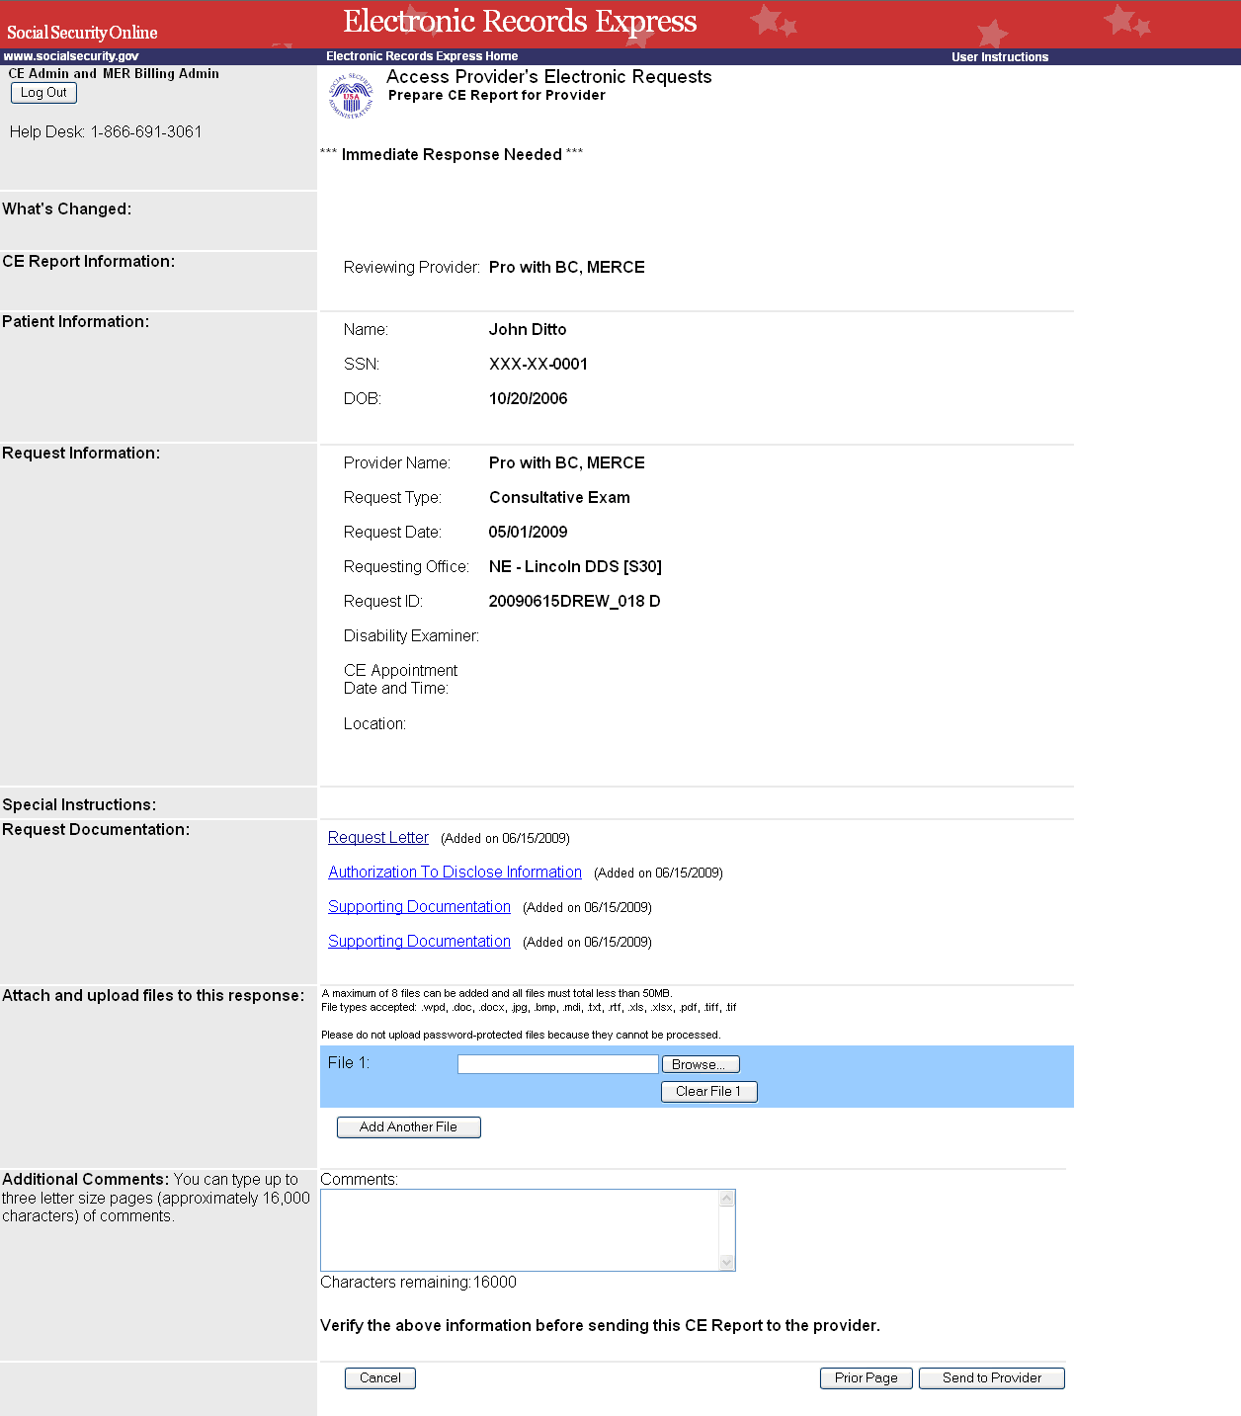
Add Comments, if needed.

Step 4—Prepare CE Report for Provider
- Select the Browse button to identify a file to send. (Do not send files that are password protected.) The Choose file window appears.
- Locate the file you wish to send and highlight the file name. The document’s file name moves into the File name box at the bottom of the Choose file window.
- Select the Open button. The Choose file window closes and the Electronic Records Express website displays the file name in the box to the left of the Browse… button. If you have chosen the incorrect file, click the Clear File 1 button to clear the File 1 field.
- Select the Add Another File button to send additional files. Only files for the SSN in the Patient and Request Information can be sent with this transaction.
Note: A maximum of eight (8) files may be sent for one individual by selecting the Add Another File button and repeating the previous steps.
SSA’s Electronic Records Express website accepts the following file formats: .wpd, .doc, .docx, .jpg, .bmp, .mdi, .txt, .rtf, .xls, xlsx, .pdf, .tiff, .tif.
Do not upload documents containing macros (i.e., a set of instructions or scripts that automates tasks). They may cause system problems, which will require you to re-submit your documents without macros.
- Type Comments, if needed. Type-in and/or cut-and-paste your text (up to 16,000 characters, approximately three letter size pages) directly into the box provided. The count of remaining characters shows beneath the box.
- Select the Send to Provider button to send the CE report to the CE Provider’s ERE inbox.
Step 5—Tracking Information
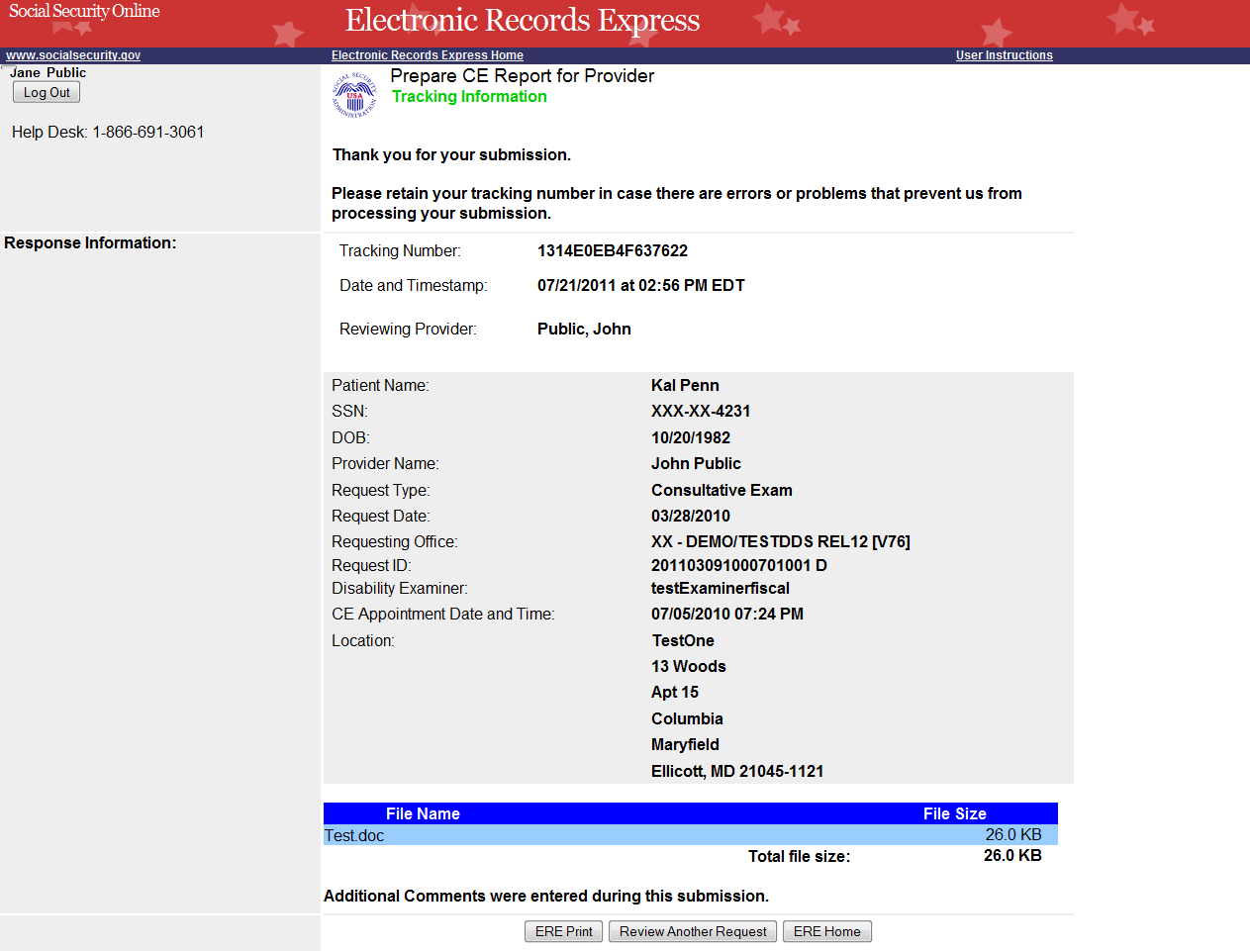
Tracking Number

Step 5—Tracking Information
- After your submission uploads, Electronic Records Express provides a Tracking Information page. The Tracking Information page provides a tracking number for you to keep and use if you want to check on the status of your submission.
- If you do not receive the Tracking Information page, you should resubmit the materials.
- If you continue to have transmitting problems, contact the Electronic Records Express Website Help Desk at EETechSupport@ssa.gov or 1-866-691-3061.
- If you have additional CE reports to submit, you may select Review Another Request button. This takes you back to the screen in Step 1.
NOTE: We strongly recommended that you print or take a screenshot of the Tracking Information page for your documentation. To do this, simply select ERE Print located at the bottom of the page. This print link works the same as if you selected File and Print from your browser’s menu. You cannot bookmark and save a Tracking Information page, and you will not be able to retrieve it later once you exit the webpage.

Access Keys
This application contains access keys to improve navigation and provide information. You will find a list of these keys in the table below:

Button | Access Key
Add Another File | 2 – 8 (number corresponds to the file to be added)
Cancel | n
Closed Requests | c
ERE Home | h
ERE Print | p
Log Out | l
No Show Response | s
Open Over 90 Days | 9
Open Payments | p
Prior Page | p
Request Payment | y
Respond | r
Review Another Request | r
Submit | s
Submitted Requests | s
Other keyboard commands, hotkeys or access keys will vary based upon browser and the version of the browser that you are using. A list of these commands can be found in the Help section of your browser. The Help feature can be located on the Menu bar of your browser or by using the F1 function key on the keyboard. Any assistive devices that you may be using will also have a list of these shortcut keys in their Help section.
Note: To use these keys select the “Alt” button on your keyboard and the access key simultaneously.

How to Get Important Information about Electronic Records Express Website Availability
You may subscribe to receive ERE website availability notifications through the GovDelivery services on the Social Security Administration’s Electronic Records Express internet website: Social Security Online: Electronic Records Express. Please see the following website for GovDelivery FAQs: https://service.govdelivery.com/service/help.html#general1
To subscribe to the ERE website availability notification, follow these instructions:
- Click Get important information about Electronic Records Express website availability.
- Type your email address and select Go
- Confirm your email address
- Select “Send updates immediately by e-mail.”
- Choose an optional password
- Select Save
- Select Next
- Subscribe to additional topics by checking the boxes or unsubscribe by un-checking the boxes
- Select Save
- Subscribe to topics from other agencies by checking the boxes or unsubscribe by
un-checking the boxes
- Select Save
**Once you have subscribed, you will receive a Subscription Acknowledgement e-mail with instructions on how to update your user profile**

