Representative Guide for Communication Utility

Sending Communication by Secure Website

Office of Disability Adjudication and Review
October 2011

ODAR COMMUNICATION UTILITY INSTRUCTIONS
The Communication Utility (CU) is a tool which allows external users to securely send a one-way communication to a specific Hearing Office (HO). All communications sent through the CU are sent to an administrative mailbox of the selected HO. The CU is intended for non-case related communications, such as a change of address for a representative or a representative’s schedule.
The CU is not a utility to send the HO electronic evidence; as such evidence is not routed to the Electronic Folder. Any case-related documents MUST be submitted via the Electronic Records Express (ERE) website or another method such as fax or mail.

User Instructions for the Communication Utility

Logging In
- Open an Internet browser
- In the address window type in: http://eme.ssa.gov (do not type “www.”).
- Once you have this page up, add to your Favorites
- Enter your case-sensitive Username and Password
NOTE: The Office of Disability Adjudication and Review (ODAR) will assist you in obtaining a Username and Password.
- Select the LOGIN button.
NOTE: Users should be aware that, after three failed attempts to sign in, their account will be locked. If this occurs, additional assistance may be obtained online by sending an email to EE Technical Support or calling 1-866-691-3061. You may also report problems to ODAR Rep Mail.
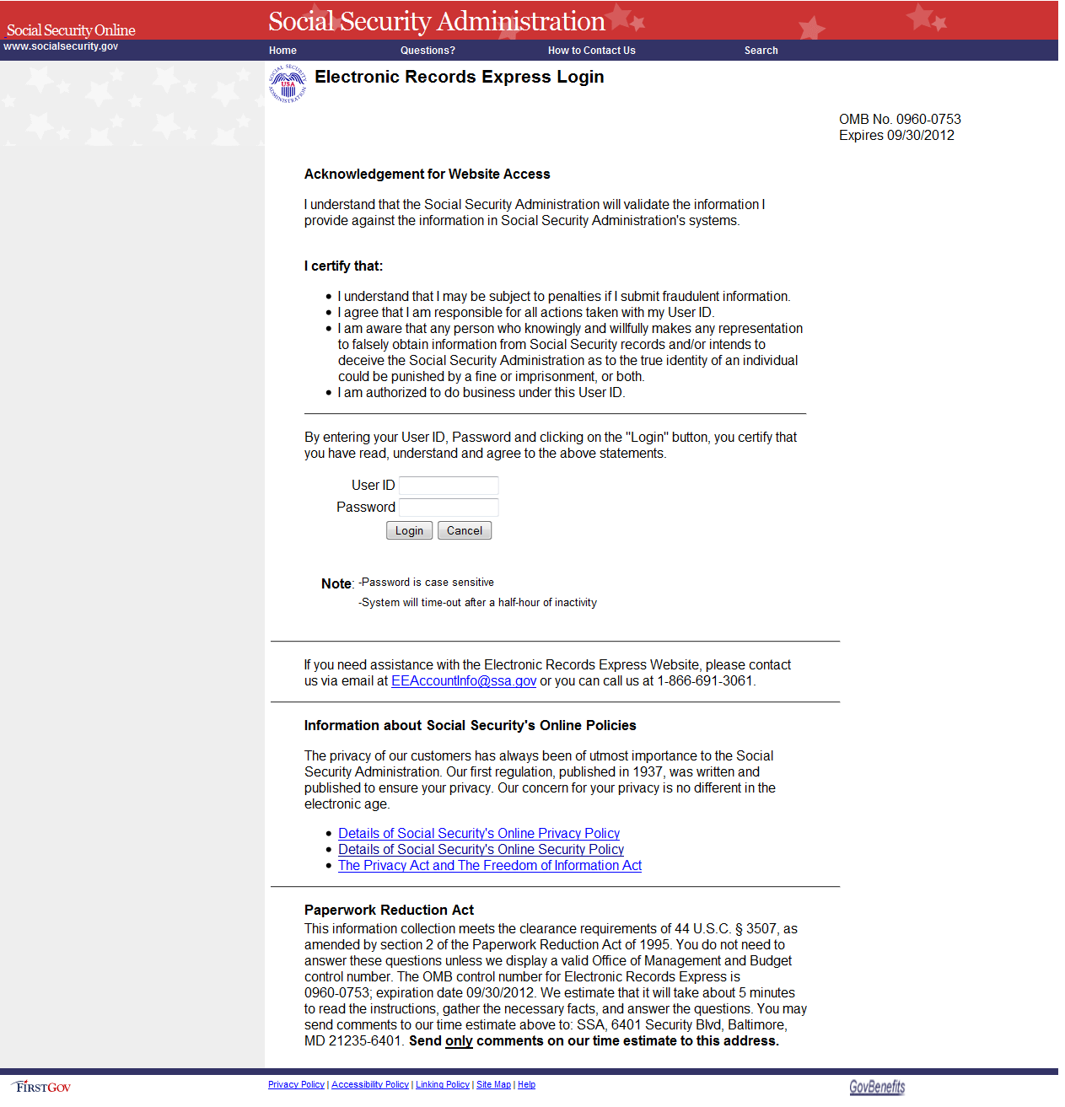

- If this is the first time you are logging into the ERE website, you will be required to change your password; this is a security feature.
- The Change Password page should automatically appear. You can also access the Change Password option from the ERE Home page (scroll down and the Change Password option is on the left side of your screen).
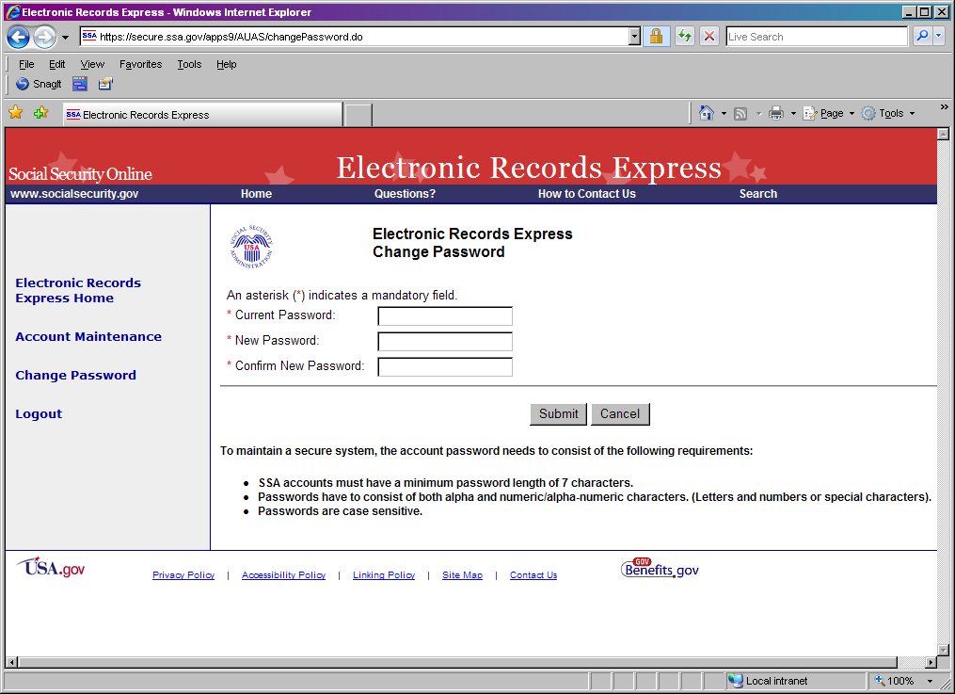

- Enter the password given to you by ODAR in the old password window.
- Enter a new password that is at least 7 characters long and includes both letters and numbers. Confirm your new password by entering it again in the last box. Remember that your Username and Password are case sensitive.
- Your password will expire every 90 days and you will be prompted to change your password; the page below will appear after you login.
NOTE: You have three attempts to enter your password. After the third attempt you will be locked out. If you are locked out of the website, you will need to send an email to EE Account Info.

- Entering a correct Username and Password will bring you to the Electronic Records Express Home page.
When you have changed your password after your first login, you may proceed with sending a secure one-way communication to ODAR.
Note: The Electronic Records Express Home page lists a number of electronic transmission features. Only the Communication Utility under Communication Services, Track Status of Submissions under Document Exchange Services, and Send Response for Individual Case under Evidence Submission Services are available for ODAR users.

Getting Started
At the Home page, select the Communication Utility link under the Communications Services section.
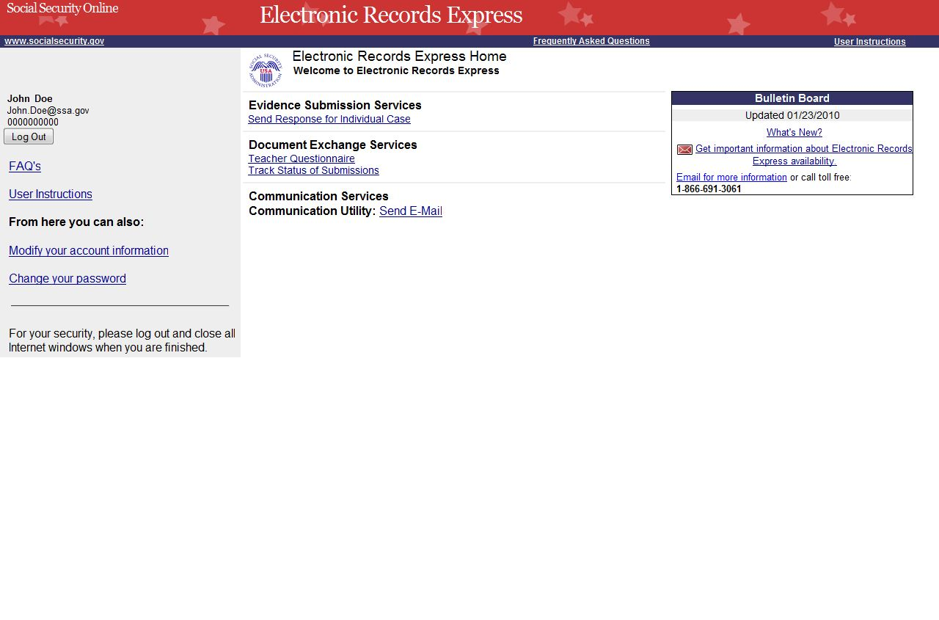

This takes you to the Communication Utility page
- Select the HO Destination from the drop-down menu. Enter the subject of the communication in the Subject box.
- To attach a document, use the Browse button to select the file to send. To send additional files, select Add Another File. The file(s) cannot exceed 5 megabytes in size.
NOTES:
- DO NOT SEND DOCUMENTS THAT ARE CASE RELATED. The Communication Utility is for general information purposes only.
- Do not upload documents containing macros (i.e., a set of instructions or scripts that automates tasks). They may cause system problems, which will require you to resubmit your documents without macros.
- If you are including a narrative, enter your text message here.
- Select the Submit button to send your message. A Tracking Information page displays after you submit your message.
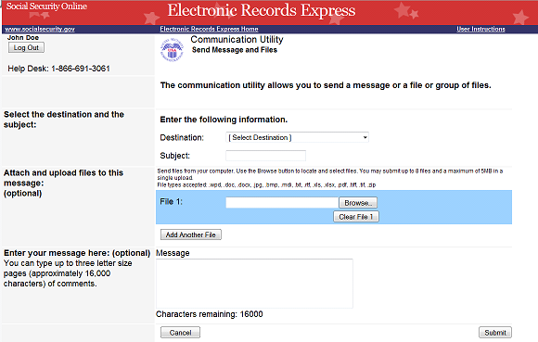

Change Your Email Address:
- If your email address shown on the Electronic Records Express Home page (in the User Information box) is incorrect, take the following steps to correct: Select the Modify your account information link within the User Information box.
- Enter your new email address within the Email field.
- Select the Modify button to forward the change.
- A Confirmation Email will be sent to your email address once the change is processed.

Access Keys:
This application contains access keys to improve navigation and provide information. You will find a list of these keys in the table below:
Button | Access Key
Add Another File | 2 – 8 (number corresponds to the file to be added)
Cancel | n
ERE Home | h
ERE Print | p
Log Out | l
Send Another Message | r
Submit | s
Other keyboard commands, hotkeys or access keys will vary based upon the browser and the version of the browser that you are using. A list of these commands can be found in the Help section of your browser. The Help feature can be located on the Menu bar of your browser. Any assistive devices that you may be using will also have a list of these shortcut keys in their Help section.
Note:
- To use these keys on Windows-based browsers select the Alt button on your keyboard and the access key simultaneously. On the Mac, use the Ctrl key.
- Internet Explorer Browser Users Only: In order to trigger the Browse button on the Electronic Records Express Submission pages you will need to use the space bar if you are using keyboard access.

