Representative Guide for Communication Utility

Sending Communication by Secure Website

Office of Disability Adjudication and Review
February 2012

ODAR COMMUNICATION UTILITY INSTRUCTIONS
The Communication Utility (CU) is a tool which allows external users to securely send a one-way communication to a specific Hearing Office (HO). All communications sent through the CU are sent to an administrative mailbox of the selected HO. The CU is intended for non-case related communications, such as a change of address for a representative or a representative’s schedule.
The CU is not a utility to send the HO electronic evidence; as such evidence is not routed to the Electronic Folder. Any case-related documents MUST be submitted via the Electronic Records Express (ERE) website or another method such as fax.

User Instructions for the Communication Utility
The Communication Utility is available from the Electronic Records Express Home page.
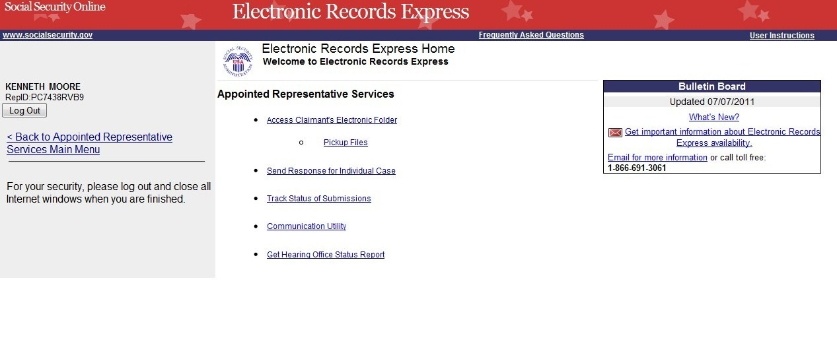

Getting Started
At the Electronic Records Express Home page, select the Communication Utility link.

The next page displayed is the Communication Utility page.
- Select the HO Destination from the drop-down menu. Enter the subject of the communication in the Subject box.
- To attach a document, use the Browse button to select the file to send. To send additional files, select Add Another File. The file(s) cannot exceed 5 megabytes in size.
NOTES:
- DO NOT SEND DOCUMENTS THAT ARE CASE RELATED. The Communication Utility is for general information purposes only.
- Do not upload documents containing macros (i.e., a set of instructions or scripts that automates tasks). They may cause system problems, which will require you to resubmit your documents without macros.
- If a narrative is necessary, enter the text in the area marked Enter your message here.
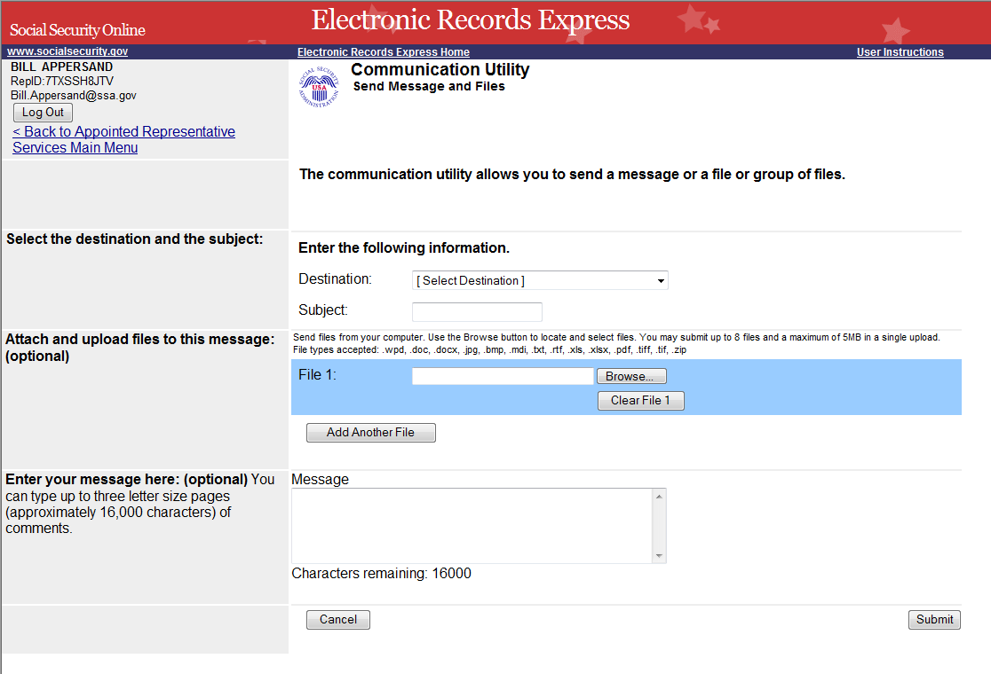

- Select the Submit button to send the message. After you submit your message, you receive a Tracking Information page.
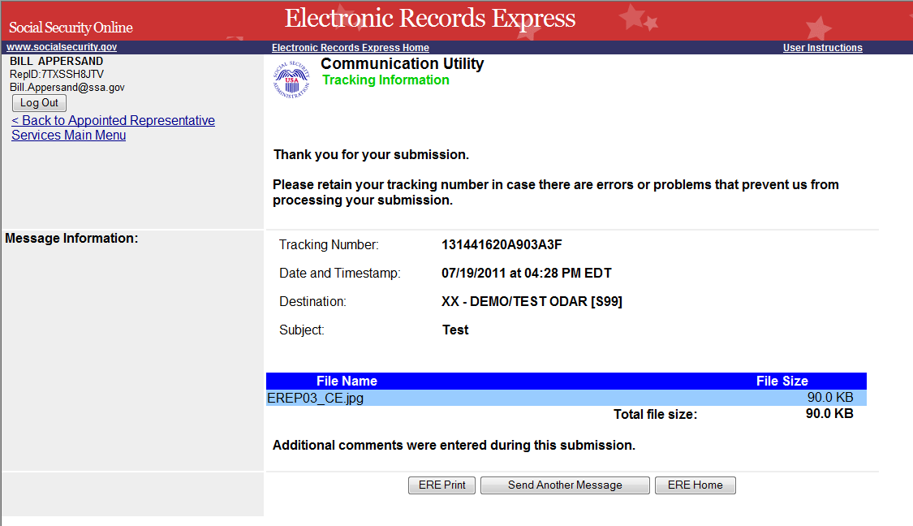

Access Keys:
This application contains access keys to improve navigation and provide information. You will find a list of these keys in the table below:
Button | Access Key
Add Another File | 2 – 8 (number corresponds to the file to be added)
Cancel | n
ERE Home | h
ERE Print | p
Log Out | l
Send Another Message | r
Submit | s
Other keyboard commands, hotkeys or access keys will vary based upon the browser and the version of the browser that you are using. A list of these commands can be found in the Help section of your browser. The Help feature can be located on the Menu bar of your browser. Any assistive devices that you may be using will also have a list of these shortcut keys in their Help section.
Note:
- To use these keys on Windows-based browsers select the Alt button on your keyboard and the access key simultaneously. On the Mac, use the Ctrl key.
- Internet Explorer Browser Users Only: In order to trigger the Browse button on the Electronic Records Express Submission pages you will need to use the space bar if you are using keyboard access.

