Representative Guide for Electronic Records Express
Sending Individual Case Responses by Secure Website

Office of Disability Adjudication and Review
October 2011
Representative Guide for Electronic Records Express Records
Table of Contents
The Social Security Administration’s Electronic Disability System 1
Submitting Electronic Evidence Using the Electronic Records Express Website 1
How Do I Get Started? 1
New User Instructions for ERE – Logging In 3
How to Use Send Response for Individual Case 7
Logging Out of the ERE Website 16
Special Considerations When Using the ERE Website 17
Logging Into the ERE Website 17
Updating Your Email Address 17
Changing Your Password 19
Naming Your Electronic Claimant Records 19
Timing Out 19
Avoiding User Errors 19
Bookmarking the ERE Website 20
Saving ERE Tracking Information Pages 20
How SSA Communicates Information to ERE Users 21
ERE Electronic File Format Options: 21
Access Keys: 22
Contacts for Additional Assistance 23
Glossary 23

The Social Security Administration’s Electronic Disability System
This guide provides claimants’ representatives with detailed instructions for submitting ODAR level appeals materials in electronic format, e.g., briefs and additional disability-related evidence, using the upload feature of SSA’s secure website. SSA, including ODAR, is striving to obtain disability records in electronic format whenever feasible.
If you have questions regarding these instructions or the process for submitting electronic evidence, please email: odar.hq.rep.mail@ssa.gov

Submitting Electronic Evidence Using the Electronic Records Express Website
The Social Security Administration (SSA) has developed a free, easy-to-use website called Electronic Records Express (ERE) for representatives who can create an electronic record (either by scanning paper records or receiving electronic claimant records from medical providers). Representatives can use the ERE website to securely send evidence direct to their client’s electronic folder. Representatives will receive a tracking information page acknowledging that SSA received their transmission.
To use the ERE website, you need:
- Internet access
- A Web browser
- A computer that supports an encryption level of 128 bits (most computers purchased in the last five years support 128 bit encryption)
- A Username and Password to access the ERE website (the Office of Disability Adjudication and Review will assist you with the registration process)
No special software is required to use the ERE website.

How Do I Get Started?
When an electronic claim file meets all the technical prerequisites for receiving electronic evidence submissions, ODAR will forward you a bar code. You will need to have the ODAR barcode when you log onto the ERE website because you will need to enter information such as the claimant’s social security number and the Request ID. This information ensures that the claimant’s records are properly transmitted to the appropriate electronic disability claim file.
Before using the ERE website, you should have existing electronic records and you should know where they are stored on your computer system (i.e., which drive, which folders, etc.). The ERE website accepts the following types of electronic files: .doc, .docx .wpd, .jpg, .bmp, .txt, .mdi, .rtf, .xls, .xlsx, .pdf, .tiff, and .tif. Please use only the following types of characters when naming your electronic claimant files: numbers, letters, hyphens/dashes, underscores, backslashes, and spaces. Please refer to the section Special Considerations beginning on page 17 for additional information.

The following pages contain instructions and screenshots to illustrate the user-friendly design and functionality of the ERE website. To use ERE, simply follow the instructions on the next page to get started.

New User Instructions for ERE – Logging In
- Open an Internet browser
- In the address window type in: http://eme.ssa.gov (do not type the “www.”)
- Once you have this page up, select “Favorites”
  - Select “Add to Favorites”
  - Where it says name, type in “Electronic Records Express” and select the OK button.
- Enter your case-sensitive Username and Password
NOTE: The Office of Disability Adjudication and Review will assist you in obtaining a Username and Password.
- Select the LOGIN button.
NOTE: You should be aware that after 3 failed attempts to sign in, your account will be locked. If this occurs, you may obtain additional assistance online by reporting problems to EEAccountInfo@ssa.gov or calling 1-866-691-3061. You may also report problems to the Office of Disability Adjudication and Review at odar.hq.rep.mail@ssa.gov.
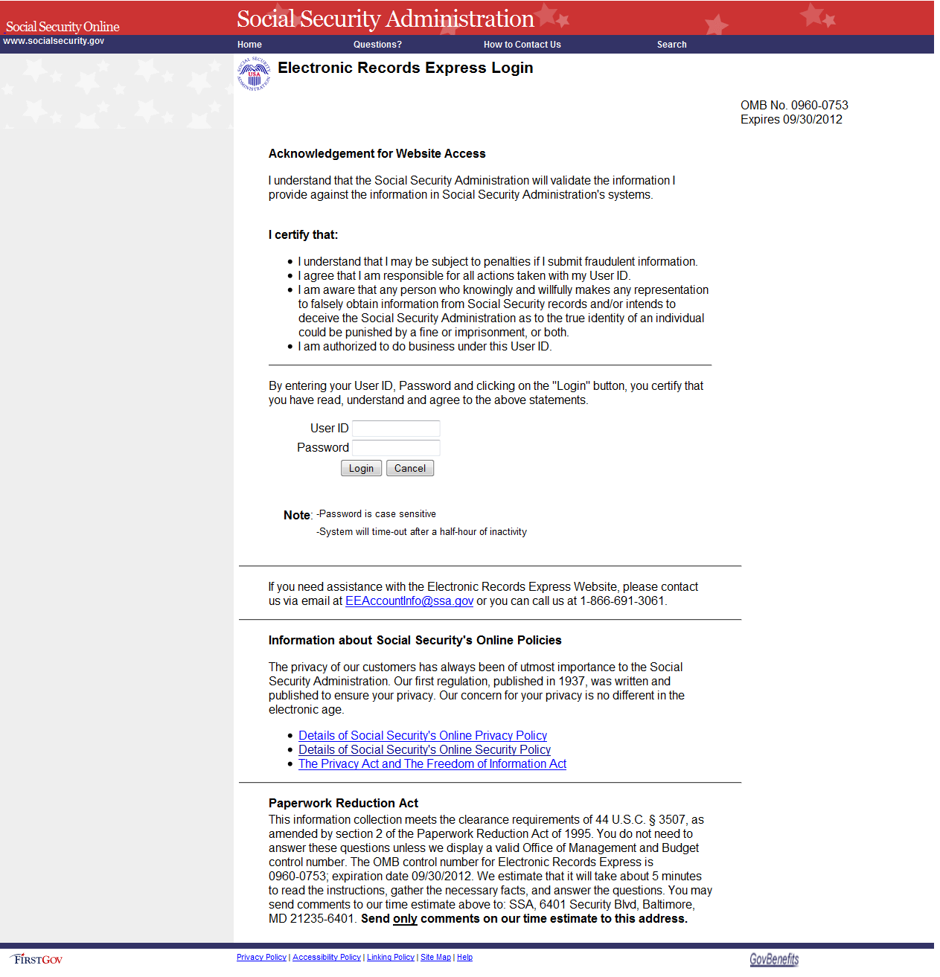
- Entering a correct Username and Password will bring you to the Electronic Records Express Home page.

Note: Although the Electronic Records Express Home page lists a number of electronic transmission features, at this time the only features available to ODAR users are Send Responses for Individual Case listed under the Evidence Submission Services box, Track Status of Submissions listed under the Document Exchange Services, and Communication Utility listed under the Communication Services box, above. Guidance for using the Track Status of Submissions and Communication Utility is provided in separate ODAR instructions available in the User Instructions link in the upper right corner of the screen.
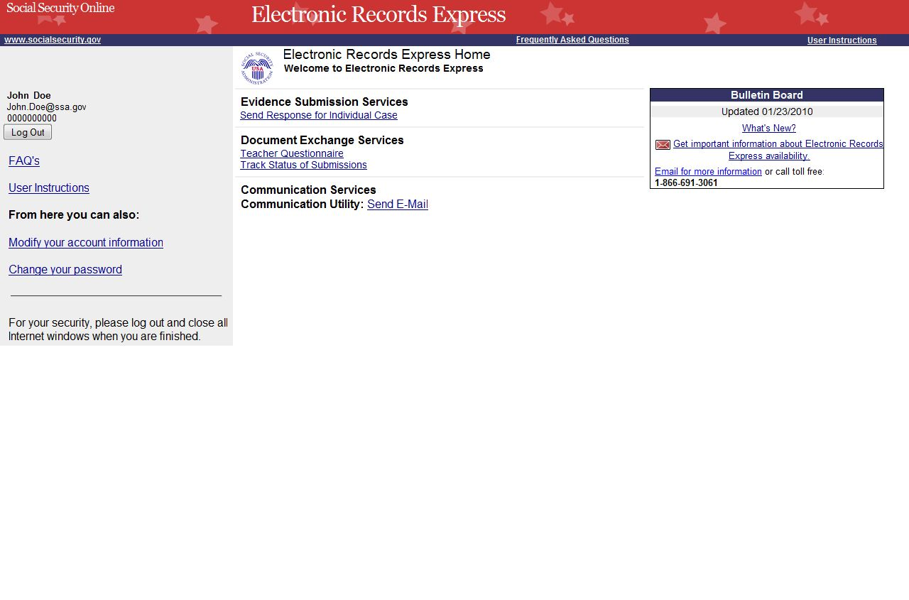
If this is the first time you are logging into ERE, you will be required to change your password (this is a security feature).
- The Change Password page should automatically appear. You can also access the Change Password option from the ERE Home page (scroll down and the Change Password option is on the left side of your screen).

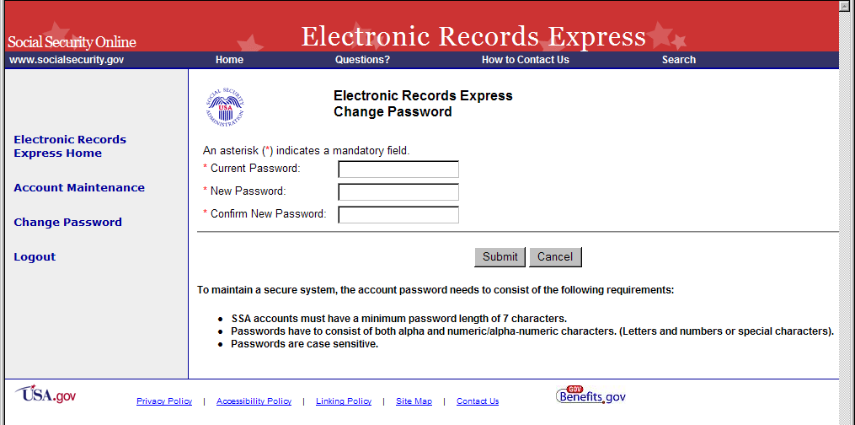

- Enter the password given you by ODAR in the old password window.
- Enter a new password that is at least 7 characters long and includes both letters and numbers. Confirm your new password by entering it again in the last box. Remember that your Username and Password are case sensitive.
- Your password will expire every 90 days and you will be prompted to change your password (the page above will appear after you login).
- NOTE: You have three attempts to enter your password. After the third attempt you will be locked out. If you are locked out of the website, you will need to send an email to EEAccountInfo@ssa.gov or call 866-691-3061.
- When you have changed your password after your first login, you may proceed with sending evidence to ODAR.

How to Use Send Response for Individual Case
On the Electronic Records Express Home page, under Evidence Submission Services, select Send Response for Individual Case.
NOTE: You will need to have the ODAR barcode to enter information in the next few steps. The following illustration will help you find the necessary information on the ODAR barcode.
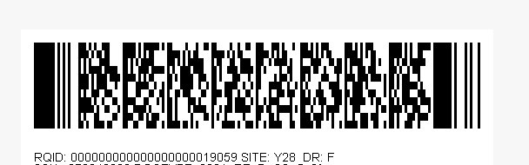
Step 1: Enter the Site Code in the SITE CODE field. It is important that you select the SITE code from the barcode sheet provided by ODAR. DO NOT USE A BARCODE PROVIDED FROM ANOTHER SOURCE WHEN YOU ARE SENDING INFORMATION TO AN ODAR OFFICE (i.e. Disability Determination Services).
NOTE: When the SITE code is entered the appropriate ODAR office and state will be shown in the DESTINATION and STATE field. The DESTINATION field has both ODAR and Disability Determination Service offices listed. Be sure that an ODAR office is shown in the Destination field.
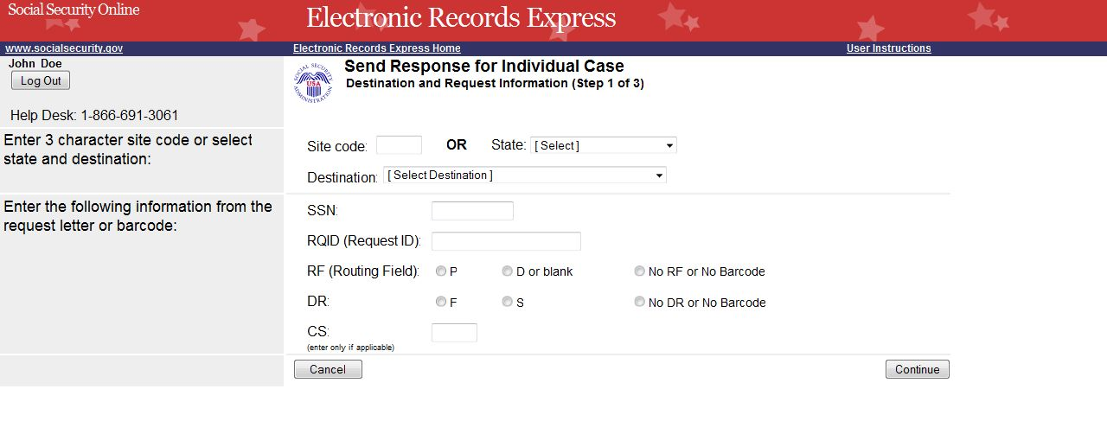
Step 2: From the barcode provided by ODAR, enter the following information in the appropriate fields. (See the figure shown below).
- Enter the claimant’s Social Security Number.
- Enter the Request ID information. The Request ID is the document number or serial number which is usually located on the barcode. Be sure to enter the Request ID beginning with the first non-zero number. For example, if the request letter shows RQID as 00000001102400, enter 1102400.
- Enter the RF (Routing Field) information shown on the barcode.
- Enter the DR code information shown on the barcode.
- Do NOT enter the CS code.
- Select Continue to go to the next page.

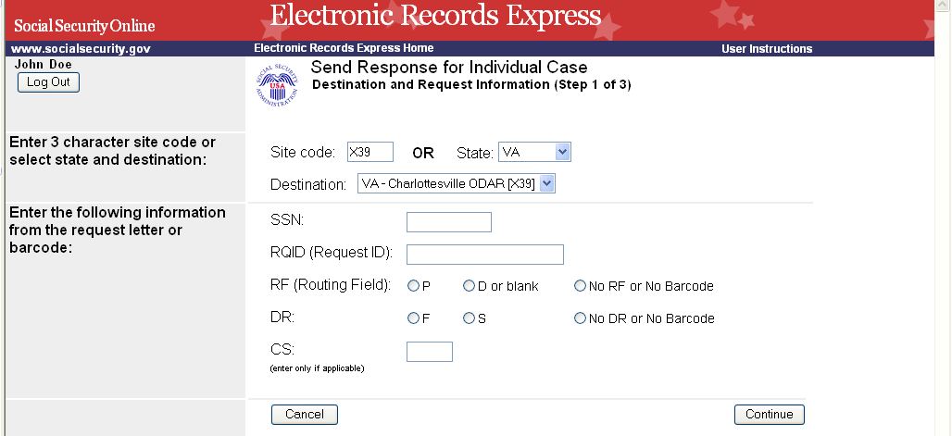
Do not Enter the CS code

Do not Enter the CS code

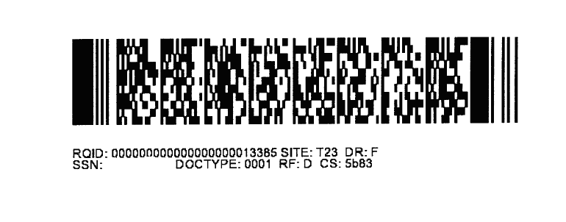
Step 3: Send Files from your computer
If you have records for the requested claimant in an electronic format, you can send existing files from your computer to ODAR.
NOTES:
- File types accepted are: .wpd, .doc, .docx, .jpg, .bmp, .mdi, .txt, .rtf, .xls, .xlsx, .pdf, .tiff, and .tif.
- Please refer to the section entitled Naming Your Electronic Claimant Records on page 19, for more information on acceptable file names.
- Do not upload documents containing macros (i.e., a set of instructions or scripts that automates tasks). They may cause system problems, which will require you to resubmit your documents without macros.
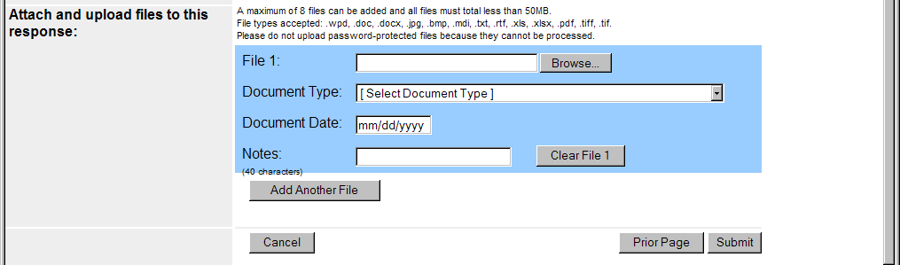
- Select the Browse button to find the file you wish to send to the electronic folder
- The Choose file window appears

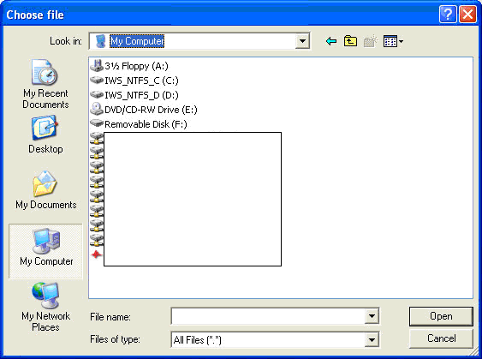
- Locate the file you wish to send and select the file name. This inserts the document’s file name into the File name box at the bottom of the Choose file window.
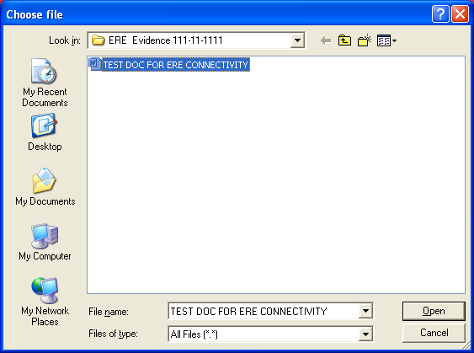
- Next, select the Open button. The Choose File window closes and the file name displays in the box to the left of the Browse button. You have successfully attached the named file to the website.
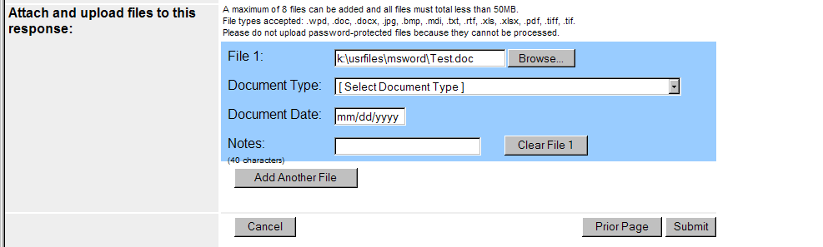
- Document Type: Select from the drop down list a document type for the document you are sending.
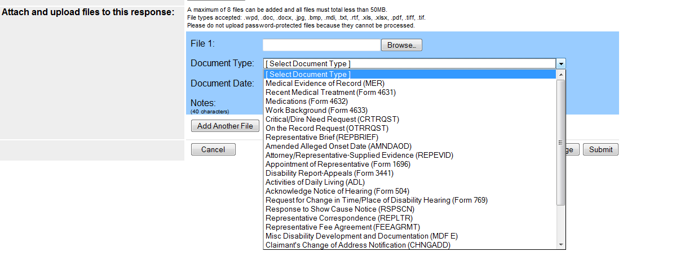
- Depending on the document type you select, additional fields may appear which require completion.
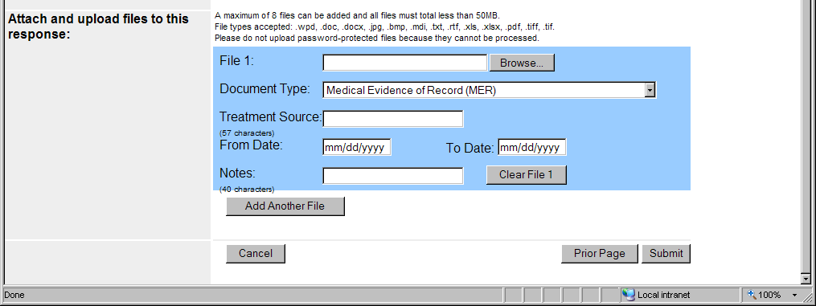
- You may send additional files (maximum of 8 files for one claimant) by selecting the Add Another File button and repeating the previous steps.
- If you select Prior Page, you will return to the Destination page.
NOTE: You will lose all information entered on the page and any file selected.
Step 4: Verify the Destination and information.
Compare the information in the Destination and request summary box to the ODAR barcode before submitting a response. If the information does not match, then re-enter the correct information at Step 1. If the information matches, select the Submit button.
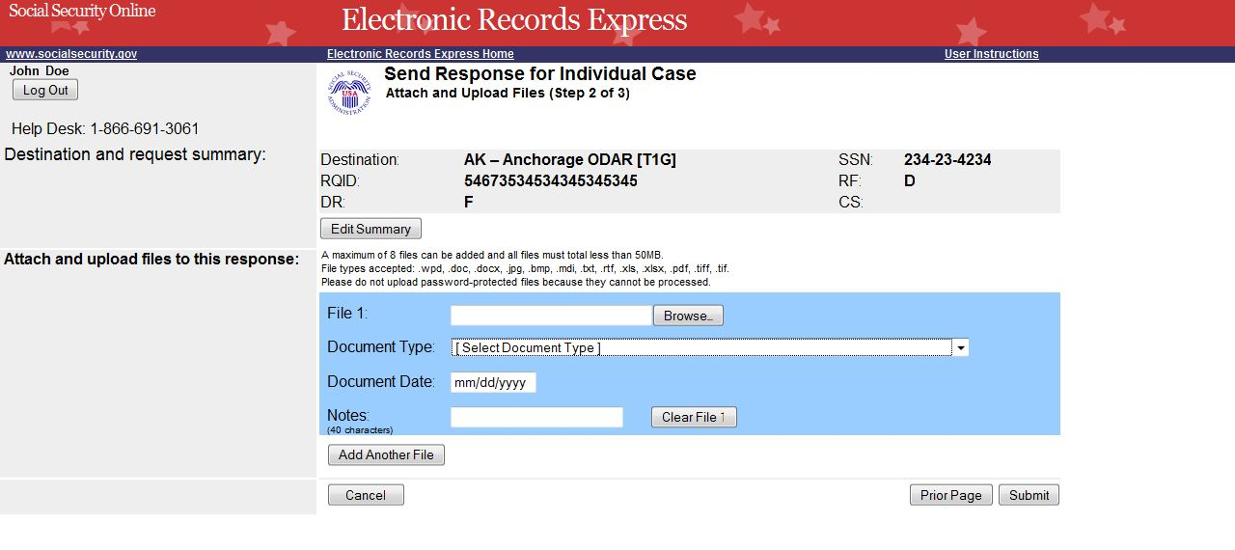

If an invalid document was attached you will receive an alert message similar to the message shown below. Select Try Again to re-enter the correct information.
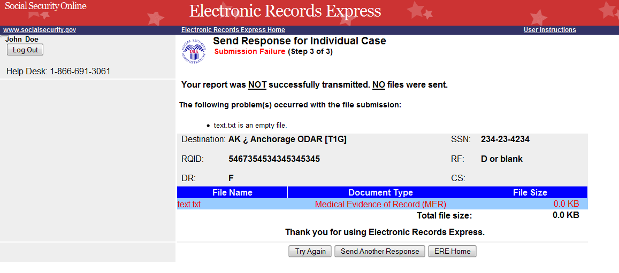

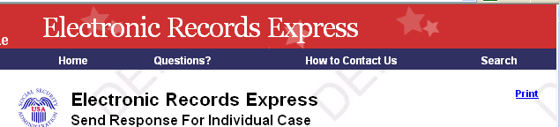
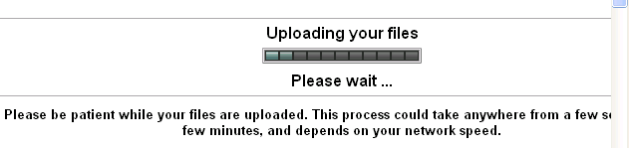
You should receive a Tracking Information page acknowledging that SSA has received your transmission. The Tracking Information page indicates the specific filename and document type of each file that was transmitted.
The Tracking Information page only acknowledges that the transmission has been received. The transmission must still go through a SSA systems check before being sent to the electronic folder. You will be notified by email if there are any errors or problems that prevent SSA from processing your submission.
NOTE: In the unlikely event that you do not receive the Tracking Information page, you should resubmit the materials.
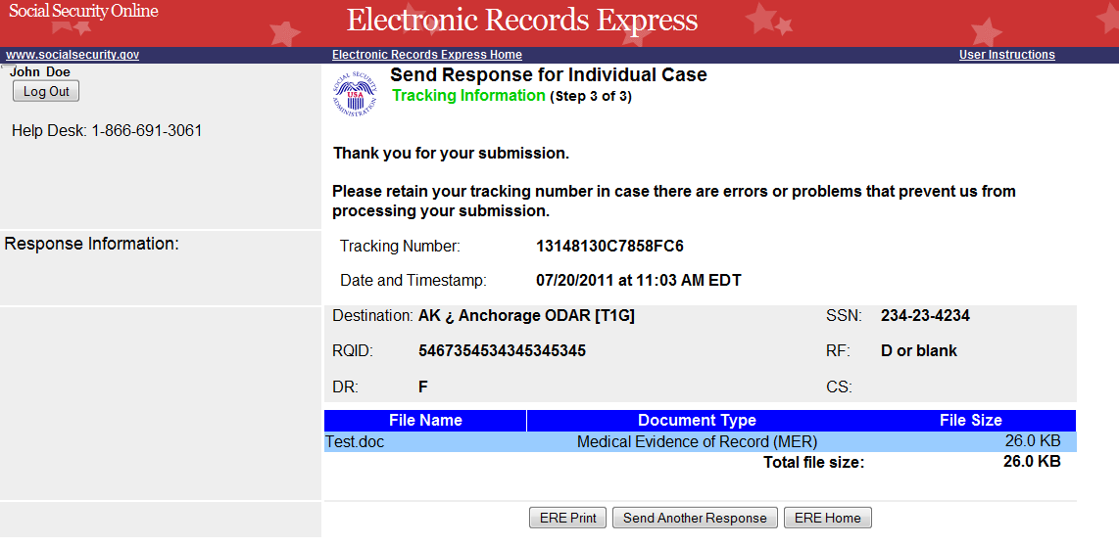
NOTE: We recommend that you print or take a screenshot of the Tracking Information page for documentation. You will not be able to retrieve this information from SSA (including ODAR) after you exit this page.
If you have evidence to send for another individual, you can select the Send Another Response link toward the bottom of the Tracking Information page. This will bring you to the webpage to enter information to send medical records for another claimant. Please be sure to have the ODAR request letter available.

Logging Out of the ERE Website
When you have completed your file uploads, select Log Out on the left navigation bar of the ERE website. Logging out ensures that others may not access the ERE website through your Username and Password.

Special Considerations When Using the ERE Website

Logging Into the ERE Website
The Username and Password are case sensitive.
NOTE: Your ODAR contact will assist you in obtaining a Username and Password.
Be aware that after 3 failed attempts to sign in, your account will be locked. If this occurs, you may obtain additional online assistance by selecting the ERE email address link. You may also report problems to your ODAR contact.

Updating Your Email Address
Your email address currently on file with SSA displays on the Electronic Records Express Home page in the top left corner.
If the email address or phone number shown is incorrect, you may change your email address by performing the following steps:
- Select the Modify your account information link.
- Enter your new or correct information in the appropriate field.
- Select the Modify button.
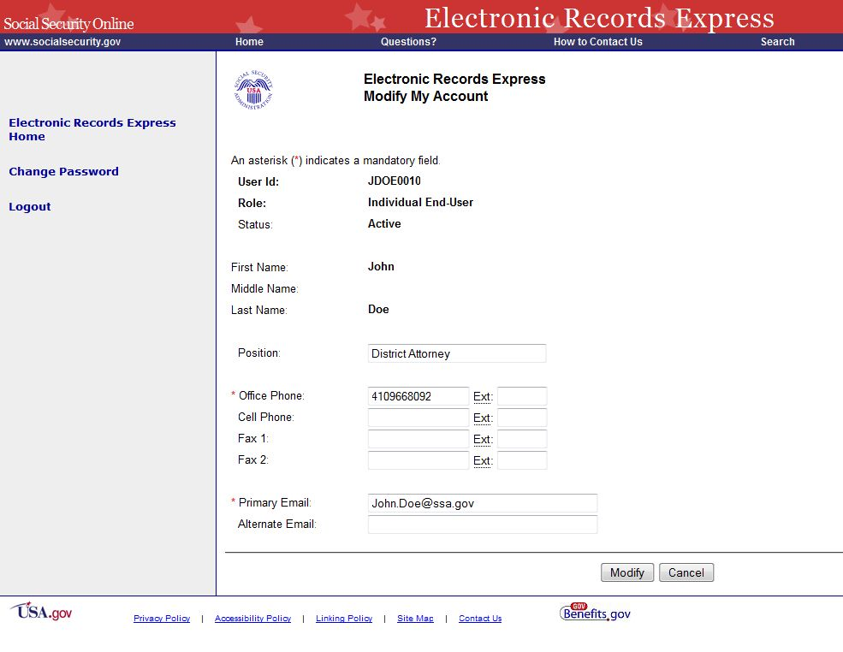
A page displays verifying that the account information was successfully modified.
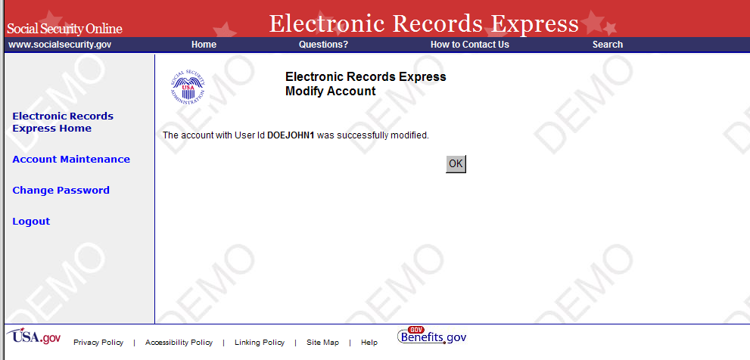

In addition to a confirmation page, ERE will send a confirmation email to your email address once your change(s) are processed.
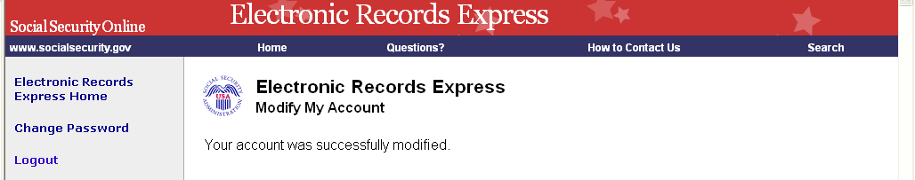

Changing Your Password
You are required to change your password upon your very first login to the ERE website. Afterward, you will be prompted to change your password every 90 days.

Naming Your Electronic Claimant Records
The ERE website will accept electronic filenames that contain the following characters:
- Numbers
- Letters (uppercase and lowercase)
- Backslashes “\”
- Underscores “_”
- Hyphens or Dashes “-”
- Spaces
Other special characters may make your electronic filename invalid, such as:
- Certain Punctuation Marks (commas, semicolons, parentheses, etc.)
- Symbols (*, %, <, >, |, etc.)
Please be sure that your electronic records include the acceptable character types shown above.
NOTE: Please be sure to upload only non-password protected documents.

Timing Out
The website will time out after 30 minutes of inactivity, so you should be ready to enter information from the records request letter and have files ready to upload. After 2 hours, the website will log you out and you must re-enter your User ID and Password to continue.

Avoiding User Errors
Errors can occur for many reasons. The following list briefly explains some common ERE website user “errors”:
- Bookmarking the Tracking Information page – Never bookmark pages within the ERE website. The only bookmark you should use for the ERE website is the Home page at http://eme.ssa.gov. Please note you cannot bookmark and save a Tracking Information page.
- Leaving the ERE session unattended for 30 minutes will cause a session timeout. If you need to do something else please log out and exit your ERE session.
- Once you have submitted documents by selecting the Submit button, you should not use the Back button, Stop button, or close your Internet browser file until you receive the Tracking Information page.
- Typing in an incorrect file path for a file saved on your local system. This can occur if you type in a file name rather than using the Browse button to navigate to where files are stored on your system and then selecting the files you wish to attach. You may not receive notification if this type of error occurs. The best way to avoid this type of error is to use the Browse button to attach your files and then wait for the Tracking Information page to appear after you have successfully transmitted your electronic files.

Bookmarking the ERE Website
- Please be sure to bookmark the ERE Home Page only. You should never bookmark intermediate webpages within the ERE website. Doing so can cause problems the next time you try to send files.

Saving ERE Tracking Information Pages
- You cannot bookmark and save a Tracking Information page. You cannot retrieve tracking information after exiting the page. If you wish to have a record of the ERE transaction, we suggest you save your Tracking Information page.

How SSA Communicates Information to ERE Users
SSA will use the Bulletin Board section of the ERE website to alert registered users of new information, such as any scheduled maintenance or new functionality. You can also be notified by email prior to any scheduled maintenance by selecting the red envelope link, Get important information about Electronic Records Express availability. Select the link and follow the instructions.

ERE Electronic File Format Options:
SSA’s ERE website currently supports the following file formats:
.wpd | .doc | .txt
.pdf | .xls | .jpg
.bmp | .tiff | .tif
.docx | .rtf | .mdi
 | .xlsx

Access Keys:
This application contains access keys to improve navigation and provide information. You will find a list of these keys in the table below:
Button | Access Key
Add Another File | 2 – 8 (number corresponds to the file to be added)
Cancel | n
Continue | c
Edit Summary | w
ERE Home | h
ERE Print | p
Log Out | l
Prior Page | p
Send Another Response | r
Submit | s
Submit Additional Files | s
Other keyboard commands, hotkeys or access keys will vary based upon the browser and the version of the browser that you are using. A list of these commands can be found in the Help section of your browser. The Help feature can be located on the Menu bar of your browser. Any assistive devices that you may be using will also have a list of these shortcut keys in their Help section.
Note:
- To use these keys on Windows-based browsers select the Alt button on your keyboard and the access key simultaneously. On the Mac, use the Ctrl key.
- Internet Explorer Browser Users Only: In order to trigger the Browse button on the Electronic Records Express Submission pages you will need to use the space bar if you are using keyboard access.

Contacts for Additional Assistance
If you need additional assistance, you should contact:
Email: | odar.hq.rep.mail@ssa.gov

Glossary
Acceptable File Type | Types of files that are compatible with a given computer program or website. The ERE website currently supports the following type of files:  .bmp, .doc, .docx, .jpg, .mdi, .pdf, .tif, .tiff, .txt, .rtf, .wpd, .xls, and .xlsx.
Barcode | A 2-D barcode determines the ultimate destination (paper folder and/or electronic folder) for the evidence submitted (uploaded). The 2-D barcode acts as a portable database to store the following information: SSN, request ID number, site number (Disability Determination Service or ODAR), and document type (e.g., MER, CE). The request ID number (also known as the turnaround document number or contract number) is SSA’s/ODAR’s unique transaction tracking number, and when received, can be used to generate a follow-up in the case processing system. If a Representative fails to submit the bar-coded information, the document must be manually indexed at the ODAR.
.bmp | The filename extension for a bitmap file. Bitmap is a common graphic format used by computers. A graphic or picture is made up of a number of individual dots (bits) to form an image. A bitmap is essentially a map of bits (hence the name). Bitmap files can get very large in size and if storage space is a factor then it is best to convert the image into a more compressed format such as .jpg.
.doc | The filename extension for a Microsoft Word document file.
Download | The process of transferring a file from a remote computer, server, or webpage to your own computer. Download is the opposite of upload.
ERE | Electronic Records Express, SSA’s secure website to be used primarily for uploading (sending) electronic medical and other evidence to be considered in determining disability eligibility.
eDib | Electronic Disability (eDib) is SSA’s endeavor for enhancing the disability claims process. It is a major Agency initiative comprised of interdependent projects that are designed to move all components involved in claims adjudication/review to an electronic business process through the use of an electronic disability folder. It expands Internet use, it automates disability intake, provides electronic access to disability-related information, and will improve overall efficiency of the disability claims process.
e-folder | The electronic disability folder (e-folder or EF) is SSA’s electronic disability repository of data that will, when eDib is fully implemented, be accessible by all components involved in the processing of disability claims. Data that is housed in the e-folder will come from many different SSA and ODAR systems as well as from external sources (e.g., medical Representatives). The e-folder is not a case processing system. The e-folder will allow components to share disability case information without having to move a paper folder between components.
Extract | To obtain selected information from a source; an excerpt of a record.
.jpg | .jpg or .jpeg (pronounced “jay-peg”) is a standardized image compression format named after its developers (the Joint Photographic Experts Group) that can compress images to very small file sizes, commonly used on the Internet due to faster image transfer rates. JPEG images can contain thousands of colors which make for the format ideal for compressing images such as photographs. The JPEG format can compress images up to around 10% of their original file size without losing too much quality (depending on the image used) although the image will lose its sharpness. JPEG files use both the .jpg and .jpeg file extensions and can be created in most popular graphics applications.
MER | Medical evidence of record (MER) is collected from sources identified by the claimant.
.pdf | The filename extension for a Portable Document Format (PDF) file. PDF is a universal file format developed by Adobe® that preserves all the fonts, formatting, graphics, and color of any source document, regardless of the application and platform used to create it. PDF is a reliable format for electronic document exchange. To view PDF files you need Adobe Reader® which you can download free at http://www.adobe.com/products/acrobat/readstep2.html.
Secure Website | A website that uses encryption and access controls so that personal information sent via the website is not susceptible to interception, loss, or alteration.
.tif or .tiff | TIF or TIFF is short for “Tagged Image File Format” and refers to a type of image format developed by Aldus and Microsoft that is commonly used within computing. It was designed primarily for faster data interchange. TIFF files are basically Bitmap images; they are not restricted in resolution and can be black and white, grey scale or full color. Most (if not all) image editing software can support the TIFF format and TIFF files typically have the .tif or .tiff file extension.
.txt | The filename extension for a text file.
Upload | The process of transferring a file from a personal computer to a server. This process makes the file available to others. Upload is the opposite of download.
.wpd | The filename extension for a Word Perfect Document.
.xls | The filename extension for a Microsoft Excel file.

