User Guide for Pickup Provider’s Transcription Reports

Office of Disability Determinations
October 2011

Electronic Records Express Website

Consultative Examination (CE) Services

Instructions for Pickup Provider’s Transcription Reports
Pickup Provider’s Transcription Reports is part of the “CE Administrative Staff Upload” feature. This allows a Provider to delegate the gathering and preparing of a CE submission to administrative staff. If the transcriptionist uploads the report to the Electronic Records Express website, this link allows a Provider’s administrative staff to directly download the transcribed reports from the Provider’s website Inbox.
The Pickup Provider’s Transcription Reports link will only display once the CE administrative staff has been registered to use this function.
Please contact your Medical/Professional Relations Officer if you are interested in having this function available to you.
Start the process by logging into the Electronic Records Express website using your username and password. Select the link, Pickup Provider’s Transcription Reports under the Consultative Examination (CE) Services heading.
Electronic Records Express Home—Pickup Provider’s Transcription Reports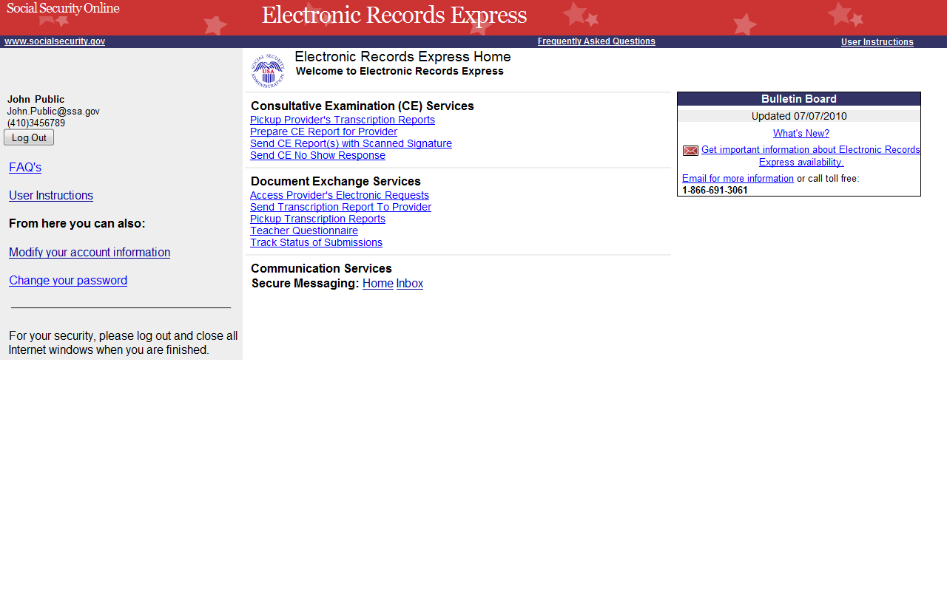

Instructions for Pickup Provider’s Transcription Reports
Step 1—Select a Provider
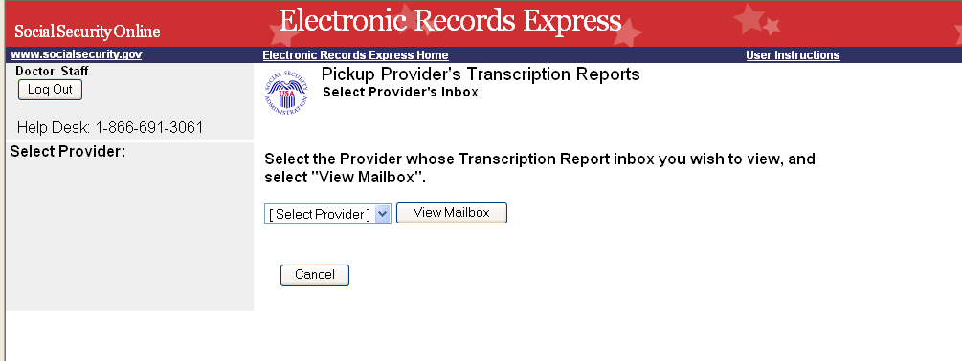
Select a Provider from the dropdown box
Select View Mailbox to view transcribed reports

Step 1—Select a Provider
- Select a Provider from the dropdown box. Only CE Providers associated with the username will display in the drop down list.
- Select the View Mailbox button.
If you do not wish to continue with the transaction and you want to return to the Home page, select the Cancel button.
Step 2 & 3—View Inbox and View and Open File
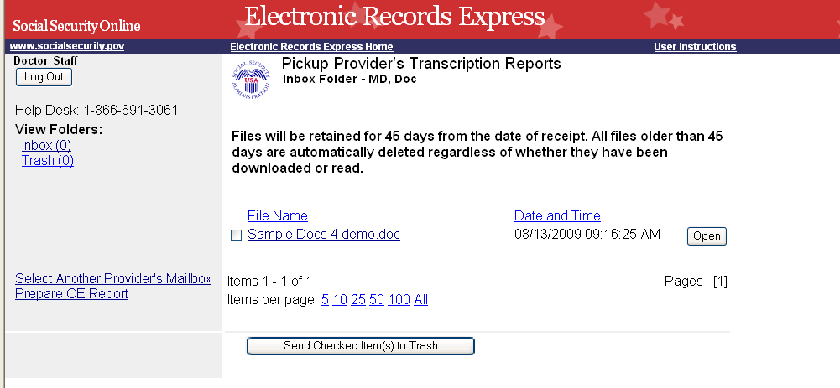
Files older than 45 days are automatically deleted from the Inbox, regardless of whether they are downloaded or read.
To delete a file, you must send it to the Trash folder and then delete it from there.
Files that are in the Trash folder can be restored to the Inbox folder.
You may select how many items to view at a time and you can easily scroll through subsequent pages if many files are stored in your Inbox.
Select Inbox to view the Provider’s Inbox
Select Prepare CE Report to begin preparing the report for the Provider

Step 2—View Inbox
- To view the Provider’s inbox, select Inbox under the View Folders: heading.

Step 3—View and Open File
- To view a file, select the file name you wish to view under the File Name heading or use the Open button. You may be prompted to either open or save the file.
- Open or save, as necessary
- Select Prepare CE Report.
Step 4—Prepare CE Report for Provider

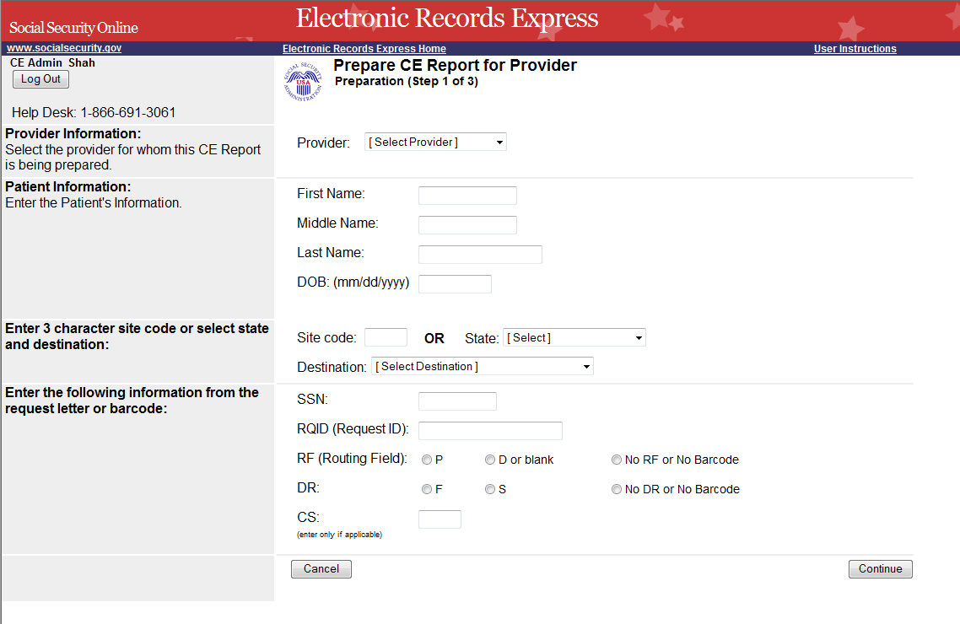

Step 4—Prepare CE Report for Provider
- Select the appropriate Provider from the dropdown box.
- Enter the First and Last Name of the patient (the Middle Name is not a required field).
- Enter the DOB (Date of Birth) of the patient.
- Select the DDS Destination from the dropdown list.
- Enter the Social Security Number (SSN). Only files for one SSN can be sent with this transaction.
- Enter the Request ID (RQID).
- Select the appropriate RF (Routing Field) option or No RF or No Barcode if not displayed on the request letter.
- Select the appropriate DR (Document Return Code) option or No DR or No Barcode if not displayed on the request letter.
- Enter the CS (Check Sum Digits) if available, or leave this field blank if not displayed on the request letter.
- Select Continue to continue this transaction or the Cancel button to cancel the transaction.
Step 5—Attach and Upload Files
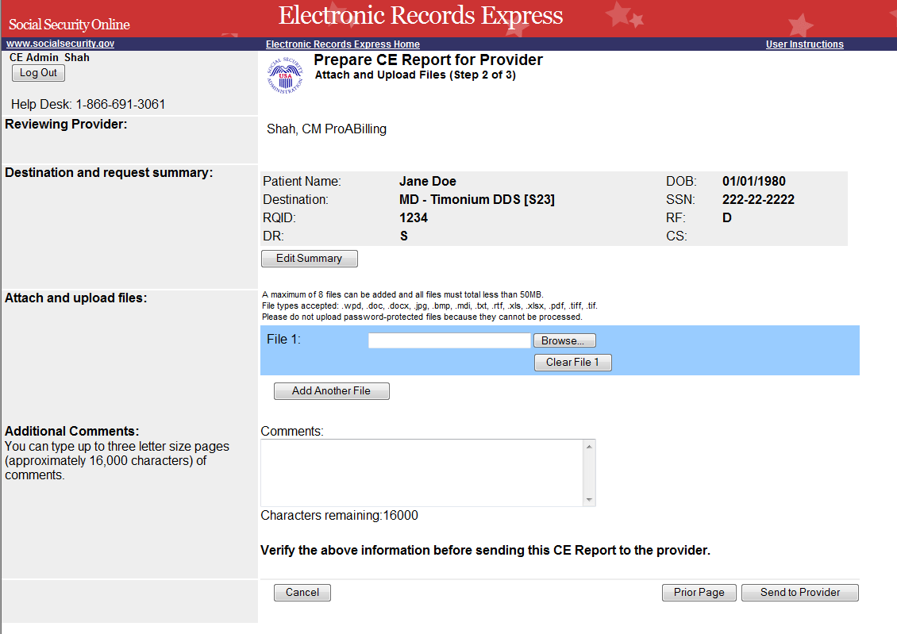
Select “Browse” to choose a file to send.

Step 5—Attach and Upload Files
- Review the Destination and request summary information. If changes are necessary, select the Edit Summary button.
- Select the Browse button to choose a file to send. (Do not send files that are password protected.) The Choose file window appears.
- Locate the file you wish to send and highlight the file name. The document’s file name moves into the File name box at the bottom of the Choose file window.
- Select the Open button. The Choose file window closes and the Electronic Records Express website displays the file name in the box to the left of the Browse… button.
- Select the Add Another File button to send additional files. Only files for the SSN in Step 1 may be sent with this transaction.
- Type Comments, if needed. The Comment field is where you can provide additional information. Type-in and/or cut-and-paste your text (up to 16,000 characters, approximately three letter size pages) directly into the box provided. a count of remaining characters is shown beneath the box. The count of remaining characters shows beneath the box.
- Verify the information you provided.
- Select the Send to Provider button to send the report to the Provider. Your file will be delivered to the Provider’s Electronic Records Express inbox and an email will alert him or her of the delivery.
- If you would like to return to the previous page, select the Prior Page button.
Select the Cancel button if you wish to cancel the transaction and return to the homepage.
Step 6 – Tracking Information
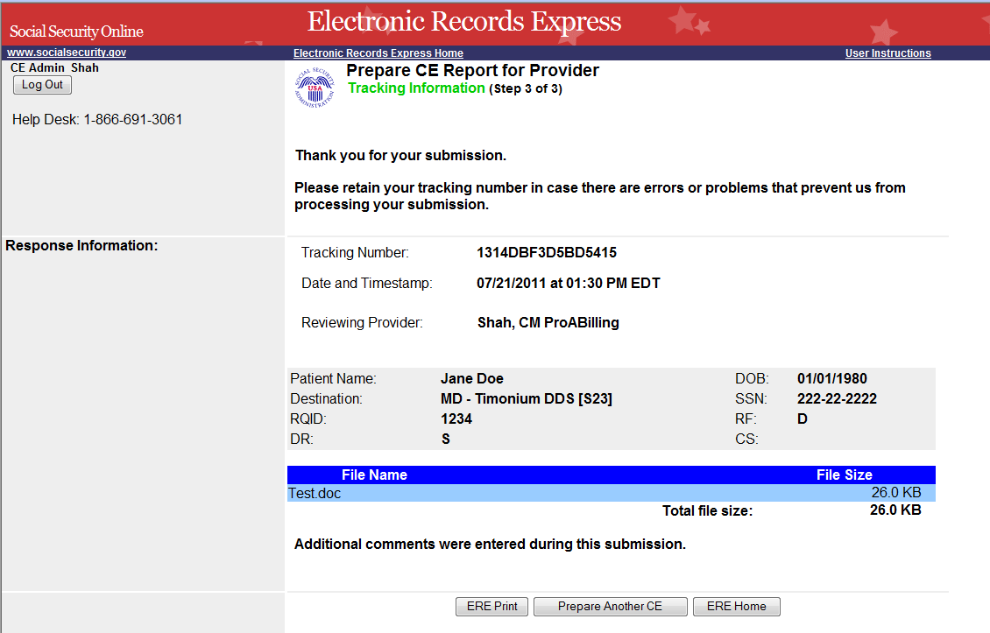
If you would like to prepare another CE report for the CE provider, choose the “Prepare Another CE” button.
Tracking Number

Step 6 – Tracking Information
- After your submission uploads, Electronic Records Express provides a Tracking Information page. The Tracking Information page provides a tracking number for you to keep and use if you want to check on the status of your submission. The Tracking Information page indicates the specific files and/or comments that you transmitted.
- If you do not receive the Tracking Information page, you should resubmit the materials.
- If you continue to have transmitting problems, contact the Electronic Records Express Website Help Desk at EETechSupport@ssa.gov or 1-866-691-3061
If you have additional CE reports to send, select Prepare Another CE. If you would like to return to the ERE Home page. select the ERE Home button.
NOTE: We strongly recommended that you print or take a screenshot of the Tracking Information page for your documentation. To do this, simply select ERE Print located at the bottom of the page. This print link works the same as if you selected File and Print from your browser’s menu. You cannot bookmark and save a Tracking Information page, and you will not be able to retrieve it later once you exit the webpage.

Instructions to Move File To Trash

Step 1—Move File to Trash
From the Provider’s Transcription Report Mailbox:
- Check the box(es) next to the File Name of the file(s) you want to add to Trash.
- Select Send Checked Item(s) to Trash.

Step 2—View Items in Trash
- Select Trash under the View Folders heading.
Step 3—View and Open File
- Continue from Step 3 above, Prepare Transcription Report for Provider
Step 1—Move File to Trash
Check the box next to the File Name of the file you want to move to Trash.

Select Send Checked Item(s) to Trash
Files older than 45 days are automatically deleted from the Inbox, regardless of whether they are downloaded or read.
To delete a file, you must send it to the Trash folder and then delete it from there.
Files that are in the Trash folder can be restored to the Inbox folder.

Access Keys
This application contains access keys to improve navigation and provide information. You will find a list of these keys in the table below:
Button | Access Key
Cancel | n
Delete Checked Item(s) | l
Log Out | l
Restore Checked Item(s) | r
Send Checked Item(s) to Trash | s
View Mailbox | x
Other keyboard commands, hotkeys or access keys will vary based upon browser and the version of the browser that you are using. A list of these commands can be found in the Help section of your browser. The Help feature can be located on the Menu bar of your browser or by using the F1 function key on the keyboard. Any assistive devices that you may be using will also have a list of these shortcut keys in their Help section.
Note: To use these keys select the “Alt” button on your keyboard and the access key simultaneously
.
How to Get Important Information about Electronic Records Express Website Availability
You may subscribe to receive ERE website availability notifications through the GovDelivery services on the Social Security Administration’s Electronic Records Express internet website: Social Security Online: Electronic Records Express. Please see the following website for GovDelivery FAQs: https://service.govdelivery.com/service/help.html#general1
To subscribe to the ERE website availability notification, follow these instructions:
- Click Get important information about Electronic Records Express website availability.
- Type your email address and select Go
- Confirm your email address
- Select “Send updates immediately by e-mail.”
- Choose an optional password
- Select Save
- Select Next
- Subscribe to additional topics by checking the boxes or unsubscribe by un-checking the boxes
- Select Save
- Subscribe to topics from other agencies by checking the boxes or unsubscribe by un-checking the boxes
- Select Save
**Once you have subscribed, you will receive a Subscription Acknowledgement e-mail with instructions on how to update your user profile**

