User Guide for Pickup Transcription Reports

Office of Disability Determinations
October 2011
Electronic Records Express Website

Document Exchange Services

Pickup Transcription Reports
The Pickup Transcription Reports feature of the website allows Consultative Examination (CE) providers to retrieve transcribed CE reports sent to the CE provider by a transcriptionist.
Users sign into the Electronic Records Express Home Page with username and password. Under the Document Exchange Services heading, select Pickup Transcription Reports. This takes you to your Inbox and allows you to pickup files sent via the Electronic Records Express website.
Please contact your Medical/Professional Relations Officer if you are interested in having this function available to you and it is not currently available to you.
Please note that you are responsible for information submitted on the ERE website when using your ERE User ID and password. You should never share your ERE User ID or password with others.
Electronic Records Express Home—Pickup Transcription Reports
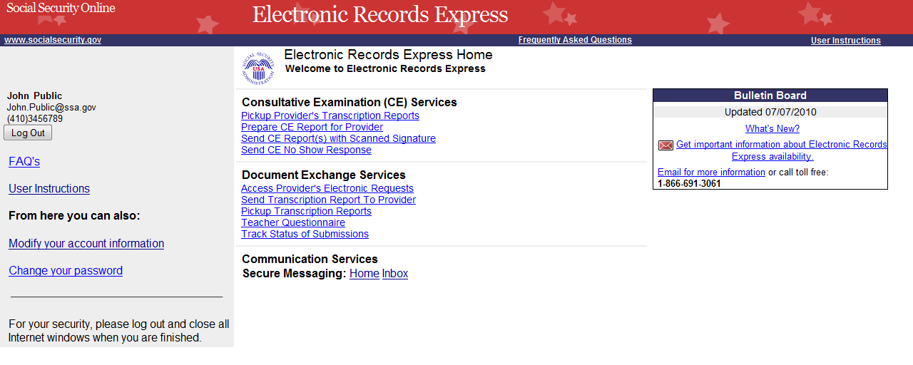
Steps 1 and 2—Pickup Transcription Reports
Choose “Inbox” to view the items in the Inbox Folder.
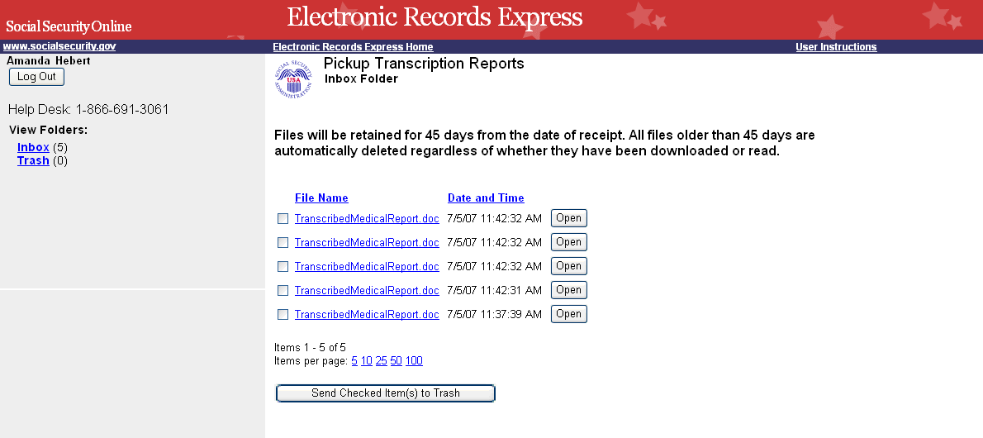
Choose the file name to view the document.

Step 1—View Inbox
- To view the inbox, select Inbox under the View Folders: heading.

Step 2—View and Open File
- To view a file, select the file name you wish to open under the File Name heading or the Open button. You may be prompted to either open or save the file.
- Open or save, as necessary

Instructions to Move File To Trash
Step 1—Move File to Trash
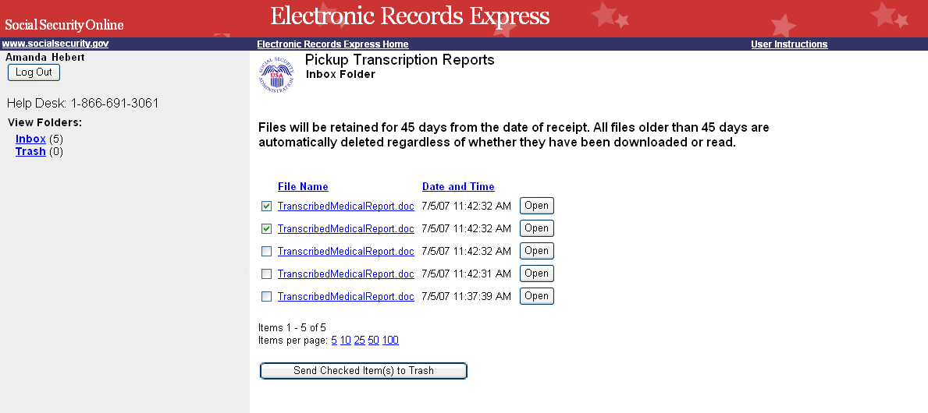
Check the box to select an item to delete. Select “Send Checked Item(s) to Trash”

Step 1—Move File to Trash
From the Inbox:
- Check the box(es) next to the File Name of the file(s) you want to add to Trash.
- Select Send Checked Item(s) to Trash.
Step 2—View Items in Trash
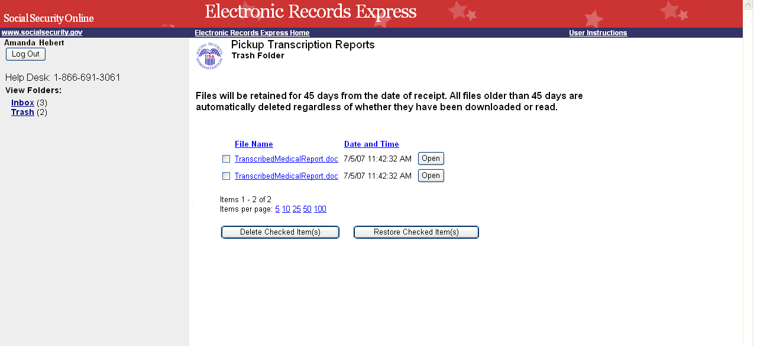
Choose “Trash” to view items in the Trash folder.

Step 2—View Items in Trash
- Select Trash under the View Folders heading.
- To delete items in Trash, select Delete Checked Item(s)
- To restore items in Trash to your Inbox, select Restore Checked Item(s).
Note: Documents are deleted after 45 days from the beginning of the process. This includes items in the Inbox and Trash.

Access Keys
This application contains access keys to improve navigation and provide information. You will find a list of these keys in the table below:
Button | Access Key
Delete Checked Item(s) | l
Log Out | l
Restore Checked Item(s) | r
Send Checked Item(s) to Trash | s
Other keyboard commands, hotkeys or access keys will vary based upon browser and the version of the browser that you are using. A list of these commands can be found in the Help section of your browser. The Help feature can be located on the Menu bar of your browser or by using the F1 function key on the keyboard. Any assistive devices that you may be using will also have a list of these shortcut keys in their Help section.
Note: To use these keys select the “Alt” button on your keyboard and the access key simultaneously.
How to Get Important Information about Electronic Records Express Website Availability
You may subscribe to receive ERE website availability notifications through the GovDelivery services on the Social Security Administration’s Electronic Records Express internet website: Social Security Online: Electronic Records Express. Please see the following website for GovDelivery FAQs: https://service.govdelivery.com/service/help.html#general1
To subscribe to the ERE website availability notification, follow these instructions:
Click Get important information about Electronic Records Express website availability.
- Type your email address and select Go
- Confirm your email address
- Select “Send updates immediately by e-mail.”
- Choose an optional password
- Select Save
- Select Next
- Subscribe to additional topics by checking the boxes or unsubscribe by un-checking the boxes
- Select Save
- Subscribe to topics from other agencies by checking the boxes or unsubscribe by un-checking the boxes
- Select Save
**Once you have subscribed, you will receive a Subscription Acknowledgement e-mail with instructions on how to update your user profile**

