User Guide for Secure Messaging

Office of Disability Determinations
October 2011

Electronic Records Express Website

Communication Services

Secure Messaging
The Secure Messaging function allows registered Electronic Records Express (ERE) users to exchange confidential messages and sensitive documents. Only registered users can send and receive secure messages, and messages can only be sent to other registered users (no forwarding to external email addresses). Messages and documents are stored in a central repository on a protected system within the SSA network. All messages and documents are scanned for virus infection before processing.
Electronic Records Express sends email notices to users sent a Secure Message. The email notification contains a link to the Electronic Records Express website. You must log into the ERE to retrieve the message. Messages have a limited lifetime of 20 days from creation date.
Electronic Records Express Home—Secure Messaging
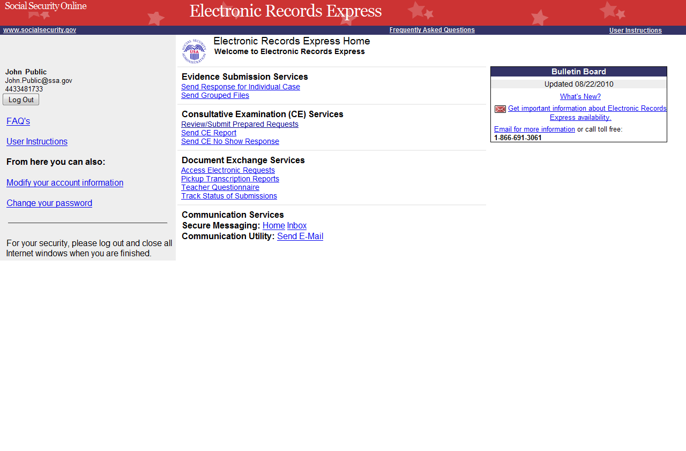
Select the Home link, and the Mailbox Home screen displays.

Secure Messaging Inbox:
Select the Inbox link from the Electronic Records Express Home page to view the Secure Messaging Inbox.
Secure Messaging Mailbox Home
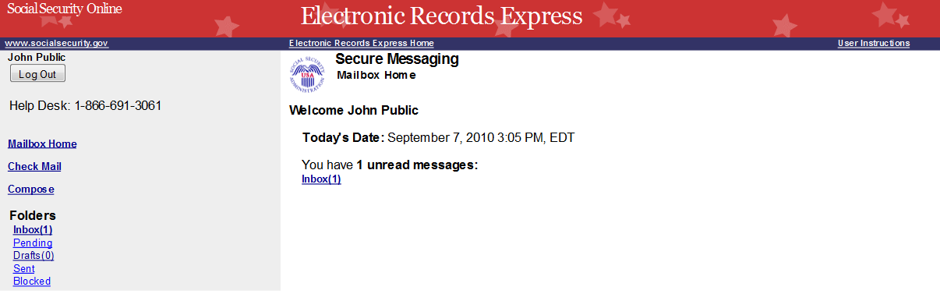

View an Individual Message:
To view an individual message, select the hyperlink of the message you would like to view in the Subject column.
Secure Messaging Inbox
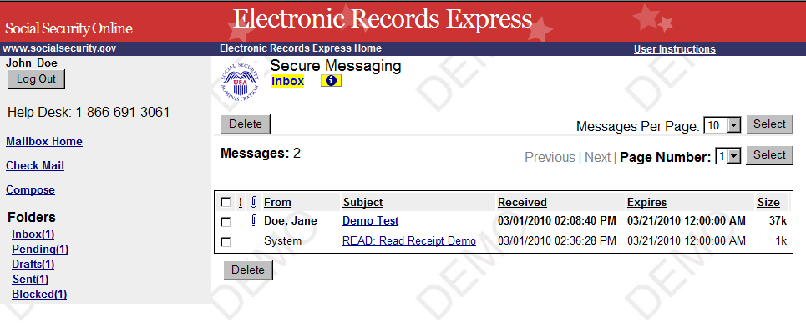

Select a hyperlink under Subject to view a message

Reply to a Message:
- Use the Reply, Reply to All, or Forward button to respond to the message. Follow the instructions for Compose and Send a Message below to send the message; or
- Choose the Delete button to delete the message; or
- To view another message, select Check Mail or Mailbox Home. Viewed messages remain in the Inbox until they are automatically deleted (20 days from creation date) or manually deleted.
Secure Messaging – Message
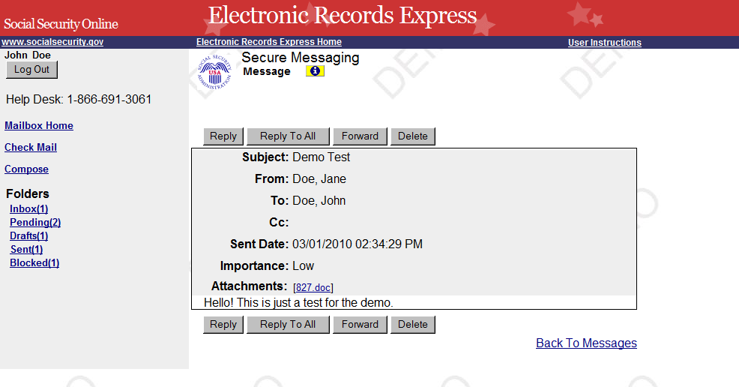

Compose and Send a Message:
- Select the link for either Home or Inbox from the Electronic Records Express Home page. You may also respond directly to a received message by choosing the Reply, Reply To All or Forward button.
- If composing a message from the Inbox page or Mailbox Home page, select the Compose link. The form for creating a new message displays.
Compose Message – Secure Messaging
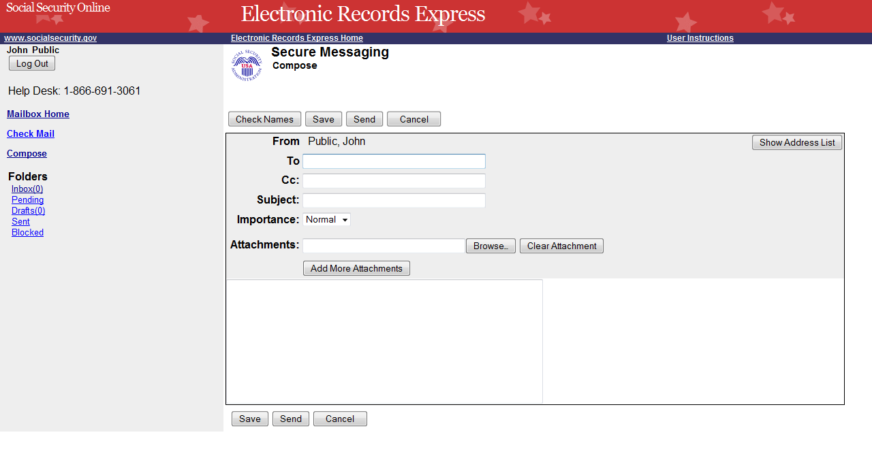
- Enter the destination recipient(s) in the To: and/or Cc: fields. (You can only send Messages to registered users of Secure Messaging.)
- The easiest way to enter a recipient is by selecting the Show Address List button. This displays the recipient pull-down list. (You can only send Messages to registered users displayed in this list.)
- Either scroll down the list to the name, or search for the name using the Search Name text box. As you type the name in the box, you advance to the corresponding location in the list.
- Highlight the name of the user you are sending a message to and insert it in either the To: box or the Cc: box by selecting the Add To: or Add Cc: button on the search window.
- Repeat this step until all you have entered all desired destination recipients (up to 76 characters).
Compose Message – Secure Messaging
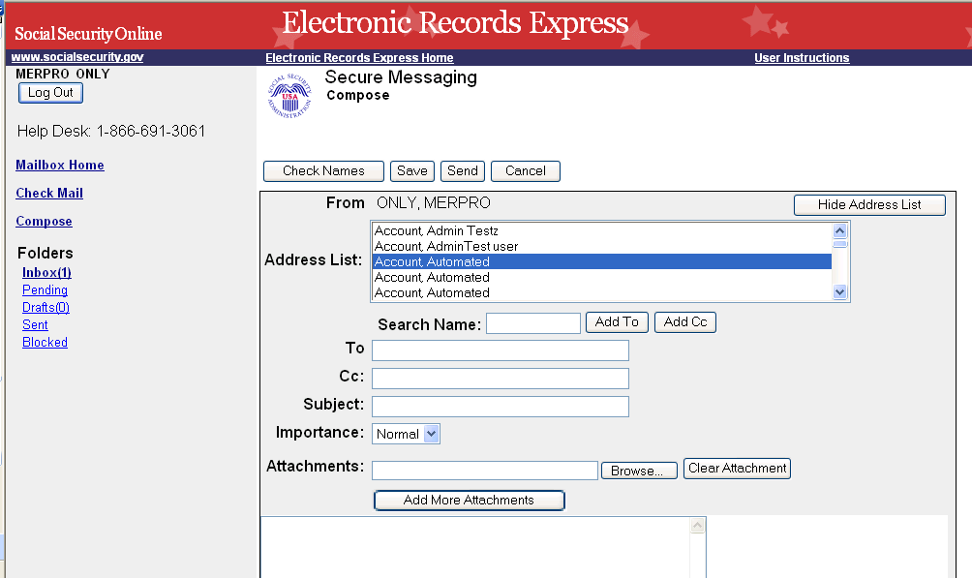
Highlight the recipient
After highlighting the recipient, choose “Add To” or “Add Cc”
Enter message in text box
- Enter a Subject, and then select the level of Importance from the drop-down list.
- Attach files as necessary using the Browse button. All file types are acceptable except .htm, .html, and .exe. A maximum of 8 attachments can be sent with each message.
- Enter any text message that needs to be included in the large text box.
- The overall size of the message cannot exceed 51 MB (50MB total for file attachments and 1MB for message text).
- Send the message by selecting the Send button. Or, you can save an unfinished message for later by selecting the Save button. (Creating a draft message starts the 20-day lifespan of the message.)
- A copy of the sent message is saved in the Sent folder.

View Blocked Messages:
Blocked messages are messages the user attempted to upload with an attachment in which the Electronic Records Express virus scan found a suspected virus. Quarantined messages are blocked from transmission and the suspected file is deleted. In addition to the benefit of knowing about the suspected file, users need to know that the message has been blocked.
- Select the hyperlink for either Home or Inbox from the Electronic Records Express Home page.
- Select the Blocked link. The blocked messages list displays.
- To take action on the message:
- To delete the message, select the checkbox next to the message and select the Delete button.
NOTE: Do not upload documents containing macros (i.e., a set of instructions or scripts that automates tasks). They may cause system problems, which will require you to re-submit your documents without macros.

Access Keys
This application contains access keys to improve navigation and provide information. You will find a list of these keys in the table below:

Button | Access Key
Cancel | n
Check Names | c
Delete | l
Delete Checked Item(s) | l
Forward | w
Log Out | l
Reply | r
Reply To All | l
Save | s
Select | l
Send | r
Other keyboard commands, hotkeys or access keys will vary based upon browser and the version of the browser that you are using. A list of these commands can be found in the Help section of your browser. The Help feature can be located on the Menu bar of your browser or by using the F1 function key on the keyboard. Any assistive devices that you may be using will also have a list of these shortcut keys in their Help section.
Note: To use these keys select the “Alt” button on your keyboard and the access key simultaneously.

How to Get Important Information about Electronic Records Express Website Availability
You may subscribe to receive ERE website availability notifications through the GovDelivery services on the Social Security Administration’s Electronic Records Express internet website: Social Security Online: Electronic Records Express. Please see the following website for GovDelivery FAQs: https://service.govdelivery.com/service/help.html#general1
To subscribe to the ERE website availability notification, follow these instructions:
- Click Get important information about Electronic Records Express website availability.
- Type your email address and select Go
- Confirm your email address
- Select “Send updates immediately by e-mail.”
- Choose an optional password
- Select Save
- Select Next
- Subscribe to additional topics by checking the boxes or unsubscribe by un-checking the boxes
- Select Save
- Subscribe to topics from other agencies by checking the boxes or unsubscribe by
un-checking the boxes
- Select Save
**Once you have subscribed, you will receive a Subscription Acknowledgement e-mail with instructions on how to update your user profile**

