User Guide for Send CE No Show Response

Office of Disability Determinations
October 2011

Electronic Records Express Website

Consultative Examination (CE) Services

Instructions for Send CE No Show Response
On the Electronic Records Express Home page, under the Consultative Examination (CE) Services heading, select Send CE No Show Response.
Selecting this link takes you to a page that allows input of information about the claimant that did not show up for the scheduled CE appointment.
Unless you received the request electronically from the DDS, you will need to have the DDS request letter to enter information in the next few steps.
If you received the CE request from the DDS electronically, you can locate the request under Access Electronic Request if you are the CE provider, or Access Provider’s Electronic Requests if you are CE administrative staff.
Please note that you are responsible for information submitted on the ERE website when using your ERE User ID and password. You should never share your ERE User ID or password with others.
Electronic Records Express Home-Send CE No Show Response-Screen as seen by CE administrative staff
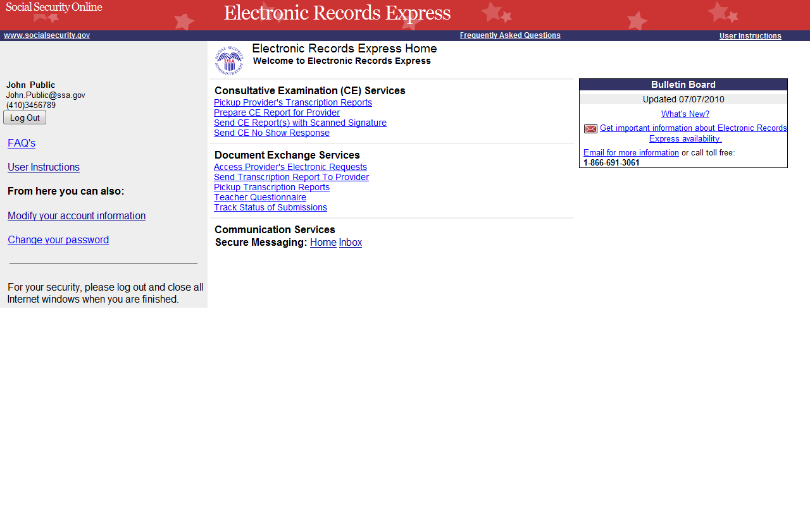

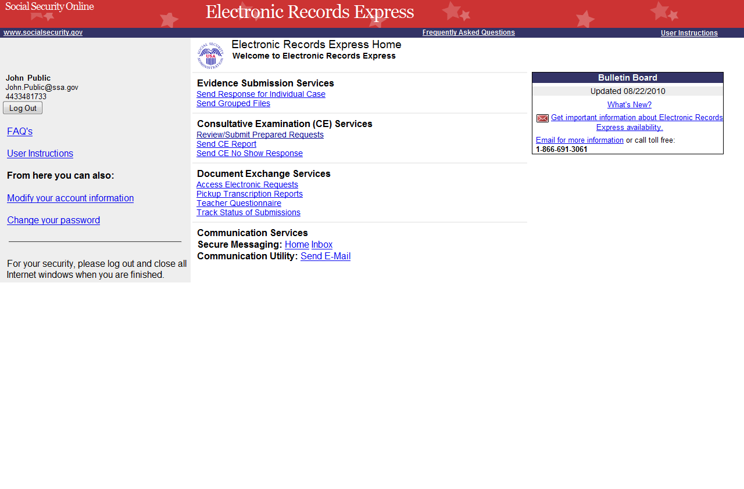
Shown above is the Electronic Records Express Home page as seen by CE providers
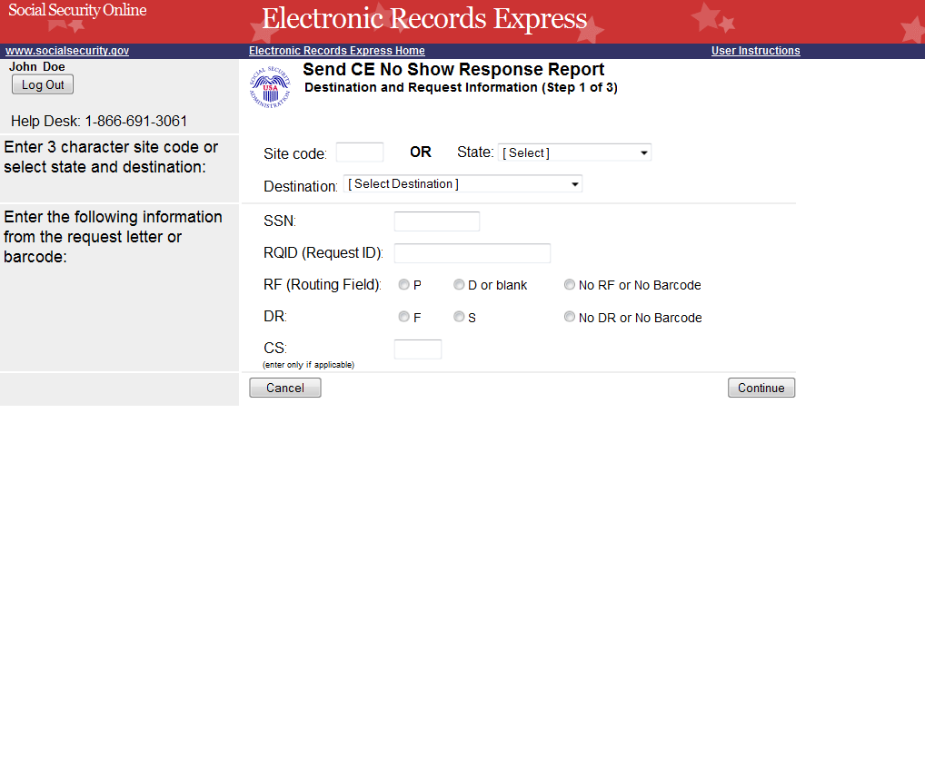
Select the destination
and complete all fields

Step 1—Destination and Request Information
- Enter the three-character Site code from the barcode. The Site code begins with a letter, followed by two digits. If you make a mistake you may backspace and enter the correct letter or digits;
or
Select the State from the dropdown. After choosing the State, the Destination list updates and lists the offices in the State you selected. Select the Destination from the dropdown;
or
Just select the Destination from the dropdown.

- Obtain the following information from the CE request letter when responding to a non-electronic request:
- Enter the Social Security Number (SSN). Only files for one SSN can be sent with this transaction.
- Enter the Request ID (RQID). The Request ID is the document number or serial number which is usually located on the request letter near the barcode.
- Select the appropriate RF (Routing Field) option, or No RF or No Barcode if not displayed on the request letter.
- Select the appropriate DR (Document Return Code) option, or No DR or No Barcode if not displayed on the request letter.
- Enter the CS (Check Sum Digits) if available, or leave this field blank if not displayed on the request letter.
- Select Continue to go to the next step or select Cancel to return to the Electronic Records Express Home page.

Step 2—Complete Reason
- Select the reason the exam was not performed. Based on the reason you select, comments may be required. .
- Type Comments, if needed. Provide information about why the exam was not performed. Type-in and/or cut-and-paste your text (up to 16,000 characters, approximately three letter size pages) directly into the box provided. The remaining character count shows beneath the box. .
- Select the Submit button to forward the information to the Destination selected in Step 1.
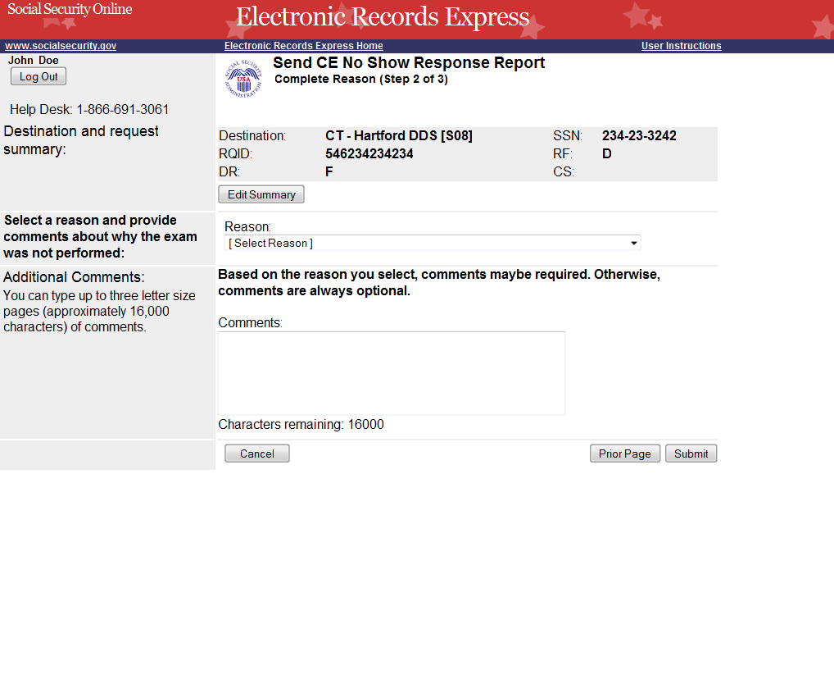
Step 3—Tracking Information
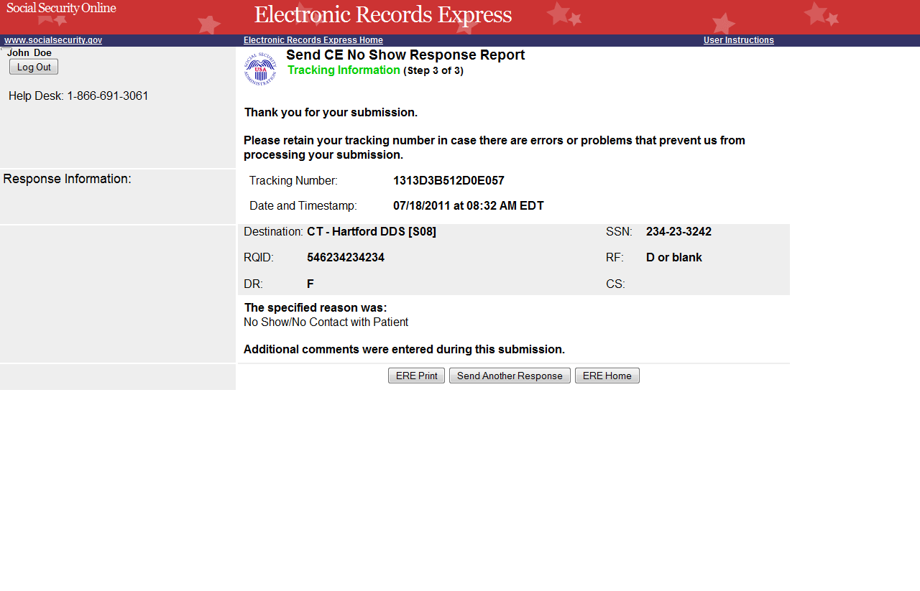
Tracking Number

Step 3—Tracking Information
- After your submission uploads, Electronic Records Express provides a Tracking Information page. The Tracking Information page provides a tracking number for you to keep and use if you want to check on the status of your submission. It also displays the reason you specified in Step 2 indicates if Comments were entered during submission.
- If you do not receive the Tracking Information page, please resubmit the information.
- If you continue to have transmitting problems, contact the Electronic Records Express Website Help Desk at EETechSupport@ssa.gov or 1-866-691-3061.
- If you have additional responses to send, you can select whichever button is displayed for you, Send Another Response or Review Another Request. This returns you to an earlier step in the process.
NOTE: We strongly recommended that you print or take a screenshot of the Tracking Information page for your documentation. To do this, simply select ERE Print located at the bottom of the page. This print link works the same as if you selected File and Print from your browser’s menu. You cannot bookmark and save a Tracking Information page, and you will not be able to retrieve it later once you exit the webpage.

Access Keys
This application contains access keys to improve navigation and provide information. You will find a list of these keys in the table below:
Button | Access Key
Cancel | n
Continue | c
Edit Summary | w
ERE Home | h
ERE Print | p
Log Out | l
Prior Page | p
Request Payment | y
Send Another Response | r
Submit | s
Other keyboard commands, hotkeys or access keys will vary based upon browser and the version of the browser that you are using. A list of these commands can be found in the Help section of your browser. The Help feature can be located on the Menu bar of your browser or by using the F1 function key on the keyboard. Any assistive devices that you may be using will also have a list of these shortcut keys in their Help section.
Note: To use these keys select the “Alt” button on your keyboard and the access key simultaneously.

How to Get Important Information about Electronic Records Express Website Availability
You may subscribe to receive ERE website availability notifications through the GovDelivery services on the Social Security Administration’s Electronic Records Express internet website: Social Security Online: Electronic Records Express. Please see the following website for GovDelivery FAQs: https://service.govdelivery.com/service/help.html#general1
To subscribe to the ERE website availability notification, follow these instructions:
- Click Get important information about Electronic Records Express website availability.
- Type your email address and select Go
- Confirm your email address
- Select “Send updates immediately by e-mail.”
- Choose an optional password
- Select Save
- Select Next
- Subscribe to additional topics by checking the boxes or unsubscribe by un-checking the boxes
- Select Save
- Subscribe to topics from other agencies by checking the boxes or unsubscribe by
un-checking the boxes
- Select Save
**Once you have subscribed, you will receive a Subscription Acknowledgement e-mail with instructions on how to update your user profile**

