User Guide for Send CE Report

Office of Disability Determinations
October 2011

Electronic Records Express

Consultative Examination (CE) Services

Instructions for Send CE Report

The Send CE Report feature of the website allows the CE provider to submit and electronically sign one individual CE report and send it to the DDS. To submit a CE report using this feature of the ERE website, select the link, Send CE Report under the Consultative Examination (CE) Services heading. You need the CE request letter with the barcode available to complete the processing steps, unless you receive your request electronically from the DDS. Note that file types accepted are: .wpd, .doc, .docx, .jpg, .bmp, .mdi, .txt, .rtf, .xls, .xlsx, .pdf, .tiff, and .tif.

You can only use the Send CE Report function if you are the CE Provider. The CE administrative staff cannot use this function.

Please note that you are responsible for information submitted on the ERE website when using your ERE User ID and password. You should never share your ERE User ID or password with others.

NOTE: If you received the CE request from the DDS electronically, you can find the request under Access Electronic Requests. After accessing the request, you can view the request and respond using the Send CE Report function.

Electronic Records Express—Instructions for Send CE Report
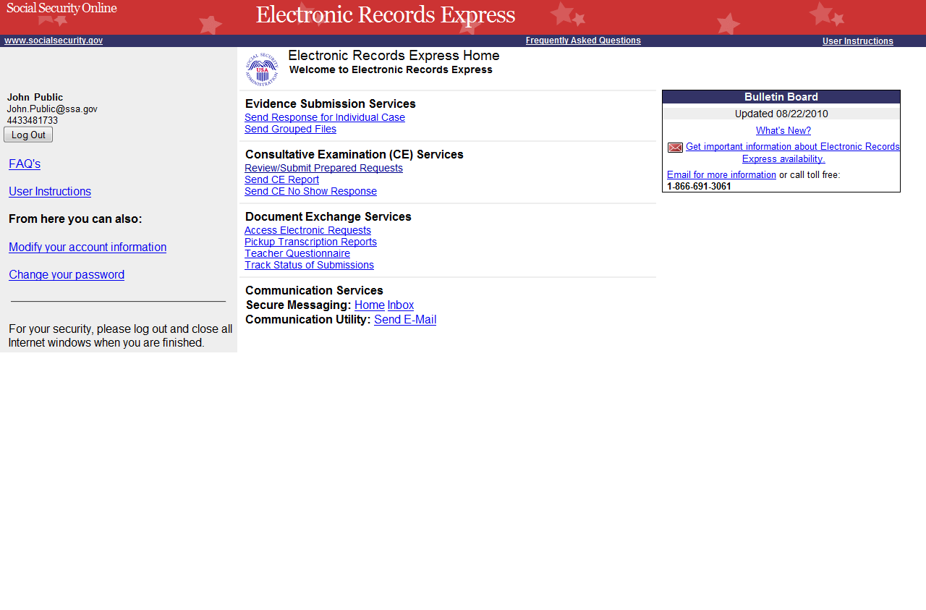

Step 1—Destination and Request Information
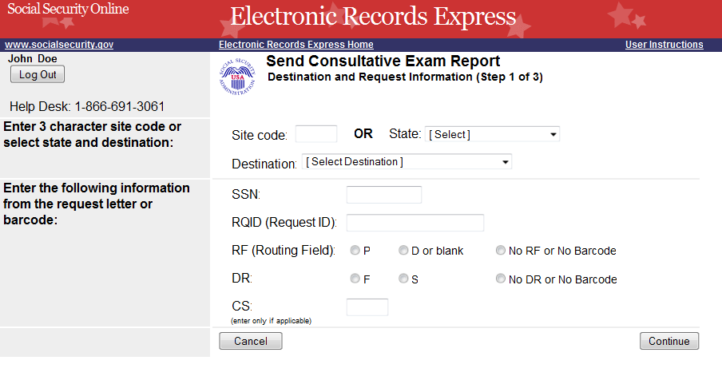
Select Destination from the dropdown box.

Step 1—Destination and Request Information
- Enter the three-character Site code from the barcode. The Site code begins with a letter, followed by two digits. If you make a mistake you may backspace and enter the correct letter or digits;
or
Select the State from the dropdown. After choosing the State, the Destination list updates with the offices in the State you selected. Select the Destination from the dropdown;
or
Just select the Destination from the dropdown.
- Obtain the following information from the CE request letter if you did not receive the request electronically (this information populates for you if you received an electronic CE request):
- Enter the Social Security Number (SSN). Only files for one SSN can be sent with this transaction.
- Enter the Request ID (RQID). The Request ID is the document number or serial number that is usually located on the request letter near the barcode.
- Select the appropriate RF (Routing Field) option, or No RF or No Barcode if not displayed on the request letter.
- Select the appropriate DR (Document Return Code) option, or No DR or No Barcode if not displayed on the request letter.
- Enter the CS (Check Sum Digits) if available, or leave this field blank if not displayed on the request letter.
- Select Continue to go to the next step or select Cancel to return to the Home page.

Step 2—Attach and Upload Files and Electronic Signature
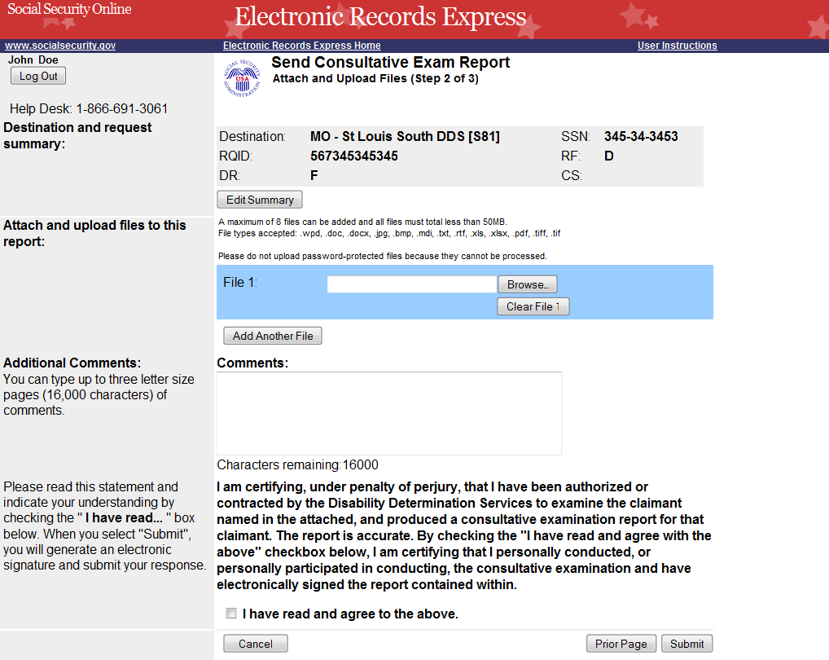

Step 2—Attach and Upload Files and Electronic Signature
- Review the Destination and request summary information, and verify the accuracy of the information selected in Step 1. If any of the information is incorrect, make the corrections by selecting the Edit Summary button. NOTE: If you respond to an electronic request, you will not be able to edit this information. Your screen will not look exactly like the screen shown above.
- Select the Browse button to identify a file to send. (Do not send files that are password protected.) The Choose file window appears on your screen.
- Locate the file you wish to send and highlight the file name. The document’s file name moves into the File name box at the bottom of the Choose file window.
- Select the Open button. The Choose file window closes and the file name displays in the box to the left of the Browse… button. If you have chosen the incorrect file, select the Clear File 1 button to clear the File 1 field.
- Select the Add Another File button to send additional files. Only files for the SSN in Step 1 can be sent with this transaction.

Note: A maximum of eight (8) files may be sent for one individual by selecting the Add Another File button and repeating the previous steps.

SSA’s Electronic Records Express website only accepts the following file formats: .wpd, .doc, .docx, .jpg, .bmp, .mdi, .txt, .rtf, .xls, .xlsx, .pdf, .tiff, .tif.

Do not upload documents containing macros (i.e., a set of instructions or scripts that automates tasks). They may cause system problems, which will require you to re-submit your documents without macros.

- The next step is your “Electronic Signature”. This step asks you to certify that you examined the claimant, prepared or reviewed the report, and the report is accurate. Read the certification statement located at the bottom of the screen and indicate your understanding by checking the box beside I have read and agree with the above. By checking the box, you affirm your intent to sign the report. You do not need to physically sign and send the paper report to the DDS.
- Type Comments, if needed. Type-in and/or cut-and-paste your text (up to 16,000 characters, approximately three letter size pages) directly into the box provided. The count of remaining characters shows beneath the box.
- Select the Submit button to provide electronic signature and forward the signed report to the selected DDS office.

The website creates a text file and adds it to the files and information you submit. This document contains the following information:
- Index information you entered from the request letter
- The signature attestation statement to which you agreed
- Your name, as it is registered in Electronic Records Express—serving as your electronic signature.
Step 3—Tracking Information
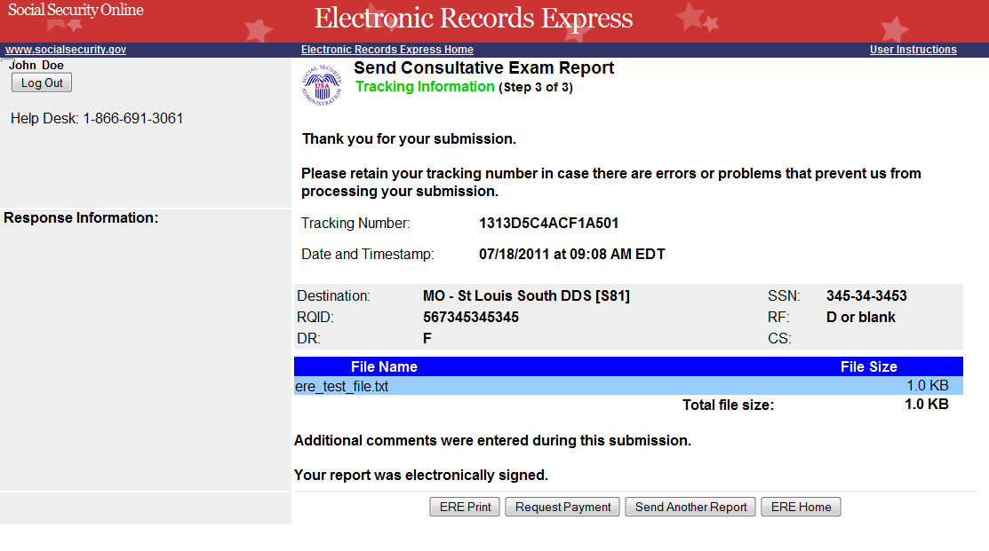
Tracking Number

Step 3—Tracking Information
- After your submission uploads, Electronic Records Express provides a Tracking Information page. The Tracking Information page provides a tracking number for you to keep and use if you want to check on the status of your submission. The Tracking Information page indicates the specific files and/or comments that you transmitted.

- If you do not receive the Tracking Information page, please resubmit the materials.

- If you continue to have transmitting problems, contact the Electronic Records Express Website Help Desk at EETechSupport@ssa.gov or 1-866-691-3061.

- If you have additional CEs to send, you can whichever button is available for at the bottom of your screen, either Send Another Response, or Review Another Request.

NOTE: We strongly recommended that you print or take a screenshot of the Tracking Information page for your documentation. To do this, simply select ERE Print located at the bottom of the page. This print link works the same as if you selected File and Print from your browser’s menu.

You cannot bookmark and save a Tracking Information page, and you will not be able to retrieve it later from the SSA/DDS after you exit the webpage.

Important Note
It is against SSA policy for a user to delegate the uploading of their Consultative Examination reports, via the Send CE Report website function, to staff members. Users interested in delegating this responsibility should consider using the Send CE Report(s) with Scanned Signature website function or CE Administrative Staff Upload (Review/Submit CE Reports, Pickup Provider’s Transcription Reports and Prepare CE Report for Provider).

Access Keys

This application contains access keys to improve navigation and provide information. You will find a list of these keys in the table below:
Button | Access Key
Add Another File | 2 – 8 (number corresponds to the file to be added)
Cancel | n
Continue | c
Edit Summary | w
ERE Home | h
ERE Print | p
Log Out | l
Prior Page | p
Request Payment | y
Send Another Report | r
Submit | s

Other keyboard commands, hotkeys or access keys will vary based upon browser and the version of the browser that you are using. A list of these commands can be found in the Help section of your browser. The Help feature can be located on the Menu bar of your browser or by using the F1 function key on the keyboard. Any assistive devices that you may be using will also have a list of these shortcut keys in their Help section.

Note: To use these keys select the “Alt” button on your keyboard and the access key simultaneously.

How to Get Important Information about Electronic Records Express Website Availability

You may subscribe to receive ERE website availability notifications through the GovDelivery services on the Social Security Administration’s Electronic Records Express internet website: Social Security Online: Electronic Records Express. Please see the following website for GovDelivery FAQs: https://service.govdelivery.com/service/help.html#general1

To subscribe to the ERE website availability notification, follow these instructions:
- Click Get important information about Electronic Records Express website availability.
- Type your email address and select Go
- Confirm your email address
- Select “Send updates immediately by e-mail.”
- Choose an optional password
- Select Save
- Select Next
- Subscribe to additional topics by checking the boxes or unsubscribe by un-checking the boxes
- Select Save
- Subscribe to topics from other agencies by checking the boxes or unsubscribe by
un-checking the boxes
- Select Save
**Once you have subscribed, you will receive a Subscription Acknowledgement e-mail with instructions on how to update your user profile**

