User Guide for Send Grouped Files

Office of Disability Determinations
October 2011

Electronic Records Express Website

Evidence Submission Services

Instructions for Send Grouped Files
You can use the Send Grouped Files function on the Electronic Records Express website to send multiple files on a single upload. You can use this function by combining the multiple files into a single .zip file.
Please note that you are responsible for information submitted on the ERE website when using your ERE User ID and password. Never share your ERE User ID or password with others.
You need the SSA/DDS evidence request letter that contains the barcode available to complete the processing steps of Send Grouped Files. If you received the request electronically from the DDS, you cannot use Grouped Files to respond.
The barcode sheet must be the topmost (first page) of the set of records belonging to one individual. Similarly, a group of files containing the records of many individuals must always have a barcode sheet for each individual when transmitted together as a group of files combined in one file.

Please note that Electronic Records Express only accepts zipped files (.zip) that contain .tif, .tiff, .jpg, .bmp, .mdi or .pdf files, and each individual's barcode sheet must be the topmost (first page) of the record. For example, a .zip file containing five record sets for five different individuals must have five barcode sheets. A barcode sheet must be the topmost (first page) of each individual’s record. You may use combinations of file types within a single transmission session on the Electronic Records Express website.
Grouped Files Upload
Under the Evidence Submission Services heading, select Send Grouped Files. Selecting this option takes you to the Electronic Records Express – Send Grouped Files page.
Electronic Records Express Home—Send Grouped Files
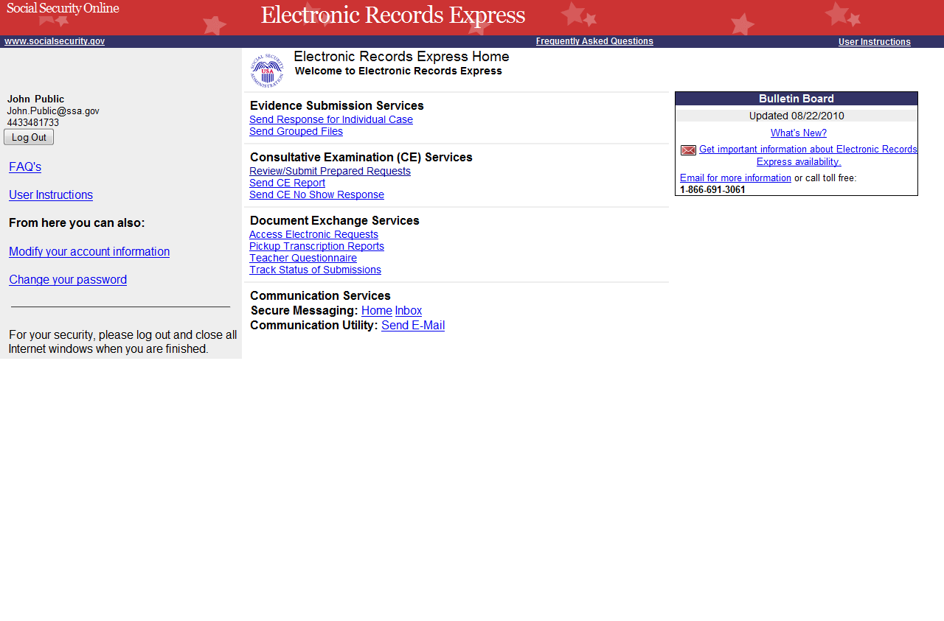

Group the records based on whether there is a 2-D/enhanced barcode on the request letter. The barcode should look like the barcode below:
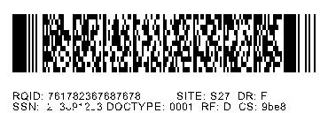
You must separate records that have a 2-D barcode from records that do not have a 2-D barcode. Submit records with a 2-D barcode in one upload. The 2-D barcode must be the first page of the file.
RQID: 123456789012345 SITE: S27 DR: F
SSN: 123456789 DOCTYPE: 001 RF: D CS: 9be8
Please note that the Send Grouped Files function only accepts .zip files. You must follow the rules listed below or your upload will not process.
- The .zip file must not contain directories.
- The .zip file must be valid and cannot be empty.
- The .zip file must contain only .tiff, .tif, .pdf, .jpg, .mdi, and .bmp files.
- The .zip file must not contain empty (zero-byte) files.
- The .zip file must contain one or more .tiff, .tif, .pdf, .jpg, .mdi, and .bmp files with either all enhanced barcodes or no enhanced barcodes.
- Each .tiff file within a .zip file should follow these specifications:
- One .tif file per patient with the request letter on the first page
- .tiff version 4, 5, or 6
- Intel format (little-endian byte order)
- CCITT Group 4 Compression
- Black & White color (Bitonal)
- 200x200 dots per inch (DPI) resolution
Step 1—Destination and Documentation Information
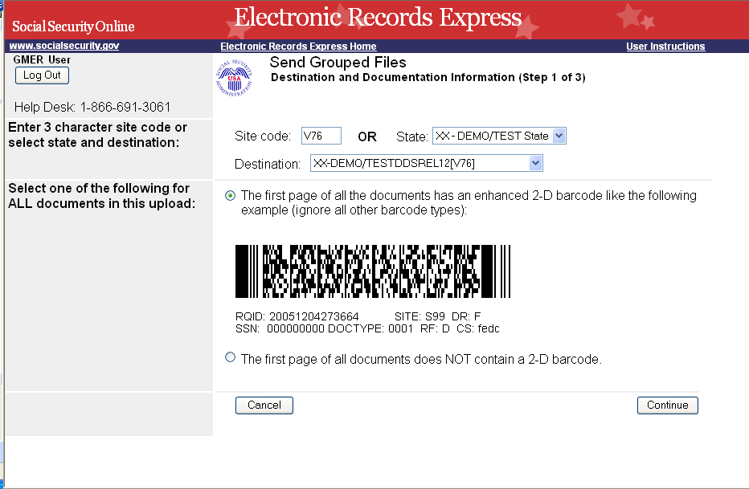
Select this bullet if the first page of your documents contains a 2-D barcode
Select the Destination
Select this bullet if the first page of your documents does not contain a 2-D barcode

Step 1—Destination and Documentation Information
- Enter the three-character Site code from the barcode. The Site code begins with a letter followed by two digits. If you make a mistake you may backspace and enter the correct letter or digits;
or
Select the State from the dropdown. If the State has more than one office destination, you must select the Destination office from the drop down list also.
or
Just select the “Destination” from the dropdown.
- There are two bullets to choose from on this page. Select the first bullet if the first page of your documents has an enhanced 2-D barcode that looks like the barcode below (the barcode may not display the DR field):
or
RQID: 123456789012345 SITE: S27 DR: F
SSN: 123456789 DOCTYPE: 001 RF: D CS: 9be8
- Select the second bullet if the first page of your documents does not contain an enhanced 2-D barcode(s) OR does not contain any barcodes at all.
- Select the Continue button to proceed to Step 2—Attach and Upload Files.
Step 2—Attach and Upload Files
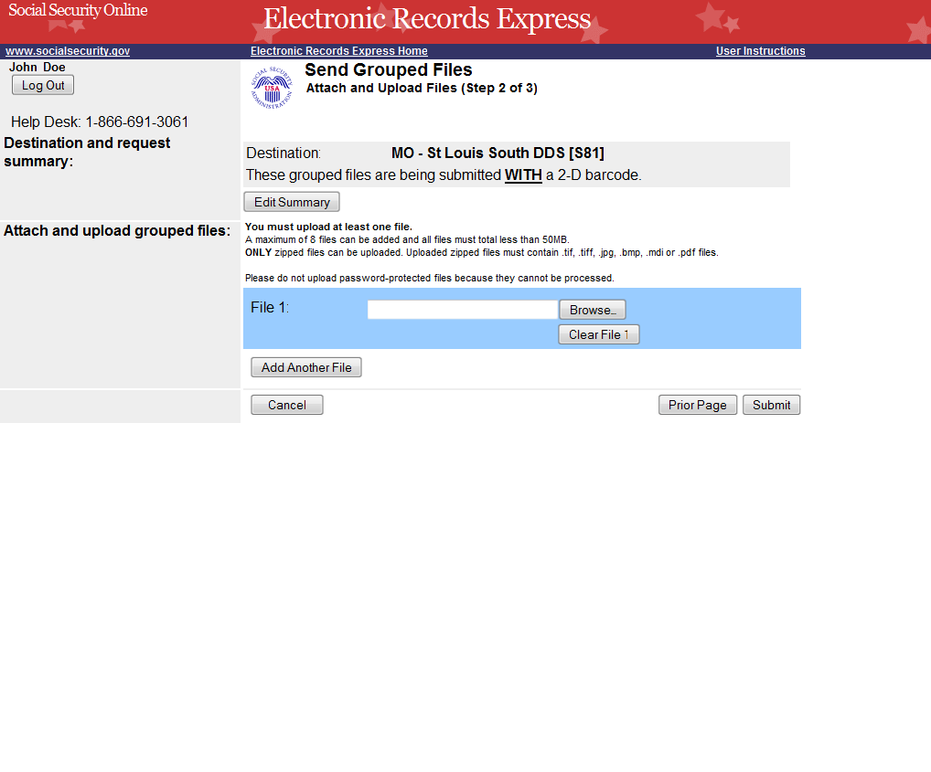
You may include up to eight (8) files in a submission. If you need to submit more than eight files for a single request, you will have to perform multiple uploads.
Step 2—Attach and Upload Files
- Review the Destination and Request Summary Information and verify the accuracy of the information selected in Step 1. If any of the information is incorrect, make the corrections by selecting the Edit Summary button.
- Select the Browse button to identify a file to send. (Do not send files that are password protected.) The Choose file window appears.
- Locate the zipped file you wish to send and highlight the file name. The document’s file name moves to the “File name” box at the bottom of the Choose file window.
- Select the Open button. The Choose file window closes and the Electronic Records Express website shows the file name displayed in the box to the left of the Browse… button. If you have chosen the incorrect file, select the Clear File 1 button to clear the File 1 field.
NOTE: Do not upload documents containing macros (i.e., a set of instructions or scripts that automates tasks). They may cause system problems, which will require you to re-submit your documents without macros.
- Select the Add Another File button to send additional zipped files.
- Select the Submit button to forward the information to the Destination selected in Step 1.
Step 3—Tracking Information
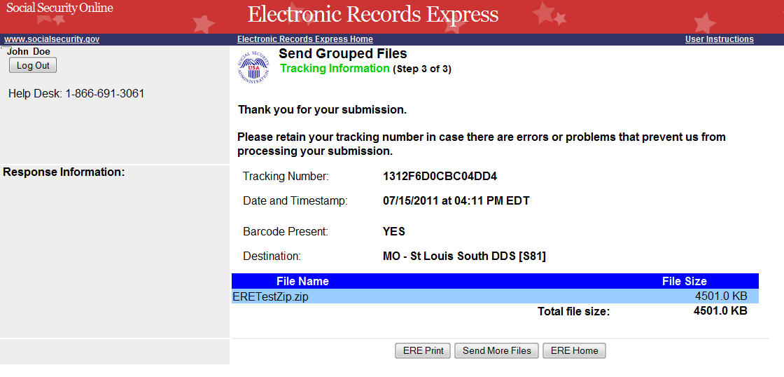
Tracking Number

Step 3—Tracking Information
- After your submission uploads, Electronic Records Express provides a Tracking Information page. The Tracking Information page provides a tracking number for you to keep and use if you want to check on the status of your submission. The Tracking Information page indicates the specific files that you transmitted.
- If you do not receive the Tracking Information page, you should resubmit the materials.
- If you continue to have transmitting problems, contact the Electronic Records Express Website Help Desk at EETechSupport@ssa.gov or 1-866-691-3061.
- If you have additional Grouped Files to send, you may select the Send More Files. This will take you to Step 1 of sending Grouped Files.
NOTE: We strongly recommend that you print or take a screenshot of the Tracking Information page for your documentation. To do this, simply select ERE Print located at the bottom of the page. This print link works the same as if you selected File and Print from your browser’s menu.

You cannot bookmark and save a Tracking Information page, and you will not be able to retrieve it later from Social Security or a DDS office once you exit the webpage.
If the file you selected to transmit is 0 byte, or too large (over 50mb), Electronic Records Express cannot process the submission. Choose Try Again on the message page to return to the previous page, update your file(s), and resubmit.

Access Keys
This application contains access keys to improve navigation and provide information. You will find a list of these keys in the table below:
Button | Access Key
Add Another File | 2 – 8 (number corresponds to the file to be added)
Cancel | n
Continue | c
Edit Summary | w
ERE Home | h
ERE Print | p
Log Out | l
Prior Page | p
Send More Files | r
Submit | s
Other keyboard commands, hotkeys or access keys will vary based upon browser and the version of the browser that you are using. A list of these commands can be found in the Help section of your browser. The Help feature can be located on the Menu bar of your browser or by using the F1 function key on the keyboard. Any assistive devices that you may be using will also have a list of these shortcut keys in their Help section.
Note: To use these keys select the “Alt” button on your keyboard and the access key simultaneously.

How to Get Important Information about Electronic Records Express Website Availability
You may subscribe to receive ERE website availability notifications through the GovDelivery services on the Social Security Administration’s Electronic Records Express internet website: Social Security Online: Electronic Records Express. Please see the following website for GovDelivery FAQs: https://service.govdelivery.com/service/help.html#general1
To subscribe to the ERE website availability notification, follow these instructions:
- Click Get important information about Electronic Records Express website availability.
- Type your email address and select Go
- Confirm your email address
- Select “Send updates immediately by e-mail.”
- Choose an optional password
- Select Save
- Select Next
- Subscribe to additional topics by checking the boxes or unsubscribe by un-checking the boxes
- Select Save
- Subscribe to topics from other agencies by checking the boxes or unsubscribe by
- un-checking the boxes
- Select Save
**Once you have subscribed, you will receive a Subscription Acknowledgement e-mail with instructions on how to update your user profile**

