User Guide for Send Response for Individual Case

Office of Disability Determinations
October 2011

Electronic Records Express Website

Evidence Submission Services

Instructions for Send Response for Individual Case
Select the link, Send Response for Individual Case under the Evidence Submission Services heading on the Electronic Records Express Home page. This brings up a different webpage designed to transmit information about your response. Unless you receive requests from DDS electronically, you should have the SSA/DDS evidence request letter readily available to complete the processing steps.
Please note that you are responsible for information submitted on the ERE website when using your ERE User ID and password. You should never share your ERE User ID or password with others.
If you receive the request from the DDS electronically, you will be able to respond to the request by following the instructions for Access Electronic Requests under the Document Exchange Services heading. If you are administrative staff, follow the instructions for Access Provider’s Electronic Requests to reply to the request. These functions allow you to view the request and respond using Send Response for Individual Case.
Electronic Records Express Home—Send Response for Individual Case
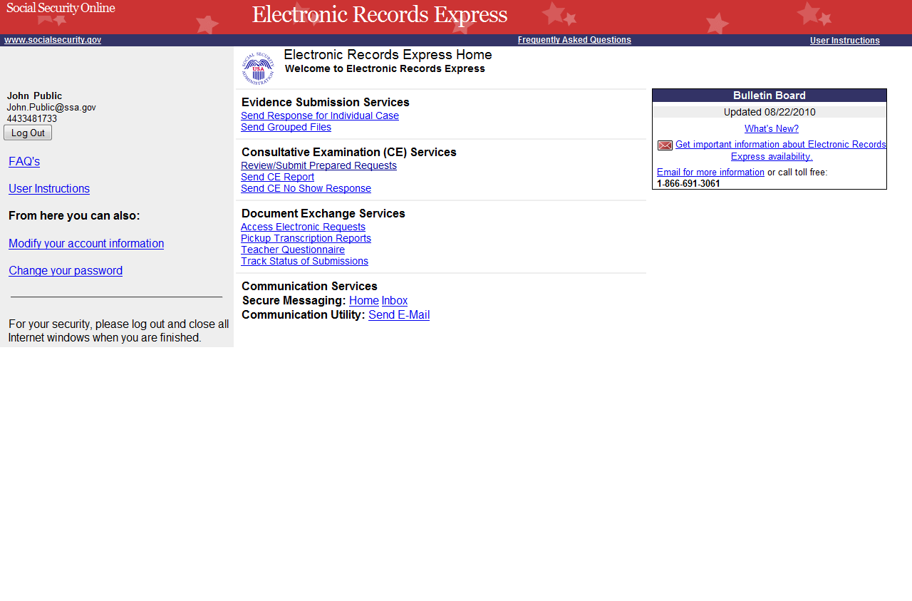
Step 1—Destination and Request Information
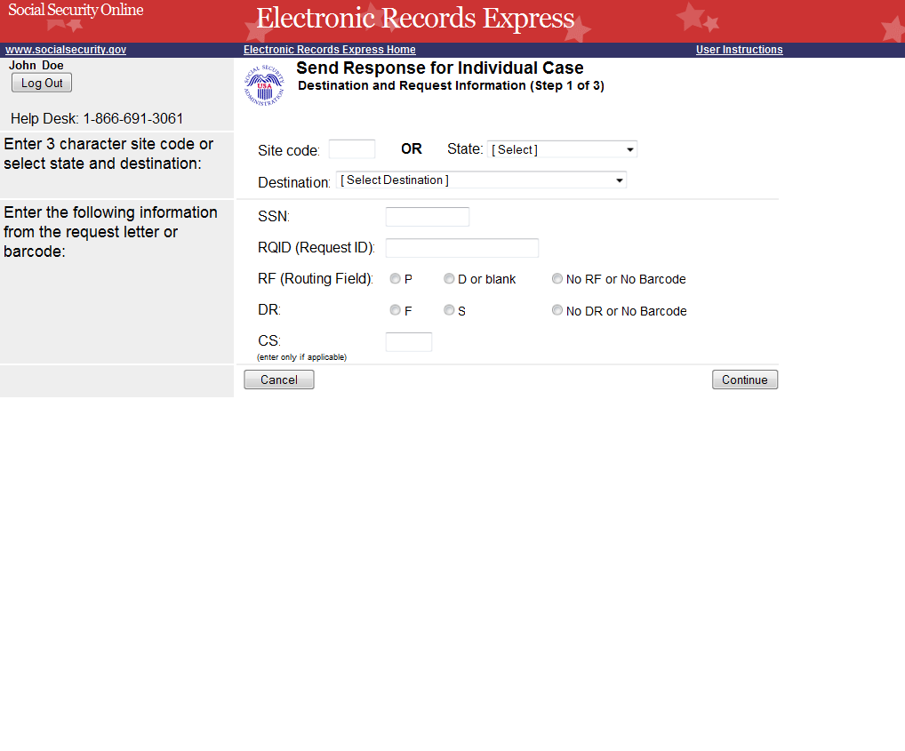
Select the DDS Destination from this dropdown list.
Enter SSN, RQID, RF, DR, and CS from the barcode

Step 1—Destination and Request Information:
- Enter the three character Site code from the barcode. The Site code begins with a letter which is followed by two digits. If you make a mistake you may backspace and enter the correct letter or digits;
or
Select the “State” from the dropdown. After choosing the State, the Destination list is refreshed to only list the offices in the State you selected. Select the “Destination” from the dropdown;
or
Just select the “Destination” from the dropdown.
- Once you select a Destination, the Yes button (at the bottom of the page) answering the question, “Do you have records to submit for this case?” is automatically selected. If you do not wish to submit records, select the button next to No.
- Obtain the following information from the request letter:
- Enter the Social Security Number (SSN). You can only send files for one SSN with this transaction.
- Enter the Request ID (RQID).
- Select the appropriate RF (Routing Field) option; or “No RF or No Barcode” if not displayed on the request letter.
- Select the appropriate DR (Document Return Code) option; or “No DR or No Barcode” if not displayed on the request letter.
- Enter the CS (Checksum Digits) if available, or leave this field blank if not displayed on the request letter.
- Select Continue to go to the next step or select Cancel to take you to the Home page.

Step 2—Attach and Upload Files/Send Response for Individual Case, “Yes” selected
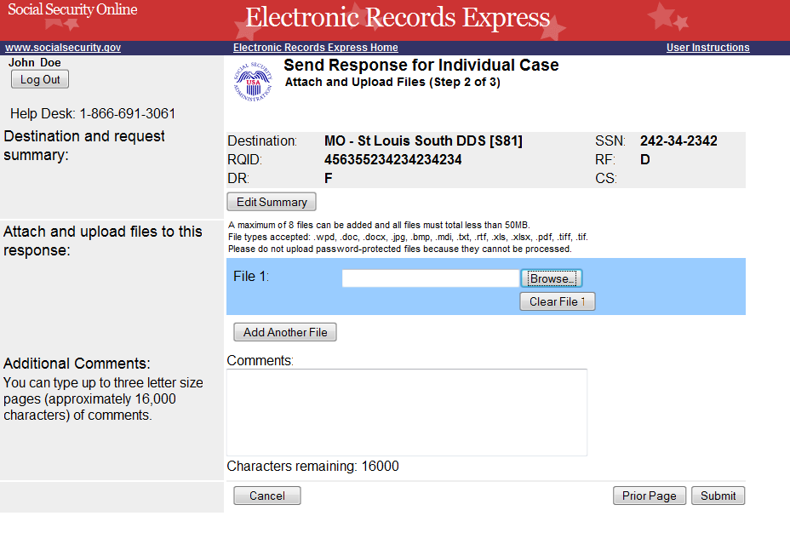
You can send up to eight (8) files for one individual by using the Add Another File button.
We accept the following file formats: .wpd, .doc, .docx, .jpg, .bmp, .mdi, .txt, .rtf, .xls, .xlsx, .pdf, .tiff, .tif
Review the information in the box above the Edit Summary button. Select the Edit Summary button to make changes.

Step 2—Attach and Upload Files or Provide Reason for not Transmitting Files:
I selected a “Yes” answer in the first step to submit records:
Follow these Step 2 instructions:
- Verify the accuracy of the information input in Step 1 against the information displayed on your request letter. If any of the information is not correct, make the corrections via the input fields by selecting the Edit Summary button.
- Select the Browse button to choose a file to send. (Do not send files that are password protected.) The Choose file window will appear on your screen.
- Locate the file you wish to send and highlight the file name. The document’s file name appears in the File name box at the bottom of the Choose file window.
- Select the Open button. The Choose file window closes and the Electronic Records Express website displays the file name in the box to the left of the Browse… button. If you have chosen the incorrect file, select the Clear File 1 button to clear the File 1 field.
- Select the Add Another File button to send additional files. You may add up to eight files for this transaction. Only files for the SSN entered in Step 1 can be sent with this transaction.
NOTE: Do not upload documents containing macros (i.e., a set of instructions or scripts that automates tasks). They may cause system problems, which will require you to re-submit your documents without macros.
- Type Comments, if needed. The Comment field is where you can provide additional information. Type-in and/or cut-and-paste your text (up to 16,000 characters, approximately three letter size pages) directly into the box provided. The count of remaining characters shows beneath the box.
- Select the Submit button to forward the information to the Destination selected in Step 1.
- Continue to Step 3—Tracking Information.
Step 2—Attach and Upload Files/Send Response for Individual Case, “No” selected
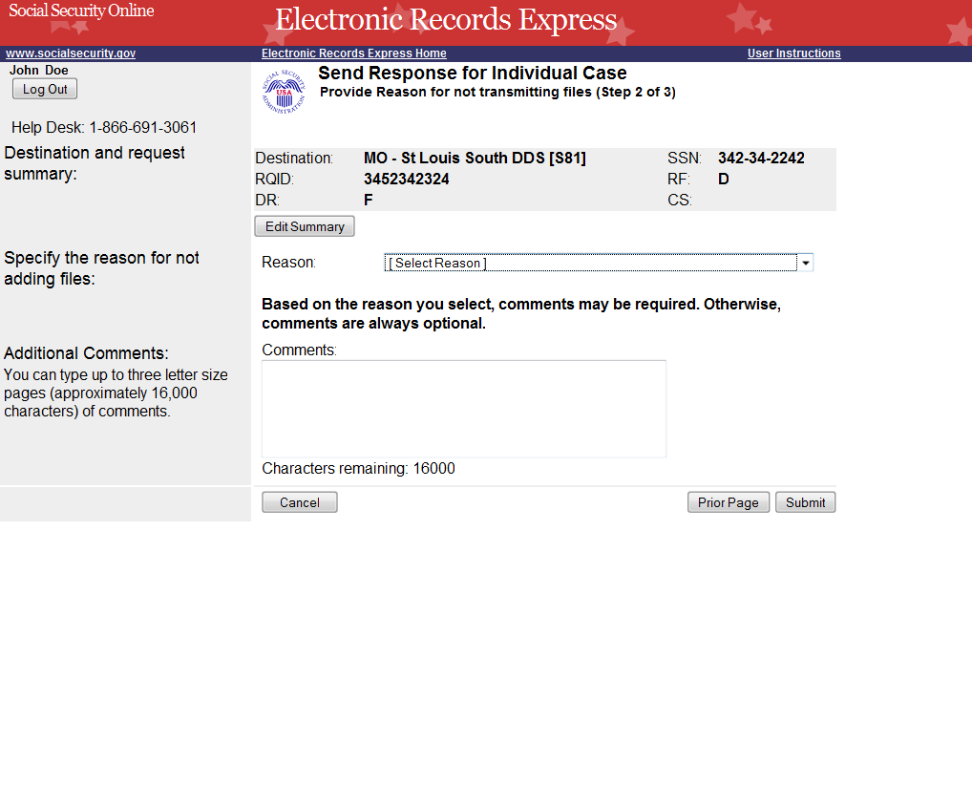
Select a Reason for not Transmitting Files
Type comments, if needed or required
Review the information in the box above the Edit button. Select the Edit Summary button to make changes.
I selected a “No” answer in the first step to submit records:
Follow these Step 2 instructions:
- Verify the accuracy of the information input in Step 1 against the information displayed on your request letter. If any of the information is not correct, make the corrections via the input fields by selecting the Edit Summary button.
- Select a reason for not transmitting files. Based on the reason you select, comments may be required.
- Type Comments, if needed. Provide an explanation of why you are not submitting records and any additional details. Type-in and/or cut-and-paste your text (up to 16,000 characters, approximately three letter size pages) directly into the box provided. The count of remaining characters shows beneath the box.
- Select the Submit button to forward the information to the Destination selected in Step 1.
- Continue to Step 3—Tracking Information.

Step 3—Tracking Information
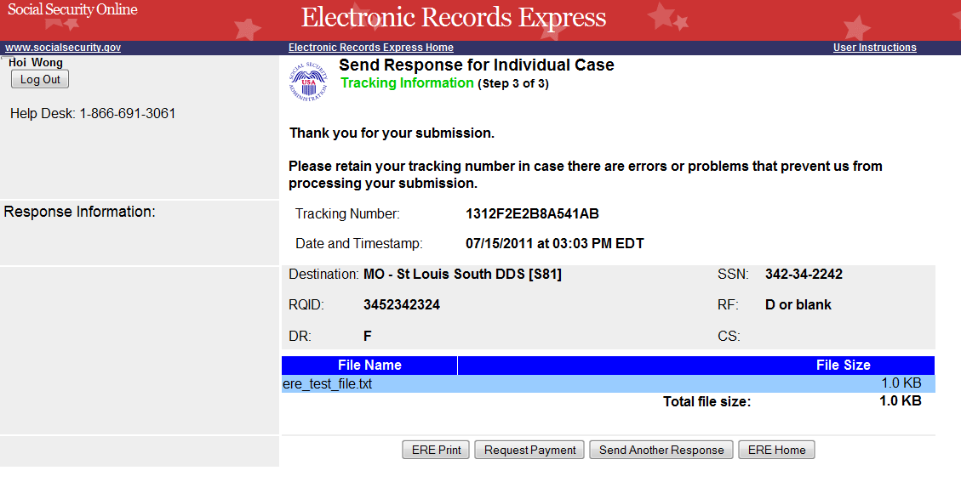
Select ERE Print to print the Tracking Information Page

Step 3—Tracking Information
- After your submission uploads, Electronic Records Express provides a Tracking Information page. The Tracking Information page provides a tracking number for you to keep and use if you want to check on the status of your submission. The Tracking Information page indicates the specific files and/or comments that you transmitted.
- If you do not receive the Tracking Information page, you should resubmit the materials.
- If you continue to have transmitting problems, contact the Electronic Records Express Website Help Desk at EETechSupport@ssa.gov or 1-866-691-3061.
- If you have records to send for another individual, you can select the Send Another Response button. This directs you to the webpage to enter information to send records for another person. Please be sure to have the SSA/DDS records request letter available.

NOTE: We strongly recommend that you print or take a screenshot of the Tracking Information page for your documentation. To do this, simply select ERE Print located at the bottom of the page. This print link works the same as if you selected File and Print from your browser’s menu.

You cannot bookmark and save a Tracking Information page, and you will not be able to retrieve it later from Social Security or a DDS office once you exit the webpage.

If the file you selected to transmit is 0 byte, or too large (over 50mb), Electronic Records Express cannot process the submission. Choose Try Again on the message page to return to the previous page, update your file(s), and resubmit.

Access Keys
This application contains access keys to improve navigation and provide information. You will find a list of these keys in the table below:

Button | Access Key
Add Another File | 2 – 8 (number corresponds to the file to be added)
Cancel | n
Continue | c
Edit Summary | w
ERE Home | h
ERE Print | p
Log Out | l
Prior Page | p
Request Payment | y
Send Another Response | r
Submit | s

Other keyboard commands, hotkeys or access keys will vary based upon browser and the version of the browser that you are using. A list of these commands can be found in the Help section of your browser. The Help feature can be located on the Menu bar of your browser or by using the F1 function key on the keyboard. Any assistive devices that you may be using will also have a list of these shortcut keys in their Help section.

Note: To use these keys select the “Alt” button on your keyboard and the access key simultaneously.

How to Get Important Information about Electronic Records Express Website Availability
You may subscribe to receive ERE website availability notifications through the GovDelivery services on the Social Security Administration’s Electronic Records Express internet website: Social Security Online: Electronic Records Express. Please see the following website for GovDelivery FAQs: https://service.govdelivery.com/service/help.html#general1

To subscribe to the ERE website availability notification, follow these instructions:
- Click Get important information about Electronic Records Express website availability.
- Type your email address and select Go
- Confirm your email address
- Select “Send updates immediately by e-mail.”
- Choose an optional password
- Select Save
- Select Next
- Subscribe to additional topics by checking the boxes or unsubscribe by un-checking the boxes
- Select Save
- Subscribe to topics from other agencies by checking the boxes or unsubscribe by
un-checking the boxes
- Select Save
**Once you have subscribed, you will receive a Subscription Acknowledgement e-mail with instructions on how to update your user profile**

