User Guide for Send Transcription Report to Provider

Office of Disability Determinations
October 2011

Electronic Records Express Website

Document Exchange Services

Send Transcription Report to Provider
This feature allows you to electronically send transcribed Consultative Examination (CE) reports via the Electronic Records Express website.
Start by logging into the Electronic Records Express Home Page using your username and password. Under the Document Exchange Services heading, select the Send Transcription Report to Provider link. This takes you to the page that allows you to send CE reports to the DDS.
Please note that you are responsible for information submitted on the ERE website when using your ERE User ID and password. You should never share your ERE User ID or password with others.
Electronic Records Express Home—Send Transcription Report to Provider
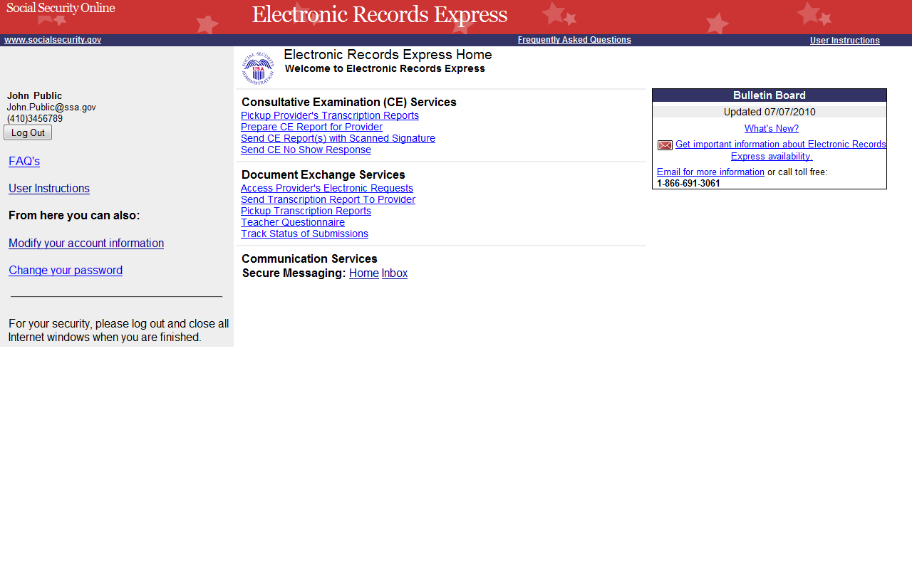
Step 1—Select Provider and DDS
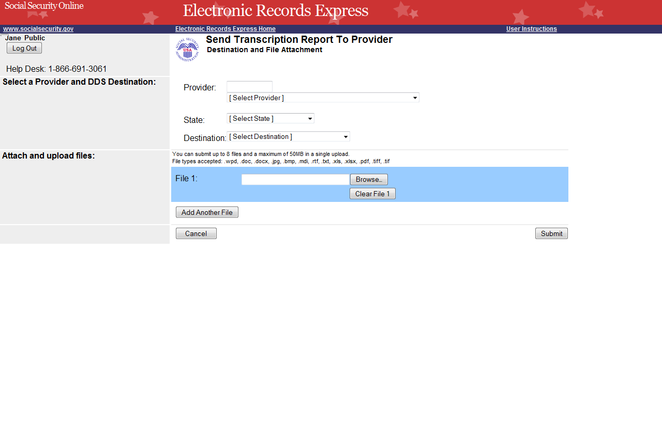
Select the Provider and DDS from the dropdown menus.
Select “Browse” to upload file.

Step 1—Destination and File Attachment
- Select the Provider that dictated the CE Report from the dropdown. You can search for a provider in the text field by typing a name in the following format: Last Name, First Name. Electronic Records Express updates the provider list during input and displays the names that match the typed entry. [Select Provider] remains displayed on the screen unless a single exact match is available. Continue to type in the search box OR select a provider from the drop-down list.
- Select the State from the dropdown list. If the State has more than one office destination, you must select the Destination office from the drop down list also. A copy of the transcribed report may also be sent to the DDS that you selected in the drop down list.
- Select the Browse button to select a file to send. (Do not send files that are password protected.) The Choose file window will appear on your screen.
- Locate the file you wish to send and select the file. The document’s file name is inserted into the File name box at the bottom of the Choose file window.
- Select the Open button. The Choose file window closes and the Electronic Records Express website displays the file name in the box to the left of the Browse… button.
- Select the Add Another File button to send additional files for this claimant. You can send a total of eight files.

NOTE: Do not upload documents containing macros (i.e., a set of instructions or scripts that automates tasks). They may cause system problems, which will require you to re-submit your documents without macros.
- Select the Submit button to forward the information to the CE Provider and DDS. Your file is delivered to the provider’s Electronic Records Express inbox and an email alerts him or her of the delivery.
- The DDS that you selected as a Destination may receive a copy along with the provider.
Step 2—Tracking information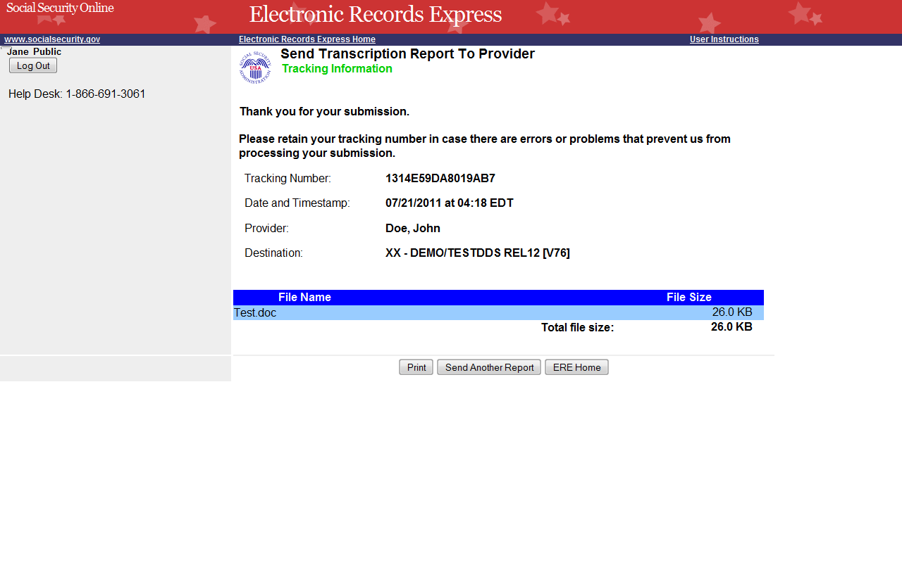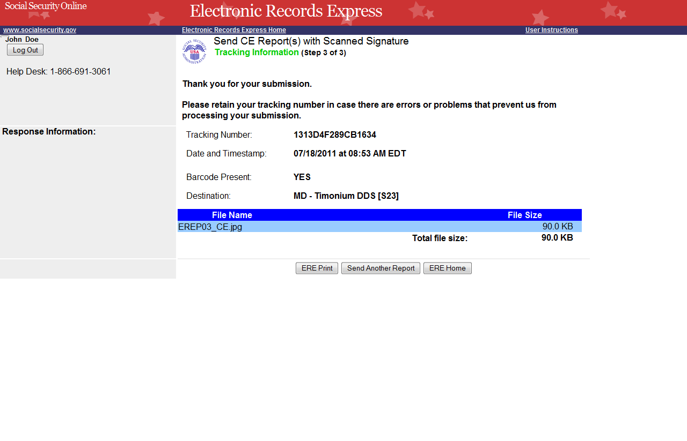
Tracking Number

Step 2—Tracking Information
- Electronic Records Express generates a Tracking Information page after you submit your transaction. This page contains a Tracking number that you can use to check the status of your submission.
- In the unlikely event that you do not receive the Tracking Information page, you should resubmit the information.
- If you continue to have transmitting problems, contact the Electronic Records Express Website Help Desk at EETechSupport@ssa.gov or 1-866-691-3061.
- If you have additional CE reports to submit, select Send Another Report.

NOTE: We strongly recommended that you print or take a screenshot of the Tracking Information page for your documentation. To do this, simply select ERE Print located at the bottom of the page. This print link works the same as if you selected File and Print from your browser’s menu. You cannot bookmark and save a Tracking Information page, and you will not be able to retrieve it later once you exit the webpage.

Access Keys
This application contains access keys to improve navigation and provide information. You will find a list of these keys in the table below:
Button | Access Key
Add Another File | 2 – 8 (number corresponds to the file to be added)
Cancel | n
ERE Home | h
ERE Print | p
Log Out | l
Send Another Report | r
Submit | s
Other keyboard commands, hotkeys or access keys will vary based upon browser and the version of the browser that you are using. A list of these commands can be found in the Help section of your browser. The Help feature can be located on the Menu bar of your browser or by using the F1 function key on the keyboard. Any assistive devices that you may be using will also have a list of these shortcut keys in their Help section.
Note: To use these keys select the “Alt” button on your keyboard and the access key simultaneously.

How to Get Important Information about Electronic Records Express Website Availability
You may subscribe to receive ERE website availability notifications through the GovDelivery services on the Social Security Administration’s Electronic Records Express internet website: Social Security Online: Electronic Records Express. Please see the following website for GovDelivery FAQs: https://service.govdelivery.com/service/help.html#general1
To subscribe to the ERE website availability notification, follow these instructions:
- Click Get important information about Electronic Records Express website availability.
- Type your email address and select Go
- Confirm your email address
- Select “Send updates immediately by e-mail.”
- Choose an optional password
- Select Save
- Select Next
- Subscribe to additional topics by checking the boxes or unsubscribe by un-checking the boxes
- Select Save
- Subscribe to topics from other agencies by checking the boxes or unsubscribe by
un-checking the boxes
- Select Save
**Once you have subscribed, you will receive a Subscription Acknowledgement e-mail with instructions on how to update your user profile**

