User Guide
Appointed Representative Services

HEARING OFFICE AND APPEALS COUNCIL STATUS REPORTS

Version 2.1
March 2014

Table of Contents
Hearing Office Status Report 3
Search for Individual Case 7
Quick View 8
Spreadsheet Download 10
Appeals Council Status Report 11
Search for Individual Case 15
Quick View 16
Spreadsheet Download 18

Hearing Office Status Report

The following section provides Social Security Administration (SSA) claimants' representatives with detailed instructions for accessing a Hearing Office Status Report. The Hearing Office Status Report provides information on cases pending at the hearing level.

NOTE: The names and other identifying information displayed in this document were created for test scenarios and do not represent actual individuals.

Step 1: Log onto Appointed Representative Services (ARS) at https://secure.ssa.gov/acu/LoginWeb with your User ID and password.

NOTE: You must open a single browser session for ARS - do not open multiple browser sessions.

Step 2: Click the “Enter ERE” button on the ARS Main Menu page.

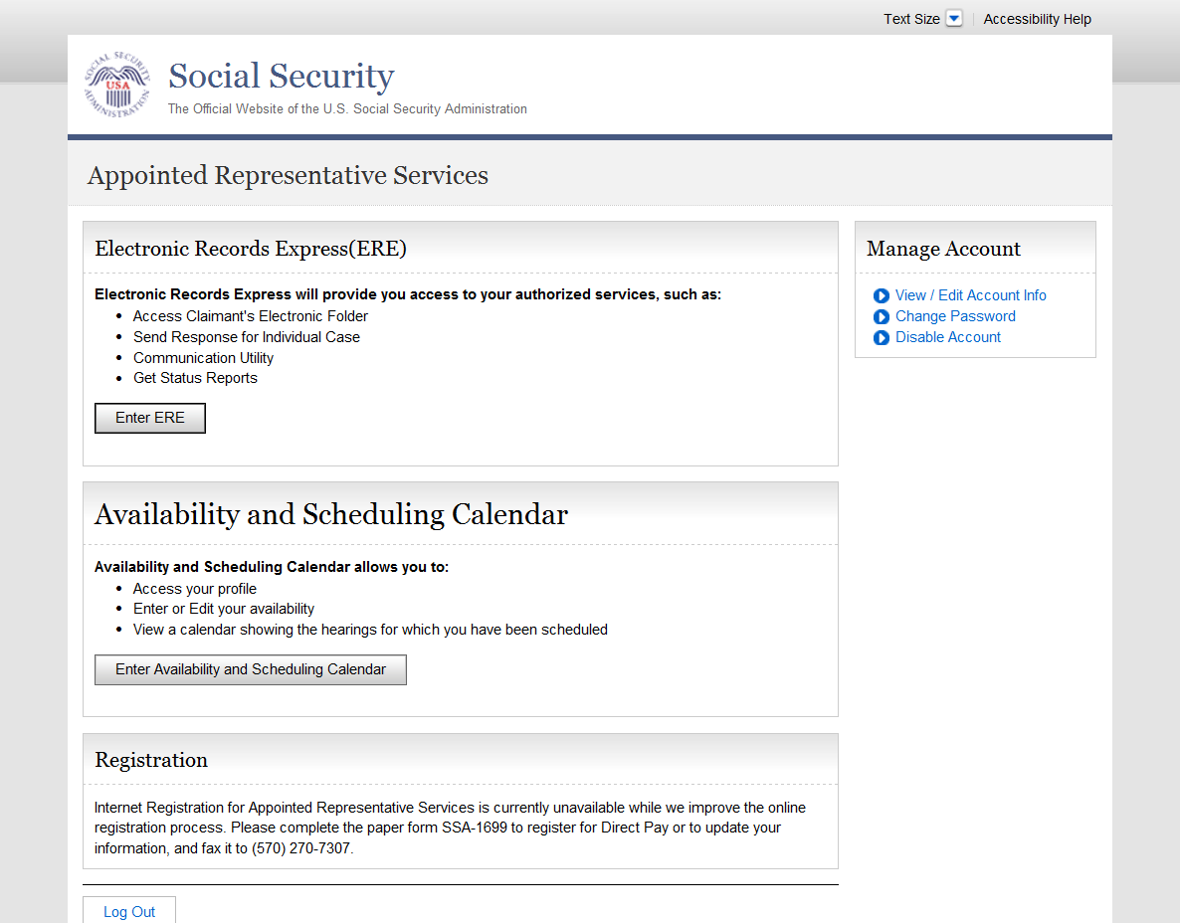
Step 3: Select the “Get Status Reports” link.

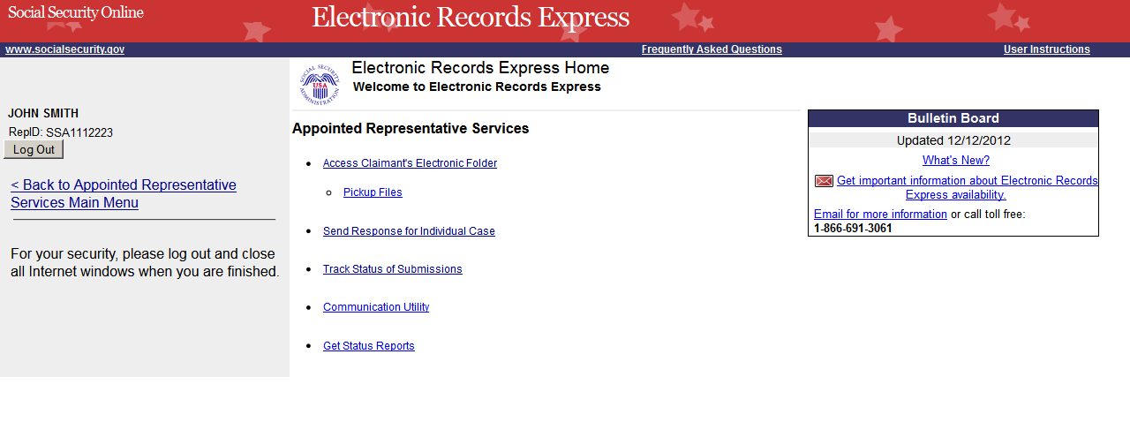

Step 4: Select the “Get Hearing Office Status Report” radio button. Click “Submit”.

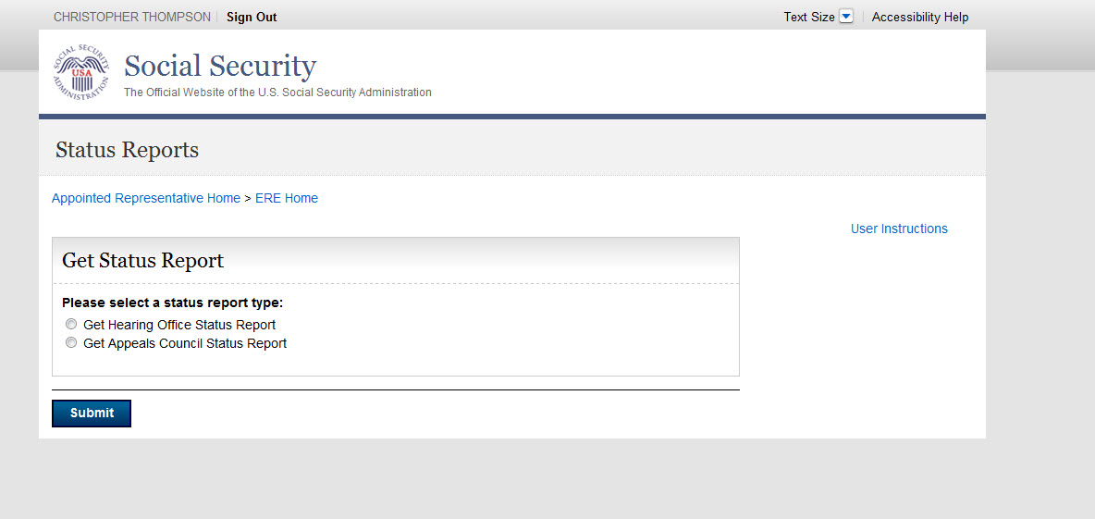

The system displays Hearing Office Status Report options.

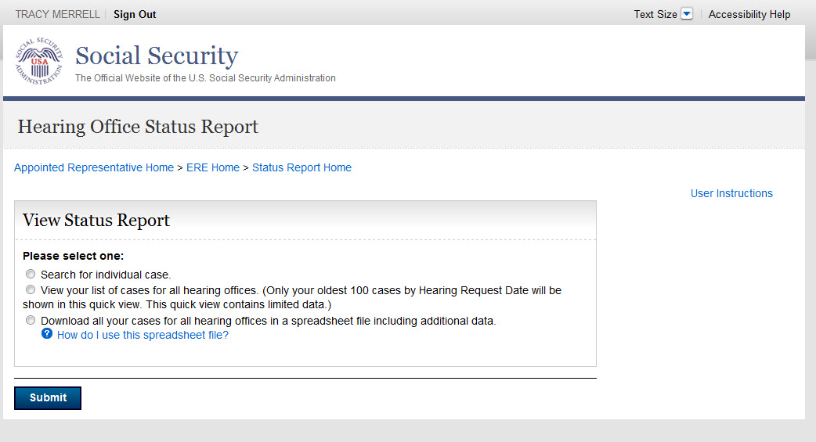

There are three options to review case status(s) information:

- Search for individual case (by Social Security Number). This view contains limited data
- View your list of cases for all hearing offices. (Only your oldest 100 cases by Hearing Request Date are shown in this quick view.) This view contains limited data
- Download all your cases for all hearing offices in a spreadsheet file. This download contains all the data listed in the table below

Column Heading | Description | Individual Case and Quick View
Claimant Last Name | Last name of the claimant | X
Claimant First Name | First name of the claimant | X
Claimant Middle Name | Middle name of the claimant
Last 4 SSN | Last 4 digits of the claimant SSN | X
Hearing Office with Jurisdiction | City and state of the Hearing Office with jurisdiction | X
Status of Case | Current status category of the SSN | X
Status Date | Date the case was entered into the current status category | X
Claim Type | TITLE 2 - DISABILITY  TITLE 2 - DISABILITY  TITLE 2 - RETIREMENT OR SURVIVOR  TITLE 2 and TITLE 16 AGED  TITLE 2 and TITLE 16 - BLIND  TITLE 2 and TITLE 16 - DISABILITY  TITLE 16- AGED  TITLE 16- BLIND  TITLE 16 DISABILITY
Electronic Folder | Yes - all the information for this SSN is stored electronically  No - this SSN is stored in a paper file and cannot be accessed via ARS
Hearing Request Date | Hearing Request date | X
Expedited Case | Yes - the case will be expedited  No - this case will be processed by Hearing Request Date | X
Hearing Schedule Date | Hearing Scheduled date (individual case and quick view will show either the hearing scheduled or hearing held date) | X
Medical Expert | Name of the Medical Expert assigned to the case
Vocational Expert | Name of the Vocational Expert assigned to the case
Claimant Location | Site where the claimant will appear
Representative Location | Site where the representative will appear
ALJ Location | Site where the ALJ will appear
ALJ Last Name | Last name of the ALJ assigned to the case | X
ALJ First Name | First name of the ALJ assigned to the case | X
Hearing Held Date | Hearing Held date
Hearing Time | Time, AM/PM, and time zone of the scheduled hearing
T2 Decision | Favorable  Unfavorable  Dismissal
T16 Decision | Favorable  Unfavorable  Dismissal
Fee Agreement | Yes - There is a Fee Agreement for this SSN  No - There is no Fee Agreement for this SSN
Fee Petition | Yes - There is a Fee Petition for this SSN  No - There is no Fee Petition for this SSN

Search for Individual Case

Enter the SSN for the case status you wish to view. You must be identified as the appointed representative on this case, and the case must be currently pending at the hearing level or closed within the past 90 days.

Step 1: Select the “Search for individual case” radio button and enter a SSN. Select the “Submit” button to display limited data for the SSN you entered.

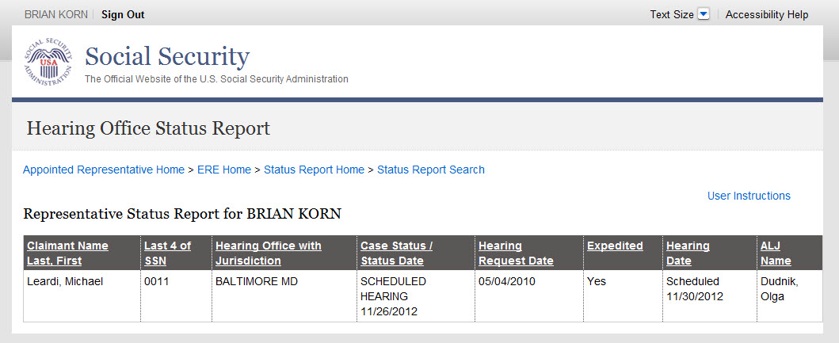

NOTE: If results are not returned for the SSN you entered, then the Hearing Office likely does not show that you are the appointed representative for the SSN you entered. If you believe you received this message in error, please contact the Hearings Office with jurisdiction of the case.

Quick View

The quick view provides limited data for up to 100 of your cases.

- If you have up to or fewer than 100 cases pending or recently closed, you will see a list containing all your cases.
- If you have more than 100 cases pending or recently closed, you will see 100 of your cases by oldest Hearing Request Date.

Step 1: Select the “View your list of cases for all hearing offices” radio button. Select the “Submit” button to display limited data for up to 100 of your cases.

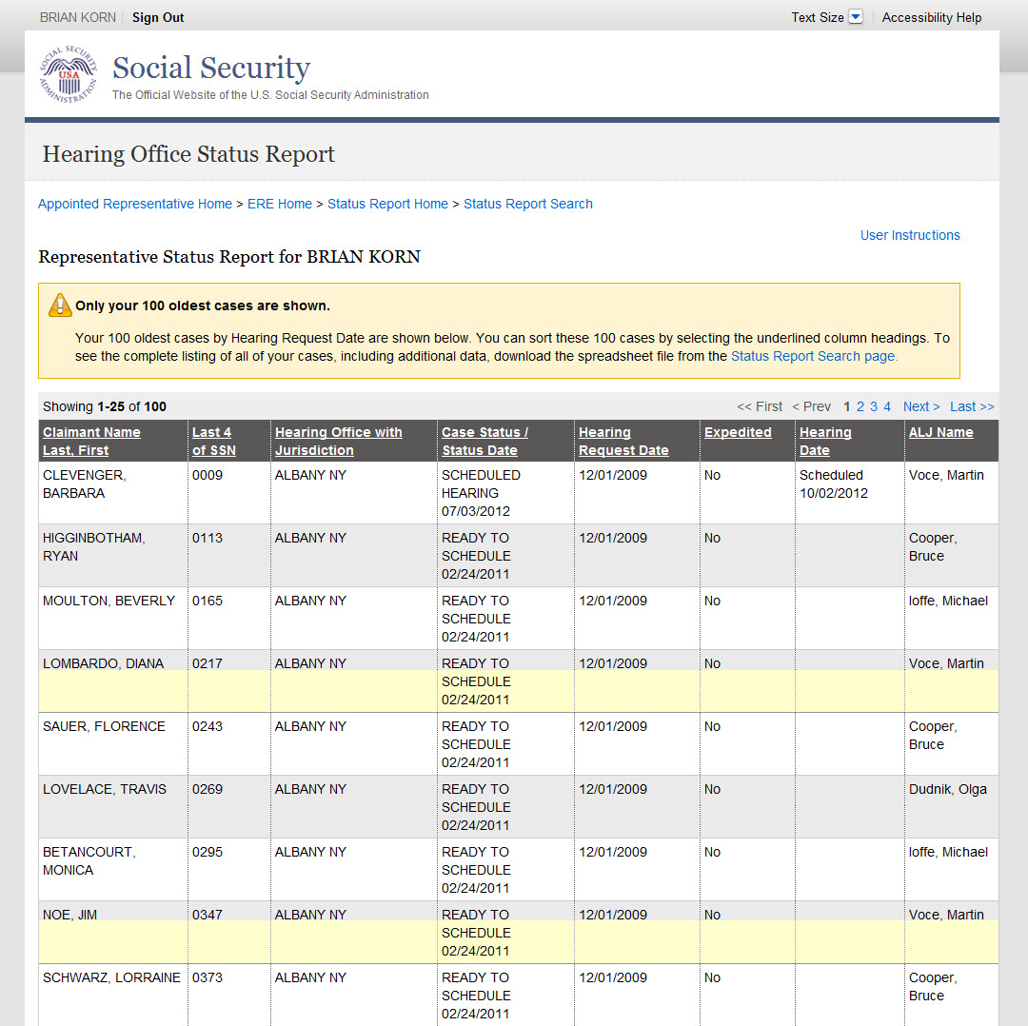

Spreadsheet Download

This option provides all data on your pending and recently closed cases.

Step 1: Select the “Download all your cases for all hearing offices in a spreadsheet file including additional data” radio button. Select the “Submit” button.

NOTE: If an SSN is not listed in your spreadsheet download, then the Hearing Office likely does not show that you are the appointed representative for the SSN. If you believe this is in error, please contact the Hearings Office with jurisdiction of the case.

Step 2: Save the file to the desired location on your computer.

Step 3: Open your spreadsheet application.

Step 4: In the dialog box that appears, select the file name and choose the Open button.

Step 5: To resize the columns and see all the data, drag the borders above the top row.

Step 6: Use the spreadsheet's sort command to sort by column.

Appeals Council Status Report

The following section provides Social Security Administration (SSA) claimants' representatives with detailed instructions for accessing an Appeals Council Status Report. The Appeals Council Status Report provides information on cases pending at the appeals level.

NOTE: The names and other identifying information displayed in this document were created for test scenarios and do not represent actual individuals.

Step 1: Log onto Appointed Representative Services (ARS) at https://secure.ssa.gov/acu/LoginWeb with your User ID and password.

NOTE: You must open a single browser session for ARS - do not open multiple browser sessions.

Step 2: Click the “Enter ERE” button on the ARS Main Menu page.

Step 3: Select the “Get Status Reports” link.

Step 4: Select the “Get Appeals Council Status Report” radio button. Click “Submit”.

The system displays Appeals Council Status Report options.

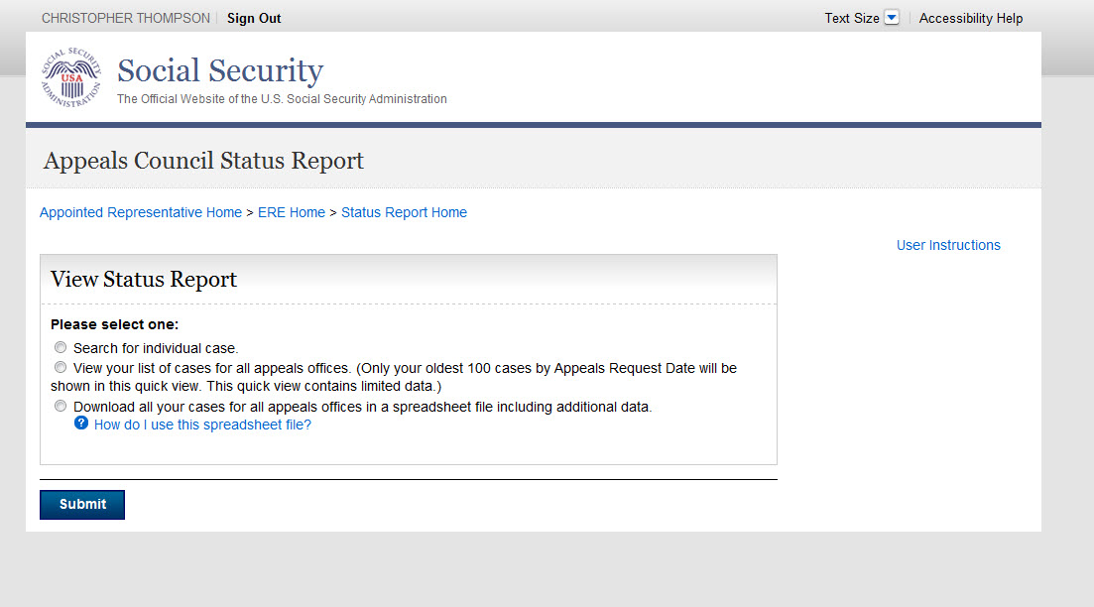

There are three options to review case status(s) information:

- Search for individual case (by Social Security Number). This view contains limited data
- View your list of cases for all appeals offices. (Only your oldest 100 cases by Appeals Request Date are shown in this quick view.) This view contains limited data
- Download all your cases for all appeals offices in a spreadsheet file. This download contains all the data listed in the table below

Column Heading | Description | Individual Case and Quick View
Claimant Last Name | Last name of the claimant | X
Claimant First Name | First name of the claimant | X
Claimant Middle Name | Middle name of the claimant
Last 4 SSN | Last 4 digits of the claimant SSN | X
Appeals Office with Jurisdiction | City and state of the Appeals Office with jurisdiction | X
Transfer Information To | City and state of the Appeals Office the case was transferred to | X
Transfer Information From | City and state of the Appeals Office the case was transferred from | X
Status of Case | Current status category of the SSN | X
Status Date | Date the case was entered into the current status category | X
Claim Type | TITLE 2 - DISABILITY  TITLE 2 - DISABILITY  TITLE 2 - RETIREMENT OR SURVIVOR  TITLE 2 and TITLE 16 AGED  TITLE 2 and TITLE 16 - BLIND  TITLE 2 and TITLE 16 - DISABILITY  TITLE 16- AGED  TITLE 16- BLIND  TITLE 16 DISABILITY
Electronic Folder | Yes - all the information for this SSN is stored electronically  No - this SSN is stored in a paper file and cannot be accessed via ARS | X
Request Date | Appeals Request date | X
Expedited Case | Yes - the case will be expedited  No - this case will be processed by Appeals Request Date | X
T2 Decision | Favorable  Unfavorable  Dismissal  Remand  Other
T16 Decision | Favorable  Unfavorable  Dismissal  Remand  Other
Fee Agreement | Yes - There is a Fee Agreement for this SSN  No - There is no Fee Agreement for this SSN
Fee Petition | Yes - There is a Fee Petition for this SSN  No - There is no Fee Petition for this SSN

Search for Individual Case

Enter the SSN for the case status you wish to view. You must be identified as the appointed representative on this case, and the case must be currently pending at the appeals level or closed within the past 90 days.

Step 1: Select the “Search for individual case” radio button and enter a SSN. Select the “Submit” button to display limited data for the SSN you entered.

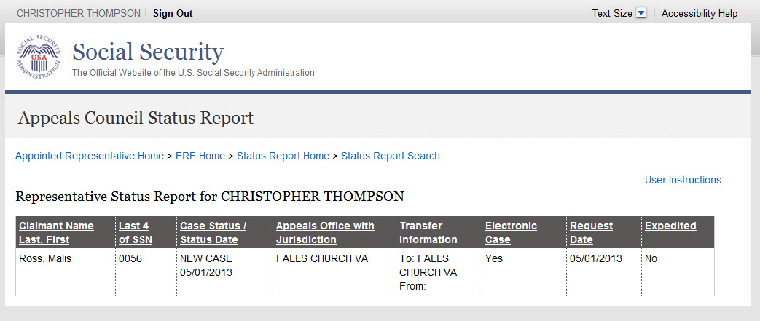

NOTE: If results are not returned for the SSN you entered, then the Appeals Office likely does not show that you are the appointed representative for the SSN you entered. If you believe this is an error, please contact the Congressional and Public Affairs Branch (CPAB) at 703-605-8000 or toll free at 877-670-2722. If you are unable to reach CPAB or require further assistance, please email ODAR.Appeals.Council.Rep.Mail@ssa.gov.

Quick View

The quick view provides limited data for up to 100 of your cases.

- If you have up to or fewer than 100 cases pending or recently closed, you will see a list containing all your cases.
- If you have more than 100 cases pending or recently closed, you will see 100 of your cases by oldest Appeals Request Date.

Step 1: Select the “View your list of cases for all hearing offices” radio button. Select the “Submit” button to display limited data for up to 100 of your cases.

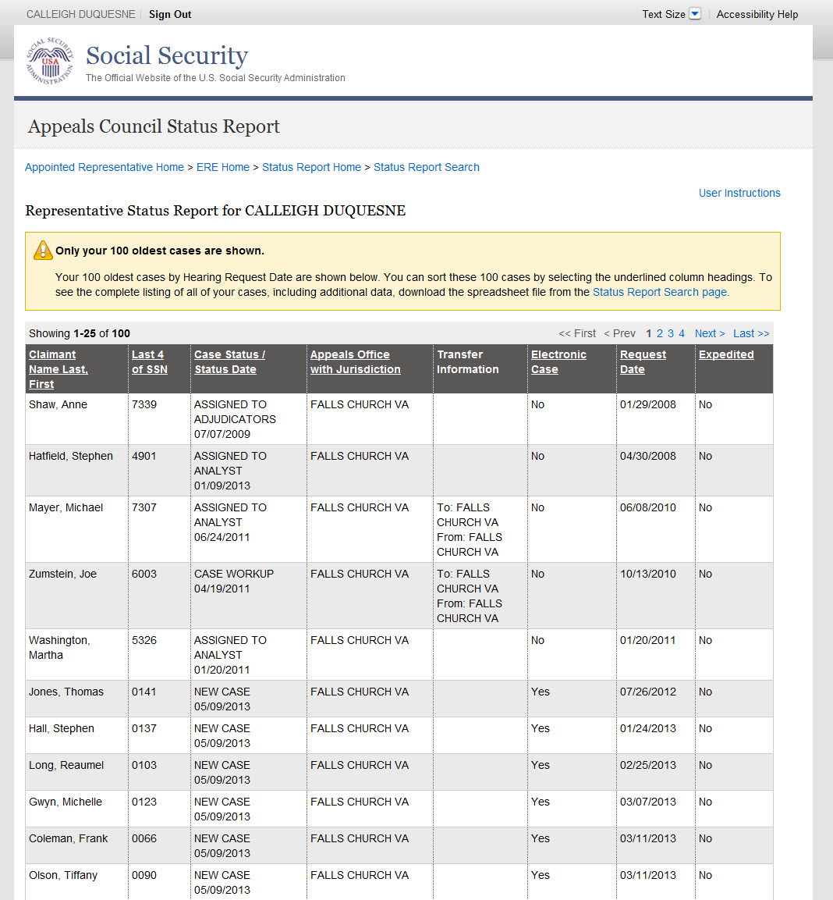

Spreadsheet Download

This option provides all data on your pending and recently closed cases.

Step 1: Select the “Download all your cases for all hearing offices in a spreadsheet file including additional data” radio button. Select the “Submit” button.

NOTE: If an SSN is not listed in your spreadsheet download, then the Appeals Office likely does not show that you are the appointed representative for the SSN. If you believe this is an error, please contact the Congressional and Public Affairs Branch (CPAB) at 703-605-8000 or toll free at 877-670-2722. If you are unable to reach CPAB or require further assistance, please email ODAR.Appeals.Council.Rep.Mail@ssa.gov.

Step 2: Save the file to the desired location on your computer.

Step 3: Open your spreadsheet application.

Step 4: In the dialog box that appears, select the file name and choose the Open button.

Step 5: To resize the columns and see all the data, drag the borders above the top row.

Step 6: Use the spreadsheet's sort command to sort by column.

