Electronic Records Express Website

Document Exchange Services

Teacher Questionnaire
This feature allows school personnel to access the Teacher Questionnaire (SSA-5665-BK) on the Electronic Records Express website. School personnel will be able to download the questionnaire, complete the form and send the form via the Electronic Records Express website to the DDS using the Send Response for Individual Case feature under the Evidence Submission Services heading on the Home page.
Start with logging into Electronic Records Express by providing your username and password. On the Electronic Records Express Home Page, under the Document Exchange Services heading, select “Teacher Questionnaire”. This will take you to the Teacher Questionnaire form.
Selecting this link directs you to get the Teacher Questionnaire as a PDF document. The first pages of the form provide brief explanations of why SSA is requesting the completion of the form and other general information.
Since this form is an important element in the decision of whether a child qualifies for disability benefits, please be sure to read all instructions and questions carefully and complete the form in its entirety and to the best of your ability, answering all questions appropriate to the child you are evaluating.

Electronic Records Express Home—Teacher Questionnaire
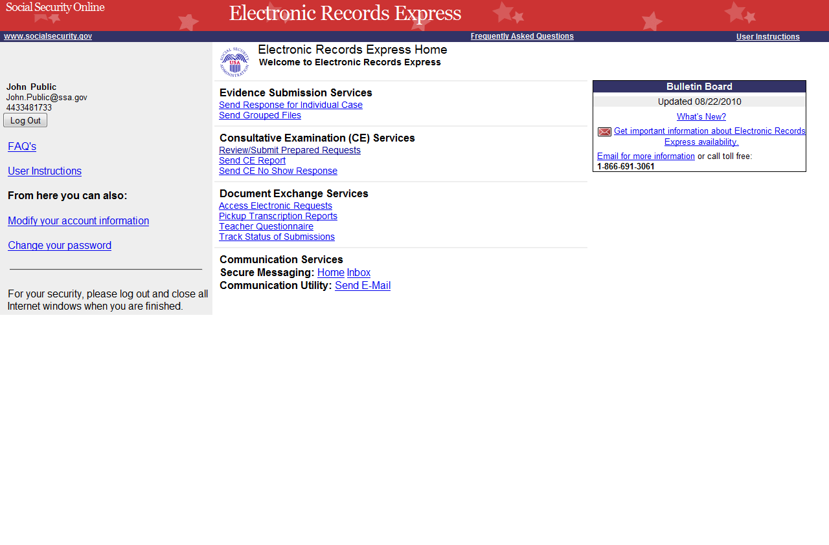

Step 1—Complete the Teacher Questionnaire
- Choose the Teacher Questionnaire hyperlink under Document Exchange Services from the Electronic Records Express Home website page. The Teacher Questionnaire link will take you to the Teacher Questionnaire form as a PDF document.
- Print and complete the Teacher Questionnaire form.

Step 2—Return Teacher Questionnaire to DDS
- You should have the SSA/DDS request letter readily available to complete the processing steps.
- Follow the user instructions for Send Response for Individual Case to send the completed Teacher Questionnaire to the DDS.
Teacher Questionnaire
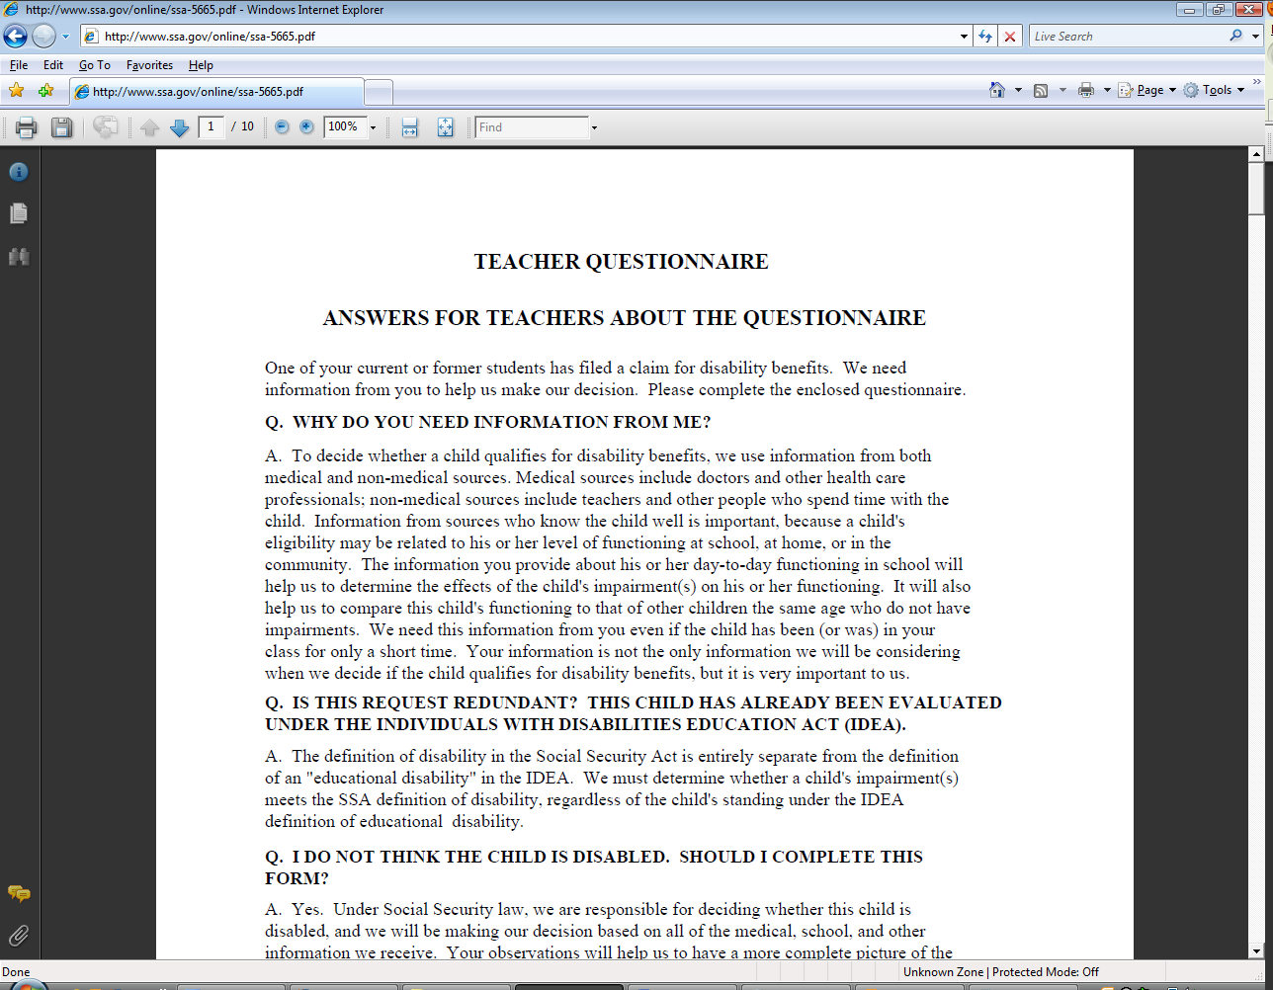

Access Keys
This application contains access keys to improve navigation and provide information. You will find a list of these keys in the table below:
Button | Access Key
Log Out | l
Other keyboard commands, hotkeys or access keys will vary based upon browser and the version of the browser that you are using. A list of these commands can be found in the Help section of your browser. The Help feature can be located on the Menu bar of your browser or by using the F1 function key on the keyboard. Any assistive devices that you may be using will also have a list of these shortcut keys in their Help section.
Note: To use these keys select the “Alt” button on your keyboard and the access key simultaneously.
How to Get Important Information about Electronic Records Express Website Availability
You may subscribe to receive ERE website availability notifications through the GovDelivery services on the Social Security Administration’s Electronic Records Express internet website: Social Security Online: Electronic Records Express. Please see the following website for GovDelivery FAQs: https://service.govdelivery.com/service/help.html#general1
To subscribe to the ERE website availability notification, follow these instructions:
- Click Get important information about Electronic Records Express website availability.
- Type your email address and select Go
- Confirm your email address
- Select “Send updates immediately by e-mail.”
- Choose an optional password
- Select Save
- Select Next
- Subscribe to additional topics by checking the boxes or unsubscribe by un-checking the boxes
- Select Save
- Subscribe to topics from other agencies by checking the boxes or unsubscribe by
un-checking the boxes
- Select Save
**Once you have subscribed, you will receive a Subscription Acknowledgement e-mail with instructions on how to update your user profile**

