Electronic Records Express

User Guide for

Track Status of Submissions


February 2012

Table of Contents

Table of Contents 2
Overview 3
Search Page 3
Inquiry Results Page 4
Details Page 5
Track Status of Submission Instructions 6
Search by Tracking Number 7
Search by Request ID 9
Search by Claimant’s SSN 11
Search by Submission Date, Status, or Site 13
Search by Submission Date, Status, or Site 16
Access Keys 19

Electronic Records Express

Track Status of Submissions

Overview
The Electronic Records Express (ERE) Track Status of Submissions application allows ERE users to view the status of submissions. You can search for information about your ERE submissions. You can select from multiple search criteria: Tracking Number, Request ID (RQID), Claimant’s SSN, Date of Submission and Status of Submission.
The Track Status of Submissions application is comprised of the following pages:
- Search Page
- Results Page
- Details Page

Search Page
You can search for information about your submissions within the past 180 calendar days after entering one or more of the following criteria on the Search page:
- Tracking Number—The Tracking Number is a unique number assigned to a submission. When tracking a submission by Tracking Number, all other fields are disabled.
- Request ID (RQID)—The RQID is a unique identifier located on the request letter near or on the barcode. When tracking a submission by RQID, all other fields are disabled. The RQID is case sensitive.
- Claimant’s SSN—You can search by entering your client’s Social Security Number (SSN).
- Date, Status or Site
- Date - a search by Date may be made by choosing one of the following Date options:
- Last 45 days—Tracks submissions made within the last 45 days of the search date.
- Single Day (date must be within 180 calendar days from the current date)
- Date of Submission
- Start Time (Eastern Time)
- End Time (Eastern Time)
- Date Range (date must be within 180 calendar days from the current date)
- From Date (Eastern Time)—The start date for your search. Note that this date must be within 180 calendar days from the current date
- To Date (Eastern Time)—The end date when a search within a certain time period is to be performed.

- Status—Search All submissions within the past 180 calendar days or choose one of the following statuses:
- Sent—your successful submissions within the past 180 days
- Error—your failed submissions within the past 180 days
- Contacted—your submissions within the past 180 days that required ERE Tech Support to contact you
- Site – Search All submissions within the past 180 days or choose of the following:
- State—Tracks submissions for a specific State within the past 180 days
- Site Code—Tracks submissions for a Site Code within the past 180 days
Note: The radio buttons for Search by date-Last 45 days, Search by status-All, and Search by site-All are automatically selected when you choose Track Status of Submissions from the Electronic Records Express Home page.

Inquiry Results Page
The Inquiry Results page displays the following information about your submissions from the past 180 calendar days:
- Tracking Number—A unique number generated by ERE to identify the submission.
- Date and Eastern Time—The date (Eastern Time) you submitted to the ERE website.
- Status—The status displayed in this column will be one of the following:
- Sent—Your submission was successfully sent.
- Error—Your submission failed.
- Contacted—A problem occurred with your submission and you were contacted by ERE Tech Support
- Processing—Your submission is being processed.
- Site Code—The Site Code where you sent your submission
- Last 4 of SSN—The last four digits of the Claimant’s Social Security Number.
- RQID—Request ID
Note: You can sort each column in ascending or descending order by selecting the column heading.

Details Page
The Details page displays details of your submission from the Tracking Number selected from the Results page.
The Details page displays the following submission information:
- Tracking Number
- Submission Date and Eastern Time
- Submission Status
- Site Code
- Last 4 of SSN
- Number of Files Uploaded
- RQID (Request ID)
- Filename—The name of your uploaded file, including its extension.
- File Status—The status displayed will be one of the following:
- Sent—Your successfully submissions
- Error—Your failed submissions
- Contacted—Submissions that required ERE Tech Support contact you
- Processing—Your submission is being processed.
- File Size—The size of the file in bytes.

Track Status of Submission Instructions
From the Electronic Records Express Home page, select Track Status of Submissions under the Appointed Representative Services heading.
Electronic Records Express Homepage
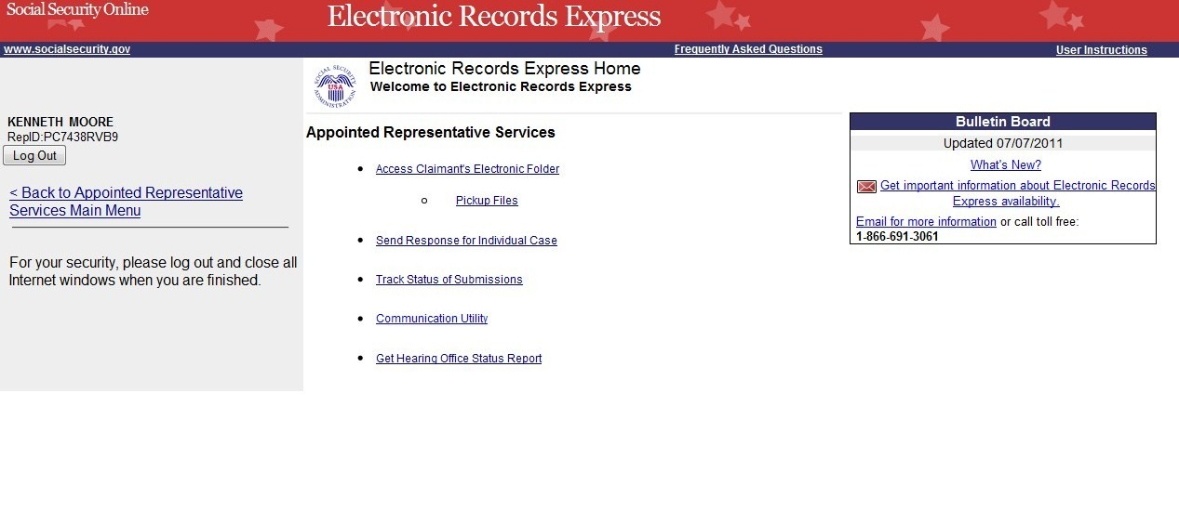
You may search by entering the Tracking Number, Request ID, other date choices, site code, or submission status. When searching a submission by Tracking Number or Request ID all other fields are disabled.

Search by Tracking Number
Note: When tracking a submission by Tracking Number all other fields are disabled.
Step 1—Enter the Tracking Number in the first block. The Tracking Number is the unique number assigned to your original submission.
Step 2—Select the Search button.
Search by Confirmation Number—Steps 1 and 2
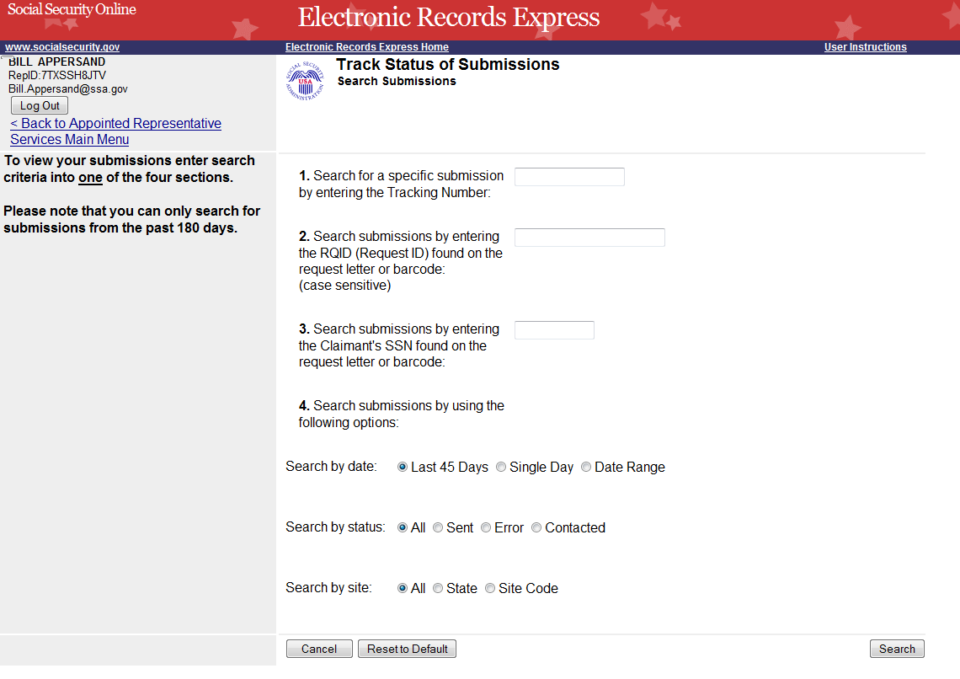
Enter the Tracking
Number
Step 3—View the inquiry results on the Inquiry Results page. Select the Tracking Number hyperlink to go to the Inquiry Results Details page.
Search by Tracking Number—Step 3
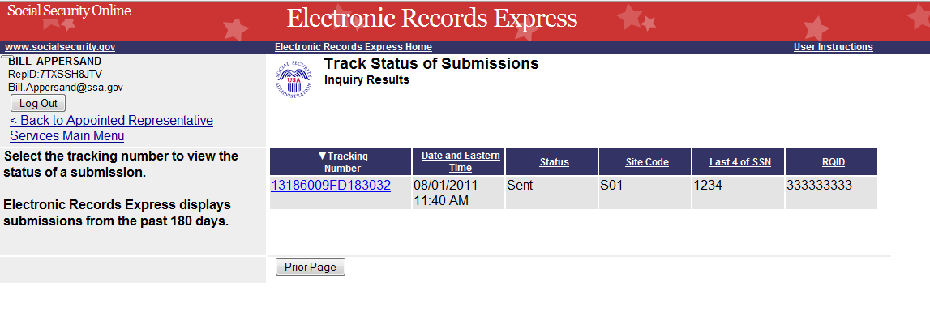
Select the Tracking Number for more details about the submission.
Step 4—View submission details on the Inquiry Results Details page. You may select Prior Page to return to the Inquiry Results or Start New Search to begin a new search for submissions.
Search by Tracking Number—Step 4
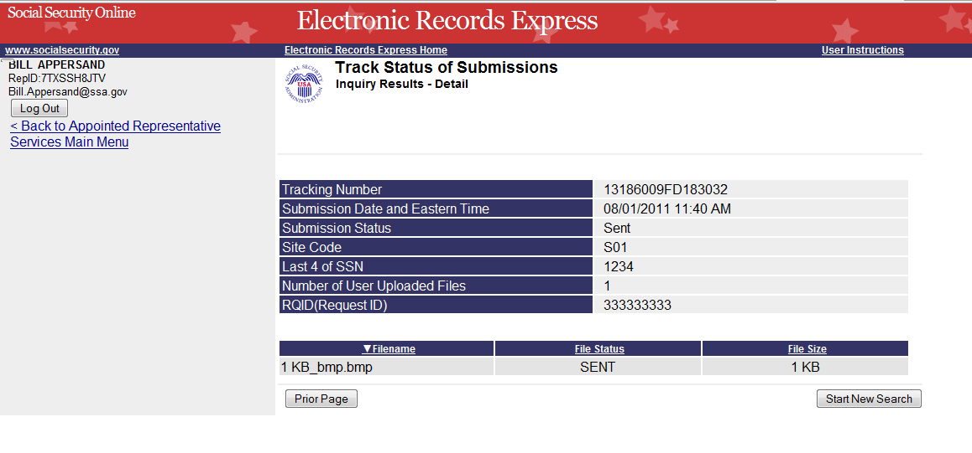
Select Start New Search to return to the Search Page

Search by Request ID
Note: When tracking a submission by Request ID all other fields are disabled.
Step 1—Enter the Request ID (RQID) found on the request letter or barcode in the second block. From the barcode provided by ODAR, (example below) enter the Request ID information. Be sure to enter the Request ID beginning with the first non-zero number. For example, if the request letter shows RQID as 000000013385, enter 13385.
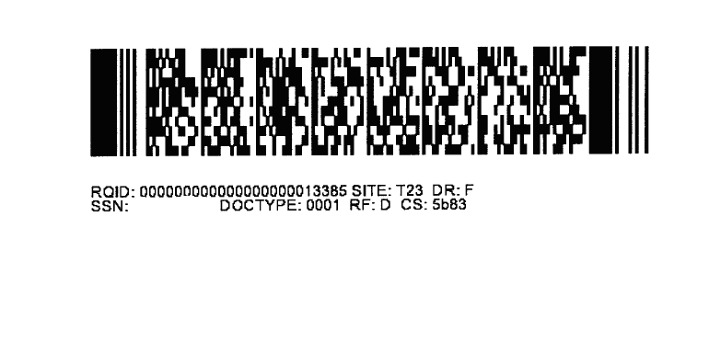
Step 2—Select the Search button.
Search by Request ID—Steps 1 and 2
Enter the RQID
Select the Search button.
Step 3—Select the Tracking Number hyperlink to obtain details about the submission.
Search by Request ID—Step 3
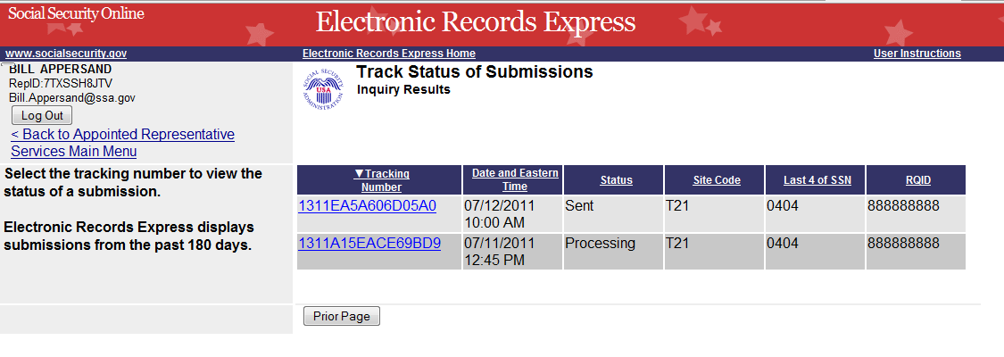
Select the Tracking Number hyperlink for more details.
Step 4—View submission details. You may select Prior Page to return to the Inquiry Results or Start New Search to begin a new search for submissions.
Search by Request ID—Step 4
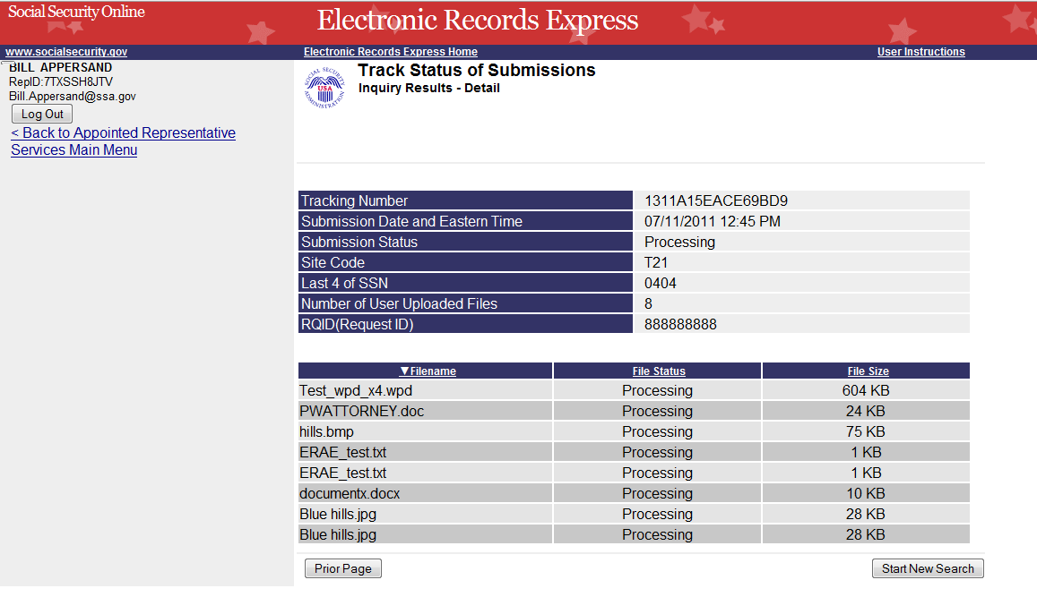

Search by Claimant’s SSN
Note: When searching a submission by Claimant SSN all other fields are disabled.
Step 1 – Enter the Claimant’s SSN found on the request letter or barcode.
Step 2 – Select the Search button.
Search by Claimant SSN - Steps 1 and 2
Enter the Claimant’s SSN
Select the Search button.
Step 3 – Select the Tracking Number hyperlink to obtain details about the submission.
Search by Claimant’s SSN – Step 3
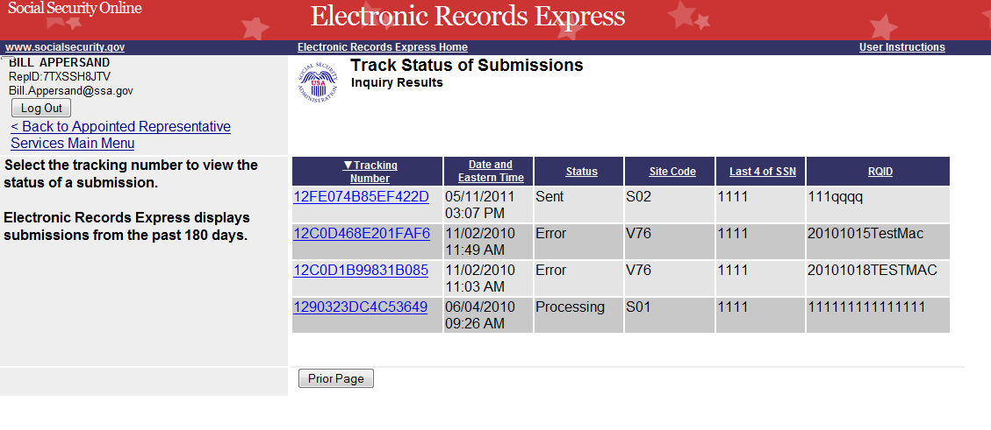
Select the Tracking Number hyperlink for more details.
Step 4 – View submission details. You may select Prior Page to return to the Inquiry Results or Start New Search to begin a new search for submissions.
Search by Claimant’s SSN – Step 4
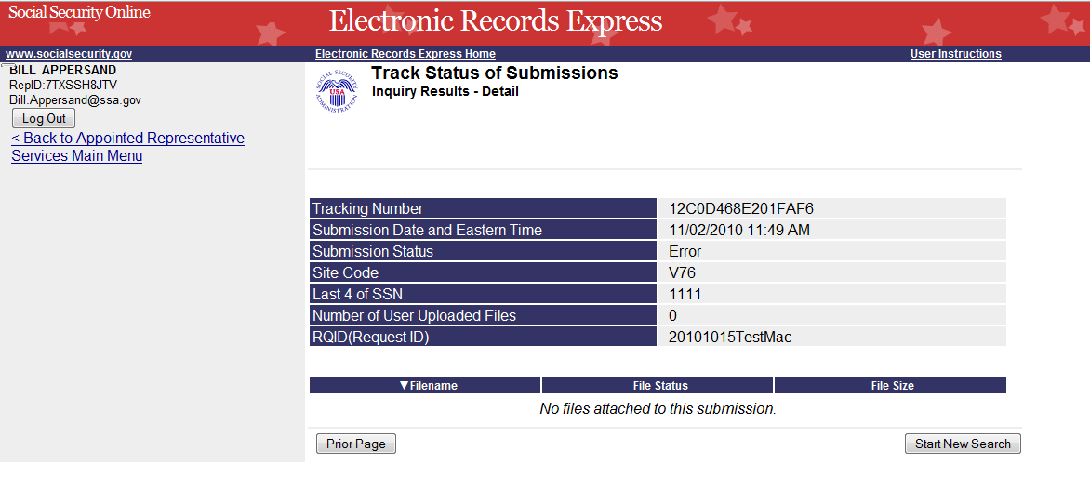

Search by Submission Date, Status, or Site

Default Search
Step 1—The Last 45 Days and All buttons are automatically selected. To search all submissions in the last 45 days, simply select the Search button.
Default Search—Step 1
“Last 45 Days” and “All” are Default selections
Step 2—All submissions in the last 45 days are displayed. You may sort the results in ascending or descending order by selecting one of the underlined headings (Tracking Number, Date and Eastern Time, Status, Site Code, or RQID).
Step 3—Select the Tracking Number to view details of the submission. You may also select the Prior Page button to return to the Search Submissions page.
Default Search—Steps 2 and 3
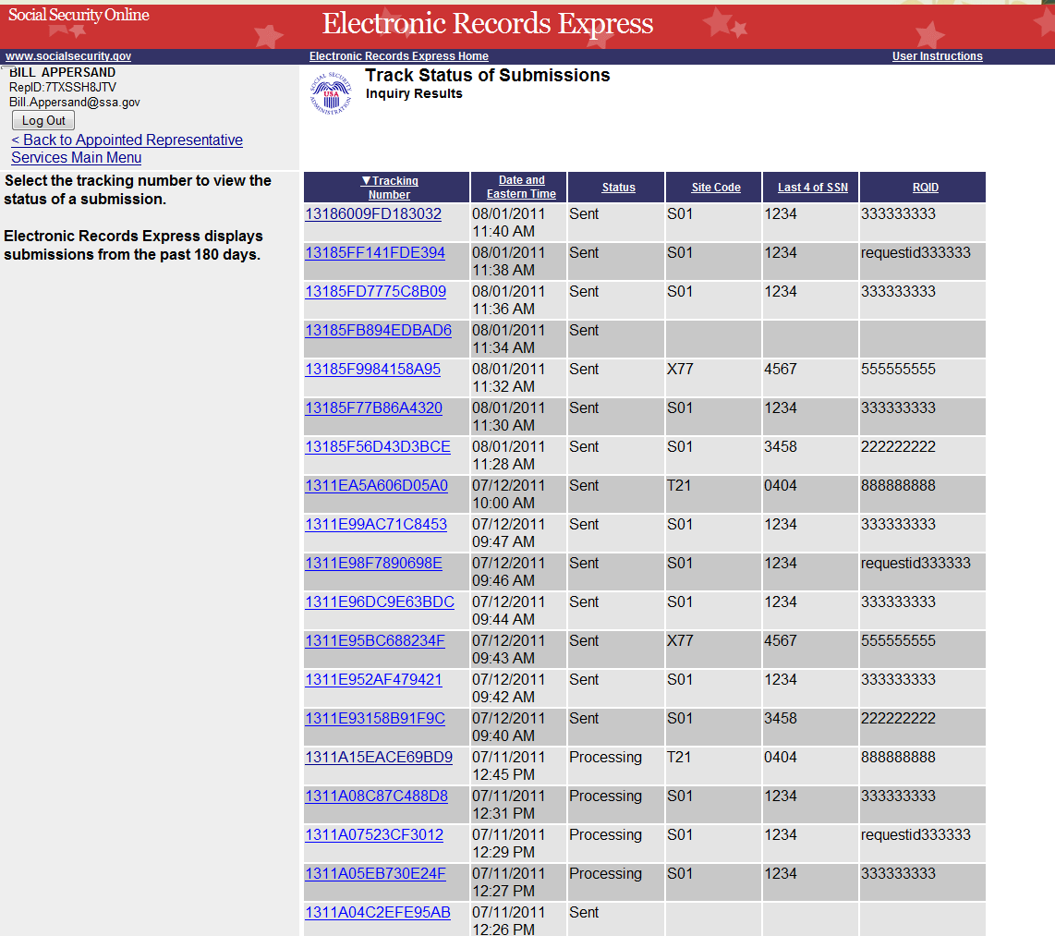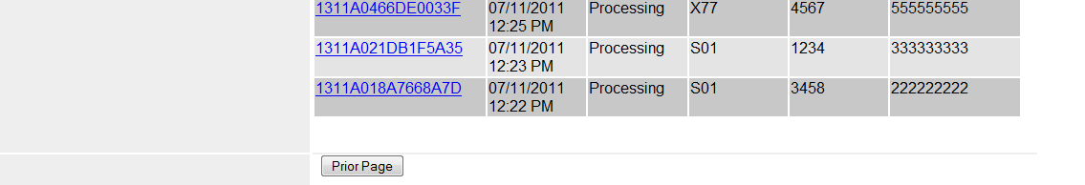
Select an underlined heading to sort.
Select a Tracking Number to view details.

Step 4—View submission details. You may select Prior Page to return to the Inquiry Results or Start New Search to begin a new search for submissions. You may sort the results in ascending or descending order by selecting one of the underlined headings (Filename, File Status or File Size).
Default Search—Step 4
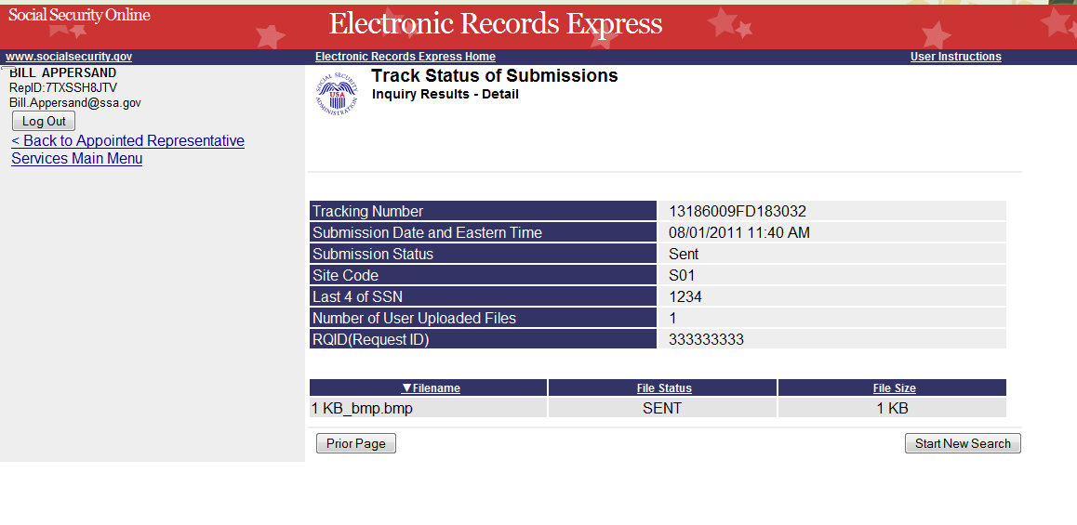

Search by Submission Date, Status, or Site

When searching by submission date, status, and site, you may choose any combination of date, status, and site searches by choosing a button next to each option (date, status, and site).
Search by Date:
- Last 45 Days – Searches all submissions made in the last 45 days.
- Single Days – Searches submissions made in a single day. (The date must be within 180 calendar days from the current date)
- Date Range – Searches submissions made in a date range. (The date must be within 180 calendar days from the current date)
Search by Status:
- All—Searches all statuses within .
- Sent—Searches submissions successfully sent by the user.
- Error—Searches submissions that failed.
- Contacted—Searches submissions that required the user to be contacted by ERE Tech Support.
and
Search by site:
- State – Searches submissions for a specific State.
- Site Code – Searches submissions for a Site Code
Step 1—
- Select the button for the date to search – Last 45 Days, Single Day, or Date Range Button
- If you choose the Single Day button, you must enter the Date of Submission (MM/DD/YYYY). The date must be within the past 180 calendar days.
- If you choose the Date Range button, you must enter the From Date (MM/DD/YYYY) and To Date (MM/DD/YYYY). Both dates must be within the past 180 calendar days.
Step 2—Select the button for a status to search – All, Sent, Error, or Contacted
Step 3—
- Select the button for a site to search – All, State, or Site Code
- If you choose the State button, you must select a State from the dropdown box.
- If you choose the Site Code button, you must select a site from the destination dropdown box. You may also type in the site code in the Site Code box (ex. V59) or you may choose the state from the State dropdown box, which narrows your choices in the Destination dropdown box.
Step 4 – Select the Search button.
Search by Date, Status, and Site – Steps 1-4
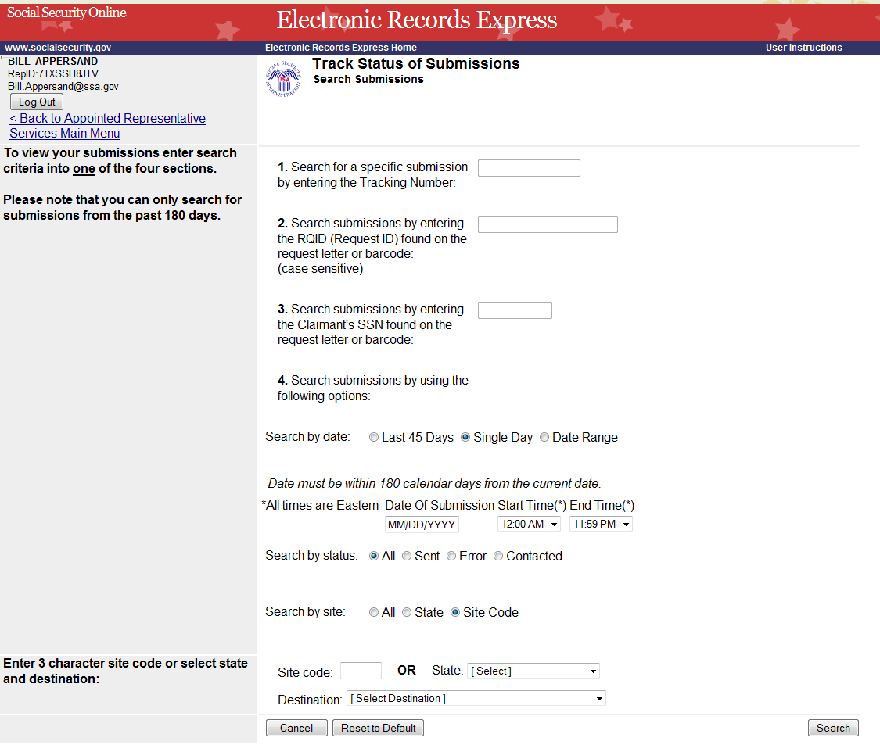
Step 5—Select the Tracking Number to obtain details about the submission.
Search by Date, Status, and Site —Step 5
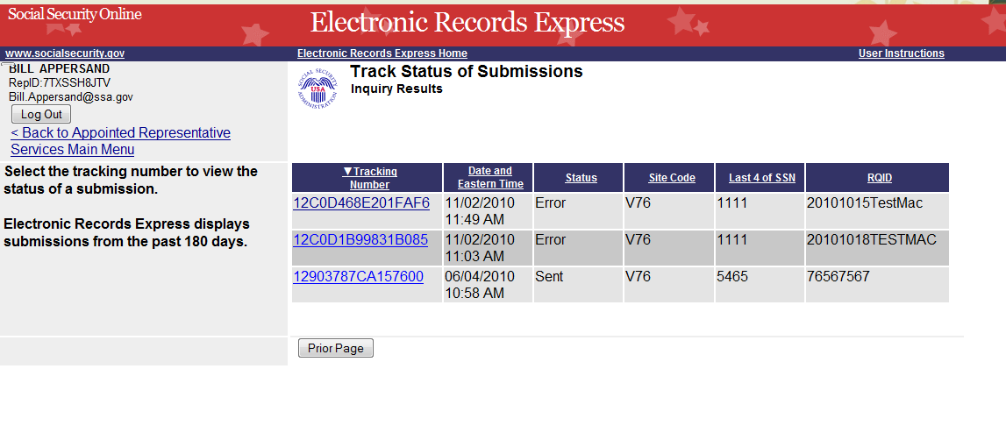
Select a Tracking Number to view details.
Step 6—View submission details. You may select Prior Page to return to the Inquiry Results page or Start New Search to return to the Search Submissions page.
Search by Date, Status, and Site —Step 6
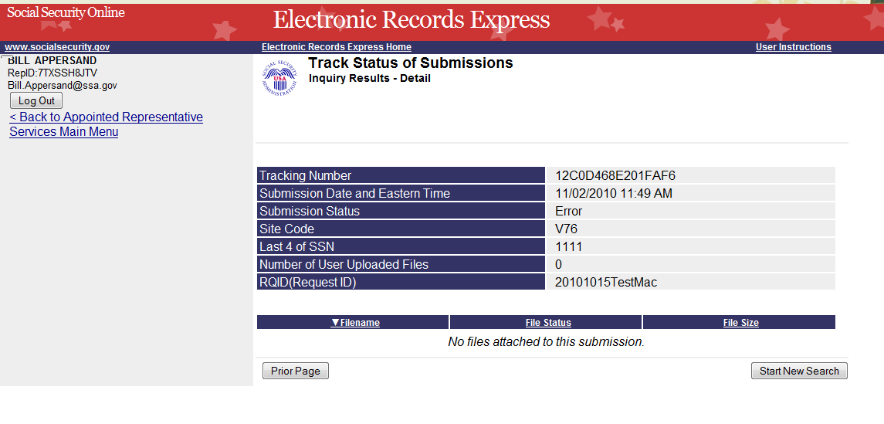

Access Keys
This application contains access keys to improve navigation and provide information. You will find a list of these keys in the table below:
Button | Access Key
Cancel | n
Log Out | l
Prior Page | p
Reset to Default | r
Search | s
Start New Search | s
Other keyboard commands, hotkeys or access keys will vary based upon the browser and the version of the browser that you are using. A list of these commands can be found in the Help section of your browser. The Help feature can be located on the Menu bar of your browser. Any assistive devices that you may be using will also have a list of these shortcut keys in their Help section.
Note:
- To use these keys on Windows-based browsers select the Alt button on your keyboard and the access key simultaneously. On the Mac, use the Ctrl key.
- Internet Explorer Browser Users Only: In order to trigger the Browse button on the Electronic Records Express Submission pages you will need to use the space bar if you are using keyboard access.

