Electronic Records Express

User Guide for

Track Status of Submissions


Office of Disability Determinations
October 2011

Table of Contents

Electronic Records Express 3
Track Status of Submissions 3
Overview 3
Search Screen 3
Inquiry Results Page 4
Inquiry Results - Detail Page 5
Track Status of Submission Instructions 6
Search by Tracking Number 7
Search by Request ID 10
Search by Claimant’s SSN 12
Search by Date, Status or Site 15
Access Keys 20
How to Get Important Information about Electronic Records Express Website Availability 21

Electronic Records Express

Track Status of Submissions

Overview
The Electronic Records Express (ERE) Track Status of Submissions application allows you to track the status of your submissions. You can select from multiple search criteria: Tracking Number, Request ID (RQID), Claimant’s SSN, Date of submission and Status of submission.

The Track Status of Submissions application is comprised of the following pages:
- Search Screen
- Results Screen
- Details Screen

Search Screen
You may search for information about files submitted within the past 180 calendar days after entering one or more of the following criteria on the Search Submissions page:

- Tracking Number – The Tracking Number is a unique number assigned to a submission. When searching by a Tracking Number, all other fields are disabled.

- RQID (Request ID) - The RQID is a unique identifier located on the request letter near or on the barcode. When searching by RQID, all other fields are disabled. The RQID is case sensitive.

- Claimant’s SSN - You can search using the individual’s Social Security Number (SSN).

- Date, Status or Site.

- Date - use the Date search and choose one of the following Date options:
- Last 45 days - Searches submissions within the last 45 days
- Single day (date must be within 180 calendar days from the current date)
- Date of Submission
- Start Time (Eastern Time)
- End Time (Eastern Time)
- Date Range (date must be within 180 calendar days from the current date)
- From Date – The start date for your search
- To Date – The end date for your search
- Status - Search all your submissions within the past 180 calendar days or choose one of the following statuses:
- Sent – Search your successful submissions within the past 180 days
- Error – Search your failed submissions within the past 180 days
- Contacted – Search your submissions that required ERE Tech Support to contact you to resolve a problem with the original submission
- Site - Search all your submissions within the past 180 days by Site or narrow your search by choosing one of the following options:
- State – searches your submissions for a specific State
- Site Code – searches your submissions for a specific Site Code

Note: The radio buttons for Search by date - Last 45 Days, Search by status-All, and Search by site-All are automatically selected after choosing the Track Status of Submissions link from the Electronic Records Express Home page.

Inquiry Results Page
The Inquiry Results page displays a list of your submissions from the past 180 calendar days that met the criteria you selected on the Search Submissions page. The list contains the following information about your submissions:
- Tracking Number – a unique number generated by ERE to identify your submission.
- Date and Eastern Time – The Date and Eastern Time your submission was uploaded to the website.
- Status – The status displayed in this column will be one of the following:
- Sent – Your submission was successful
- Error – Your submission failed
- Contacted – A problem occurred with the original submission and ERE Tech Support contacted you to resolve the issue
- Processing – Your submission is processing
- Site Code – The Site Code for your submission
- Last 4 of SSN – The last four digits of the individual’s Social Security Number (SSN)
- RQID - Request ID

Note: Each column may be sorted in ascended or descending order by selecting the column heading.

Inquiry Results - Detail Page
The Inquiry Results - Detail page displays details of your submission from the Tracking Number selected from the Results screen.

The Inquiry Results - Detail screen displays the following submission information:
- Tracking Number
- Submission Date and Eastern Time
- Submission Status
- Site Code
- Last 4 of SSN
- Number of Files Uploaded
- RQID (Request ID)
- Filename – The name of your uploaded file, including the extension
- File Status - The status displayed in this column will be one of the following:
- Sent – Your submission was successful
- Error – Your submission failed
- Contacted – You were contacted by ERE Tech Support to resolve a problem with the original submission
- Processing – Your submission is processing
- File Size – The size of your file in bytes

Track Status of Submission Instructions

From the Electronic Records Express Home page, select Track Status of Submissions under the Document Exchange Services heading.

Electronic Records Express Homepage- CE provider view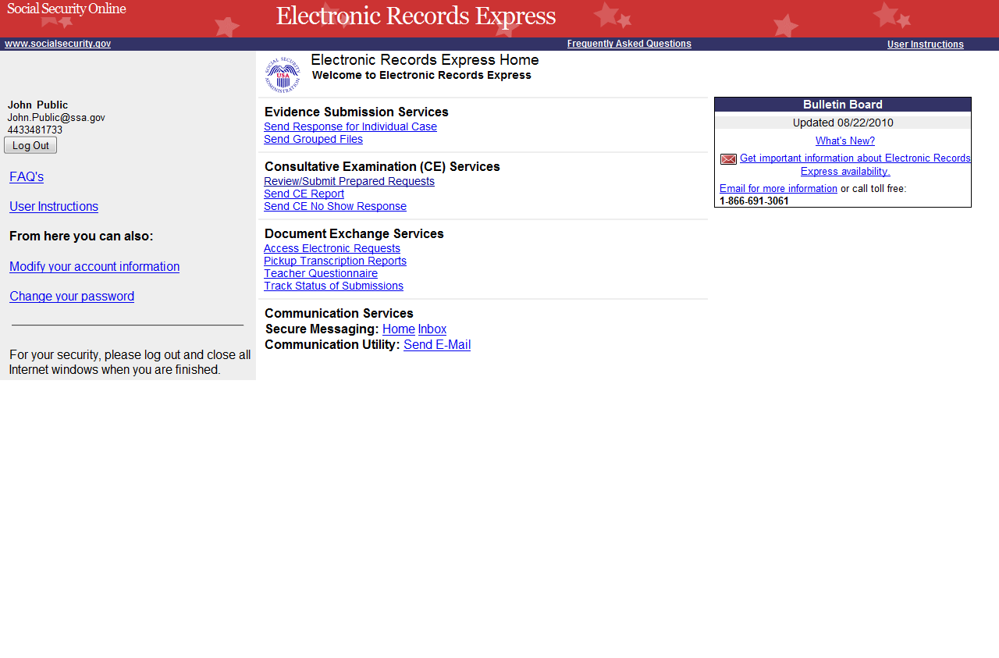

Shown below is the screen CE administrative users will see.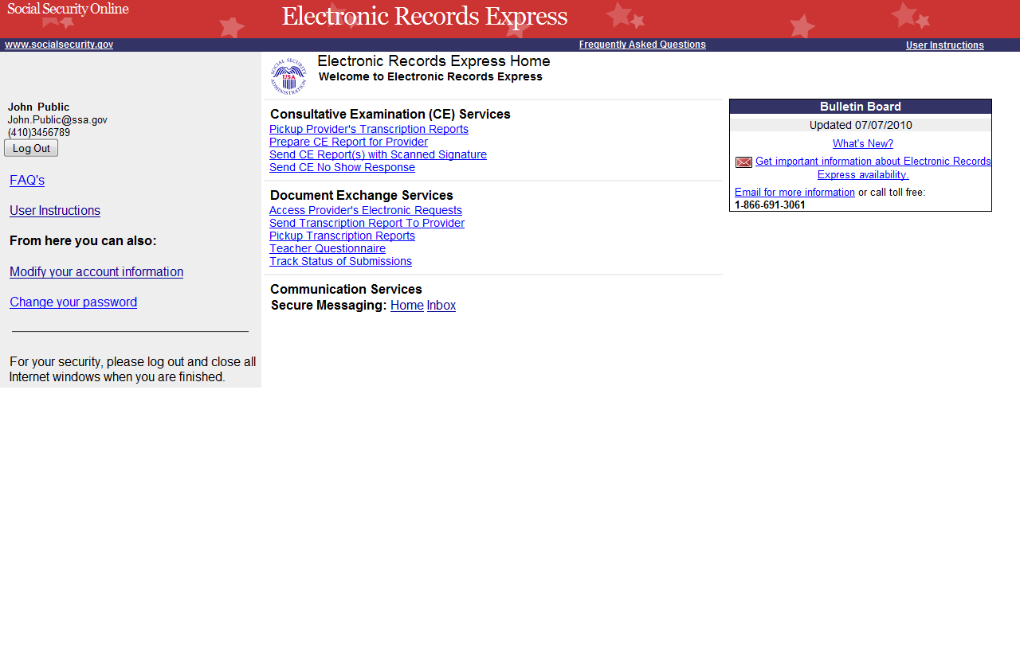

You may search by entering the Tracking Number, Request ID, Claimant’s SSN, other date choices, submission status, or site. When searching submissions by Tracking Number or Request ID, all other fields are disabled.

Note: You can only search for information about your submissions within the past 180 calendar days.

Search by Tracking Number

Note: If you search by Tracking Number, all other fields are disabled.

Step 1 – Enter the Tracking Number in the first block. The Tracking Number is the unique number assigned to your original submission.

Step 2 – Select the Search button.

Search by Tracking Number - Steps 1 and 2
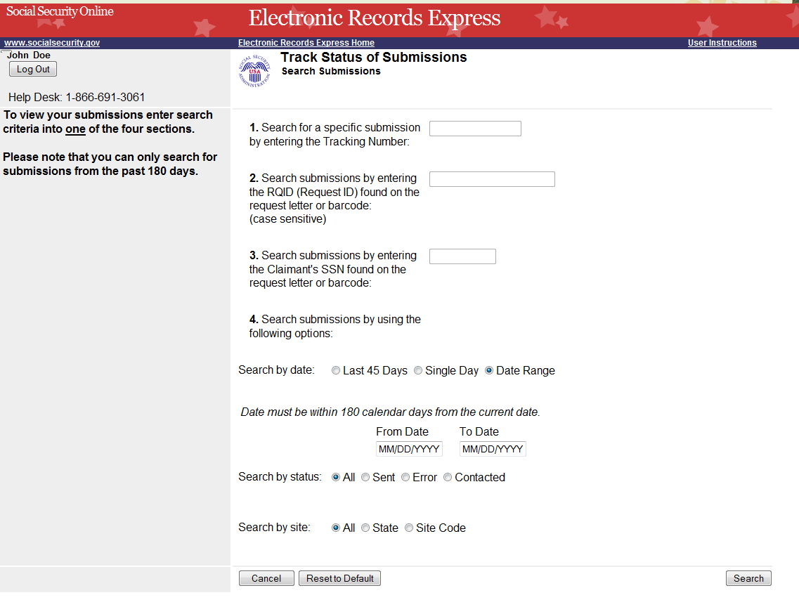
Enter the Tracking Number
Step 3 – View your search results on the Inquiry Results page. The search provides your submissions from the past 180 calendar days that match the Tracking Number you entered on the previous page. Select the Tracking Number hyperlink to go to the Inquiry Results – Detail page.

Search by Tracking Number – Step 3
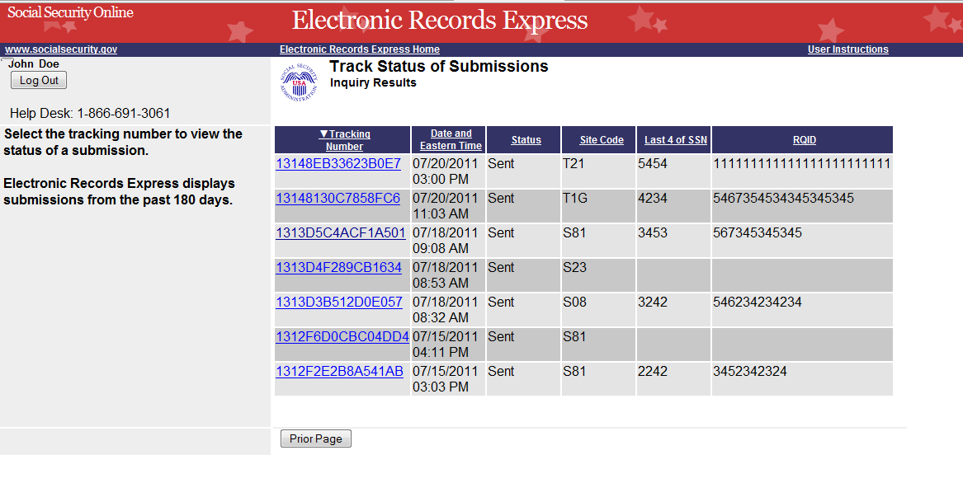
Select the Tracking Number for more details about the submission
Step 4 – View submission details on the Inquiry Results - Detail page. You may select Prior Page to return to Inquiry Results or Start New Search to begin a new search for submissions.

Search by Tracking Number – Step 4
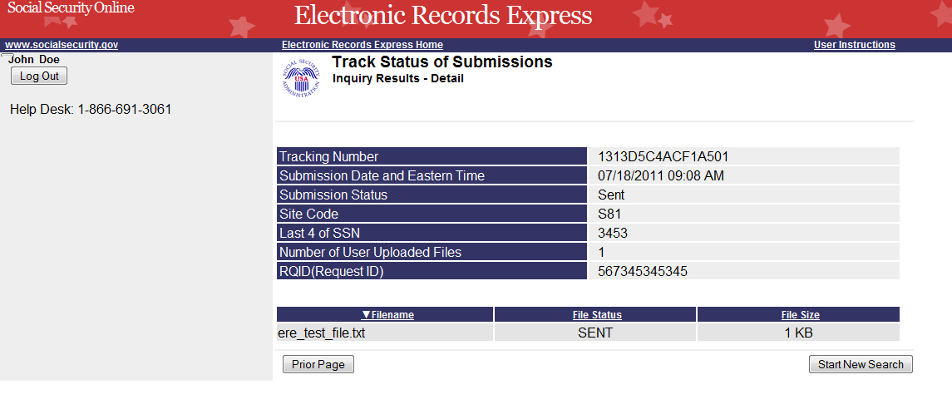
Select Start New Search to return to the Search page

Search by Request ID

Note: When searching by RQID (Request ID), all other fields are disabled.

Step 1 – Enter the RQID found on the request letter or barcode in the second block. The RQID field is case sensitive.

Step 2 – Select the Search button. Any files you submitted in the past 180 days with that RQID display on the Inquiry Results page.

Search by Request ID - Steps 1 and 2
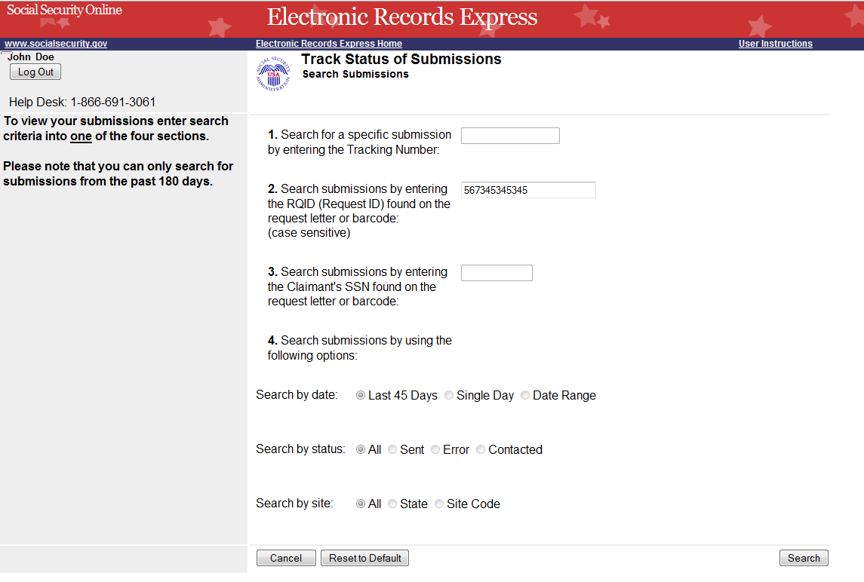
Enter the RQID
Select the Search button
Step 3 – Select the Tracking Number hyperlink to obtain details about a specific submission.

Search by Request ID – Step 3
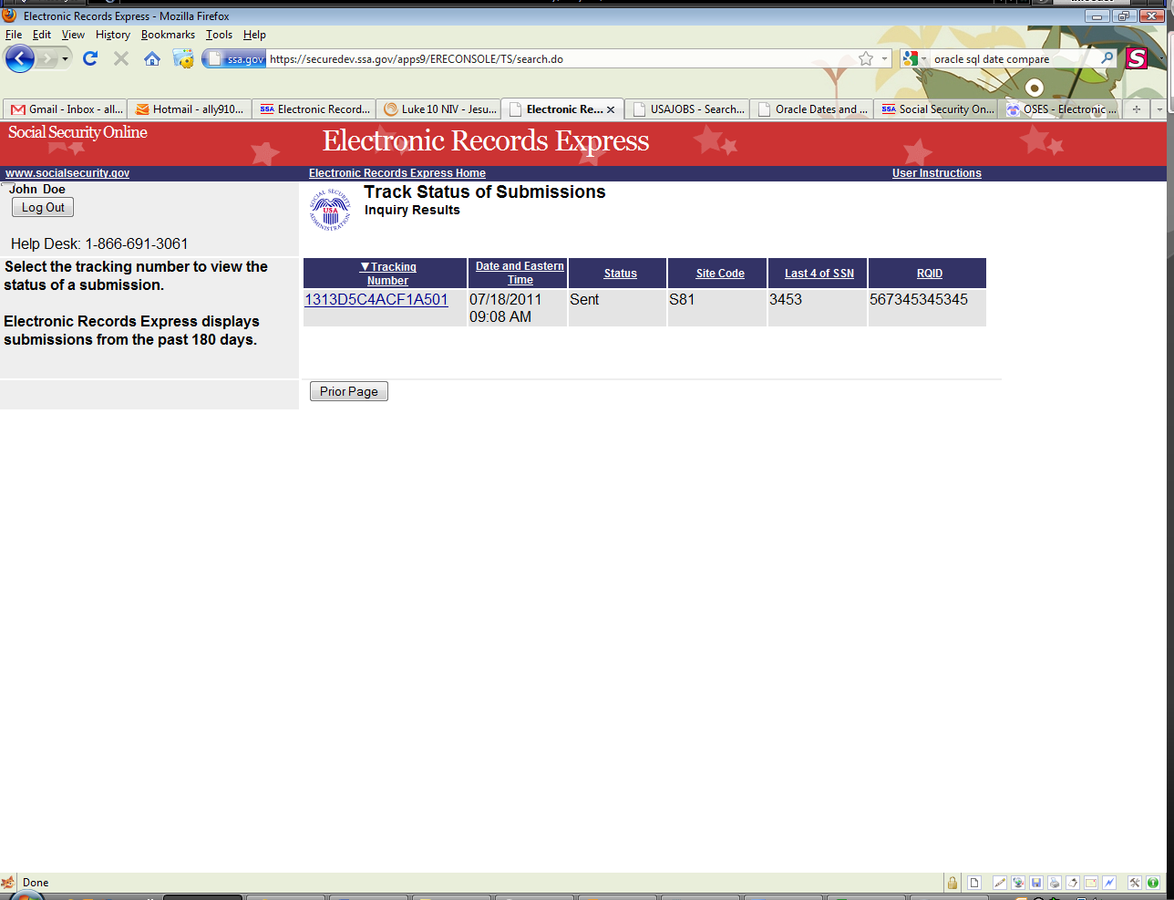
Select the Tracking Number hyperlink for more details

Step 4 – View submission details. You may select Prior Page to return to Inquiry Results or Start New Search to begin a new search for submissions.

Search by Request ID – Step 4
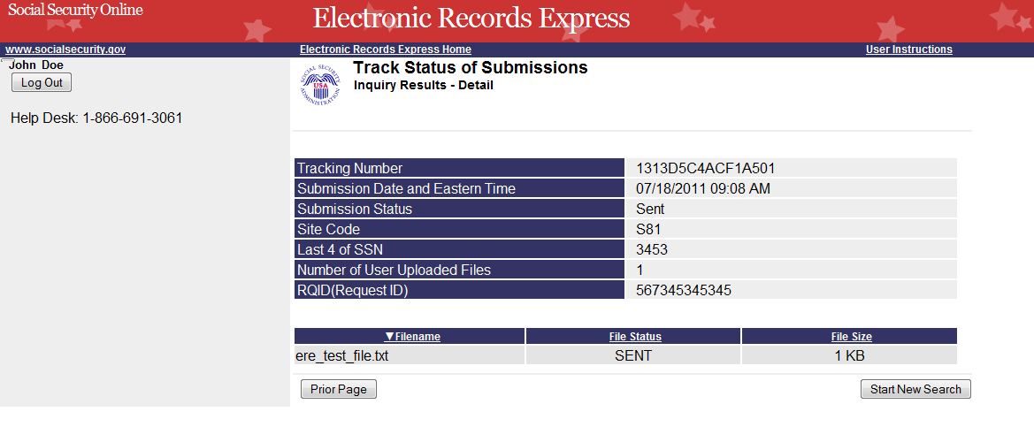

Search by Claimant’s SSN
Note: When searching by Claimant’s SSN (Social Security Number), all other fields are disabled.

Step 1 – Enter the Claimant’s SSN found on the request letter or barcode.

Step 2 – Select the Search button. Any files you submitted in the past 180 days with that SSN display on the Inquiry Results page.

Search by Claimant SSN - Steps 1 and 2
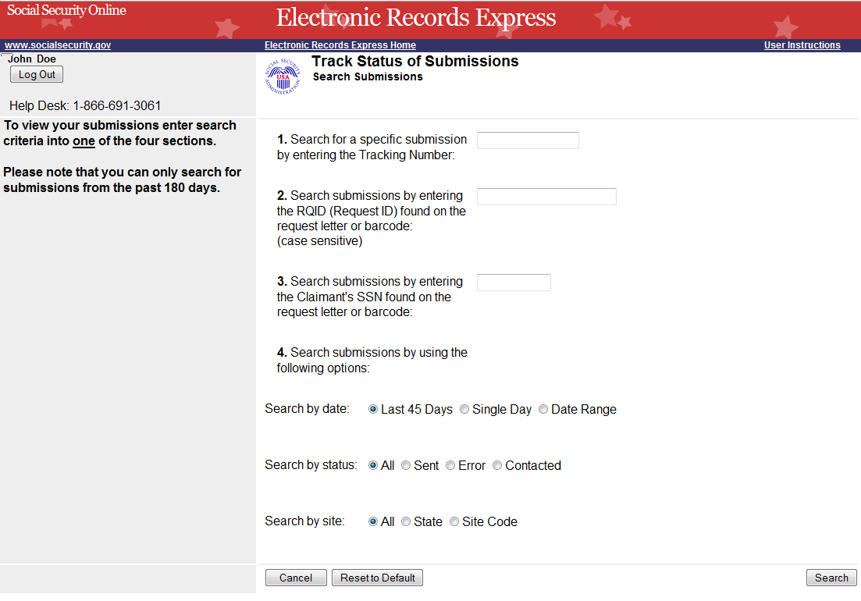
Enter the Claimant’s SSN
Select the Search button
Step 3 – Select the Tracking Number hyperlink to obtain details about a submission.

Search by Claimant’s SSN – Step 3
Select the Tracking Number hyperlink for more details
Step 4 – View submission details. You may select Prior Page to return to Inquiry Results or Start New Search to begin a new search for submissions

Search by Claimant’s SSN – Step 4

Search by Date, Status or Site

Default Search
Step 1 – The Last 45 Days and All buttons are automatically selected. To searchyou’re your submissions in the last 45 days, simply select the Search button.

Default Search - Steps 1
Last 45 Days and All (status and site) are the Default settings
Step 2 – All your submissions in the Last 45 Days display. You may sort the results in ascending or descending order by selecting of the underlined headings (Tracking Number, Date and Eastern Time, Status, Site Code, Last 4 of SSN, or RQID).

Step 3 – Select the Tracking Number to view the details of the submission. You may also select the Prior Page button to return to the Search Submissions page.

Default Search – Steps 2 and 3
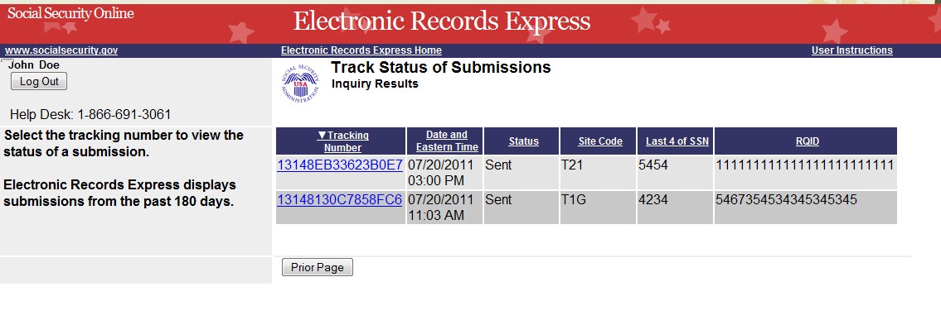
Select an underlined heading to sort
Select a Tracking Number to view details

Step 4 – View submission details. You may select Prior Page to return to Inquiry Results or Start New Search to begin a new search for submissions. You may sort the results in ascending or descending order by selecting an underlined heading (Filename, File Status or File Size).

Default Search – Step 4

Search by Submission Date, Status or Site

When searching by submission date, status, and site, you may choose any combination of date, status, and site searches. Note that your search results will only include your submissions from the past 180 calendar days.

Search by Date:
- Last 45 Days – Searches all your submissions from the last 45 days
- Single Day – Searches all your submissions from a single day (the date must be within the past 180 calendar days)
- Date Range – Searches all your submissions made in a date range (dates must be within past 180 calendar days)

Search by Status:
- All – Searches all your submissions
- Sent – Searches your successful submissions
- Error – Searches your failed submissions
- Contacted – Searches all submissions that resulted in ERE Tech Support contacting you to resolve an issue
and
Search by Site:
- State – Searches all your submissions for a specific State.
- Site Code – Searches your submissions for a specific Site Code.

Step 1 –
- Select the option for the date to search - Last 45 Days, Single Day, or Date Range
- If you choose the Single Day option, you must enter the Date of Submission (MM/DD/YYYY). This date must be within the past 180 days.
- If you choose the Date Range option, you must enter the From Date (MM/DD/YYYY) and To Date (MM/DD/YYYY). These dates must be within the past 180 days.

Step 2 – Select the status search option: All, Sent, Error, or Contacted. (The All option defaults for you.)

Step 3 –
- Select the site search option: All, State, or Site Code. (The All option defaults for you.)
- If you choose the State option, you must select a State from the dropdown box.
- If you choose the Site Code option, you must select a site from the destination dropdown box. You may also type the site code in the Site Code box (example: V59). You can first choose the state from the State dropdown box that narrows your choices in the Destination dropdown box.

Step 4 – Select the Search button. If you have any submissions from the past 180 days that match your search criteria, these results are provided on the Inquiry Results page.

Search by Date, Status or Site – Steps 1- 4
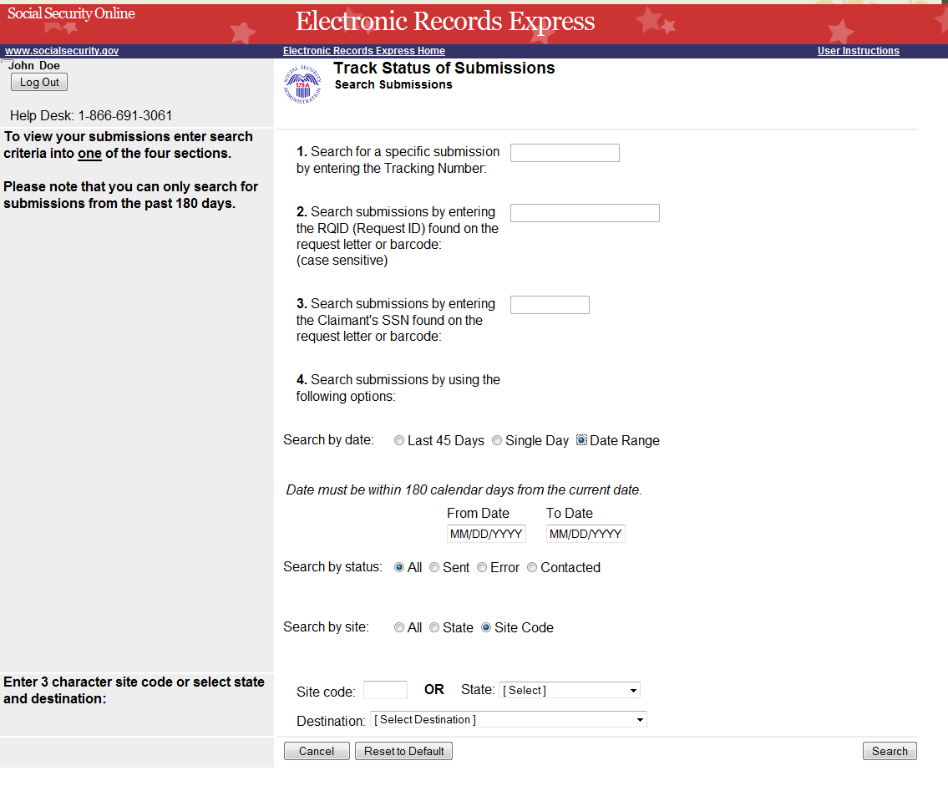
Select date search option
Key the Date Range
Select site search option
Select status search option
Select the Search Button

Step 5 – Select the Tracking Number to obtain the details of the submission

Search by Date, Status or Site – Steps 5
Select a Tracking Number to view details

Step 6 – View submission details. You may select Prior Page to return to the Inquiry Results page or Start New Search to return to the Search Submissions page.

Search by Date, Status or Site – Steps 6

Access Keys

This application contains access keys to improve navigation and provide information. You will find a list of these keys in the table below:

Button | Access Key
Cancel | n
Log Out | l
Prior Page | p
Reset to Default | r
Search | s
Start New Search | s

Other keyboard commands, hotkeys or access keys will vary based upon browser and the version of the browser that you are using. A list of these commands can be found in the Help section of your browser. The Help feature can be located on the Menu bar of your browser or by using the F1 function key on the keyboard. Any assistive devices that you may be using will also have a list of these shortcut keys in their Help section.

Note: To use these keys select the “Alt” button on your keyboard and the access key simultaneously.

How to Get Important Information about Electronic Records Express Website Availability

You may subscribe to receive ERE website availability notifications through the GovDelivery services on the Social Security Administration’s Electronic Records Express internet website: Social Security Online: Electronic Records Express. Please see the following website for GovDelivery FAQs: https://service.govdelivery.com/service/help.html#general1

To subscribe to the ERE website availability notification, follow these instructions:
- Click Get important information about Electronic Records Express website availability.
- Type your email address and select Go
- Confirm your email address
- Select “Send updates immediately by e-mail.”
- Choose an optional password
- Select Save
- Select Next
- Subscribe to additional topics by checking the boxes or unsubscribe by un-checking the boxes
- Select Save
- Subscribe to topics from other agencies by checking the boxes or unsubscribe by
un-checking the boxes
- Select Save
**Once you have subscribed, you will receive a Subscription Acknowledgement e-mail with instructions on how to update your user profile**

