Electronic Records Express

User Guide for

Track Status of Submissions



October 2011

Table of Contents

Overview 3
Search Page 3
Inquiry Results Page 4
Details Page 5
Track Status of Submission Instructions 6
Search by Tracking Number 7
Search by Request ID 10
Search by Claimant’s SSN 13
Search by Date, Status or Site 16
Search by Submission Date, Status or Site 19
Access Keys 23

Electronic Records Express Track Status of Submissions

Overview

The Electronic Records Express (ERE) Track Status of Submissions application allows you to view the status of your submissions. You can select from multiple search criteria: Tracking Number, Request ID (RQID), Claimant’s SSN, Date of Submission and Status of Submission. However, ERE can only supply information about submissions within the past 180 days.

The Track Status of Submissions application is comprised of the following pages:
- Search
- Results
- Details

Search Page
You can submit a search request after one or more of the following criteria have been entered on the Search page:

- Tracking Number – The Tracking Number is a unique number assigned to a submission. When tracking a submission by a Tracking Number, all other fields are disabled.

- Request ID (RQID) - The RQID is a unique identifier located on the request letter near or on the barcode. When tracking a submission by RQID, all other fields are disabled. The RQID is case sensitive.

- Claimant’s SSN - You can search the claimant’s Social Security Number (SSN).

- Date, Status or Site.

- Date - a search by Date may be made by choosing one of the following Date options:
  - Last 45 days - Tracks a submission made within the last 45 days of the search date.
  - Single day (date must be within 180 calendar days from the current date)
    - Date of the Submission
    - Start Time (Eastern Time)
    - End Time (Eastern Time)
  - Date Range (date must be within 180 calendar days from the current date)
    - From Date (Eastern Time) – The start date for your search.
    - To Date (Eastern Time) – The end date for your search.
- Status - Search all submissions or choose one of the following statuses:
- Sent – Tracks your successful submissions.
- Error – Tracks your submissions that have failed.
- Contacted – Tracks submissions when a problem occurs with the original submission and ERE Tech Support has contacted you to make a new submission.
- Site - Search all submissions or choose one of the following statuses:
- State – Tracks submissions from a specific State.
- Site Code – Tracks submissions from a Site Code.

Note: The radio buttons for Search by date, Last 45 days, Search by Status-All, and Search by Site-All are automatically selected after choosing Track Status of Submissions from the homepage.

Inquiry Results Page
The Inquiry Results page displays the following information about your submissions from the past 180 days:
      - Tracking Number – a unique number generated by ERE to identify the submission.

      - Date and Eastern Time – The Date and Eastern Time the submission was downloaded to the ERE website.

      - Status – The status displayed in this column will be one of the following:
- Sent – Your submission was successful.
- Error – Your submission failed.
- Contacted –A problem occurred with the original submission and ERE Tech Support has contacted you.
- Processing – Your submission is being processed.

      - Site Code – The Site Code you sent the submission

      - Last 4 of SSN – The last four digits of the individual’s Social Security Number.

      - RQID - Request ID

Note: You can sort each column in ascending or descending order by selecting the column heading.

Details Page
The Details page displays details of the submission from the Tracking Number selected from the Inquiry Results page.

The Details page displays the following submission information:
- Tracking Number

- Submission Date and Eastern Time

- Submission Status

- Site Code

- Last 4 of SSN

- Number of Files Uploaded

- Request ID (RQID)

- Filename – The name of your originally uploaded file, including its extension.

- File Status - The status displayed in this column will be one of the following:
  - Sent – Your submission was successful.
  - Error – Your submission failed.
  - Contacted –A problem occurred with the original submission and ERE Tech Support has contacted you.
  - Processing – Your submission is being processed.

- File Size – The size of the file in bytes

Track Status of Submission Instructions

From the Electronic Records Express Home page, select Track Status of Submissions under the Document Exchange Services heading.

Electronic Records Express Home
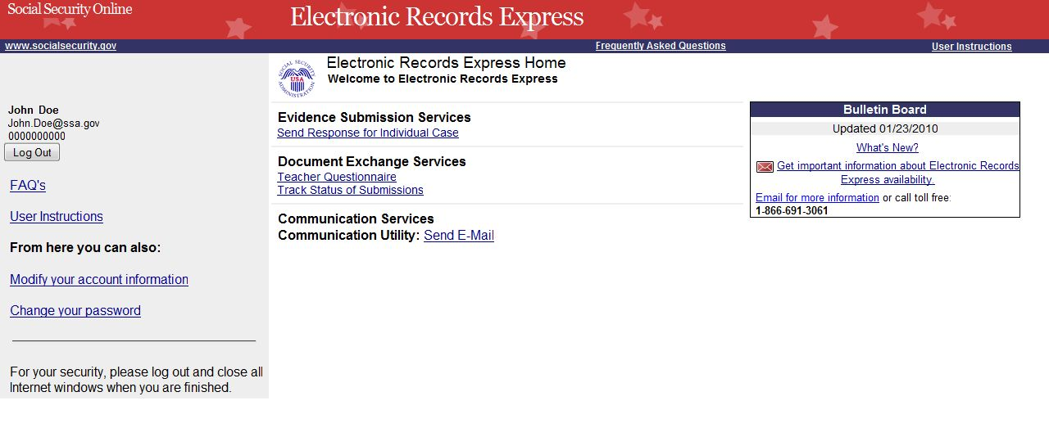

You may search by entering the Tracking Number, Request ID, Claimant’s SSN, other date choices, Submission status, or site. When tracking a submission by Tracking Number or Request ID all other fields are disabled.

Search by Tracking Number

Note: When searching a submission by Tracking Number all other fields are disabled.

Step 1 – Enter the Tracking Number in the first block. The Tracking Number is the unique number assigned to your original submission.

Step 2 – Select the Search button.

Search by Tracking Number - Steps 1 and 2
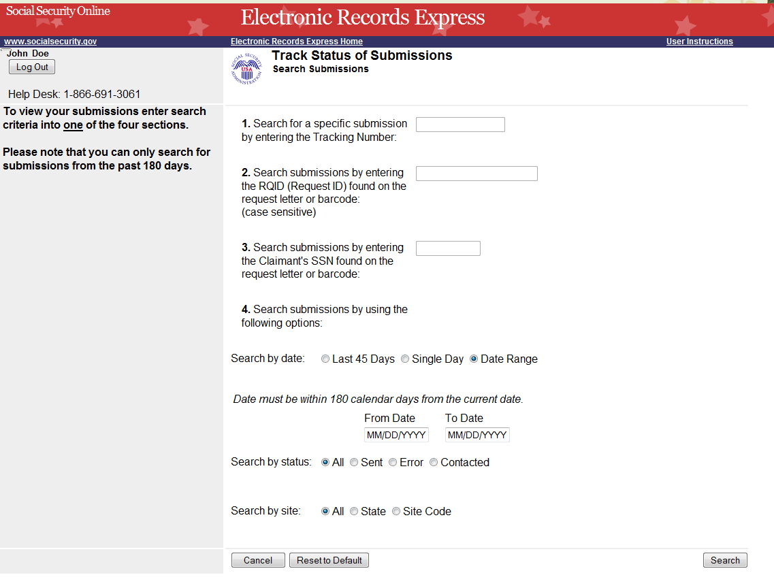
Enter the Tracking Number
Step 3 – View the inquiry results on the Inquiry Results page. Select the Tracking Number hyperlink to go to the Inquiry Details page.

Search by Tracking Number – Step 3
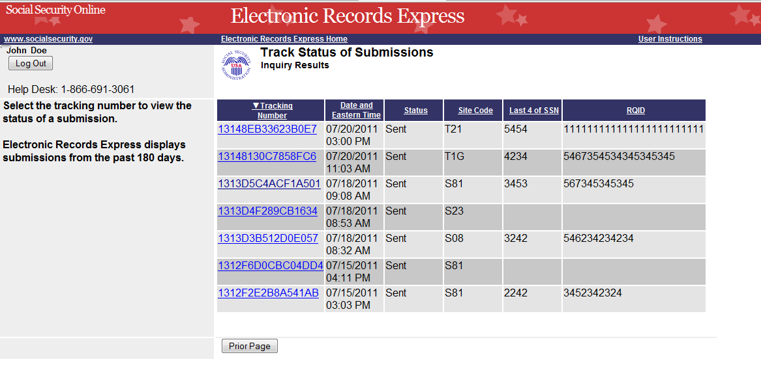
Select the Tracking Number for more details about the submission.
Step 4 – View submission details on the Inquiry Results Details page. You may select Prior Page to return to the Inquiry Results or Start New Search to begin a new search for submissions.

Search by Tracking Number – Step 4
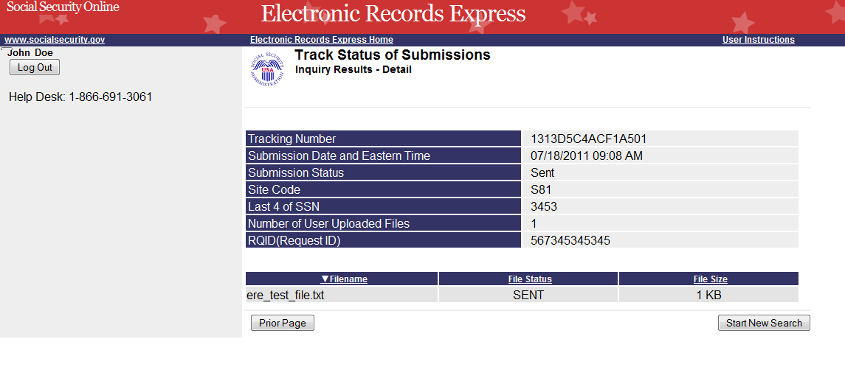
Select Start New Search to return to the Search page.

Search by Request ID

Note: When tracking a submission by Request ID all other fields are disabled.

Step 1—Enter the Request ID (RQID) found on the request letter or barcode in the second block. From the barcode provided by ODAR, (example below) enter the Request ID information. Be sure to enter the Request ID beginning with the first non-zero number. For example, if the request letter shows RQID as 000000013385, enter 13385.

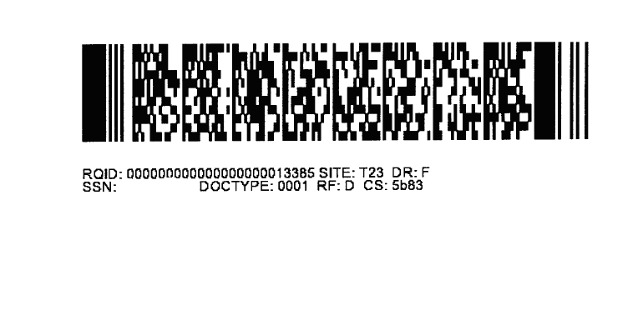

Step 2 – Select the Search button.

Search by Request ID - Steps 1 and 2
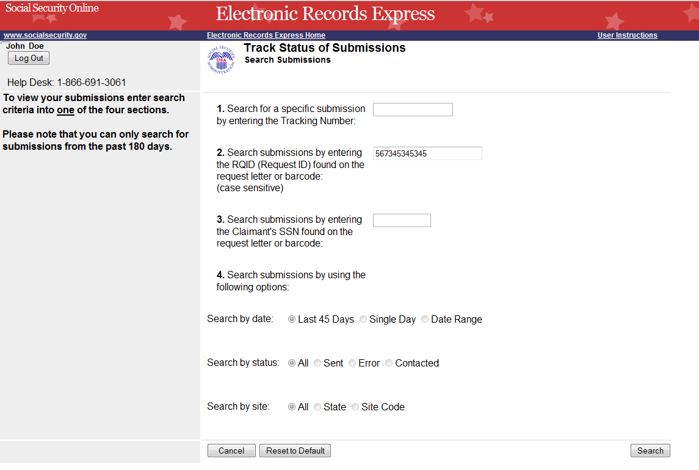
Enter the RQID
Select the Search button.
Step 3 – Select the Tracking Number hyperlink to obtain details about the submission.

Search by Request ID – Step 3
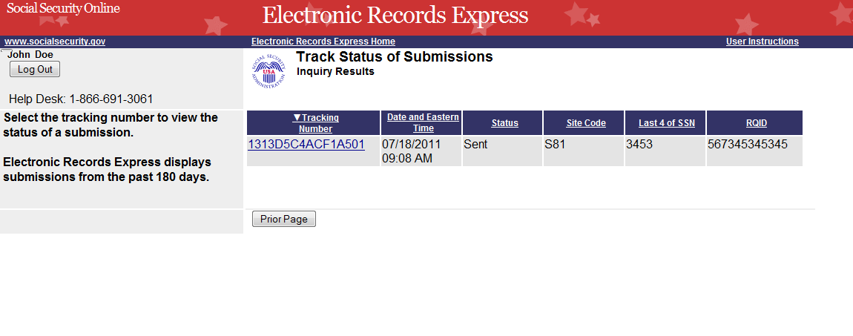
Select the Tracking Number hyperlink for more details.
Step 4 – View submission details. You may select Prior Page to return to the Inquiry Results or Start New Search to begin a new search for submissions.

Search by Request ID – Step 4
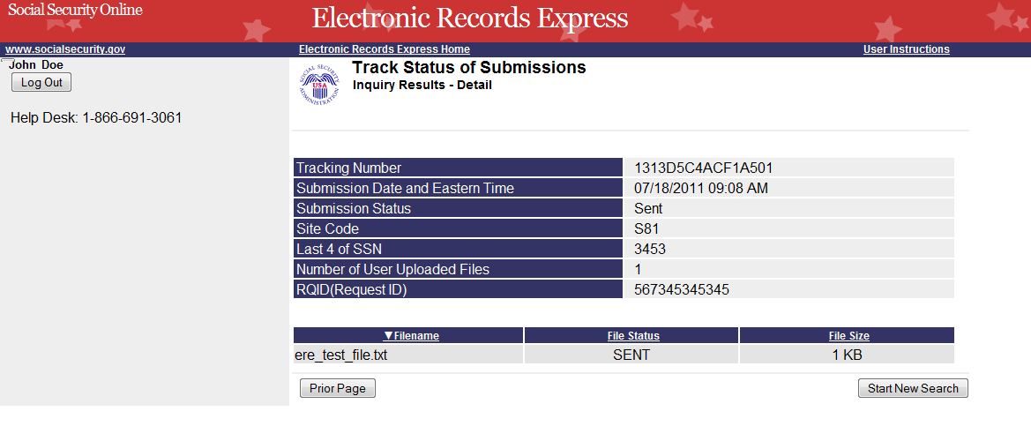

Search by Claimant’s SSN
Note: When tracking a submission by Claimant SSN all other fields are disabled.

Step 1 – Enter the Claimant’s SSN found on the request letter or barcode.

Step 2 – Select the Search button.

Search by Claimant SSN - Steps 1 and 2
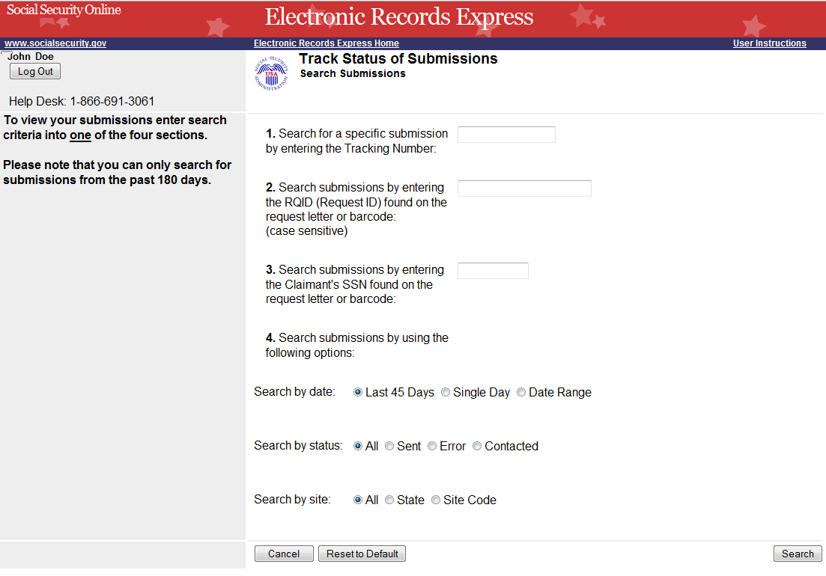
Enter the Claimant’s SSN
Select the Search button.
Step 3 – Select the Tracking Number hyperlink to obtain details about the submission.

Search by Claimant’s SSN – Step 3
Select the Tracking Number hyperlink for more details.
Step 4 – View submission details. You may select Prior Page to return to the Inquiry Results or Start New Search to begin a new search for submissions

Search by Claimant’s SSN – Step 4

Search by Date, Status or Site

Default Search
Step 1 – The Last 45 Days and All buttons are automatically selected. To search all submissions in the last 45 days, simply select the Search button.

Default Search - Steps 1
Last 45 Days and All (status and site) are the Default settings.
Step 2 – All the submissions in the Last 45 Days are displayed. You may sort the results in ascending or descending order by selecting the underlined headings (Tracking Number, Date and Eastern Time, Status, Site Code, Last 4 of SSN, or RQID).

Step 3 – Select the Tracking Number to view the details of the submission. You may also select Prior Page button to return to the Search Submissions page.

Default Search – Steps 2 and 3
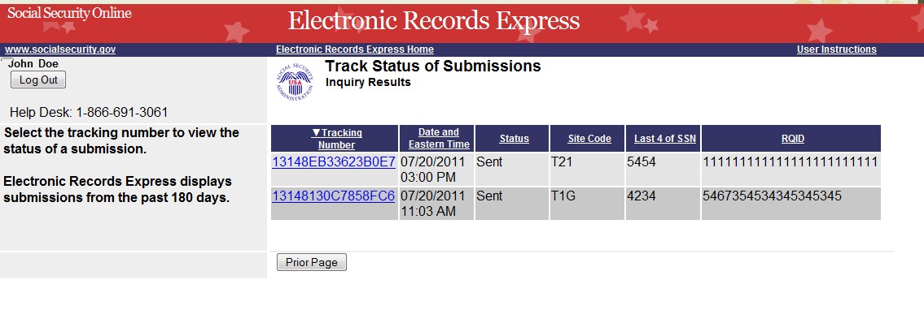
Select an underlined heading to sort
Select a Tracking Number to view details.
Step 4 – View submission details. You may select Prior Page to return to the Inquiry Results or Start New Search to begin a new search for submissions. You may sort the results in ascending or descending order by selecting one of the underlined headings (Filename, File Status, or File Size).

Default Search – Step 4

Search by Submission Date, Status or Site

When searching by submission date, status, and site, you may choose any combination of date, status, and site searches by choosing a button next to each option (date, status, and site).

Search by Date:
- Last 45 Days – Searches all submissions made in the last 45 days.
- Single Day – Searches all submissions made in a single day. (date must be within 180 calendar days from the current date)
- Date Range – Searches all submissions made in a date range. (date must be within 180 calendar days from the current date)

Search by Status:
- All – Searches all statuses within the past 180 days.
- Sent – Searches your successful submissions within the past 180 days.
- Error – Searches all your failed submissions within the past 180 days.
- Contacted – Searches all submissions that required ERE Tech Support contact you within the past 180 days.
and
Search by Site:
- State – Searches all submissions for a specific State within the past 180 days.
- Site Code – Searches submissions for a Site Code within the past 180 days.

Step 1 –
  - Select the button for the date to search - Last 45 Days, Single Day, or Date Range button.

  - If you choose the Single Day button, you must enter the Date of Submission (MM/DD/YYYY). It must be within the past 180 calendar days.

  - If you choose the Date Range button, you must enter the From Date (MM/DD/YYYY) and To Date (MM/DD/YYYY). Both dates must be within the past 180 calendar days.

Step 2 – Select the button for a status to search - All, Sent, Error, or Contacted.

Step 3 –
  - Select the button for a site to search - All, State, or Site Code.

  - If you choose the State button, you must select a State from the dropdown box.

  - If you choose the Site Code button, you must select a site from the destination dropdown box. You may also type in the site code in the Site Code box (ex. V59) or you may choose the state from the State dropdown box, which narrows your choices in the Destination dropdown box.
Step 4 – Select the Search button.

Search by Date, Status or Site – Steps 1- 4
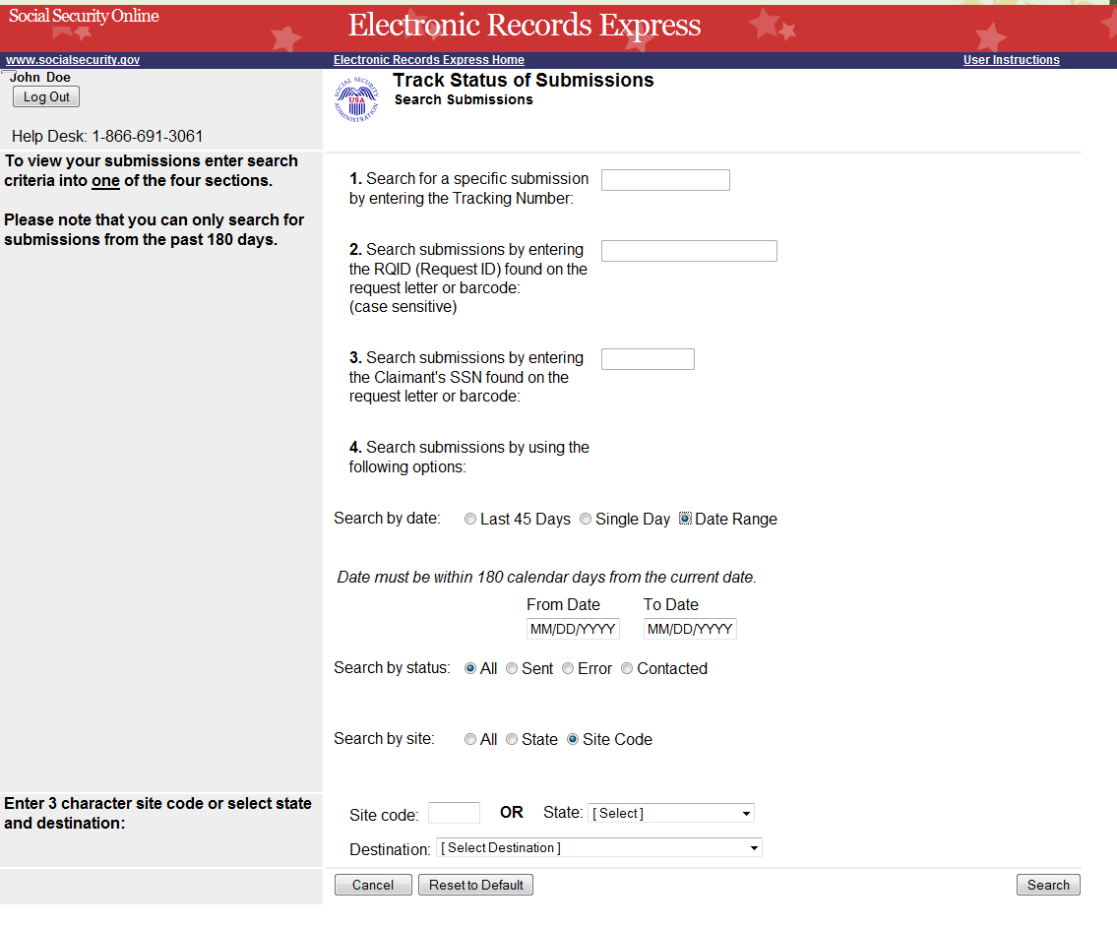
Select a button to search by date.
Type the Date Range
Select the Destination.
Select a button to search by site.
Select a button to search by status.
Select the Search Button

Step 5 – Select the Tracking Number to obtain the details of the submission

Search by Date, Status or Site – Steps 5
Select a Tracking Number to view details.
Step 6 – View submission details. You may select Prior Page to return to the Inquiry Results page or Start New Search to return to the Search Submissions page.

Search by Date, Status or Site – Steps 6

Access Keys

This application contains access keys to improve navigation and provide information. You will find a list of these keys in the table below:

Button | Access Key
Cancel | n
Log Out | l
Prior Page | p
Reset to Default | r
Search | s
Start New Search | s

Other keyboard commands, hotkeys or access keys will vary based upon the browser and the version of the browser that you are using. A list of these commands can be found in the Help section of your browser. The Help feature can be located on the Menu bar of your browser. Any assistive devices that you may be using will also have a list of these shortcut keys in their Help section.
Note:
- To use these keys on Windows-based browsers select the Alt button on your keyboard and the access key simultaneously. On the Mac, use the Ctrl key.
- Internet Explorer Browser Users Only: In order to trigger the Browse button on the Electronic Records Express Submission pages you will need to use the space bar if you are using keyboard access.

