User Guide for Access Electronic Requests


Office of Disability Determinations
October 2017

Instructions for Access Electronic Requests
This function allows providers (hospital, doctor, copy service, etc.) to respond to Consultative Examination (CE) and Medical Evidence request letters sent electronically to the ERE Website from the requesting DDS office. Using the Access Electronic Requests link providers will be able to view, download, respond, and submit documentation related to the electronic request sent by the DDS.
Electronic requests can be accessed by directly logging into ERE with a valid username and password. Once on the ERE Home page, under the Evidence Functions heading, select Access Electronic Requests. Electronic requests can also be accessed by receiving an email notification when a request is sent to an associated ERE account from the DDS. The email will include a link that will direct a user to enter their ERE User ID and password. After logging in, the user is taken to the individual request associated with the email that was received.
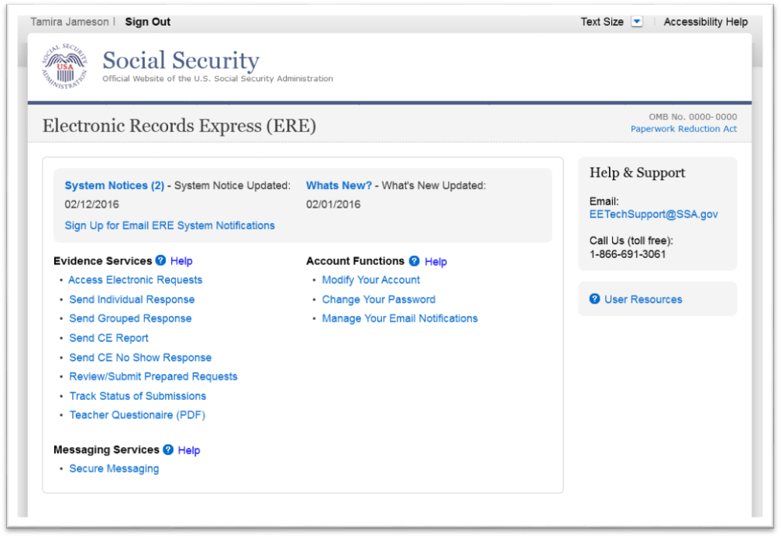

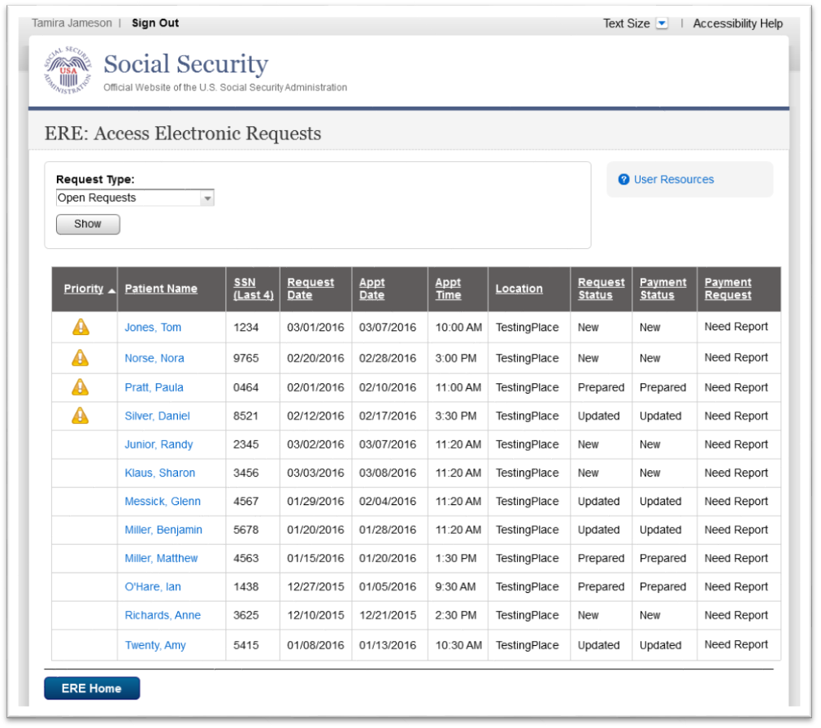

Access Electronic Requests – Request Type
- This page allows a user to view and sort the status of all requests received from the DDS. A user may also change the request type by clicking the arrow from the drop-down box under Request Type by selecting a different request type and clicking Show. The request types are:
  - Open Requests – Displays requests sent by the DDS,
  - Closed Requests – Displays requests cancelled by a DDS,
  - Submitted Requests – Displays requests that have been submitted,
  - Requests Open Over 90 Days – Displays requests sent by the DDS over 90 days ago,
  - For DDS sites that do Fiscal payments, a user will also have an Open Payments request type – Displays requests that were completed and a payment request needs to be sent to the DDS.
Request Status Definitions
- New - A new request that has not been opened.
- Pending - A request that has been opened/viewed.
- Prepared - A CE Admin staff has submitted a prepared report for the
request.
- Responded - Response submitted by provider through ERE Website.
- Accepted - The DDS received the request response.
- Cancelled - The DDS cancelled the request.
- Updated - Updated initial request
- Update Pending - Updated initial request and awaiting documents.

Note: The Electronic Request will be removed from the list based on the retention days received with the request if less than 120 days. Otherwise, Electronic Requests will be removed from the list 120 days from the Request Date.

Step 1 – Open Requests
- A user may select a column header to sort the displayed information by that column in ascending or descending order. Sorted columns display a small arrow adjacent to the column header. The column headers are:
  - Priority
  - Patient Name
  - SSN (Last 4)
  - Request Date
  - Appt Date
  - Appt Time
  - Location
  - Request Status
  - Payment Status, and
  - Payment Request
- Select a name in the Patient Name column to view an individual request and proceed to Step 2.

View/Submit Request Details and File Upload
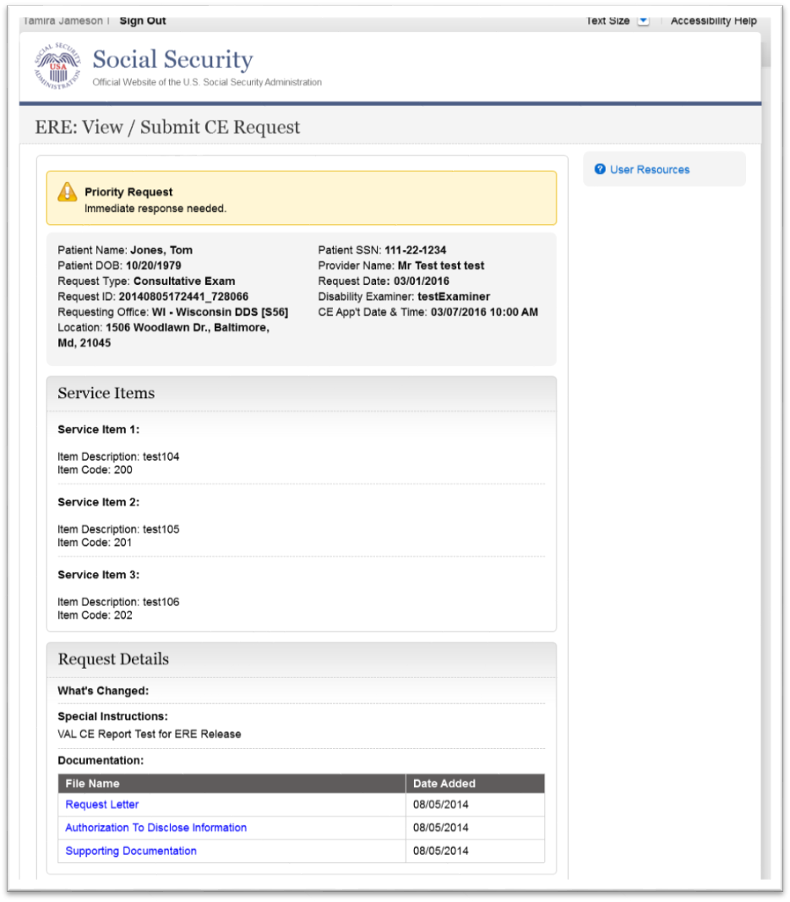
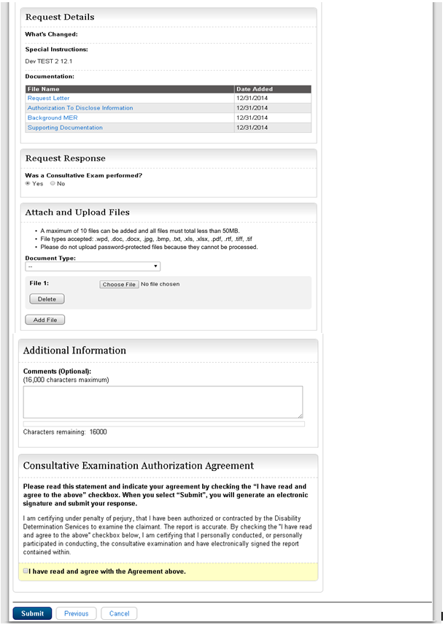

Step 2 - View / Submit Request Details and File Upload
Note: The Patient and Request information is automatically populated to this screen, and therefore cannot be edited.
- To view the files contained in the documentation section under the “Request Details” header simply left click on the file name. User will be prompted to either open or save the selected file. Open and view file.
- Review and verify the Patient Information, Request Information, and all documentation associated with the request.
- Depending on the type of request, the user will be asked if a Consultative Exam was performed or if there is an Evidence record to submit. If user selected “yes”, then they will be required to attach and upload files associated with the claimant:
  - Select the Document Type of the file(s)
  - Select the button to identify a file to send. (Do not send files that are password protected.) The Choose file window appears on your screen.
  - Locate the file you wish to send and highlight the file name. The document’s file name moves into the File name box at the bottom of the Choose file window.
  - Select the Open button. The Choose file window closes and the file name displays. If you have chosen the incorrect file, select the Delete button to clear the field.
  - Click the Add File button to send up to a maximum of 10 additional files.
- If user selected “no”, then they will be required to select a reason for not performing the Consultative Exam and provide required comments or reason for no evidence record to submit.
Note: Do not upload documents containing macros (i.e., a set of instructions or scripts that automates tasks). They may cause system problems, which will require you to re-submit your documents without macros.
- Comments can be typed into the Additional Information section, if needed. Type in and/or cut-and-paste your text (up to 16,000 characters, approximately three letter size pages) directly into the box provided. The count of remaining characters shows beneath the box.
- You will be asked to attest to an “Authorization Agreement” By checking the, “I have read and agree to the above” statement, an electronic signature will be generated and you will have electronically signed and certified the report that is being submitted to the DDS regarding the claimant.
- Select the Submit button to provide the electronic signature and the claimant information to the DDS office that sent the request.

Important Note
It is against SSA policy for a user to delegate the uploading of their Consultative Examination reports, via the Access Electronic Requests website function, to staff members. Users interested in delegating this responsibility should consider using the Send CE with Scanned Signature website function or CE Administrative Staff Upload (Review/Submit Prepared Requests, and Prepare Report for Provider).

Step 3a - Confirmation (Site does not do fiscal)
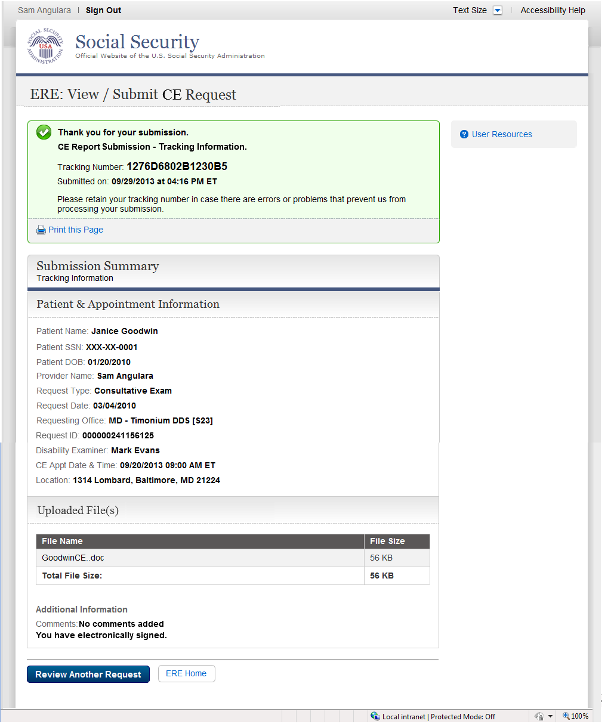

Step 3b - Confirmation (Site does fiscal)
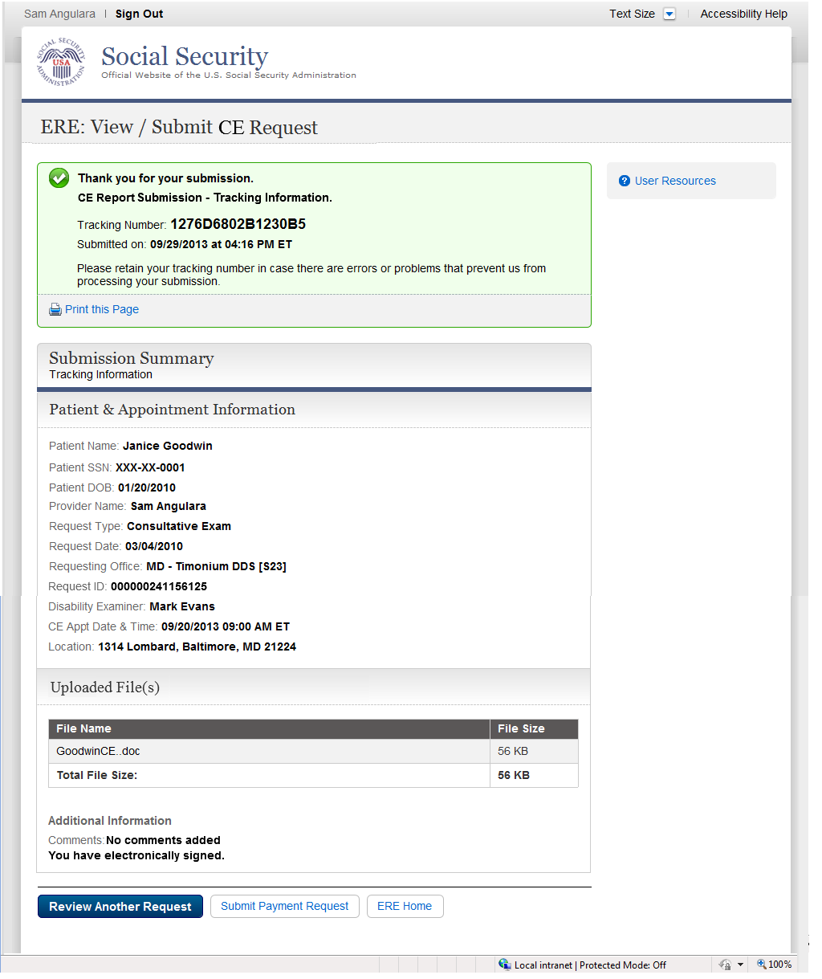

Step 4—Confirmation
After the submission uploads, Electronic Records Express provides a Confirmation page that includes a Submission Summary and a Tracking number that should be retained in case there are errors or problems that prevent the DDS from processing a submission or if a user wants to check on the status of a particular submission.
- If you do not receive the Confirmation page, you should resubmit the materials.
- If you continue to have transmitting problems, contact the Electronic Records Express Website Help Desk at EETechSupport@ssa.gov or 1-866-691-3061.
- To respond to another request, select the Review Another Request button.
- For fiscal see Step 3b and select the Submit Payment Request button.
NOTE: We strongly recommended that you print or take a screenshot of the Confirmation page for your documentation. To do this, simply select Print this page located at the bottom of the green box. This print link works the same as if you selected File and Print from your browser’s menu. You cannot bookmark and save a Confirmation page, and you will not be able to retrieve it later once you exit the webpage.

How to Get Important Information about Electronic Records Express Website Availability

You may subscribe to receive ERE website availability notifications through the GovDelivery services on the Social Security Administration’s Electronic Records Express internet website: Social Security Online: Electronic Records Express. Please see the following website for GovDelivery FAQs: https://subscriberhelp.govdelivery.com/hc/en-us
To subscribe to the ERE website availability notification, follow these instructions:
- Click “Sign Up for Email/Text ERE System Notifications” on the Electronic Records Express Home Page,
- Type your email address and select Submit
- Confirm your email address
- Select “Send updates immediately by email.”
- Choose an optional password
- Select Submit
  - You will receive a “Success” confirmation.
- Select Close to exit.

**Once you have subscribed, you will receive a Subscription Acknowledgement e-mail with instructions on how to update your user profile**

