User Guide for Access Provider’s Electronic Requests



Office of Disability Determinations
October 2017

Instructions for Access Provider’s Electronic Requests
This function is a part of the Electronic Outbound Request (eOR) feature. The DDS can electronically send Consultative Examination (CE) requests through the Electronic Records Express website to the CE Provider’s administrative staff. This function allows the CE administrative staff to view outstanding electronic requests, download request letters and other supporting documentation, and conveniently submit responses to the CE Provider without having to enter any barcode index information.
Begin by logging into the Electronic Records Express with your username and password. Under the Evidence Functions heading, select Access Provider’s Electronic Requests. This takes you to the page that allows you to access CE requests sent to the CE Provider from the DDS.

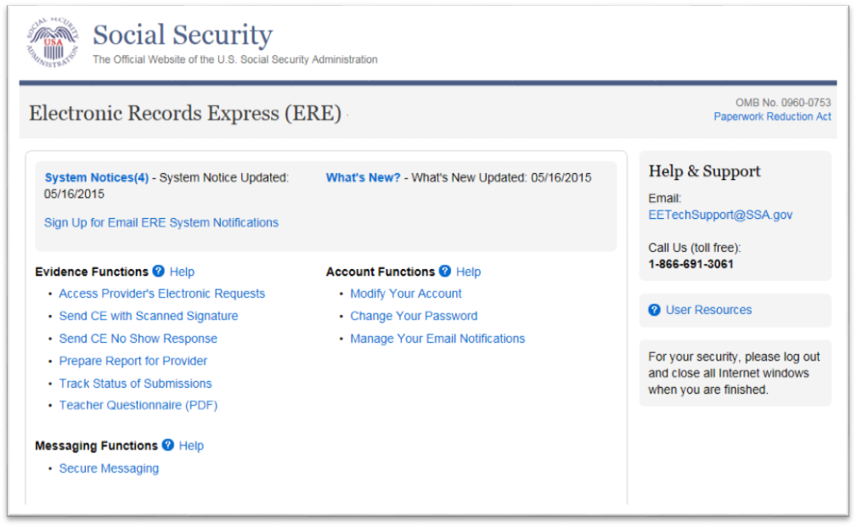

Select Provider
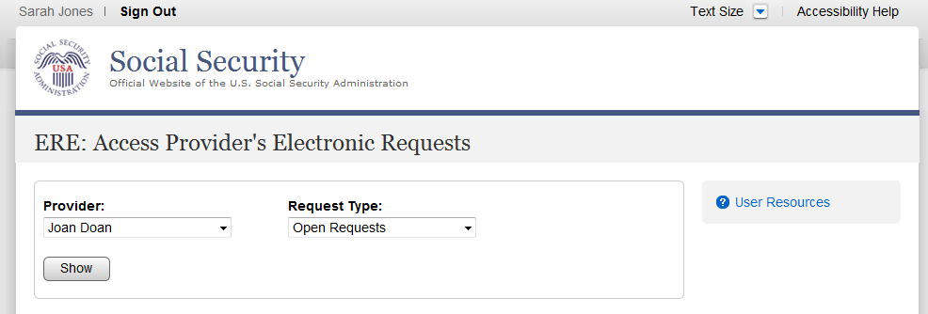

Step 1 - Select Provider
- Select a Provider from the dropdown box. Only CE Providers associated with your username will display in the drop down list.

- Select a request type by clicking the arrow from the drop-down box under Request Type and clicking Show.
- If you do not wish to continue with the transaction and you want to return to the homepage, select the ERE Home button that would be shown on the bottom of the page.

Access Provider’s Electronic Requests – Open Requests
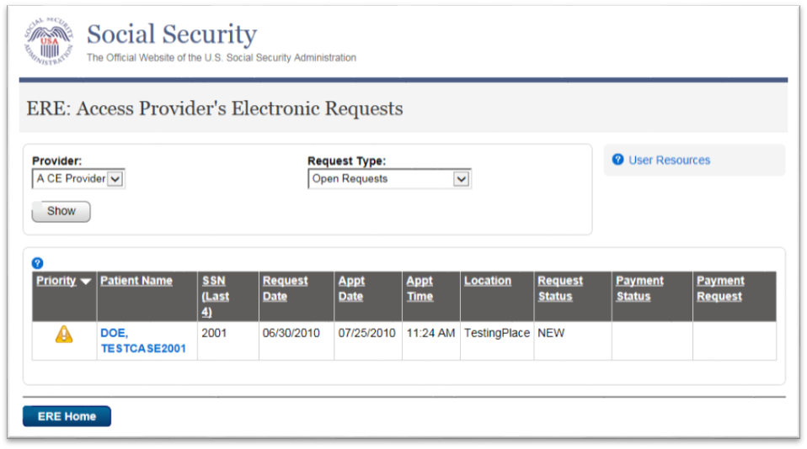
Step 2 - View Provider’s Electronic Request—Open Requests
- This page allows you to view and sort all requests received from the DDS.

- You may select a column header to sort the displayed information by that column in ascending or descending order. Sorted columns display a small arrow adjacent to the column header. The column headers are:

- Priority
- Name
- Last 4 of SSN
- Request Date
- Appt Date
- Appt Time
- Location
- Request Status
- Payment Status
- Payment Request
- Select the claimant’s name in the Patient Name column to view an individual request.
- Select the ERE Home button to go to the Electronic Records Express Home page.
Request Status Definitions
- New - A new request that has not been opened.
- Pending - A request that has been opened/viewed.
- Prepared - A CE Admin staff has submitted a prepared report for the request.
- Responded - Response submitted by provider through ERE Website.
- Accepted - The DDS received the request response.
- Cancelled - The DDS cancelled the request.
- Updated - Updated initial request
- Update Pending-Updated initial request and awaiting documents.

Note: The Electronic Request will be removed from the list based on the retention days received with the request if less than 120 days. Otherwise, Electronic Requests are removed from the list 120 days from the Request Date.
View/Submit Consultative Examination (CE) Request – Prepare Report for Provider (eOR)
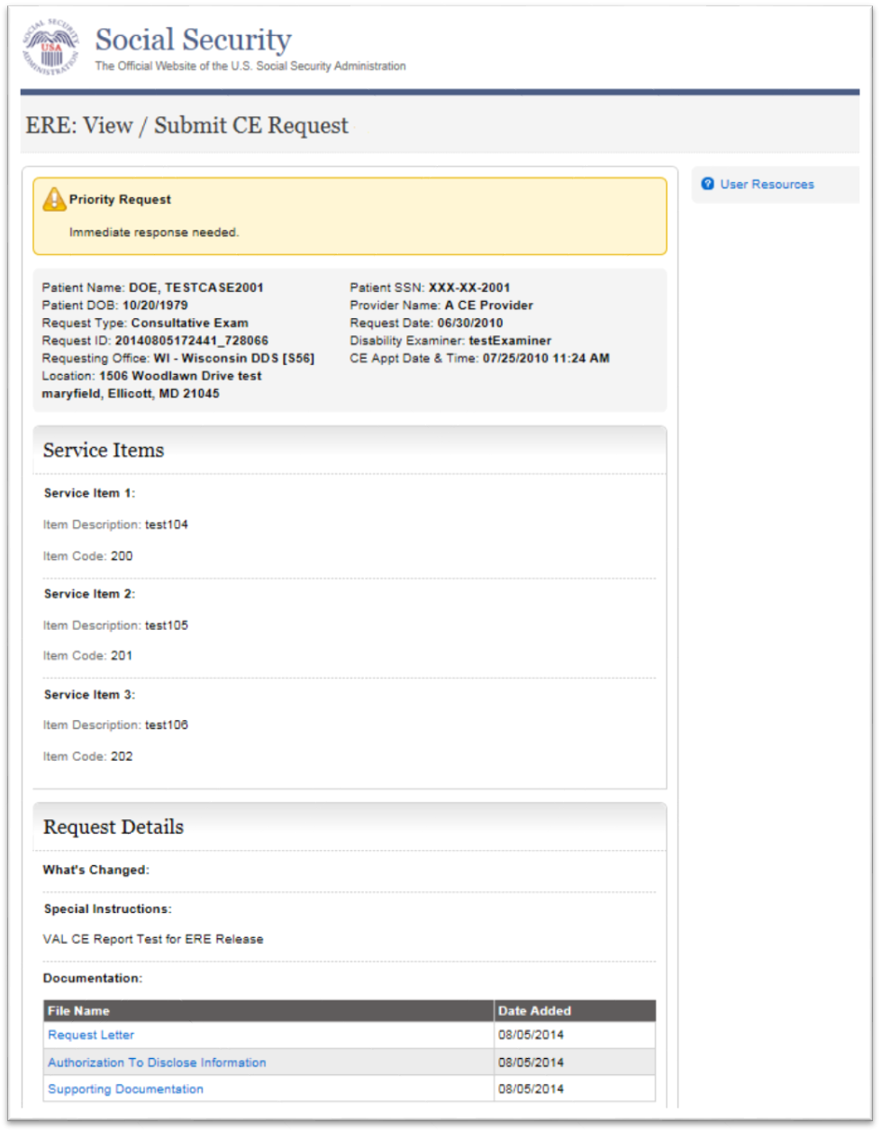

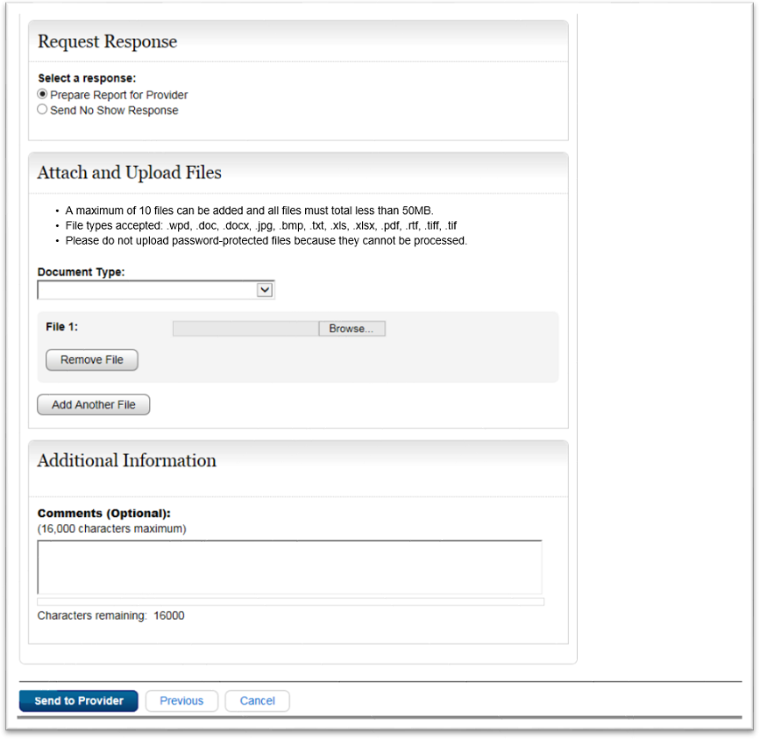

Step 3 - View/Submit Consultative Examination (CE) Request – Prepare Report for Provider (eOR)

- To view the request documentation, click on the blue document heading in the Documentations section.
- Select the appropriate radio button in the Request Response section.
- Select the button to attach and upload files for this patient. (Do not send files that are password protected.) The Choose file window appears.
- Locate the file you wish to send and highlight the file name. The document’s file name moves into the File name box at the bottom of the Choose file window.
- Select the Open button. The Choose file window closes and the file name displays. If you have chosen the incorrect file, select the Delete button to clear the field.
- Select the Add File button to send additional files. Only files for the SSN in Step 1 can be sent with this transaction.
Note: A maximum of 10 files may be sent for one individual by selecting the Add File button and repeating the previous steps.
SSA’s Electronic Records Express website accepts the following file formats: .wpd, .doc, .docx, .jpg, .bmp, .txt, .rtf, .xls, xlsx, .pdf, .tiff, .tif.
Do not upload documents containing macros (i.e., a set of instructions or scripts that automates tasks). They may cause system problems, which will require you to re-submit your documents without macros.
- Type Comments, if needed. Type-in and/or cut-and-paste your text (up to 16,000 characters, approximately three letter size pages) directly into the box provided. The count of remaining characters shows beneath the box.
- Select the Send to Provider button to send the CE report to the CE Provider’s ERE inbox.
Confirmation
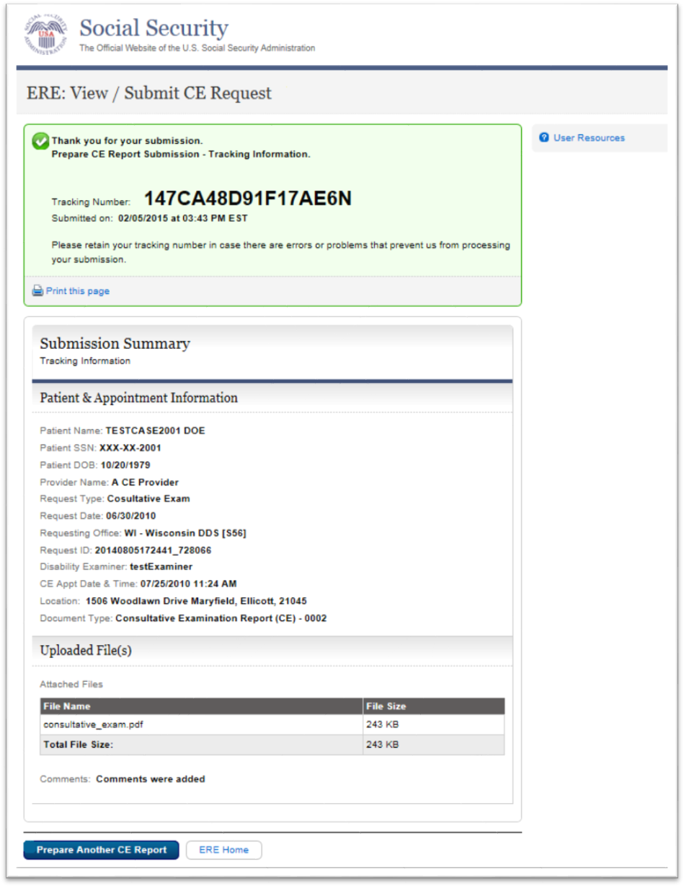

Step 4 - Confirmation
- After your submission uploads, Electronic Records Express provides a Confirmation page that provides a tracking number for you to keep and use if you want to check on the status of your submission.
- If you do not receive the Confirmation page, you should resubmit the materials.
- If you continue to have transmitting problems, contact the Electronic Records Express Website Help Desk at EETechSupport@ssa.gov or 1-866-691-3061.
- If you have additional CE reports to submit, you may select Prepare Another CE Report button. This takes you back to the screen in Step 1.

Note: We strongly recommended that you print or take a screenshot of the Confirmation page for your documentation. To do this, simply select Print this page located at the bottom of the green box. This print link works the same as if you selected File and Print from your browser’s menu. You cannot bookmark and save a Confirmation page, and you will not be able to retrieve it later once you exit the webpage.

How to Get Important Information about Electronic Records Express Website Availability

You may subscribe to receive ERE website availability notifications through the GovDelivery services on the Social Security Administration’s Electronic Records Express internet website: Social Security Online: Electronic Records Express. Please see the following website for GovDelivery FAQs: https://subscriberhelp.govdelivery.com/hc/en-us
To subscribe to the ERE website availability notification, follow these instructions:
- Click “Sign Up for Email/Text ERE System Notifications” on the Electronic Records Express Home Page,
- Type your email address and select Submit
- Confirm your email address
- Select “Send updates immediately by email.”
- Choose an optional password
- Select Submit
  - You will receive a “Success” confirmation.
- Select Close to exit.

**Once you have subscribed, you will receive a Subscription Acknowledgement e-mail with instructions on how to update your user profile**

