User Guide for Secure Messaging


Office of Disability Determinations

October 2017

Instructions for Secure Messaging
The Secure Messaging function allows registered Electronic Records Express (ERE) users to exchange confidential messages and sensitive documents. Only registered users can send and receive secure messages, and messages can only be sent to other registered users (no forwarding to external email addresses). Messages and documents are stored in a central repository on a protected system within the SSA network. All messages and documents are scanned for virus infection before processing.
Electronic Records Express sends email notices to users via a Secure Message. The email notification contains a link to the Electronic Records Express website. You must log into the ERE to retrieve the message. Messages have a limited lifetime of 20 days from creation date.
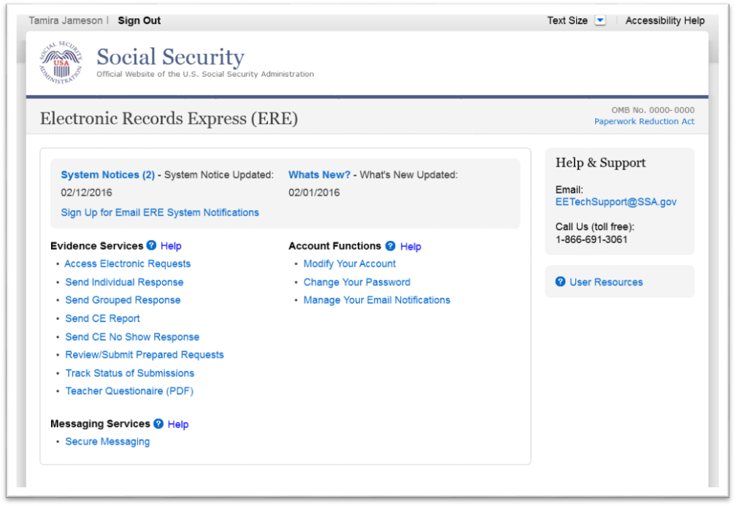
Select the Secure Messaging link from the Electronic Records Express Home page to view the Secure Messaging Inbox.

Secure Messaging – Inbox
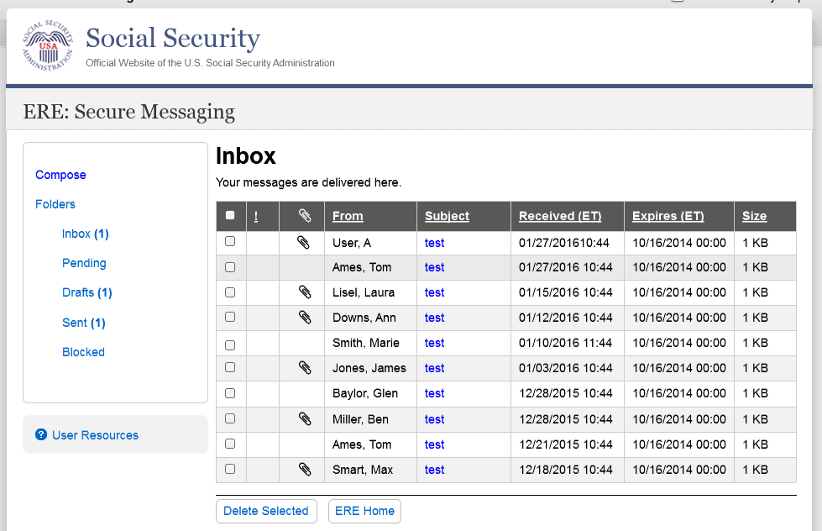

View an Individual Message:
To view an individual message, select the hyperlink of the message you would like to view in the Subject column.

Reply to a Message:
- Use the Reply, Reply to All, or Forward button to respond to the message. Follow the instructions for Compose and Send a Message below to send the message; or
- Choose the Delete button to delete the message; or
- To view another message, select Check Mail or Mailbox Home. Viewed messages remain in the Inbox until they are automatically deleted (20 days from creation date) or manually deleted.

Secure Messaging – Message
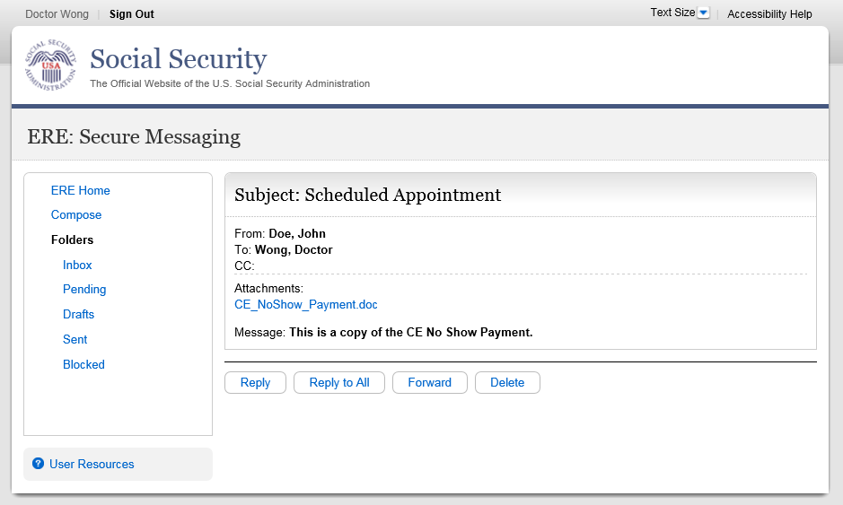

Compose and Send a Message:

- You may respond directly to a received message by choosing the Reply, Reply to All or Forward button.
- If composing a new message, select the Compose link. The form for creating a new message displays.

Compose Message

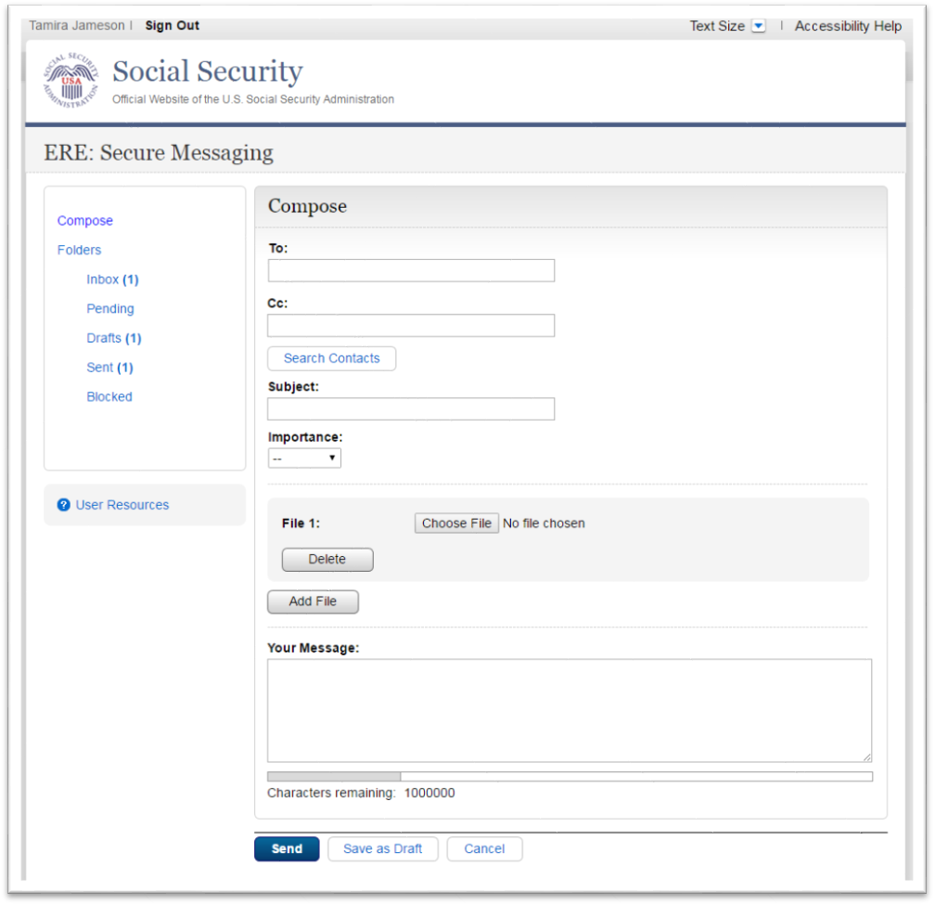
- Enter the destination recipient(s) in the To: and/or Cc: fields. (You can only send Messages to registered users of Secure Messaging.)

- The easiest way to enter a recipient is by selecting the Search Contacts button. This opens up to a light box and it allows you to filter by a user’s first or last name. (You can only send Messages to registered users displayed in this list.)
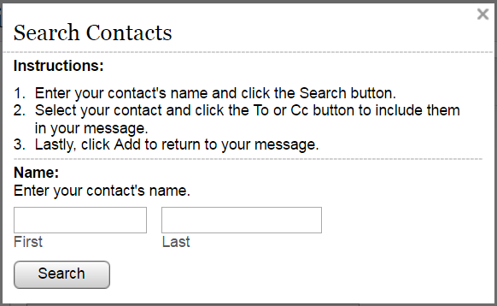

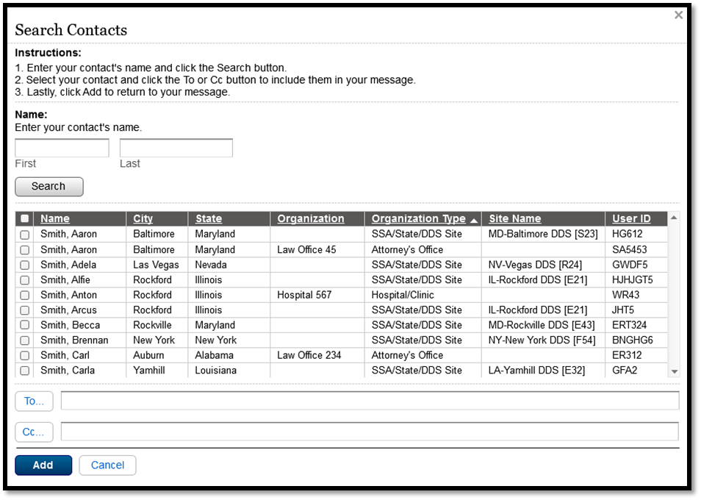

- Search for the name using the Filter By text box. As you type the name in the box, you advance to the corresponding location in the list.
- Highlight the name of the user you are sending a message to and insert it in either the To: box or the Cc: box by selecting the To: or Cc: button on the search window.
- Repeat this step until you have entered all desired destination recipients
- Select Add to include the selected recipients in your message.
- Enter a Subject, and then select the level of Importance from the drop-down list.
- Attach files as necessary.
Note: A maximum of 10 files may be sent by selecting the Add File button and repeating the previous steps.
SSA’s Electronic Records Express website accepts the following file formats: .wpd, .doc, .docx, .jpg, .bmp, .mdi, .txt, .rtf, .xls, xlsx, .pdf, .tiff, .tif.
Do not upload documents containing macros (i.e., a set of instructions or scripts that automates tasks). They may cause system problems, which will require you to re-submit your documents without macros.

- Enter any text message that needs to be included in the large text box.
- The overall size of the message cannot exceed 51 MB (50MB total for file attachments and 1MB for message text).
- Send the message by selecting the Send button. Or, you can save an unfinished message for later by selecting the Save as Draft button. (Creating a draft message starts the 20-day lifespan of the message.)
- A copy of the sent message is saved in the Sent folder.

Compose Message – Confirmation
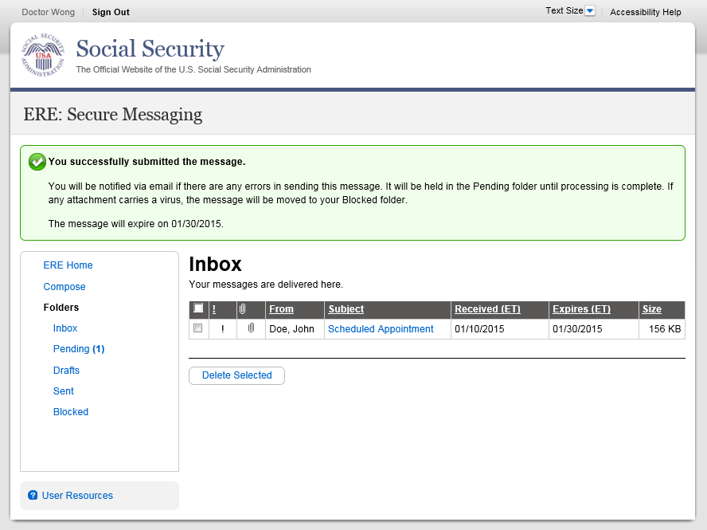

View Blocked Messages:
Blocked messages are messages the user attempted to upload with an attachment in which the Electronic Records Express virus scan found a suspected virus. Quarantined messages are blocked from transmission and the suspected file is deleted. In addition to the benefit of knowing about the suspected file, users need to know that the message has been blocked.
- Select the Blocked link. The blocked messages list displays.
- To take action on the message:
- To delete the message, select the checkbox next to the message and select the Delete button.
NOTE: Do not upload documents containing macros (i.e., a set of instructions or scripts that automates tasks). They may cause system problems, which will require you to re-submit your documents without macros.

Access Keys:
This application contains access keys to improve navigation and provide information. You will find a list of these keys in the table below:

Button | Access Key
Delete | l
Send | s
Save as Draft | r
Reply | r
Replay All | y
Forward | w
Apply | y
To | t
Cc | c
Add | a
Other keyboard commands, hotkeys or access keys will vary based upon browser and the version of the browser that you are using. A list of these commands can be found in the Help section of your browser. The Help feature can be located on the Menu bar of your browser or by using the F1 function key on the keyboard. Any assistive devices that you may be using will also have a list of these shortcut keys in their Help section.
Note: To use these keys select the “Alt” button on your keyboard and the access key simultaneously.

How to Get Important Information about Electronic Records Express

Website Availability

You may subscribe to receive ERE website availability notifications through the GovDelivery services on the Social Security Administration’s Electronic Records Express internet website: Social Security Online: Electronic Records Express. Please see the following website for GovDelivery FAQs: https://subscriberhelp.govdelivery.com/hc/en-us

To subscribe to the ERE website availability notification, follow these instructions:
- Click “Sign Up for Email/Text ERE System Notifications” on the Electronic Records Express Home Page,
- Type your email address and select Submit
- Confirm your email address
- Select “Send updates immediately by email.”
- Choose an optional password
- Select Submit
  - You will receive a “Success” confirmation.
- Select Close to exit.

**Once you have subscribed, you will receive a Subscription Acknowledgement e-mail with instructions on how to update your user profile**

