User Guide for Send CE Report


Office of Disability Determinations
October 2015

Instructions for Send CE Report
The Send CE Report feature of the website allows the CE provider to submit and electronically sign one individual CE report and send it to the DDS. To submit a CE report using this feature of the ERE website, select the link, Send CE Report under the Evidence Functions heading. You need the CE request letter with the barcode available to complete the processing steps, unless you receive your request electronically from the DDS.
You can only use the Send CE Report function if you are the CE Provider. The CE administrative staff cannot use this function.
NOTE: If you received the CE request from the DDS electronically, you can find the request under Access Electronic Requests. After accessing the request, you can view the request and respond using the Send CE Report function.
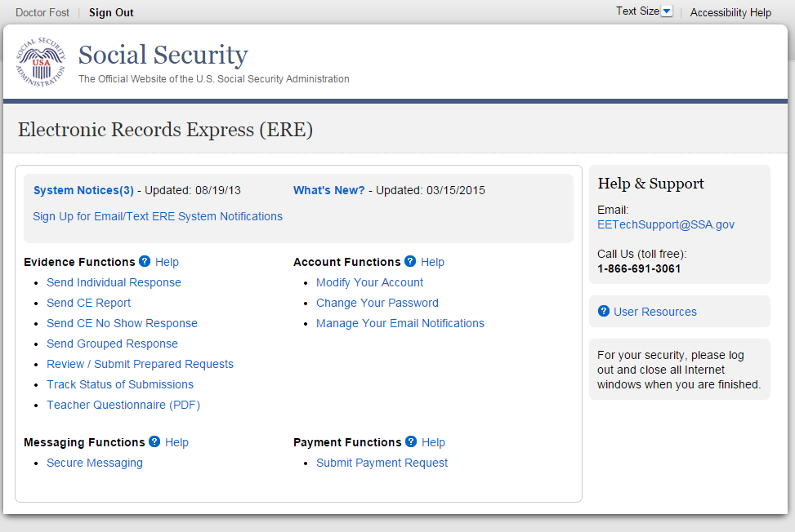

Destination and Request Information (Step 1 of 3)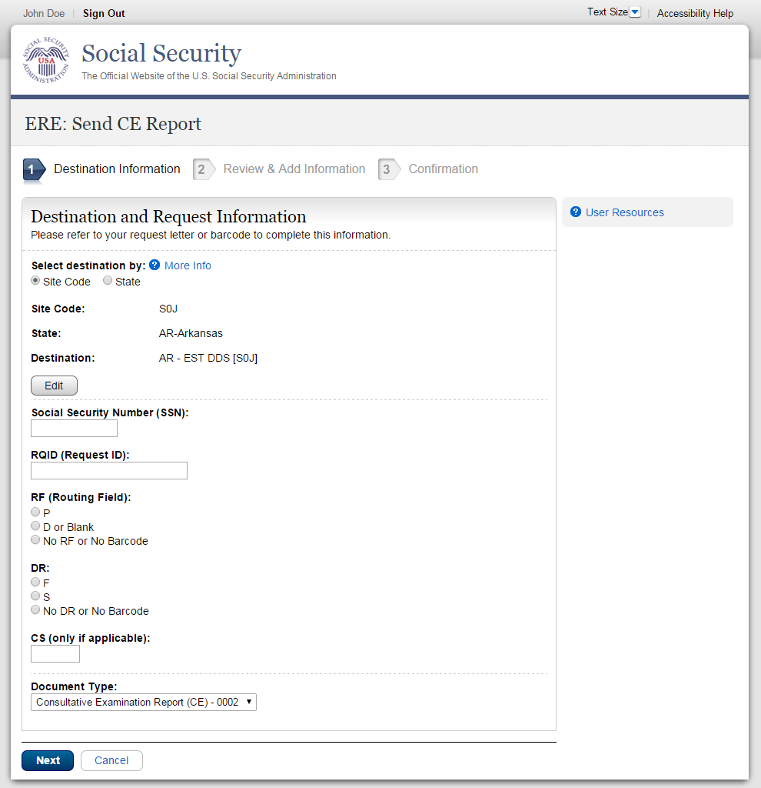

Step 1—Destination and Request Information
- Select the DDS Destination by first selecting the appropriate radio button depending on your desire to search by either Site Code or State

- Enter the three-character Site code from the barcode. The Site code begins with a letter, followed by two digits.
or
- Select the State from the dropdown. After choosing the State, the Destination list updates with the offices in the State you selected. Select the Destination from the dropdown.
- Obtain the following information from the CE request letter if you did not receive the request electronically (this information populates for you if you received an electronic CE request):
- Enter the Social Security Number (SSN). Only files for one SSN can be sent with this transaction.
- Enter the Request ID (RQID). The Request ID is the document number or serial number that is usually located on the request letter near the barcode.
- Select the appropriate RF (Routing Field) option, or No RF or No Barcode if not displayed on the request letter.
- Select the appropriate DR (Document Return Code) option, or No DR or No Barcode if not displayed on the request letter.
- Enter the CS (Check Sum Digits) if available, or leave this field blank if not displayed on the request letter.
- Select the Document Type from the drop down box.
- Select Next to go to the next step or select Cancel to return to the Home page.

Review and Add Information (Step 2 of 3) 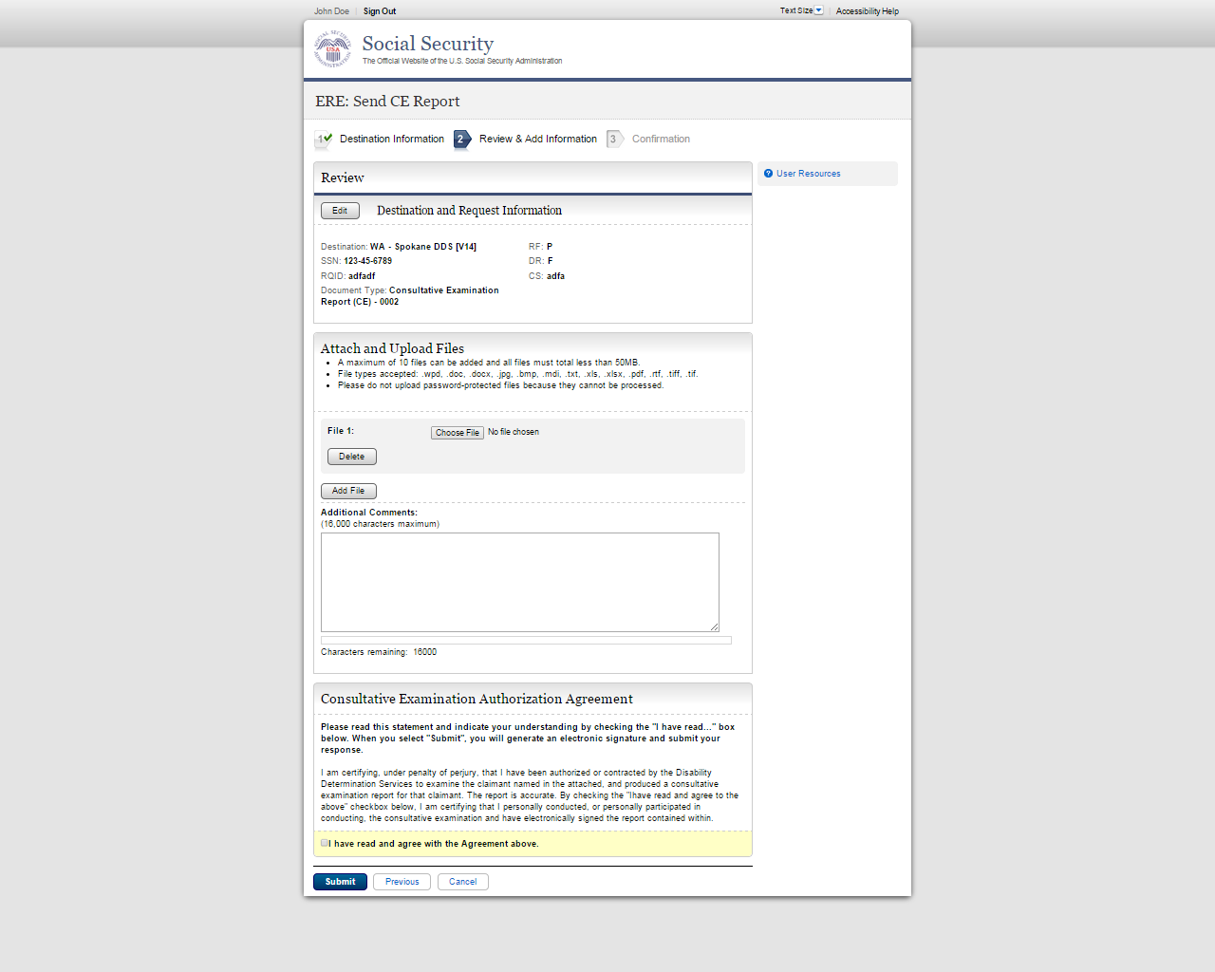

Step 2—Review and Add Information
- Review the Destination and Request summary information, and verify the accuracy of the information selected in Step 1. If any of the information is incorrect, make the corrections by selecting the Edit button. NOTE: If you respond to an electronic request, you will not be able to edit this information. Your screen will not look exactly like the screen shown above.
- Select the button to identify a file to send. (Do not send files that are password protected.) The Choose file window appears on your screen.
- Locate the file you wish to send and highlight the file name. The document’s file name moves into the File name box at the bottom of the Choose file window.
- Select the Open button. The Choose file window closes and the file name displays. If you have chosen the incorrect file, select the Delete button to clear the field.
- Select the Add File button to send additional files.
Note: A maximum of 10 files may be sent for one individual by selecting the Add File button and repeating the previous steps.
SSA’s Electronic Records Express website accepts the following file formats: .wpd, .doc, .docx, .jpg, .bmp, .mdi, .txt, .rtf, .xls, xlsx, .pdf, .tiff, .tif.
Do not upload documents containing macros (i.e., a set of instructions or scripts that automates tasks). They may cause system problems, which will require you to re-submit your documents without macros.

- Type Comments, if needed. Type-in and/or cut-and-paste your text (up to 16,000 characters, approximately three letter size pages) directly into the box provided. The count of remaining characters shows beneath the box.
- The next step is your “Electronic Signature”. This step asks you to certify that you examined the claimant, prepared or reviewed the report, and the report is accurate. Read the certification statement located at the bottom of the screen and indicate your understanding by checking the box beside I have read and agree with the Agreement above. By checking the box, you affirm your intent to sign the report. You do not need to physically sign and send the paper report to the DDS.
- Select the Submit button to provide electronic signature and forward the signed report to the selected DDS office.

The website creates a text file and adds it to the files and information you submit. This document contains the following information:
- Index information you entered from the request letter
- The signature attestation statement to which you agreed
- Your name, as it is registered in Electronic Records Express—serving as your electronic signature.

Confirmation (Step 3 of 3) - no fiscal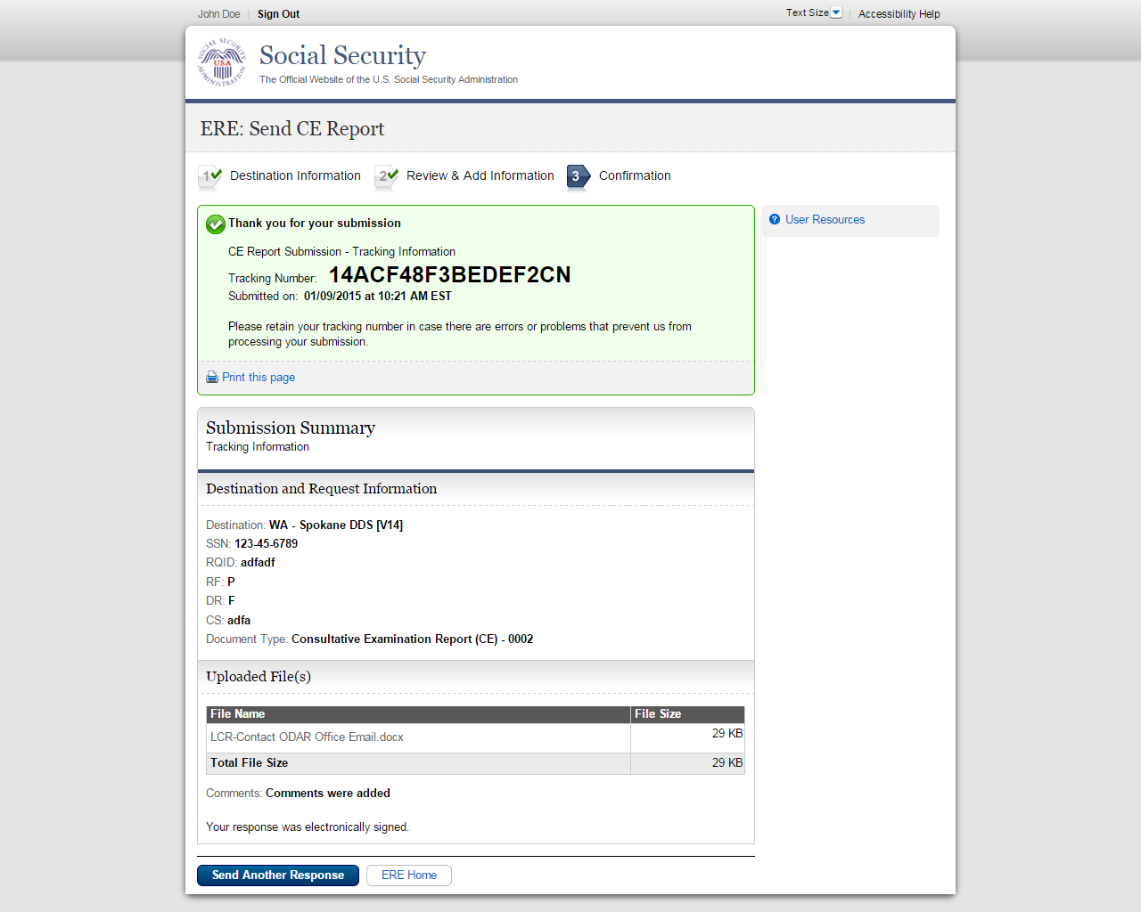

Confirmation (Step 3 of 3) - with fiscal
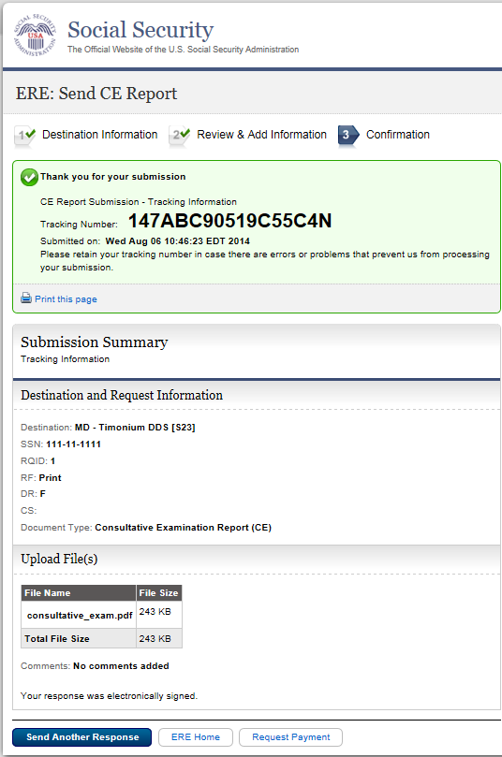

Step 3—Confirmation
- After your submission, Electronic Records Express provides a Confirmation page. The Confirmation page provides a tracking number for you to keep and use if you want to check on the status of your submission. The Confirmation page indicates the specific files and/or comments that you transmitted.
- If you do not receive the Confirmation page, please resubmit the materials.
- If you continue to have transmitting problems, contact the Electronic Records Express Website Help Desk at EETechSupport@ssa.gov or 1-866-691-3061.
- If you have additional CEs to send, you can select Send Another Response.
- To Submit Payment Request, after reviewing the summary select the Request Payment button at the bottom of your screen as shown in the image above (Confirmation with fiscal.
NOTE: We strongly recommended that you print or take a screenshot of the Confirmation page for your documentation. To do this, simply select Print this page located at the bottom of the green box. This print link works the same as if you selected File and Print from your browser’s menu. You cannot bookmark and save a Confirmation page, and you will not be able to retrieve it later once you exit the webpage.

Important Note
It is against SSA policy for a user to delegate the uploading of their Consultative Examination reports, via the Send CE Report website function, to staff members. Users interested in delegating this responsibility should consider using the Send CE with Scanned Signature website function or CE Administrative Staff Upload (Review/Submit Prepared Requests, and Prepare Report for Provider).

.

Access Keys
This application contains access keys to improve navigation and provide information. You will find a list of these keys in the table below:

Button/Link | Access Key
Next | n
Submit | p
User Resources | u
Other keyboard commands, hotkeys or access keys will vary based upon browser and the version of the browser that you are using. A list of these commands can be found in the Help section of your browser. The Help feature can be located on the Menu bar of your browser or by using the F1 function key on the keyboard. Any assistive devices that you may be using will also have a list of these shortcut keys in their Help section.
Note: To use these keys select the “Alt” or “Ctrl” button on your keyboard and the access key simultaneously.

How to Get Important Information about Electronic Records Express Website Availability

You may subscribe to receive ERE website availability notifications through the GovDelivery services on the Social Security Administration’s Electronic Records Express internet website: Social Security Online: Electronic Records Express. Please see the following website for GovDelivery FAQs: https://subscriberhelp.govdelivery.com/hc/en-us

To subscribe to the ERE website availability notification, follow these instructions:
- Click “Sign Up for Email/Text ERE System Notifications” on the Electronic Records Express Home Page,
- Type your email address and select Submit
- Confirm your email address
- Select “Send updates immediately by email.”
- Choose an optional password
- Select Submit
You will receive a “Success” confirmation.
- Select Close to exit.

**Once you have subscribed, you will receive a Subscription Acknowledgement e-mail with instructions on how to update your user profile**

