User Guide for Send Grouped Response


Office of Disability Determinations
October 2015

Instructions for Send Grouped Response

Use the Send Grouped Response function on the Electronic Records Express website to send multiple files on a single upload. You can use this function by combining the multiple files into a single .zip file.
- You need the SSA/DDS evidence request letter that contains the barcode available to complete the processing steps of Send Grouped Response. If you received the request electronically from the DDS, you cannot use “Send Grouped Response” function to respond.
- The barcode sheet must be the topmost (first page) of the record set belonging to one individual. Similarly, a group of files containing the records of many individuals must always have a barcode sheet for each individual when transmitted together as a group of files combined in one file.
- Electronic Records Express only accepts zipped files (.zip) that contain .tif, .tiff, .jpg, .bmp, .mdi or .pdf files. You may use combinations of file types within a single transmission session on the Electronic Records Express website.
- Each individual's barcode sheet must be the topmost (first page) of the record. For example, a .zip file containing five record sets for five different individuals must have five barcode sheets. A barcode sheet must be the topmost (first page) of each individual’s record.

Under the Evidence Functions heading, select Send Grouped Response.
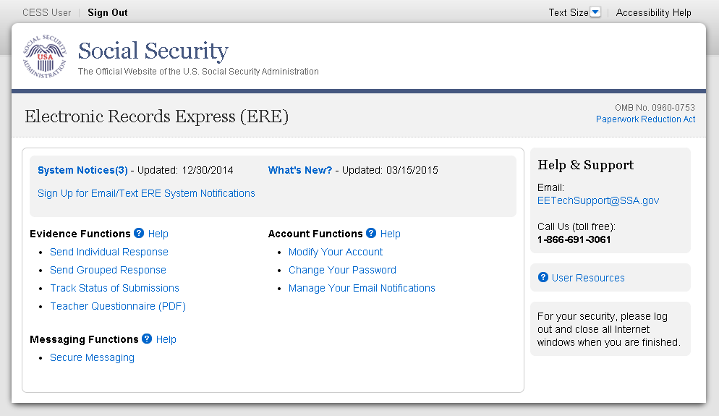
Preparing your files:
Group the records based on whether there is a 2-D/enhanced barcode on the request letter. The barcode should look like the barcode below:
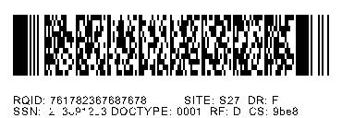
RQID: 123456789012345 SITE: S27 DR: FSSN: 123456789 DOCTYPE: 001 RF: D CS: 9be8

You must separate records that have a 2-D barcode from records that do not have a 2-D barcode. Submit records with a 2-D barcode in one upload. The 2-D barcode must be the first page of the file.

Note: The Send Grouped Response function only accepts .zip files. You must follow the rules listed below or your upload will not process.
- The .zip file must not contain directories.
- The .zip file must be valid and cannot be empty.
- The .zip file must contain only .tiff, .tif, .pdf, .jpg, .mdi, and .bmp files.
- The .zip file must not contain empty (zero-byte) files.
- The .zip file must contain one or more .tiff, .tif, .pdf, .jpg, .mdi, and .bmp files with either all enhanced barcodes or no enhanced barcodes.
- Each .tiff file within a .zip file should follow these specifications:
- One .tif file per patient with the request letter on the first page
- .tiff version 4, 5, or 6
- Intel format (little-endian byte order)
- CCITT Group 4 Compression
- Black & White color (Bitonal)
- 200x200 dots per inch (DPI) resolution

Note: Do not upload documents containing macros (i.e., a set of instructions or scripts that automates tasks). They may cause system problems, which will require you to re-submit your documents without macros.

Destination and Request Information (Step 1 of 3)
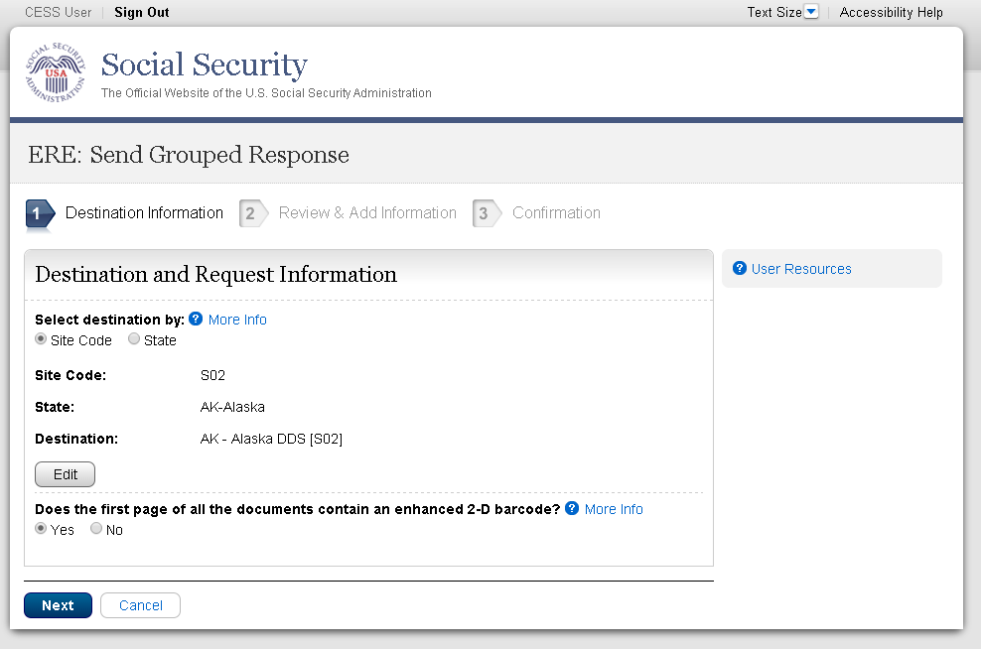

Step 1: Destination and Request Information
- Select the DDS Destination by first selecting the appropriate radio button depending on your desire to search by either Site Code or State

- Enter the three-character Site code from the barcode. The Site code begins with a letter, followed by two digits.
or
- Select the State from the dropdown. After choosing the State, the Destination list updates with the offices in the State you selected. Select the Destination from the dropdown.

- If the topmost (first page) of each record contains an enhanced 2-D barcode, select “Yes”. Otherwise, select “No”.

- Select the Next button to proceed to Step 2: Review and Add Information

Review and Add Information (Step 2 of 3)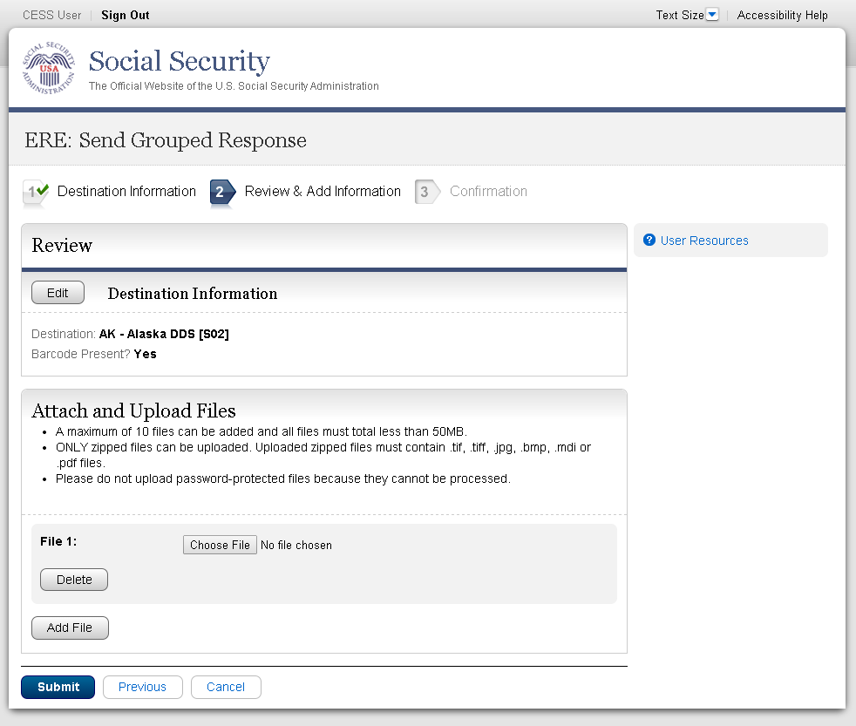
Step 2: Review and Add Information
- Review the Destination and Request Information and verify the accuracy of the information selected in Step 1. If any of the information is incorrect, make the corrections by selecting the Edit button.
- Select the button to identify a file to send. (Do not send files that are password protected.) The Choose file window appears on your screen.
- Locate the file you wish to send and highlight the file name. The document’s file name moves into the File name box at the bottom of the Choose file window.

- Select the Open button. The Choose file window closes and the file name displays. If you have chosen the incorrect file, select the Delete button to clear the field.
- Select the Add File button to send additional zipped files.
- Select the Submit button to forward the information to the Destination selected in Step 1.

Confirmation (Step 3 of 3) 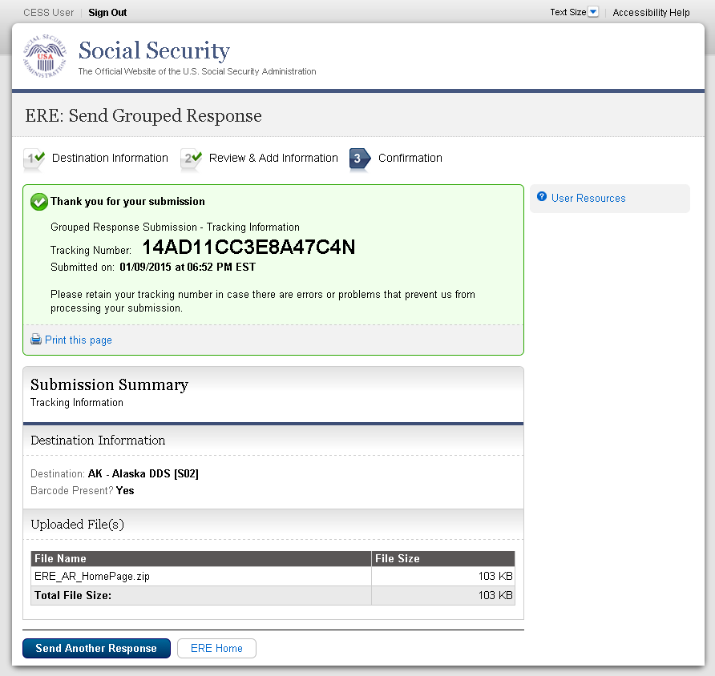

Step 3: Confirmation
After your submission uploads, Electronic Records Express provides a Confirmation page. The Confirmation page provides a tracking number for you to keep and use if you want to check on the status of your submission.
- If you do not receive the Confirmation page, you should resubmit the materials.
- If you continue to have transmitting problems, contact the Electronic Records Express Website Help Desk at EETechSupport@ssa.gov or 1-866-691-3061.
- To respond to another request, select the Send Another Response button.

NOTE: We strongly recommended that you print or take a screenshot of the Confirmation page for your documentation. To do this, simply select Print this page located at the bottom of the green box. This print link works the same as if you selected File and Print from your browser’s menu. You cannot bookmark and save a Confirmation page, and you will not be able to retrieve it later once you exit the webpage.

Access Keys
This application contains access keys to improve navigation and provide information. You will find a list of these keys in the table below:

Button/Link | Access Key
Next | n
Submit | p
User Resources | u
Other keyboard commands, hotkeys or access keys will vary based upon browser and the version of the browser that you are using. A list of these commands can be found in the Help section of your browser. The Help feature can be located on the Menu bar of your browser or by using the F1 function key on the keyboard. Any assistive devices that you may be using will also have a list of these shortcut keys in their Help section.
Note: To use these keys select the “Alt” or “Ctrl” button on your keyboard and the access key simultaneously.

How to Get Important Information about Electronic Records Express Website Availability

You may subscribe to receive ERE website availability notifications through the GovDelivery services on the Social Security Administration’s Electronic Records Express internet website: Social Security Online: Electronic Records Express. Please see the following website for GovDelivery FAQs: https://subscriberhelp.govdelivery.com/hc/en-us

To subscribe to the ERE website availability notification, follow these instructions:
- Click “Sign Up for Email/Text ERE System Notifications” on the Electronic Records Express Home Page,
- Type your email address and select Submit
- Confirm your email address
- Select “Send updates immediately by email.”
- Choose an optional password
- Select Submit
You will receive a “Success” confirmation.
- Select Close to exit.

**Once you have subscribed, you will receive a Subscription Acknowledgement e-mail with instructions on how to update your user profile**

