User Guide for Send Individual Response


Office of Disability Determinations
October 2015
Instructions for Send Individual Response
The Send Individual Response link is available only for users registered to use this function of the website.
On the Electronic Records Express Home page, select the link, Send Individual Response, under the Evidence Functions heading.
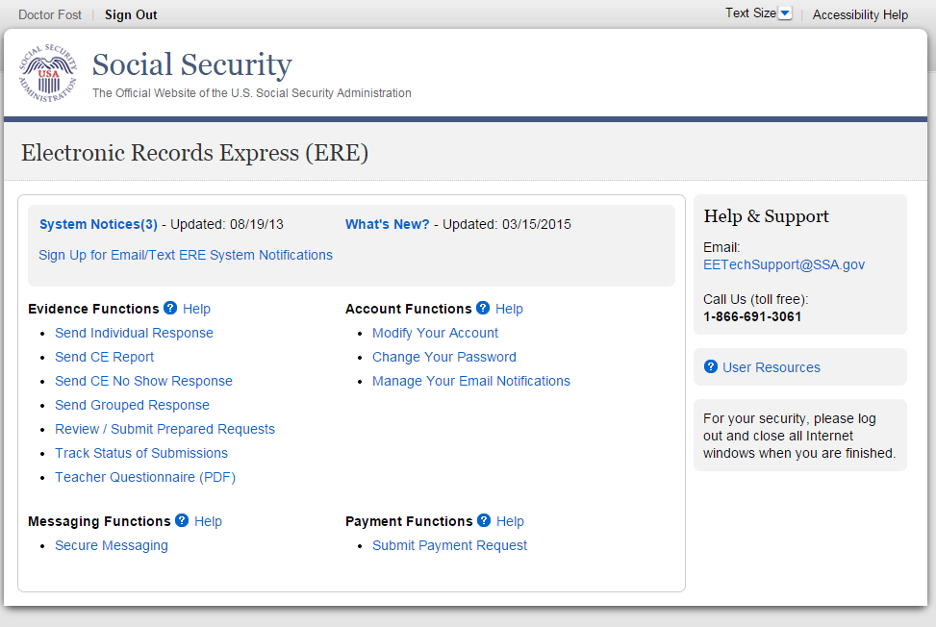

Destination and Request Information (Step 1 of 3)
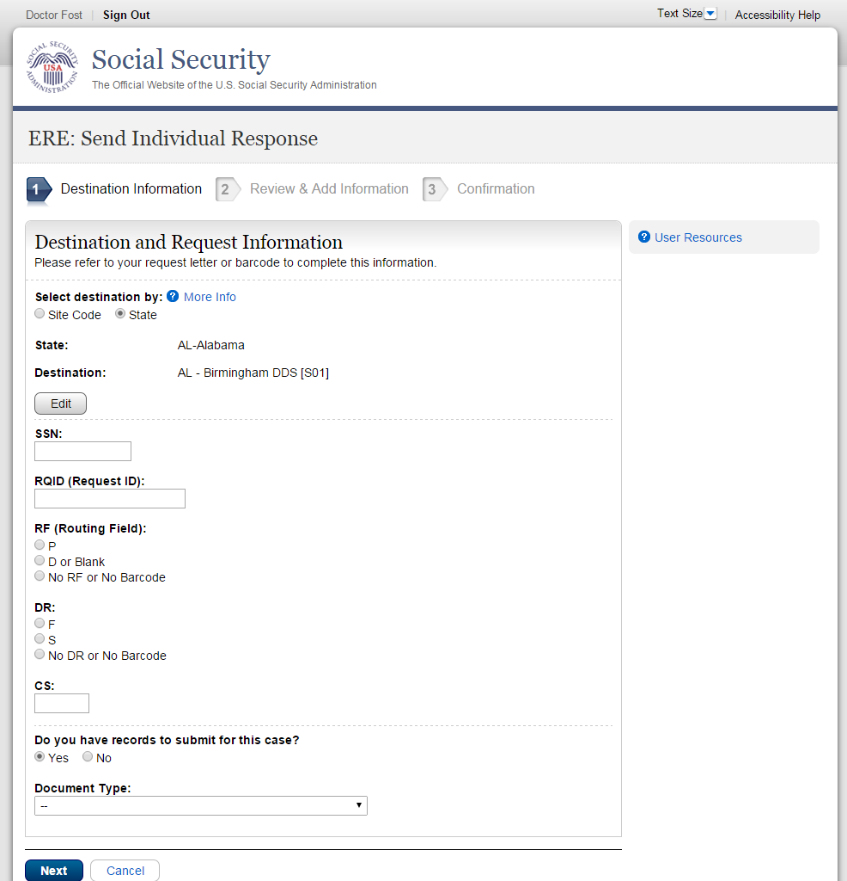

Step 1—Destination and Request Information:
- Select the Destination by first selecting the appropriate radio button depending on your desire to search by either Site Code or State

- Enter the three-character Site code from the barcode. The Site code begins with a letter, followed by two digits.
or
- Select the State from the dropdown. After choosing the State, the Destination list updates with the offices in the State you selected. Select the Destination from the dropdown.
- Obtain the following information from the CE request letter if you did not receive the request electronically (this information populates for you if you received an electronic CE request):
- Enter the Social Security Number (SSN). Only files for one SSN can be sent with this transaction.
- Enter the Request ID (RQID). The Request ID is the document number or serial number that is usually located on the request letter near the barcode.
- Select the appropriate RF (Routing Field) option, or No RF or No Barcode if not displayed on the request letter.
- Select the appropriate DR (Document Return Code) option, or No DR or No Barcode if not displayed on the request letter.
- Enter the CS (Check Sum Digits) if available, or leave this field blank if not displayed on the request letter.
- Select “Yes” to submit records (attach and upload files, comments, and/or electronic signature).
- Select the Document Type from the drop down box.
- Select Next to go to the next step or select Cancel to return to the Home page.
- Continue to Step 2 - Attach and Upload Files, Comments, and/or Electronic Signature.

Review & Add Information (Step 2 of 3)
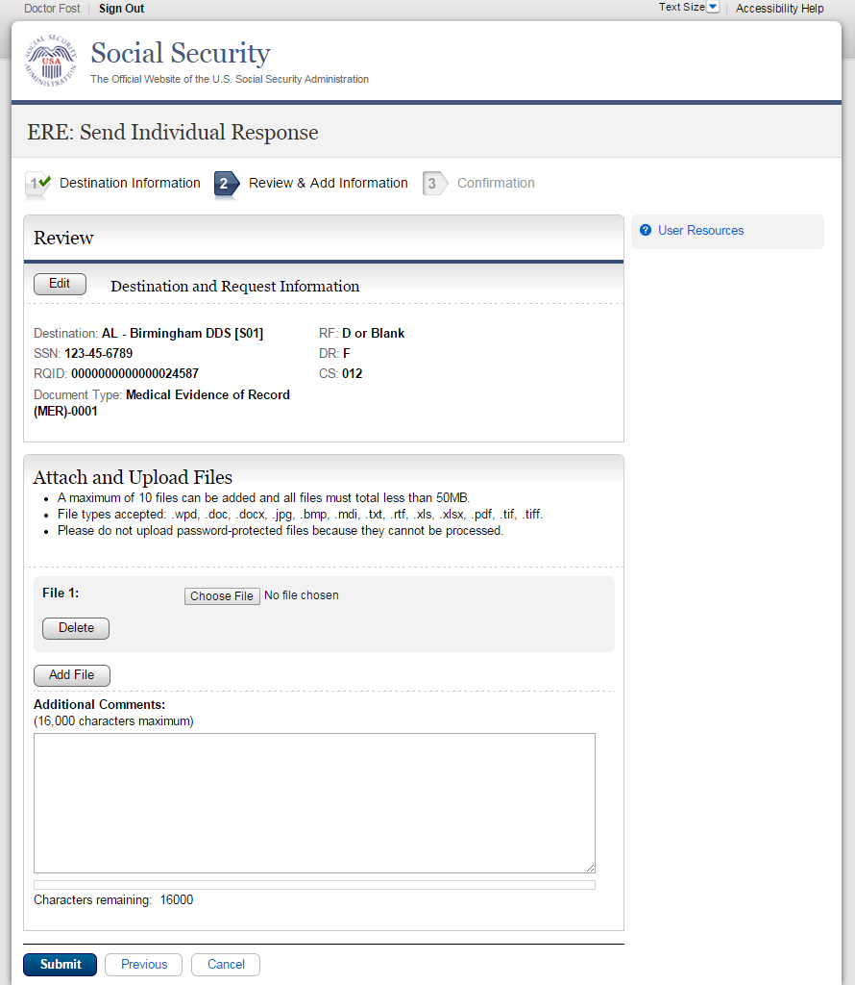

Step 2 – Attach and Upload Files, Comments, and/or Electronic Signature

- Verify the accuracy of the information input in Step 1 against the information displayed on your request letter. If any of the information is not correct, make the corrections via the input fields by selecting the Edit button.

- Choose a file to send. (Do not send files that are password protected.) The Open file window will appear on your screen.
- Locate the file you wish to send and highlight the file name. The document’s file name appears in the File name box at the bottom of the Open file window.

- Select the Open button. The Open file window closes and the Electronic Records Express website displays the file name. If you have chosen the incorrect file, select the Delete button to clear the File 1 field.
- Select the Add File button to send additional files. You may add up to ten files for this transaction. Only files for the SSN entered in Step 1 can be sent with this transaction.
NOTE: Do not upload documents containing macros (i.e., a set of instructions or scripts that automates tasks). They may cause system problems, which will require you to re-submit your documents without macros.
- Type Additional Comments, if needed. The Additional Comment field is where you can provide additional information. Type-in and/or cut-and-paste your text (up to 16,000 characters, approximately three letter size pages) directly into the box provided. The count of remaining characters shows beneath the box.
- Select the Submit button to forward the information to the Destination selected in Step 1.

- Continue to Step 3—Tracking Information.

Confirmation (Step 3 of 3) 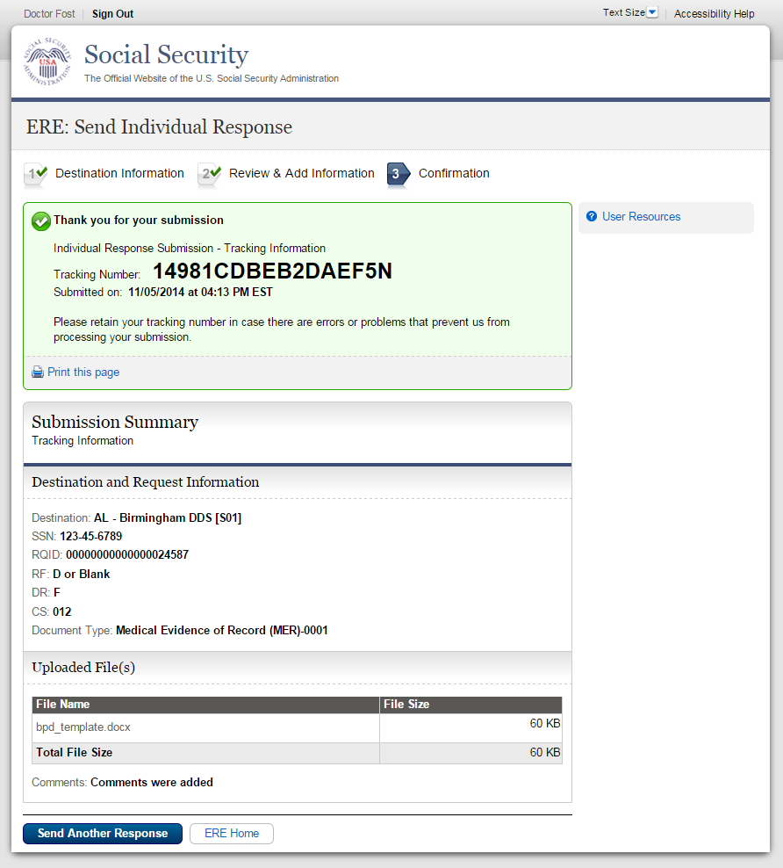
- Review Submission Summary and retain tracking number.
- It provides a tracking number for you to keep and use if you want to check on the status of your submission.
- If you do not receive the Confirmation page, you should resubmit the materials.

- If you continue to have transmitting problems, contact the Electronic Records Express Website Help Desk at EETechSupport@ssa.gov or 1-866-691-3061.

NOTE: We strongly recommended that you print or take a screenshot of the Confirmation page for your documentation. To do this, simply select Print this page located at the bottom of the green box. This print link works the same as if you selected File and Print from your browser’s menu. You cannot bookmark and save a Confirmation page, and you will not be able to retrieve it later once you exit the webpage.

Access Keys
This application contains access keys to improve navigation and provide information. You will find a list of these keys in the table below:

Button/Link | Access Key
Next | n
Submit | p
User Resources | u
Other keyboard commands, hotkeys or access keys will vary based upon browser and the version of the browser that you are using. A list of these commands can be found in the Help section of your browser. The Help feature can be located on the Menu bar of your browser or by using the F1 function key on the keyboard. Any assistive devices that you may be using will also have a list of these shortcut keys in their Help section.
Note: To use these keys select the “Alt” or “Ctrl” button on your keyboard and the access key simultaneously.

How to Get Important Information about Electronic Records Express Website Availability

You may subscribe to receive ERE website availability notifications through the GovDelivery services on the Social Security Administration’s Electronic Records Express internet website: Social Security Online: Electronic Records Express. Please see the following website for GovDelivery FAQs: https://subscriberhelp.govdelivery.com/hc/en-us

To subscribe to the ERE website availability notification, follow these instructions:
- Click “Sign Up for Email/Text ERE System Notifications” on the Electronic Records Express Home Page,
- Type your email address and select Submit
- Confirm your email address
- Select “Send updates immediately by email.”
- Choose an optional password
- Select Submit
You will receive a “Success” confirmation.
- Select Close to exit.

**Once you have subscribed, you will receive a Subscription Acknowledgement e-mail with instructions on how to update your user profile**

