User Guide for Teacher Questionnaire


Office of Disability Determinations
March 2015

Instructions for Teacher Questionnaire
This function allows school personnel to access the Teacher Questionnaire (SSA-5665-BK) on the Electronic Records Express website. School personnel will be able to download the questionnaire, complete the form and send the form via the Electronic Records Express website to the DDS using the Send Individual Response feature under the Evidence Functions heading on the Home page.
Start by logging into Electronic Records Express with your username and password. On the Electronic Records Express Home Page, under the Evidence Functions heading, select “Teacher Questionnaire (PDF)”. This will take you to the Teacher Questionnaire form.
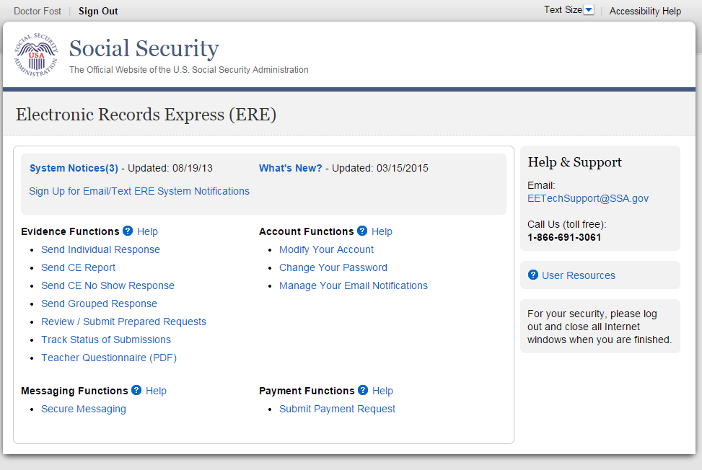
Selecting this link directs you to get the Teacher Questionnaire as a PDF document. The first pages of the form provide brief explanations of why SSA is requesting the completion of the form and other general information.
Since this form is an important element in the decision of whether a child qualifies for disability benefits, please be sure to read all instructions and questions carefully and complete the form in its entirety and to the best of your ability, answering all questions appropriate to the child you are evaluating.
Step 1: Complete the Teacher Questionnaire
- Choose the Teacher Questionnaire (PDF) hyperlink under Evidence Functions from the Electronic Records Express Home website page. The Teacher Questionnaire PDF link will take you to the Teacher Questionnaire form as a PDF document.
- Print and complete the Teacher Questionnaire form.

Step 2: Return Teacher Questionnaire to DDS
- You should have the SSA/DDS request letter readily available to complete the processing steps.
- Follow the user instructions for Send Individual Response to send the completed Teacher Questionnaire to the DDS.

How to Get Important Information about Electronic Records Express Website Availability

You may subscribe to receive ERE website availability notifications through the GovDelivery services on the Social Security Administration’s Electronic Records Express internet website: Social Security Online: Electronic Records Express. Please see the following website for GovDelivery FAQs: https://subscriberhelp.govdelivery.com/hc/en-us

To subscribe to the ERE website availability notification, follow these instructions:
- Click “Sign Up for Email/Text ERE System Notifications” on the Electronic Records Express Home Page,
- Type your email address and select Submit
- Confirm your email address
- Select “Send updates immediately by email.”
- Choose an optional password
- Select Submit
You will receive a “Success” confirmation.
- Select Close to exit.

**Once you have subscribed, you will receive a Subscription Acknowledgement e-mail with instructions on how to update your user profile**

