Monthly Information Package

March 2025

Columns & Features

social security and scam awareness 2

SOCIAL SECURITY'S SCHOOL EMPLOYEES AND SURVIVORS Benefits Toolkits. 4

OUR TOP SOCIAL MEDIA PAGES 6

SOCIAL SECURITY ANNOUNCES NEW RESOURCES FOR SICKLE CELL WARRIORS… 8

Produced at U.S. taxpayer expense.

Social Security Column

# SOCIAL SECURITY AND SCAM AWARENESS

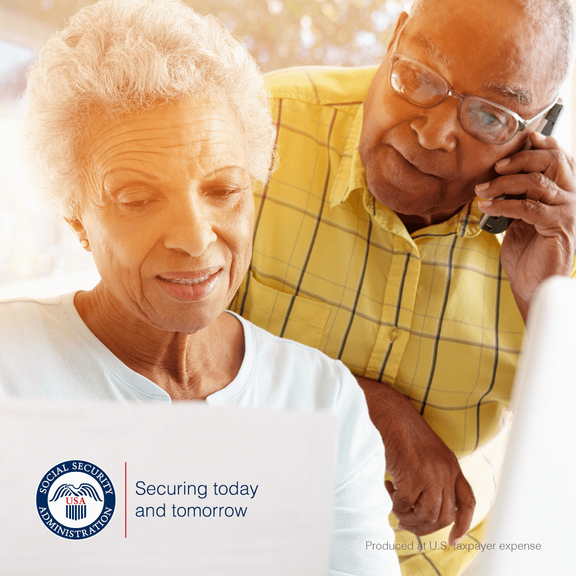

Social Security imposter scams continue to be widespread across the United States. Scammers use tactics to deceive you into providing sensitive information or money. If you receive a suspicious letter, text, email, or call, do not respond.

We will NEVER:

* Text or email images of an employee’s official government identification.
* Suspend your Social Security number.
* Threaten you with arrest or other legal action unless you immediately pay a fine or fee.
* Require payment by retail gift card, wire transfer, internet currency, or cash by mail.
* Promise a benefit increase or other assistance in exchange for payment.
* Mail or email “official” letters or reports containing your personal information.

We only send text messages in limited situations, including:

* When you have subscribed to receive updates and notifications by text.
* As part of our enhanced security when accessing your personal *my* Social Securityaccount.

If you owe money to us, we will mail you a letter with payment options and appeal rights. Social Security employees do contact the public by telephone for business purposes. Ordinarily, the agency calls people who have recently applied for a Social Security benefit, are already receiving payments and require an update to their record or have requested a phone call from the agency. If there is a problem with a person's Social Security number or record, Social Security will typically mail a letter.

We encourage you to report suspected Social Security imposter scams — and other Social Security fraud — to the OIG’s website at [oig.ssa.gov/report](https://oig.ssa.gov/report/). You can find more information about scams at [www.ssa.gov/scam](https://www.ssa.gov/scam). Please share this information with your friends, family, and colleagues to help spread awareness about Social Security imposter scams.

# # #

**Social Security Column**

# SOCIAL SECURITY’S SCHOOL EMPLOYEES AND SURVIVORS BENEFITS TOOLKITS

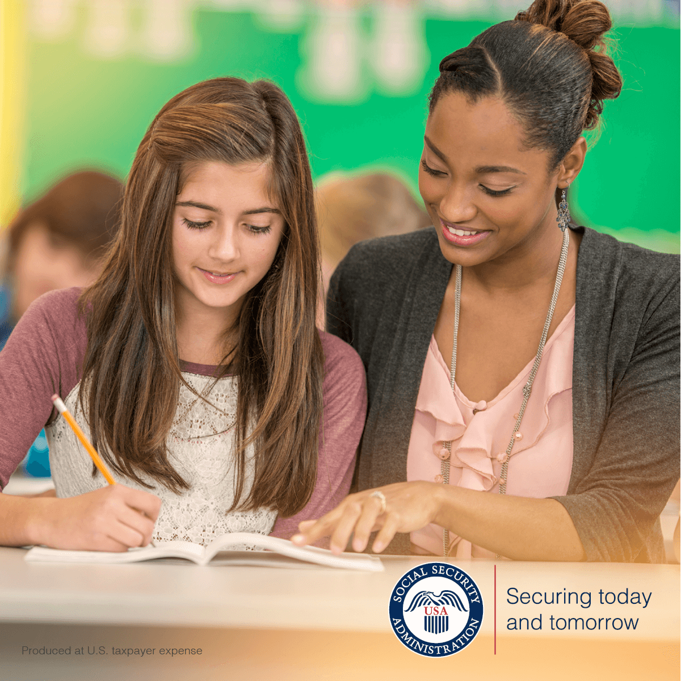

We’ve released new resources to help you better understand Social Security benefits. We’ve designed easy-to-use toolkits to provide education about our programs for children and our benefits for families after the death of a loved one. Our toolkits (School Professional and Survivor Benefits) are downloadable PDFs that include ready-to-go communications, such as sample email blasts, newsletter articles, handouts, and social media posts.

The School Professional Toolkit at [www.ssa.gov/marketing/assets/materials/toolkit-ss-benefits-and-ssi-payments-for-children.pdf](https://www.ssa.gov/marketing/assets/materials/toolkit-ss-benefits-and-ssi-payments-for-children.pdf) is for teachers, school counselors, and other educators. The purpose of this toolkit is to educate parents and guardians about the financial help we provide. We make payments to students with disabilities and to those who have experienced the loss of a parent or have a parent who is receiving retirement or disability benefits.

The toolkit discusses:

* Eligibility requirements.
* How to apply.
* How to respond to requests for school records and forms.
* Evidence we need from school professionals to determine whether a child with a disability may be eligible for SSI.

The Survivors Benefits Toolkit at [www.ssa.gov/marketing/assets/materials/toolkit-ss-survivors-benefit.pdf](https://www.ssa.gov/marketing/assets/materials/toolkit-ss-survivors-benefit.pdf) is for funeral homes, care facilities, and other organizations working with people who have lost a loved one. This toolkit increases awareness about survivors benefits for eligible family members. We make monthly payments to surviving spouses, minor children, adult children with disabilities, and dependent parents of workers who paid Social Security taxes before they died.

The toolkit discusses:

* Eligibility requirements.
* How to apply.
* Evidence we need to process applications.

For more information about our toolkits, visit the blog post titled *New Resources for School Employees and Survivors* at [blog.ssa.gov/new-resources-to-educate-school-employees-and-survivors](https://blog.ssa.gov/new-resources-to-educate-school-employees-and-survivors/).

Please help us spread the word about our toolkits with your colleagues and others who may find them helpful.

# # #

Social Security Column

# OUR TOP SOCIAL MEDIA PAGES

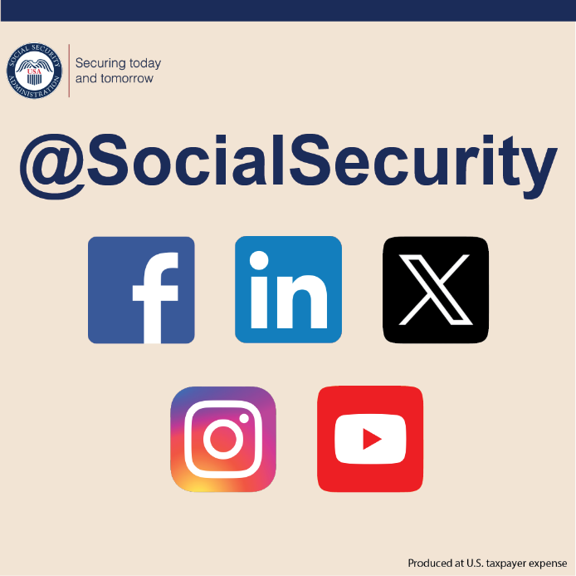

We strive to provide the public with accurate and helpful information. In addition to the resources available on our website at [www.ssa.gov](https://www.ssa.gov/), we post useful information on our social media channels. We invite you to learn about our programs and services on our social media pages:

* Our Social Security Blog – Here we post articles about our program, current events, and online services. We respond to general questions and comments people share. You can read our articles and subscribe at [blog.ssa.gov](https://blog.ssa.gov/). Our blog is now available in Spanish at [blog.ssa.gov/es](https://blog.ssa.gov/es/).
* Facebook – [www.facebook.com/socialsecurity](https://www.facebook.com/socialsecurity). Facebook is our primary page for sharing information about our programs and services with our vast network of followers and advocacy groups.
* Administración del Seguro Social – [www.facebook.com/segurosocial](https://www.facebook.com/segurosocial). Our Spanish Facebook page shares information about our programs and services.
* X – [www.x.com/socialsecurity](https://www.x.com/socialsecurity). *@SocialSecurity* is our official account. This page to provide timely information and updates about our programs and services with our followers and advocacy groups.
* Seguro Social – [www.x.com/segurosocial](https://www.x.com/segurosocial). On this page we share information about our programs and services in Spanish.
* Instagram – [www.instagram.com/SocialSecurity](https://www.instagram.com/SocialSecurity). Onthis page we share stories and resources that can help you and your loved ones.
* YouTube –[www.youtube.com/SocialSecurity](https://www.youtube.com/SocialSecurity). We have many informative videos on this page. Our videos cover online services, applying for retirement and disability benefits, Social Security-related scams, and much more. We also offer some of our videos in Spanish and other languages.

You can find a full list of our social media channels at [www.ssa.gov/socialmedia](https://www.ssa.gov/socialmedia/). Connect with us on social media to learn helpful information and ask general questions. But remember, you should never post personal information on social media. Follow along and share our pages with friends, neighbors, or loved ones today.

# # #

Social Security Column

# SOCIAL SECURITY ANNOUNCES NEW RESOURCES FOR SICKLE CELL WARRIORS



Are you a sickle cell warrior or do you know someone with sickle cell disease? At Social Security, we’re committed to supporting sickle cell warriors and the people who care for them.

An adult or child with sickle cell disease may be eligible for benefits through Social Security Disability Insurance (SSDI) or Supplemental Security Income (SSI).

SSDI benefits are based on earnings and are not subject to income and resource limits. SSI is a needs-based program that provides payments to people who are age 65 or older, blind, or have a disability and have limited income and resources.

Our publications provide information, examples, and tips to help you understand the disability application and evaluation process. You can learn more by reading:

* *Sickle Cell Disease and the Social Security Disability Evaluation Process for Adults* at

[www.ssa.gov/pubs/EN-60-003.pdf](http://www.ssa.gov/pubs/EN-60-003.pdf).

* *Sickle Cell Disease and the Social Security Disability Evaluation Process for Children* at

[www.ssa.gov/pubs/EN-60-004.pdf](http://www.ssa.gov/pubs/EN-60-004.pdf).

Our publication, *Sickle Cell Disease: A Guide for Health Professionals on Providing Medical Evidence for Social Security Disability Claims* at [www.ssa.gov/pubs/EN-60-005.pdf](http://www.ssa.gov/pubs/EN-60-005.pdf), explains the medical evidence we need to make medical decisions for people with sickle cell disease. For more information about our disability programs and related topics, visit our blog article titled *Understanding Social Security Disability Benefits* at [blog.ssa.gov/understanding-social-security-disability-benefits](https://blog.ssa.gov/understanding-social-security-disability-benefits/). These resources help ensure timely, equitable, and accurate disability evaluations for people with sickle cell disease.

Please share this article with your loved ones.

*# # #*