Social Security Column

# SOCIAL SECURITY CARDS ARE SAFER AT HOME

By <Name>

Social Security <Title> in <Place>

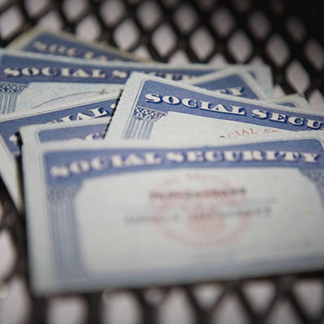

Scams to steal your personal information are at an all-time high. The need to safeguard important personal documents such as your Social Security card continues to be very important.

A Social Security card is not an identification document. In many situations, you only need to know your Social Security number (SSN). Your physical card is not necessary for most business needs.

Do you need evidence for work? There are several documents you can use instead of your card. Other acceptable evidence includes the following:

* Birth Certificate.
* Permanent Resident Card or Alien Registration Receipt.
  + Employment Authorization Document.
  + Form I-94 or Form I-94A.

You do not need to show your physical card to apply for certain benefits. You can simply provide your SSN for benefits like:

* Housing.
* Health insurance.
* Food assistance.

You should also know your physical card is not required as evidence for the Department of Motor Vehicles or Driver License (REAL ID). The only state that requires a physical card is Pennsylvania.  For all other states, other acceptable evidence includes:

* W-2 forms.
* Form SSA-1099.
* Non-SSA-1099 forms.
  + Pay stubs.

Keeping your card at home reduces the risk of loss or theft – and helps you keep your information safe.

# # #